Supplementary Figure 1. Flow chart of study sample selection
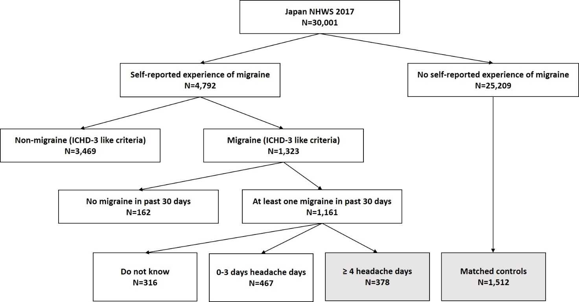
Abbreviations: NHWS=National Health and Wellness Survey, ICHD-3=International Criteria of Headache Disorders, 3rd edition.

