Supp Fig 1. Acute medication use – proportion of patientsª in the 183 days before and after erenumab initiation

OnabotulinumtoxinA Users Subgroup (n=720)
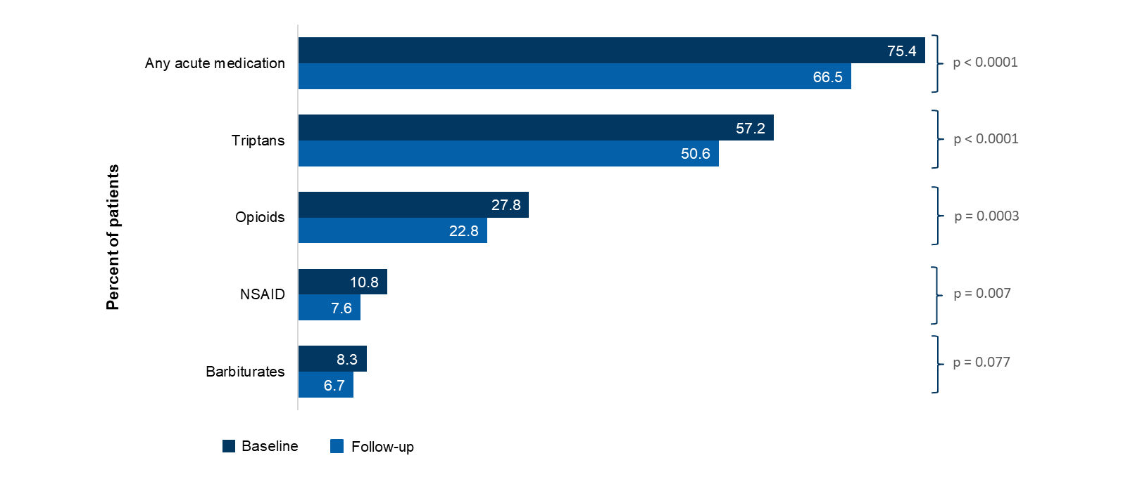
ªNote that the results for ergots are not included due to insufficient data.
The McNemar test was performed.
NSAID, Non-steroidal anti-inflammatory drug.

Supp Fig 2. Healthcare resource utilization – proportion of patients in the 183 days before and after erenumab initiation

Overall Population (n=3171)
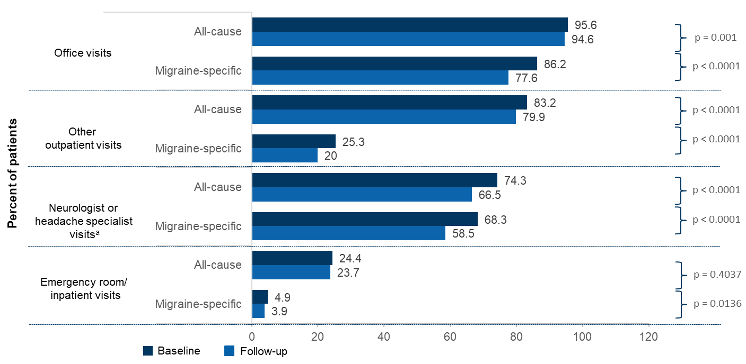
ªNeurologist or headache specialist visits are a subset of the office visits.
The McNemar test was performed.

Supp Fig 3. Acute medication use – mean number of claimsª in the 183 days before and after erenumab initiation

OnabotulinumtoxinA Users Subgroup (n=720)
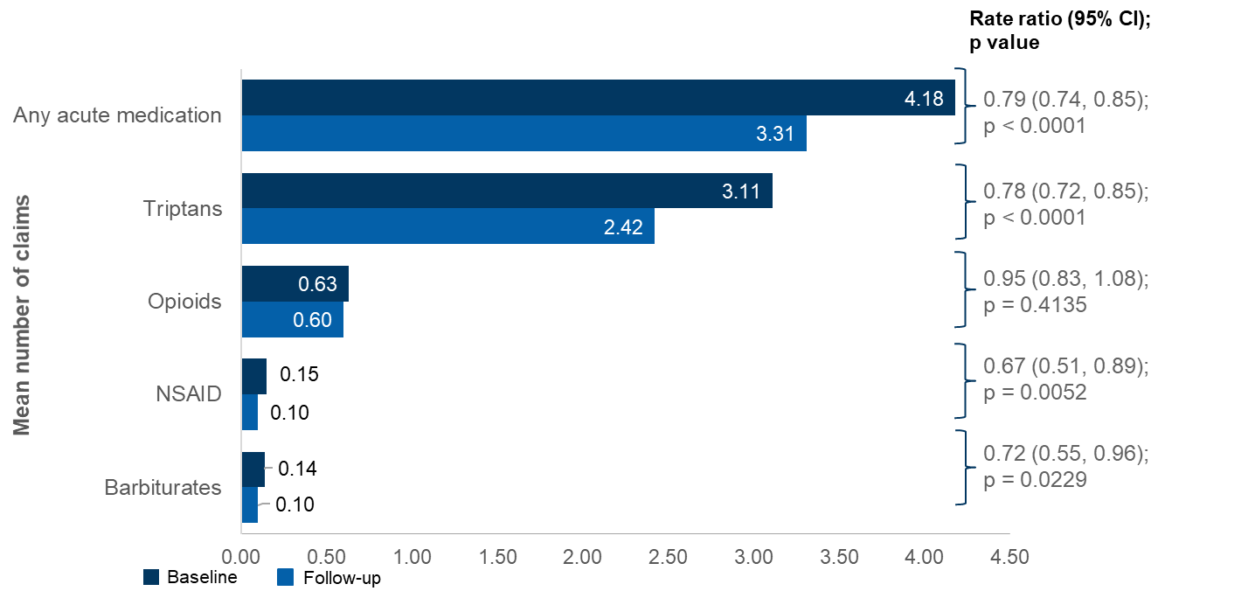
ªUse of non-migraine specific acute medications (NSAIDs, opioids, and barbiturates) required a migraine diagnosis on or before 7 days of the medication claim to proxy migraine-specific acute medication.
Negative binomial model with repeated measure was used.
CI, confidence interval; ER, emergency room; IPTW, inverse probability of treatment weighting; NSAID, nonsteroidal anti-inflammatory drug; RR, rate ratio.

Supp Fig 4. Healthcare resource utilization – mean number of visits in the 183 days before and after erenumab initiation

OnabotulinumtoxinA Users Subgroup (n=720)
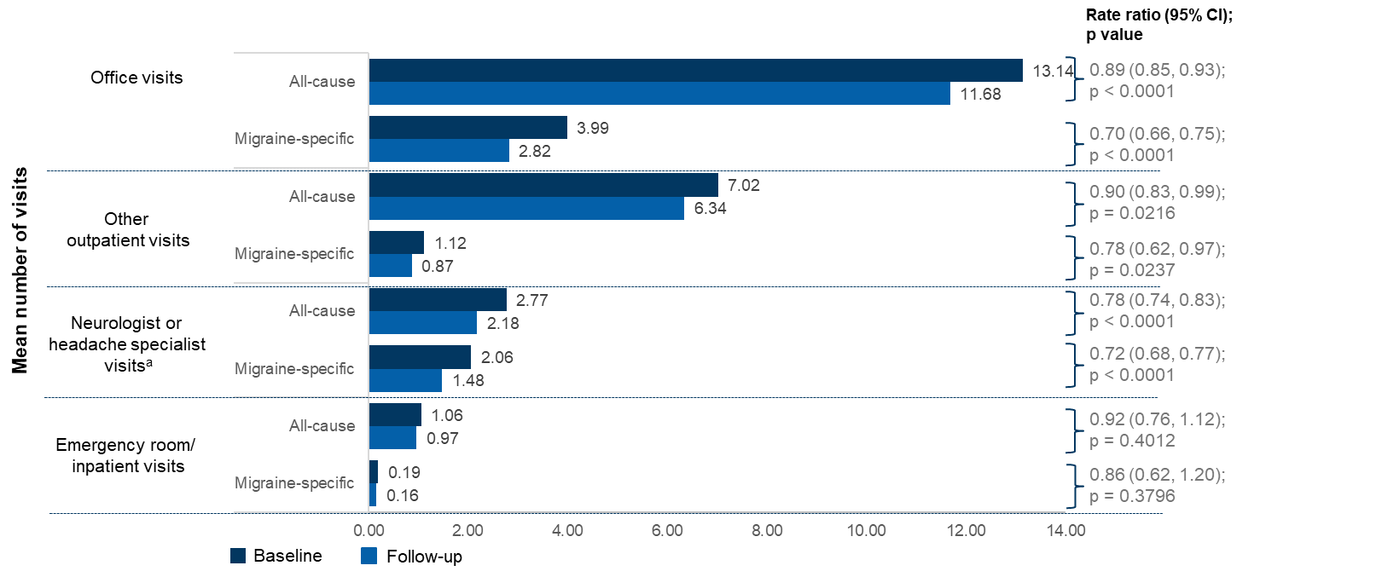
ªNeurologist or headache specialist visits are a subset of the office visits.
Negative binomial model with repeated measure was used.
CI, confidence interval; ER, emergency room; IPTW, inverse probability of treatment weighting; NSAID, nonsteroidal anti-inflammatory drug; RR, rate ratio.

Supp Fig 5. Healthcare resource utilization – proportion of patients in the 183 days before and after erenumab initiation

OnabotulinumtoxinA Users Subgroup (n=720)
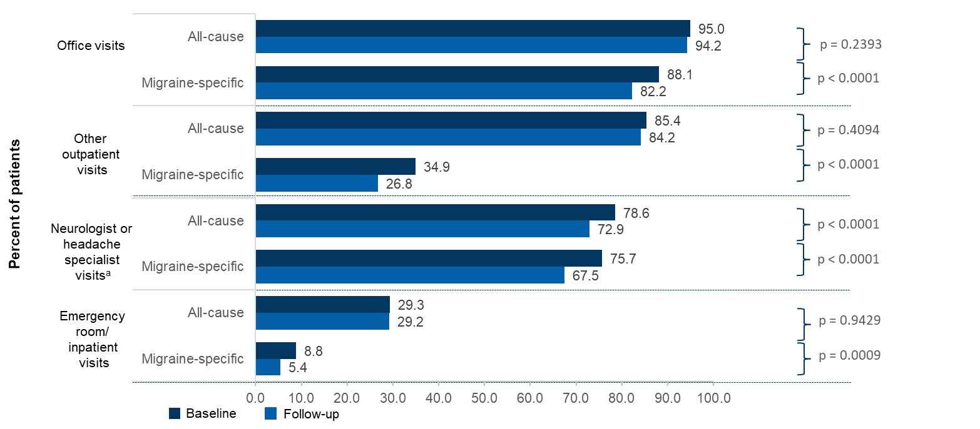
ªNeurologist or headache specialist visits are a subset of the office visits.
The McNemar test was performed.

Supp Fig 6. Composite endpointª in the 183 days before and after erenumab initiation

OnabotulinumtoxinA Users Subgroup (n=720)
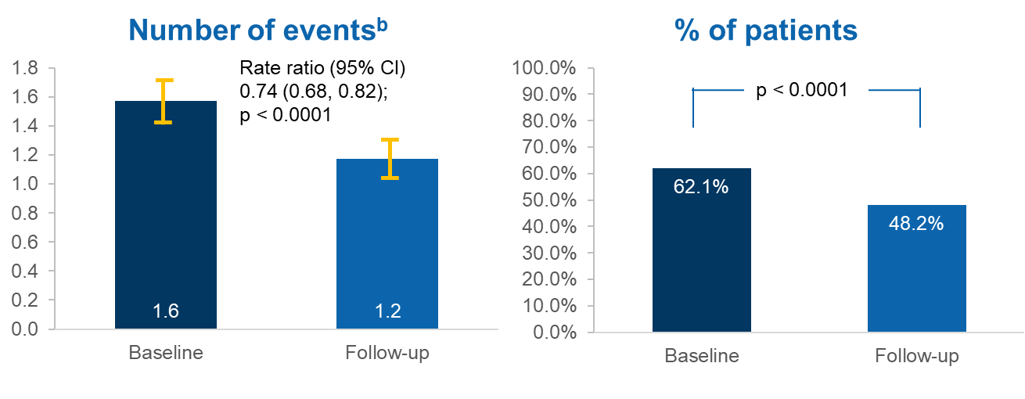
ªOutpatient visit with a diagnosis of migraine and an associated acute medication claim, hospital admission or emergency room visit with a primary diagnosis for migraine. Any events occurred ≤3 days apart were counted only once. McNemar test for binary endpoint and Negative binomial model with repeated measure for count data were used.
^{b}Number of events are plotted as relative risk and 95% confidence intervals.

Supp Table 1. Diagnosis codes
Disease | ICD10
Stroke | G450, G451, G452, G453, G458, G459, H340, I60, I61, I62, I63
CV Disease | E85, I0981, I10, I11, I110, I12, I120, I13, I130, I132, I15, I16, I20, I21, I22, I25, I2511, I25110, I25111, I25118, I25119, I252, I257, I2570, I25700, I25701, I25708, I25709, I2571, I25710, I25711, I25718, I25719, I2572, I25720, I25721, I25728, I25729, I2573, I25730, I25731, I25738, I25739, I2575, I25750, I25751, I25758, I25759, I2576, I25760, I25761, I25768, I25769, I2579, I25790, I25791, I25798, I25799, I34, I340, I35, I350, I351, I36, I37, I480, I481, I482, I4891, I50, I700, I739, N183, N184, N185, N186
Depression | F0631, F0632, F251, F313, F314, F315, F3175, F3176, F32, F33, F341, F4321, F4323
Anxiety | F064, F40, F41, F4322, F4323
Insomnia | A8183, F510, G470, Z7381
Epilepsy | G40
Constipation | K560, K564, K566, K567, K590, K5939, 3E1H78Z.
Gastroparesis | K3184
IBS | K58, K580, K581, K582, K588, K589
Endometriosis | N80
Obesity | E6601, E6609, E661, E662, E668, E669
Migraine | G43
CM w/o aura | G437
Brain Injury | S0
Menstrual Migraine | G4382, G4383
Fibromyalgia | M797
CM, chronic migraine; CV, cardiovascular; IBS, irritable bowel syndrome; w/o, without.
Note: The medication codes are provided in the accompanying excel sheet.

Supp Table 2. Elixhauser Comorbidities (≥5%)
Elixhauser Comorbidities with Any Comorbidities: N (%) | 2588 (81.6%)
Elixhauser disease groups: | N (%)
Depression | 1325 (41.8%)
Uncomplicated Hypertension | 1143 (36.0%)
Hypothyroidism | 775 (24.4%)
Chronic Pulmonary Disease | 761 (24.0%)
Obesity | 690 (21.8%)
Cardiac Arrhythmias | 448 (14.1%)
Rheumatoid Arthritis/Collagen Vascular Diseases | 432 (13.6%)
Uncomplicated Diabetes | 421 (13.3%)
Fluid and Electrolyte Disorders | 350 (11.0%)
Complicated Diabetes | 292 (9.2%)
Other Neurological Disorders | 283 (8.9%)
Deficiency Anemia | 274 (8.6%)
Drug Abuse | 266 (8.4%)
Peripheral Vascular Disease | 215 (6.8%)
Renal Failure | 193 (6.1%)
Liver Disease | 191 (6.0%)
Valvular Disease | 187 (5.9%)
Complicated Hypertension | 181 5.7%)
The Elixhauser comorbidity index measures the baseline comorbidity based on inpatient and outpatient administrative claims data.

Supp Table 3. Baseline preventive drugs used in the 12 month pre-index period
 | Erenumab cohort  N = 3171 | OnabotA subgroup N = 720

Number of preventive drug classes used, n (%)
0 | 902 (28.5) | 0
1 | 1110 (35.0) | 201 (27.9)
2 | 751 (23.7) | 255 (35.4)
3+ | 408 (12.9) | 264 (36.7)

Preventive medications used in 12 months pre-index period, n (%)
Anticonvulsant | 1338 (42.2) | 348 (48.3)
Antidepressant | 920 (29.0) | 248 (34.4)
OnabotA | 720 (22.7) | 720 (100)
Beta blocker | 597 (18.8) | 164 (22.8)
Calcium channel blocker | 274 (8.6) | 73 (10.1)
ACE inhibitor | 61 (1.9) | 19 (2.6)
ACE, Angiotensin-converting enzyme; onabotA, onabotulinumtoxinA.

Supp Table 4. Number of acute medications by generic and drug class in the 183 days before and after erenumab initiation
OnabotA subgroup | Baseline |  | Follow-up
N = 720 | Number | % | Number | % |  | ORª  (95% CI) | P value

Number of generic drugs used

0 | 170 | 23.6% | 228 | 31.7% |  | 0.51  (0.41-0.63) | <0.0001
1 | 260 | 36.1% | 268 | 37.2% |  | 0.51  (0.41-0.63) | <0.0001
2 | 152 | 21.1% | 125 | 17.4% |  | 0.51  (0.41-0.63) | <0.0001
3+ | 138 | 19.2% | 99 | 13.8% |  | 0.51  (0.41-0.63) | <0.0001

Number of drug classes used
0 | 170 | 23.6% | 228 | 31.7% |  | 0.56  (0.46-0.70) | <0.0001
1 | 307 | 42.6% | 305 | 42.4% |  | 0.56  (0.46-0.70) | <0.0001
2 | 166 | 23.1% | 123 | 17.1% |  | 0.56  (0.46-0.70) | <0.0001
3+ | 77 | 10.7% | 64 | 8.9% |  | 0.56  (0.46-0.70) | <0.0001
OR, odds ratio; SD, standard deviation.

ªProportional odds model with repeated measure was used.

