Supplementary materials
Supplementary Materials I
Table 1: Correlation between baseline GABA+ and clinical characteristics of migraine
 | Change in frequency (days/month)  r (p-value) | Change in intensity (HIT-6)  r (p-value) | Change in disability (WHODAS)  r (p-value)
Baseline GABA+  PCG  ACC | −0.07 (0.80)  −0.15 (0.57) | −0.17 (0.50)  −0.23 (0.37) | 0.05 (0.85)  0.01 (0.10)
*statistically significant p <0.05, all negligible correlations

Supplementary Materials II
Table 2: Post-hoc between group comparison of primary outcomes
 | CGRP-mAbs  (n = 10) | Botox®  (n = 8) | Mean difference  [95% CI] | Independent t-test  t (df), p-value
Change in frequency (days/month) | −8.8 ± 7.38 | 1.5 ± 8.16 | 10.3 [2.52 to 18.07] | t (16) = 2.81, p = 0.01*
Change in intensity (HIT-6) | −8.8 ± 2.97 | −4.13 ± 5.72 | 4.68 [0.26 to 9.09] | t (16) = 2.25, p = 0.04*
Change in disability (WHODAS) | −8.4 ± 14.92 | 4.25 ± 22.75 | 12.65 [−6.21 to 31.5] | t (16) = 1.42, p = 0.17
Change in ACC GABA+ | 0.12 ± 0.63 | −0.41 ± 0.37 | 0.54 [0.02 to 1.05] | t (16) = 2.10, p = 0.05*
Change in PCG GABA+ | −0.59 ± 0.82 | −0.27 ± 0.51 | 0.31 [−0.39 to 1.02] | t (16) = 0.95, p = 0.36
Reported as mean ± SD unless stated, *statistically significant p <0.05

9.3 Supplementary Materials III

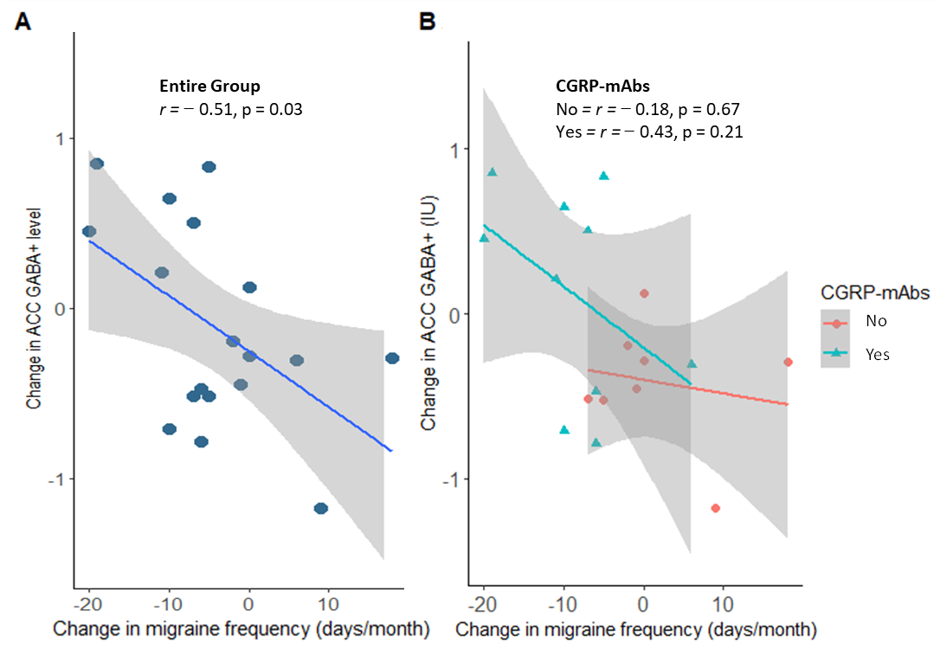
Figure 1: Correlation between change in ACC GABA+ levels and change in migraine frequency.
Figure 1A) demonstrates the correlation of the whole group of people with migraine reported in this study. Figure 1B) demonstrates the correlation divided by group and shows that the group escalated with CGRP-mAbs had a stronger correlation with an increase in ACC GABA+ than those who did not, although neither correlation reached statistical significance. Further, the people escalated with CGRP-mAbs generally had a greater reduction in migraine days a month compared to those who were not escalated with CGRP-mAbs.

