Supplemental Figure 2
Fig.2 Brain perfusion SPECT of patient 1-7 with arrows pointing to the hot spot

Fig.2A Patient 1
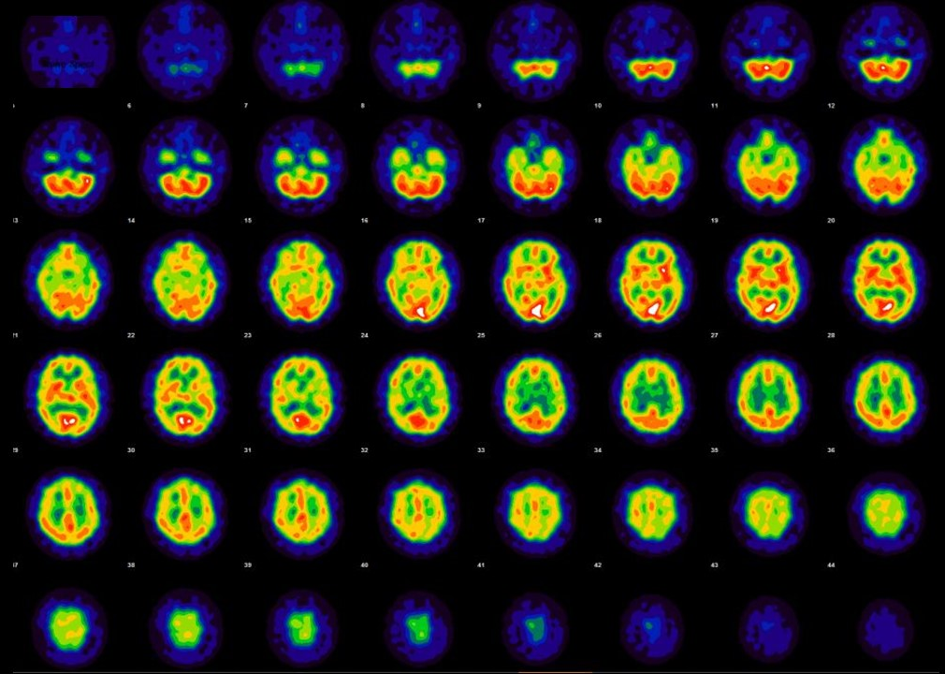

Fig.2B Patient 2
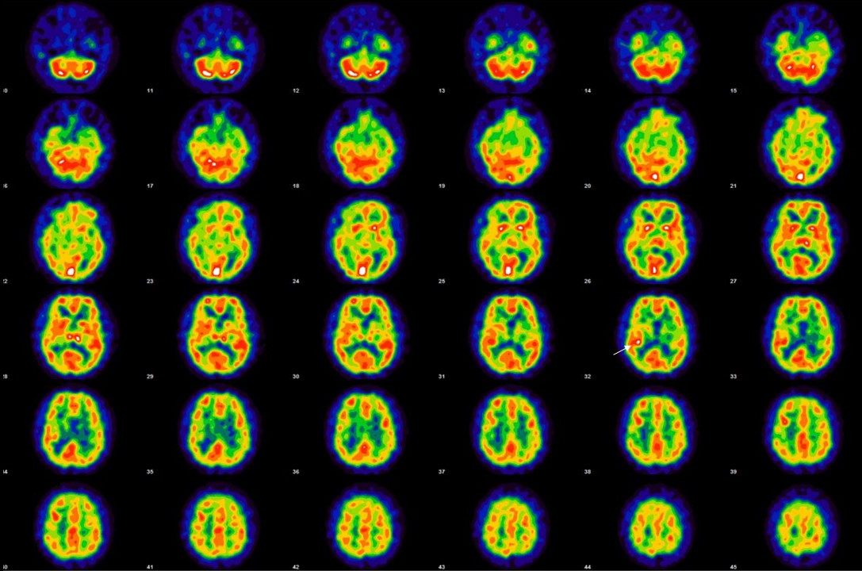

Fig.2C Patient 3
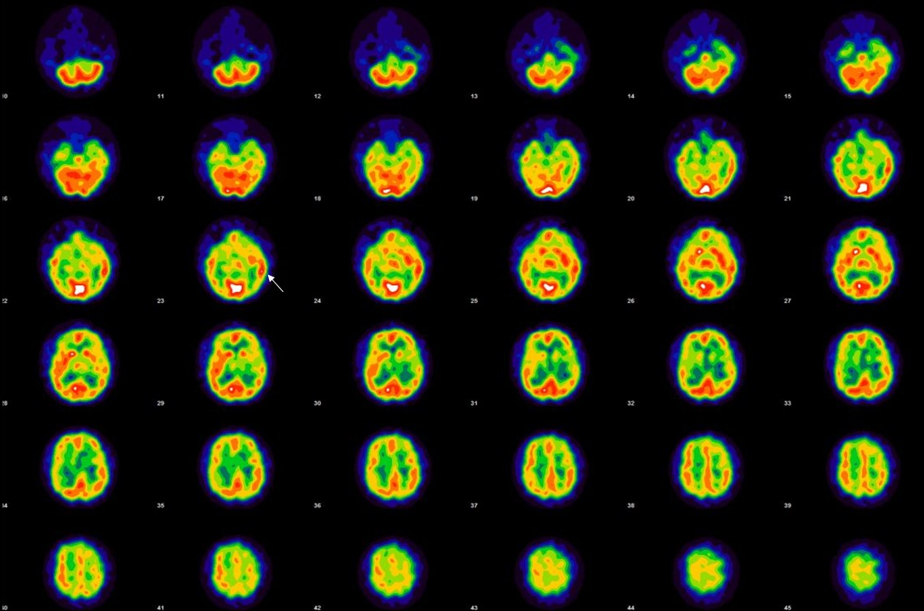

Fig.2D Patient 4
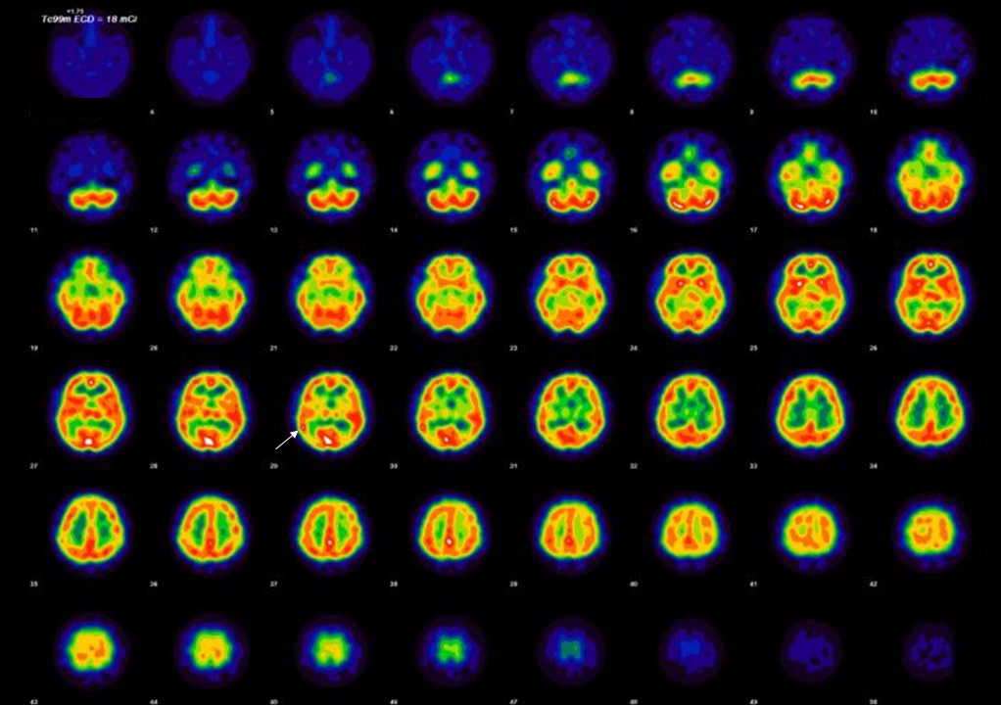

Fig.2E Patient 5
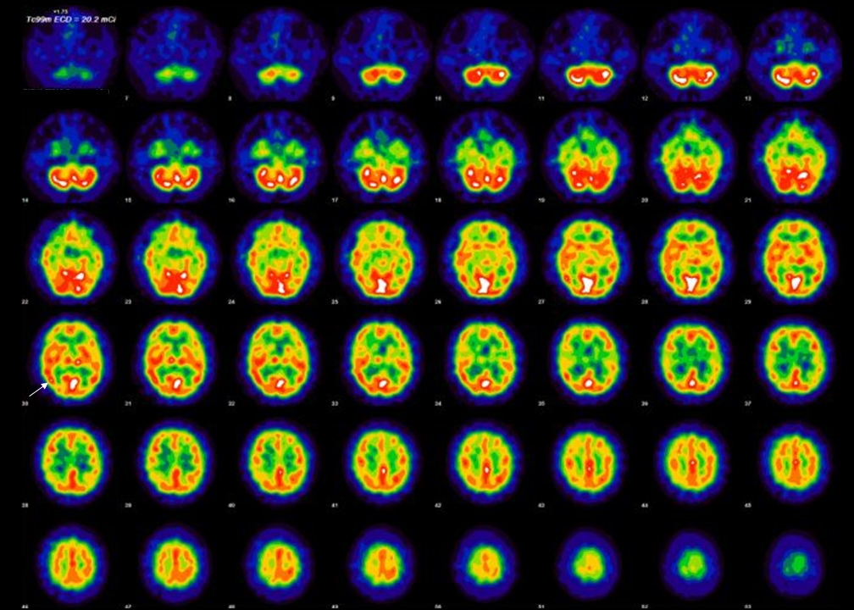

Fig.2F Patient 6
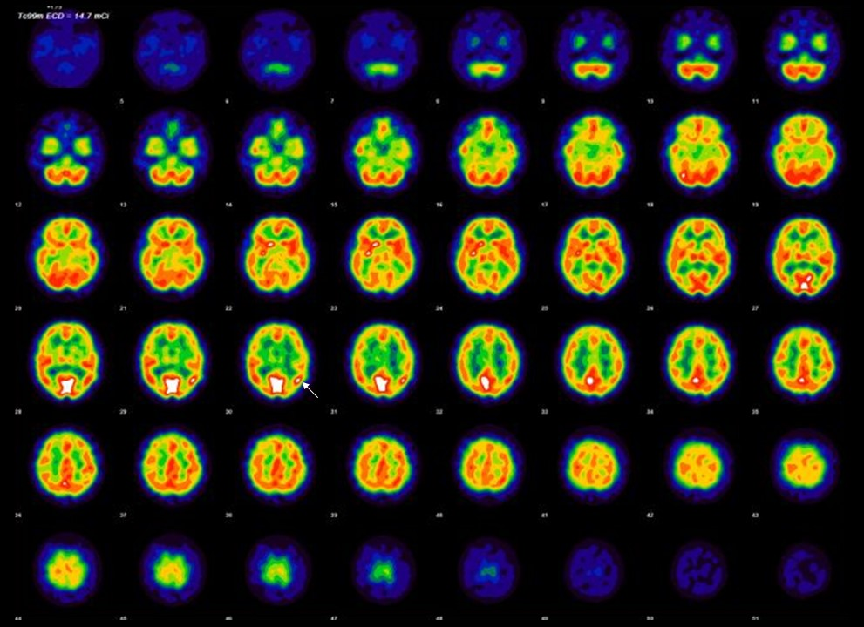

Fig.2G Patient 7
