Additional File 2. Effectiveness outcomes by proportion of patients with ≥30% reduction from baseline in MMD: A) total population; B) dosing schedule subgroups; C) prior treatment failures subgroups.
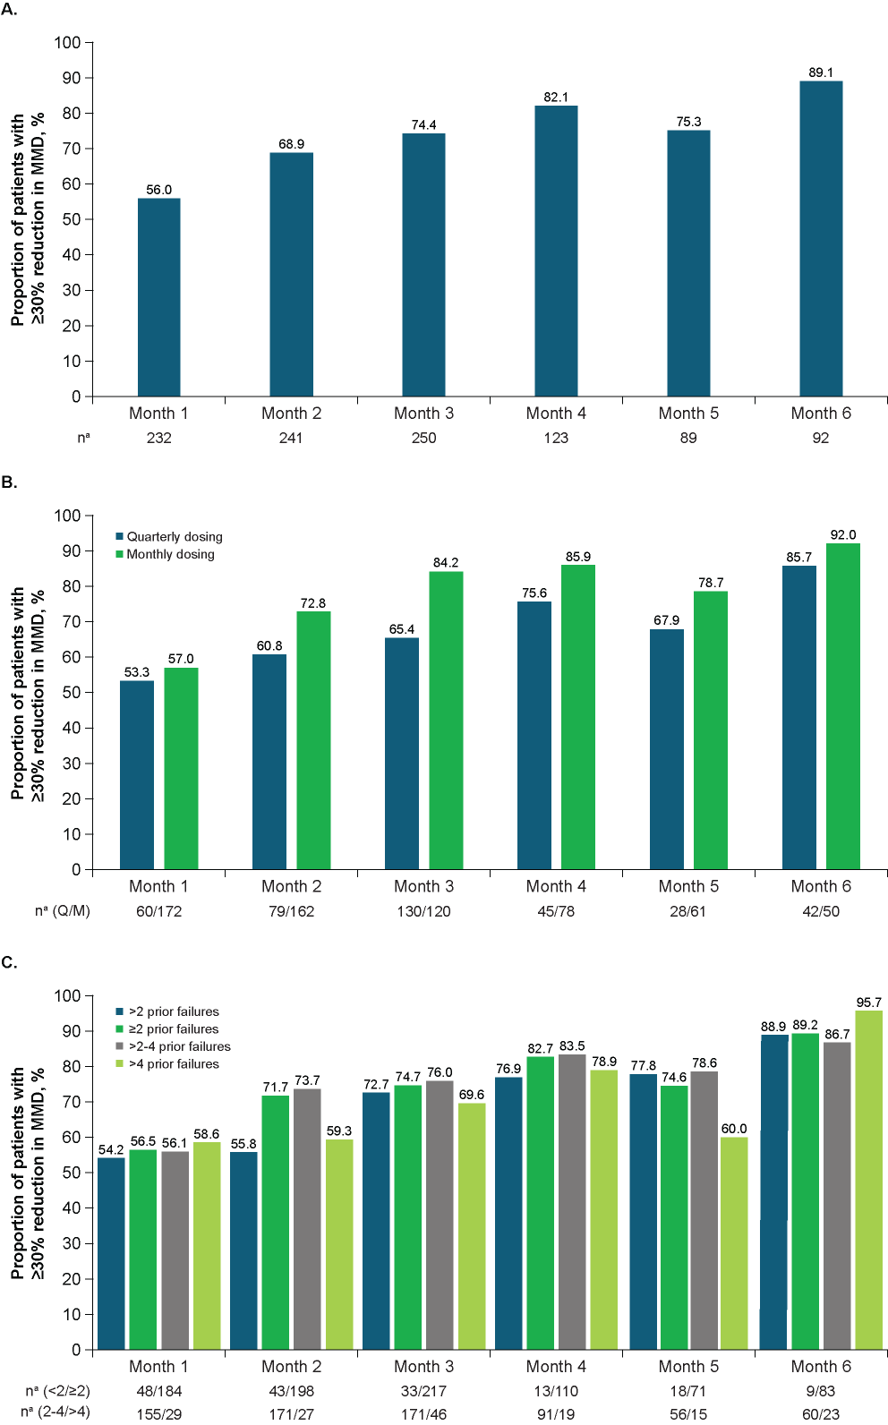
BL, baseline; MMD, monthly migraine days; Q, quarterly; M, monthly.
ªNumber of patients with available assessments at each time point.

