Supplementary material
Supplementary Table 1 Search strategies
Embase 1974 to 2018 April 03
# |  | Searches | Results
1 |  | exp migraine/ | 55,777
2 |  | migrain$.ti,ab,kw . | 47,248
3 |  | 1 or 2 | 62,219
4 |  | Clinical trial/ | 967,992
5 |  | Controlled clinical trial/ | 458,812
6 |  | randomised controlled trial/ | 496,175
7 |  | Randomization/ | 77,559
8 |  | multicenter study/ | 181,397
9 |  | phase 3 clinical trial/ | 33,368
10 |  | phase 4 clinical trial/ | 2913
11 |  | Double Blind procedure/ | 148,403
12 |  | Single Blind procedure/ | 30,929
13 |  | crossover procedure/ | 54,983
14 |  | placebo/ | 322,972
15 |  | Randomi?ed controlled trial$.tw . | 178,468
16 |  | RCT.tw . | 27,953
17 |  | (random$ adj2 allocat$).tw . | 36,334
18 |  | Single blind$.tw . | 20,914
19 |  | Double blind$.tw . | 188,096
20 |  | ((treble or triple) adj blind$).tw . | 788
21 |  | placebo$.tw . | 271922
22 |  | prospective study/ | 437,826
23 |  | or/4-22 | 1,971,402
24 |  | case study/ | 53,276
25 |  | case report.tw . | 360,240
26 |  | abstract report/ or letter/ | 1,050,270
27 |  | conference abstract.pt. | 2,955,112
28 |  | Editorial.pt. | 561,572
29 |  | Letter.pt. | 1,010,462
30 |  | Note.pt. | 709,291
31 |  | or/24-30 | 5,645,262
32 |  | 23 not 31 | 1,530,873
33 |  | lasmiditan/ | 67
34 |  | (lasmiditan or COL-144 or UNII-760I9WM792 or AK118948 or LY- 573144).ti,ab,kw . | 42
35 |  | paracetamol/ | 80,476
36 |  | (acetaminophen or paracetamol or APAP or tylenol).ti,ab,kw . | 34,860
37 |  | acetylsalicylic acid/ | 194,208
38 |  | (Acetylsalicylic Acid or aspirin or ecotrin).ti,ab,kw . | 76,526
39 |  | celecoxib/ | 20,022
40 |  | (celecoxib or celebrex).ti,ab,kw . | 8059
41 |  | diclofenac/ | 36,298
42 |  | (diclofenac or volteran or volterol).ti,ab,kw . | 15,381
43 |  | Mefenamic acid/ | 5563
44 |  | Mefenamic acid.ti,ab,kw . | 1560
45 |  | flurbiprofen/ | 7291
46 |  | flurbiprofen.ti,ab,kw . | 2880
47 |  | ibuprofen/ | 45,034
48 |  | (ibuprofen or advil or motrin or proprinal).ti,ab,kw . | 16,813
49 |  | indometacin/ | 76,366
50 |  | (indomethacin or indocin or tivorbex).ti,ab,kw . | 41,068
51 |  | ketoprofen/ | 12,266
52 |  | ketoprofen.ti,ab,kw . | 4969
53 |  | ketorolac/ | 8578
54 |  | ketorolac.ti,ab,kw . | 3775
55 |  | naproxen/ | 24,628
56 |  | (naproxen or Aleve or Naprosyn).ti,ab,kw . | 7899
57 |  | nimesulide/ | 4464
58 |  | nimesulide.ti,ab,kw . | 2230
59 |  | piroxicam/ | 10,931
60 |  | (piroksikam or piroxi?am).ti,ab,kw . | 4044
61 |  | tolfenamic acid/ | 902
62 |  | (Tolfenamic Acid or clotam).ti,ab,kw . | 404
63 |  | phenazone/ | 6326
64 |  | (phenazon or antipyrine or analgesine).ti,ab,kw . | 3214
65 |  | etodolac/ | 2594
66 |  | (etodolac or lodine).ti,ab,kw . | 969
67 |  | zaltoprofen/ | 189
68 |  | zaltoprofen$.ti,ab,kw . | 109
69 |  | pranoprofen/ | 274
70 |  | pranoprofen.ti,ab,kw . | 143
71 |  | loxoprofen/ | 1095
72 |  | loxoprofen.ti,ab,kw . | 413
73 |  | lornoxicam/ | 1002
74 |  | lornoxicam.ti,ab,kw . | 637
75 |  | oxaprozin/ | 706
76 |  | oxaprozin.ti,ab,kw . | 217
77 |  | almotriptan/ | 1152
78 |  | (almotriptan or axert).ti,ab,kw . | 353
79 |  | eletriptan/ | 1327
80 |  | (eletriptan or relpax).ti,ab,kw . | 371
81 |  | frovatriptan/ | 936
82 |  | (Frovatriptan or frova).ti,ab,kw . | 337
83 |  | sumatriptan/ | 7750
84 |  | (sumatriptan or Imitrex or Imigran or Sumatran or Sumatriptanum or Sumax).ti,ab,kw . | 3910
85 |  | naratriptan/ | 1621
86 |  | (naratriptan or Amerge or Naramig).ti,ab,kw . | 399
87 |  | rizatriptan/ | 2251
88 |  | (rizatriptan or maxalt).ti,ab,kw . | 680
89 |  | zolmitriptan/ | 2696
90 |  | zolmitriptan.ti,ab, kw . | 755
91 |  | chlorpromazine/ | 44,525
92 |  | (Chlorpromazine or cpz orThorazine or Largactil).ti,ab,kw . | 13,899
93 |  | prochlorperazine/ | 5793
94 |  | Prochlorperazine.ti,ab,kw . | 970
95 |  | promethazine/ | 13,591
96 |  | promethazine.ti,ab,kw . | 2703
97 |  | propyphenazone/ | 900
98 |  | Propyphenazone.ti,ab,kw . | 234
99 |  | isometheptene/ | 403
100 |  | Isometheptene.ti,ab,kw . | 60
101 |  | lidocaine/ | 68,585
102 |  | (lidocaine or xylocaine or lignocaine).ti,ab,kw . | 30,693
103 |  | dipyrone/ | 7708
104 |  | (Metamizole or dipyrone).ti,ab,kw . | 1773
105 |  | magnesium sulfate/ | 15,044
106 |  | (magnesium sulphate or mgso4).ti,ab,kw . | 4987
107 |  | octreotide/ | 20,239
108 |  | (Octreotide or Sandostatin).ti,ab,kw . | 11,376
109 |  | valproic acid/ | 58,044
110 |  | (valproic acid or valproate).ti,ab,kw . | 23,354
111 |  | dexamethasone/ | 136,150
112 |  | dexamethasone.ti,ab,kw . | 69,405
113 |  | hydrocortisone/ | 122,485
114 |  | hydrocortisone.ti,ab,kw . | 19,731
115 |  | prednisone/ | 158,849
116 |  | prednisone.ti,ab,kw . | 41,402
117 |  | butorphanol/ | 2986
118 |  | Butorphanol.ti,ab,kw . | 1606
119 |  | codeine/ | 19,631
120 |  | Codeine.ti,ab,kw . | 6385
121 |  | pethidine/ | 22,574
122 |  | (Meperidine or pethidine).ti,ab,kw . | 6327
 | 123 | methadone/ | 29,626
 | 124 | (methadone or Dolophine).ti,ab,kw . | 16,934
 | 125 | tramadol/ | 17,795
 | 126 | tramadol.ti,ab,kw . | 7128
 | 127 | dihydroergotamine/ | 5105
 | 128 | (Dihydroergotamine or DHE).ti,ab,kw . | 3676
 | 129 | ergotamine/ | 5465
 | 130 | Ergotamine.ti,ab,kw . | 1924
 | 131 | domperidone/ | 8364
 | 132 | (domperidone or Motilium).ti,ab,kw . | 3042
 | 133 | droperidol/ | 9191
 | 134 | Droperidol.ti,ab,kw . | 2685
 | 135 | granisetron/ | 5102
 | 136 | granisetron.ti,ab,kw . | 2159
 | 137 | metoclopramide/ | 23,776
 | 138 | Metochlopramide.ti,ab,kw . | 44
 | 139 | zatosetron/ | 54
 | 140 | zatosetron.ti,ab,kw . | 32
 | 141 | butalbital/ | 1072
 | 142 | Butalbital.ti,ab,kw . | 205
 | 143 | ubrogepant/ | 25
 | 144 | (ubrogepant or MK-1602 or UNII-AD0O8X2QJR or AD0O8X2QJR).ti,ab,kw . | 8
 | 145 | rimegepant/ | 32
 | 146 | (rimegepant or BMS-927711 or BMS 927711 or UNII-997WVV895X or CHEMBL2178422).ti,ab,kw . | 17
 | 147 | Telcagepant/ | 278
 | 148 | (Telcagepant or MK-0974 or "MK 0974" or MK0974 or UNII- D42O649ALL).ti,ab,kw . | 153
 | 149 | or/33-148 | 1,087,233
 | 150 | 3 and 32 and 149 | 4212
 | 151 | limit 150 to (conference abstract or conference paper or "conference review " or editorial or letter or note) | 202
 | 152 | 150 not 151 | 4010
 | 153 | limit 152 to english language | 3646

Ovid MEDLINE(R) Epub Ahead of Print, In-Process & Other Non-Indexed Citations, Ovid MEDLINE (R) Daily and Ovid MEDLINE (R) 1946 to Present
# |  | Searches |  | Results
1 |  | exp Migraine Disorders/ |  | 24,767
2 |  | migrain$.ti,ab,kw . |  | 31,376
3 |  | or/1-2 |  | 35,274
4 |  | Randomised Controlled Trials as Topic/ |  | 115,057
5 |  | randomised controlled trial/ |  | 456,829
6 |  | Random Allocation/ |  | 93,649
7 |  | Double Blind Method/ |  | 144,833
8 |  | Single Blind Method/ |  | 24,861
9 |  | clinical trial/ |  | 509,310
10 |  | clinical trial, phase i.pt. |  | 17,899
11 |  | clinical trial, phase ii.pt. |  | 28,901
12 |  | clinical trial, phase iii.pt. |  | 13,549
13 |  | clinical trial, phase iv.pt. |  | 1488
14 |  | controlled clinical trial.pt. |  | 92,281
15 |  | randomised controlled trial.pt. |  | 456,829
16 |  | multicenter study.pt. |  | 230,691
17 |  | clinical trial.pt. |  | 509,310
18 |  | exp Clinical Trials as topic/ |  | 312,028
19 |  | (clinical adj trial$).tw . |  | 303,418
20 |  | ((singl$ or doubl$ or treb$ or tripl$) adj (blind$3 or mask$3)).tw . |  | 155,551
21 |  | PLACEBOS/ |  | 33,839
22 |  | placebo$.tw . |  | 193,782
23 |  | randomly allocated.tw . |  | 23,924
24 |  | (allocated adj2 random$).tw . |  | 26,944
25 |  | or/4-24 |  | 1,445,995
26 |  | case report.tw . |  | 268,289
27 |  | letter/ |  | 982,254
28 |  | historical article/ |  | 344,050
29 |  | 26 or 27 or 28 |  | 1,580,483
30 |  | 25 not 29 |  | 1,412,871
31 |  | (lasmiditan or COL-144 or UNII-760I9WM792 or AK118948 or LY-573144).ti,ab,kw . |  | 31
32 |  | paracetamol/ |  | 16,453
33 |  | (acetaminophen or paracetamol or APAP or tylenol).ti,ab,kw . |  | 22,233
34 |  | acetylsalicylic acid/ |  | 42,141
35 |  | (Acetylsalicylic Acid or aspirin or ecotrin).ti,ab,kw . |  | 51,198
36 |  | celecoxib/ |  | 3943
37 |  | (celecoxib or celebrex).ti,ab,kw . |  | 5550
38 |  | diclofenac/ |  | 7078
39 |  | (diclofenac or volteran or volterol).ti,ab,kw . |  | 10,206
40 |  | Mefenamic acid/ |  | 1009
41 |  | Mefenamic acid.ti,ab,kw . |  | 1199
42 |  | flurbiprofen/ |  | 1788
43 |  | flurbiprofen.ti,ab,kw . |  | 2233
44 |  | ibuprofen/ |  | 7915
45 |  | (ibuprofen or advil or motrin or proprinal).ti,ab,kw . |  | 11,826
46 |  | indometacin/ |  | 27,645
47 |  | (indomethacin or indocin or tivorbex).ti,ab,kw . |  | 34,759
48 |  | ketoprofen/ |  | 2566
49 |  | ketoprofen.ti,ab,kw . |  | 3495
50 |  | ketorolac/ |  | 1326
51 |  | ketorolac.ti,ab,kw . |  | 2557
52 |  | naproxen/ |  | 3813
53 |  | (naproxen or Aleve or Naprosyn).ti,ab,kw . |  | 5588
54 |  | nimesulide.ti,ab,kw . |  | 1523
55 |  | piroxicam/ |  | 2685
56 |  | (piroksikam or piroxi?am).ti,ab,kw . |  | 2841
57 |  | (Tolfenamic Acid or clotam).ti,ab,kw . |  | 302
58 |  | phenazone/ |  | 4433
59 |  | (phenazon or antipyrine or analgesine).ti,ab,kw . |  | 2834
60 |  | etodolac/ |  | 454
61 |  | (etodolac or lodine).ti,ab,kw . |  | 632
62 |  | zaltoprofen$.ti,ab,kw . |  | 56
63 |  | pranoprofen.ti,ab,kw . |  | 89
64 |  | loxoprofen.ti,ab,kw . |  | 257
65 |  | lornoxicam.ti,ab,kw . |  | 342
66 |  | oxaprozin/ |  | 0
67 |  | oxaprozin.ti,ab,kw . |  | 144
68 |  | (almotriptan or axert).ti,ab,kw . |  | 249
69 |  | (eletriptan or relpax).ti,ab,kw . |  | 234
70 |  | (Frovatriptan or frova).ti,ab,kw . |  | 215
71 |  | sumatriptan/ |  | 2139
72 |  | (sumatriptan or Imitrex or Imigran or Sumatran or Sumatriptanum or Sumax).ti,ab,kw . |  | 2872
73 |  | (naratriptan or Amerge or Naramig).ti,ab,kw . |  | 284
74 |  | (rizatriptan or maxalt).ti,ab,kw . |  | 433
75 |  | zolmitriptan.ti,ab,kw . |  | 504
76 |  | chlorpromazine/ |  | 17,123
77 |  | (Chlorpromazine or cpz orThorazine or Largactil).ti,ab,kw . |  | 13,461
78 |  | prochlorperazine/ |  | 1042
79 |  | Prochlorperazine.ti,ab,kw . |  | 928
80 |  | promethazine/ |  | 2969
81 |  | promethazine.ti,ab,kw . |  | 2359
82 |  | Propyphenazone.ti,ab,kw . |  | 162
83 |  | Isometheptene.ti,ab,kw . |  | 37
84 |  | lidocaine/ |  | 23,217
85 |  | (lidocaine or xylocaine or lignocaine).ti,ab,kw . |  | 23,547
86 |  | dipyrone/ |  | 1450
87 |  | (Metamizole or dipyrone).ti,ab,kw . |  | 1213
88 |  | magnesium sulfate/ |  | 4837
89 |  | (magnesium sulphate or mgso4).ti,ab,kw . |  | 3236
 | 90 |  | octreotide/ |  | 7121
 | 91 |  | (Octreotide or Sandostatin).ti,ab,kw . |  | 7573
 | 92 |  | valproic acid/ |  | 11,616
 | 93 |  | (valproic acid or valproate).ti,ab,kw . |  | 15,555
 | 94 |  | dexamethasone/ |  | 48,417
 | 95 |  | dexamethasone.ti,ab,kw . |  | 52,149
 | 96 |  | hydrocortisone/ |  | 68,375
 | 97 |  | hydrocortisone.ti,ab,kw . |  | 16,888
 | 98 |  | prednisone/ |  | 37,580
 | 99 |  | prednisone.ti,ab,kw . |  | 25,691
 | 100 |  | butorphanol/ |  | 1027
 | 101 |  | Butorphanol.ti,ab,kw . |  | 1391
 | 102 |  | codeine/ |  | 4306
 | 103 |  | Codeine.ti,ab,kw . |  | 4780
 | 104 |  | pethidine/ |  | 5606
 | 105 |  | (Meperidine or pethidine).ti,ab,kw . |  | 5162
 | 106 |  | methadone/ |  | 11,484
 | 107 |  | (methadone or Dolophine).ti,ab,kw . |  | 12,478
 | 108 |  | tramadol/ |  | 2726
 | 109 |  | tramadol.ti,ab,kw . |  | 4235
 | 110 |  | dihydroergotamine/ |  | 1384
 | 111 |  | (Dihydroergotamine or DHE).ti,ab,kw . |  | 2563
 | 112 |  | ergotamine/ |  | 2290
 | 113 |  | Ergotamine.ti,ab,kw . |  | 1802
 | 114 |  | domperidone/ |  | 1691
 | 115 |  | (domperidone or Motilium).ti,ab,kw . |  | 2216
 | 116 |  | droperidol/ |  | 1966
 | 117 |  | Droperidol.ti,ab,kw . |  | 2037
 | 118 |  | granisetron/ |  | 1044
 | 119 |  | granisetron.ti,ab,kw . |  | 1483
 | 120 |  | metoclopramide/ |  | 4707
 | 121 |  | Metochlopramide.ti,ab,kw . |  | 29
 | 122 |  | zatosetron.ti,ab,kw . |  | 22
 | 123 |  | Butalbital.ti,ab,kw . |  | 118
 | 124 |  | (ubrogepant or MK-1602 or UNII-AD0O8X2QJR or AD0O8X2QJR).ti,ab,kw . |  | 5
 | 125 |  | (rimegepant or BMS-927711 or BMS 927711 or UNII-997WVV895X or CHEMBL2178422).ti,ab,kw . |  | 14
 | 126 |  | (Telcagepant or MK-0974 or "MK 0974" or MK0974 or UNII- D42O649ALL).ti,ab,kw . |  | 93
 | 127 |  | or/31-124 |  | 474,602
 | 128 |  | 3 and 30 and 127 |  | 1889
 | 129 |  | limit 128 to (case reports or clinical conference or comment or congresses or editorial or interview or  letter or new s or new spaper article or patient education handout or periodical index or personal narratives or portraits or published erratum or "review " or "scientific integrity review ") |  | 511
 | 130 |  | 128 not 129 |  | 1378
 | 131 |  | limit 130 to english language |  | 1282

Cochrane CENTRAL
ID | Search | Hits
#2 | MeSH descriptor: [Migraine Disorders] explode all trees | 1959
#3 | migraine:ti,ab,kw (Word variations have been searched) | 4360
#4 | #2 or #3 | 4360
#5 | lasmiditan:ti,ab,kw (Word variations have been searched) | 9
#6 | acetaminophen:ti,ab,kw | 3695
#7 | paracetamol:ti,ab,kw | 5596
#8 | acetylsalicylic acid:ti,ab,kw | 7540
#9 | aspirin:ti,ab,kw | 10,091
#10 | celecoxib:ti,ab,kw | 1329
#11 | diclofenac:ti,ab,kw | 4072
#12 | Mefenamic acid:ti,ab,kw | 320
#13 | flurbiprofen:ti,ab,kw | 764
#14 | ibuprofen:ti,ab,kw | 3297
#15 | indometacin:ti,ab,kw | 1053
#16 | ketoprofen:ti,ab,kw | 1018
#17 | ketorolac:ti,ab,kw | 1907
#18 | naproxen:ti,ab,kw | 1853
#19 | nimesulide:ti,ab,kw | 334
#20 | piroxicam:ti,ab,kw | 1131
#21 | Tolfenamic Acid:ti,ab,kw | 58
#22 | phenazone:ti,ab,kw | 122
#23 | etodolac:ti,ab,kw | 224
#24 | zaltoprofen:ti,ab,kw | 17
#25 | pranoprofen:ti,ab,kw | 30
#26 | loxoprofen:ti,ab,kw | 105
#27 | almotriptan:ti,ab,kw | 81
#28 | eletriptan:ti,ab,kw | 67
#29 | Frovatriptan:ti,ab,kw | 66
#30 | sumatriptan:ti,ab,kw | 729
#31 | naratriptan:ti,ab,kw | 66
#32 | rizatriptan:ti,ab,kw | 154
#33 | zolmitriptan:ti,ab,kw | 146
#34 | chlorpromazine:ti,ab,kw | 1315
#35 | prochlorperazine:ti,ab,kw | 360
#36 | Propyphenazone:ti,ab,kw | 25
#37 | Isometheptene:ti,ab,kw | 34
#38 | lidocaine:ti,ab,kw | 8901
#39 | dipyrone:ti,ab,kw | 615
#40 | magnesium sulfate:ti,ab,kw | 1633
#41 | octreotide:ti,ab,kw | 1221
#42 | valproic acid:ti,ab,kw | 1651
#43 | dexamethasone:ti,ab,kw | 7673
#44 | hydrocortisone:ti,ab,kw | 8604
#45 | prednisone:ti,ab,kw | 7606
#46 | butorphanol:ti,ab,kw | 362
#47 | Codeine:ti,ab,kw | 1412
#48 | pethidine:ti,ab,kw | 2000
#49 | methadone:ti,ab,kw | 2249
#50 | tramadol:ti,ab,kw | 2569
#51 | dihydroergotamine:ti,ab,kw | 400
#52 | Ergotamine:ti,ab,kw | 196
#53 | domperidone:ti,ab,kw | 607
#54 | droperidol:ti,ab,kw | 1039
#55 | granisetron:ti,ab,kw | 893
#56 | metoclopramide:ti,ab,kw | 2638
#57 | zatosetron:ti,ab,kw | 3
#58 | Butalbital:ti,ab,kw | 27
#59 | ubrogepant:ti,ab,kw | 2
#60 | rimegepant:ti,ab,kw | 1
#61 | telcagepant:ti,ab,kw | 31
#62 | oxaprozin:ti,ab,kw | 58
#63 | Promethazine:ti,ab,kw | 684
#64 | #5 or #6 or #7 or #8 or #9 or #10 or #11 or #12 or #13 or #14 or #15 or #16 or #17 or #18 or #19 or #20 or #21 or #22 or #23 or #24 or #25 or #26 or #27 or #28 or #29 or #30 or #31 | 33,215
#65 | #32 or #33 or #34 or #35 or #36 or #37 or #38 or #39 or #40 or #41 or #42 or #43 or #44 or #45 or #46 or #47 or #48 or #49 or #50 or #51 or #52 or #53 or #54 or #55 or #56 or #57 or #58 or #59 or #60 or #61 or #62 or #63 | 49,786
#66 | #64 or #65 | 78,291
#67 | #4 and #66 in Trials | 1502

Supplementary Table 2 Eligibility criteria for the SLR
Patient population | All patients diagnosed with moderate or severe migraine (with or without aura) per international guidelines  Subgroups of interest:  - Patients with cardiovascular comorbidities (including confirmed cardiovascular disease or cardiovascular risk factors)  - Adult patients (≥18 years)  - Adolescent patients (≥12 years)  - Paediatric patients (≥6 years)  - Menstrual-related migraine
Interventions/Comparators | Key interventions – any combinations in all routes of administrations  Lasmiditan  Ubrogepant  Rimegepant  NSAIDs  - Aspirin  - Celecoxib  - Ibuprofen  - Indomethacin  - Naproxen  - Nimesulide  - Diclofenac  - Tolfenamic acid  - Ketorolac  - Ketoprofen  - Flurbiprofen  - Mefenamic acid  - Phenazone  - Piroxicam  Triptans  - Sumatriptan  - Zolmitriptan  - Naratriptan  - Rizatriptan  - Almotriptan  - Eletriptan  - Frovatriptan  Ergots  - Ergotamine  - Dihydroergotamine  Corticosteroids  - Dexamethasone  - Hydrocortisone  - Prednisone  Opioids  - Butorphanol  - Codeine  - Meperidine  - Methadone  - Tramadol  Others  - Acetaminophen  - Butalbital  - Propyphenazone  - Isometheptene  - Metamizole (dipyrone)  - Lidocaine  - Octreotide  - Magnesium Sulphate (MgSO4)  - Valproic acid/valproate
Outcomes | Efficacy endpoints (if studies include multiple migraine episodes, only first attack efficacy endpoints were extracted):  - Pain-free at 2 hours, without the use of rescue medication  - Reduction in headache pain (‘headache relief’) at 1 and 2 hours (pain reduced from moderate or severe to none or mild without the use of rescue medication)  - Sustained pain-free over 24 hours (pain-free within 2 hours, and pain-free at 24 hours with no use of rescue medication or recurrence within 24 hours)  - Sustained pain relief over 24 hours (headache relief at 2 hours, sustained for 24 hours, with no use of rescue medication or a second dose of study medication)  - Most bothersome symptom (MBS) free at 2 hours  - Headache recurrence and use of rescue medications (e.g., second dose of study drug or other medication) with 2-48 hours  Safety endpoints (number and proportion experiencing event):  - Patients with any chest AEs (at least one chest symptom, defined as chest pressure, chest pain, radiating pain in arm, any other chest feelings, heavy arms, shortness of breath, palpitations and anxiety)  - Patients with chest pressure  - Patients with dizziness  - Patients with paraesthesia  - Patients with vertigo
Study design | - Phase II/III/IV RCTs  - Crossover studies accepted if there was adequate washout (≥48 hours) between treatments  - Relevant published systematic reviews  - English language studies only  - Non-RCT studies excluded
AE, adverse event; NSAID, non-steroidal anti-inflammatory drug; RCT, randomised controlled trial, SLR, systematic literature review

Supplementary Table 3 Summary DIC and model choice for all outcomes (Base Case)
Endpoint | Model | DIC | Residual Deviance |  | $$p_{D}$$ | Sigma ${ (σ}_{δ})$ | Model Choice
Pain Freedom at 2 hr  (36 data points) | FE | 59.13 | 40.12 |  | 19.01 | - | FEadj
Pain Freedom at 2 hr  (36 data points) | FEadj | 56.55 | 36.26 |  | 20.3 | - | FEadj
Pain Freedom at 2 hr  (36 data points) | RE* | 58.96 | 34.69 |  | 24.27 | 0.13(0.01,0.3) | FEadj
Pain Freedom at 2 hr  (36 data points) | REadj | 57.77 | 34.57 |  | 23.2 | 0.07(0.0,0.2) | FEadj
Pain Freedom at 2 hr  (36 data points) | REip* | 58.76 | 36.19 |  | 22.57 | 0.09(0.01,0.24) | FEadj
Pain relief at 1 hr (16 data points) | FE | 30.17 | 21.16 |  | 9.01 | - | FE
Pain relief at 1 hr (16 data points) | FEadj | 32.01 | 22.02 |  | 9.99 | - | FE
Pain relief at 1 hr (16 data points) | RE* | 30.2 | 17.35 |  | 12.85 | 0.16 (0.01,0.43) | FE
Pain relief at 1 hr (16 data points) | REadj | 31.24 | 17.34 |  | 13.9 | 0.2 (0.01,0.53) | FE
Pain relief at 1 hr (16 data points) | REip* | 30.02 | 18.52 |  | 11.49 | 0.1 (0.01,0.3) | FE
Pain relief at 2 hr  (36 data points) | FE | 56.3 | 37.31 |  | 18.99 | - | FE
Pain relief at 2 hr  (36 data points) | FEadj | 57.62 | 37.55 |  | 20.07 | - | FE
Pain relief at 2 hr  (36 data points) | RE* | 57.51 | 35.03 |  | 22.48 | 0.08(0.0,0.21) | FE
Pain relief at 2 hr  (36 data points) | REadj | 59.22 | 35.39 |  | 23.83 | 0.0(0.08,0.22) | FE
Pain relief at 2 hr  (36 data points) | Reip* | 56.93 | 35.65 |  | 21.28 | 0.06(0.05,0.17) | FE
Sustained pain free 2-24 hr (32 data points) | FE | 59.46 | 41.41 |  | 18.04 | - | RE adj
Sustained pain free 2-24 hr (32 data points) | FEadj | 57.86 | 38.36 |  | 19.5 | - | RE adj
Sustained pain free 2-24 hr (32 data points) | RE* | 57.61 | 33.4 |  | 24. 21 | 0.20(0.02,0.43) | RE adj
Sustained pain free 2-24 hr (32 data points) | RE adj | 58.15 | 33.92 |  | 24.23 | 0.12(0.01,0.31) | RE adj
Sustained pain free 2-24 hr (32 data points) | Reip* | 58.13 | 35.86 |  | 22.27 | 0.13(0.01,0.34) | RE adj
MBS freedom at 2 hours  (26 data points) | FE | 35.08 | 19.07 |  | 16 | - | FE
MBS freedom at 2 hours  (26 data points) | FE adj | 37.14 | 20.22 |  | 16.92 | - | FE
MBS freedom at 2 hours  (26 data points) | RE* | 37.05 | 19.61 |  | 17.44 | 0.05(0.0,0.17) | FE
MBS freedom at 2 hours  (26 data points) | RE adj | 39.16 | 20.7 |  | 18.47 | 0.06(0.0,0.18) | FE
MBS freedom at 2 hours  (26 data points) | REip* | 36.38 | 19.4 |  | 16.97 | 0.04(0.0,0.13) | FE
hr: hour; FE: Fixed Effects; RE: Random Effects; adj.: adjusted for baseline risk; RE*: Random Effects increased sample; REip: Random Effects informative Prior; DIC: Deviance Information Criteria; $p_{D}$: effective number of parameters; Sigma$:$between studies standard deviation

Supplementary Table 4 Characteristics of studies included in the base case analysis
Study acronym and identifier | Design and duration of follow up | Interventions and dosing procedures | Main inclusion and exclusion criteria
LASMIDITAN
SAMURAI  Kuca et al. 2018 [1]  (NCT02439320) | Randomised, double-blind, placebo-controlled, multicentre, phase III, single attack study; follow-up visit 7 days after treated migraine attack | Lasmiditan (100 mg or 200 mg) vs placebo – study medication to be taken within 4-hours of migraine onset (moderate to severe pain); second dose for rescue allowed 2–24 hours after first dose | Inclusion: Adults ≥18 years; ≥1-year history of disabling migraine attacks with or without aura; onset before age 50; 3–8 migraine attacks/month (<15 headache days/month)  Exclusion: History of chronic migraine or other forms of primary or secondary headache disorder in past 12 months; ≥15 headache days/month within past 12 months; initiation of or change in migraine preventive medication within 3 months; known coronary artery disease; clinically significant arrythmia; uncontrolled hypertension; condition increasing risk of seizures
SPARTAN  Goadsby et al. 2019 [2]  (NCT02605174) | Prospective, randomised, double-blind, placebo-controlled, multicentre, phase III, single attack study; follow-up visit 7 days after treated migraine attack | Lasmiditan (50 mg, 100 mg, or 200 mg) vs placebo – study medication to be taken within 4-hours of migraine onset (moderate to severe pain); second dose for rescue or recurrence allowed 2–24 hours after first dose | Inclusion: Adults ≥18 years; ≥1-year history of disabling migraine attacks with or without aura; MIDAS score ≥11; onset before age 50; 3–8 migraine attacks/month (<15 headache days/month).  Exclusion: History of chronic migraine; other forms of primary or secondary headache disorder; ≥15 headache days/month within past 12 months; condition increasing risk of seizures; recurrent dizziness or vertigo; diabetes mellitus with complications; orthostatic hypotension with syncope; renal or hepatic impairment; current SUD past 3 years; imminent risk of suicide or suicide attempt within past 6 months
CENTURION  Ashina et al. 2021 [3]  (NCT03670810) | Randomised, double-blind, placebo-controlled, parallel assignment, multicentre, phase III, study; consistency over four migraine attacks | Lasmiditan (100 mg and 200 mg) vs placebo – study medication to be taken within 4-hours of migraine onset (moderate to severe pain) | Inclusion: ≥18 years; migraine with or without aura; history of disabling migraine for at least 1 year; migraine onset before the age of 50 years; 3–8 migraine attacks/month (<15 headache days/month) during the past 3 months; MIDAS score ≥11  Exclusion: Known hypersensitivity to lasmiditan; history of haemorrhagic stroke, epilepsy, or any other condition placing the participant at increased risk of seizures; history of recurrent dizziness and/or vertigo; history of diabetes mellitus with complications; history of orthostatic hypotension with syncope; significant renal or hepatic impairment; participants who are deemed to be at significant risk for suicide; history of chronic migraine or other forms of primary or secondary chronic headache disorder within past 12 months; use of more than 3 doses/month of either opioids or barbiturates; initiation of or a change in concomitant medication to reduce the frequency of migraine episodes within 3 months prior to screening; SUD within 1 year prior to screening; currently enrolled in any other clinical study involving an investigational product
MONONOFU  Sakai et al. 2021 [4]  (NCT03962738) | Randomised, double-blind, placebo-controlled, parallel assignment, multicentre, phase II, single attack study in a Japanese population; follow-up visit within 3 to 28 days of treated migraine attack | Lasmiditan (50 mg, 100 mg, or 200 mg) vs placebo – study medication to be taken within 4 hours of migraine onset (moderate to severe pain); unexcluded patient´s medication for rescue or recurrence allowed 2–24 hours after first dose | Inclusion: ≥18 years; migraine with or without aura; history of disabling migraine for at least 1 year; MIDAS score ≥11; migraine onset before the age of 50 years; 3–8 migraine attacks/month and <15 headache days/month during the past 3 months  Exclusion: Known hypersensitivity to lasmiditan; history of haemorrhagic stroke, epilepsy, or any other condition placing the patient at increased risk of seizures; history of recurrent dizziness and/or vertigo; history of diabetes mellitus with complications; history of orthostatic hypotension with syncope
Färkkilä et al. 2012  [5]  (NCT00883051) | Randomised, double-blind, placebo-controlled, parallel-group, multicentre, dose-ranging study, phase II, single attack; follow-up visit within 14 days of treated migraine attack | Lasmiditan (50 mg, 100 mg, 200, or 400mg) vs placebo – study medication to be taken within 4 hours of migraine onset (moderate to severe pain); second dose for rescue allowed (excl. triptans or ergotamines) 2 hours after first dose | Inclusion: Adults ≥18 years; ≥1-year history of acute migraine attacks with or without aura; onset before age 50; 1–8 migraine attacks/month  Exclusion: Use of migraine prophylaxis (unless discontinued at least 15 days prior to screening), vasoactive drugs, serotonin reuptake inhibitors, or known cytochrome P450 inhibitors
RIMEGEPANT
Study 301  Lipton et al. 2018 [6]  (NCT03235479) | Randomised, double-blind, placebo-controlled, multicentre, phase III, single attack study; follow-up visit within 7 days of treated migraine attack | Rimegepant tablets (75 mg) vs placebo; rescue medication was allowed within 24 hours | Inclusion: Adults ≥18 years of age; ≥1-year history of migraine; 2–8 migraine attacks/month (moderate to severe intensity); <15 headache days/month within the past 3 months; patients receiving preventive migraine medications had to be receiving stable dose for at least 3 months before trial entry  Exclusion: History of any clinically significant or unstable medical condition, including alcohol or drug abuse and SUD; use of any biological investigational agents within 90 days of baseline visit; received non-biological investigational agents within 30 days before baseline visit
Study 302  Lipton et al. 2019 [7]  (NCT03237845) | Randomised, double-blind, placebo-controlled, multicentre, phase III, single attack study; follow-up visit within 7 days of treated migraine attack | Rimegepant tablets (75 mg) vs placebo – study medication to be taken when migraine of moderate to severe intensity occurred; use of second dose as rescue medication was allowed within 24 hours | Inclusion: Adults ≥18 years of age; ≥1-year history of migraine with or without aura; onset before age 50; 2–8 migraine attacks/month (moderate to severe intensity); <15 days/month with headache within the past 3 months; patients receiving preventive migraine medications had to be receiving stable dose for at least 3 months before trial entry  Exclusion: History of any clinically significant or unstable medical condition, including alcohol or drug abuse and SUD; use of any biological investigational agents within 90 days of baseline visit; received non-biological investigational agents within 30 days before baseline visit
Study 303  Croop et al. 2019 [8]  (NCT03461757) | Randomised, double-blind, placebo-controlled, multicentre, phase III, single attack study; follow-up visit within 7 days of treated migraine attack | Rimegepant ODT (75 mg) vs placebo – study medication to be taken when migraine attack of moderate to severe intensity occurred; rescue medications (e.g., aspirin, ibuprofen, acetaminophen [up to 1000 mg/day], naproxen [or any other NSAIDs], antiemetics, or baclofen) after 2 hours post-dose | Inclusion: Adults ≥18 years of age; ≥1-year history of migraine with or without aura; onset before age 50; 2–8 migraine attacks/month (moderate to severe intensity); <15 days per month with headache within the past 3 months  Exclusion: SUD within past 12 months; history of drug or other allergy that made them unsuitable for participation; ECG or laboratory test findings that raised safety or tolerability concerns
Marcus et al. 2014 [9] | Randomised, double-blind, multicentre, placebo-controlled, phase II, single attack study; follow-up visit within 7 days of treated migraine attack | Rimegepant tablets (10 mg, 25 mg, 75 mg, 150 mg, 300 mg, or 600 mg) vs sumatriptan (100 mg) and placebo – study medication to be taken at onset of moderate to severe migraine; use of rescue medication (aspirin, ibuprofen, acetaminophen, NSAID, antiemetics or baclofen) after 2 hours post-dose | Inclusion: Adults aged 18-65 years; ≥1-year history of migraine with or without aura; onset before age 50; duration of migraine attack 4–72 hours if untreated; 2–7 attacks/month (moderate to severe)  Exclusion: History of stroke/transient ischaemic attacks, ischaemic heart disease, coronary artery vasospasm, other significant underlying CVD, uncontrolled hypertension or diabetes, HIV; current diagnosis of major depression, other pain syndromes, psychiatric conditions, dementia, or significant neurological disorders, other than migraine; SUD within the past 12 months; use of known cytochrome P450 inhibitors or medications that may alter the pH of the stomach; use of barbiturates, opioids, triptans, ergotamines and muscle relaxants from within 2 days before randomisation and during the study
UBROGEPANT
ACHIEVE I  Dodick et al. 2019 [10]  (NCT02828020) | Randomised, double-blind, placebo-controlled, multicentre, phase III, single attack study; follow-up visit within 7 days of treated migraine attack | Ubrogepant (50 or 100 mg) vs placebo; second dose or rescue medication allowed in patients with inadequate response or headache recurrence | Inclusion: Adults 18-75 years old; ≥1-year history of migraine attacks with or without aura; onset before age 50; duration of migraine attack 4–72 hours and separated by ≥48 hours; 2–8 migraine attacks/month with moderate to severe headache pain in previous 3 months  Exclusion: Taken medication for acute treatment of headache on ≥10 days/month in previous 3 months; history of aura with diplopia or impairment of level of consciousness, hemiplegic or retinal migraine; current diagnosis of new persistent daily headache, trigeminal autonomic cephalalgia, or painful cranial neuropathy; required hospital treatment of a migraine attack ≥3 times in previous 6 months; chronic non-headache pain condition requiring daily pain medication; history of malignancy in the prior 5 years; history of any prior GI conditions that may affect the absorption or metabolism; history of hepatitis within previous 6 months
ACHIEVE II  Lipton et al. 2019 [11] (NCT02867709) | Randomised, double-blind, placebo-controlled, multicentre, phase III, single attack study; follow-up visit within 7 days of treated migraine attack | Ubrogepant (25 mg, 50 mg, or 100 mg) vs placebo; second dose or rescue medication allowed in patients with inadequate response or headache recurrence | Inclusion: Adults 18–75 years old; ≥1-year history of migraine attacks with or without aura; onset before age 50; duration of migraine attack 4–72 hours and separated by ≥48 hours; 2–8 migraine attacks/month (moderate to severe intensity) in previous 3 months  Exclusion: Taken medication for acute treatment of headache on ≥10 days/month in the previous 3 months; history of migraine aura with diplopia or impairment of level of consciousness, hemiplegic or retinal migraine; current diagnosis of new persistent daily headache, trigeminal autonomic cephalalgia, or painful cranial neuropathy; required hospital treatment of a migraine attack ≥3 times in previous 6 months; chronic non-headache pain condition requiring daily pain medication; history of malignancy in the prior 5 years; history of any prior GI conditions that may affect the absorption or metabolism; history of hepatitis within previous 6 months
Voss et al. 2016 [12] | Randomised, double-blind, placebo-controlled, phase IIb, single attack study; follow-up visit 5 days post-treatment | Ubrogepant (1 mg, 10 mg, 25 mg, 50 mg, or 100 mg) vs placebo – study drug to be taken to treat a migraine of moderate to severe intensity; non-study medication allowed as rescue or recurrence treatment | Inclusion: Adults ≥18 years; ≥1-year history of acute migraine attacks with or without aura; onset before age 50; 1–8 migraine attacks/month  Exclusion: Difficulty distinguishing migraine attacks from tension type headaches; uncontrolled hypertension; basilar-type or hemiplegic migraine headache; >15 headache days/month or had taken medication for acute headache on >10 days/month in the 3 months prior to screening; acute attack within past 2 months that required inpatient or ER treatment; use of an opioid or barbiturate for migraine in the past 2 months; recent change in dose of migraine-prophylactic medication
CVD, cardiovascular disease; ECG, electrocardiogram; ER, emergency room; GI, gastrointestinal; HIV, human immunodeficiency virus; MIDAS, Migraine Disability Assessment Test; NSAID, non-steroidal anti-inflammatory drug; ODT, oral disintegrating tablet; SUD, substance use disorder

Supplementary Table 5 Median event rates and SUCRA values: base case analyses
 | Pain freedom at 2 hours |  | Pain relief at 2 hours |  | Pain relief at 1 hour |  | MBS freedom at 2 hours |  | Sustained pain freedom over 24 hours
Treatment | Median event rateª, % (95% Crl) | SUCRA | Median event rateª, % (95% Crl) | SUCRA | Median event rateª, % (95% Crl) | SUCRA | Median event rateª,  % (95% Crl) | SUCRA | Median event rateª, % (95% Crl) | SUCRA
Lasmiditan 200 mg | 33.6 (30.2, 36.9) | 100% | 65.4 (62.0, 68.6) | 90% | 49.3 (45.4, 53.2) | 99% | 40.9 (37.0, 44.9) | 84% | 19.4 (9.9, 34.4) | 97%
Lasmiditan 100 mg | 28.1 (25.0, 31.2) | 84% | 66.1 (62.8, 69.3) | 95% | 46.7 (42.9, 50.6) | 81% | 39.5 (35.7, 43.4) | 68% | 15.6 (7.8, 28.7) | 63%
Lasmiditan 50 mg | 23.9 (20.1, 27.9) | 57% | 58.1 (53.4, 62.6) | 40% | 38.0 (33.1, 43.0) | 37% | 35.3 (30.4, 40.4) | 28% | 14.4 (6.8, 27.4) | 47%
Rimegepant 75 mg | 21.9 (19.4, 24.7) | 36% | 59.8 (56.4, 63.2) | 56% | 38.6 (33.1, 44.4)^{b} | 41% | 38.6 (34.9, 42.4) | 58% | 15.4 (7.6, 28.6) | 59%
Ubrogepant 100 mg | 24.1 (19.8, 28.9) | 58% | 58.8 (53.1, 64.3) | 47% | NA | NA | 38.9 (32.7, 45.4) | 61% | 16.6 (8.0, 31.2) | 73%
Ubrogepant 50 mg | 21.6 (18.5, 25.1) | 34% | 58.4 (53.8, 62.8) | 44% | 38.6 (33.9, 43.6) | 42% | 39.9 (35.0, 45.1) | 72% | 13.4 (6.5, 25.6) | 34%
Ubrogepant 25 mg | 21.2 (17.3, 25.6) | 30% | 56.3 (50.5, 61.9) | 27% | NA | NA | 35.2 (29.2, 41.7) | 30% | 12.6 (5.9, 24.7) | 27%
Placebo | 13.5 (12.6, 14.5) | 0% | 45.3 (43.9, 46.7) | 0% | 32.9 (31.4, 34.5) | 10% | 28.5 (27.2, 29.9) | 0% | 7.7 (3.7, 15.0) | 0%
ªMedian event rate derived from posterior distributions
^{b}Evaluated for orally disintegrating tablet only
SUCRA values range from 0% to 100%, where 100% reflects the best treatment with no uncertainty and 0% reflects the worst treatment with no uncertainty; higher value has the greatest probability of being the best
CrI, credible interval; NA, not available; SUCRA, surface under the cumulative ranking curve

References
- Kuca B, Silberstein SD, Wietecha L, Berg PH, Dozier G, Lipton RB; COL MIG-301 Study Group (2018) Lasmiditan is an effective acute treatment for migraine: a phase 3 randomized study. Neurology 91(24):e2222-e2232.
- Goadsby PJ, Wietecha LA, Dennehy EB, Kuca B, Case MG, Aurora SK, Gaul C (2019) Phase 3 randomized, placebo-controlled, double-blind study of lasmiditan for acute treatment of migraine. Brain 142(7):1894-1904.
- Ashina M, Reuter U, Smith T, Krikke-Workel J, Klise SR, Bragg S, Doty EG, Dowsett SA, Lin Q, Krege JH (2021) Randomized, controlled trial of lasmiditan over four migraine attacks: Findings from the CENTURION study. Cephalalgia 41(3):294-304.
- Sakai F, Takeshima T, Homma G, Tanji Y, Katagiri H, Komori M (2021) Phase 2 randomized placebo-controlled study of lasmiditan for the acute treatment of migraine in Japanese patients. Headache 61(5):755-765.
- Färkkilä M, Diener HC, Géraud G, Láinez M, Schoenen J, Harner N, Pilgrim A, Reuter U; COL MIG-202 study group (2012) Efficacy and tolerability of lasmiditan, an oral 5-HT(1F) receptor agonist, for the acute treatment of migraine: a phase 2 randomised, placebo-controlled, parallel-group, dose-ranging study. Lancet Neurol 11(5):405-413.
- Lipton RB, Conway CM, Stock EG, Stock D, Morris BA, McCormack TJ, Frost M, Gentile K, Dubowchik GM, Coric V, Croop R (2018) Efficacy, safety, and tolerability of rimegepant 75 mg, an oral CGRP receptor antagonist, for the treatment of migraine: results from a phase 3, double blind, randomized, placebo-controlled trial, Study 301. Presented at: the 60th Annual Scientific Meeting of the American Headache Society; June 28-July 1, 2018; San Francisco, CA, USA, Abstract 492562.
- Lipton RB, Croop R, Stock EG, Stock DA, Morris BA, Frost M, Dubowchik GM, Conway CM, Coric V, Goadsby PJ (2019) Rimegepant, an oral calcitonin gene-related peptide receptor antagonist, for migraine. N Engl J Med 381(2):142-149.
- Croop R, Goadsby PJ, Stock DA, Conway CM, Forshaw M, Stock EG, Coric V, Lipton RB (2019) Efficacy, safety, and tolerability of rimegepant orally disintegrating tablet for the acute treatment of migraine: a randomised, phase 3, double-blind, placebo-controlled trial. Lancet 394(10200):737-745.
- Marcus R, Goadsby PJ, Dodick D, Stock D, Manos G, Fischer TZ (2014) BMS-927711 for the acute treatment of migraine: a double-blind, randomized, placebo controlled, dose-ranging trial. Cephalalgia 34(2):114-125.
- Dodick DW, Lipton RB, Ailani J, Lu K, Finnegan M, Trugman JM, Szegedi A (2019) Ubrogepant for the treatment of migraine. N Engl J Med 381(23):2230-2241.
- Lipton RB, Dodick DW, Ailani J, et al (2019) Effect of ubrogepant vs placebo on pain and the most bothersome associated symptom in the acute treatment of migraine: the ACHIEVE II randomized clinical trial. JAMA 322(19):1887-1898.
- Voss T, Lipton RB, Dodick DW, Dupre N, Ge JY, Bachman R, Assaid C, Aurora SK, Michelson D (2016) A phase IIb randomized, double-blind, placebo-controlled trial of ubrogepant for the acute treatment of migraine. Cephalalgia 36(9):887-898.

Supplementary Figure 1. Risk of bias assessment for 11 studies* included in the NMA. 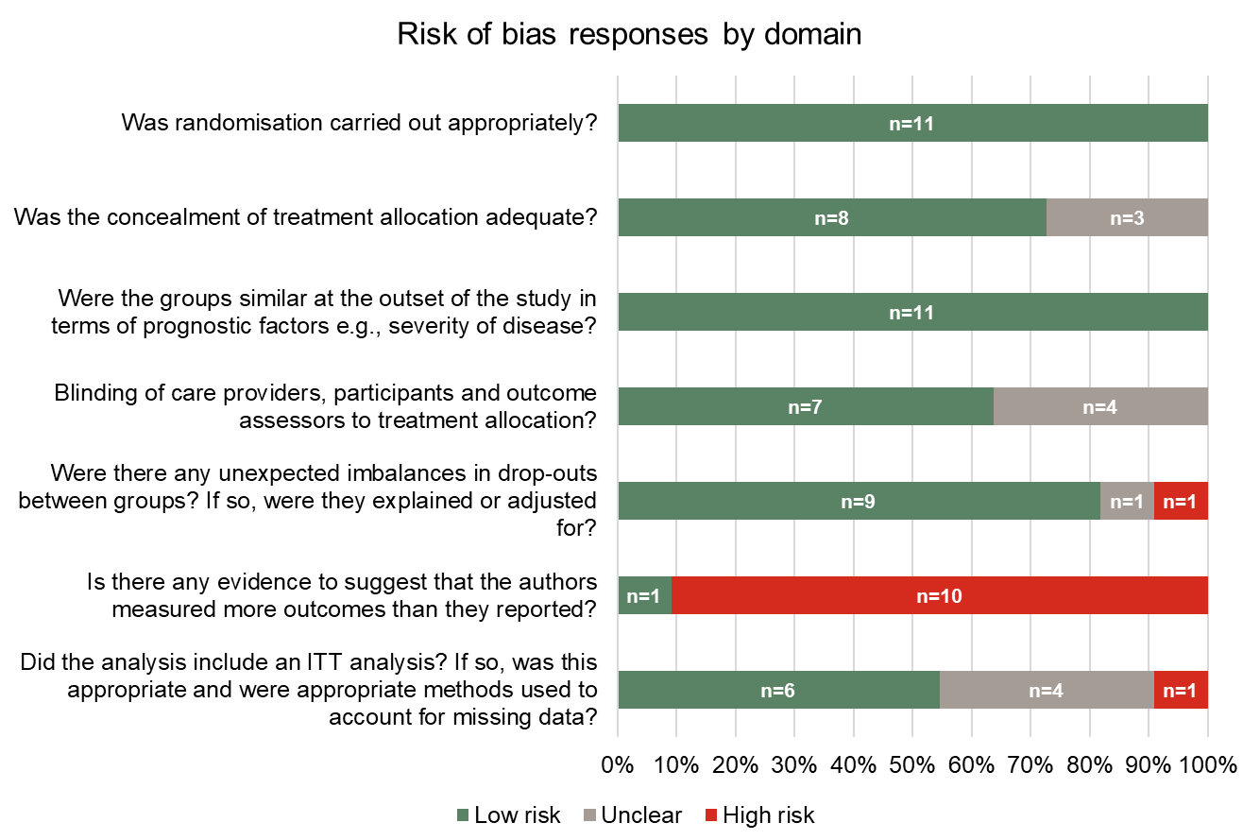
*One study (Study 301 [Lipton et al. 2018]) was available as an abstract only and could not be assessed. An unclear risk of bias was applied when data concerning a particular domain were not provided in the publication. NMA, network meta-analysis; ITT, intention to treat
Supplementary Figure 2. Assessment of heterogeneity. Bubble plots showing the treatment effect by placebo response
(a) Pain freedom at 2 hours
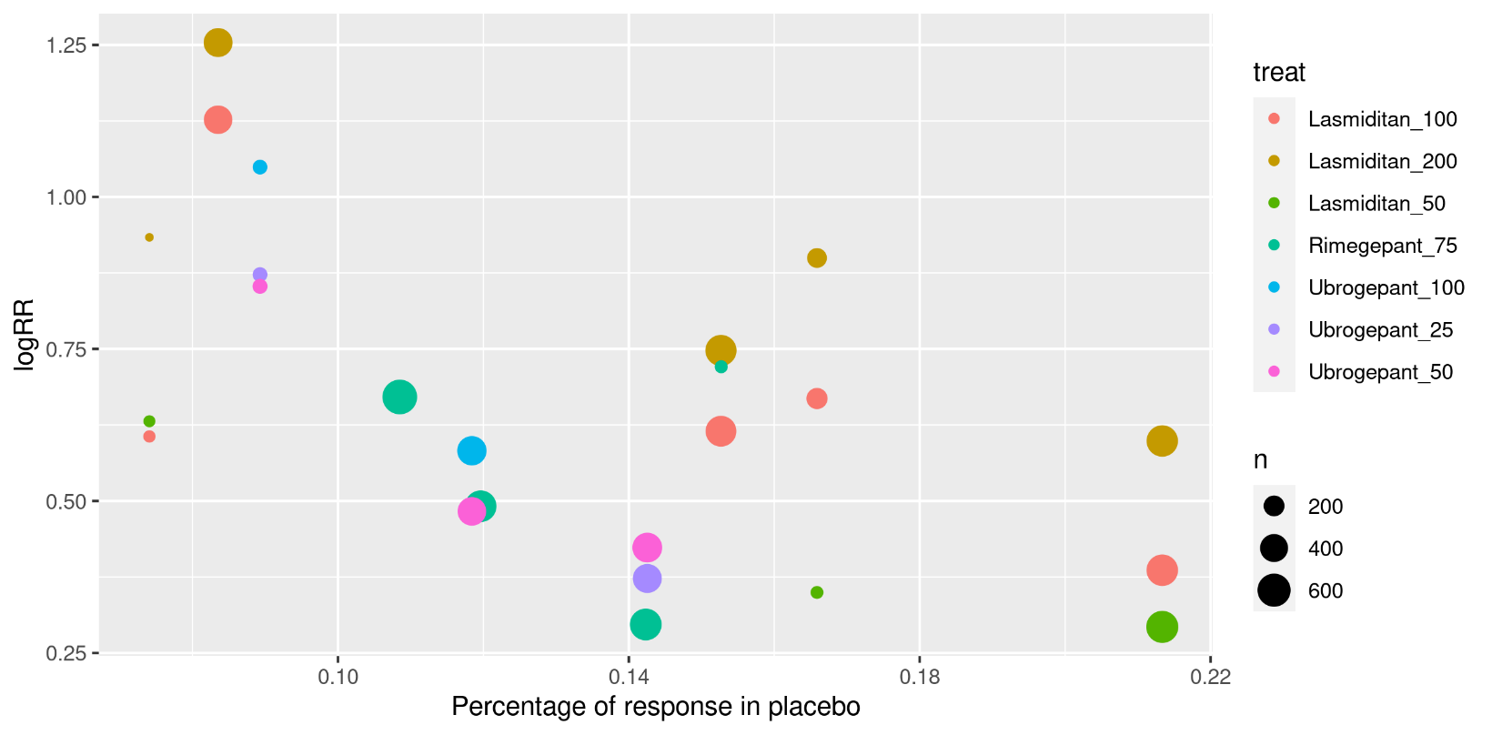
(b) Pain relief at 2 hours
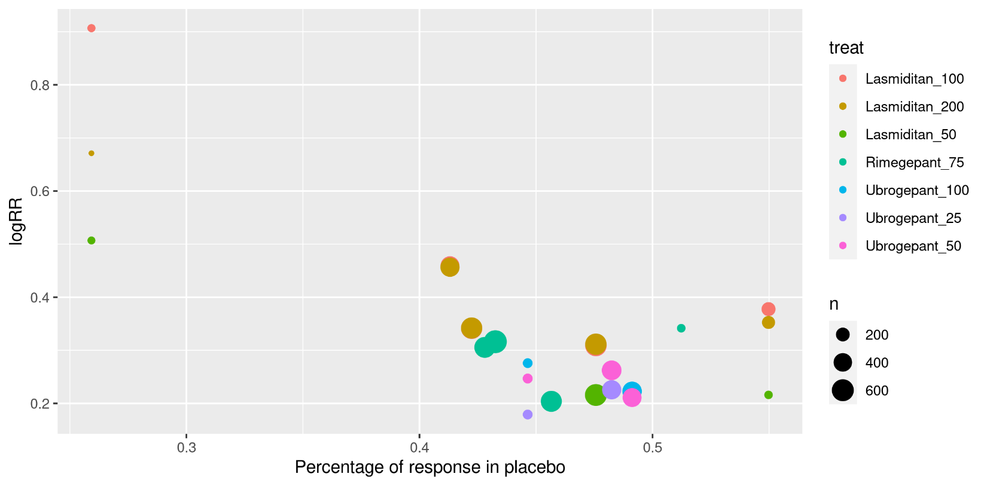

(c) Pain relief at 1 hour
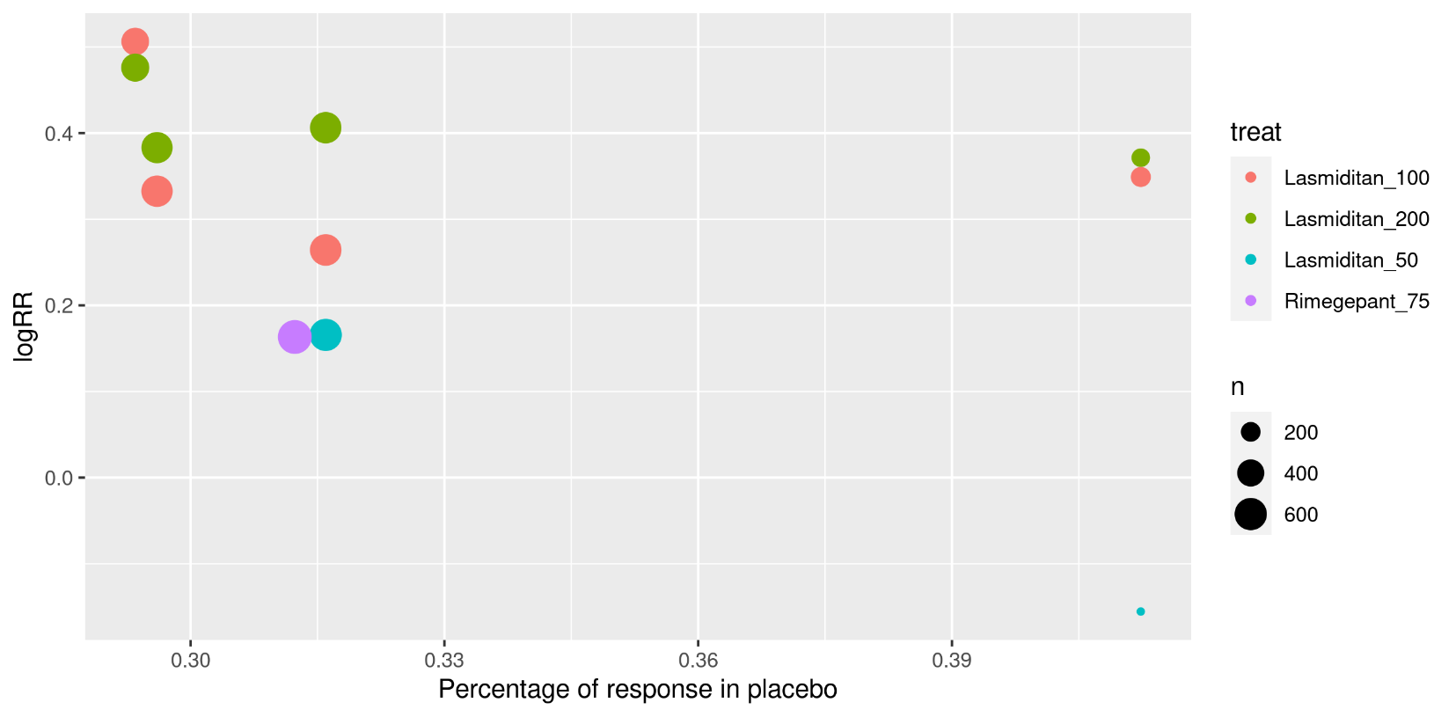
(d) Sustained pain freedom over 24 hours
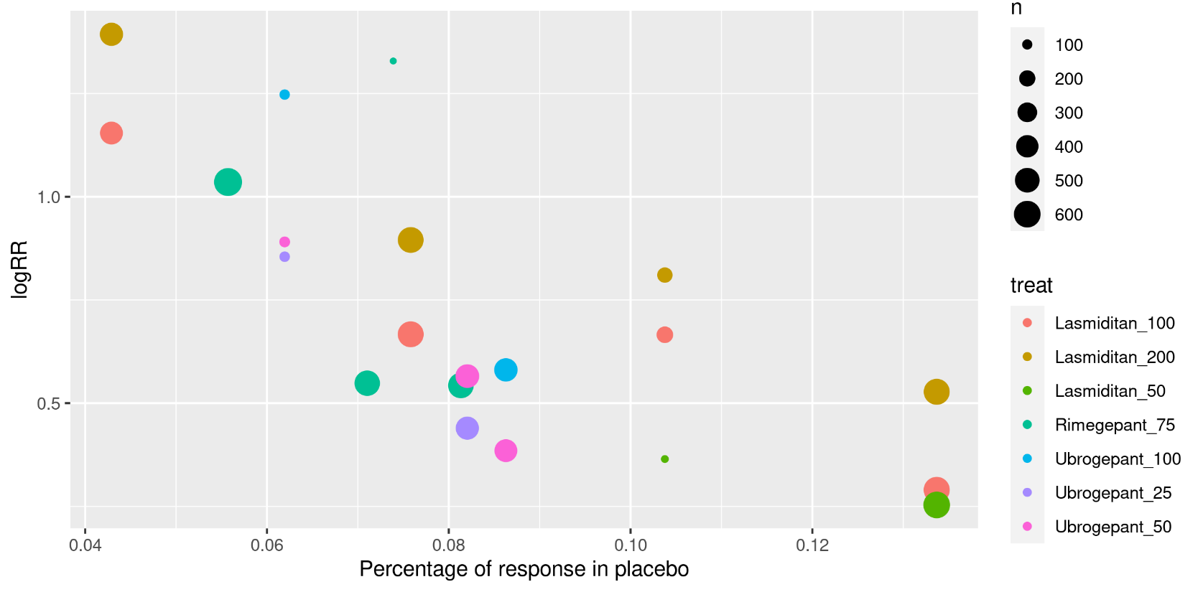

(e) Most bothersome symptom-free at 2 hours
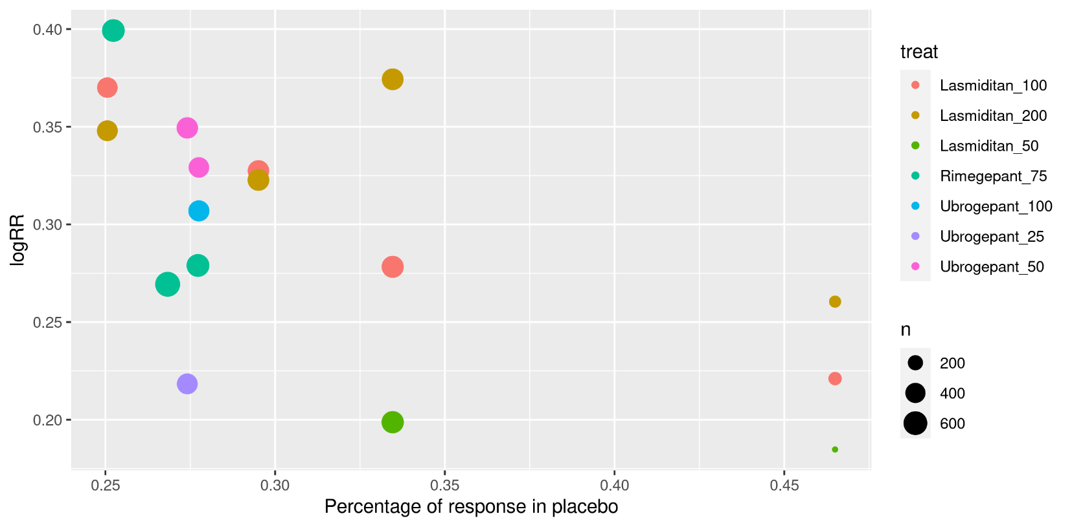

Supplementary Figure 3. NMA results for all outcomes – placebo comparisons.
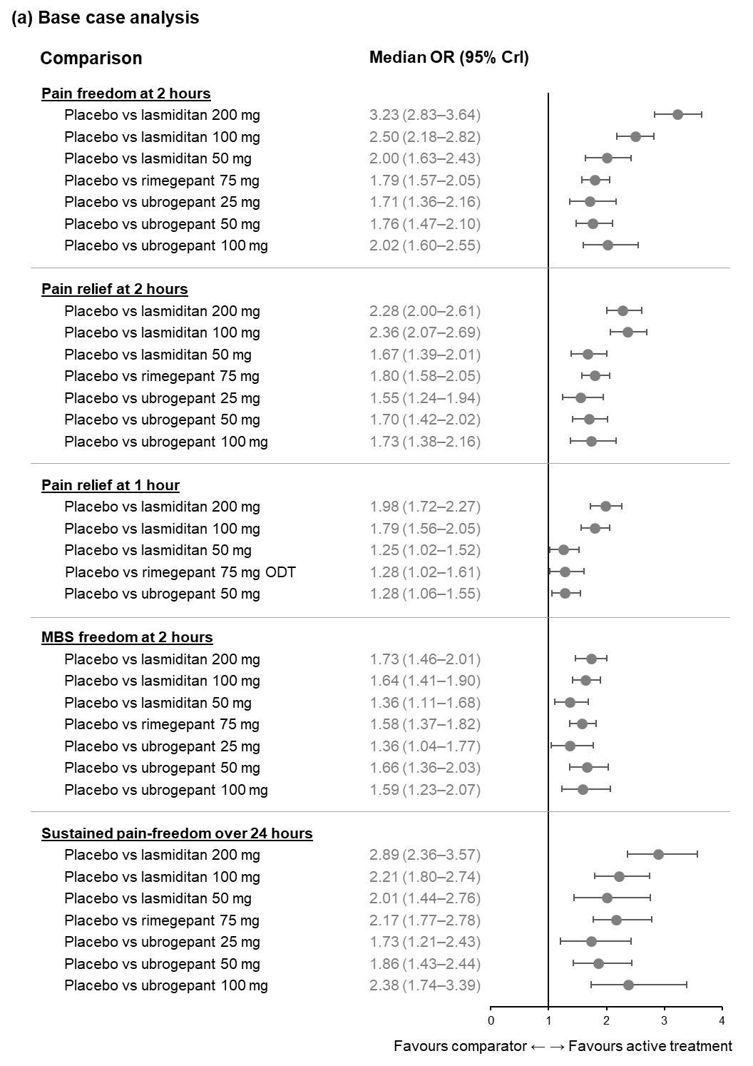
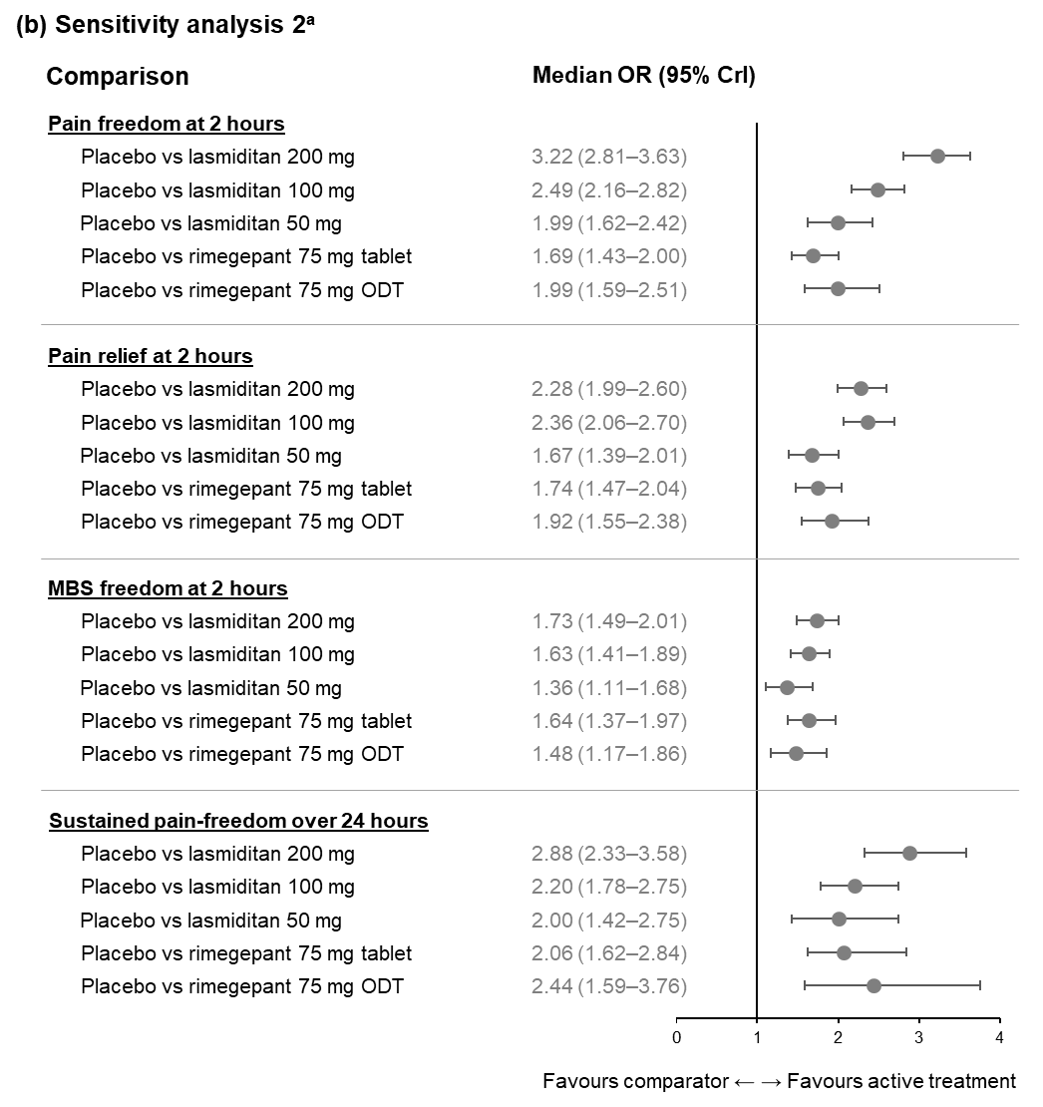

ªSensitivity analysis 2 analysed rimegepant according to its mode of administration (tablet or ODT). Pairwise treatment comparisons – results from Bayesian fixed-effects NMA adjusted for baseline risk (pain freedom at 2 hours: base case analysis: 36 observations, residual deviance = 36.26 [adjusted baseline risk: mean -0.54 (95% Crl -0.73, -0.28)]; sensitivity analysis 2: 36 observations, residual deviance = 35.74 [adjusted baseline risk: mean -0.52 (95% Crl -0.71, -0.25)]); Bayesian fixed-effects NMA (pain relief at 2 hours: base case analysis: 36 observations, residual deviance = 37.31; sensitivity analysis 2: 36 observations, residual deviance = 37.81; pain relief at 1 hour: base case analysis: 16 observations; residual deviance = 23.16; MBS freedom at 2 hours: base case analysis: 26 observations, residual deviance = 19.07; sensitivity analysis 2: 26 observations, residual deviance = 19.60) or Bayesian random-effects model adjusted for baseline risk NMA (sustained pain freedom over 24 hours: base case analysis: 32 observations, residual deviance = 34.00 [adjusted baseline risk: mean -0.72 (95% Crl -1.10, -0.32)]; sensitivity analysis 2: 32 observations, residual deviance = 34.00 [adjusted baseline risk: mean -0.69 (95% Crl -1.10, -0.24)]). Sensitivity analysis 2 could not be performed for pain relief at 1 hour as no suitable data were available for rimegepant tablets. Crl, credible interval; MBS, most bothersome symptom; NMA, network meta-analysis; ODT, oral disintegrating tablet; OR, odds ratio

Supplementary Figure 4. Fixed effects analysis with and without baseline risk adjustment for pain freedom at 2 hours.
Pairwise treatment comparisons – results from Bayesian fixed-effects NMA adjusted for baseline risk (base case analysis: 36 observations, residual deviance = 36.26 [adjusted baseline risk: mean -0.54 (95% Crl -0.73, -0.28)]
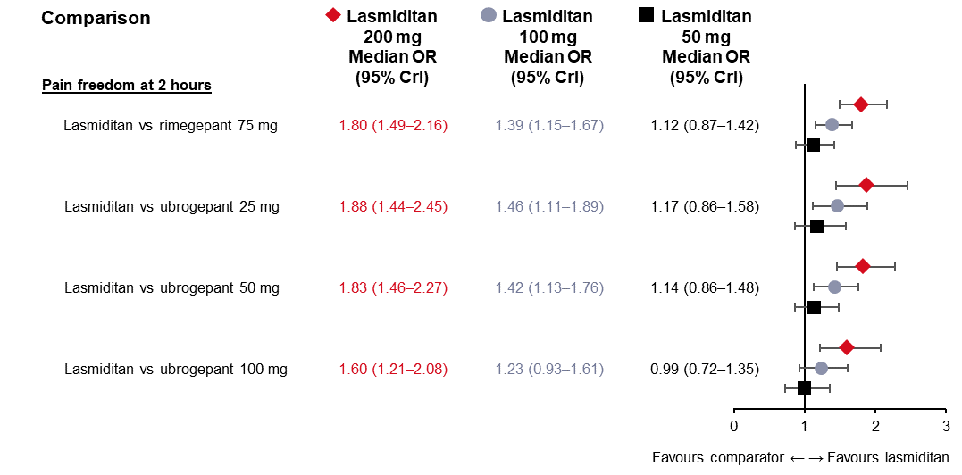
Pairwise treatment comparisons – results from Bayesian fixed-effects NMA not adjusted for baseline risk (base case analysis: 36 observations, residual deviance = 40.12
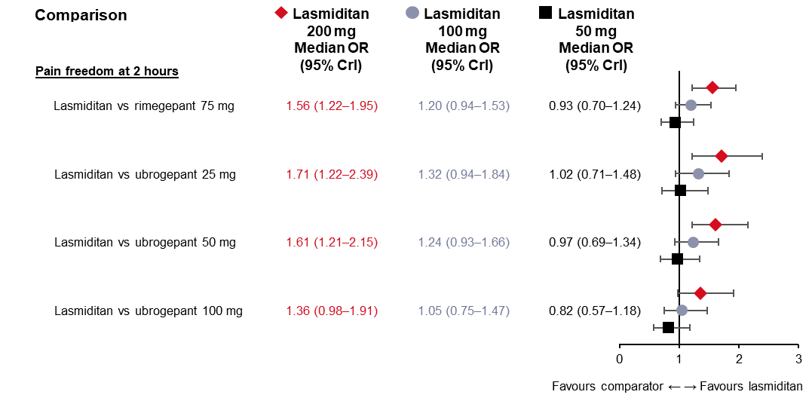
Crl, credible interval; NMA, network meta-analysis; ODT, oral disintegrating tablet; OR, odds ratio
Supplementary Figure 5. Sensitivity analysis 1 results for all outcomes.
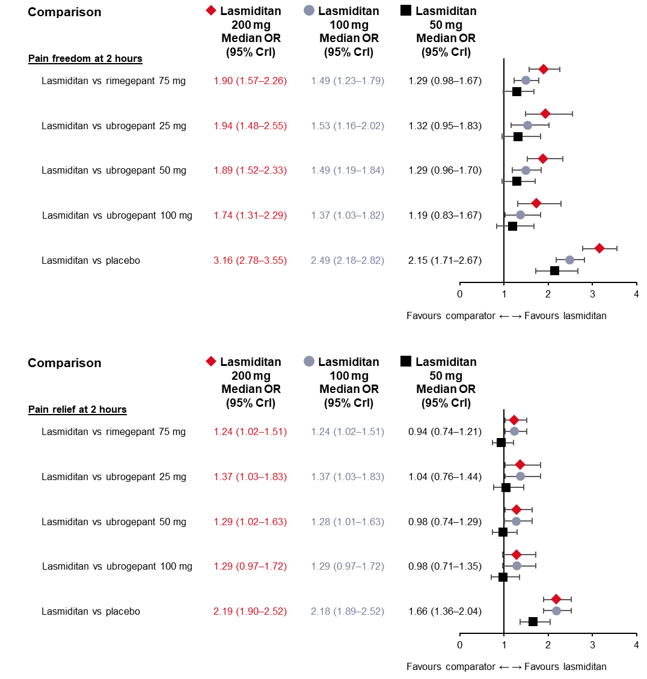
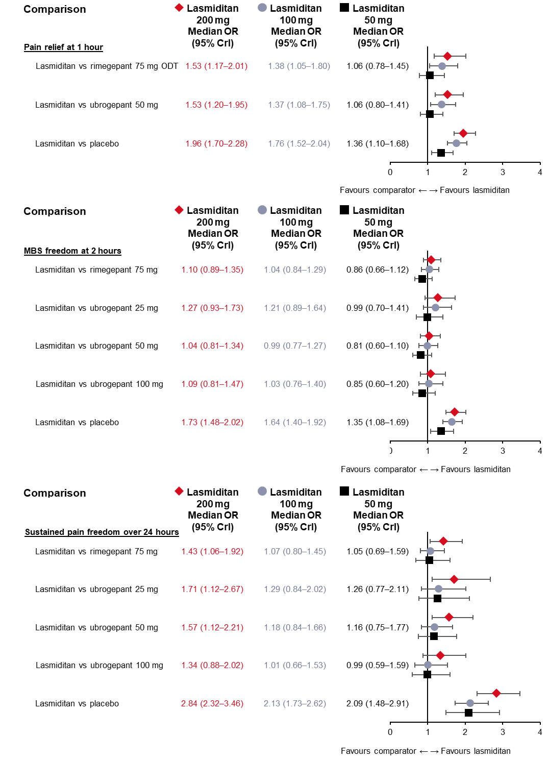

Pairwise treatment comparisons – results from Bayesian fixed-effects model adjusted for baseline risk NMA (pain freedom at 2 hours: 22 observations, residual deviance = 20.13 [adjusted baseline risk: mean -0.69 (95% Crl -0.88, -0.44)]); Bayesian fixed-effects NMA (pain relief at 2 hours: 22 observations; residual deviance = 21.66; pain relief at 1 hour: residual deviance = 15.84; MBS freedom at 2 hours: 22 observations; residual deviance = 17.97) or Bayesian random-effects model adjusted for baseline risk NMA (sustained pain freedom over 24 hours: 22 observations; residual deviance = 20.5 [adjusted baseline risk: mean -0.77 (95% Crl -1.10, -0.41)]). Crl, credible interval; MBS, most bothersome symptom; NMA, network meta-analysis; ODT, oral disintegrating tablet; OR, odds ratio

Supplementary Figure 6 NMA results for pain relief at 2 hours.
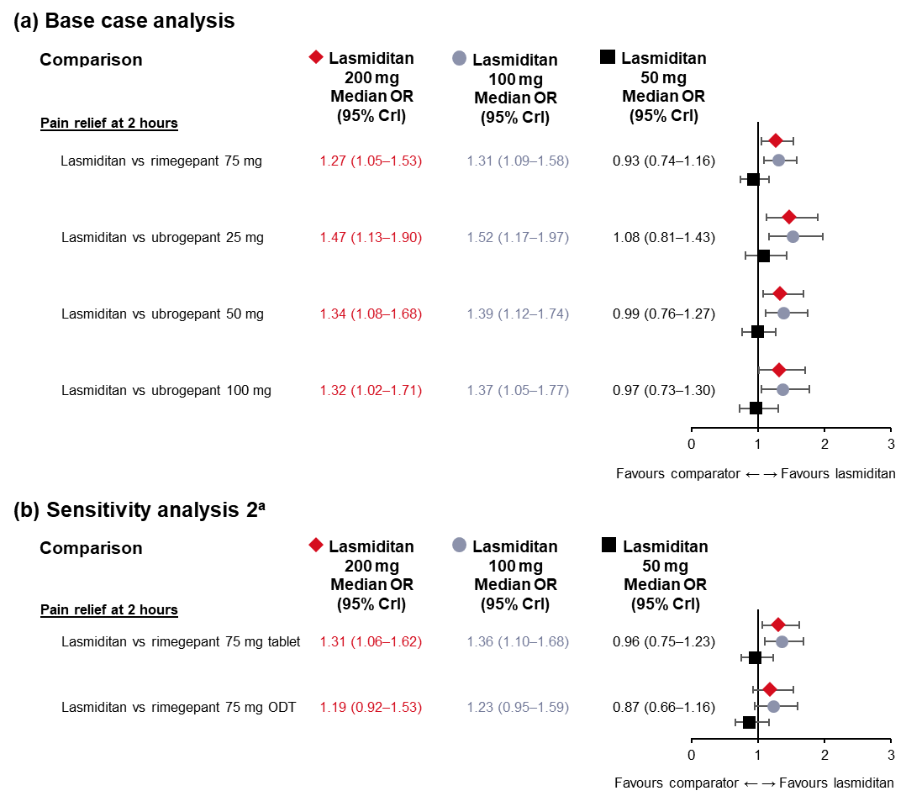
ªSensitivity analysis 2 analysed rimegepant according to its mode of administration (tablet or ODT). Pairwise treatment comparisons – results from Bayesian fixed-effects NMA (base case analysis: 36 observations, residual deviance = 37.31; sensitivity analysis 2: 36 observations, residual deviance = 37.81). Crl, credible interval; NMA, network meta-analysis; ODT, oral disintegrating tablet; OR, odds ratio

Supplementary Figure 7. NMA results for pain relief at 1 hour – base case analysis.
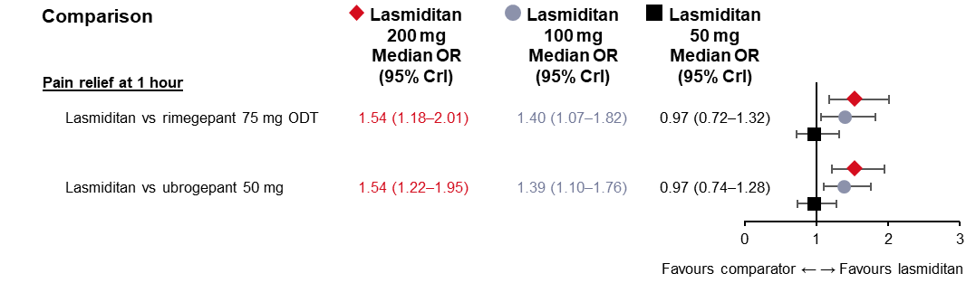
Pairwise treatment comparisons – results from Bayesian fixed-effects NMA (16 observations; residual deviance=23.16). Sensitivity analysis 2 could not be performed for pain relief at 1 hour as no suitable data were available for rimegepant tablets. Crl, credible interval; NMA, network meta-analysis; ODT, oral disintegrating tablet; OR, odds ratio

Supplementary Figure 8. NMA results for MBS freedom at 2 hours.
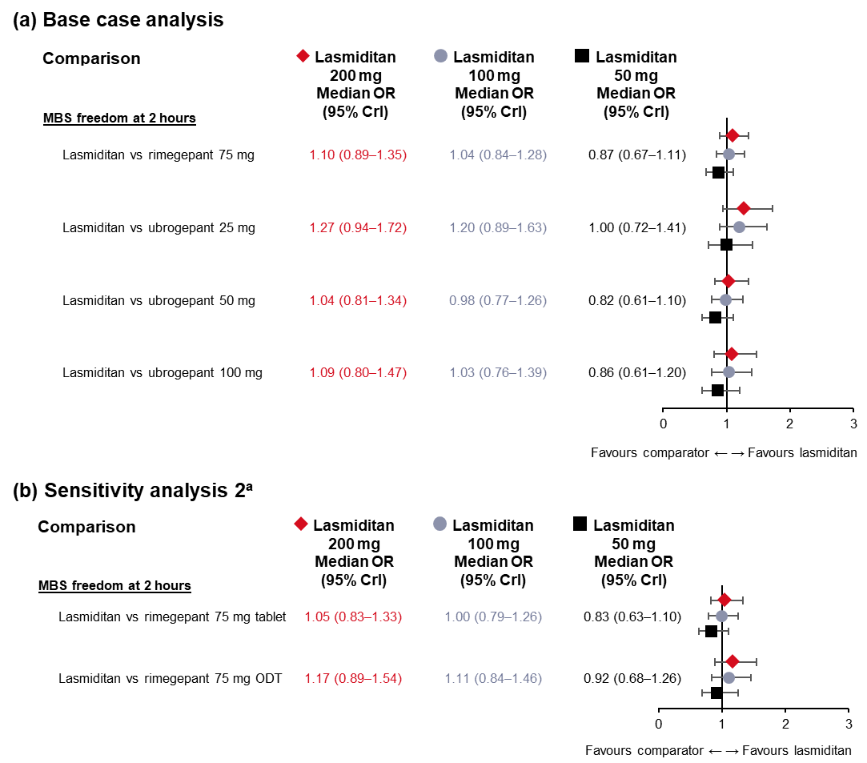
ªSensitivity analysis 2 analysed rimegepant according to its mode of administration (tablet or ODT). Pairwise treatment comparisons – results from Bayesian fixed-effects NMA (base case analysis: 26 observations, residual deviance = 19.07; sensitivity analysis 2: 26 observations, residual deviance = 19.60). Crl, credible interval; MBS, most bothersome symptom; NMA, network meta-analysis; ODT, oral disintegrating tablet; OR, odds ratio
Supplementary Figure 9. NMA results for sustained pain freedom over 24 hours.
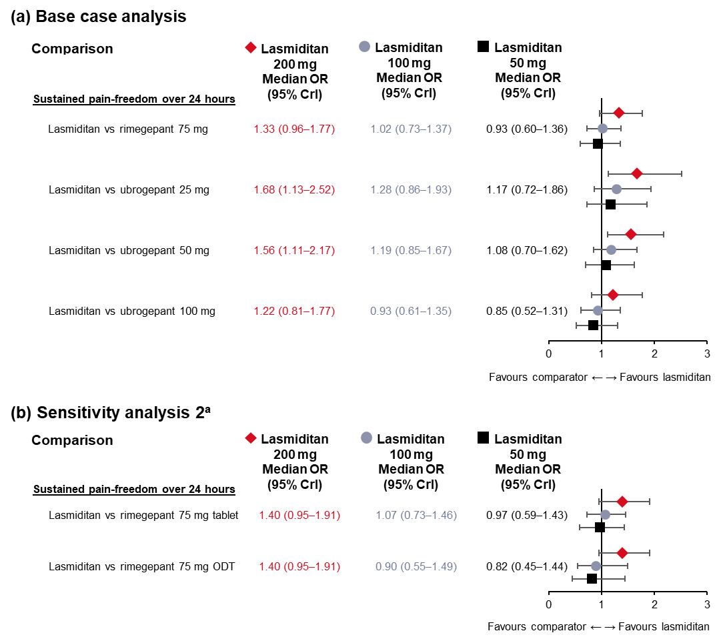
ªSensitivity analysis 2 analysed rimegepant according to its mode of administration (tablet or ODT). Pairwise treatment comparisons – results from Bayesian random-effects model adjusted for baseline risk (base case analysis: 32 observations, residual deviance = 34.00 [adjusted baseline risk: mean -0.72 (95% Crl -1.10, -0.32)]; sensitivity analysis 2: 32 observations, residual deviance = 34.00 [adjusted baseline risk: mean -0.69 (95% Crl -1.10, -0.24)]). Crl, credible interval; NMA, network meta-analysis; ODT, oral disintegrating tablet; OR, odds ratio

Supplementary Figure 10. Fixed effects analysis with and without baseline risk adjustment for sustained pain freedom at 2–24 hours.
Pairwise treatment comparisons – results from Bayesian random-effects model adjusted for baseline risk (base case analysis: 32 observations, residual deviance = 34.00 [adjusted baseline risk: mean -0.72 (95% Crl -1.10, -0.32)]
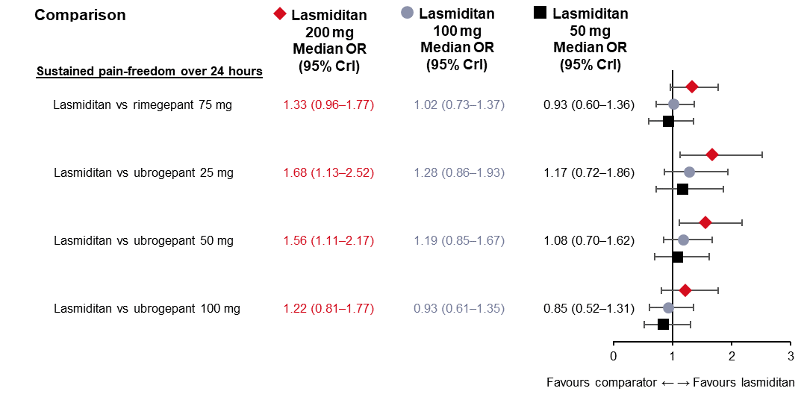
Pairwise treatment comparisons – results from Bayesian fixed-effects NMA not adjusted for baseline risk (base case analysis: 32 observations, residual deviance = 41.41
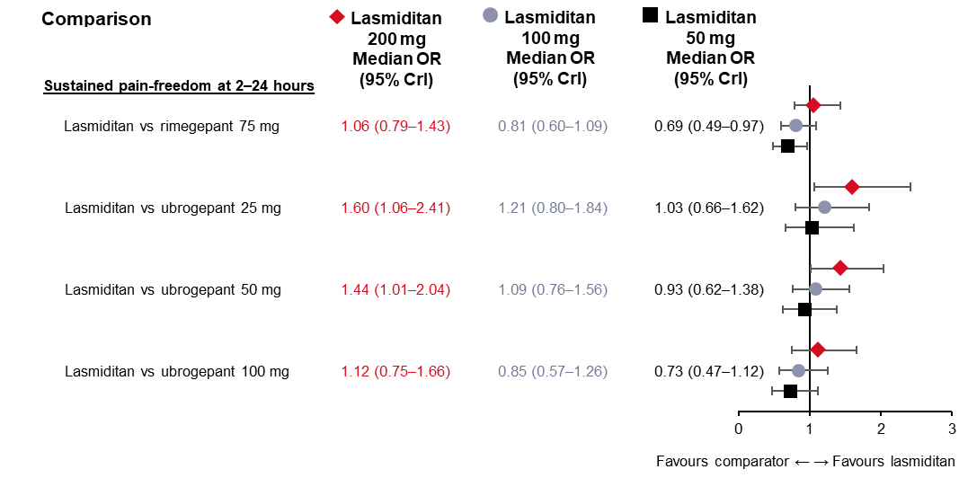
Crl, credible interval; NMA, network meta-analysis; ODT, oral disintegrating tablet; OR, odds ratio

Supplementary Figure 11. Very early-onset outcomes exploration (sensitivity analysis 3ª) (base case analysis).
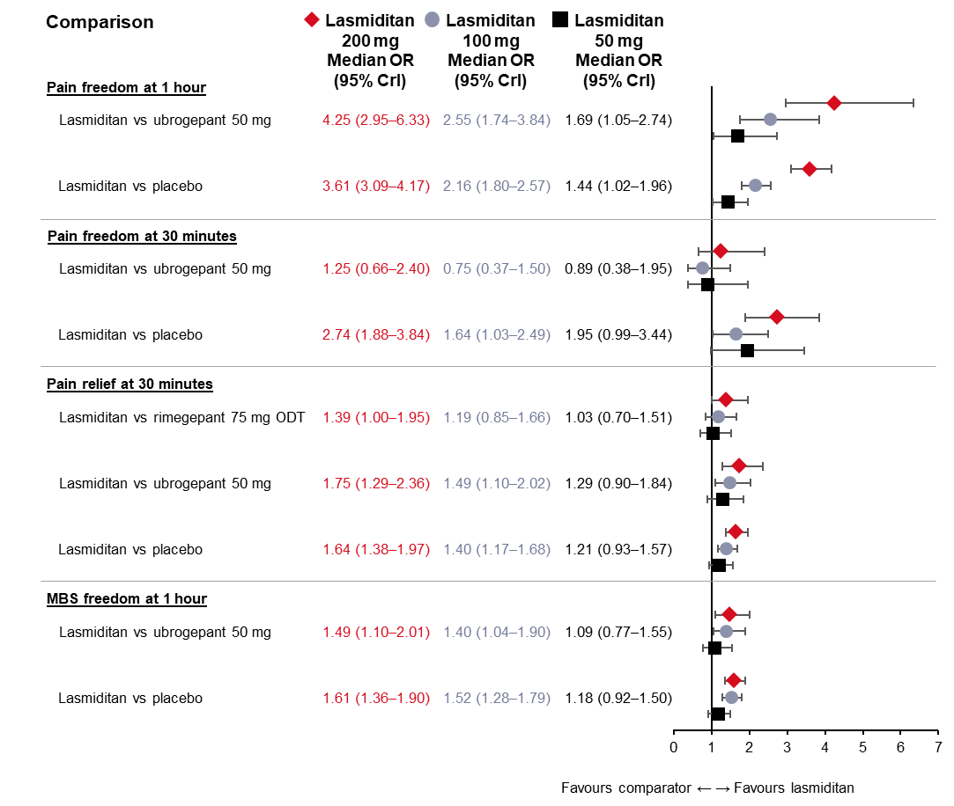
ªSensitivity analysis 3 analysed pain freedom at 1 hour and at 30 min, pain relief at 30 minutes and MBS freedom at 1 hour. Assessed using Bayesian fixed-effects model adjusted for baseline risk (pain freedom at 1 hour: 16 observations, residual deviance = 18.45 [adjusted baseline risk: mean -0.79 (95% Crl -0.97, -0.53)]; pain freedom at 30 min: 16 observations, residual deviance = 15.22 [adjusted baseline risk: mean -0.93 (95% Crl -1.45, -0.25)]), Bayesian fixed-effects model (pain relief at 30 min: 18 observations, residual deviance = 14.48; MBS freedom at 1 hour: 16 observations, residual deviance = 17.33). Crl, credible interval; MBS, most bothersome symptom; ODT, oral disintegrating tablet; OR, odds ratio

