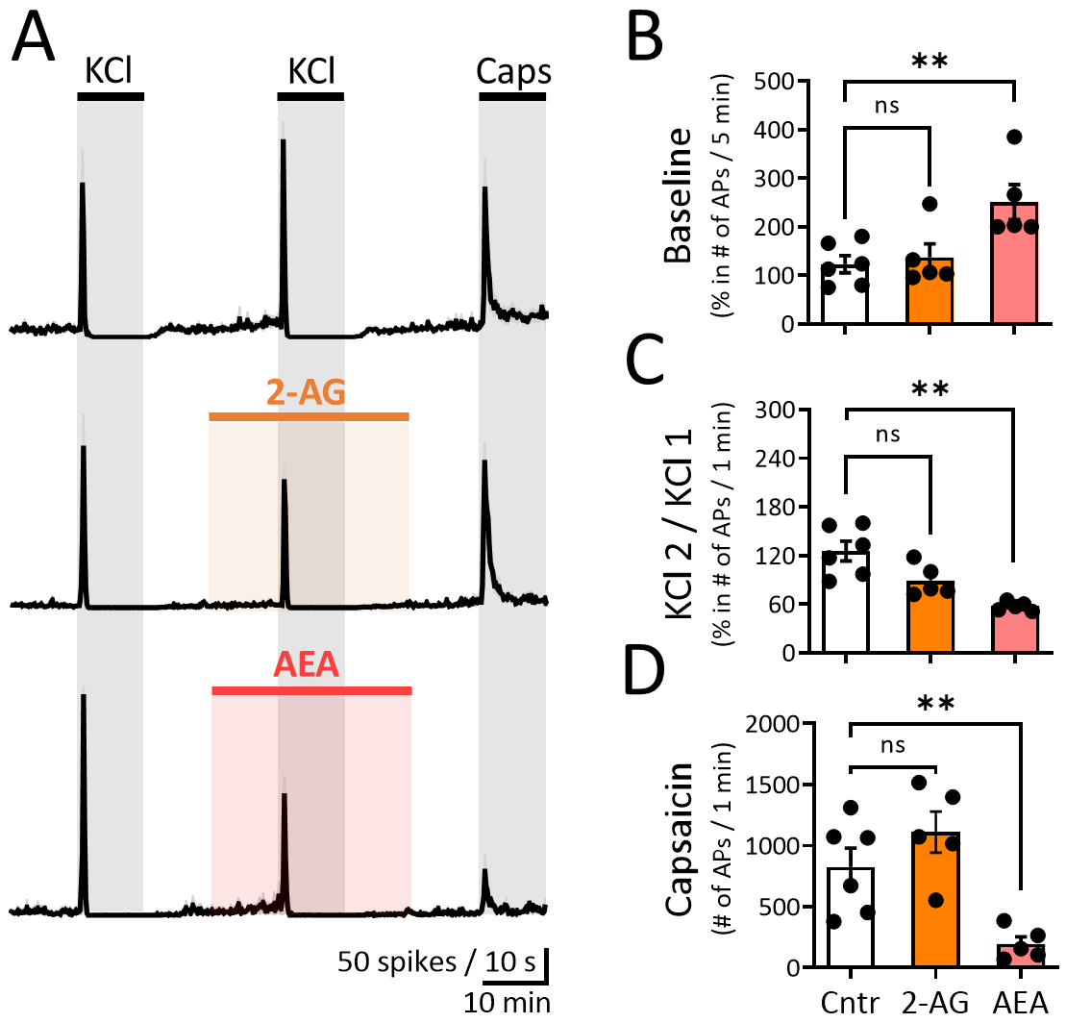

Additional File 3. Endocannabinoids 2-AG and AEA modulate KCl-induced spiking from meningeal afferents in female rats.
(A) Time courses of spike frequency (10-s bin size) induced by APs recorded from the peripheral part of trigeminal nerve innervating female rat meninges within the 1-min active phase of the 2nd KCl pulse in combination with 10 µM AEA or 10 µM 2-AG. Note changes in KCL-induced firing during applications of 2-AG and AEA. Notably, capsaicin-induced firing decreased during the combined application of 10 µM AEA, but not during 2-AG. (B) No difference was observed between the APs ratio before and during 5 min 2-AG (N = 5), although it was between the APs ratio before and during 5 min AEA (N = 5) comparing to the APs ratio of the same tine windows in the control condition (Cntr, N = 6, Mann Whitney U test, ** = 0.004). (C) The ratio of APs for 1 min between the 2nd and 1st KCl pulses was affected by both endocannabinoids in comparison to control conditions (N = 6), but significantly only with 10 µM AEA (N = 5, Mann Whitney U test, ** = 0.004). (D) The number of APs during the 1-min active phase of 1 µM Capsaicin was reduced after application of 10 µM AEA only (N = 5, Mann Whitney U test, ** = 0.008).

