Appendix 1. Sensitivity analysis of quantitative endpoints at month 6.
Missing data is shown below each variable for both assessments (observed and LOCF)
Variables at M6 [mean±SD] | Observed | LOCF | Difference (CI 95%)
MMD  MHD  MAMI  Intensities  Mild days/month  Moderate days/month  Severe days/month  HIT-6  MIDAS  PGIC | 7.3±7.6  n=134/134  12.5±10.0  n=134/134  9.4±8.9  n=129/134  6.0±8.4  n=96/134  3.4±4.3  n=96/134  2.2±4.1  n=96/134  55.2±11.1  n=114/134  34.4±48.1  n=101/134  4.13±2.1  n=110/134 | 9.5±9.4  n=162/162  14.7±10.8  n=162/162  10.8±10.0  n=151/162  6.0±8.1  n=114/162  4.6±5.9  n=114/162  3.3±5.9  n=114/162  56.5±11.5  n=137/162  41.0±52.9  n=124/162  4.0±2.0  n=132/162 | -2.2 (-4.1, -0.2)  -2.2 (-4.6, 0.2)  -1.4 (-3.6, 0.9)  0.0 (-2.2, 2.6)  -1.2 (-2.6, 0.2)  -1.1 (-2.4, 0.3)  -1.3 (-4.2, 1.5)  -6.6 (-20.0, 6.8)  0.1 (-0.4, 0.6) | 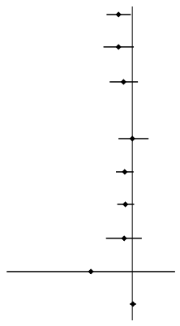
M6 = month 6; LOCF = last observation carried forward, MMD = monthly migraine days; MHD = monthly headache days; MAMI = monthly acute medication intake; SD = standard deviation.

