eFigure 1 Flowchart of study identification, screening and inclusion

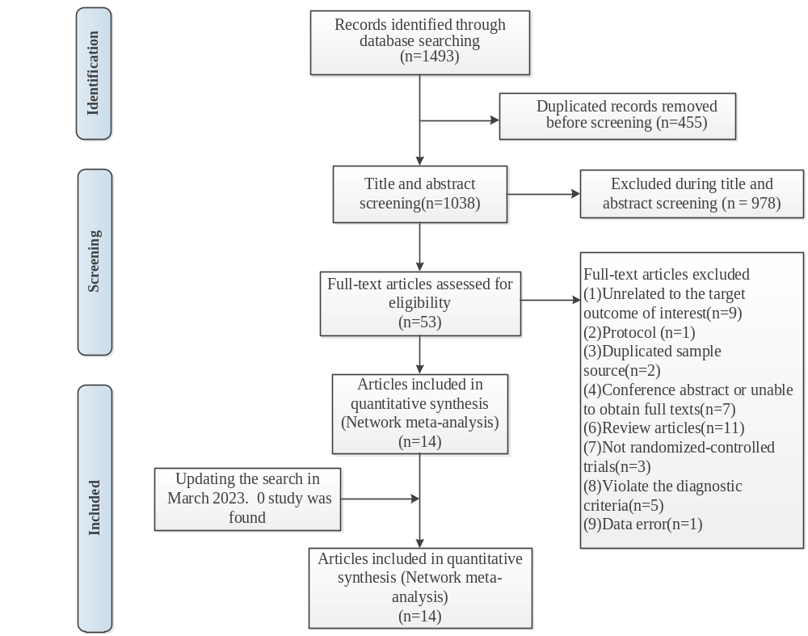

eFigure 2A Risk of bias assessment for 8 studies included in the NMA.
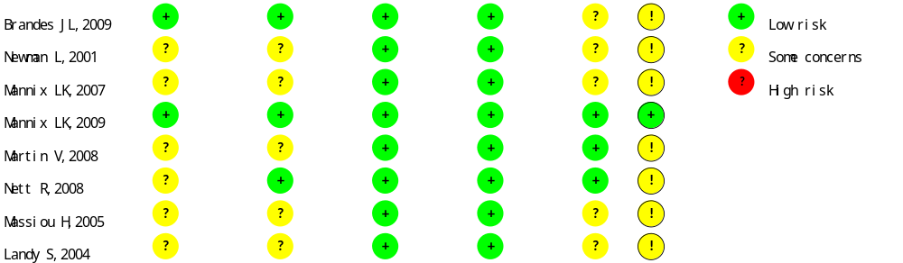

eFigure 2B Risk of bias assessment for 6 crossover trials included in the NMA. .
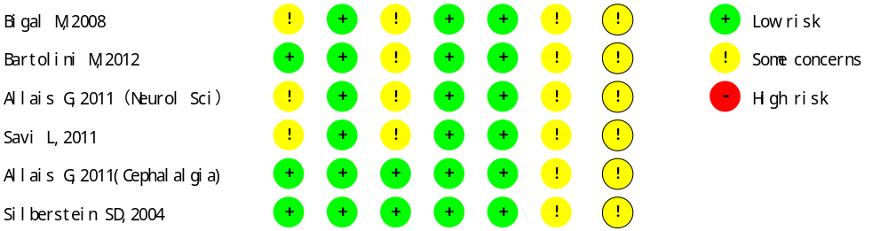

eFigure 3A Pairwise comparison of interventions with placebo----mean percentage of PMPs without MRM
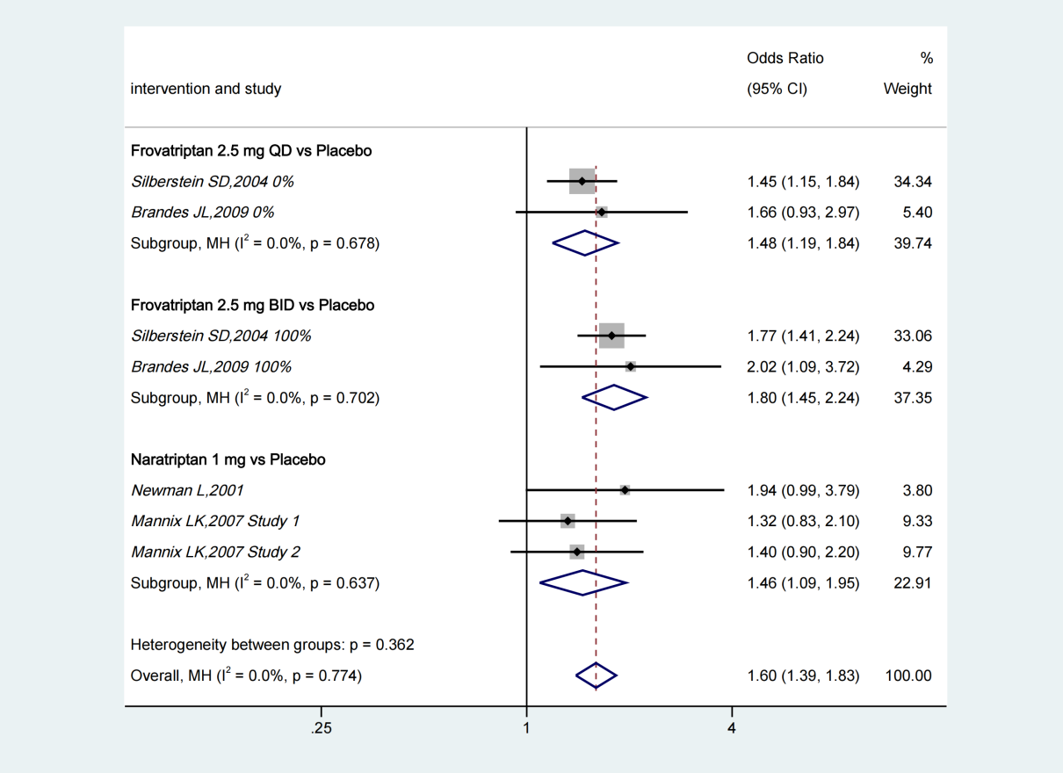

eFigure 3B Pairwise comparison of interventions with placebo----all adverse events
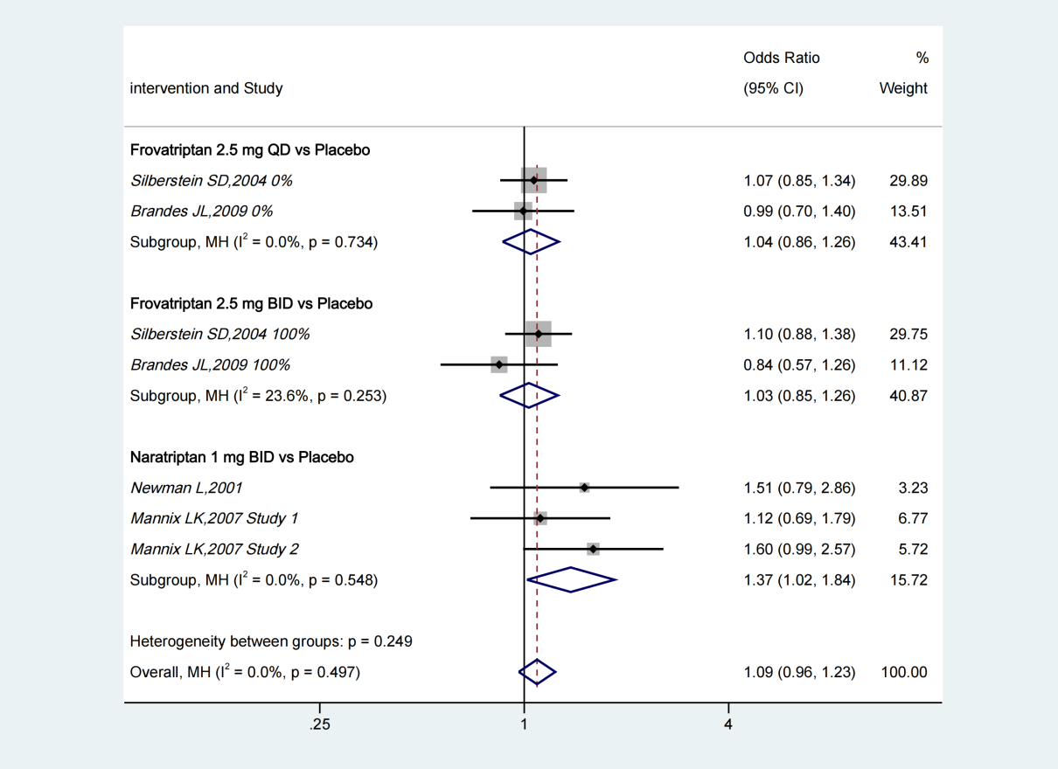
eFigure 3C Pairwise comparison of interventions with placebo----2-hour pain freedom (percentage of patients)
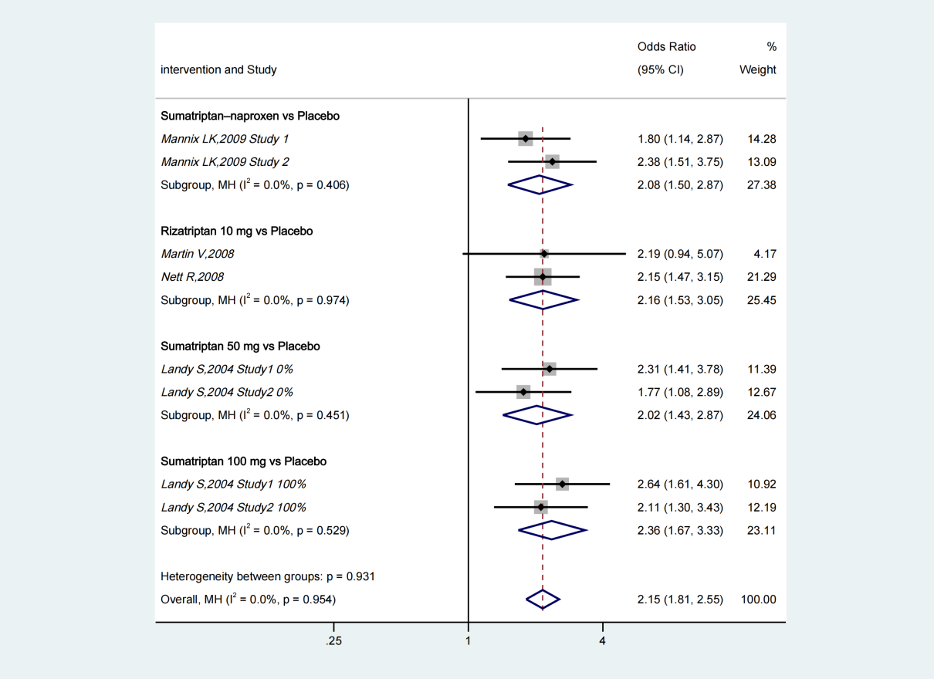

eFigure 3D Pairwise comparison of interventions with placebo----recurrent episodes at 24 hours (percentage of attacks)
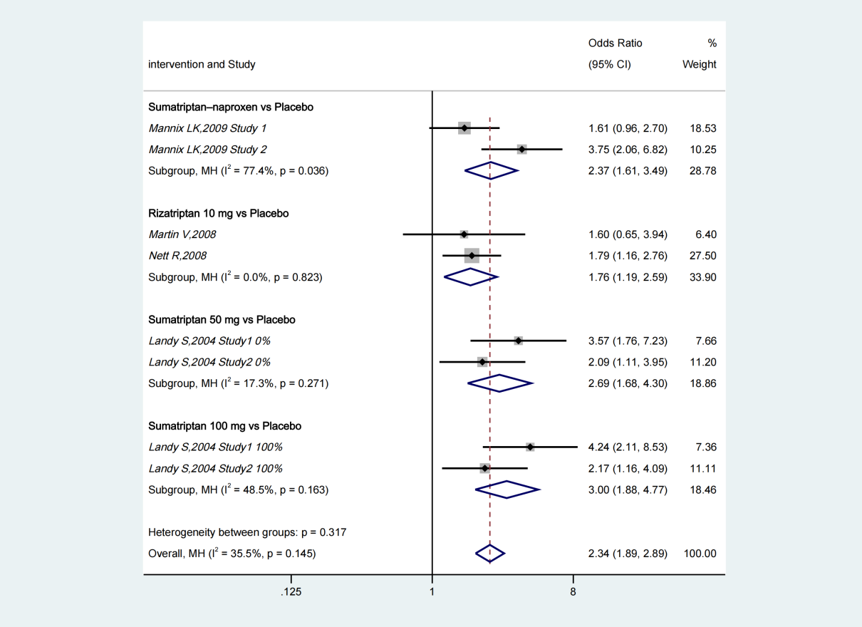

eFigure 4A Funnel plot of “ mean percentage of PMPs without MRM”
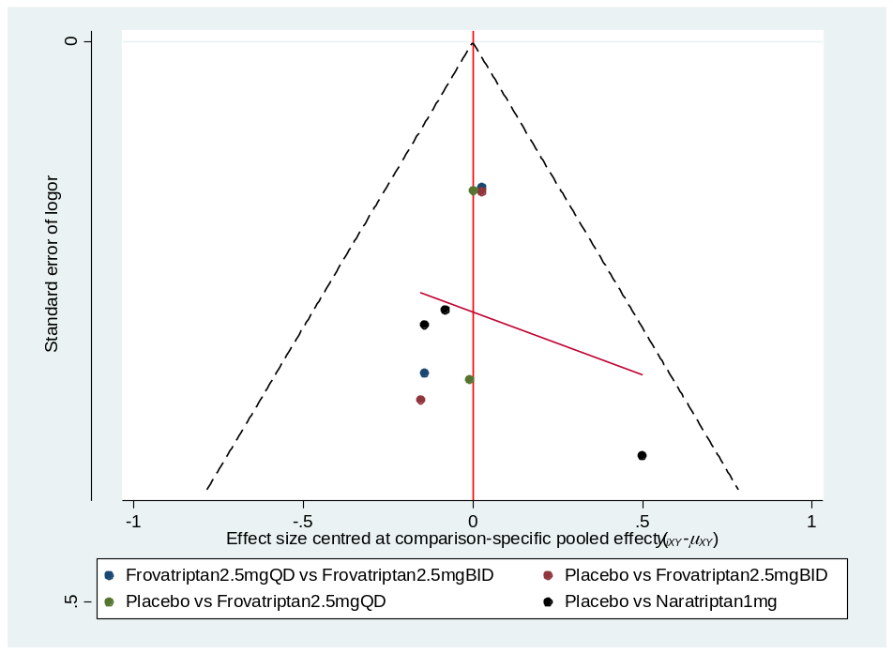

eFigure 4B Funnel plot of “2-hour pain freedom (percentage of patients)”
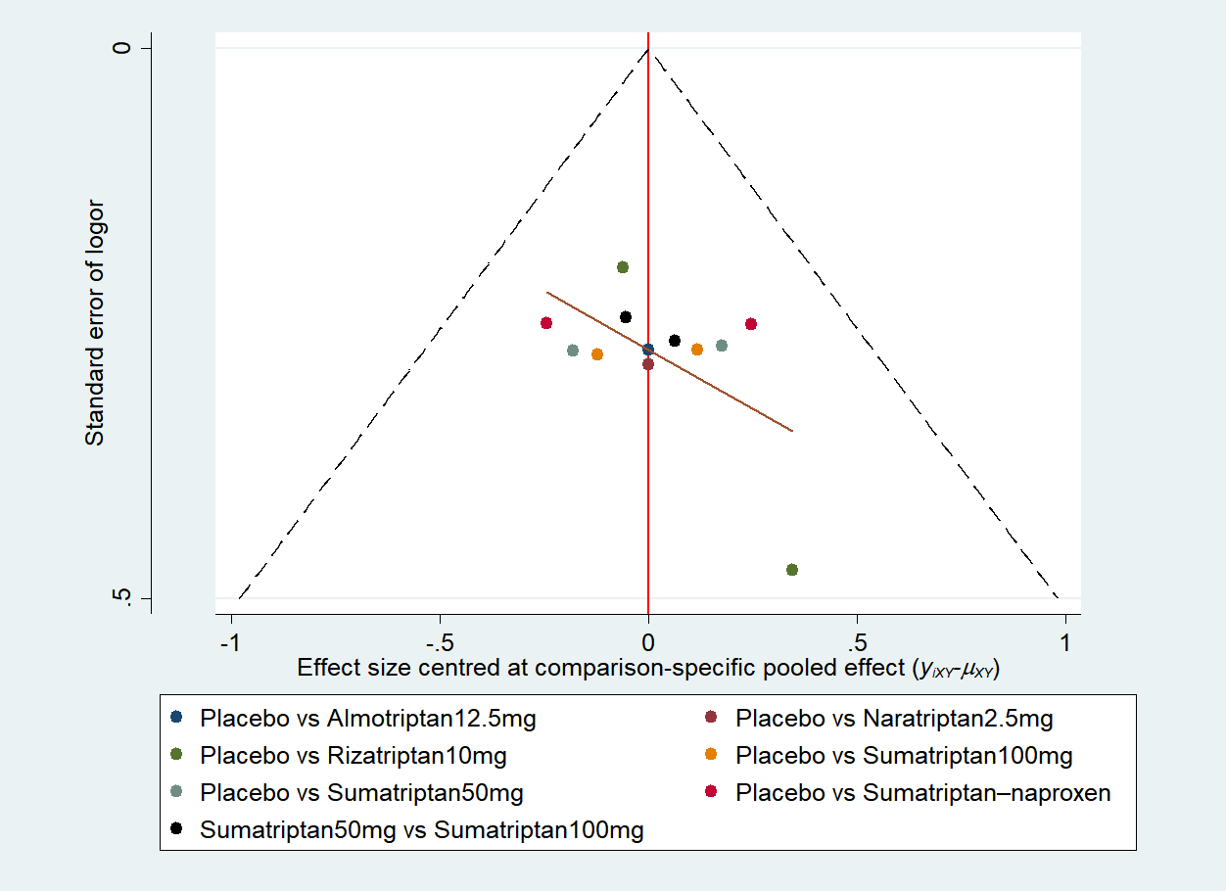

eFigure 5A network evidence plot of (1) mean percentage of PMPs without MRM; (2) all adverse events
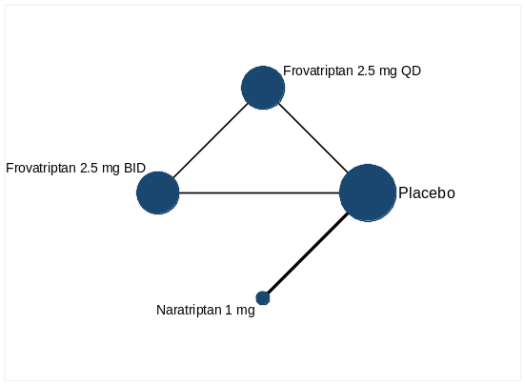

eFigure 5B network evidence plot of 2-hour pain freedom (percentage of attacks)
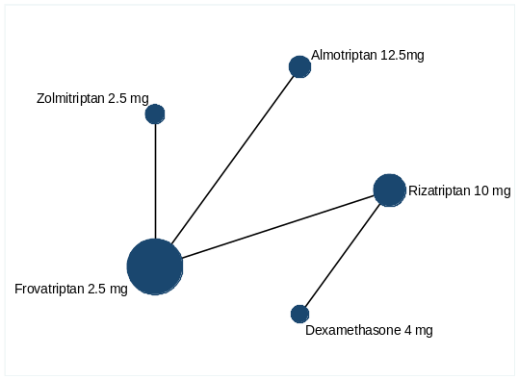

eFigure 5C network evidence plot of recurrent episodes at 24 hours (percentage of attacks)
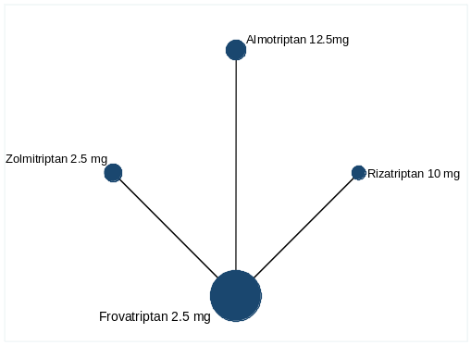

eFigure 6A Sensitivity analysis：Forest plot of mean percentage of PMPs without MRM

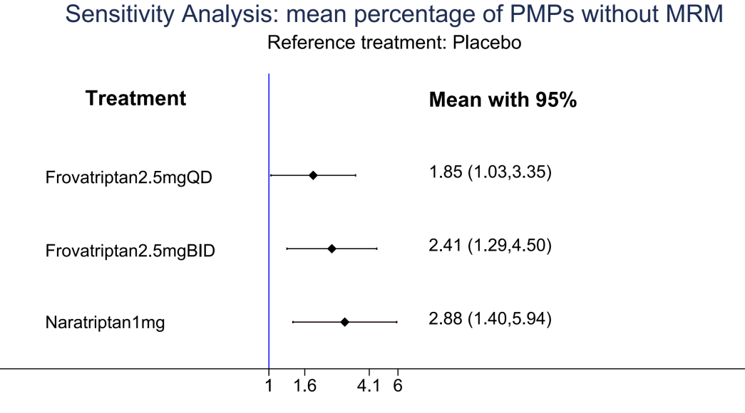

eFigure 6B Sensitivity analysis：Forest plot of 2-hour pain freedom(percentage of patients)

