Supplementary Material

Supplementary Table 1.- Variables and costs used for the cost-benefit analysis. Drug prices have been obtained from the Spanish national records of the Ministry of Health (1,2), costs related to hospital care from the reports of the Catalan Health Institute (3) and the most recently published hourly salary by the institute of statistics of Catalonia (4).

 |  |  | Cost per unity (euros) | Period
Direct costs | Anti-CGRP MAbs | Erenumab | 445 | Monthly
Direct costs | Anti-CGRP MAbs | Galcanezumab | 450 | Monthly
Direct costs | Anti-CGRP MAbs | Fremanezumab | 498 | Monthly
Direct costs | Follow-up | Outpatient visit | 80 | Every 3 months
Direct costs | Emergency visits |  | 172.5 | On demand
Direct costs | Triptans |  | 1.95 | On demand
Indirect Costs | Hourly salary |  | 17.93

Supplementary Table 2.- Comparison of the results variables at time M0, M3 and M6 for the 83 patients who completed the follow up. We can appreciate great improvement between M0 and M3, maintaining it in month 6. No statistically significant changes were identified in the Wilcoxon test between month 3 and month 6. Abbreviations: M0 = Baseline; M3 = after 3 months of treatment; M6 = after 6 months of treatment

n=83 | M0 | M3 | M6 | p-value  M3 vs M6
Headache days/month, mean (SD) | 18.4 (7.6) | 11 (8) | 10.5 (8.3) | 0.74
Migraine days/month, mean (SD) | 13.2 (7.3) | 6.3 (6.2) | 5.5 (6.2) | 0.55
Acute medication days/month, mean (SD) | 12.1 (6) | 7.2 (4.9) | 7.2 (5.7) | 0.76
Triptans used/month, mean (SD) | 8.3 (6.7) | 4.1 (4.7) | 4.2 (4.9) | 0.78
Absenteeism (%), mean (SD) | 12.7 (26.2) | 8.8 (25.6) | 10.3 (24.6) | 0.39
Presenteeism (%), mean (SD) | 41.8 (30.3) | 21.2 (26.6) | 20.5 (33) | 0.55

Supplementary Table 3.- Cost-benefit balance at months 3 and 6. The table shows comparisons between month 0 and month 3 for 148 patients; and between month 3 and month 6 for 83 patients. Abbreviations: M0 = Baseline; M3 = after 3 months of treatment; M6 = after 6 months of treatment; EUR = euros; MAbs = Monoclonal antibodies

 |  | M0  (EUR per month and patient) | M3  (EUR per month and patient) | Monthly balance  M0 vs. M3 | Total balance  M0 vs. M3  (n=148) | M3  (EUR per month and patient) | M6  (EUR per month and patient) | Monthly balance  M3 vs. M6 | Total balance M3 vs. M6  (n=83)
Direct cost | Anti-CGRP MAbs | 0 | 453.67 | -453.67 | -1361 | 453.67 | 453.67 | 0 | 0
 | Follow-up | 0 | 80 | -26.6 | -80 | 80 | 80 | 0 | 0
Direct Savings | Emergency visits | 55.6 | 24.5 | +31.1 | +93.3 | 27 | 2.1 | +24.9 | +74.7
 | Triptans | 5.4 | 2.6 | +2.8 | +8.4 | 2.5 | 2.5 | 0 | 0
Indirect Savings | Absenteeism | 330.5 | 225.1 | +105.4 | +316.2 | 238.6 | 220.2 | +18.4 | +55.2
 | Presenteeism | 929.7 | 535.4 | +394.3 | +1182.9 | 455.2 | 446.9 | +8.3 | +25
 |  |  |  |  | 159.8/patient |  |  |  | Additional 154.9/patient
 |  |  |  |  | Total= 23650.4 |  |  |  | Additional total= 12856.7

Supplementary Table 4.- Comparison between the baseline characteristics of responders (>50% reduction in monthly headache days) vs. partial responder’s and non-responders’ (<50% reduction in monthly headache days). Abbreviations: SD = Standard deviation; Q1-Q3 = Interquartile range; WPAI = Work productivity and activity impairment

Variables at baseline | Total,  N =148 | Responders,  n=61 | Partial responders’ and non-responders, n=87 | p-value
Age, mean (SD) | 47.6 (8.5) | 47.9 (7.8) | 47.4 (9.1) | 0.743
Sex (woman), n (%) | 132 (89.2%) | 54 (88.5%) | 78 (89.7%) | >0.999
Years of evolution, mean (SD) | 28.3 (12.3) | 30.1 (10.5) | 27.1 (13.3) | 0.163
Diagnosis, n (%)  Episodic migraine  Chronic migraine | 56 (37.8%)  92 (62.2%) | 21 (34.4%)  40 (65.5%) | 35 (40.2%)  52 (59.8%) | 0.48
Anti-CGRP, n (%)  Erenumab  Galcanezumab  Fremanezumab | 93 (62.8%)  34 (23%)  21 (14.2%) | 37 (60.7%)  13 (21.3%)  11 (18%) | 56 (54.4%)  21 (24.1%)  10 (11.5%) | 0.575
Total working hours, mean (SD) | 37.1 (8.2) | 38 (8.6) | 36.4 (7.9) | 0.257
Absenteeism, median (Q1-Q3) | 0 (12.3-0) | 0 (10.8-0) | 0 (13.4-0) | 0.073
Presentism, median (Q1-Q3) | 40 (66.3-0) | 40 (60-10) | 50 (70-20) | 0.036

Supplementary Table 5. – Costs and savings in euros for partial responders (30-50%) at month 3, n=23. Abbreviations: M0 = Baseline; M3 = after 3 months of treatment; MAbs = Monoclonal antibodies

 |  | M0  (per patient) | M3  (per patient) | Monthly balance | Total balance  (per patient)
Direct cost | Anti-CGRP MAbs | 0 | 453.7 | -453.7 | -1361
Direct cost | Follow-up | 0 | 80 | -26.6 | -80
Direct savings | Emergency visit | 25 | 2.5 | +22.5 | +67.5
Direct savings | Triptans | 6.2 | 3.1 | +3.1 | +9.2
Indirect savings | Absenteeism | 505.4 | 192.7 | +312.6 | +937.8
Indirect savings | Presenteeism | 834.1 | 529.2 | +304.8 | +914.5
 |  |  |  |  | 488
 |  |  |  |  | Cohort’s total=11224

Supplementary Table 6. – Costs and savings in euros for non-responders (<30%) at month 3, n=64. Abbreviations: M0 = Baseline; M3 = after 3 months of treatment; MAbs = Monoclonal antibodies

 |  | M0  (per patient) | M3  (per patient) | Monthly balance | Total balance  (per patient)
Direct cost | Anti-CGRP MAbs | 0 | 453.7 | -453.7 | -1361
Direct cost | Follow-up | 0 | 80 | -26.6 | -80
Direct savings | Emergency visit | 66.5 | 46.7 | +19.8 | +59.3
Direct savings | Triptans | 5.1 | 3.8 | +1.3 | +3.9
Indirect savings | Absenteeism | 401.7 | 362.8 | +39 | +116.9
Indirect savings | Presenteeism | 997.8 | 744.8 | +253 | +759
 |  |  |  |  | -501,9
 |  |  |  |  | Cohort’s total=-32121.6

Supplementary Table 7.- Comparison between the responder rates of the 170 patients excluded from the study due to lack of WPAI data and the final analysed cohort (n=148).

 | Final analysed cohort  n = 148 | Excluded patients due to not available WPAI  n = 170
Responders (>50% decrease in monthly headache days) | 61/148 (41.2%) | 66/170 (38.8%)
Partial responders (30-49% decrease in monthly headache days) | 23/148 (15.5%) | 18/170 (10.6%)
Non-responders (<30% decrease in monthly headache days) | 64/148 (43.2%) | 82/170 (48.2%)
No available frequency data | 0/148 (0%) | 4/170 (2.4%)

Supplementary Figure 1. Reasons for not being actively working at the time the study was conducted, reported by the 96 patients. 53% were unemployed (n=51, from which a 55% (n=28) reported migraine as the main reason for this condition), 29.1% homemakers (n=28), 8.3% students (n=8) and 9.3% unknown (n=9).

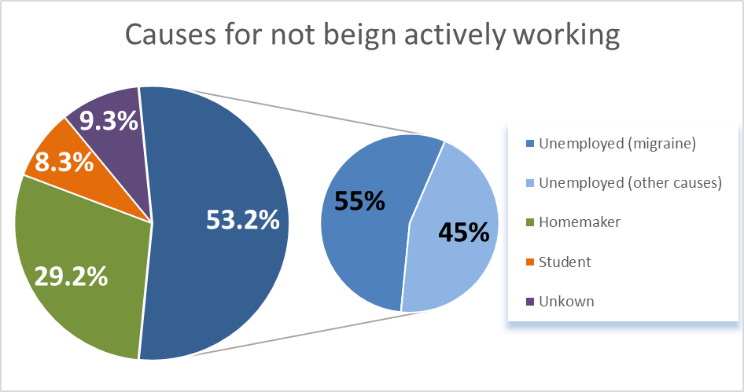

Supplementary Figure 2. Triptans used/month, absenteeism and presenteeism compared between baseline (M0) and month 3 (M3). They are separately compared for non-responders, partial-responders and responders.

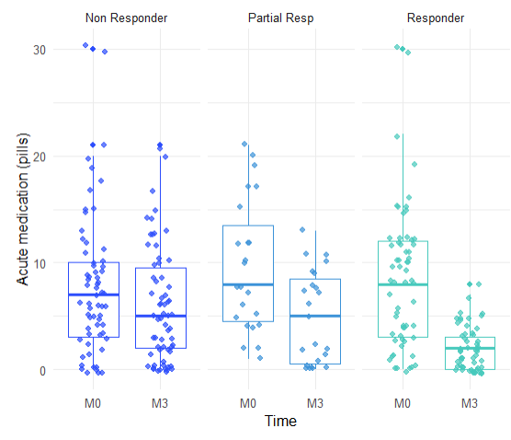

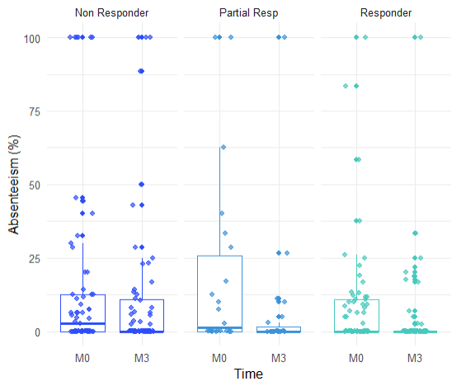
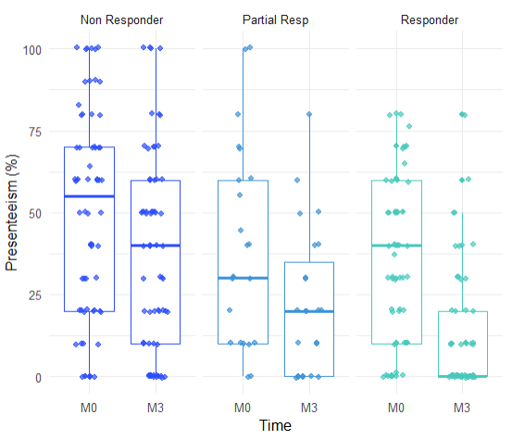

Bibliography

1. Ministerio de sanidad de España. Acuerdos de la comisión interministerial de precios de los medicamentos. 2023.
2. Ministerio de Sanidad de España. Listado de agrupaciones homogéneas de medicamentos y precios menores - Octubre 2023. 2023.
3. de Salut D. ORDRE SLT/71/2020, de 2 de juny, per la qual es regulen els supòsits i. 2020 [cited 2023 Apr 2]; Available from: https://www.gencat.cat/dogc
4. Institut d’Estadística de catalunya. https://www.idescat.cat/indicadors/?id=anuals&n=10402. 2023. Salari brut anual i guany per hora. Per sexe i sectors d’activitat.

