CGRP-TARGETED MEDICATION IN CHRONIC MIGRAINE

Renato Oliveira, Raquel Gil-Gouveia, Francesca Puledda

SUPPLEMENTAL MATERIALS

SUPPLEMENTAL METHODS
Search algorithm used in MEDLINE search

# | SEARCHES | RESULTS
1 | migraine[MeSH Terms] | 47006
2 | headache[MeSH Terms] | 118237
3 | (((migraine or migraines or “chronic migraine”) or ((headache or headaches))) OR ((“migraine attack”)) OR (“head pain” or “trigeminal pain”))) | 113123
4 | 1 or 2 or 3 | 139134
5 | CGRP | 11289
6 | Anti-CGRP | 288
7 | ((“CGRP medication” or “CGRP drugs” or “CGRP antagonist")) | 1090
8 | 6 or 7 | 1306
9 | 5 and 8 | 1306
10 | erenumab or fremanezumab or galcanezumab or eptinezumab | 858
11 | Gepant* or atogepant or rimegepant | 310
12 | 10 or 11 | 1108
13 | 4 and 9 and 12 | 275

Figure 1 – Flowchart summarizing literature search strategy

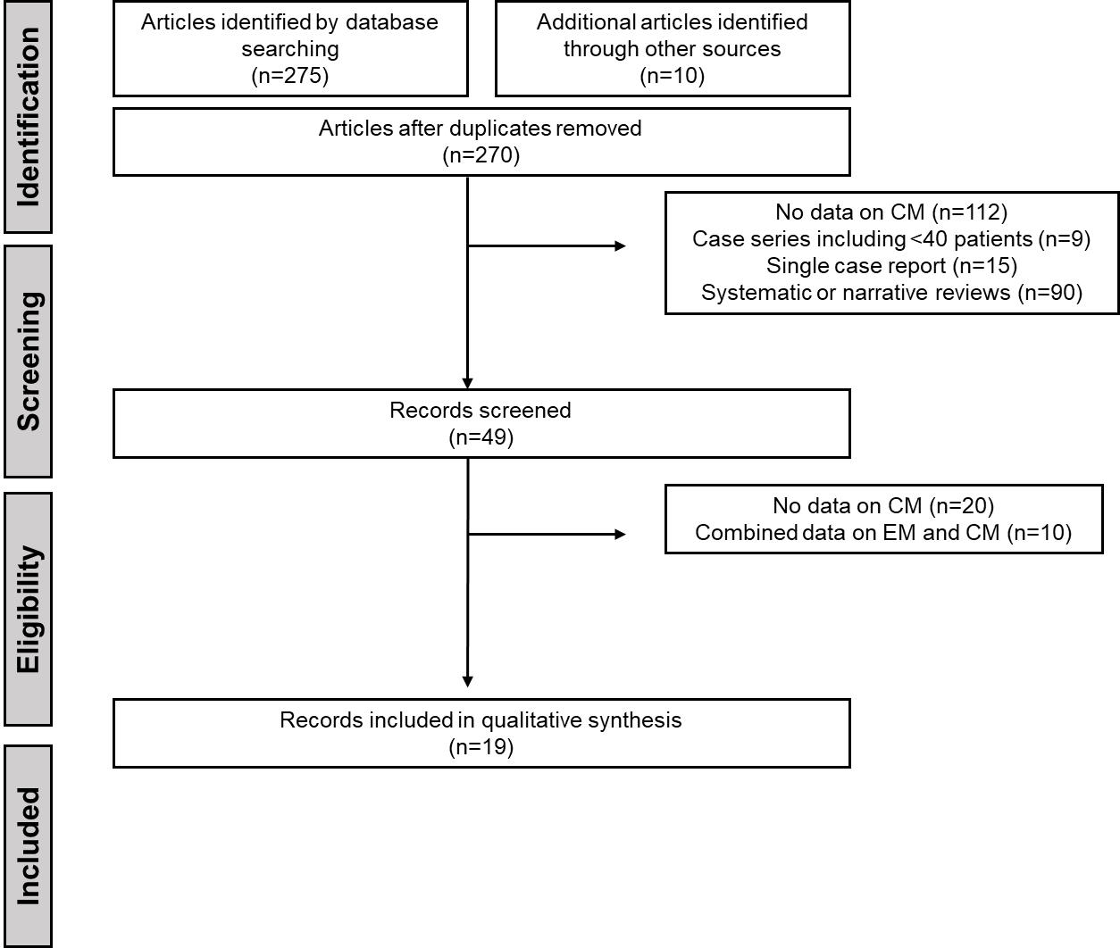

Supplemental Table I – Summary of Quality analysis of the included studies using the Newcastle-Ottawa Quality Assessment Scale for cohort studies
Author, year | Selection |  |  |  | Comparability | Outcome and reporting |  |  | Score | Overall quality
Author, year | Representativeness | Selection of the cohort | Ascertainment of exposure | Baseline assessment | Comparability | Assessment of outcome | Follow-up length | Adequacy of ascertainment | Score | Overall quality
Richard B. Lipton et al., 2020 | 0 | 1 | 1 | 1 | 2 | 1 | 0 | 1 | 7 | Moderate
Fumihiko Sakai, et al., 2021 | 0 | 1 | 1 | 1 | 2 | 1 | 0 | 1 | 7 | Moderate
Holland C Detke, et al., 2018 | 0 | 1 | 1 | 1 | 2 | 1 | 1 | 1 | 8 | High
Stephen D Silberstein, et al., 2017 | 1 | 1 | 1 | 1 | 2 | 1 | 0 | 1 | 8 | High
Stewart J Tepper, et al., 2017 | 0 | 1 | 1 | 1 | 2 | 1 | 1 | 1 | 8 | High
Luigi F. Iannone et al., 2022 | 1 | 1 | 1 | 1 | 1 | 1 | 1 | 1 | 8 | High
Umberto Pensato et al., 2022 | 1 | 1 | 1 | 1 | 1 | 1 | 0 | 1 | 7 | Moderate
Marcella Curone et al., 2022 | 0 | 1 | 1 | 1 | 1 | 1 | 1 | 1 | 7 | Moderate
Giorgio Lambru et al., 2020 | 1 | 1 | 1 | 1 | 1 | 1 | 1 | 1 | 8 | High
Antonio Russo et al., 2020 | 1 | 1 | 1 | 1 | 1 | 1 | 1 | 1 | 8 | High
Stewart J Tepper et al., 2019 | 0 | 1 | 1 | 1 | 2 | 1 | 0 | 1 | 7 | Moderate
Abouch V. Krymchantowski, et al., 2023 | 0 | 1 | 1 | 1 | 1 | 1 | 0 | 1 | 6 | Moderate
Umberto Pensato, et al., 2022 | 0 | 1 | 1 | 1 | 2 | 1 | 1 | 1 | 8 | High
Luigi Francesco Iannone, et al., 2022 | 0 | 1 | 1 | 1 | 1 | 1 | 0 | 1 | 6 | Moderate
Jessica Ailani, et al., 2020 | 0 | 1 | 1 | 1 | 2 | 1 | 0 | 1 | 7 | Moderate
Alicia Alpuente, et al., 2021 | 0 | 1 | 1 | 1 | 1 | 1 | 0 | 1 | 6 | Moderate
Patricia Pozo-Rosic, et al., 2023 | 1 | 1 | 1 | 1 | 2 | 1 | 0 | 1 | 8 | High
Piero Barbanti, et al., 2022 | 1 | 1 | 1 | 1 | 1 | 1 | 1 | 1 | 8 | High
Luigi F. Iannone, et al., 2023 | 0 | 1 | 1 | 1 | 1 | 1 | 1 | 1 | 7 | Moderate

