Table S1. The SNPs used for MR analysis between migraine and dementia
No. | SNP | Effect allele | Reference allele
Exposure (Migraine); Outcome (AD)
1 | Rs10166942 | T | C
2 | Rs10218452 | A | G
3 | Rs10234636 | C | T
4 | Rs10456100 | C | T
5 | Rs10849061 | C | T
6 | Rs11153082 | A | G
7 | Rs11172113 | T | C
8 | Rs11187838 | G | A
9 | Rs2078371 | T | C
10 | Rs2274319 | C | T
11 | Rs34979631 | C | T
12 | Rs42854 | C | G
13 | Rs4910165 | G | C
14 | Rs9349379 | A | G
Exposure (Migraine); Outcome (VaD)
1 | Rs10166942 | T | C
2 | Rs10218452 | A | G
3 | Rs10234636 | C | T
4 | Rs10456100 | C | T
5 | Rs10849061 | C | T
6 | Rs11153082 | A | G
7 | Rs11172113 | T | C
8 | Rs11187838 | G | A
9 | Rs2078371 | T | C
10 | Rs2274319 | C | T
11 | Rs34979631 | C | T
12 | Rs4910165 | G | C
13 | Rs9349379 | A | G
Exposure (Migraine); Outcome (FTD)
1 | Rs10166942 | T | C
2 | Rs10218452 | A | G
3 | Rs10234636 | C | T
4 | Rs10849061 | C | T
5 | Rs11153082 | A | G
6 | Rs11172113 | T | C
7 | Rs11187838 | G | A
8 | Rs2078371 | T | C
9 | Rs2274319 | C | T
10 | Rs34979631 | C | T
11 | Rs9349379 | A | G
Exposure (Migraine); Outcome (LBD)
1 | Rs10166942 | T | C
2 | Rs10218452 | A | G
3 | Rs10234636 | C | T
4 | Rs10456100 | C | T
5 | Rs10849061 | C | T
6 | Rs11153082 | A | G
7 | Rs11172113 | T | C
8 | Rs11187838 | G | A
9 | Rs2078371 | T | C
10 | Rs2274319 | C | T
11 | Rs34979631 | C | T
12 | Rs4910165 | G | C
13 | Rs9349379 | A | G
Abbreviations: AD, Alzheimer's disease; VaD, vascular dementia; FTD, frontotemporal dementia; LBD, Lewy body dementia; SNP, Single Nucleotide Polymorphism.

Table S2. The SNPs used for MR analysis between migraine and longitudinal brain measures
No. | SNP | Effect allele | Reference allele
Exposure (Migraine); Outcome (Total brain volume)
1 | Rs10166942 | T | C
2 | Rs10218452 | A | G
3 | Rs10234636 | C | T
4 | Rs10456100 | C | T
5 | Rs10849061 | C | T
6 | Rs11153082 | A | G
7 | Rs11172113 | T | C
8 | Rs11187838 | G | A
9 | Rs145639541 | T | C
10 | Rs2078371 | T | C
11 | Rs2274319 | C | T
12 | Rs34979631 | C | T
13 | Rs4910165 | G | C
14 | Rs9349379 | A | G
Exposure (Migraine); Outcome (Total cortical volume)
1 | Rs10166942 | T | C
2 | Rs10218452 | A | G
3 | Rs10234636 | C | T
4 | Rs10456100 | C | T
5 | Rs10849061 | C | T
6 | Rs11153082 | A | G
7 | Rs11172113 | T | C
8 | Rs11187838 | G | A
9 | Rs145639541 | T | C
10 | Rs2078371 | T | C
11 | Rs2274319 | C | T
12 | Rs34979631 | C | T
13 | Rs4910165 | G | C
14 | Rs9349379 | A | G
Exposure (Migraine); Outcome (Total cortical surface area)
1 | Rs10166942 | T | C
2 | Rs10218452 | A | G
3 | Rs10234636 | C | T
4 | Rs10456100 | C | T
5 | Rs10849061 | C | T
6 | Rs11153082 | A | G
7 | Rs11172113 | T | C
8 | Rs11187838 | G | A
9 | Rs145639541 | T | C
10 | Rs2078371 | T | C
11 | Rs2274319 | C | T
12 | Rs34979631 | C | T
13 | Rs4910165 | G | C
14 | Rs9349379 | A | G
Exposure (Migraine); Outcome (Mean cortical thickness)
1 | Rs10166942 | T | C
2 | Rs10218452 | A | G
3 | Rs10234636 | C | T
4 | Rs10456100 | C | T
5 | Rs10849061 | C | T
6 | Rs11153082 | A | G
7 | Rs11172113 | T | C
8 | Rs11187838 | G | A
9 | Rs2078371 | T | C
10 | Rs2274319 | C | T
11 | Rs34979631 | C | T
12 | Rs4910165 | G | C
13 | Rs9349379 | A | G
Exposure (Migraine); Outcome (Caudate volume)
1 | Rs10166942 | T | C
2 | Rs10218452 | A | G
3 | Rs10234636 | C | T
4 | Rs10456100 | C | T
5 | Rs10849061 | C | T
6 | Rs11153082 | A | G
7 | Rs11172113 | T | C
8 | Rs145639541 | T | C
9 | Rs2078371 | T | C
10 | Rs2274319 | C | T
11 | Rs34979631 | C | T
13 | Rs4910165 | G | C
14 | Rs9349379 | A | G
Exposure (Migraine); Outcome (Hippocampal volume)
1 | Rs10166942 | T | C
2 | Rs10218452 | A | G
3 | Rs10234636 | C | T
4 | Rs10456100 | C | T
5 | Rs10849061 | C | T
6 | Rs11153082 | A | G
7 | Rs11172113 | T | C
8 | Rs11187838 | G | A
9 | Rs145639541 | T | C
10 | Rs2078371 | T | C
11 | Rs2274319 | C | T
12 | Rs34979631 | C | T
13 | Rs4910165 | G | C
14 | Rs9349379 | A | G
Exposure (Migraine); Outcome (Thalamic volume)
1 | Rs10166942 | T | C
2 | Rs10218452 | A | G
3 | Rs10234636 | C | T
4 | Rs10456100 | C | T
5 | Rs10849061 | C | T
6 | Rs11153082 | A | G
7 | Rs11172113 | T | C
8 | Rs11187838 | G | A
9 | Rs145639541 | T | C
10 | Rs2078371 | T | C
11 | Rs2274319 | C | T
12 | Rs34979631 | C | T
13 | Rs4910165 | G | C
14 | Rs9349379 | A | G
Abbreviations: SNP, Single Nucleotide Polymorphism.

Table S3. The SNPs used for MR analysis between migraine subtypes, dementia and longitudinal brain measures
No. | SNP | Effect allele | Reference allele
Exposure (MO); Outcome (AD)
1 | Rs11172113 | C | T
2 | Rs2078371 | C | T
3 | Rs2160875 | T | C
4 | Rs6478241 | G | A
5 | Rs6724624 | G | C
6 | Rs7775721 | T | C
7 | Rs9349379 | G | A
Exposure (MO); Outcome (Total cortical surface area)
1 | Rs11172113 | C | T
2 | Rs2078371 | C | T
3 | Rs2160875 | T | C
4 | Rs6478241 | G | A
5 | Rs6724624 | G | C
6 | Rs7775721 | T | C
7 | Rs9349379 | G | A
Exposure (MO); Outcome (Thalamic volume)
1 | Rs11172113 | C | T
2 | Rs2078371 | C | T
3 | Rs2160875 | T | C
4 | Rs6478241 | G | A
5 | Rs6724624 | G | C
6 | Rs7775721 | T | C
7 | Rs9349379 | G | A
Exposure (MA); Outcome (AD)
1 | rs10812660 | A | T
2 | rs111622936 | T | C
3 | rs11172113 | C | T
4 | rs115695766 | C | T
5 | rs1157316 | A | G
6 | rs116487794 | T | G
7 | rs11702060 | C | A
8 | rs117067760 | A | G
9 | rs117727533 | A | G
10 | rs12967385 | C | T
11 | rs138553949 | A | G
12 | rs140390695 | A | G
13 | rs143910632 | C | T
14 | rs146241454 | T | C
15 | rs17887050 | A | C
16 | rs1832937 | A | G
17 | rs2225164 | A | G
18 | rs2506145 | C | T
19 | rs35695296 | A | T
20 | rs4708524 | T | G
21 | rs4910165 | G | C
22 | rs61945078 | C | T
23 | rs6535076 | C | T
24 | rs72738438 | C | G
25 | rs75879915 | T | C
Exposure (MA); Outcome (Total cortical surface area)
1 | Rs11172113 | C | T
2 | rs1157316 | A | G
3 | rs11702060 | C | A
4 | rs12967385 | C | T
5 | rs12988953 | G | C
6 | rs1832937 | A | G
7 | rs2506145 | C | T
8 | rs35695296 | A | T
9 | rs4910165 | G | C
10 | rs6535076 | C | T
11 | rs7713256 | T | C
Exposure (MA); Outcome (Thalamic volume)
1 | Rs11172113 | C | T
2 | rs1157316 | A | G
3 | rs11702060 | C | A
4 | rs12967385 | C | T
5 | rs12988953 | G | C
6 | rs1832937 | A | G
7 | rs2506145 | C | T
8 | rs35695296 | A | T
9 | rs4708524 | T | G
10 | rs4910165 | G | C
11 | rs6535076 | C | T
12 | rs7713256 | T | C
Abbreviations: AD, Alzheimer's disease; SNP, Single Nucleotide Polymorphism; MA, migraine with aura; MO, migraine without aura.

Table S4. The sensitivity analysis of MR analysis between migraine and dementia
Exposure | Outcome | MR-egger regression | MR-PRESSO Global test | Cochran’s Q-test
Migraine | AD | Intercept = 0.01  p = 0.921 | RSS = 12.87  p = 0.614 | Q-value = 11.17  p = 0.597
Migraine | VaD | Intercept = 0.02  p = 0.694 | RSS = 13.12  p = 0.532 | Q-value = 10.67  p = 0.557
Migraine | FTD | Intercept = 0.09  p = 0.212 | RSS = 16.82  p = 0.185 | Q-value = 11.17  p = 0.202
Migraine | LBD | Intercept = 0.08  p = 0.166 | RSS = 10.25  p = 0.728 | Q-value = 8.56  p = 0.740
Abbreviations: AD, Alzheimer's disease; VaD, vascular dementia; FTD, frontotemporal dementia; LBD, Lewy body dementia; RSS, residual sum of squares.

Table S5. The sensitivity analysis of MR analysis between migraine and longitudinal brain measures
Exposure | Outcome | MR-egger regression | MR-PRESSO  Global test | Cochran’s  Q-test
Migraine | Total brain volume | Intercept = -0.55  p = 0.994 | RSS = 12.35  p = 0.662 | Q-value = 10.52  p = 0.651
Migraine | Total cortical volume | Intercept = 43.15  p = 0.516 | RSS = 17.82  p = 0.287 | Q-value = 15.32  p = 0.288
Migraine | Total cortical surface area | Intercept = -9.21  p = 0.311 | RSS = 9.90  p = 0.834 | Q-value = 8.79  p = 0.788
Migraine | Mean cortical thickness | Intercept = 0.04  p = 0.866 | RSS = 9.51  p = 0.793 | Q-value = 8.19  p = 0.770
Migraine | Thalamic volume | Intercept = 0.71  p = 0.672 | RSS = 7.24  p = 0.945 | Q-value = 6.35  p = 0.932
Migraine | Hippocampal volume | Intercept = -0.60  p = 0.612 | RSS = 4.85  p = 0.987 | Q-value = 4.11  p = 0.990
Migraine | Caudate volume | Intercept = 0.53  p = 0.644 | RSS = 11.38  p = 0.616 | Q-value = 9.80  p = 0.633
Abbreviations: RSS, residual sum of squares.

Table S6. The sensitivity analysis of MR analysis between migraine subtypes and AD
Exposure | Outcome | MR-egger regression | MR-PRESSO Global test | Cochran’s Q-test
MA | AD | Intercept = 0.01  p = 0.225 | RSS = 20.90  p = 0.741 | Q-value = 19.25  p = 0.739
MO | AD | Intercept = -0.01  p = 0.987 | RSS = 3.03  p = 0.908 | Q-value = 2.25  p = 0.895
Abbreviations: AD, Alzheimer's disease; MA, migraine with aura; MO, migraine without aura; RSS, residual sum of squares.

Table S7. The sensitivity analysis of MR analysis between migraine subtypes and longitudinal brain measures
Exposure | Outcome | MR-egger regression | MR-PRESSO  Global test | Cochran’s  Q-test
MA | Total cortical surface area | Intercept = -7.27  p = 0.575 | RSS = 5.38  p = 0.929 | Q-value = 4.45  p = 0.925
MA | Thalamic volume | Intercept = 0.26  p = 0.912 | RSS = 10.59  p = 0.627 | Q-value = 8.86  p = 0.635
MO | Total cortical surface area | Intercept = 4.07  p = 0.855 | RSS = 0.88  p = 0.998 | Q-value = 0.66  p = 0.995
MO | Thalamic volume | Intercept = 3.45  p = 0.430 | RSS = 7.82  p = 0.468 | Q-value = 5.83  p = 0.442
Abbreviations: MA, migraine with aura; MO, migraine without aura; RSS, residual sum of squares.

Exposure | Outcome | MR-egger regression | MR-PRESSO Global test | Cochran’s Q-test
Migraine | AD | Intercept = 0.02  p = 0.441 | RSS = 8.55  p = 0.886 | Q-value = 7.32  p = 0.885
Table S8. The sensitivity analysis of MR analysis between migraine and AD using the GWAS of AD in the FinnGen database
Abbreviations: AD, Alzheimer's disease; RSS, residual sum of squares.

Figure S1. LOO sensitivity analysis of MR analysis between migraine and AD

Figure S2. LOO sensitivity analysis of MR analysis between migraine and total cortical surface area
Figure S3. LOO sensitivity analysis of MR analysis between migraine and thalamic volume

Figure S4. LOO sensitivity analysis of MR analysis between MO and AD

Figure S5. LOO sensitivity analysis of MR analysis between MO and total cortical surface area
Figure S6. LOO sensitivity analysis of MR analysis between migraine and AD using the GWAS of AD in the FinnGen database
Figure S7. MR effects of migraine on AD and longitudinal brain measures after removing potential pleiotropic IVs
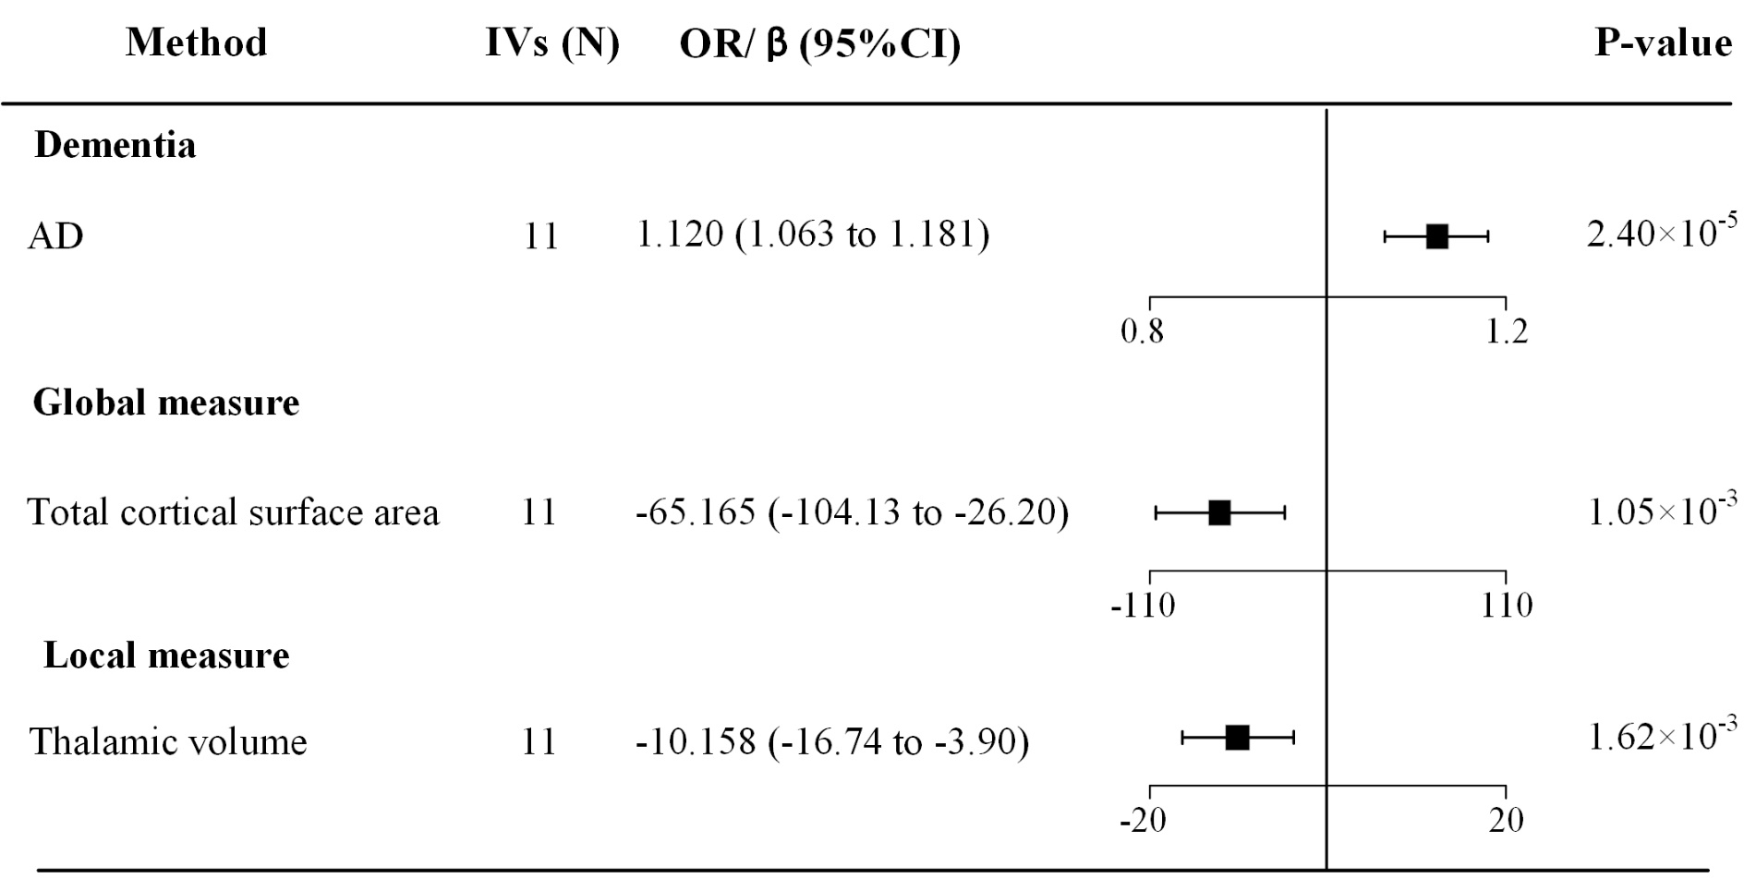Abbreviations: AD, Alzheimer's disease; IVs, instrumental variables; OR, odds ratio; CI, confidence interval.

Figure S8. MR effects of MO on AD and longitudinal brain measures after removing potential pleiotropic IVs
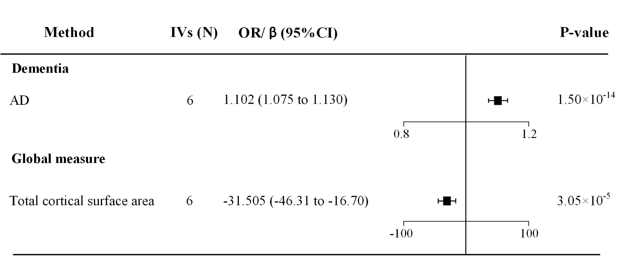Abbreviations: AD, Alzheimer's disease; IVs, instrumental variables; OR, odds ratio; CI, confidence interval.

Figure S9. Supplementary MR estimates between migraine and AD
Abbreviations: IVs, instrumental variables; OR, odds ratio; CI, confidence interval; IVW, multiplicative random-effects inverse-variance weighted.

Figure S10. Supplementary MR estimates between migraine and total cortical surface area Abbreviations: IVs, instrumental variables; OR, odds ratio; CI, confidence interval; IVW, multiplicative random-effects inverse-variance weighted.

Figure S11. Supplementary MR estimates between migraine and thalamic volume
Abbreviations: IVs, instrumental variables; OR, odds ratio; CI, confidence interval; IVW, multiplicative random-effects inverse-variance weighted.

Figure S12. Supplementary MR estimates between MO and AD
Abbreviations: IVs, instrumental variables; OR, odds ratio; CI, confidence interval; IVW, multiplicative random-effects inverse-variance weighted.

Figure S13. Supplementary MR estimates between MO and total cortical surface area
Abbreviations: IVs, instrumental variables; OR, odds ratio; CI, confidence interval; IVW, multiplicative random-effects inverse-variance weighted.

Figure S14. Supplementary MR estimates between migraine and AD using the GWAS of AD in the FinnGen database
Abbreviations: IVs, instrumental variables; OR, odds ratio; CI, confidence interval; IVW, multiplicative random-effects inverse-variance weighted.

Figure S15. Reversed MR estimates between migraine and AD
Abbreviations: IVs, instrumental variables; OR, odds ratio; CI, confidence interval; IVW, multiplicative random-effects inverse-variance weighted.

Figure S16. MR effects of migraine on four longitudinal local brain measures not included in the primary analysis
Abbreviations: IVs, instrumental variables; CI, confidence interval.

