Supplemental figures

Brain-Wide Mapping of C-Fos Expression in Nitroglycerin-Induced Models of Migraine

Shaobo Xiao,# Guangshuang Lu,# Jiayi Liu,# Wenjie Su, Chenhao Li, Yingyuan Liu, Fanchao Meng, Jinjing Zhao, Nan Gao, Yan Chang, Xinghao Guo, Shengyuan Yu,* and Ruozhuo Liu*
# These authors have contributed equally to this work.
*Correspondence: yusy1963@126.com (S.Y.), liuruozhuo301@163.com (R.L.)

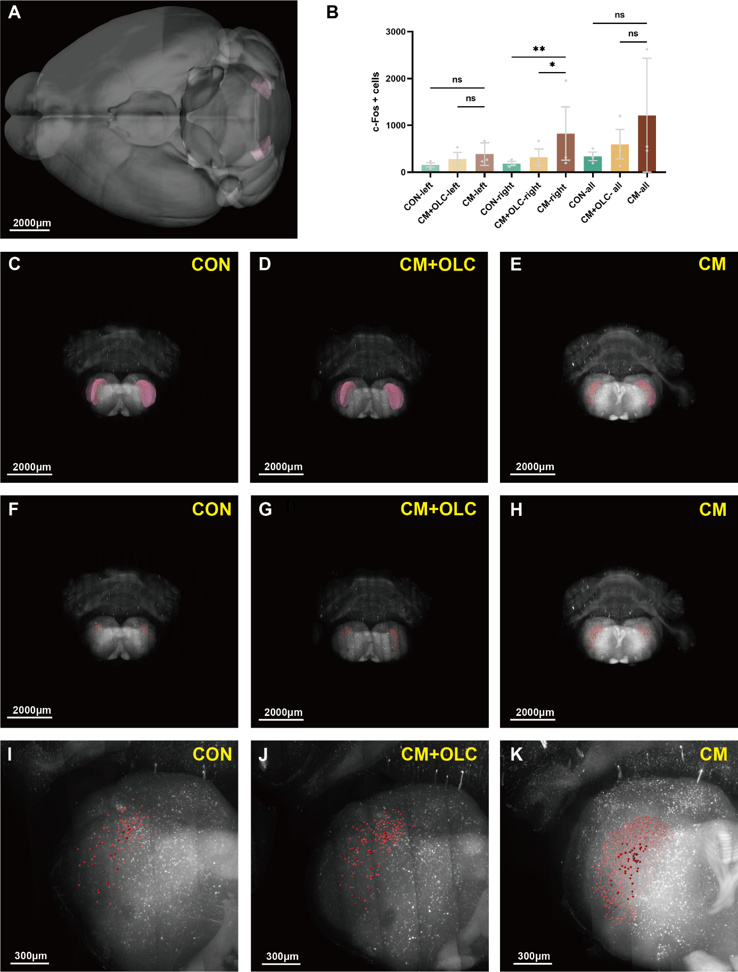
Figure S1. The number of c-Fos+ expressing cells in the spinal nucleus of the trigeminal, caudal part (Sp5c). (A, C, D, E) Sp5c was located at the medulla, sensory related (MY-sen). Pink marks the Sp5c according to Allen Mouse Brain Common Coordinate Framework V3. (B, F, G, H) The number of c-Fos + cells in the Sp5c of the CM group was more than that of the CON group or the CM+OLC group. Red marks the c-Fos + cells. (I, J, K) The enlarged view from (F, G, H). Scale bar: (A–H) 2000 μm, (I, J, K) 300 μm. Two-tailed unpaired Student’s t-test. Error bars indicate SEM. (n=3 per group, *p < 0.05, **p < 0.01, ***p < 0.001, ****p < 0.0001).
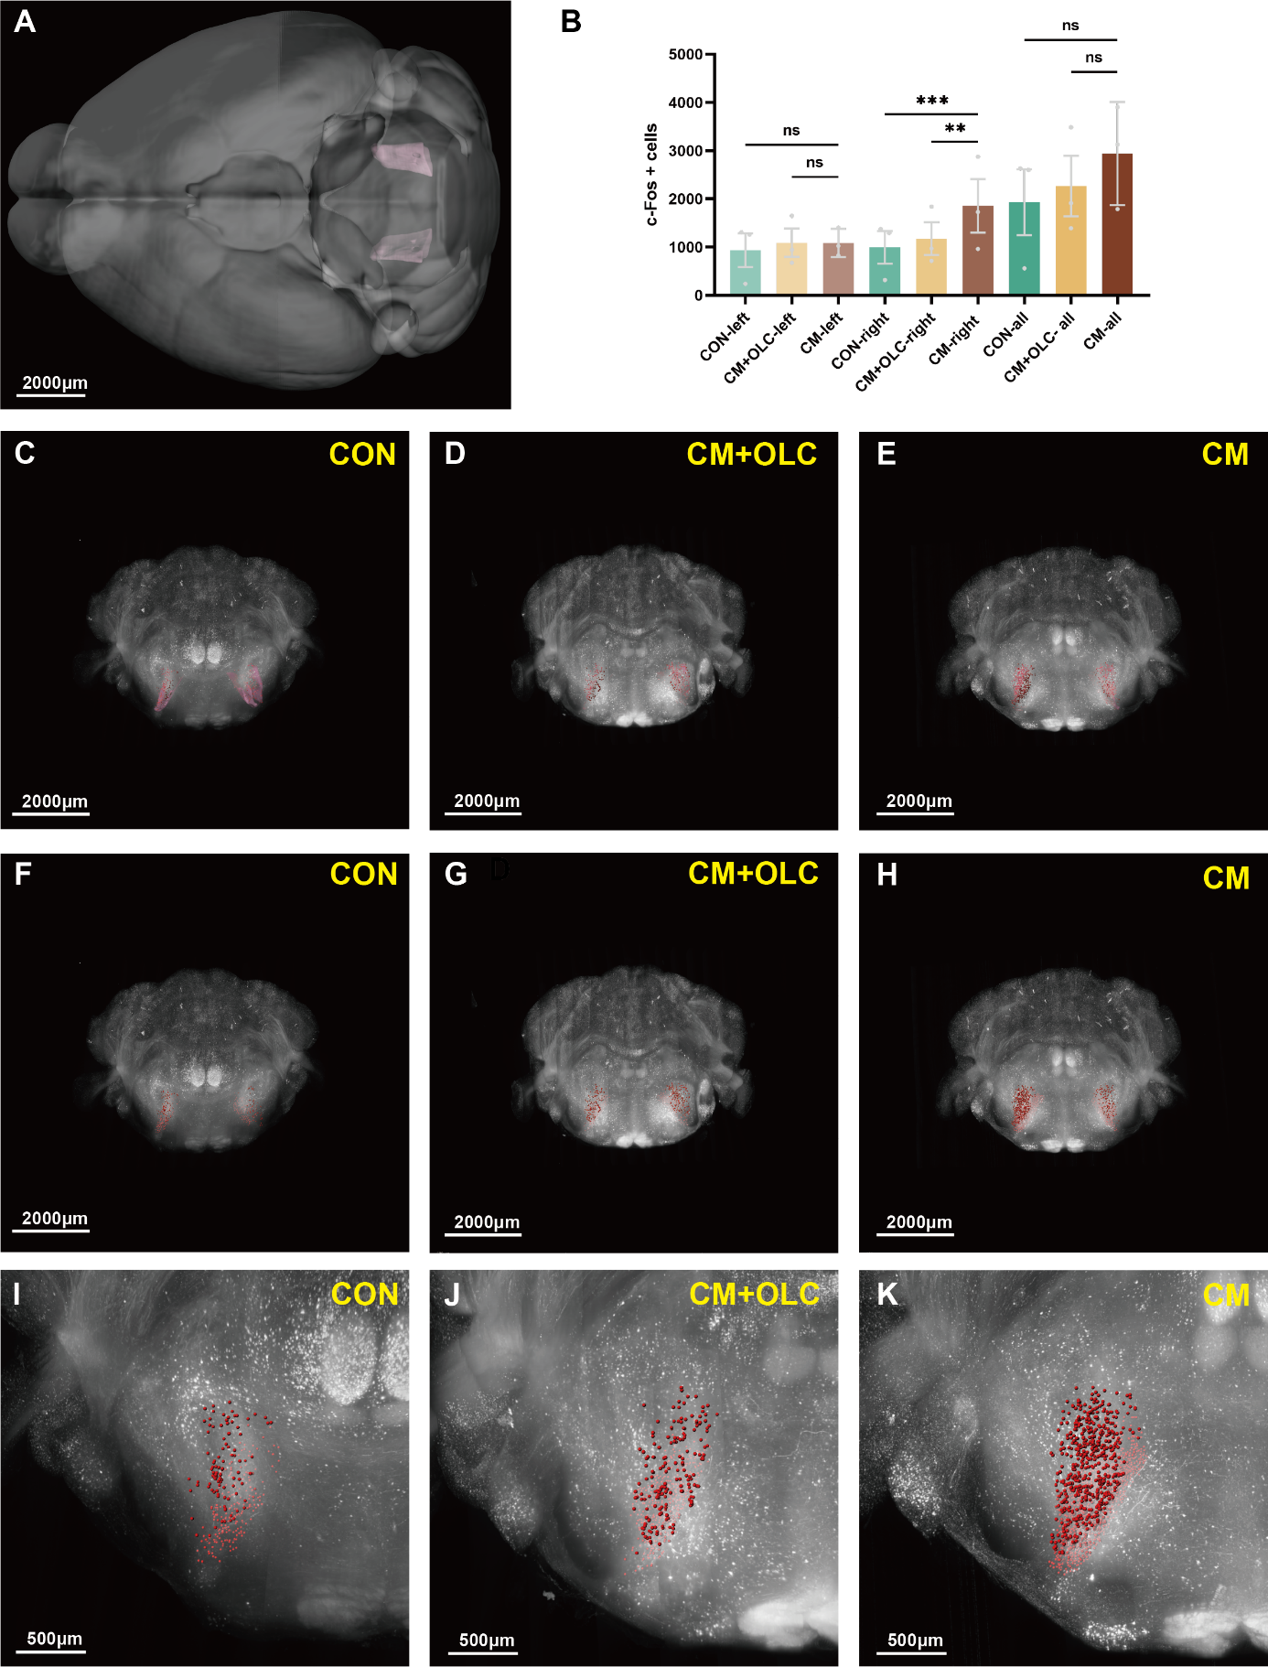
Figure S2. The number of c-Fos+ expressing cells in the parvicellular reticular nucleus (PARN). (A, C, D, E) PARN was located at the medulla, motor related (MY-mot). Pink marks the PARN according to Allen Mouse Brain Common Coordinate Framework V3. (B, F, G, H) The number of c-Fos + cells in the PARN of the CM group was more than that of the CON group or the CM+OLC group. Red marks the c-Fos + cells. (I, J, K) The enlarged view from (F, G, H). Scale bar: (A–H) 2000 μm, (I, J, K) 500 μm. Two-tailed unpaired Student’s t-test. Error bars indicate SEM. (n=3 per group, *p < 0.05, **p < 0.01, ***p < 0.001, ****p < 0.0001).
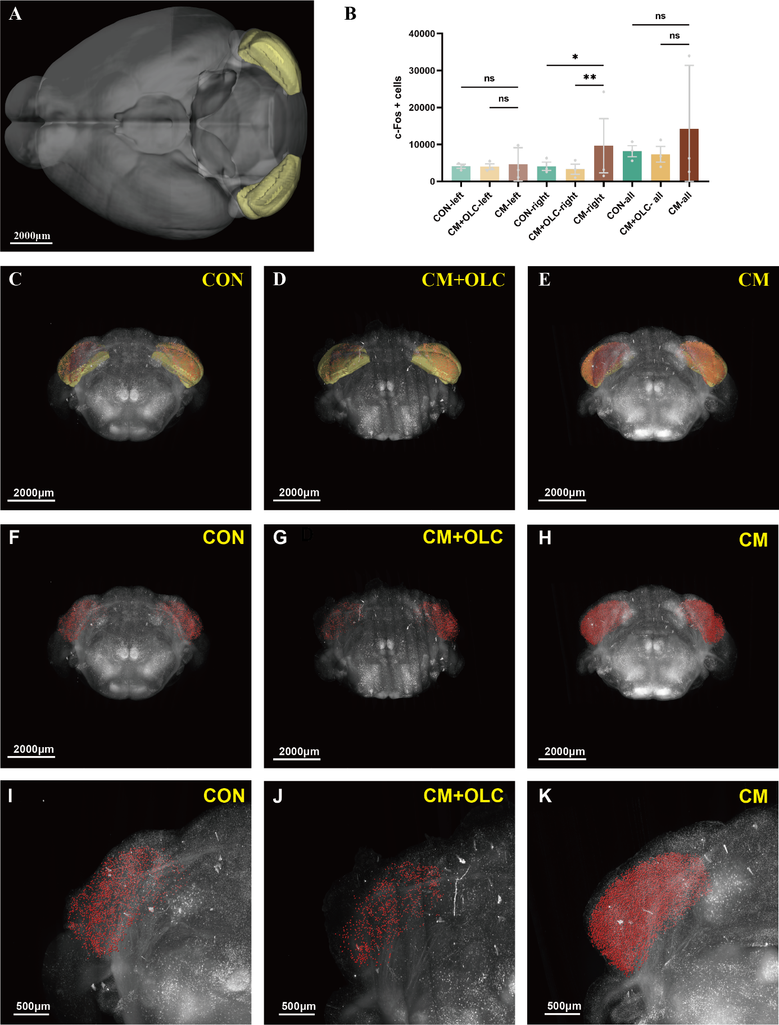
Figure S3. The number of c-Fos+ expressing cells in the ansiform lobule (AN). (A, C, D, E) AN was located at the cerebellar cortex. Yellow marks the AN according to Allen Mouse Brain Common Coordinate Framework V3. (B, F, G, H) The number of c-Fos + cells in the AN of the CM group was more than that of the CON group or the CM+OLC group. Red marks the c-Fos + cells. (I, J, K) The enlarged view from (F, G, H). Scale bar: (A–H) 2000 μm, (I, J, K) 500 μm. Two-tailed unpaired Student’s t-test. Error bars indicate SEM. (n=3 per group, *p < 0.05, **p < 0.01, ***p < 0.001, ****p < 0.0001).

