Supplementary materials
Supplementary Figures
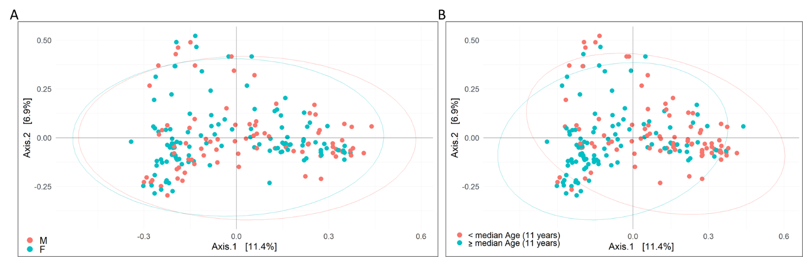

Supplementary Figure 1. Beta diversity analysis performed of the faecal microbiota composition of subjects grouped by gender and median age (Bray-Curtis algorithm and presented as a Principal Coordinate Analysis (PCoA) plot). The PERMANOVA test was applied to the β-diversity distance matrices (p-value=0.25 for gender and p-value=0.001 for age). F, female; M, male.

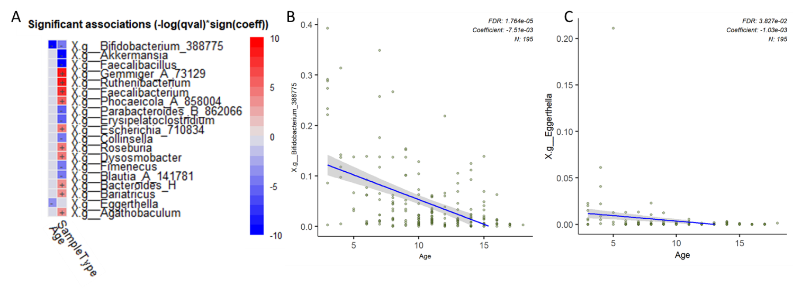

Supplementary Figure 2. Microbiome Multivariate Associations with Linear Models (MaAsLin2) applied to age as covariate in the gut microbiota analysis. A: Significant association of ASV with age and sample Type (Case-Control) detected by MaAsLin 2’s default linear model (q-value > 0.05). B and C: Scatter plots for age and Bifidobacterium 388775 and age and Eggerthella.

Supplementary Figure 3. Multivariate analysis on the bacterial dataset. A: bar plot of variable importance in the projection (VIP) from partial least square-discriminant analysis (PLS-DA). VIP values are reported on the horizontal axis. B: receiver operating characteristic (ROC) analysis of the PLS-DA model. The value of AUROC=0.969 indicates a high accuracy of the prediction model.

