Table S1 MRI scanning times of the three groups

MRI scanning time | MI (n=28) | MnI (n=28) | HC (n=29)
16:00 to 18:00 | 4 | 6 | 11
18:00 to 20:00 | 22 | 19 | 11
20:00 to 22:00 | 2 | 3 | 7
Abbreviations: MI, patients with comorbid migraine and insomnia; MnI, patients with migraine with no insomnia; MRI, magnetic resonance imaging; HC, healthy controls.
Table S2 Z-transformed correlation matrix of clinical features and behavioral assessments in the MI and MnI groups
MI group | Frequency | Attack duration | VAS | HIT-6 | PSQI | SDS | SAS
Frequency | inf | 0.60 | 0.02 | 0.15 | 0.18 | 0.24 | 0.19
Attack duration | 0.60 | inf | -0.08 | 0.00 | 0.24 | 0.07 | -0.14
VAS | 0.02 | -0.08 | inf | 0.28 | -0.14 | 0.04 | 0.21
HIT-6 | 0.15 | 0.00 | 0.28 | inf | -0.06 | 0.46 | 0.79
PSQI | 0.18 | 0.24 | -0.14 | -0.06 | inf | 0.00 | 0.03
SDS | 0.24 | 0.07 | 0.04 | 0.46 | 0.00 | inf | 0.85
SAS | 0.19 | -0.14 | 0.21 | 0.79 | 0.03 | 0.85 | inf
MnI group | Frequency | Attack duration | VAS | HIT-6 | PSQI | SDS | SAS
Frequency | inf | 0.22 | 0.39 | 0.25 | 0.16 | -0.07 | 0.19
Attack duration | 0.22 | inf | 0.03 | 0.24 | 0.49 | 0.12 | 0.24
VAS | 0.39 | 0.03 | inf | 0.25 | -0.07 | -0.60 | -0.11
HIT-6 | 0.25 | 0.24 | 0.25 | inf | 0.06 | 0.14 | 0.62
PSQI | 0.16 | 0.49 | -0.07 | 0.06 | inf | -0.16 | 0.09
SDS | -0.07 | 0.12 | -0.60 | 0.14 | -0.16 | inf | 0.52
SAS | 0.19 | 0.24 | -0.11 | 0.62 | 0.09 | 0.52 | inf
Abbreviations: MI, patients with comorbid migraine and insomnia; MnI, patients with migraine with no insomnia; VAS, Visual Analogue Scale; HIT-6, Headache Impact Test six; PSQI, Pittsburgh Sleep Quality Index; SDS, Zung self-depression scale; SAS, Zung self-anxiety scale.

Table S3 Fisher’s z-transformed correlation coefficients between altered LC-FC strength and behavior features in examined groups
MI group | PHG | Left STG/MTG | Right DLPFC | aCbm | Thalamus | Caudate | DMPFC
Duration | 0.09 | 0.15 | 0.09 | -0.02 | -0.04 | -0.33 | 0.04
Frequency | 0.05 | -0.26 | 0.13 | 0.02 | -0.24 | -0.26 | 0.24
Attack duration | -0.08 | -0.13 | 0.01 | 0.36 | -0.24 | 0.41 | 0.44
VAS | -0.01 | 0.22 | 0.06 | 0.21 | 0.10 | -0.07 | -0.10
HIT-6 | 0.00 | -0.11 | -0.09 | 0.15 | 0.06 | 0.05 | -0.06
PSQI | -0.29 | -0.24 | 0.56 | 0.15 | 0.10 | -0.03 | -0.10
SAS | -0.20 | -0.05 | 0.00 | -0.07 | 0.01 | 0.04 | -0.01
MnI group | PHG | Left STG/MTG | Right DLPFC | aCbm | Thalamus | Caudate | DMPFC
Duration | -0.05 | 0.14 | -0.26 | -0.12 | -0.04 | -0.30 | 0.05
Frequency | 0.11 | -0.28 | -0.29 | -0.12 | -0.09 | 0.14 | 0.24
Attack duration | 0.30 | -0.08 | -0.18 | -0.04 | 0.04 | -0.14 | -0.05
VAS | -0.03 | 0.01 | 0.09 | -0.20 | -0.39 | 0.09 | 0.05
HIT-6 | 0.15 | 0.09 | 0.05 | -0.23 | 0.10 | -0.18 | 0.20
PSQI | 0.14 | -0.04 | 0.02 | -0.15 | 0.02 | -0.20 | -0.03
SAS | 0.32 | -0.15 | 0.07 | -0.26 | 0.32 | 0.26 | -0.09
Abbreviations: MI, patients with comorbid migraine and insomnia; MnI, patients with migraine with no insomnia; VAS, Visual Analogue Scale; HIT-6, Headache Impact Test six; PSQI, Pittsburgh Sleep Quality Index; SDS, Zung self-depression scale; SAS, Zung self-anxiety scale; PHG, parahippocampal gyrus; STG, superior temporal gyrus; MTG, middle temporal gyrus; DLPFC, dorsolateral prefrontal cortex; DMPFC, dorsomedial prefrontal cortex.

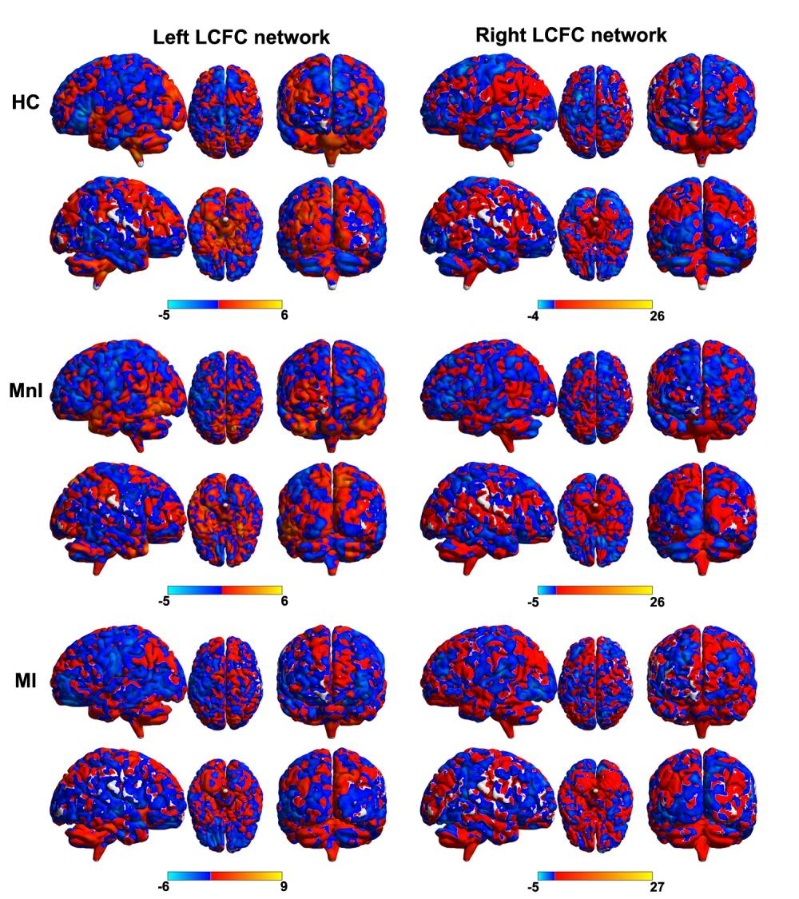

Figure S1. The bilateral LC-FC network patterns for the three groups. Abbreviations: LC-FC, locus coeruleus functional connectivity; MI, patients with comorbid migraine and insomnia; MnI, patients with migraine with no insomnia; HC, healthy control.

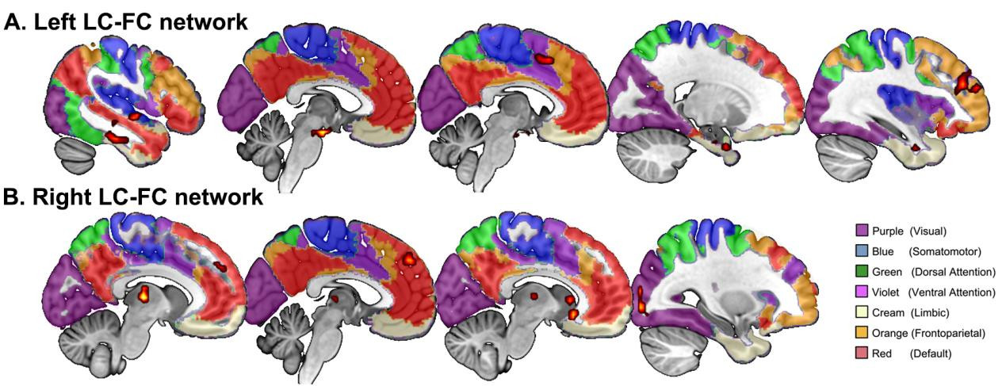
Figure S2. The LC-FC results overlapped with the Yeo 7 functional network atlas. Abbreviations: LC, locus coeruleus; FC, functional connectivity.
.

