ADDITIONAL FILE 1: SUPPLEMENTAL MATERIALS
Supplemental Figure 1. Flow diagram of the study.
ªAny subject with a CBF > 90 or < 30 was considered an outlier and was excluded from analysis.
^{b}HC = Healthy control
^{c}EM = Episodic migraine
^{d}CM = Chronic migraine
^{e}Only those with complete records of headache frequency were analyzed.

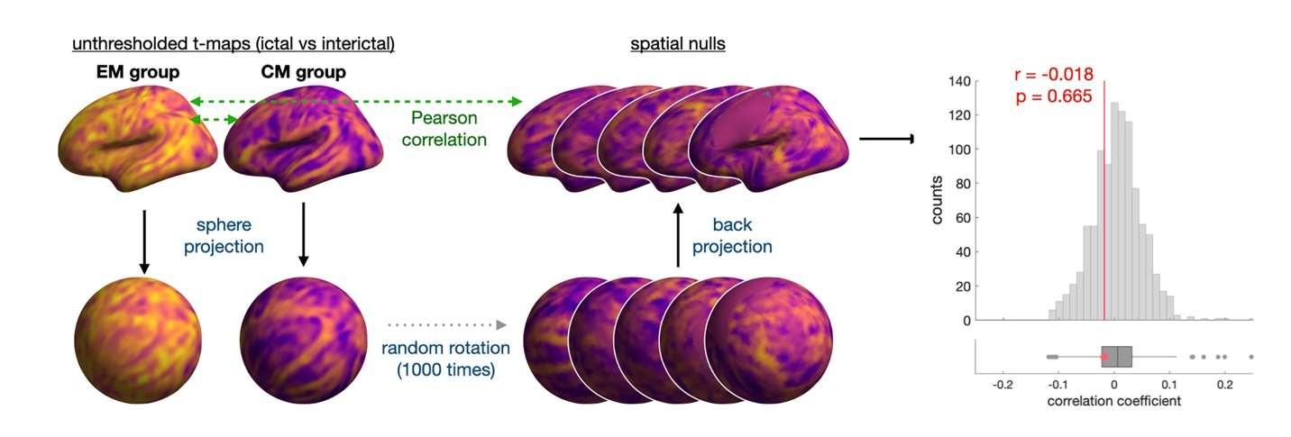
Supplemental Figure 2. The results of ictal-interictal pattern analysis in EM and CM subjects.
The spin test revealed that the t values of the ictal-interictal patterns of the EM and CM subjects were not correlated with each other (p = 0.665; r = - 0.018).

Supplemental Table 1. Definitions of the Migraine Phases
Episodic migraine (EM)
Preictal | Migraine attacks occurred within 2 days after an MRI, but no attacks occurred within 2 days beforehand.
Ictal | Migraine attacks during the MRI
Postictal | Migraine attacks occurred within 2 days before the MRI, but no attacks occurred within 2 days afterward.
Interictal | No migraine attacks during the MRI, within 2 days before or after the MRI
Chronic migraine (CM)
Ictal | Migraine attacks during the MRI
Interictal | No moderate or severe headache within 2 days before or after the MRI
Unclassified | No apparent distinction for ictal or interictal; excluded from the phasic comparisons

Supplemental Table 2. All Anatomical Locations with Significant Cerebral Blood Flow (CBF) Differences in the Anatomical Location Analysis for Bundle 3 (Equivalent of Corrected p < 0.05)
Anatomical location | Volume percentage of the anatomical location in the cluster (%)
Cluster #1; EMª > CM^{b}; 1683 voxels
Left cerebellum crus II | 49.20
Left cerebellum crus I | 27.39
Left occipital pole | 21.81
Cluster #2; ictal CM > interictal CM; 1891 voxels
Right cerebellum crus II | 54.63
Right cerebellum crus I | 24.38
Right cerebellum VIIb | 20.99
Cluster #3; HC^{c} > interictal CM; 434 voxels
Right cerebellum crus II | 87.79
Right cerebellum VIIb | 9.22
Right cerebellum crus I | 3.00
Cluster #4; ictal EM > interictal EM; 1718 voxels
Left cerebellum crus II | 75.32
Left cerebellum VIIb | 22.70
Left cerebellum VIIIa | 1.34
Cluster #5; ictal EM > interictal EM; 510 voxels
Left frontal pole | 30.39
Left superior frontal gyrus | 4.90
Left middle frontal gyrus | 4.71
Cluster #6; ictal EM > interictal EM; 394 voxels
Left superior frontal gyrus | 69.80
Left middle frontal gyrus | 30.20
Cluster #7; ictal EM > interictal EM; 377 voxels
Right cerebellum crus II | 327.99
Right cerebellum crus VIIb | 49.01
Cluster #8; ictal EM > interictal EM; 375 voxels
Left middle temporal gyrus | 29.07
Left angular occipital cortex | 18.93
Left lateral occipital cortex | 18.93
Cluster #9; ictal EM > interictal EM; 593 voxels
Right cerebellum IX | 52.61
Right cerebellum VIIIb | 34.74
Right cerebellum VIIIa | 12.65
Cluster #10; ictal EM > interictal EM; 1059 voxels
Right cerebellum VIIIb | 64.78
Right cerebellum VIIIa | 21.91
Right cerebellum IX | 12.56
Cluster #11; ictal EM > interictal EM; 487 voxels
Left putamen | 28.8
Left frontal orbital cortex | 18.96
Left subcallosal cortex | 18.41
Cluster #12; ictal EM > interictal EM; 397 voxels
Right cerebellum VIIIa | 51.64
Right cerebellum VIIIb | 47.36
Right cerebellum crus I | 0.76
Cluster #13; ictal EM > postictal EM; 36691 voxels
Left frontal pole | 7.79
Left thalamus | 4.10
Left putamen | 3.72
Cluster #14; ictal EM > postictal EM; 4567 voxels
Left cerebellum crus II | 47.69
Left cerebellum VIIIb | 17.23
Left cerebellum crus I | 15.22
Cluster #15; ictal EM > postictal EM; 736 voxels
Right cerebellum IX | 48.64
Right cerebellum X | 21.33
Cerebellum vermis | 13.04
Cluster #16; ictal EM > postictal EM; 507 voxels
Right frontal pole | 100
Cluster #17; ictal EM > postictal EM; 691 voxels
Left inferior temporal gyrus | 36.03
Left temporal fusiform cortex | 28.36
Left temporal pole | 22.72
Cluster #18; ictal EM > postictal EM; 370 voxels
Right temporal pole | 82.97
Right superior temporal gyrus | 8.38
Cluster #19; ictal EM > preictal EM; 117088 voxels
Right frontal pole | 2.96
Left frontal pole | 2.95
Left cerebellum crus II | 2.89
Cluster #20; ictal EM > HC; 3614 voxels
Right supramarginal gyrus | 14.67
Right parietal operculum | 13.86
Right lateral occipital cortex | 12.01
Cluster #21; ictal EM > HC; 4272 voxels
Left cerebellum crus II | 54.63
Left cerebellum crus I | 29.87
Left cerebellum crus VIIb | 6.74
Cluster #22; ictal EM > HC; 8844 voxels
Right precuneus cortex | 24.21
Left lateral occipital cortex | 22.33
Left precuneus cortex | 19.83
Cluster #23; ictal EM > HC; 1287 voxels
Left frontal pole | 83.29
Left middle frontal gyrus | 25.63
Left precentral gyrus | 25.49
Cluster #24; ictal EM > HC; 5490 voxels
Left middle frontal gyrus | 22.20
Left superior frontal gyrus | 18.16
Left precentral gyrus | 15.30
Cluster #25; ictal EM > HC; 3601 voxels
Right frontal pole | 26.52
Right middle frontal gyrus | 25.63
Right superior frontal gyrus | 25.49
Cluster #26; ictal EM > HC; 827 voxels
Left paracingulate gyrus | 63.36
Left superior frontal gyrus | 27.69
Left cingulate gyrus | 5.08
Cluster #27; ictal EM > HC; 759 voxels
Right putamen | 35.84
Right insular cortex | 14.10
Right amygdala | 12.78
Cluster #28; ictal EM > HC; 693 voxels
Left inferior temporal gyrus | 38.82
Left inferior temporal gyrus | 28.14
Left temporal fusiform gyrus | 18.61
Cluster #29; ictal EM > HC; 1356 voxels
Left postcentral gyrus | 59.96
Left precentral gyrus | 22.71
Left supramarginal gyrus | 9.88
Cluster #30; ictal EM > HC; 406 voxels
Right temporal pole | 89.16
Right inferior temporal gyrus | 5.67
Right parahippocampal gyrus | 5.17
Cluster #31; ictal EM > HC; 395 voxels
Right superior parietal lobule | 80.51
Right lateral occipital cortex | 10.63
Right postcentral gyrus | 8.86
Cluster #30; ictal EM > HC; 361 voxels
Left postcentral gyrus | 63.99
Left precentral gyrus | 36.01
ªEM = Episodic migraine
^{b}CM = Chronic migraine
^{c}HC = Healthy control

Supplemental Table 3. Results of the Clinical Analysis of Correlations between Cerebral Blood Flow (CBF) and Headache Frequency
 | Ictal EM |  | Interictal EM |  | Ictal CM |  | Interictal CM
 | r | p | r | p | r | p | r | p
Right planum temporale | 0.201 | 0.263 | 0.049 | 0.704 | -0.079 | 0.537 | 0.349 | 0.064
Left cerebellum crus II | 0.280 | 0.114 | 0.011 | 0.935 | -0081 | 0.530 | 0.309 | 0.103
Right inferior temporal gyrus | 0.353 | 0.044 | -0.041 | 0.750 | -0.155 | 0.225 | 0.375 | 0.045
Left precuneus cortex | 0.141 | 0.433 | -0.017 | 0.895 | -0.086 | 0.502 | 0.423 | 0.022
Right cerebellum crus II | 0.200 | 0.263 | 0.008 | 0.953 | -0.024 | 0.853 | 0.352 | 0.061
Whole brain gray matter | 0.243 | 0.173 | -0.035 | 0.786 | -0.144 | 0.261 | 0.470 | 0.010

