Consistency between headache diagnoses and ICHD-3 criteria across different levels of care

Supplementary material

Lucas Hendrik Overeem ^{1,2}, Marlene Ulrich ¹, Mira Pauline Fitzek ^{1,3}, Kristin Sophie Lange ^{1,4}, Ja Bin Hong ¹, Uwe Reuter ^{1,5}, Bianca Raffaelli ^{1,4*}

Author affiliations:
1 Charité – Universitätsmedizin Berlin, Department of Neurology, 10117 Berlin, Germany
2 Doctoral Program, International Graduate Program Medical Neurosciences, Humboldt Graduate School, 10117 Berlin, Germany.
3 Junior Clinician Scientist Program, Berlin Institute of Health (BIH), 10117 Berlin, Germany.
4 Clinician Scientist Program, Berlin Institute of Health (BIH), 10117 Berlin, Germany.
5 Universitätsmedizin Greifswald, Greifswald, Germany.

Correspondence to:
*Bianca Raffaelli
Charité – Universitätsmedizin Berlin
Department of Neurology with Experimental Neurology
Charitéplatz 1
10117 Berlin, Germany
bianca.raffaelli@charite.de

Content:
sFigure 1: Diagnostic fulfillment per diagnostic criteria for probable migraine (A), probable TTH (B), and probable CH (C) | 3
sTable 1: Headache characteristics | 5
sTable 2. Pre-existing headache diagnosis from the primary and secondary level of care | 6
sTable 3: Agreement of headache diagnosis from primary/secondary level of care relative to the tertiary level of care | 7
sTable 4: Agreement of headache diagnosis from primary/secondary level of care relative to the ICHD-3 Guidelines | 8
sTable 5a: Agreement of headache diagnosis from primary level of care relative to the ICHD-3 Guidelines | 9
sTable 5b: Agreement of headache diagnosis from secondary level of care relative to the ICHD-3 Guidelines | 10
sTable 6: Agreement of diagnosis from headache specialist according to the ICHD-3 Guidelines | 11
sTable 7: Predictors for a positive disagreement in diagnosing migraine in the PSLC according to the ICHD-3 criteria, n=1042 | 12
sTable 8: Predictors for a negative diagnostic disagreement of TTH in the PSLC according to the ICHD-3 criteria, n=1544 | 13
sTable 9: Predictors for a negative diagnostic disagreement of CH in the PSLC according to the ICHD-3 criteria, n=1600 | 14

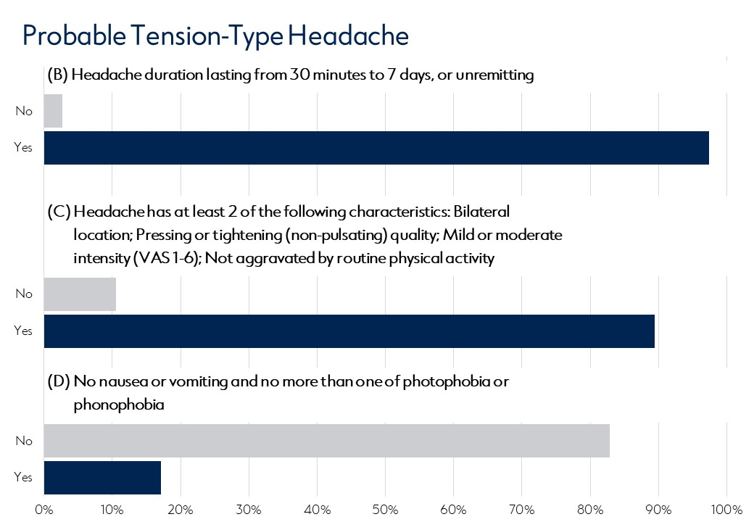
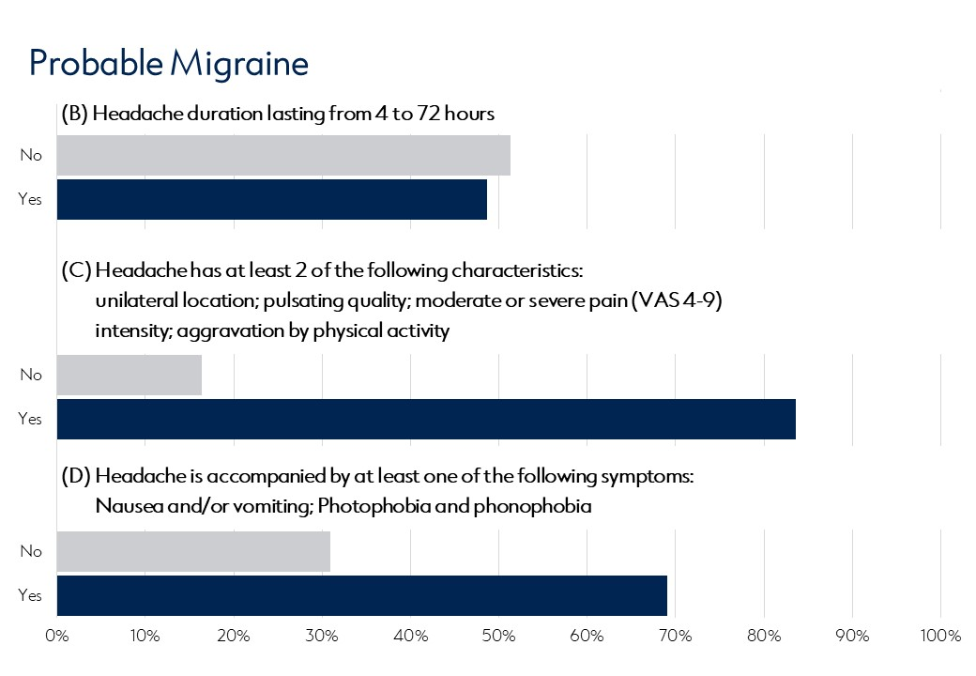
sFigure 1: Diagnostic fulfillment per diagnostic criteria for probable migraine (A), probable TTH (B), and probable CH (C)
[B] Probable Tension-Type Headache
[A] Probable Migraine

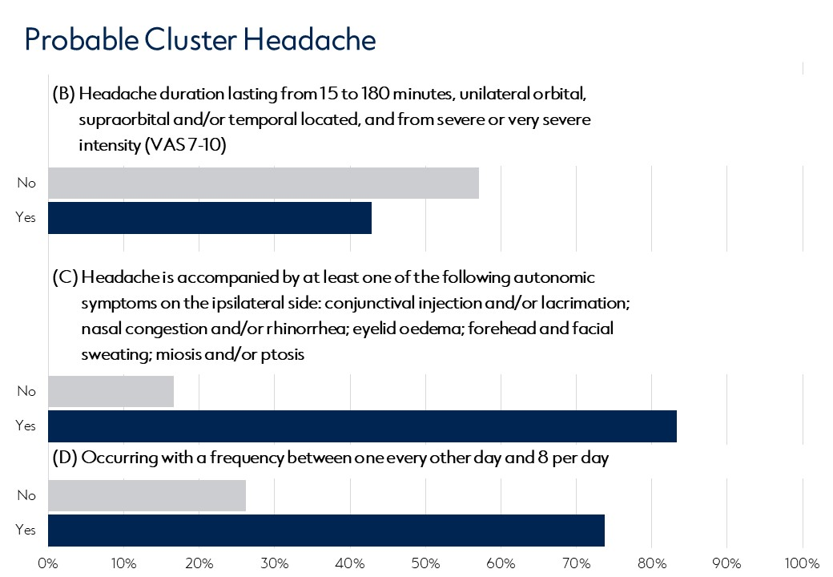
[C] Probable Cluster Headache

sTable 1: Headache characteristics
Headache characteristics
Minimal attack duration |  | 46.1 ± 113.1
Maximal attack duration |  | 75.3 ± 148.4
Monthly headache days |  | 14.7 ± 9.2
Daily headache attacks |  | 1.3 ± 5.7
Daily headache attacks if more than one |  | 12.5 ± 36
Location | Unilateral | 1034 (64.2)
 | Bilateral | 540 (33.5)
 | Both Uni- and Bilateral | 37 (2.3)
Aura
Visually |  | 383 (56.4)
Sensitive |  | 77 (11.3)
Motor |  | 14 (2.1)
Aphasic |  | 60 (8.8)
Not Specified |  | 6 (0.9)
Pain aggravation by physical activity
No |  | 271 (20.2)
Yes |  | 959 (71.4)
Sometimes |  | 114 (8.5)
Pain intensity (Visual Analog Scale) |  | 7 ± 1.8
Pain quality
Pulsing |  | 695 (43.7)
Dull |  | 464 (29.1)
Cramping |  | 4 (0.3)
Pounding |  | 187 (11.7)
Pressing |  | 828 (52)
Pulling |  | 159 (10)
Stinging |  | 532 (33.4)
Throbbing |  | 98 (6.2)
Thumping |  | 2 (0.1)
Accompanying symptoms
Photophobia |  | 1115 (82.2)
Phonophobia |  | 1077 (79.4)
Osmophobia |  | 319 (23.5)
Nausea |  | 1032 (76.1)
Vomiting |  | 450 (33.2)
Dizziness |  | 201 (14.8)
Autonomic Symptoms
No |  | 746 (75.1)
Yes |  | 236 (23.8)
Sometimes |  | 11 (1.1)
Side | Contralateral | 10 (4.2)
 | Ipsilateral | 158 (66.9)
 | Both Sides | 6 (2.5)
 | Not Specified | 51 (26.3)
Watery Eye |  | 158 (17)
Reddened Eye |  | 87 (9.4)
Drooping Eyelid |  | 57 (6.1)
Stuffy Nose |  | 93 (10)
Runny Nose |  | 91 (9.8)
Sweating |  | 21 (2.3)

sTable 2: Pre-existing headache diagnosis from the primary and secondary level of care
Diagnosis | Total cohort  N=1468 | Primary  level of care  n=854 | Secondary  level of care  n=614 | p-value
Pre-existing diagnosis | 1020 (69.5) | 581 (68.0) | 439 (71.5) | 0.168
None | 448 (30.5) | 273 (32.0) | 175 (28.5) | 0.437
One diagnosis | 725 (49.4) | 408 (47.8) | 317 (51.6) | 0.437
Two diagnoses | 268 (18.3) | 156 (18.3) | 112 (18.2) | 0.437
Three diagnoses | 27 (1.8) | 17 (2.0) | 10 (1.6) | 0.437
Migraine | 824 (56.1) | 458 (53.6) | 366 (59.6) | 0.025*
Tension-type headache | 365 (24.9) | 219 (25.6) | 146 (23.8) | 0.427
Cluster headache | 111 (7.6) | 70 (8.2) | 41 (6.7) | 0.317
Other headache | 42 (2.9) | 24 (2.8) | 18 (2.9) | 0.999
Values are given in n (%)
* Statistically significant (p<0.05).

sTable 3: Agreement of headache diagnosis from primary/secondary level of care relative to the tertiary level of care
Diagnosis from  Tertiary level of care | Pre-existing diagnosis from  primary/secondary care |  |  |  |  |  | Agreement Statistics
Diagnosis from  Tertiary level of care | Agreement |  |  | Disagreement |  |  | Cohen's Kappa  (95% CI) | coefficient of determination (R²) | p-value
Diagnosis from  Tertiary level of care | Positive agreement | Negative  agreement | Total  agreement | Positive disagreement | Negative disagreement | Total  disagreement | Cohen's Kappa  (95% CI) | coefficient of determination (R²) | p-value
Migraine | 800  54.5% | 276  18.8% | 1076  73.3% | 368  25.1% | 24  1.6% | 392  26.7% | 0.424  (0.375 - 0.473) | 0.180  (0.141 - 0.224) | <0.001*
TTH | 97  6.6% | 973  66.3% | 1070  72.9% | 130  8.9% | 268  18.3% | 398  27.1% | 0.169  (0.100 - 0.239) | 0.029  (0.010 - 0.057) | <0.001*
Cluster headache | 51  3.5% | 1346  91.7% | 1397  95.2% | 11  0.7% | 60  4.1% | 71  4.8% | 0.566  (0.468 - 0.665) | 0.320  (0.219 - 0.442) | <0.001*
All diagnoses | 948  21.5% | 2595  58.9% | 3543  80.4% | 509  11.6% | 352  8.0% | 861  19.6% | 0.546  (0.519 - 0.573) | 0.298  (0.269 - 0.329) | <0.001*
TTH = Tension-type headache, 95%CI = 95% confidence interval.
* Statistically significant (p<0.05).

sTable 4: Agreement of headache diagnosis from primary/secondary level of care relative to the ICHD-3 Guidelines
ICHD-3 Diagnosis | All | All-but-one | Pre-existing diagnosis from  primary/secondary care |  |  |  |  |  | Agreement Statistics
ICHD-3 Diagnosis | All | All-but-one | Agreement |  |  | Disagreement |  |  | Cohen's Kappa  (95% CI) | coefficient of determination (R²) | p-value
ICHD-3 Diagnosis | All | All-but-one | Positive agreement | Negative  agreement | Total  agreement | Positive disagreement | Negative disagreement | Total  disagreement | Cohen's Kappa  (95% CI) | coefficient of determination (R²) | p-value
Migraine | 1017 | 1237 | 806  54.9% | 328  22.3% | 1134  77.2% | 316  21.5% | 18  1.2% | 334  22.8% | 0.513 ^{A}  (0.468 - 0.559) | 0.264  (0.219 - 0.313) | <0.001*
TTH | 59 | 363 | 144  9.8% | 1063  72.4% | 1207  82.2% | 40  2.7% | 221  15.1% | 261  17.8% | 0.430 ^{A}  (0.367 - 0.492) | 0.184  (0.135 - 0.242) | <0.001*
Cluster headache | 36 | 78 | 54  3.7% | 1350  92.0% | 1404  95.6% | 7  0.5% | 57  3.9% | 64  4.4% | 0.607 ^{B}  (0.513 - 0.701) | 0.368  (0.263 - 0.491) | <0.001*
All diagnoses | 1112 | 1678 | 1004  22.8% | 2741  62.2% | 3745  85.0% | 363  8.2% | 296  6.7% | 659  15.0% | 0.646 ^{B}  (0.621 - 0.671) | 0.417  (0.385 - 0.450) | <0.001*
TTH = Tension-type headache, 95%CI = 95% confidence interval.
* Statistically significant (p<0.05).

sTable 5a: Agreement of headache diagnosis from primary level of care relative to the ICHD-3 Guidelines
ICHD-3 Diagnosis | All | All-but-one | Pre-existing diagnosis from  Primary level of care |  |  |  |  |  | Agreement Statistics
ICHD-3 Diagnosis | All | All-but-one | Agreement |  |  | Disagreement |  |  | Cohen's Kappa  (95% CI) | coefficient of determination (R²) | p-value
ICHD-3 Diagnosis | All | All-but-one | Positive agreement | Negative  agreement | Total  agreement | Positive disagreement | Negative disagreement | Total  disagreement | Cohen's Kappa  (95% CI) | coefficient of determination (R²) | p-value
Migraine | 583 | 717 | 449  52.6% | 203  23.8% | 652  76.3% | 193  22.6% | 9  1.1% | 202  23.7% | 0.518  (0.445 - 0.591) | 0.268  (0.198 - 0.349) | <0.001*
TTH | 38 | 225 | 91  10.7% | 612  71.7% | 703  82.3% | 23  2.7% | 128  15.0% | 151  17.7% | 0.398  (0.296 - 0.500) | 0.158  (0.088 - 0.250) | <0.001*
Cluster headache | 22 | 42 | 31  3.6% | 780  91.3% | 811  95.0% | 4  0.5% | 39  4.6% | 43  5.0% | 0.669  (0.530 - 0.808) | 0.448  (0.281 - 0.653) | <0.001*
All diagnoses | 643 | 984 | 571  22.3% | 1595  62.3% | 2166  84.5% | 220  8.6% | 176  6.9% | 396  15.5% | 0.664  (0.627 - 0.702) | 0.441  (0.393 - 0.492) | <0.001*
TTH = Tension-type headache, 95%CI = 95% confidence interval.
* Statistically significant (p<0.05).

sTable 5b: Agreement of headache diagnosis from secondary level of care relative to the ICHD-3 Guidelines
ICHD-3 Diagnosis | All | All-but-one | Pre-existing diagnosis from  Secondary level of care |  |  |  |  |  | Agreement Statistics
ICHD-3 Diagnosis | All | All-but-one | Agreement |  |  | Disagreement |  |  | Cohen's Kappa  (95% CI) | coefficient of determination (R²) | p-value
ICHD-3 Diagnosis | All | All-but-one | Positive agreement | Negative  agreement | Total  agreement | Positive disagreement | Negative disagreement | Total  disagreement | Cohen's Kappa  (95% CI) | coefficient of determination (R²) | p-value
Migraine | 434 | 520 | 357  58.1% | 125  20.4% | 482  78.5% | 123  20.0% | 9  1.5% | 132  21.5% | 0.509  (0.450 - 0.568) | 0.259  (0.202 - 0.323) | <0.001*
TTH | 21 | 138 | 53  8.6% | 451  73.5% | 504  82.1% | 17  2.8% | 93  15.1% | 110  17.9% | 0.450  (0.370 - 0.530) | 0.202  (0.137 - 0.280) | <0.001*
Cluster headache | 14 | 36 | 23  3.7% | 570  92.8% | 593  96.6% | 3  0.5% | 18  2.9% | 21  3.4% | 0.567  (0.441 - 0.693) | 0.321  (0.194 - 0.480) | <0.001*
All diagnoses | 469 | 694 | 433  23.5% | 1146  62.2% | 1579  85.7% | 143  7.8% | 120  6.5% | 263  14.3% | 0.632  (0.599 - 0.666) | 0.400  (0.359 - 0.443) | <0.001*
TTH = Tension-type headache, 95%CI = 95% confidence interval.
* Statistically significant (p<0.05).

sTable 6: Agreement of diagnosis from headache specialist according to the ICHD-3 Guidelines
ICHD-3 Diagnosis | All | All-but-one | Diagnosis from  Tertiary level of care |  |  |  |  |  | Agreement Statistics
ICHD-3 Diagnosis | All | All-but-one | Agreement |  |  | Disagreement |  |  | Cohen's Kappa  (95% CI) | coefficient of determination (R²) | p-value
ICHD-3 Diagnosis | All | All-but-one | Positive agreement | Negative  agreement | Total  agreement | Positive disagreement | Negative disagreement | Total  disagreement | Cohen's Kappa  (95% CI) | coefficient of determination (R²) | p-value
Migraine | 1017 | 1237 | 1163  79.2% | 296  20.2% | 1459  99.4% | 4  0.3% | 5  0.3% | 9  0.6% | 0.981  (0.969 - 0.993) | 0.963  (0.939 - 0.987) | <0.001*
TTH | 59 | 363 | 214  14.6% | 1237  84.3% | 1451  98.8% | 4  0.3% | 13  0.9% | 17  1.2% | 0.955  (0.934 - 0.976) | 0.912  (0.872 - 0.953) | <0.001*
Cluster headache | 36 | 78 | 61  4.2% | 1406  95.8% | 1467  99.9% | 0  0.0% | 1  0.1% | 1  0.1% | 0.992  (0.975 – 0.999) | 0.983  (0.95 - 0.998) | <0.001*
All diagnoses | 1112 | 1678 | 1438  32.7% | 2939  66.7% | 4377  99.4% | 8  0.2% | 19  0.4% | 27  0.6% | 0.986  (0.981 - 0.991) | 0.972  (0.962 - 0.983) | <0.001*
TTH = Tension-type headache, 95%CI = 95% confidence interval.
* Statistically significant (p<0.05).

sTable 7: Predictors for a positive disagreement in diagnosing migraine in the PSLC according to the ICHD-3 criteria, n=1042
Clinical migraine features as mentioned in the ICHD-3 |  | Positive disagreement  (missed diagnosis) |  | Univariate | Multivariate
 |  | No  N=708 | Yes  n=334 | OR (95% CI)  p-value | OR (95% CI)  p-value
Attack duration 4 - 72 hours | No | 42 (66.7) | 21 (33.3) | 1.06 (0.62 - 1.83)  0.822
 | Yes | 666 (68) | 313 (32) | rev.
Pain location unilateral | No | 82 (73.9) | 29 (26.1) | 0.73 (0.47 - 1.13)  0.158
 | Yes | 626 (67.2) | 305 (32.8) | rev.
Pain quality pulsating | No | 107 (66.9) | 53 (33.1) | 1.06 (0.74 - 1.52)  0.752
 | Yes | 601 (68.1) | 281 (31.9) | rev.
Pain intensity VAS 4-9 | No | 116 (51.3) | 110 (48.7) | 2.51 (1.85 - 3.39)  <0.001* | 2.27 (1.67 - 3.1)  <0.001*
 | Yes | 592 (72.5) | 224 (27.5) | rev. | rev.
Pain aggravation by PA | No | 298 (63.8) | 169 (36.2) | 1.41 (1.09 - 1.83)  0.010*
 | Yes | 410 (71.3) | 165 (28.7) | rev.
Photophobia | No | 71 (57.3) | 53 (42.7) | 1.69 (1.15 - 2.48)  0.007* | 1.58 (1.06 - 2.34)  0.024*
 | Yes | 637 (69.4) | 281 (30.6) | rev. | rev.
Phonophobia | No | 90 (61.6) | 56 (38.4) | 1.38 (0.96 - 1.99)  0.079
 | Yes | 618 (69) | 278 (31) | rev.
Nausea | No | 91 (55.8) | 72 (44.2) | 1.86 (1.32 - 2.62)  <0.001* | 1.5 (1.04 - 2.17)  0.030*
 | Yes | 617 (70.2) | 262 (29.8) | rev. | rev.
Vomiting | No | 404 (63.4) | 233 (36.6) | 1.74 (1.32 - 2.29)  <0.001* | 1.54 (1.14 - 2.07)  0.004*
 | Yes | 304 (75.1) | 101 (24.9) | rev. | rev.
Aura | No | 395 (63.5) | 227 (36.5) | 1.68 (1.28 - 2.21)  <0.001* | 1.7 (1.28 - 2.26)  <0.001*
 | Yes | 313 (74.5) | 107 (25.5) | rev. | rev.
OR = Odds Ratio; 95% CI = 95% Confidence interval.
* Statistically significant (p<0.05).

sTable 8: Predictors for a negative diagnostic disagreement of TTH in the PSLC according to the ICHD-3 criteria, n=1544
Clinical TTH features as mentioned in the ICHD-3 |  | Negative disagreement |  | Univariate | Multivariate
 |  | No  n=1362 | Yes  n=182 | OR (95% CI)  p-value | OR (95% CI)  p-value
Duration 30 min - 7 days or  unremitting | No | 63 (87.5) | 9 (12.5) | 1.07 (0.52 - 2.2)  0.848
 | Yes | 1299 (88.2) | 173 (11.8) | rev.
Pain location bilateral | No | 892 (85.5) | 151 (14.5) | 2.57 (1.72 - 3.84)  <0.001* | 1.69 (1.11 - 2.57)  0.014*
 | Yes | 470 (93.8) | 31 (6.2) | rev. | rev.
Pain quality pressing | No | 896 (85.3) | 154 (14.7) | 2.86 (1.88 - 4.34)  <0.001* | 2.12 (1.38 - 3.26)  0.001*
or tightening (non-pulsating) | Yes | 466 (94.3) | 28 (5.7) | rev. | rev.
Pain intensity VAS 1 -6 | No | 920 (85.6) | 155 (14.4) | 2.76 (1.8 - 4.22)  <0.001* | 2.02 (1.31 - 3.12)  0.001*
 | Yes | 442 (94.2) | 27 (5.8) | rev. | rev.
No pain aggravation by PA | No | 1148 (86.7) | 176 (13.3) | 5.47 (2.39 - 12.5)  <0.001* | 3.6 (1.56 - 8.33)  0.003*
 | Yes | 214 (97.3) | 6 (2.7) | rev. | rev.
Photophobia | No | 431 (92.7) | 34 (7.3) | 0.5 (0.34 - 0.73)  <0.001*
 | Yes | 931 (86.3) | 148 (13.7) | rev.
Phonophobia | No | 446 (92) | 39 (8) | 0.56 (0.39 - 0.81)  0.002*
 | Yes | 916 (86.5) | 143 (13.5) | rev.
Nausea | No | 473 (92.4) | 39 (7.6) | 0.51 (0.35 - 0.74)  <0.001*
 | Yes | 889 (86.1) | 143 (13.9) | rev.
Vomiting | No | 976 (89.2) | 118 (10.8) | 0.73 (0.53 - 1.01)  0.058
 | Yes | 386 (85.8) | 64 (14.2) | rev.
PA = physical activity; OR = Odds Ratio; 95% CI = 95% Confidence interval.
* Statistically significant (p<0.05).

sTable 9: Predictors for a negative diagnostic disagreement of CH in the PSLC according to the ICHD-3 criteria, n=1600
Clinical migraine features as mentioned in the ICHD-3 |  | Negative disagreement |  | Univariate | Multivariate
 |  | No  N=1536 | Yes  n=64 | OR (95% CI)  p-value | OR (95% CI)  p-value
Attack duration 15 - 180 minutes | No | 1480 (95.9) | 63 (4.1) | 2.38 (0.32 - 17.5)  0.393
 | Yes | 56 (98.2) | 1 (1.8) | rev.
Pain location unilateral | No | 552 (97.7) | 13 (2.3) | 0.45 (0.24 - 0.84)  0.012* | 0.46 (0.24 - 0.87)  0.017*
 | Yes | 984 (95.1) | 51 (4.9) | rev. | rev.
Pain Intensity VAS 7 - 10 | No | 593 (96.9) | 19 (3.1) | 0.67 (0.39 - 1.16)  0.153
 | Yes | 943 (95.4) | 45 (4.6) | rev.
Presence of Ipsilateral | No | 1417 (96.4) | 53 (3.6) | 0.4 (0.21 - 0.8)  0.009* | 0.49 (0.25 - 0.98)  0.043*
autonomic symptoms | Yes | 119 (91.5) | 11 (8.5) | rev. | rev.
Attack frequency of one every | No | 931 (96.5) | 34 (3.5) | 0.74 (0.45 - 1.22)  0.232 | 0.65 (0.39 - 1.08)  0.094
other day - 8 per day | Yes | 605 (95.3) | 30 (4.7) | rev. | rev.
OR = Odds Ratio; 95% CI = 95% Confidence interval; VAS = Visual Analog Scale.
* Statistically significant (p<0.05).

