Headache after Pediatric Traumatic Brain Injury: A Comparison between a Post-Acute Sample of Children and Adolescents and General Population –Supplemental Material

Figure S1. Summary on balance in the matched sample using Love plot (Model I).
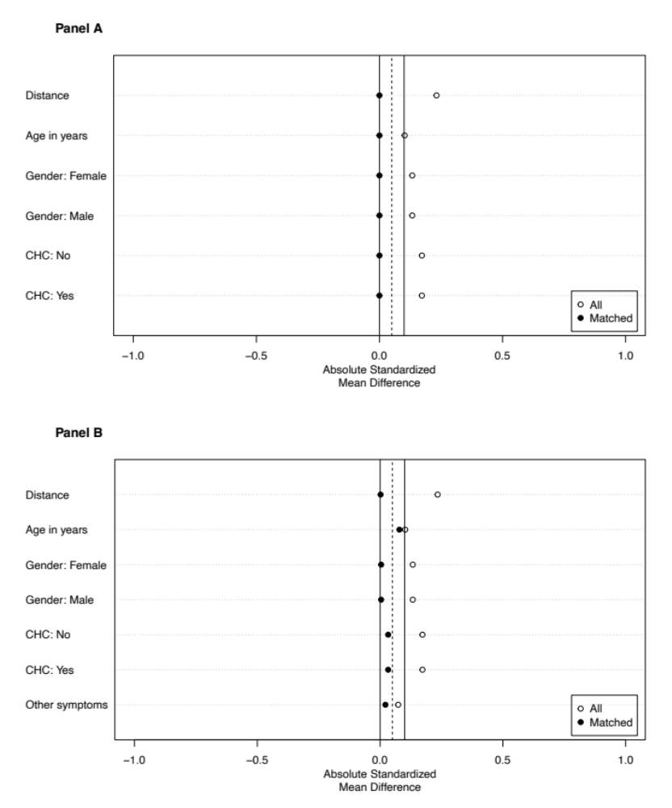
Note. Panel A: Matching based on age, gender, and presence of the chronic health conditions. Panel B: Matching based on age, gender, presence of the chronic health conditions, and presence of symptoms other than headache. Distance: estimated propensity score, CHC: presence of at least one chronic health condition coded as “No” or “Yes”. The empty circles show the absolute standardized mean difference between the samples before matching, the filled circles show the difference after matching.

Table S1. Relative frequencies of endorsed symptoms other than headache.
Symptoms | TBI  (N = 463) | Matched controls  (N = 463)
Children*
Nausea | 20% | 21%
Balance problems | 16% | 13%
Dizziness | 19% | 14%
Blurred vision | 16% | 11%
Feeling slowed down | 21% | 14%
Bothered by bright light | 23% | 21%
Bothered by loud noises | 21% | 24%
Irritability | 49% | 48%
Sadness | 35% | 38%
Nervousness | 34% | 34%
Difficulty thinking clearly | 25% | 23%
Difficulty concentrating | 36% | 41%
Difficulty remembering | 32% | 28%
Thinking more slowly | 21% | 25%
Fatigue | 21% | 32%
Drowsiness | 27% | 17%
Adolescents**
Nausea | 7% | 20%
Balance problems | 10% | 14%
Dizziness | 14% | 14%
Visual problems | 10% | 12%
Move clumsy | 10% | 12%
Sensitivity to light | 8% | 14%
Sensitivity to noise | 15% | 14%
Irritability | 25% | 28%
Sadness | 19% | 22%
Nervousness | 19% | 21%
Feeling more emotional | 19% | 24%
Feeling mentally foggy | 8% | 12%
Difficulty concentrating | 26% | 23%
Difficulty remembering | 17% | 16%
Get confused | 13% | 20%
Answers more slowly | 8% | 14%
Feeling slowed down | 5% | 15%
Fatigue | 25% | 21%
Drowsiness | 23% | 25%
Sleeping more | 11% | 21%
Note. * Relative frequencies of the sum of symptoms rated 1 (“a little”). ** Relative frequencies of symptoms rated 3 (“moderate problem”).

