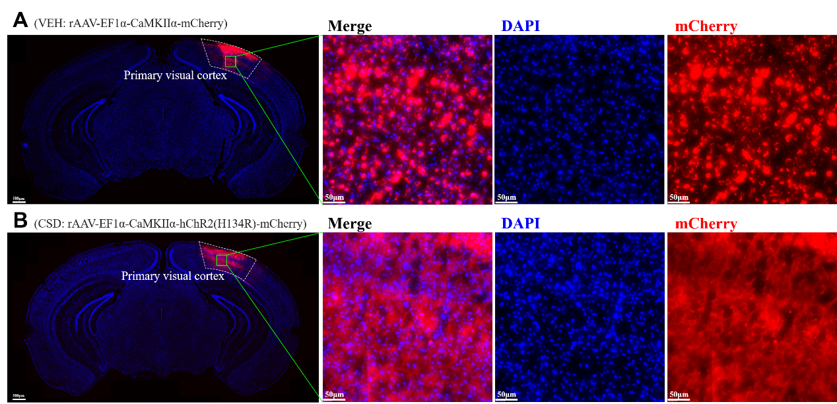
Fig. S1 The virus expression in the primary visual cortex.

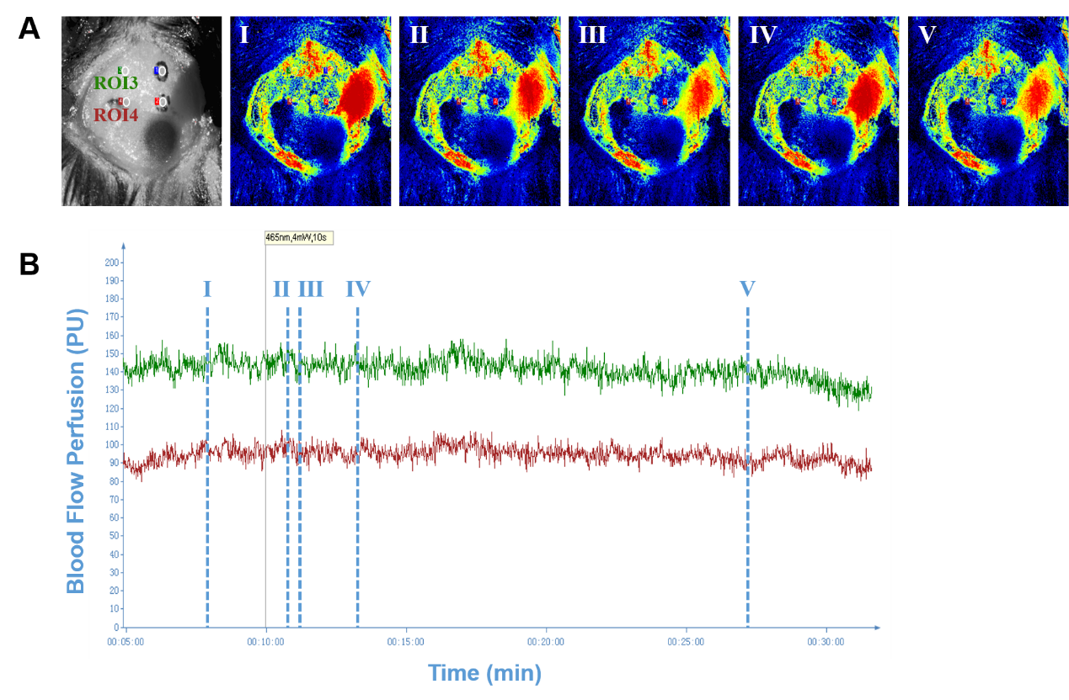
Fig. S2 The rCBF recording of the contralateral motor cortex (ROI 3) and somatosensory cortex (ROI 4).

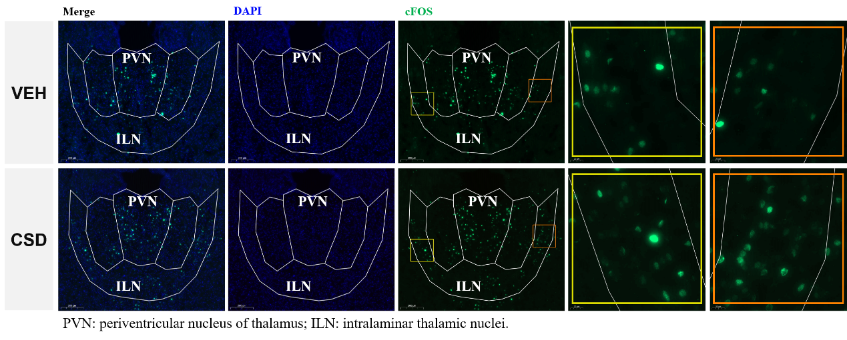
Fig. S3 The c-FOS immunofluorescent staining in the periventricular nucleus of thalamus and intralaminar thalamic nuclei.

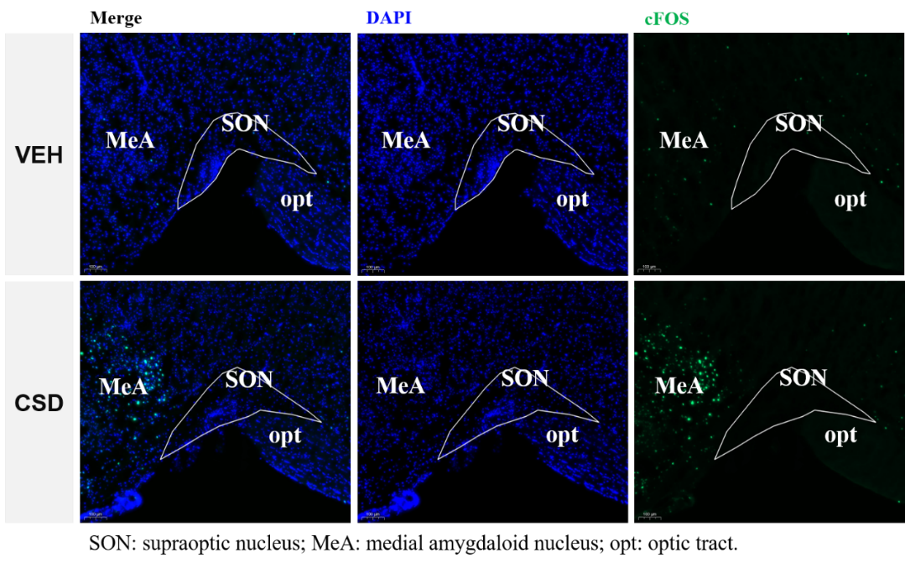
Fig. S4 The c-FOS immunofluorescent staining in the supraoptic nucleus.

