Supplementary material
Table S1: PRISMA checklist of the current network meta-analysis
Table S2: Search strategies and results
Table S3: GRADE ratings for each network
eFig.1 Funnel plots of the efficacy outcomes.
eFig.2 Trace and density of the network meta-analysis: pain freedom at 2 hours.
eFig.3 Trace and density of the network meta-analysis: freedom from MBS at 2 hours.
eFig.4 Trace and density of the network meta-analysis: pain relief at 2 hours.
eFig.5 Trace and density of the network meta-analysis: sustained pain freedom from 2 to 24 hours.
eFig.6 Trace and density of the network meta-analysis: sustained pain freedom from 2 to 48 hours.
eFig.7 Trace and density of the network meta-analysis: sustained pain relief from 2 to 24 hours.
eFig.8 Trace and density of the network meta-analysis: sustained pain relief from 2 to 48 hours.
eFig.9 Trace and density of the network meta-analysis: phonophobia freedom at 2 hours.
eFig.10 Trace and density of the network meta-analysis: photophobia freedom at 2 hours.
eFig.11 Convergence diagnostic charts of the network meta-analysis: pain freedom at 2 hours.
eFig.12 Convergence diagnostic charts of the network meta-analysis: freedom from MBS at 2 hours.
eFig.13 Convergence diagnostic charts of the network meta-analysis: pain relief at 2 hours.
eFig.14 Convergence diagnostic charts of the network meta-analysis: sustained pain freedom from 2 to 24 hours.
eFig.15 Convergence diagnostic charts of the network meta-analysis: sustained pain freedom from 2 to 48 hours.
eFig.16 Convergence diagnostic charts of the network meta-analysis: sustained pain relief from 2 to 24 hours.
eFig.17 Convergence diagnostic charts of the network meta-analysis: sustained pain relief from 2 to 48 hours.
eFig.18 Convergence diagnostic charts of the network meta-analysis: phonophobia freedom at 2 hours.
eFig.19 Convergence diagnostic charts of the network meta-analysis: photophobia freedom at 2 hours.
eFig.20 Forest plots for the heterogeneity: pain freedom at 2 hours.
eFig.21 Forest plots for the heterogeneity: freedom from MBS at 2 hours.
eFig.22 Forest plots for the heterogeneity: pain relief at 2 hours.
eFig.23 Forest plots for the heterogeneity: sustained pain freedom from 2 to 24 hours.
eFig.24 Forest plots for the heterogeneity: sustained pain freedom from 2 to 48 hours.
eFig.25 Forest plots for the heterogeneity: sustained pain relief from 2 to 24 hours.
eFig.26 Forest plots for the heterogeneity: sustained pain relief from 2 to 48 hours.
eFig.27 Forest plots for the heterogeneity: phonophobia freedom at 2 hours.
eFig.28 Forest plots for the heterogeneity: photophobia freedom at 2 hours.
eFig.29 Forest plots of the efficacy outcomes between zavegepant and the placebo.
eFig.30 Forest plots of the primary outcome: pain freedom at 2 hours.
eFig.31 Forest plots of the primary outcome: freedom from MBS at 2 hours.
eFig.32 Forest plots of the efficacy outcomes between the placebo and the CGRP receptor antagonists.
eFig.33 Forest plots of the efficacy outcomes between zavegepant and the oral CGRP receptor antagonists.
eFig.34 Forest plots of the secondary outcome: pain relief at 2 hours.
eFig.35 Forest plots of the secondary outcome: sustained pain freedom from 2 to 24 hours.
eFig.36 Forest plots of the secondary outcome: sustained pain freedom from 2 to 48 hours.
eFig.37 Forest plots of the secondary outcome: sustained pain relief from 2 to 24 hours.
eFig.38 Forest plots of the secondary outcome: sustained pain relief from 2 to 48 hours.
eFig.39 Forest plots of the secondary outcome: phonophobia freedom at 2 hours.
eFig.40 Forest plots of the secondary outcome: photophobia freedom at 2 hours.
eFig.41 Forest plots of the safety outcomes between zavegepant and the placebo.
eFig.42 The cumulative probability of obtaining a particular rank for the primary outcomes.
eFig.43 The cumulative probability of obtaining a particular rank for the secondary outcomes.

This supplementary material has been provided by the authors to give readers additional information about their work.

Table S1: PRISMA checklist of the current network meta-analysis
Section and Topic | Item # | Checklist item | Location where item is reported
TITLE
Title | 1 | Identify the report as a systematic review. | 1
ABSTRACT
Abstract | 2 | See the PRISMA 2020 for Abstracts checklist. | 2
INTRODUCTION
Rationale | 3 | Describe the rationale for the review in the context of existing knowledge. | 3
Objectives | 4 | Provide an explicit statement of the objective(s) or question(s) the review addresses. | 4
METHODS
Eligibility criteria | 5 | Specify the inclusion and exclusion criteria for the review and how studies were grouped for the syntheses. | 4
Information sources | 6 | Specify all databases, registers, websites, organisations, reference lists and other sources searched or consulted to identify studies. Specify the date when each source was last searched or consulted. | 4
Search strategy | 7 | Present the full search strategies for all databases, registers and websites, including any filters and limits used. | 4
Selection process | 8 | Specify the methods used to decide whether a study met the inclusion criteria of the review, including how many reviewers screened each record and each report retrieved, whether they worked independently, and if applicable, details of automation tools used in the process. | 5
Data collection process | 9 | Specify the methods used to collect data from reports, including how many reviewers collected data from each report, whether they worked independently, any processes for obtaining or confirming data from study investigators, and if applicable, details of automation tools used in the process. | 5
Data items | 10a | List and define all outcomes for which data were sought. Specify whether all results that were compatible with each outcome domain in each study were sought (e.g. for all measures, time points, analyses), and if not, the methods used to decide which results to collect. | 5,6
Data items | 10b | List and define all other variables for which data were sought (e.g. participant and intervention characteristics, funding sources). Describe any assumptions made about any missing or unclear information. | 4
Study risk of bias assessment | 11 | Specify the methods used to assess risk of bias in the included studies, including details of the tool(s) used, how many reviewers assessed each study and whether they worked independently, and if applicable, details of automation tools used in the process. | 4
Effect measures | 12 | Specify for each outcome the effect measure(s) (e.g. risk ratio, mean difference) used in the synthesis or presentation of results. | 6
Synthesis methods | 13a | Describe the processes used to decide which studies were eligible for each synthesis (e.g. tabulating the study intervention characteristics and comparing against the planned groups for each synthesis (item #5)). | 6
Synthesis methods | 13b | Describe any methods required to prepare the data for presentation or synthesis, such as handling of missing summary statistics, or data conversions. | 6
Synthesis methods | 13c | Describe any methods used to tabulate or visually display results of individual studies and syntheses. | 6
Synthesis methods | 13d | Describe any methods used to synthesize results and provide a rationale for the choice(s). If meta-analysis was performed, describe the model(s), method(s) to identify the presence and extent of statistical heterogeneity, and software package(s) used. | 6
Synthesis methods | 13e | Describe any methods used to explore possible causes of heterogeneity among study results (e.g. subgroup analysis, meta-regression). | 6
Synthesis methods | 13f | Describe any sensitivity analyses conducted to assess robustness of the synthesized results. | 6
Reporting bias assessment | 14 | Describe any methods used to assess risk of bias due to missing results in a synthesis (arising from reporting biases). | 6
Certainty assessment | 15 | Describe any methods used to assess certainty (or confidence) in the body of evidence for an outcome. | 7
RESULTS
Study selection | 16a | Describe the results of the search and selection process, from the number of records identified in the search to the number of studies included in the review, ideally using a flow diagram. | 7
Study selection | 16b | Cite studies that might appear to meet the inclusion criteria, but which were excluded, and explain why they were excluded. | 7
Study characteristics | 17 | Cite each included study and present its characteristics. | 7
Risk of bias in studies | 18 | Present assessments of risk of bias for each included study. | 7,8
Results of individual studies | 19 | For all outcomes, present, for each study: (a) summary statistics for each group (where appropriate) and (b) an effect estimate and its precision (e.g. confidence/credible interval), ideally using structured tables or plots. | 8,9
Results of syntheses | 20a | For each synthesis, briefly summarise the characteristics and risk of bias among contributing studies. | 7
Results of syntheses | 20b | Present results of all statistical syntheses conducted. If meta-analysis was done, present for each the summary estimate and its precision (e.g. confidence/credible interval) and measures of statistical heterogeneity. If comparing groups, describe the direction of the effect. | 9-12
Results of syntheses | 20c | Present results of all investigations of possible causes of heterogeneity among study results. | 8
Results of syntheses | 20d | Present results of all sensitivity analyses conducted to assess the robustness of the synthesized results. | 8
Reporting biases | 21 | Present assessments of risk of bias due to missing results (arising from reporting biases) for each synthesis assessed. | 8
Certainty of evidence | 22 | Present assessments of certainty (or confidence) in the body of evidence for each outcome assessed. | 9-12
DISCUSSION
Discussion | 23a | Provide a general interpretation of the results in the context of other evidence. | 13
Discussion | 23b | Discuss any limitations of the evidence included in the review. | 17
Discussion | 23c | Discuss any limitations of the review processes used. | 17
Discussion | 23d | Discuss implications of the results for practice, policy, and future research. | 17
OTHER INFORMATION
Registration and protocol | 24a | Provide registration information for the review, including register name and registration number, or state that the review was not registered. | 4
Registration and protocol | 24b | Indicate where the review protocol can be accessed, or state that a protocol was not prepared. | 4
Registration and protocol | 24c | Describe and explain any amendments to information provided at registration or in the protocol. | 4
Support | 25 | Describe sources of financial or non-financial support for the review, and the role of the funders or sponsors in the review. | 19
Competing interests | 26 | Declare any competing interests of review authors. | 19
Availability of data, code and other materials | 27 | Report which of the following are publicly available and where they can be found: template data collection forms; data extracted from included studies; data used for all analyses; analytic code; any other materials used in the review. | 19

Table S2: Search strategies and results
Database1 Pubmed <Dec 1, 2024>
# | Searches | Results
#1 | migraine attack[Title/Abstract] OR acute migraine[Title/Abstract] OR acute migraine management[Title/Abstract] OR migraine attacks[Title/Abstract] OR acute migraines[Title/Abstract] | 6044
#2 | Zavegepant[Title/Abstract] OR zavegepant[Title/Abstract] OR Zavegepant nasal inhalation[Title/Abstract] OR zavegepant nasal inhalation[Title/Abstract] OR ZM-001[Title/Abstract] OR Vyepti[Title/Abstract] OR zavegepant nasal[Title/Abstract] OR zavegepant spray[Title/Abstract] | 66
#3 | calcitonin gene-related peptide[Title/Abstract] OR CGRP[Title/Abstract] OR CGRP receptor antagonists[Title/Abstract] OR CGRP antagonists[Title/Abstract] OR CGRP inhibitors[Title/Abstract] OR CGRP-R antagonists[Title/Abstract] OR CGRP-R inhibitors[Title/Abstract] OR monoclonal antibody to CGRP[Title/Abstract] OR CGRP receptor blockers[Title/Abstract] | 15839
#4 | #2 OR #3 | 15859
#5 | randomized controlled trial[Title/Abstract] OR RCT[Title/Abstract] OR randomized trial[Title/Abstract] OR "randomized"[Title/Abstract] | 751,053
#6 | #1 AND #4 AND #5 | 534

Database2 Cochrane Central Register of Controlled Trials <Dec 1, 2024>
# | Searches | Results
#1 | (migraine attack):ti,ab,kw OR (acute migraine):ti,ab,kw OR (acute migraine management):ti,ab,kw OR (migraine attacks):ti,ab,kw OR (acute migraines):ti,ab,kw | 4744
#2 | (Zavegepant):ti,ab,kw OR (zavegepant):ti,ab,kw OR (Zavegepant nasal inhalation):ti,ab,kw OR (zavegepant nasal inhalation):ti,ab,kw OR (ZM-001):ti,ab,kw OR (Vyepti):ti,ab,kw OR (zavegepant nasal):ti,ab,kw OR (zavegepant spray):ti,ab,kw | 43
#3 | calcitonin gene-related peptide):ti,ab,kw OR (CGRP):ti,ab,kw OR (CGRP receptor antagonists):ti,ab,kw OR (CGRP antagonists):ti,ab,kw OR (CGRP inhibitors):ti,ab,kw OR (monoclonal antibody to CGRP):ti,ab,kw OR (CGRP receptor blockers):ti,ab,kw | 1866
#4 | #2 OR #3 | 1885
#5 | (randomized controlled trial):ti,ab,kw OR (RCT):ti,ab,kw OR (randomized trial):ti,ab,kw OR randomized:ti,ab,kw | 967869
#6 | #1 AND #4 AND #5 | 530

Database3 EMBASE <Dec 1, 2024>
# | Searches | Results
#1 | 'migraine attack' :ti,ab,kw OR 'acute migraine' :ti,ab,kw OR 'acute migraine management' :ti,ab,kw OR 'migraine attacks' :ti,ab,kw OR 'acute migraines' :ti,ab,kw | 9783
#2 | 'Zavegepant' :ti,ab,kw OR 'zavegepant' :ti,ab,kw OR 'Zavegepant nasal inhalation' :ti,ab,kw OR 'ZM-001' :ti,ab,kw OR 'Vyepti' :ti,ab,kw OR 'zavegepant nasal' :ti,ab,kw OR 'zavegepant spray' :ti,ab,kw | 189
#3 | 'calcitonin gene-related peptide' :ti,ab,kw OR 'CGRP' :ti,ab,kw OR 'CGRP receptor antagonists' :ti,ab,kw OR 'CGRP antagonists' :ti,ab,kw OR 'CGRP inhibitors' :ti,ab,kw OR 'CGRP-R antagonists' :ti,ab,kw OR 'CGRP-R inhibitors' :ti,ab,kw OR 'monoclonal antibody to CGRP' :ti,ab,kw OR 'CGRP receptor blockers' :ti,ab,kw | 22510
#4 | #2 OR #3 | 22570
#5 | 'randomized controlled trial' :ti,ab,kw OR 'RCT' :ti,ab,kw OR 'randomized trial' :ti,ab,kw OR 'randomized' :ti,ab,kw | 1,545,543
#6 | #1 AND #4 AND #5 | 438

Database4 Scopus <Dec 1, 2024>
# | Searches | Results
#1 | TITLE-ABS-KEY("migraine attack" OR "acute migraine" OR "acute migraine management" OR "migraine attacks" OR "acute migraines") | 7300
#2 | TITLE-ABS-KEY(Zavegepant OR zavegepant OR "Zavegepant nasal inhalation" OR "ZM-001" OR Vyepti OR "zavegepant nasal" OR "zavegepant spray") | 146
#3 | TITLE-ABS-KEY("calcitonin gene-related peptide" OR CGRP OR "CGRP receptor antagonists" OR "CGRP antagonists" OR "CGRP inhibitors" OR "CGRP-R antagonists" OR "CGRP-R inhibitors" OR "monoclonal antibody to CGRP" OR "CGRP receptor blockers") | 22,744
#4 | #2 OR #3 | 22798
#5 | TITLE-ABS-KEY("randomized controlled trial" OR RCT OR "randomized trial" OR randomized) | 1,479,952
#6 | #1 AND #4 AND #5 | 199

Database5 Web of Science <Dec 1, 2024>
# | Searches | Results
#1 | TS=("migraine attack" OR "acute migraine" OR "acute migraine management" OR "migraine attacks" OR "acute migraines") | 8272
#2 | TS=(Zavegepant OR zavegepant OR "Zavegepant nasal inhalation" OR "ZM-001" OR Vyepti OR "zavegepant nasal" OR "zavegepant spray") | 104
#3 | TS=("calcitonin gene-related peptide" OR CGRP OR "CGRP receptor antagonists" OR "CGRP antagonists" OR "CGRP inhibitors" OR "CGRP-R antagonists" OR "CGRP-R inhibitors" OR "monoclonal antibody to CGRP" OR "CGRP receptor blockers") | 18910
#4 | #2 OR #3 | 18973
#5 | TS=("randomized controlled trial" OR RCT OR "randomized trial" OR randomized) | 1,571,700
#6 | #1 AND #4 AND #5 | 201

Table S3: GRADE ratings for each network
Pain freedom at 2 hours
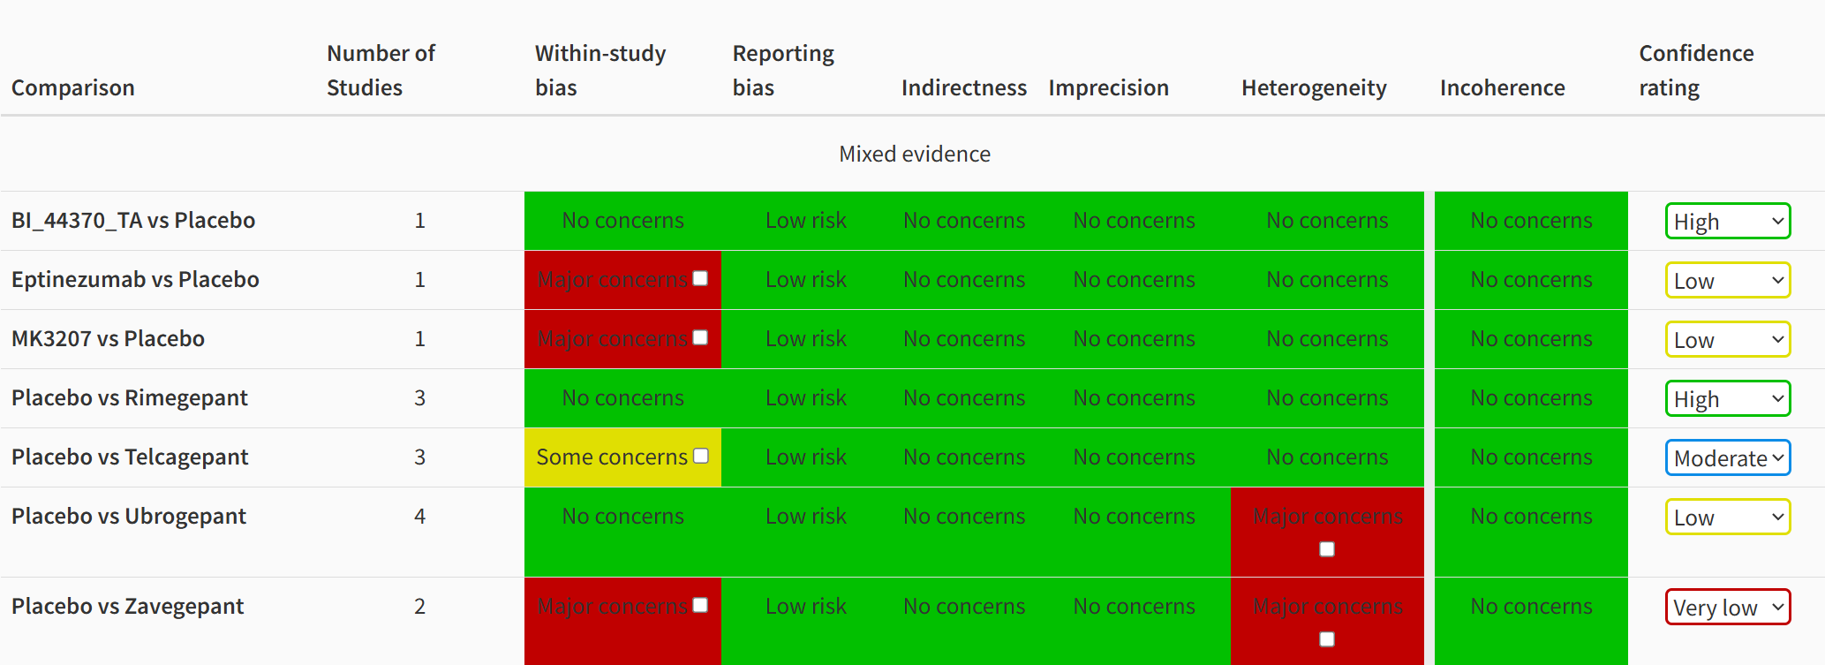

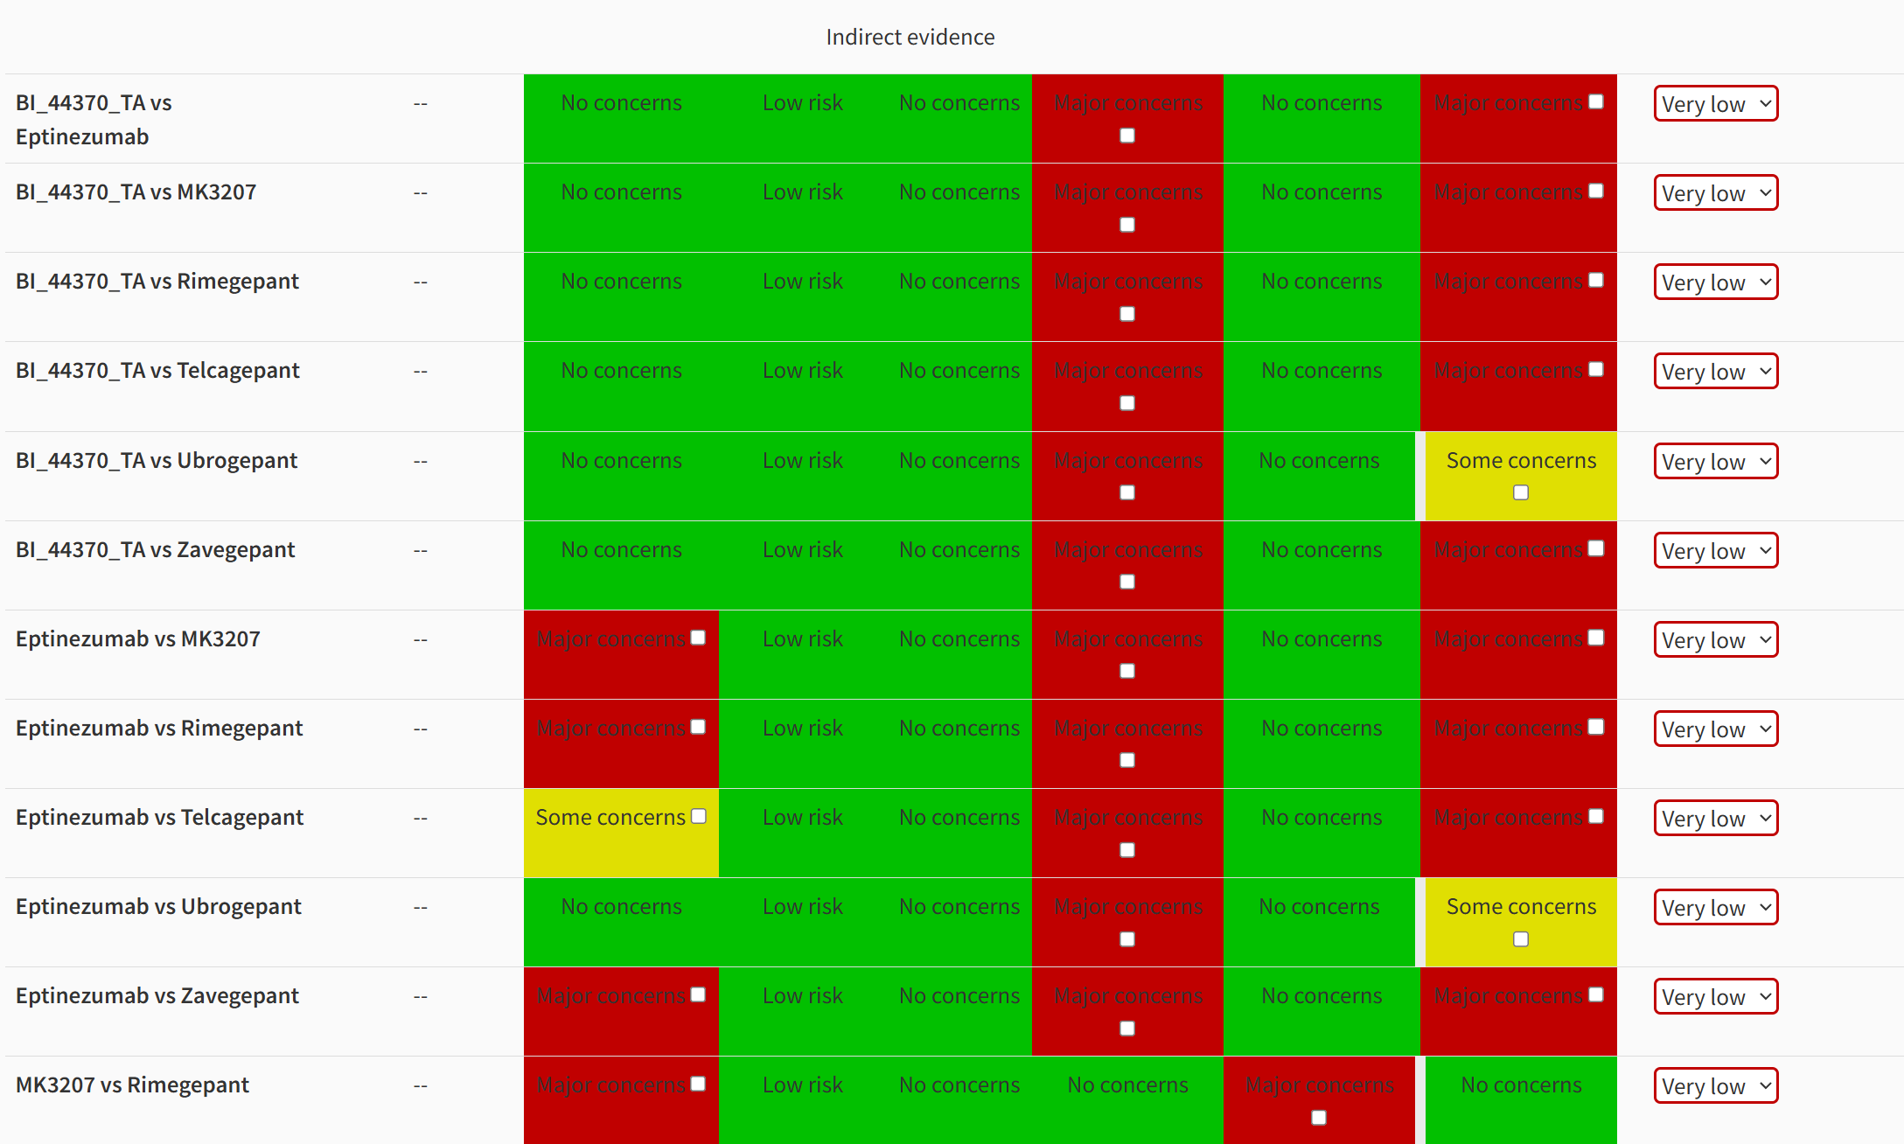
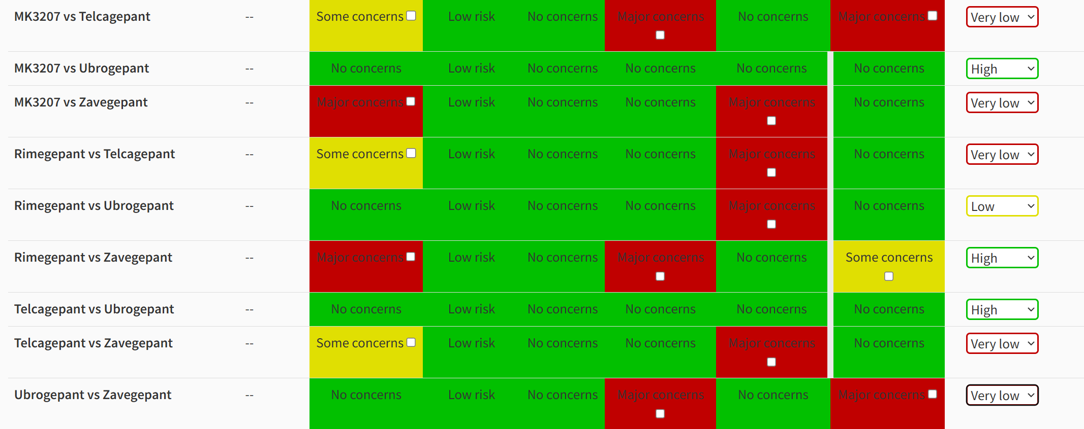

Most bothersome symptom (MBS) freedom at 2 hours
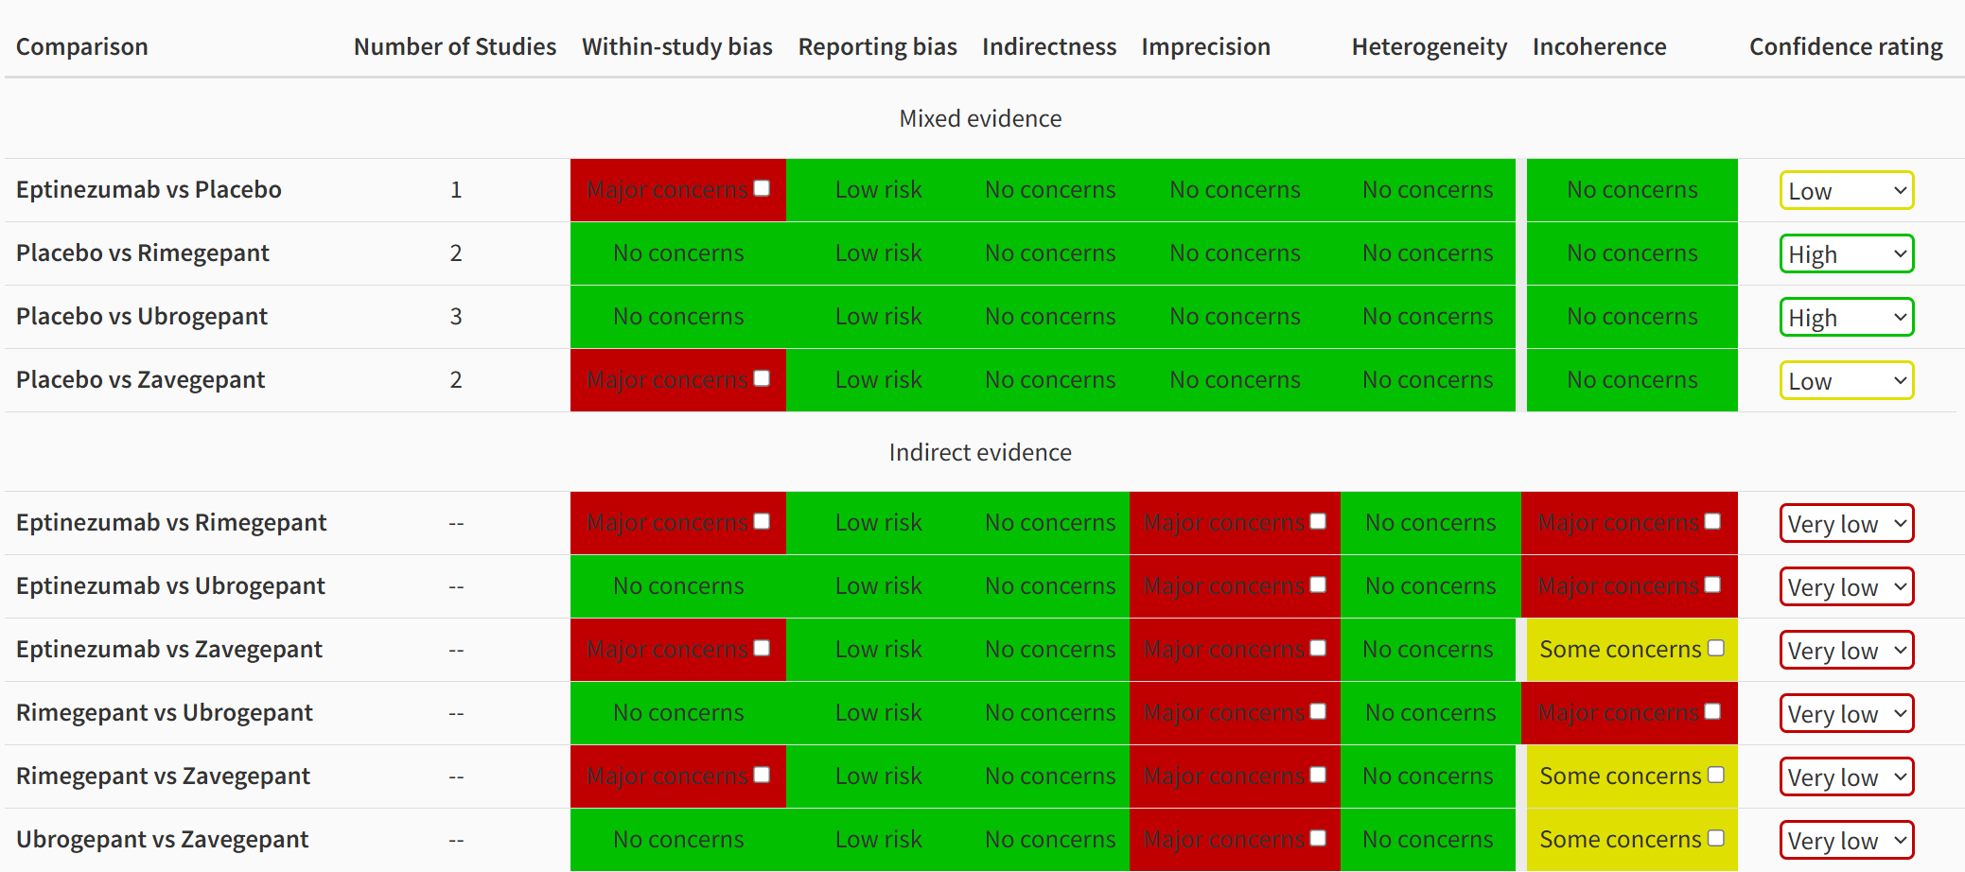

Pain relief at 2 hours
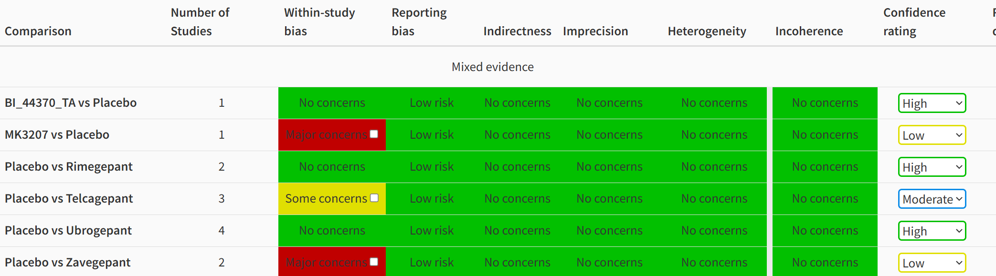

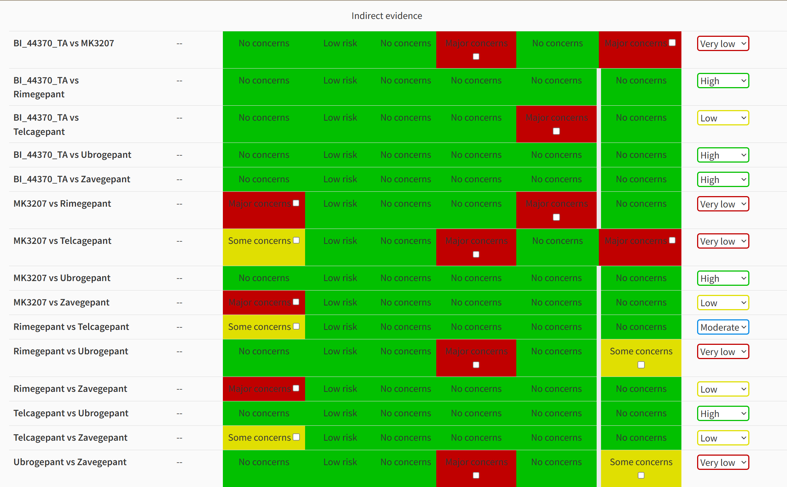

Sustained pain freedom from 2 to 24 hours

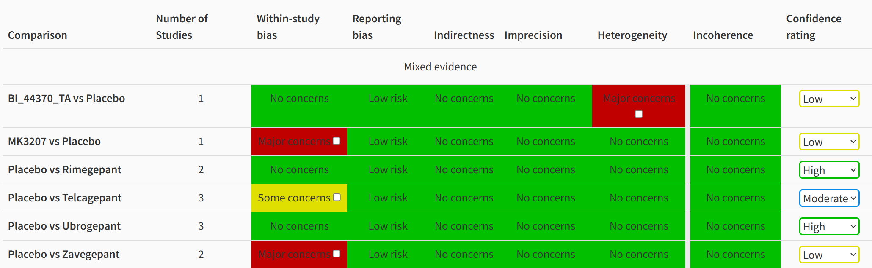
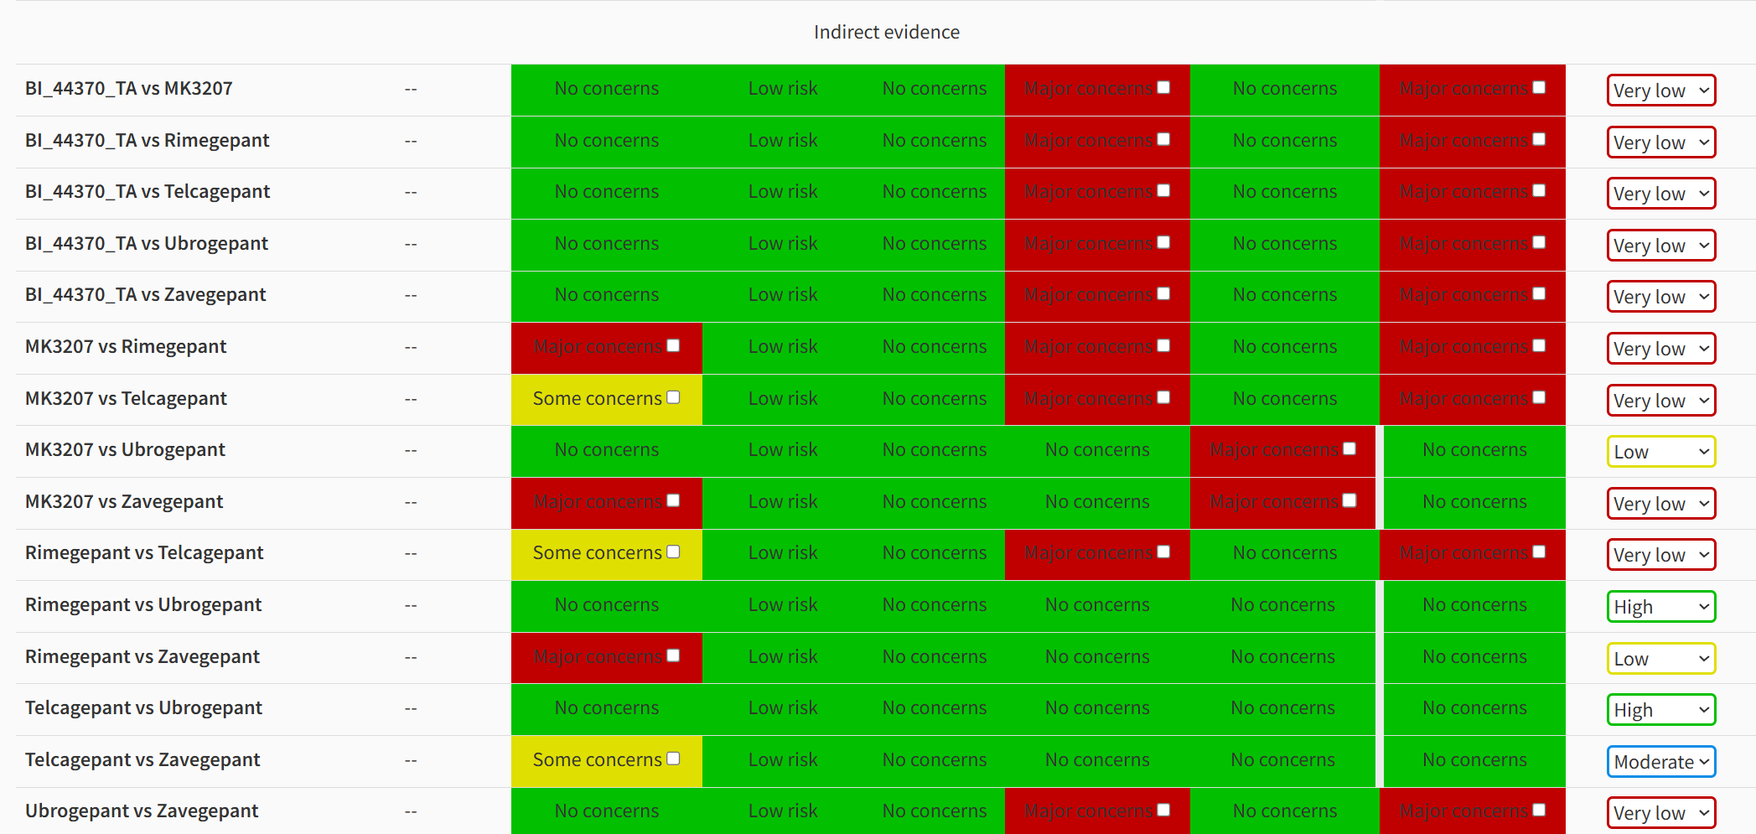
Sustained pain freedom from 2 to 48 hours
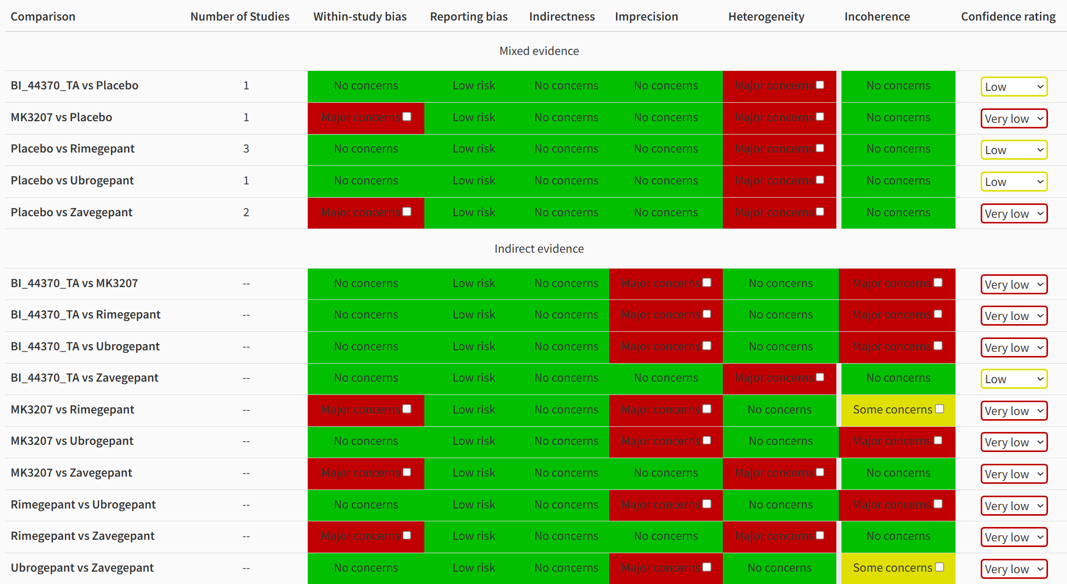
Sustained pain relief from 2 to 24 hours
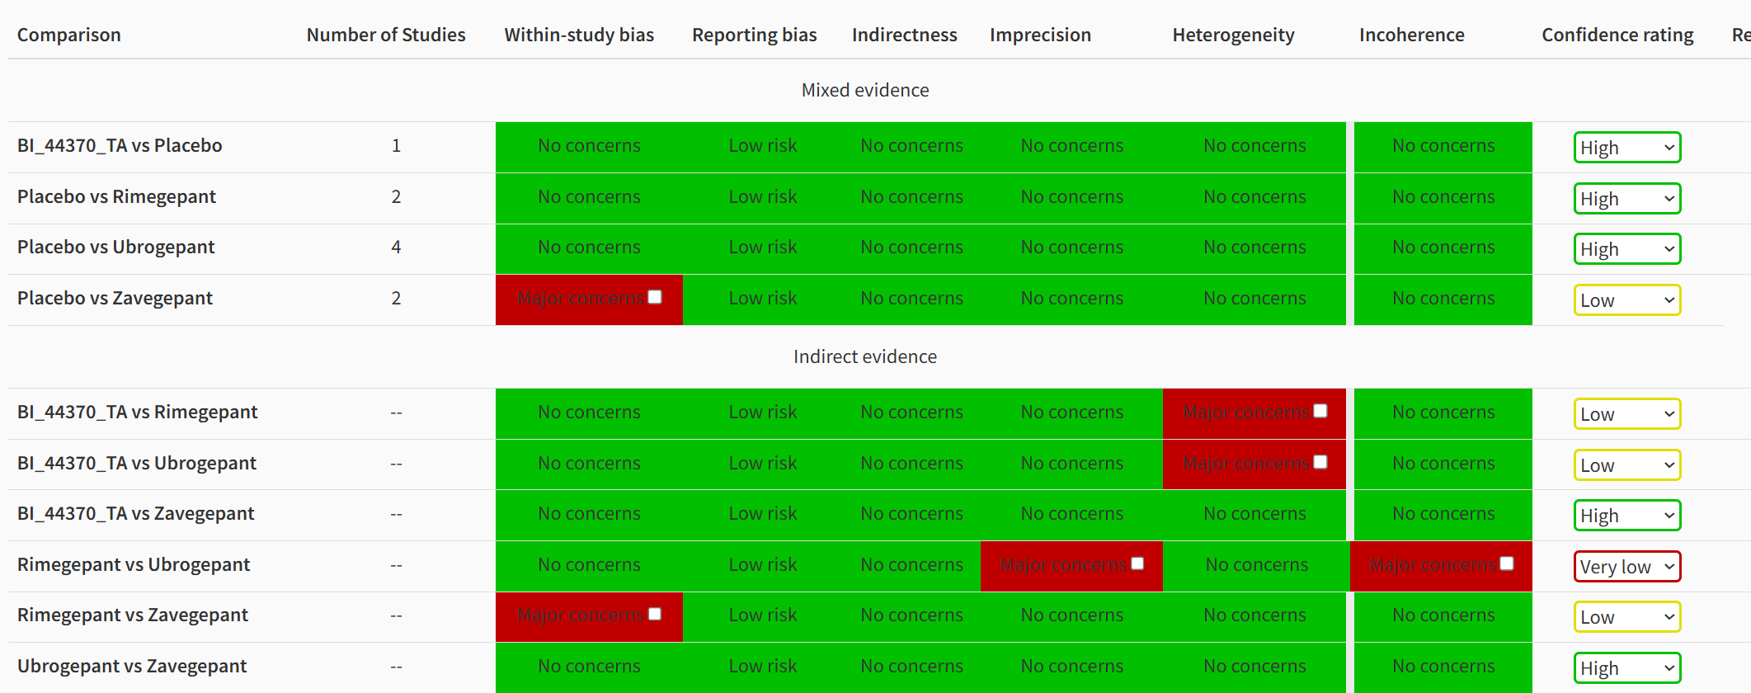
Sustained pain relief from 2 to 48 hours
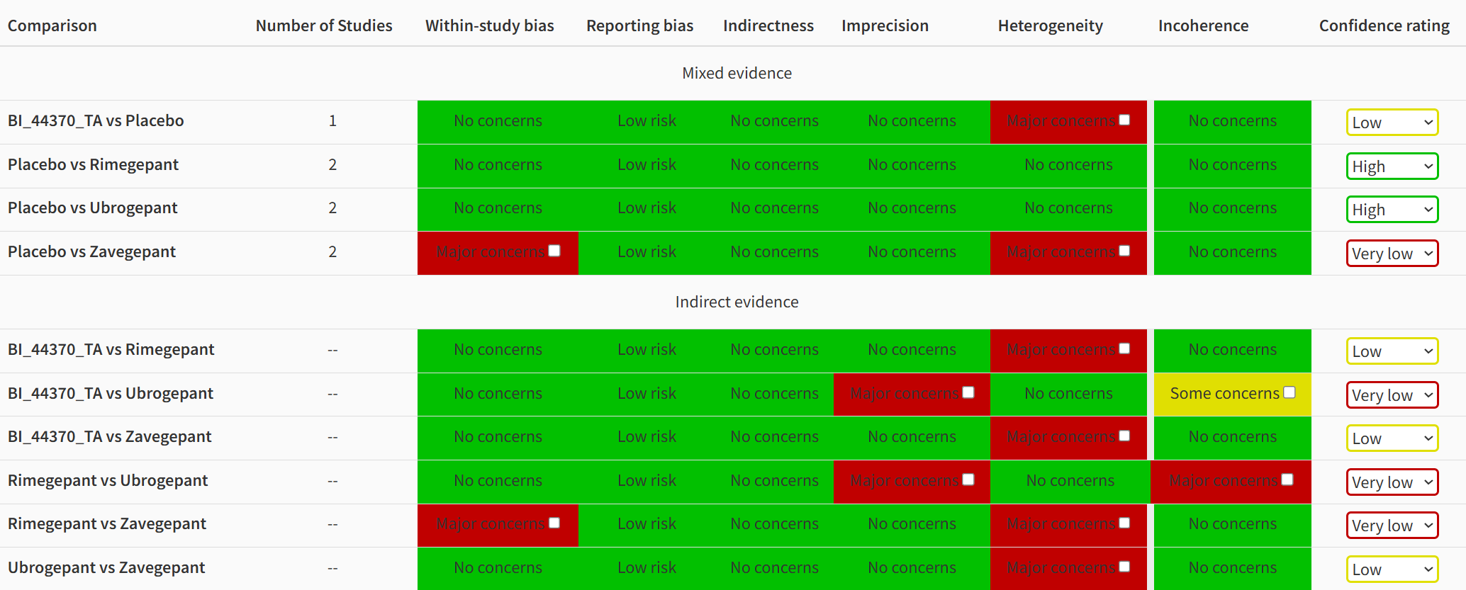
Freedom from phonophobia at 2 hours
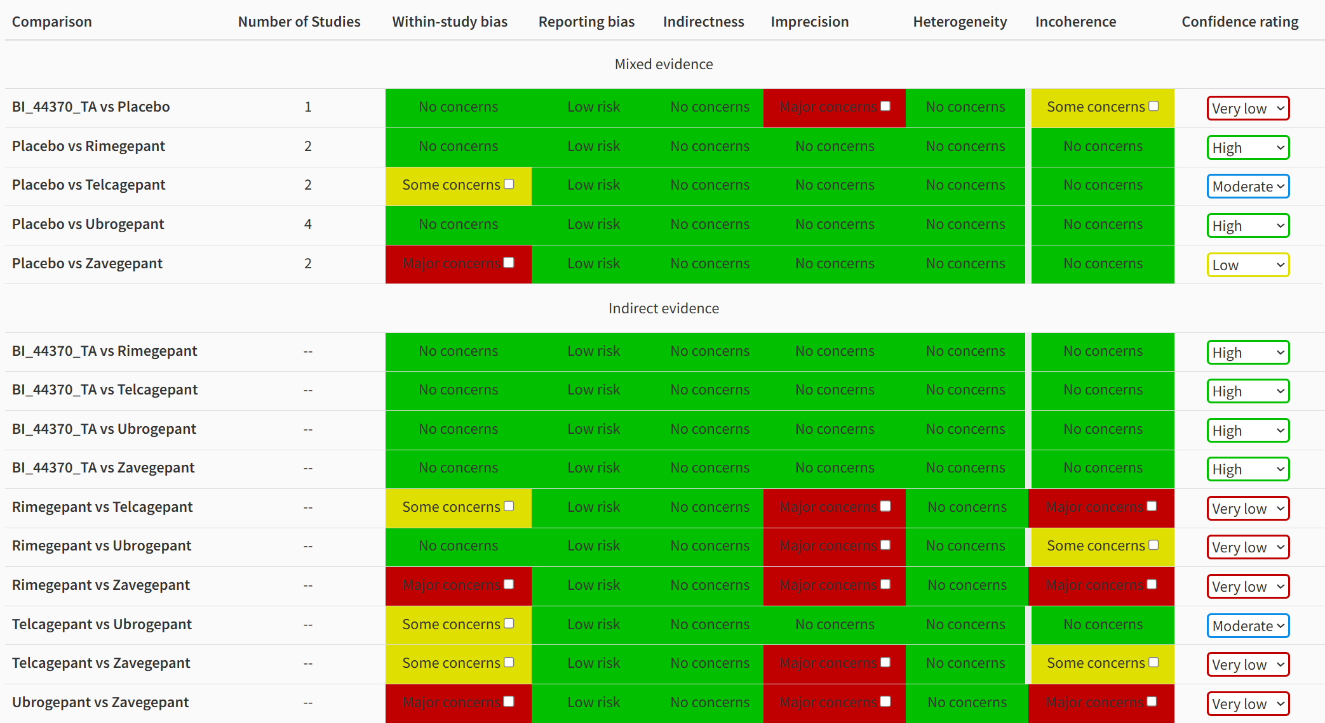
Freedom from photophobia at 2 hours
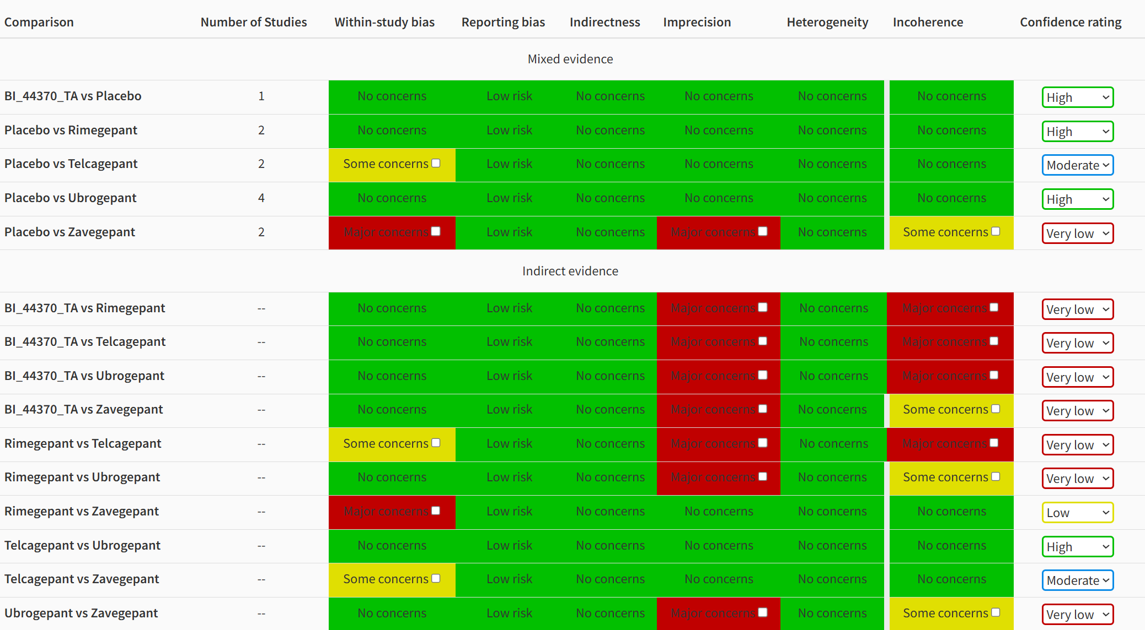
Adverse events
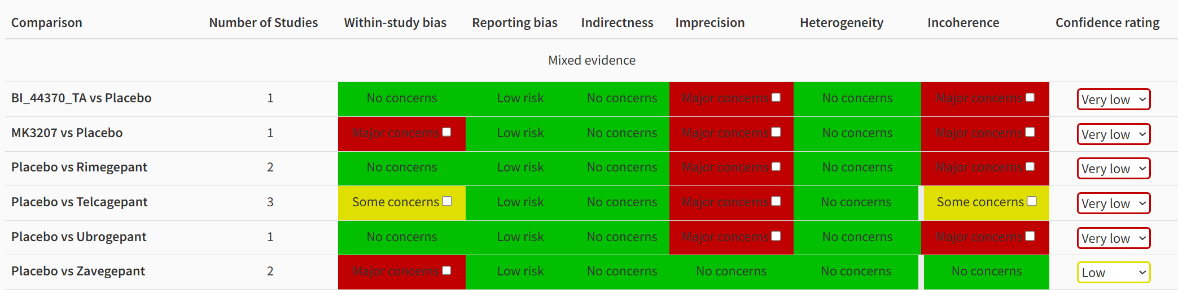
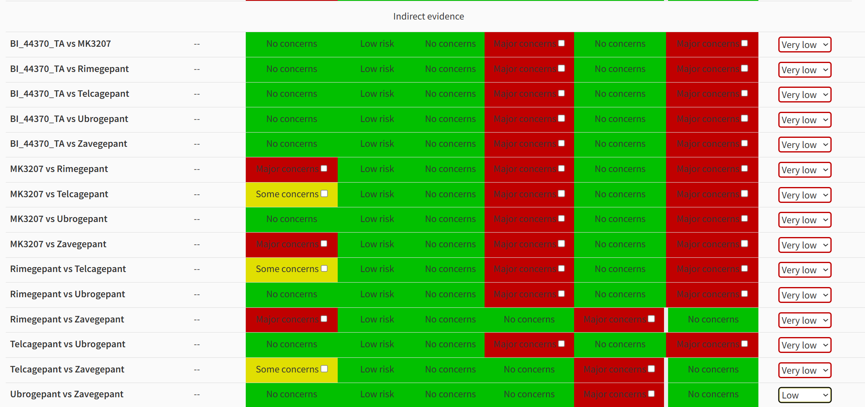

eFig.1 Funnel plots of the efficacy outcomes.
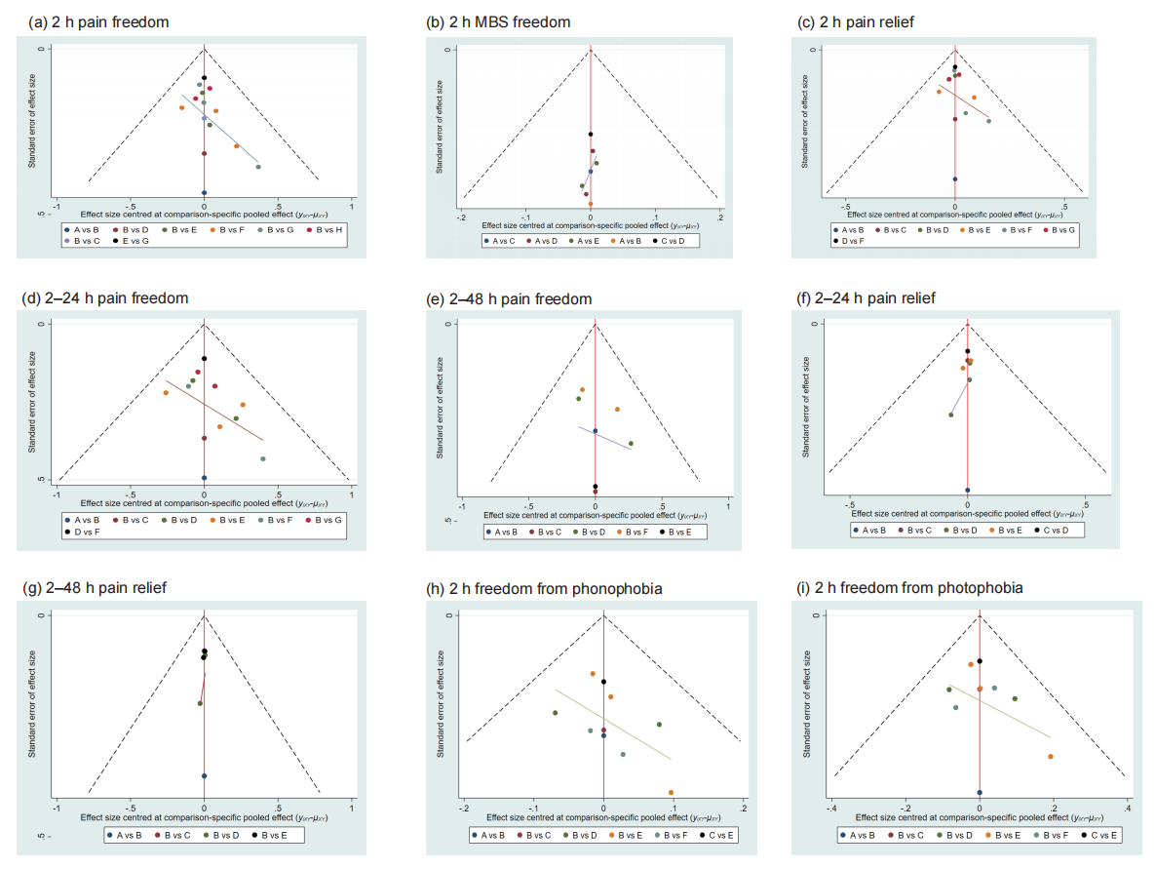
(a-b) Primary outcome: (a) pain freedom at 2 hours. (b) freedom from the most bothersome symptom (MBS) at 2 hours. (c-i) Secondary outcome: (c) pain relief at 2 hours. (d) sustained pain freedom from 2 to 24 hours. (e) sustained pain freedom from 2 to 4 hours. (f) sustained pain relief from 2 to 24 hours. (g) sustained pain relief from 2 to 4 hours. (h) phonophobia freedom at 2 hours. (i) photophobia freedom at 2 hours.
eFig.2 Trace and density of the network meta-analysis: pain freedom at 2 hours.
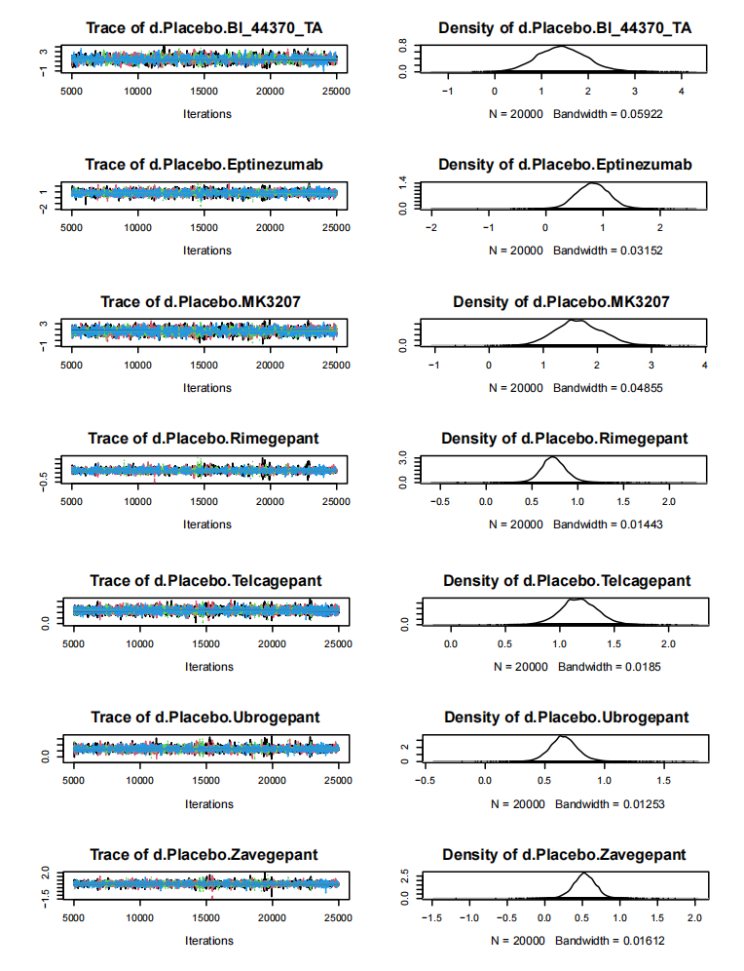

eFig.3 Trace and density of the network meta-analysis: freedom from MBS at 2 hours.
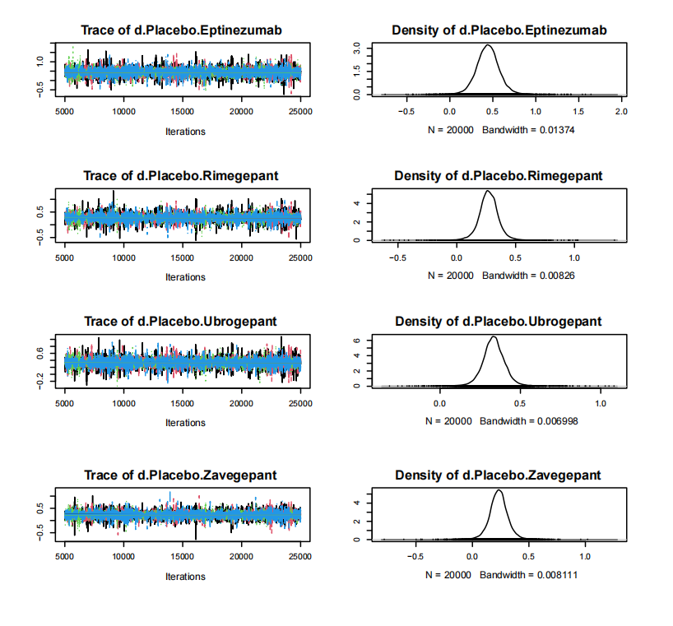

eFig.4 Trace and density of the network meta-analysis: pain relief at 2 hours.
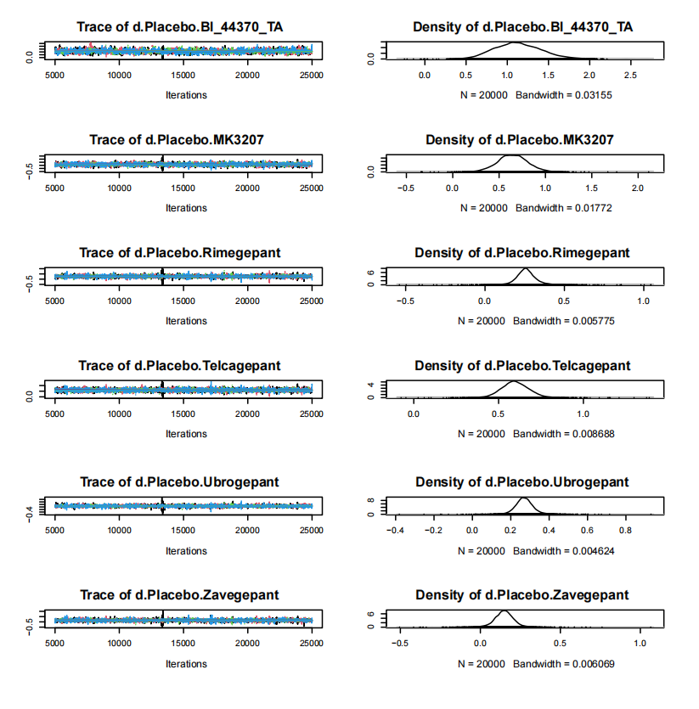

eFig.5 Trace and density of the network meta-analysis: sustained pain freedom from 2 to 24 hours.
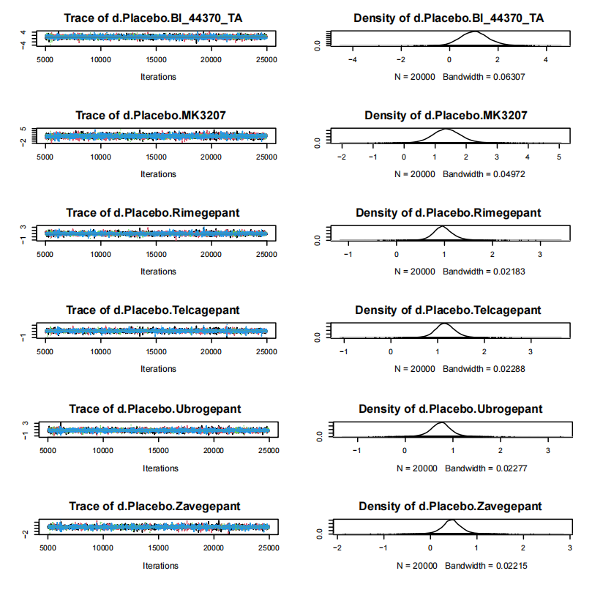

eFig.6 Trace and density of the network meta-analysis: sustained pain freedom from 2 to 48 hours.
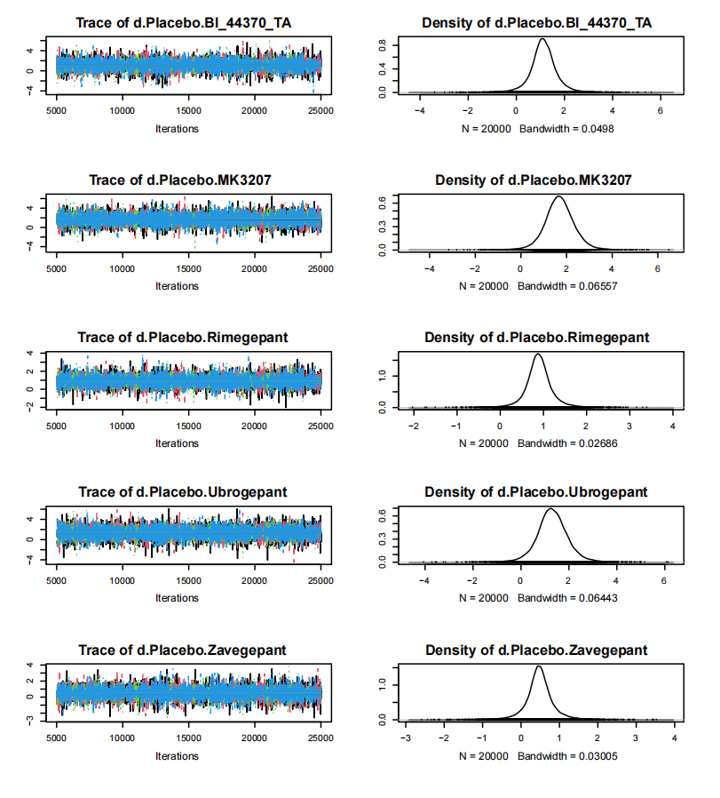

eFig.7 Trace and density of the network meta-analysis: sustained pain relief from 2 to 24 hours.
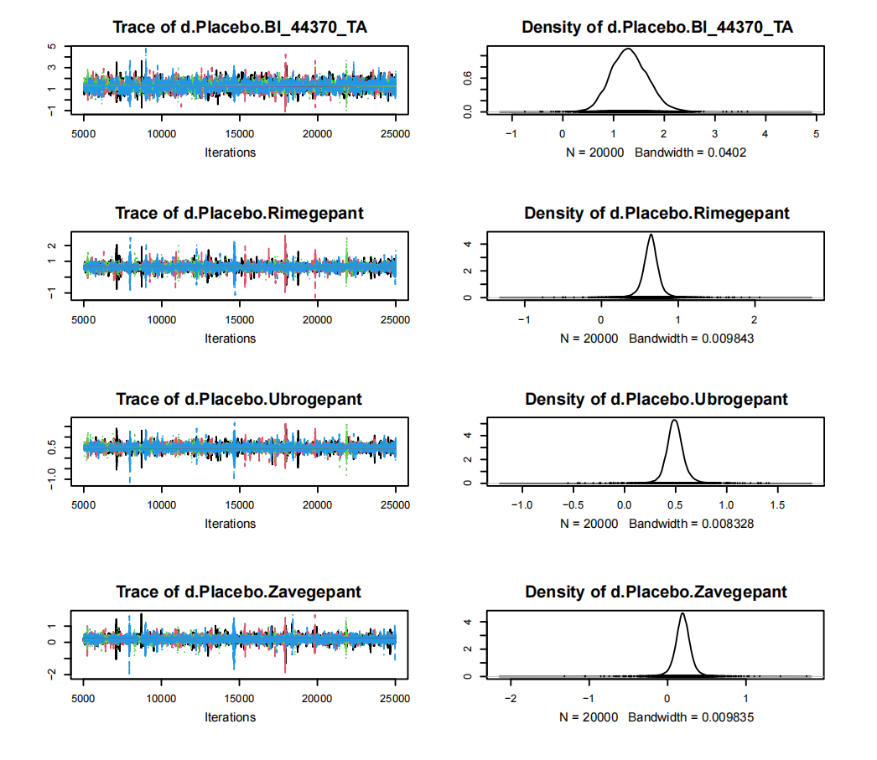

eFig.8 Trace and density of the network meta-analysis: sustained pain relief from 2 to 48 hours.
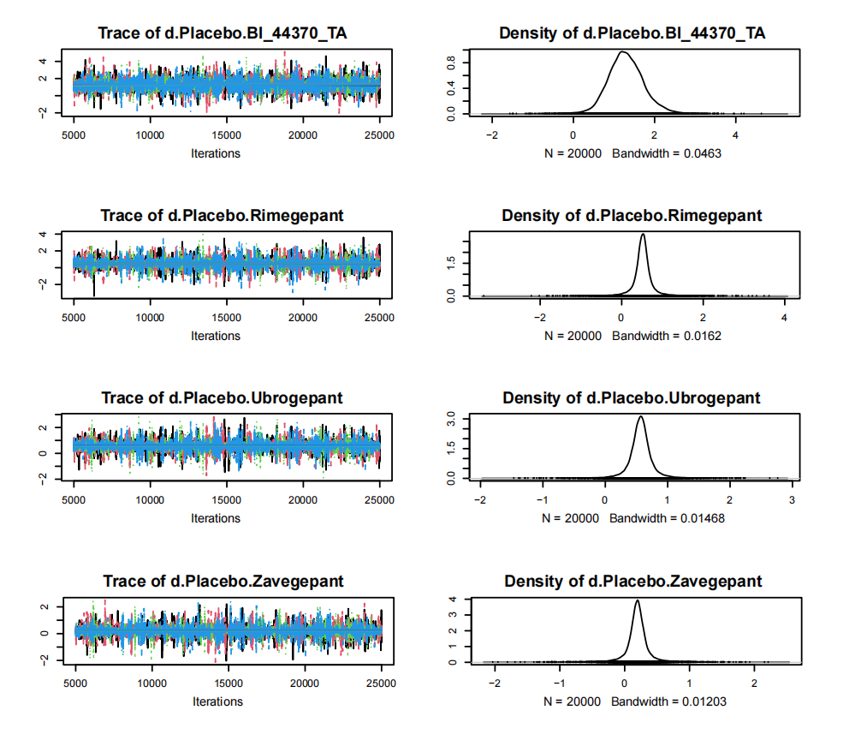

eFig.9 Trace and density of the network meta-analysis: phonophobia freedom at 2 hours.
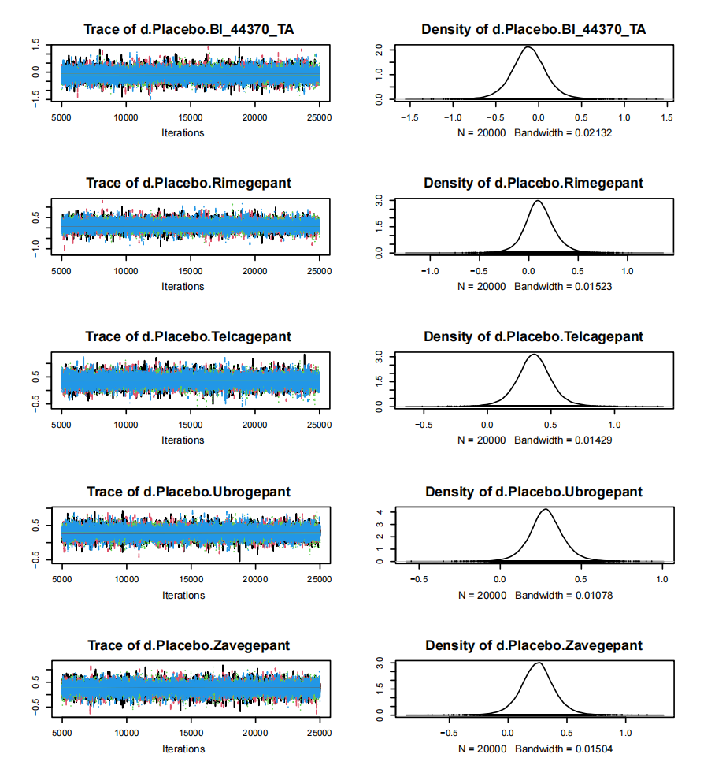

eFig.10 Trace and density of the network meta-analysis: photophobia freedom at 2 hours.
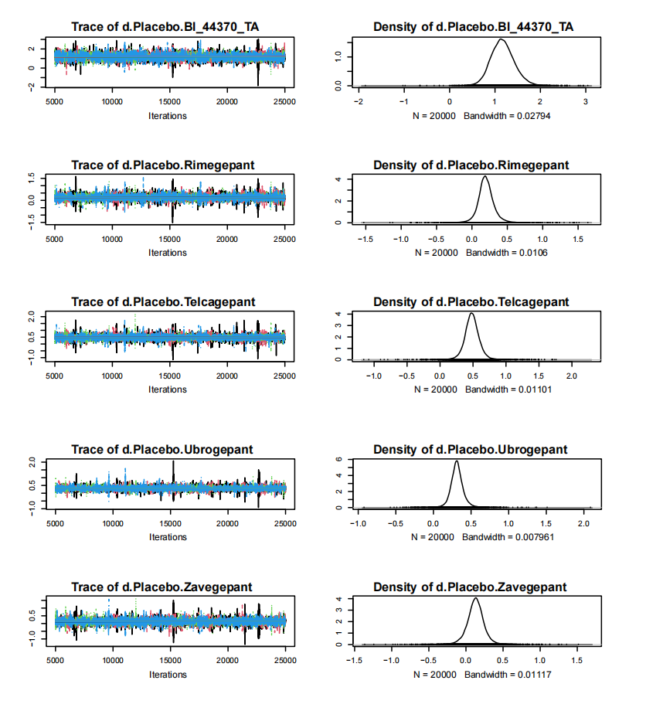

eFig.11 Convergence diagnostic charts of the network meta-analysis: pain freedom at 2 hours.
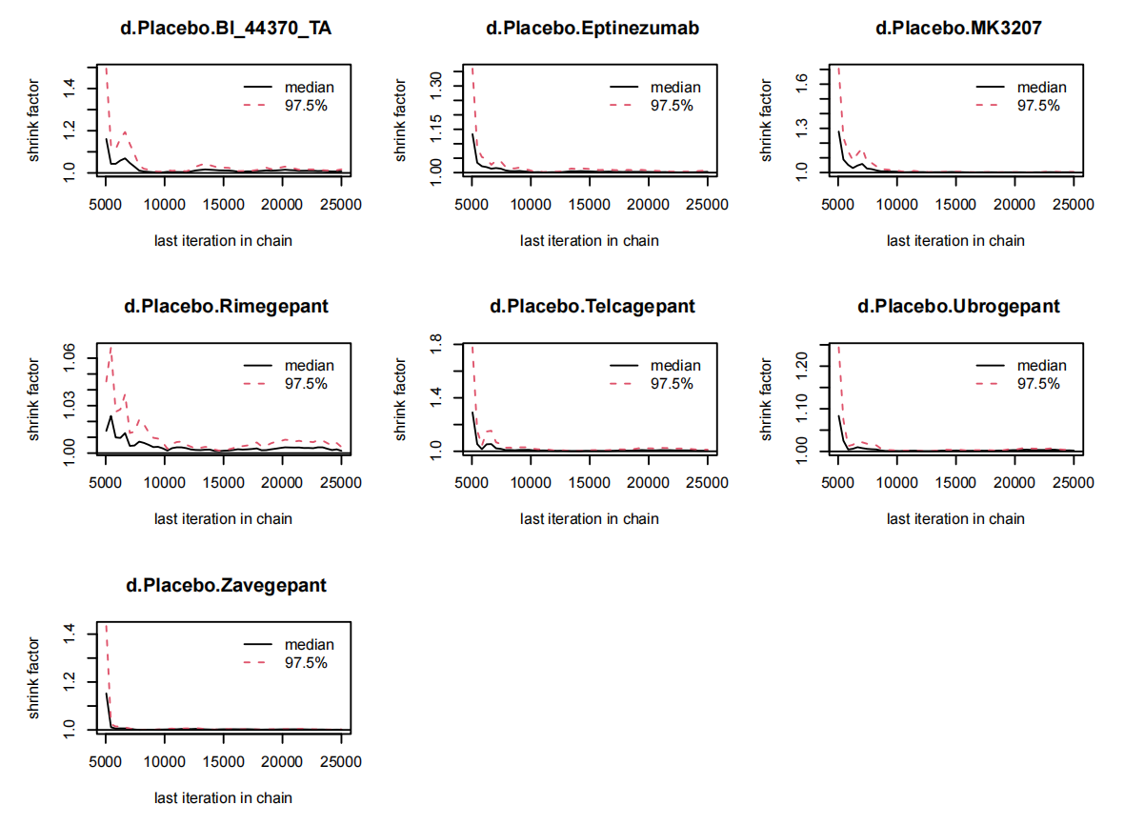
eFig.12 Convergence diagnostic charts of the network meta-analysis: freedom from MBS at 2 hours.
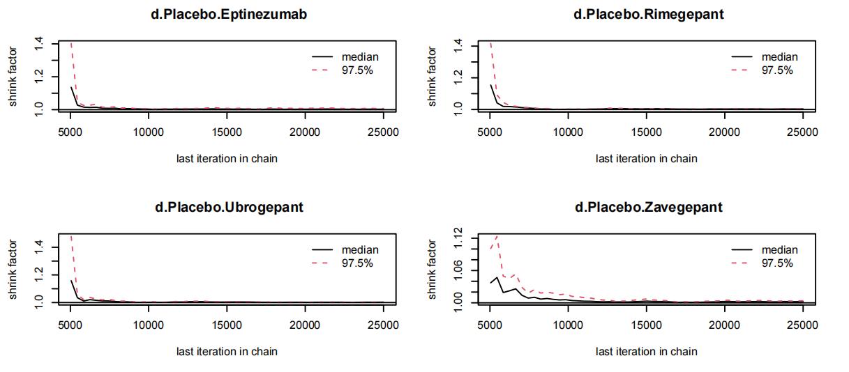

eFig.13 Convergence diagnostic charts of the network meta-analysis: pain relief at 2 hours.
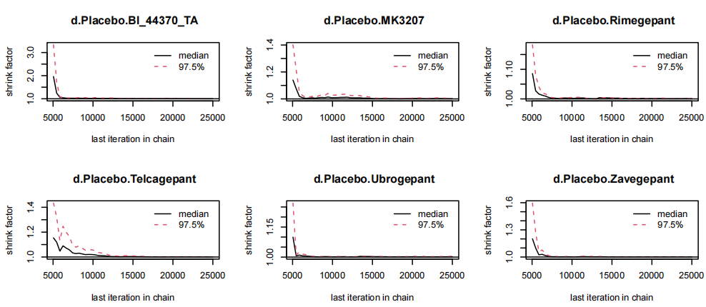

eFig.14 Convergence diagnostic charts of the network meta-analysis: sustained pain freedom from 2 to 24 hours.
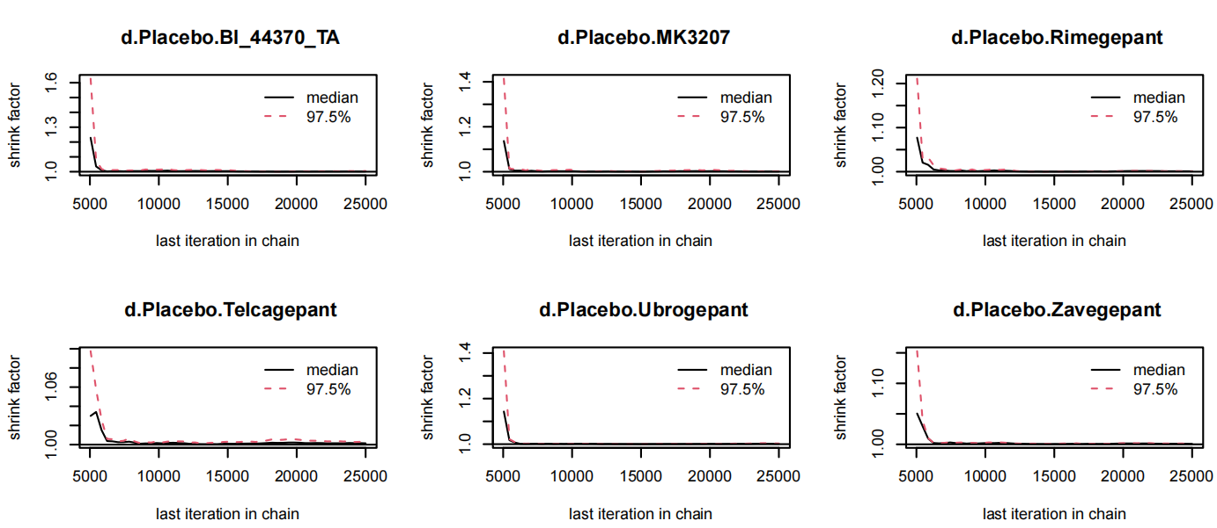

eFig.15 Convergence diagnostic charts of the network meta-analysis: sustained pain freedom from 2 to 48 hours.
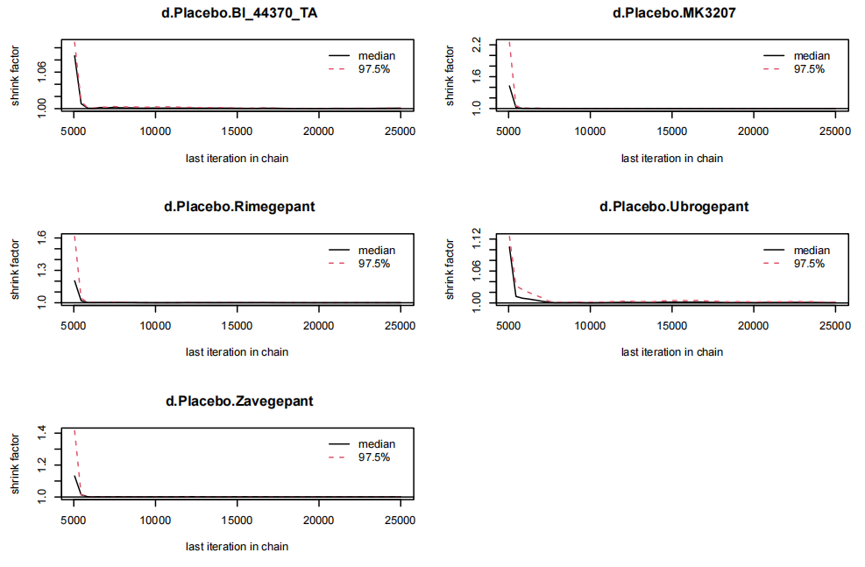

eFig.16 Convergence diagnostic charts of the network meta-analysis: sustained pain relief from 2 to 24 hours.
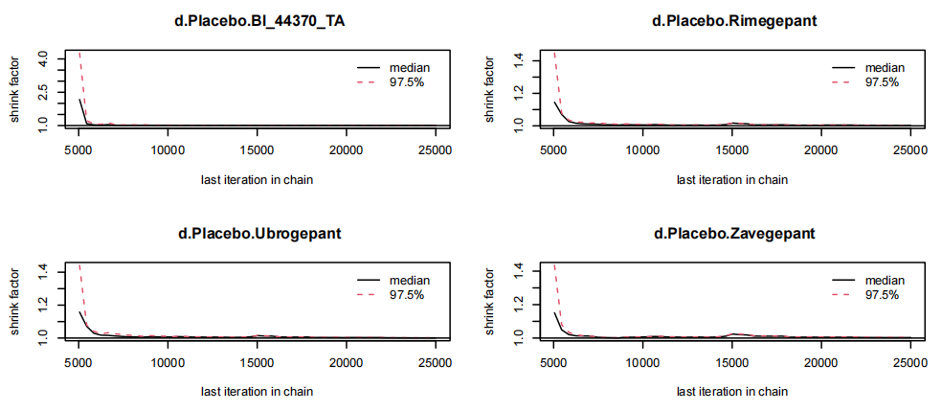

eFig.17 Convergence diagnostic charts of the network meta-analysis: sustained pain relief from 2 to 48 hours.
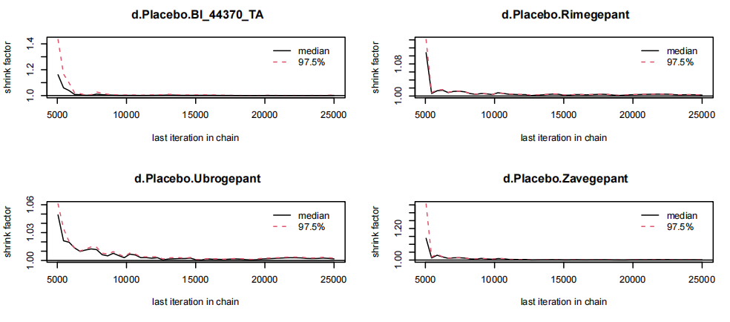

eFig.18 Convergence diagnostic charts of the network meta-analysis: phonophobia freedom at 2 hours.
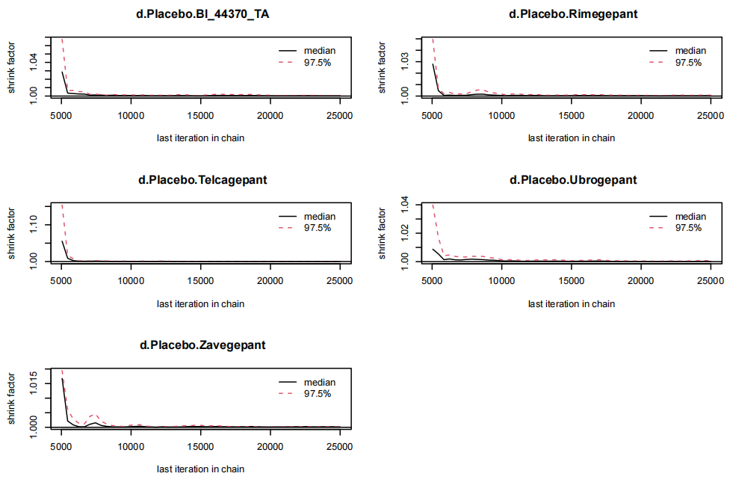

eFig.19 Convergence diagnostic charts of the network meta-analysis: photophobia freedom at 2 hours.
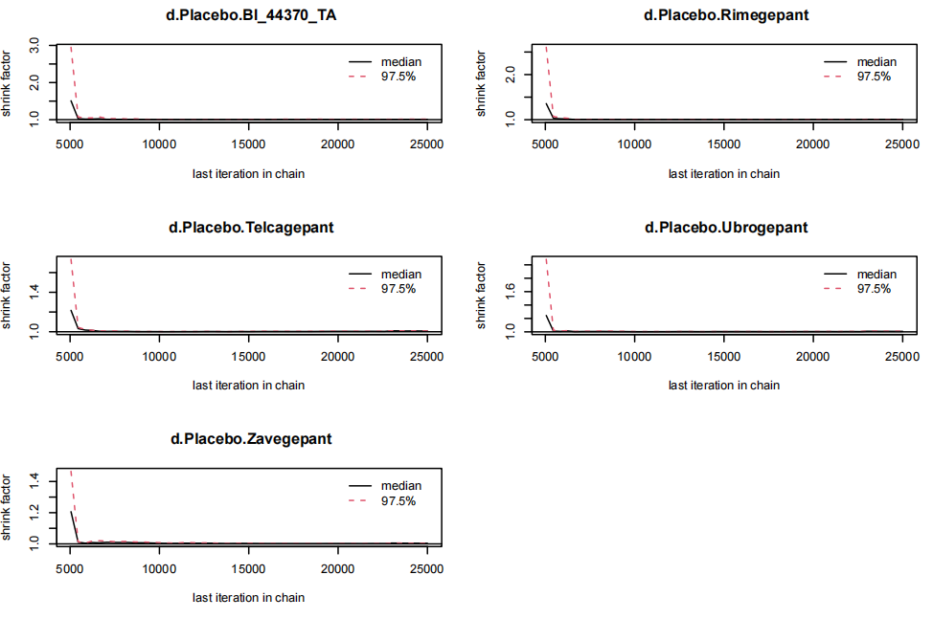
eFig.20 Forest plots for the heterogeneity: pain freedom at 2 hours.
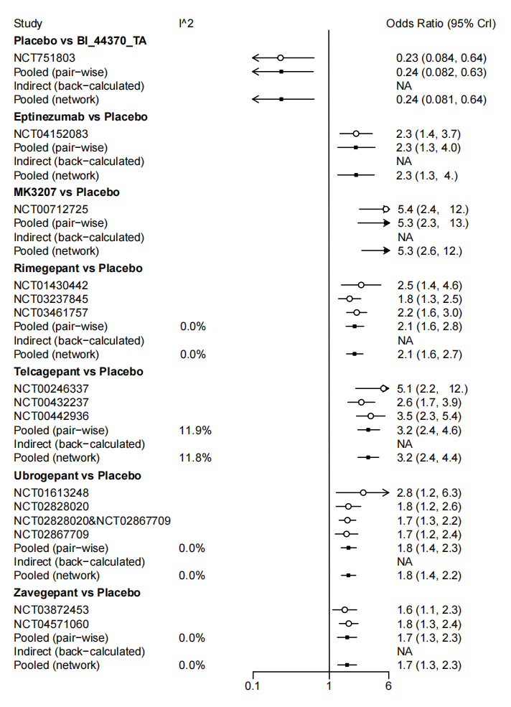

eFig.21 Forest plots for the heterogeneity: freedom from MBS at 2 hours.
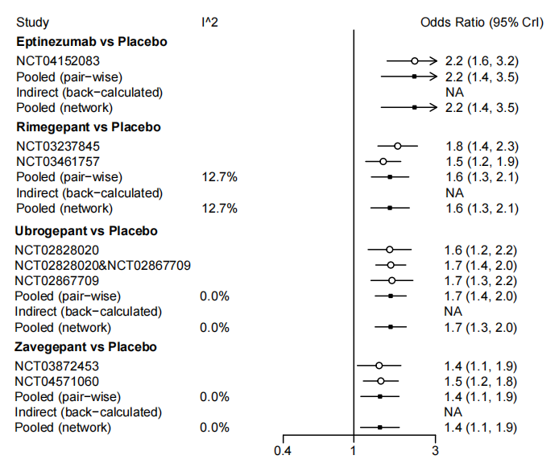

eFig.22 Forest plots for the heterogeneity: pain relief at 2 hours.
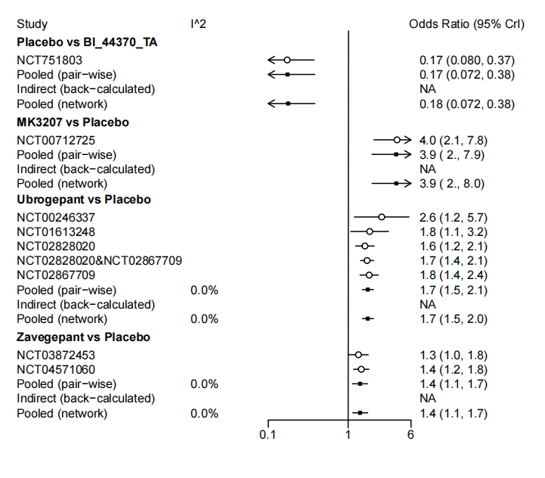

eFig.23 Forest plots for the heterogeneity: sustained pain freedom from 2 to 24 hours.
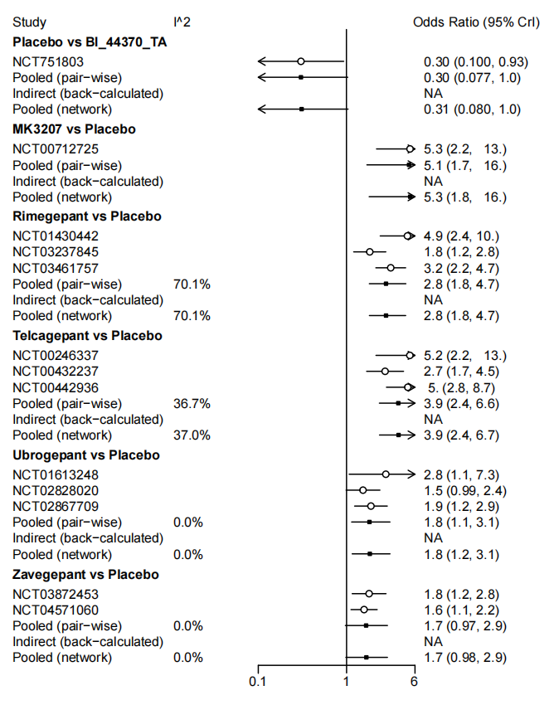
eFig.24 Forest plots for the heterogeneity: sustained pain freedom from 2 to 48 hours.
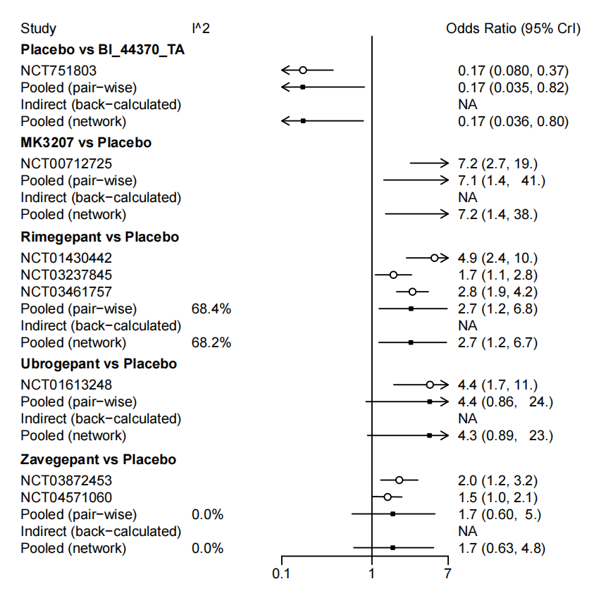

eFig.25 Forest plots for the heterogeneity: sustained pain relief from 2 to 24 hours.
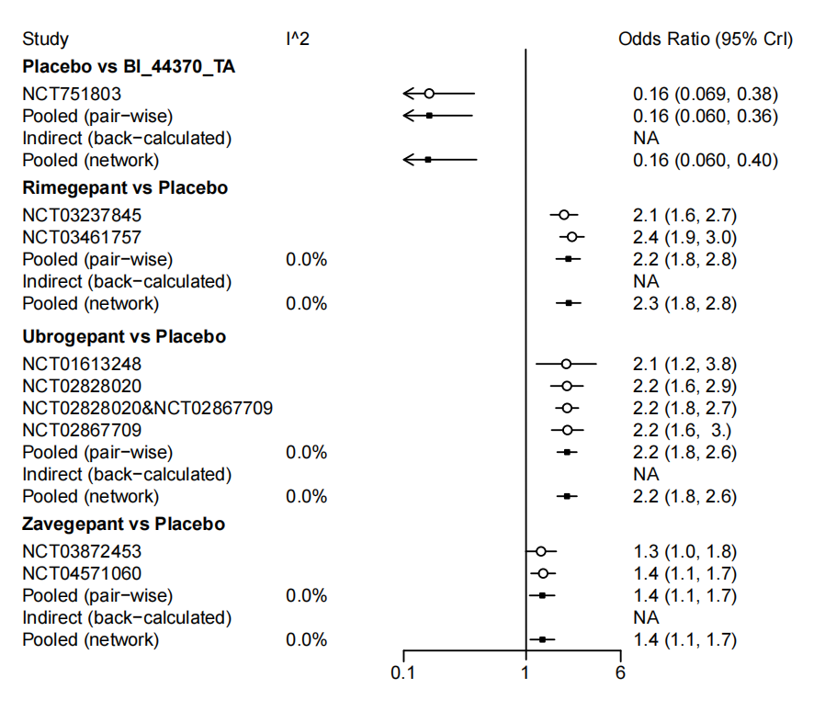

eFig.26 Forest plots for the heterogeneity: sustained pain relief from 2 to 48 hours.
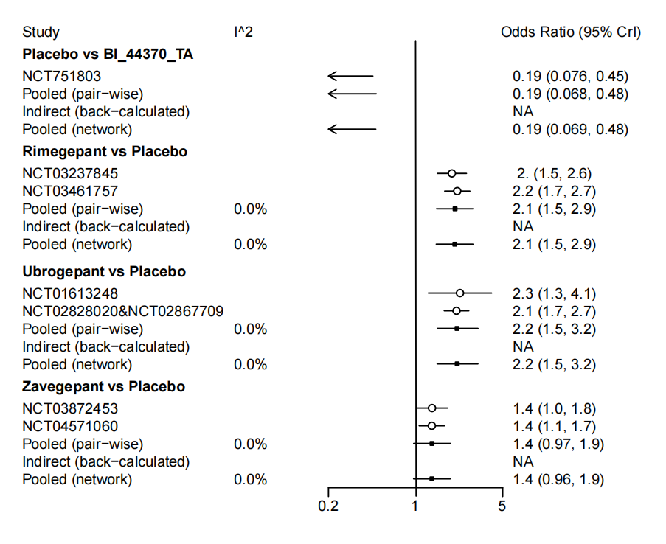

eFig.27 Forest plots for the heterogeneity: phonophobia freedom at 2 hours.
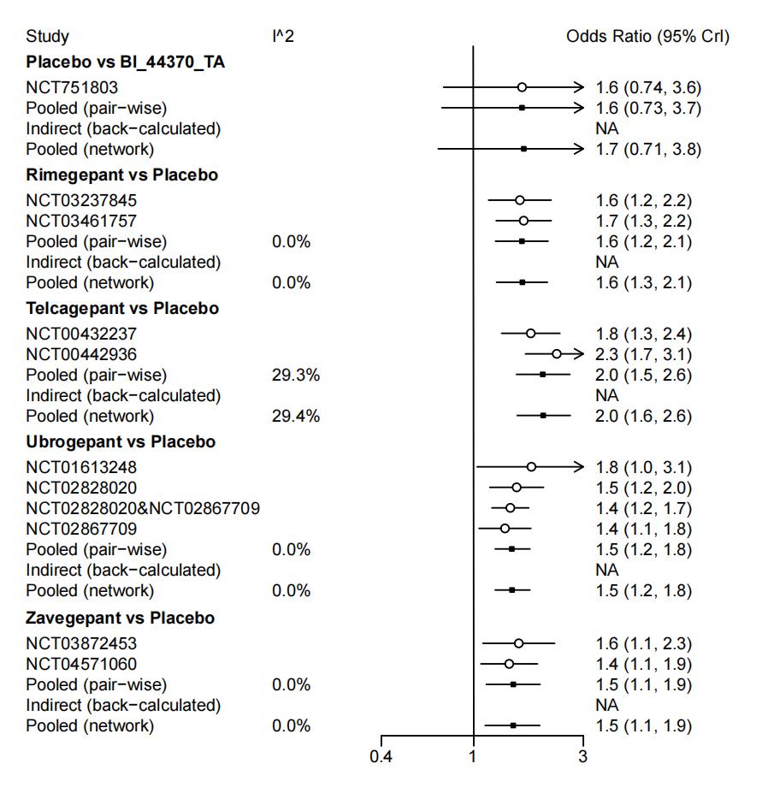

eFig.28 Forest plots for the heterogeneity: photophobia freedom at 2 hours.
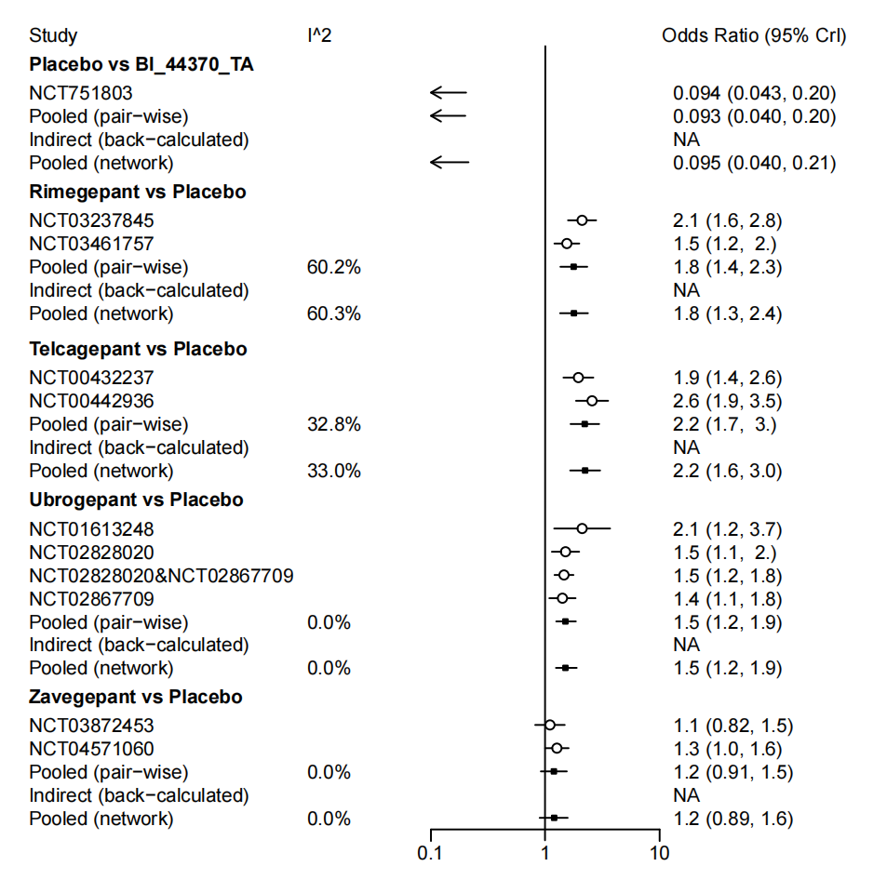

eFig.29 Forest plots of the efficacy outcomes between zavegepant and the placebo.
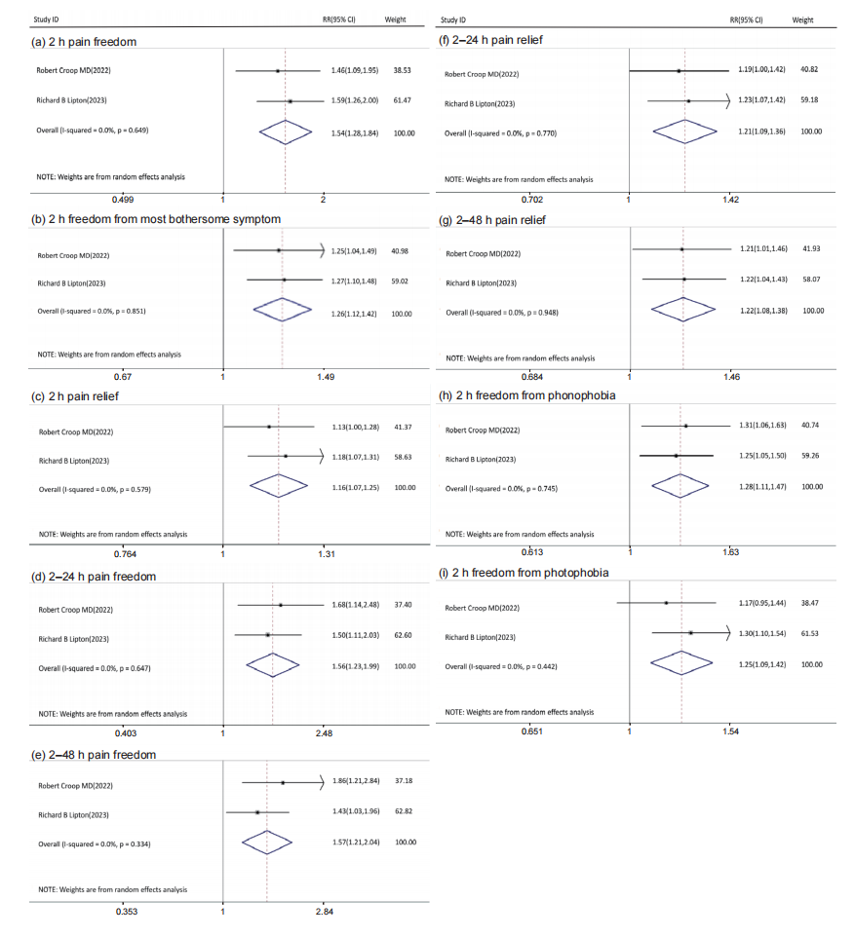
(a-b) Primary outcome: (a) pain freedom at 2 hours. (b) freedom from the most bothersome symptom (MBS) at 2 hours. (c-i) Secondary outcome: (c) pain relief at 2 hours. (d) sustained pain freedom from 2 to 24 hours. (e) sustained pain freedom from 2 to 4 hours. (f) sustained pain relief from 2 to 24 hours. (g) sustained pain relief from 2 to 4 hours. (h) phonophobia freedom at 2 hours. (i) photophobia freedom at 2 hours.

eFig.30 Forest plots of the primary outcome: pain freedom at 2 hours.
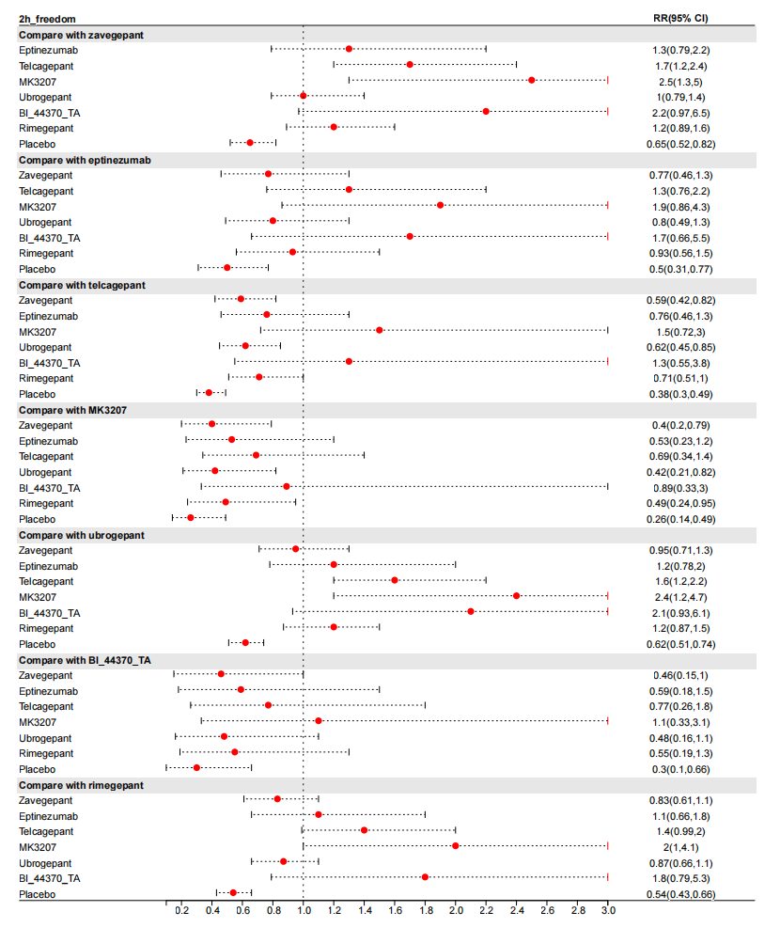

eFig.31 Forest plots of the primary outcome: freedom from MBS at 2 hours.
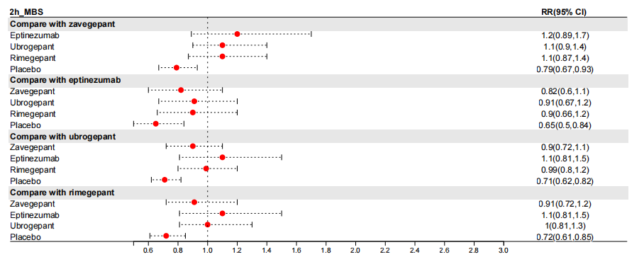

eFig.32 Forest plots of the efficacy outcomes between the placebo and the CGRP receptor antagonists.
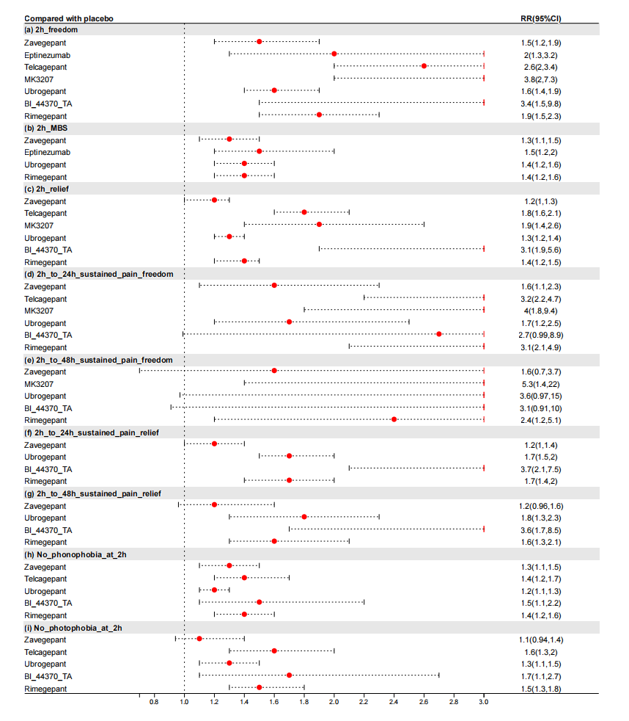

eFig.33 Forest plots of the efficacy outcomes between zavegepant and the oral CGRP receptor antagonists.
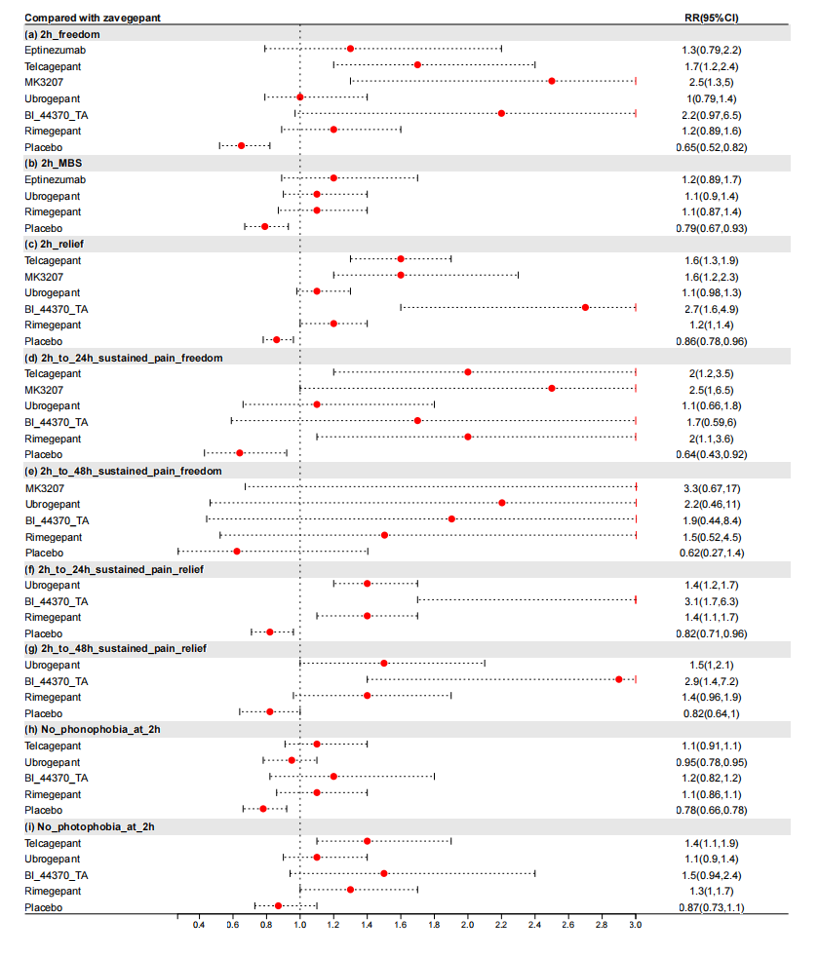

eFig.34 Forest plots of the secondary outcome: pain relief at 2 hours.
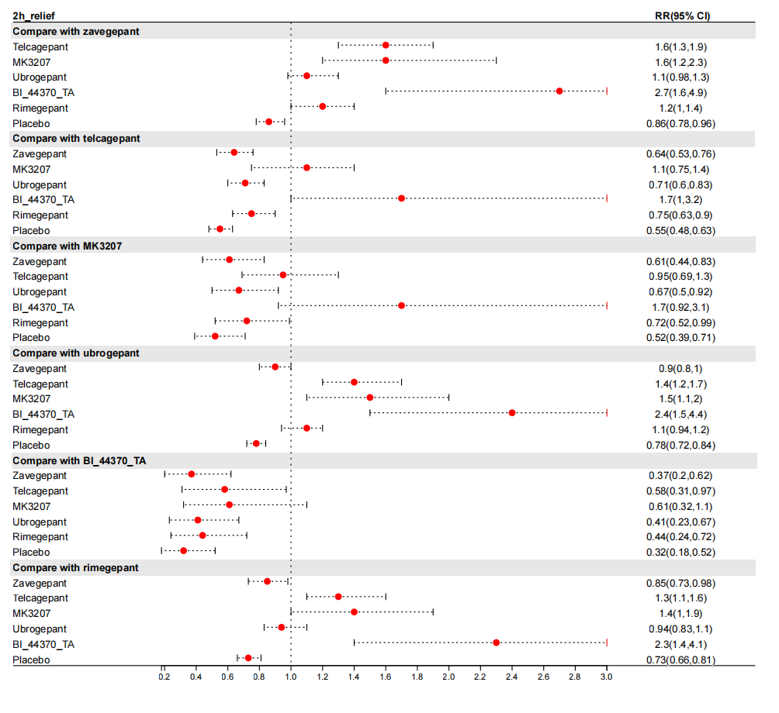

eFig.35 Forest plots of the secondary outcome: sustained pain freedom from 2 to 24 hours.
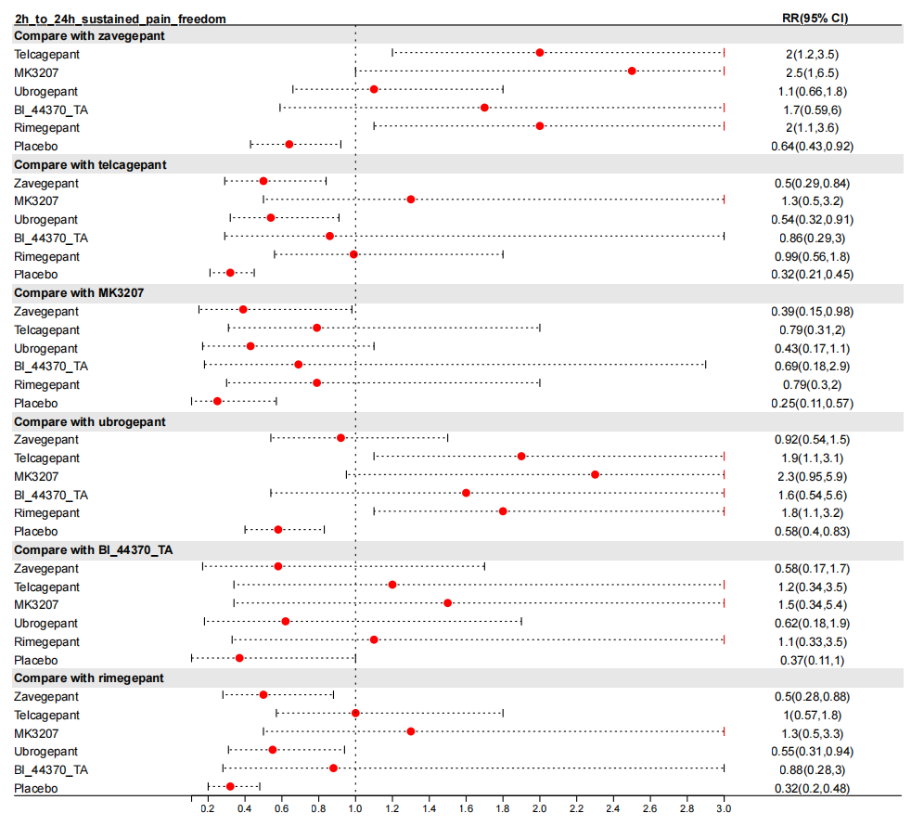

eFig.36 Forest plots of the secondary outcome: sustained pain freedom from 2 to 48 hours.
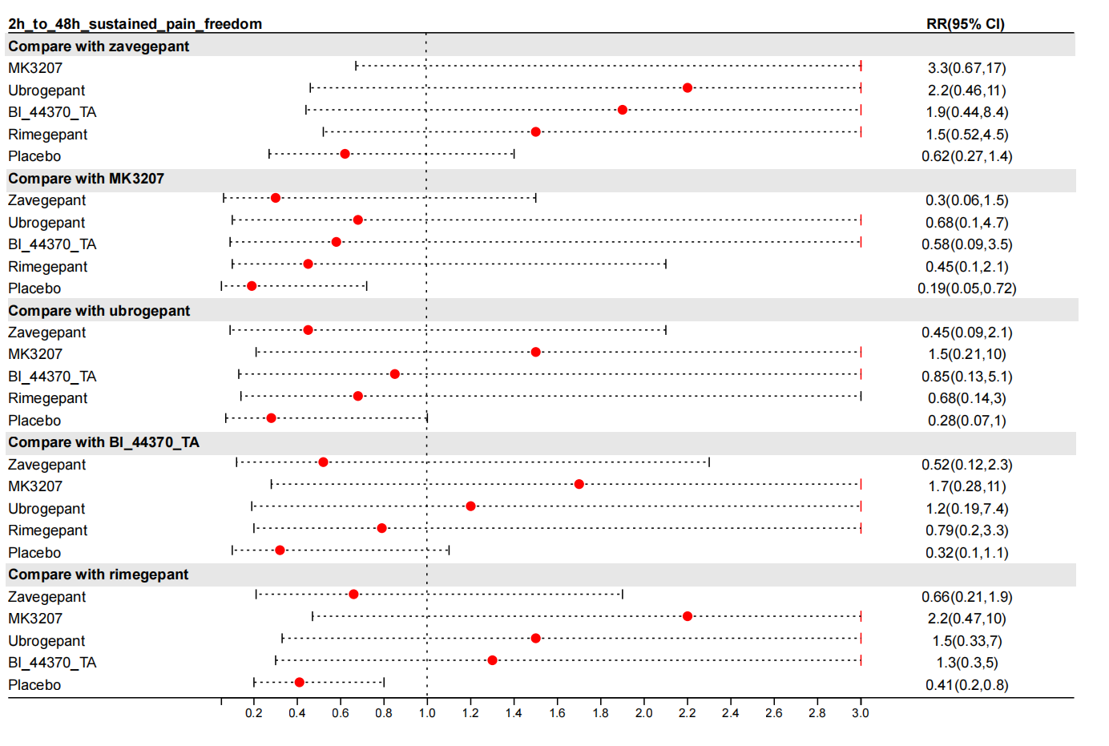

eFig.37 Forest plots of the secondary outcome: sustained pain relief from 2 to 24 hours.
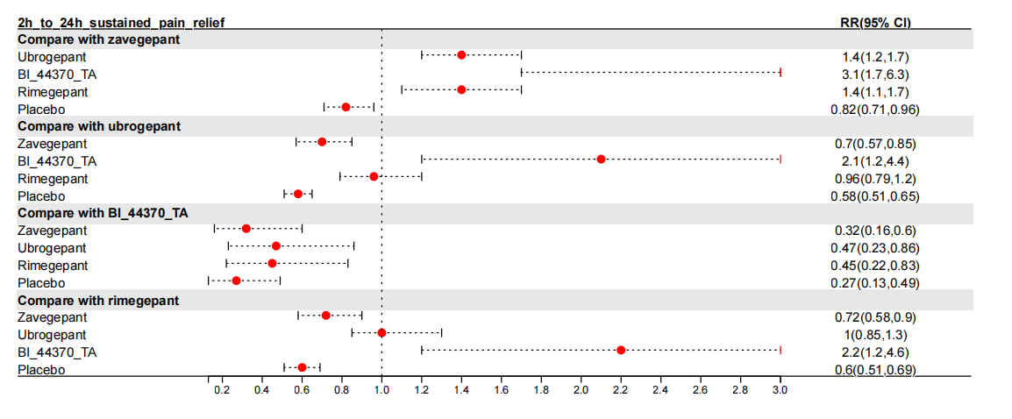

eFig.38 Forest plots of the secondary outcome: sustained pain relief from 2 to 48 hours.
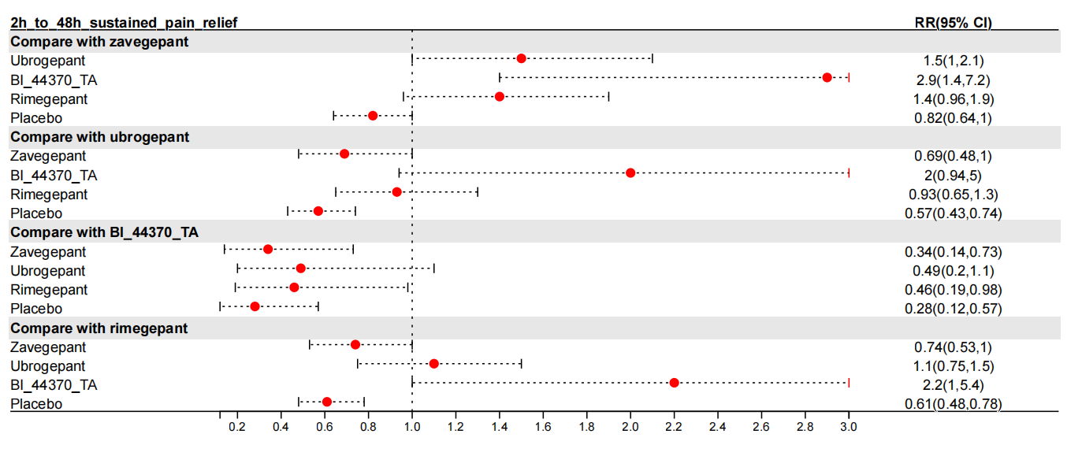

eFig.39 Forest plots of the secondary outcome: phonophobia freedom at 2 hours.
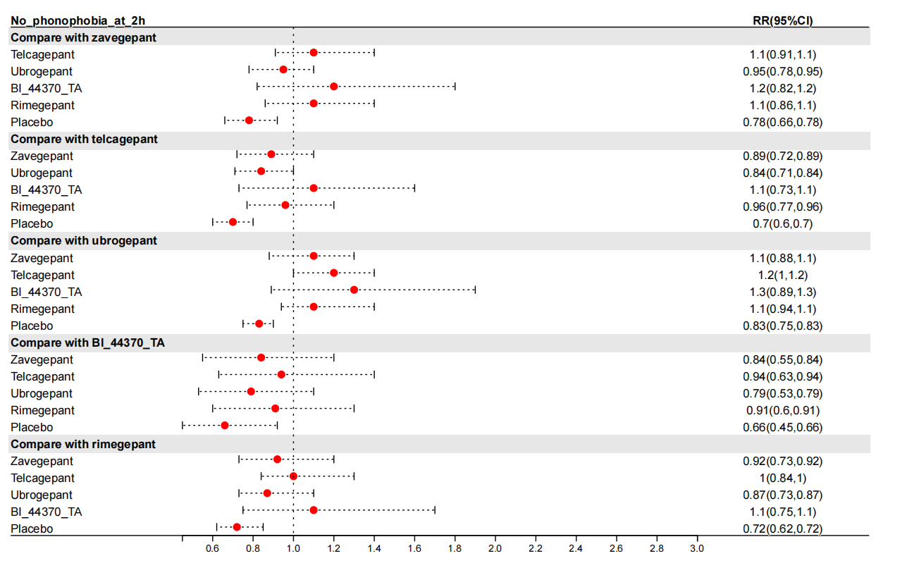

eFig.40 Forest plots of the secondary outcome: photophobia freedom at 2 hours.
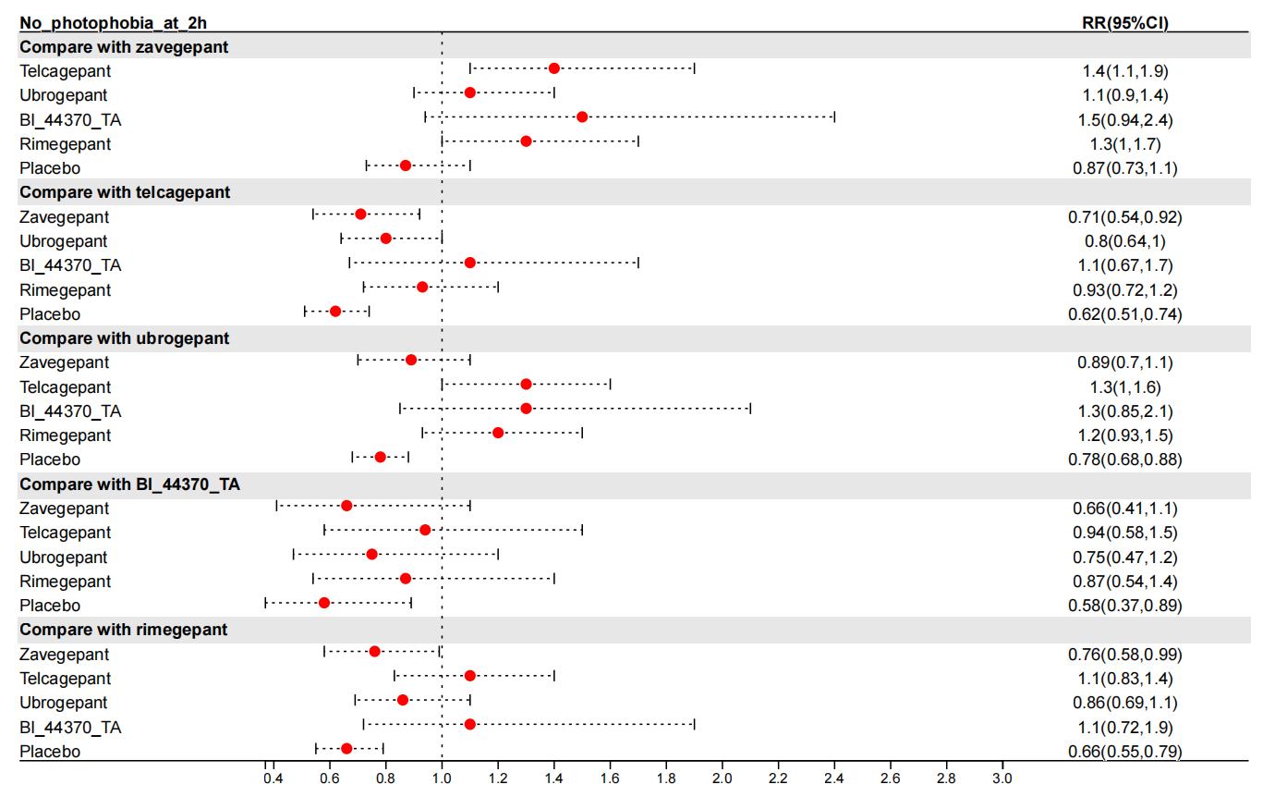

eFig.41 Forest plots of the safety outcomes between zavegepant and the placebo.
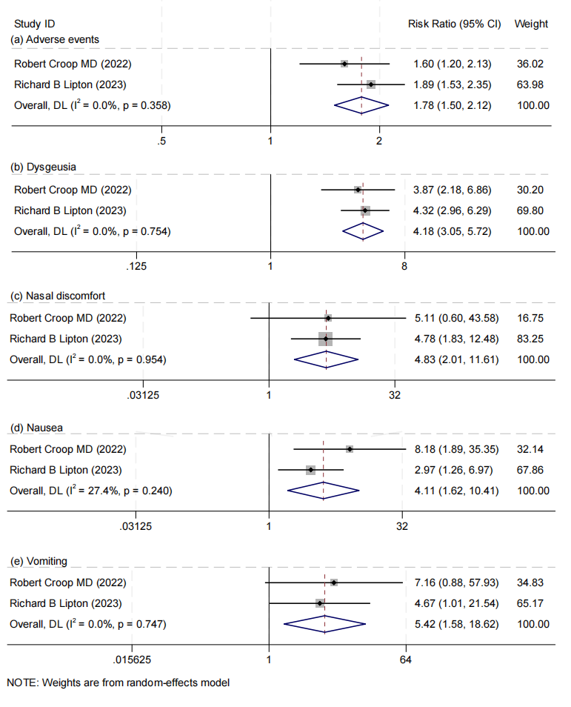
(a) adverse events. (b) dysgeusia. (c) nasal discomfort. (d) nausea. (e) vomiting.

eFig.42 The cumulative probability of obtaining a particular rank for the primary outcomes.
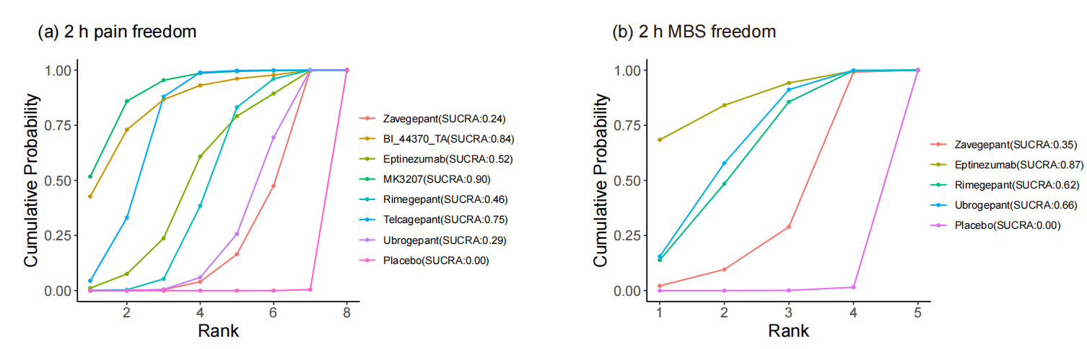
The higher the surface under the cumulative ranking curve (SUCRA) value, the better the rank of the intervention. (a) pain freedom at 2 hours. (b) freedom from the most bothersome symptom (MBS) at 2 hours.

eFig.43 The cumulative probability of obtaining a particular rank for the secondary outcomes.
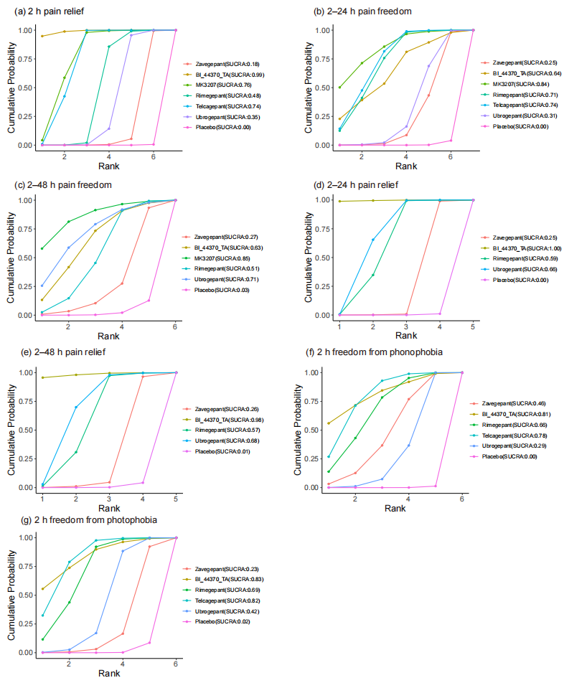
The higher the surface under the cumulative ranking curve (SUCRA) value, the better the rank of the intervention. (a) pain relief at 2 hours. (b) sustained pain freedom from 2 to 24 hours. (c) sustained pain freedom from 2 to 4 hours. (d) sustained pain relief from 2 to 24 hours. (e) sustained pain relief from 2 to 4 hours. (f) phonophobia freedom at 2 hours. (g) photophobia freedom at 2 hours.

