Supplementary Materials

Table S1: PRISMA Checklist
Section and Topic | Item # | Checklist item | Page no. where item is reported
TITLE
Title | 1 | Identify the report as a systematic review. | 1
ABSTRACT
Abstract | 2 | See the PRISMA 2020 for Abstracts checklist. (made as per the Journal guidelines) | 2
INTRODUCTION
Rationale | 3 | Describe the rationale for the review in the context of existing knowledge. | 3
Objectives | 4 | Provide an explicit statement of the objective(s) or question(s) the review addresses. | 3
METHODS
Eligibility criteria | 5 | Specify the inclusion and exclusion criteria for the review and how studies were grouped for the syntheses. | 4
Information sources | 6 | Specify all databases, registers, websites, organisations, reference lists and other sources searched or consulted to identify studies. Specify the date when each source was last searched or consulted. | 4, Table S2
Search strategy | 7 | Present the full search strategies for all databases, registers and websites, including any filters and limits used. | Table S2
Selection process | 8 | Specify the methods used to decide whether a study met the inclusion criteria of the review, including how many reviewers screened each record and each report retrieved, whether they worked independently, and if applicable, details of automation tools used in the process. | 4
Data collection process | 9 | Specify the methods used to collect data from reports, including how many reviewers collected data from each report, whether they worked independently, any processes for obtaining or confirming data from study investigators, and if applicable, details of automation tools used in the process. | 4
Data items | 10a | List and define all outcomes for which data were sought. Specify whether all results that were compatible with each outcome domain in each study were sought (e.g., for all measures, time points, analyses), and if not, the methods used to decide which results to collect. | 3
Data items | 10b | List and define all other variables for which data were sought (e.g., participant and intervention characteristics, funding sources). Describe any assumptions made about any missing or unclear information. | 4
Study risk of bias assessment | 11 | Specify the methods used to assess risk of bias in the included studies, including details of the tool(s) used, how many reviewers assessed each study and whether they worked independently, and if applicable, details of automation tools used in the process. | Table S3
Effect measures | 12 | Specify for each outcome the effect measure(s) (e.g. risk ratio, mean difference) used in the synthesis or presentation of results. | 5
Synthesis methods | 13a | Describe the processes used to decide which studies were eligible for each synthesis (e.g. tabulating the study intervention characteristics and comparing against the planned groups for each synthesis (item #5)). | 4,5
Synthesis methods | 13b | Describe any methods required to prepare the data for presentation or synthesis, such as handling of missing summary statistics, or data conversions. | NA
Synthesis methods | 13c | Describe any methods used to tabulate or visually display results of individual studies and syntheses.
Synthesis methods | 13d | Describe any methods used to synthesize results and provide a rationale for the choice(s). If meta-analysis was performed, describe the model(s), method(s) to identify the presence and extent of statistical heterogeneity, and software package(s) used. | 4.5
Synthesis methods | 13e | Describe any methods used to explore possible causes of heterogeneity among study results (e.g. subgroup analysis, meta-regression). | 5
Synthesis methods | 13f | Describe any sensitivity analyses conducted to assess robustness of the synthesized results. | NA
Reporting bias assessment | 14 | Describe any methods used to assess risk of bias due to missing results in a synthesis (arising from reporting biases). | 5
Certainty assessment | 15 | Describe any methods used to assess certainty (or confidence) in the body of evidence for an outcome. | NA
RESULTS
Study selection | 16a | Describe the results of the search and selection process, from the number of records identified in the search to the number of studies included in the review, ideally using a flow diagram. | Table S2
Study selection | 16b | Cite studies that might appear to meet the inclusion criteria, but which were excluded, and explain why they were excluded. | NA
Study characteristics | 17 | Cite each included study and present its characteristics. | 4,5  Table 1
Risk of bias in studies | 18 | Present assessments of risk of bias for each included study. | Table S3
Results of individual studies | 19 | For all outcomes, present, for each study: (a) summary statistics for each group (where appropriate) and (b) an effect estimate and its precision (e.g. confidence/credible interval), ideally using structured tables or plots. | Table 1
Results of syntheses | 20a | For each synthesis, briefly summarise the characteristics and risk of bias among contributing studies. | 4
Results of syntheses | 20b | Present results of all statistical syntheses conducted. If meta-analysis was done, present for each the summary estimate and its precision (e.g. confidence/credible interval) and measures of statistical heterogeneity. If comparing groups, describe the direction of the effect. | 5,4
Results of syntheses | 20c | Present results of all investigations of possible causes of heterogeneity among study results. | NA
Results of syntheses | 20d | Present results of all sensitivity analyses conducted to assess the robustness of the synthesized results. | NA
Reporting biases | 21 | Present assessments of risk of bias due to missing results (arising from reporting biases) for each synthesis assessed. | Table S3
Certainty of evidence | 22 | Present assessments of certainty (or confidence) in the body of evidence for each outcome assessed. | NA
DISCUSSION
Discussion | 23a | Provide a general interpretation of the results in the context of other evidence. | 5,6, 7
Discussion | 23b | Discuss any limitations of the evidence included in the review. | 7
Discussion | 23c | Discuss any limitations of the review processes used. | 7
Discussion | 23d | Discuss implications of the results for practice, policy, and future research. | 7
OTHER INFORMATION
Registration and protocol | 24a | Provide registration information for the review, including register name and registration number, or state that the review was not registered. | 3
Registration and protocol | 24b | Indicate where the review protocol can be accessed, or state that a protocol was not prepared. | 3
Registration and protocol | 24c | Describe and explain any amendments to information provided at registration or in the protocol. | NA
Support | 25 | Describe sources of financial or non-financial support for the review, and the role of the funders or sponsors in the review. | 8
Competing interests | 26 | Declare any competing interests of review authors. | 7
Availability of data, code and other materials | 27 | Report which of the following are publicly available and where they can be found: template data collection forms; data extracted from included studies; data used for all analyses; analytic code; any other materials used in the review. | Supplementary Materials

Table S2: Inclusion and Exclusion criteria
Research Question: “Risk of Migraine Associated with Proton Pump Inhibitor Use: A Systematic Review and Meta-Analysis”
Inclusion |  | Exclusion
Participants | - Individuals with gastroesophageal reflux disease, peptic ulcers, or other acid-related gastrointestinal disorders of any age using proton pump inhibitor
Intervention/Exposure | - Proton pump inhibitors
Comparator | - Individuals not using proton pump inhibitors or baseline before PPI use
Outcome | - Incidence or risk of migraine
Study Designs | - Clinical trials  - Cross-sectional  - Cohort studies  - Case control studies | Letter to editor, Commentaries,  Qualitative studies, Abstract only, Case series, case reports, reviews, Discussion papers
Time period and language | Only published articles English language till January 2024 | Unavailable full-text articles

Table S3: The adjusted search term as per searched electronic database
Database | Search Strategy | No. of Hits
PubMed | ("Migraine Disorders"[Mesh] OR "Migraine Headache" OR Migraine OR "Chronic Migraine") AND ("Proton Pump Inhibitors"[Mesh] OR "Proton Pump Inhibitor" OR omeprazole OR esomeprazole OR lansoprazole OR pantoprazole OR Rabeprazole OR Dexlansoprazole OR "Acid Pump Antagonists" OR "Gastric Acid Pump Inhibitors" OR H+/K+ ATPase Inhibitors) | 17
Embase | ('Migraine Disorders'/exp OR 'Migraine Headache' OR Migraine OR 'Chronic Migraine') AND ('Proton Pump Inhibitors'/exp OR 'Proton Pump Inhibitor' OR omeprazole OR esomeprazole OR lansoprazole OR pantoprazole OR rabeprazole OR dexlansoprazole OR 'Acid Pump Antagonists' OR 'Gastric Acid Pump Inhibitors' OR 'H+/K+ ATPase Inhibitors') | 544
Web of Science | TS=("Migraine Disorders" OR "Migraine Headache" OR Migraine OR "Chronic Migraine") AND  TS=("Proton Pump Inhibitors" OR "Proton Pump Inhibitor" OR omeprazole OR esomeprazole OR lansoprazole OR pantoprazole OR rabeprazole OR dexlansoprazole OR "Acid Pump Antagonists" OR "Gastric Acid Pump Inhibitors" OR "H+/K+ ATPase Inhibitors") | 22

Table S4: NOS for the quality assessment of included case-control studies
Study | Selection (max 4 points) |  |  |  | Comparability (max 2 points) | Exposure (max 3 points) |  |  | Score (out of 9)
Study | Adequate case definition | Representativeness of the cases | Selection of controls | Definition of controls | Comparability of cases and controls on the basis of design and analysis | Assessment of exposure | Same method of ascertainment for cases and controls | Non-Response rate | Score (out of 9)
Liang, 2015 (1) | 1 | 1 | 1 | 1 | 1 | 1 | 1 | 1 | 8
Kang, 2022 (2) | 1 | 1 | 1 | 1 | 2 | 1 | 1 | 1 | 9

Table S5: NOS for the quality assessment of included cohort studies
Study | Selection (max 4 points) |  |  |  | Comparability (max 2 points) | Outcome (max 3 points) |  |  | Score (out of 9)
Study | Representativeness of the population | Selection of the comparator | Ascertainment of events | Demonstration of the outcome of interest was not present at start of study | Comparability the basis of the design or analysis | Assessment of outcome | Was follow-up long enough for outcomes to occur? | Adequacy of the follow-up | Score (out of 9)
Pisanu, 2021 (3) | 1 | 0 | 1 | 1 | 0 | 1 | 1 | 1 | 6
Makunts, 2019 (4) | 1 | 0 | 1 | 1 | 0 | 1 | 1 | 1 | 6

Table S6: NOS for the quality assessment of included cross-sectional studies
Study | Selection (max 5 points) |  |  |  | Comparability (max 1 points) | Outcome (max 3 points) |  |  | Score (out of 9)
Study | Representativeness of the cases | Sample size | Non-Response rate | Ascertainment of the screening/surveillance tool (max. 2 points) | Potential confounders | Assessment of outcome | Was follow-up long enough for outcomes to occur? | Statistical test | Score (out of 9)
Slavin, 2024 (5) | 1 | 0 | 1 | 1 | 0 | 1 | 1 | 1 | 6

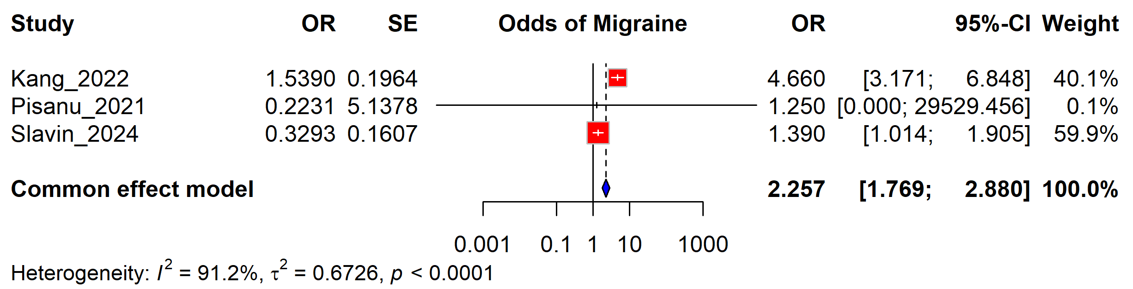
Figure S1: Forest plot illustrating the association between PPI use with migraine risk (fixed effect model)

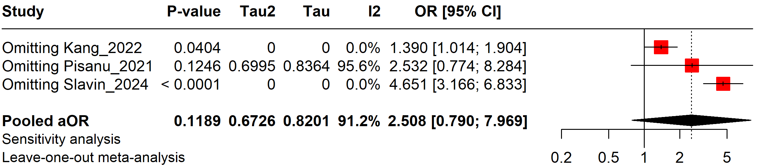

Figure S2: Forest plot illustrating the sensitivity analysis of association of PPI use with migraine

1. Liang J-F, Chen Y-T, Fuh J-L, Li S-Y, Chen T-J, Tang C-H, et al. Proton pump inhibitor-related headaches: a nationwide population-based case-crossover study in Taiwan. Cephalalgia. 2015;35(3):203-10.
2. Kang HS, Kim SY, Kim JH, Kim ES, Choi HG, Lim H, et al. Association between Migraines and Prior Proton Pump Inhibitor Use: A Nested Case-Control Study Using a National Health Screening Cohort. Pharmaceuticals. 2022;15(11):1385.
3. Pisanu C, Welander NZ, Rukh G, Schiöth HB, Mwinyi J. Association between migraine prevalence, treatment with proton-pump inhibitors and CYP2C19 phenotypes in UK Biobank. Biomedicine & Pharmacotherapy. 2021;143:112234.
4. Makunts T, Alpatty S, Lee KC, Atayee RS, Abagyan R. Proton-pump inhibitor use is associated with a broad spectrum of neurological adverse events including impaired hearing, vision, and memory. Scientific reports. 2019;9(1):17280.
5. Slavin M, Frankenfeld CL, Guirguis AB, Seng EK. Use of acid-suppression therapy and odds of migraine and severe headache in the National Health and Nutrition Examination Survey. Neurology: Clinical Practice. 2024;14(3):e200302.

