Supplementary Appendix

Search strategy

Embase Classic + Embase 1947 to 2024 Week 29
22/07/2024 – 1264 results
 | Search
1 | exp endometriosis/
2 | endometrio$.ti,ab,kw.
3 | 1 or 2
4 | exp headache/
5 | exp migraine disorders/
6 | migrai$.ti,ab,kw.
7 | 4 or 5 or 6
8 | 3 and 7

Ovid MEDLINE(R) ALL 1946 to July 22, 2024
22/07/2024 – 130 results
 | Search
1 | exp Endometriosis/
2 | endometrio$.ti,ab,kw.
3 | 1 or 2
4 | exp Cluster Headache/ or exp Headache/ or exp Headache Disorders/ or exp Headache Disorders, Secondary/ or exp Post-Traumatic Headache/ or exp Tension-Type Headache/ or exp Headache Disorders, Primary/ or exp Post-Dural Puncture Headache/
5 | exp Migraine Disorders/
6 | migrai$.ti,ab,kw.
7 | 4 or 5 or 6
8 | 3 and 7

CINAHL
22/07/2024 – 41 results
 | Search
1 | (MM "Endometriosis")
2 | TI endometrio*
3 | AB endometrio*
4 | S1 OR S2 OR S3
5 | (MH "Headache+")
6 | (MM "Migraine")
7 | TI migrai*
8 | AB migrai*
9 | S5 OR S6 OR S7 OR S8
10 | S4 AND S9

Cochrane Central Register of Controlled Trials (CENTRAL)
22/07/2024 – 35 results
 | Search
1 | MeSH descriptor: [Endometriosis] explode all trees
2 | endometrio*
3 | #1 OR #2
4 | MeSH descriptor: [Headache] explode all trees
5 | MeSH descriptor: [Migraine Disorders] explode all trees
6 | migrai*
7 | #4 OR #5 OR #6
8 | #3 AND #7

WHO International Clinical Trials Registry Platform (ICTRP)
22/07/2024 – 0 results
 | Search
1 | endometriosis AND migraine

ClinicalTrials.gov
22/07/2024 – 16 results
 | Search
1 | endometriosis AND migraine

Google Scholar
22/07/2024 – 38 results
 | Search
1 | allintitle: endometriosis; migraine

Studies excluded from quantitative analysis but included in quantitative analysis:
Mirkin et al., 2007 [21] was not eligible for inclusion in the meta-analysis as the number of individuals included in the study was reported in person-years (total days of eligibility to be enrolled in the study of an individual divided by 365) and the number of individuals with migraine reported only as a percentage.

Table S1: Studies excluded at full-text review with rationale for the decision
Authors | Study title | Year of Publication | Reason for exclusion
Bagirova et al. | Features of pain syndrome in genital endometriosis and migraine | 2021 | Unsuitable control group
Bagirova et al. | Migraine and endometriosis as comorbid diseases | 2019 | Unsuitable publication type
Bilir et al. | Electrocardiographic findings in patients with primary dysmenorrhea | 2007 | Unsuitable control group
Chakraborty et al. | Presence of stage III/IV endometriosis associated with systemic inflammation poses as individual risk factor for coronary heart disease in Indian women: Inklings for the search | 2023 | Unsuitable publication type
Estes et al. | Depression, anxiety, and self-directed violence in women with endometriosis: A retrospective matched-cohort study | 2021 | Unsuitable outcome
Evans et al. | The comorbidities of dysmenorrhea: A clinical survey comparing symptom profile in women with and without endometriosis | 2018 | Unsuitable control group
Gemmill et al. | Assessment of the relationship among multifocal pain, pain severity, disturbed sleep, and psychological symptoms in women with chronic pelvic pain associated with endometriosis | 2012 | Unsuitable publication type
Karp et al. | Migraine in women with chronic pelvic pain with and without endometriosis | 2011 | Unsuitable control group
Kiryanova et al. | Menstrual cycle and gynecologic pathology in menstrual-related migraine | 2021 | Unsuitable control group
Merki et al. | Investigating migraine phenotype and dynamics in women with endometriosis: an observational pilot study | 2024 | Unsuitable control group
Metzler et al. | Impact of family history for endometriosis, migraine, depression and early menopause on endometriosis symptoms, localization and stage: A case control study | 2023 | Unsuitable control group
Mormile et al. | Endometriosis and migraine: what is there behind the scenes? | 2014 | Unsuitable publication type
Pasquini et al. | Endometriosis and the diagnosis of different forms of migraine: an association with dysmenorrhoea | 2023 | Unsuitable control group
Raffaelli et al. | Plasma calcitonin gene-related peptide (CGRP) in migraine and endometriosis during the menstrual cycle | 2021 | Unsuitable control group
Selntigia et al. | Correlation between endometriosis and migraine features: Results from a prospective case-control study | 2024 | Unsuitable control group
Tietjen et al. | Endometriosis in migraine influences headache frequency, impact, and the association with comorbid conditions | 2005 | Unsuitable publication type
Tietjen et al. | Allodynia in Migraine: Association With Comorbid Pain Conditions | 2009 | Unsuitable control group
Tietjen et al. | Childhood maltreatment and migraine (part III). Association with comorbid pain conditions | 2010 | Unsuitable control group
Till et al. | Approach to Diagnosis and Management of Chronic Pelvic Pain in Women: Incorporating Chronic Overlapping Pain Conditions in Assessment and Management | 2022 | Unsuitable publication type

Figure S1: Traffic light plot of ROBINS-E risk of bias assessment

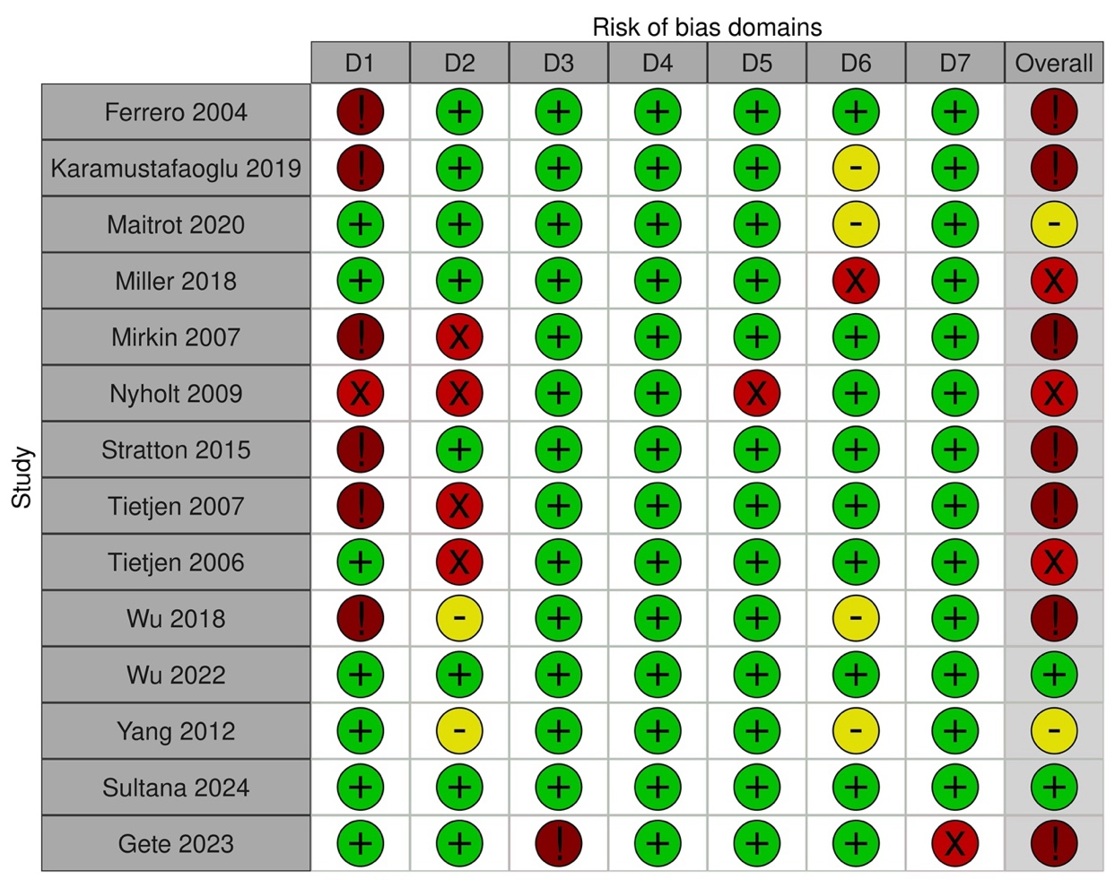
D1: Bias due to confounding
D2: Bias arising from measurement of the exposure
D3: Bias in selection of the participants into the study (or into the analysis)
D4: Bias due to post-exposure interventions
D5: Bias due to missing data
D6: Bias arising from measurement of the outcome
D7: Bias in selection of the reported result


Judgement
Very high
High
Moderate
Low

Figure S2: Forest plot for the sensitivity analysis excluding studies at “high” or “very high” risk of bias
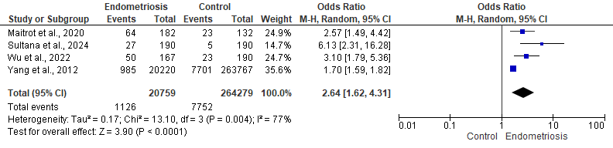

Figure S3: Forest plot for the sensitivity analysis excluding studies which did not adjust for confounding factors
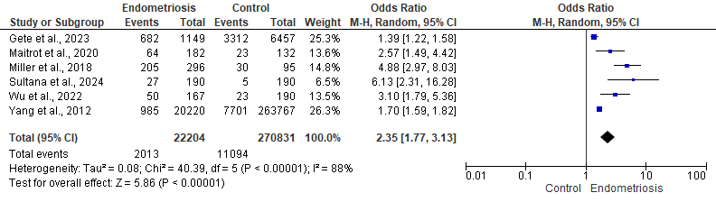

Figure S4: Forest plot for the sensitivity analysis including only studies adjusting for hormonal therapy use
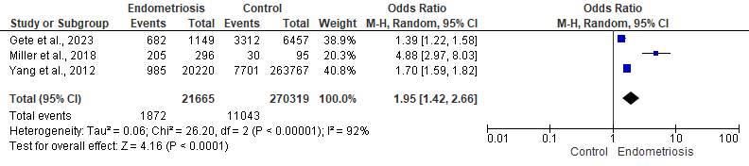

Figure S5: Forest plot for the subgroup analysis by endometriosis diagnostic method
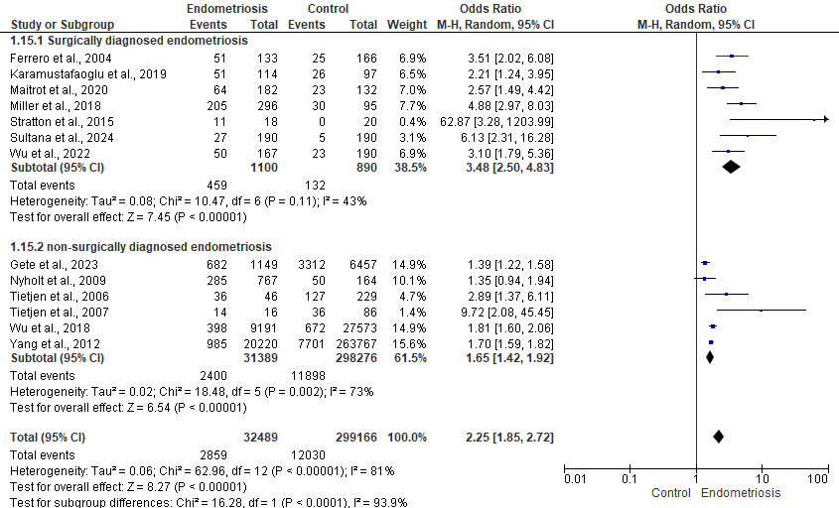

Figure S6: Forest plot for the subgroup analysis by migraine diagnostic method
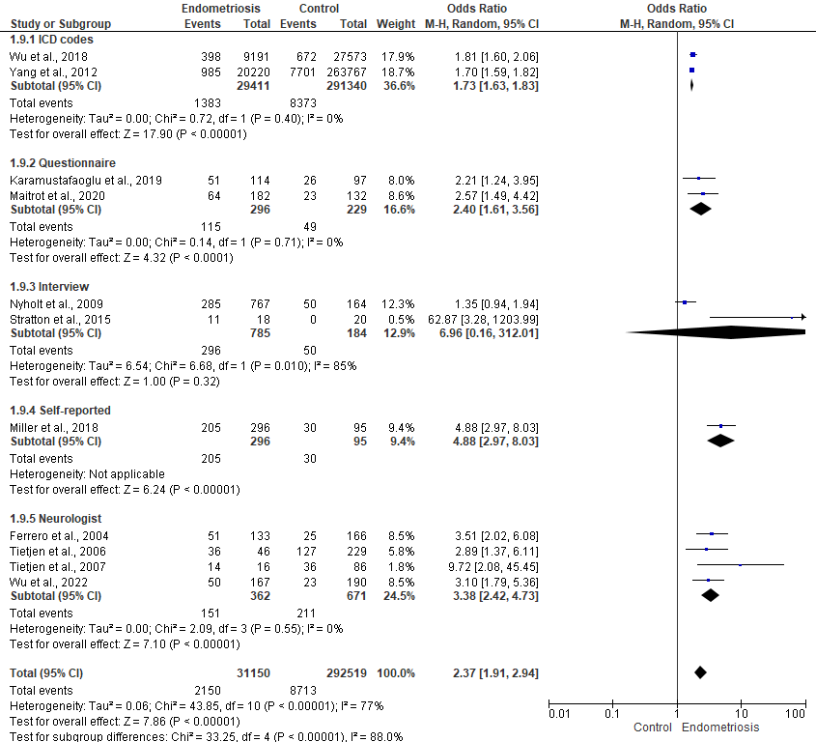

References for studies excluded at full-text review
1 Bagirova UA, Chernukha EG, Filatova EG. Features of pain syndrome in genital endometriosis and migraine. Neurology, Neuropsychiatry, Psychosomatics. 2021;13:31–7.
2 Bagirova UFE. Migraine and endometriosis as comorbid diseases. Pharmateca. 2019;26:10–7.
3 Bilir C, Çolak D, Akdemir N, et al. Electrocardiographic Findings in Patients With Primary Dysmenorrhea. Am J Med Sci. 2012;343:27–9. doi: 10.1097/MAJ.0b013e31821904e1
4 Chakraborty P, Sharma S, Kalapahar S, et al. P-336 Presence of stage III/IV endometriosis associated with systemic inflammation poses as individual risk factor for coronary heart disease in Indian women: Inklings for the search. Human Reproduction. 2023;38:dead093.694. doi: 10.1093/humrep/dead093.694
5 Estes SJ, Huisingh CE, Chiuve SE, et al. Depression, Anxiety, and Self-Directed Violence in Women With Endometriosis: A Retrospective Matched-Cohort Study. Am J Epidemiol. 2021;190:843–52. doi: 10.1093/aje/kwaa249
6 Evans SF, Brooks TA, Esterman AJ, et al. The comorbidities of dysmenorrhea: A clinical survey comparing symptom profile in women with and without endometriosis. J Pain Res. 2018;11:3181–94. doi: 10.2147/JPR.S179409
7 Ferrero S, Pretta S, Bertoldi S, et al. Increased frequency of migraine among women with endometriosis. Human Reproduction. 2004;19:2927–32. doi: 10.1093/humrep/deh537
8 Gemmill JAL, Sinaii N, Shanis D, et al. Assessment of the relationship among multifocal pain, pain severity, disturbed sleep, and psychological symptoms in women with chronic pelvic pain associated with endometriosis. Fertil Steril. 2012;98:S67. doi: 10.1016/j.fertnstert.2012.07.240
9 Illowsky Karp B, Sinaii N, Nieman LK, et al. Migraine in women with chronic pelvic pain with and without endometriosis. Fertil Steril. 2011;95:895–9. doi: 10.1016/j.fertnstert.2010.11.037
10 Kiryanova ETG. Menstrual cycle and gynecologic pathology in menstrual-related migraine. Nevrologiya, neiropsikhiatriya, psikhosomatika = Neurology, Neuropsychiatry, Psychosomatics. 2021;13:12–7.
11 Merki-Feld G, Dietrich H, Imesch P, et al. Investigating migraine phenotype and dynamics in women with endometriosis: an observational pilot study. Acta Neurol Belg. 2024;124:1263–71. doi: 10.1007/s13760-024-02484-2
12 Metzler JM, Imesch P, Dietrich H, et al. Impact of family history for endometriosis, migraine, depression and early menopause on endometriosis symptoms, localization and stage: A case control study. European Journal of Obstetrics and Gynecology and Reproductive Biology. 2024;293:36–43. doi: 10.1016/j.ejogrb.2023.12.016
13 Mormile R, Vittori G. Endometriosis and migraine: what is there behind the scenes? 2014;27:389–90. doi: doi:10.1515/jpem-2013-0384
14 Pasquini B, Seravalli V, Vannuccini S, et al. Endometriosis and the diagnosis of different forms of migraine: an association with dysmenorrhoea. Reprod Biomed Online. 2023;47:71–6. doi: 10.1016/j.rbmo.2023.03.020
15 Raffaelli B, Overeem LH, Mecklenburg J, et al. Plasma calcitonin gene-related peptide (CGRP) in migraine and endometriosis during the menstrual cycle. Ann Clin Transl Neurol. 2021;8:1251–9. doi: https://doi.org/10.1002/acn3.51360
16 Selntigia A, Exacoustos C, Ortoleva C, et al. Correlation between endometriosis and migraine features: Results from a prospective case-control study. Cephalalgia. 2024;44:03331024241235210. doi: 10.1177/03331024241235210
17 Tietjen GE, Brandes JL, Peterlin BL, et al. Childhood Maltreatment and Migraine (Part III). Association With Comorbid Pain Conditions. Headache: The Journal of Head and Face Pain. 2010;50:42–51. doi: https://doi.org/10.1111/j.1526-4610.2009.01558.x
18 Tietjen GE, Bushnell CD, Herial NA, et al. Endometriosis Is Associated With Prevalence of Comorbid Conditions in Migraine. Headache: The Journal of Head and Face Pain. 2007;47:1069–78. doi: https://doi.org/10.1111/j.1526-4610.2007.00784.x
19 Tietjen GE, Brandes JL, Peterlin BL, et al. Allodynia in Migraine: Association With Comorbid Pain Conditions. Headache: The Journal of Head and Face Pain. 2009;49:1333–44. doi: https://doi.org/10.1111/j.1526-4610.2009.01521.x
20 Till SR, Nakamura R, Schrepf A, et al. Approach to Diagnosis and Management of Chronic Pelvic Pain in Women: Incorporating Chronic Overlapping Pain Conditions in Assessment and Management. Obstet Gynecol Clin North Am. 2022;49:219–39. doi: 10.1016/j.ogc.2022.02.006
21 Mirkin D, Murphy-Barron C, Iwasaki K. Actuarial Analysis of Private Payer Administrative. Health (San Francisco). 2007;13:262–72.

