1.The bioinformation analysis and verification of hub genes
RNA sequencing data was firstly analyzed to select the DEGs of the mice spinal cord. The DEGs were performed by the STRING database and the CytoHubba in Cytoscape software to identify the top 20 hub genes. Heatmap of the 20 genes was plotted by https://www.bioinformatics.com.cn (last accessed on 10 Dec 2024), an online platform for data analysis and visualization (Fig.S1A). Some hub genes that had been studied before were eliminated. PCR was performed to determine the mRNA expression of the following genes. Spi1 was the most remarkably upregulated gene in the SNI group compared to the Sham group (Fig.S1B). The results of Matescape database processing with the top 20 hub genes showed that these genes mainly expressed in microglia (Fig.S1C) and related to pathways like phagocytosis, engulfment; Microglia pathogen phagocytosis pathway; regulation of cell activation; negative regulation of immune system process; Adaptive Immune System; innate immune response (Fig.S1D).
Additional file1: Figure S1. The bioinformation analysis and verification of hub genes. (A) Heatmap of the top 20 hub genes. (B) PCR for Spi1, Irf8, Ptprc, C1qa, Lyz2, Adgre1, Itgb2, Fcer1g (n=6). (C, D) The results of Matescape database processing with the top 20 hub genes. Two-sided Unpaired Student’s t test (B: Spi1 t₍₁₀₎ = 4.721, P =0.0008; B: Irf8 t₍₁₀₎ = 6.314, P＜0.0001; B: Ptprc t₍₁₀₎ = 7.841, P＜0.0001; B: C1qa t₍₁₀₎ = 4.821, P = 0.0007; B: Lyz2 t₍₁₀₎ = 4.259, P = 0.0017; B: Adgre1 t₍₁₀₎ = 5.901, P = 0.0002; B: Itgb2 t₍₁₀₎ = 7.248, P＜0.0001; B: Fcer1g t₍₁₀₎ = 5.056, P = 0.0005). *P < 0.05, **P < 0.01, ***P < 0.001.

2. Downregulation of Spi1 increased the mean number of inhibitory synapses in neuron
To confirm whether knockdown Spi1 decrease microglial engulfment of inhibitory synapses and increase the number and/or the volume of inhibitory synapses in neuron. Spinal cord triple immunofluorescence of neuron, Iba1 and VGAT were performed (Fig. S2A). The results showed that knockdown Spi1 decreased the volume and the mean number of VGAT in microglia compared to SNI + Sh-NC groups (Figs. S2B, C). Moreover, VGAT in neurons connecting to microglia (Iba1) were rendered to reveal the neuron activity. Downregulation of Spi1 increased the mean number of VGAT in neuron while the volume of VGAT in neuron was no difference among groups (Figs. S2D, E). These results were consistent to the electrophysiological results detecting that the frequency of sIPSCs increased and the amplitude of sIPSCs was no difference after the injection of Sh-Spi1 AAV.
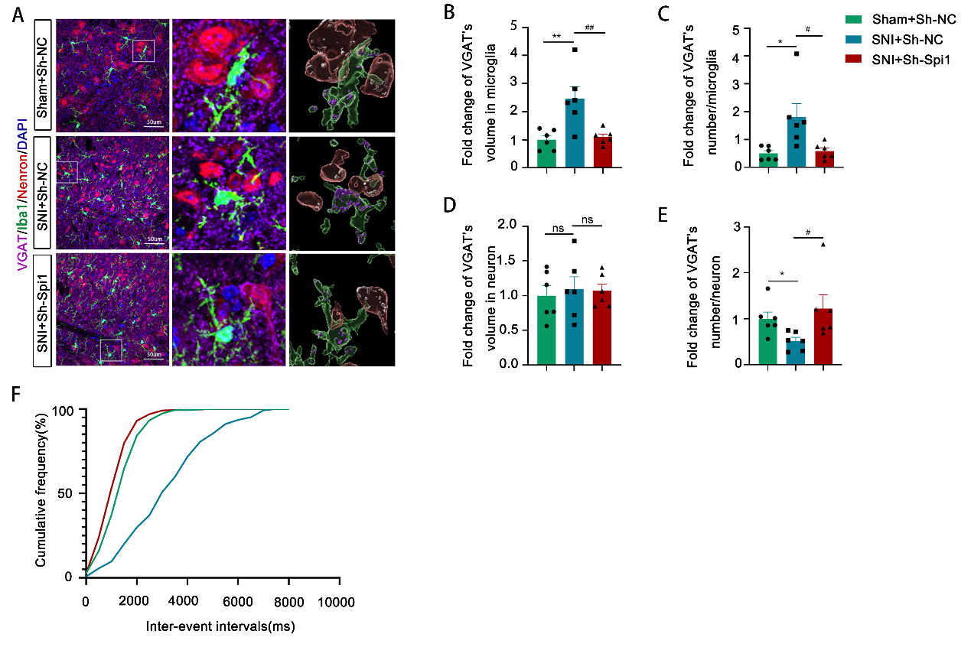
Additional file2: Figure S2. Downregulation of Spi1 increased the mean number of VGAT in neuron. (A, B, C, D, E) Spinal cord triple immunofluorescence of neuron (neurons connecting to Iba1), Iba1 and VGAT were rendered by Imaris software. The volume of VGAT in microglia/neuron and the number of VGAT in microglia/neuron were calculated and normalized (n=6). (F) The sIPSC’s cumulative distributions of the inter-event intervals determined from the neuron shown in panel. One-way ANOVA followed by Tukey’s post hoc test (B: F_{2, 15} = 9.712, P = 0.0020; C: F_{2, 15} = 6.343, P = 0.0101; D: F_{2, 15} = 0.1083, P = 0.8980). Kruskal-Wallis test followed by Dunn’s multiple comparisons test (E: H = 8.994, P = 0.0055). *P < 0.05, **P < 0.01; #P < 0.05, ##P < 0.01.

3. Silencing Spi1 reduced the release of pro-inflammatory factors and phagocytosis in vitro.
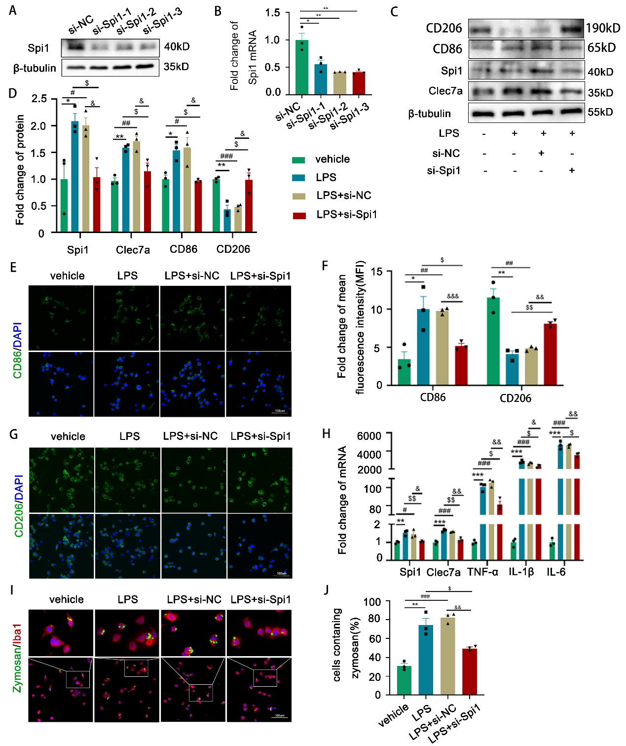
Additional file3: Figure S3. Silencing Spi1 reduced the release of pro-inflammatory factors and phagocytosis in vitro. (A, B) The knockdown sequence of Spi1 was determined by western blot and qPCR. (C, D) BV2 cells were transfected with si-NC or si-Spi1 for 48 hours, and then treated with LPS (1000 ng/ml) for 24 hours. CD86(proinflammatory factors), CD206(anti-inflammatory factors) were evaluated by western blot (n = 3). (E, F, G) CD86 and CD206 expression were also assessed by Immunofluorescence staining (n = 3). (H)The levels of TNF-α, IL-1β and IL-6 were quantified by PCR (n = 3). (I, J) Phagocytosis assay and calculation of cells containing zymosan (n = 3). One-way ANOVA followed by Dunnett’s t‐test ( B: F_{3, 8} = 14.19, P = 0.0014). One-way ANOVA followed by Tukey’s post hoc test (D: Spi1 F_{3, 8} = 7.945, P = 0.0088; D: Clec7a F_{3, 8} = 13.40, P = 0.0017; D: CD86 F_{3, 8} = 9.041, P = 0.0060; D: CD206 F_{3, 8} = 15.23, P = 0.0011; F: CD86 F_{3, 8} = 11.48, P = 0.0029; F: CD206 F_{3, 8} = 28.86, P = 0.0001; H: Spi1 F_{3, 8} = 10.75, P = 0.0035; H: Clec7a F_{3, 8} = 43.70, P < 0.0001; H: TNF-α F_{3, 8} = 342.8, P < 0.0001; H: IL-1β F_{3, 8} = 313.6, P < 0.0001; H: IL-6 F_{3, 8} = 196.7, P < 0.0001; J: F_{3, 8} = 31.99, P < 0.0001). *P < 0.05, **P < 0.01, ***P < 0.001; #P < 0.05, ##P < 0.01, ###P < 0.001; $P < 0.05, $$P < 0.01, $$$P < 0.001; &P < 0.05, &&P < 0.01, &&&P < 0.001.

4. Overexpressing Spi1 promoted the release of pro-inflammatory factors and phagocytosis in vitro
Additional file4: Figure S4. Overexpressing Spi1 promoted the release of pro-inflammatory factors and phagocytosis in vitro. (A, B) BV2 cells were transfected with oe-NC or oe-Spi1 for 48 hours, and then treated with LPS (1000 ng/ml) for 24 hours. The quantification of CD86, CD206 proteins by western blot (n = 3). (C, D, E) Immunofluorescence results of CD86 and CD206(n = 3). (F) PCR results of the inflammatory factors TNF‐α, IL1β and IL6 (n = 3-4). (G, H) The results of Phagocytosis assay (n = 3). One-way ANOVA followed by Tukey’s post hoc test (B: Spi1 F_{3, 8} = 43.26, P < 0.0001; B: Clec7a F_{3, 8} = 28.95, P = 0.0001; B: CD86 F_{3, 8} = 82.29, P < 0.0001; B: CD206 F_{3, 8} = 18.05, P = 0.0006; D: CD86 F_{3, 8} = 48.61, P < 0.0001; D: CD206 F_{3, 8} = 18.54, P = 0.0006; F: Spi1 F_{3, 8} = 7.395, P = 0.0046; F: Clec7a F_{3, 8} = 10.83, P = 0.0034; F: TNF-α F_{3, 8} = 217.7, P < 0.0001; F: IL-1β F_{3, 8} = 158.9, P < 0.0001; F: IL-6 F_{3, 8} = 247.5, P < 0.0001; G: F (3, 8) = 59.28, P < 0.0001. *P < 0.05, **P < 0.01, ***P < 0.001; #P < 0.05, ##P < 0.01, ###P < 0.001; $P < 0.05, $$P < 0.01, $$$P < 0.001; &P < 0.05, &&P < 0.01, &&&P < 0.001.

5. The expression of Spi1’s downstream gene and the screening of Clec7a’s knockdown sequence
The results of PCR showed that Clec7a mRNA was downregulated more obvious in contrast with Msr1 following Spi1 knockdown (S5A). PCR results showed that si-3 was the optimal sequence for knockdown the expression of Clec7a in mRNA level(S5B) and protein level(S5C). The immunofluorescence results displayed that the number of Iba1⁺ cells declined after knockdown Spi1(S5D) or Clec7a(S5E), the immunofluorescence images for this analysis were respectively from the groups in Figs 3B&D and Figs 7B&D.
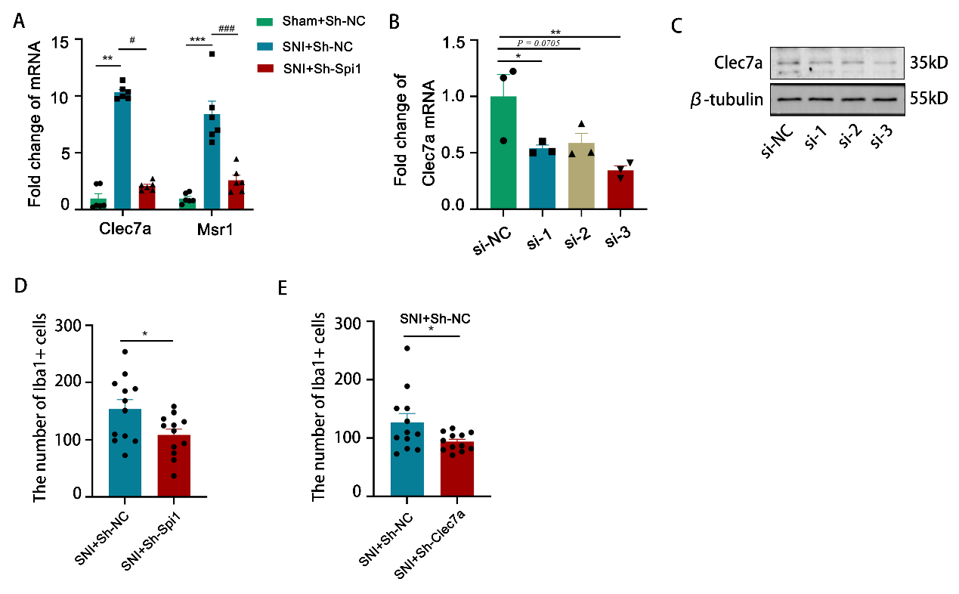
Additional file5: Figure S5. (A) Spinal cord PCR results of Clec7a and Msr1. (B) The knockdown sequence of Clec7a was determined by qPCR. (C) The knockdown sequence of Clec7a was determined by western blot. (D, E) The number of Iba1⁺ cells in the spinal cord dorsal horn (n=6, 2 slices of each animal). Kruskal–Wallis test followed by Dunn’s multiple comparisons test (A: Clec7a H = 12.12, P = 0.0002). One-way ANOVA followed by Tukey’s post hoc test (A: Msr1 F_{2, 15} = 29.31, P<0.0001). One-way ANOVA followed by Dunnett’s t‐test(B: F_{3, 8} = 6.221, P = 0.0174). Two-sided Unpaired Student’s t test (D: t₍₂₂₎ = 2.340, P = 0.0288; E: t₍₁₀₎ = 2.107, P = 0.0468). *P < 0.05, **P < 0.01, ***P < 0.001; #P < 0.05, ##P < 0.01, ###P < 0.001.

