Supplementary Materials
Supplementary Fig. S1 Subtype-specific analysis of prioritized eGenes in migraine. (A) Forest plot of MR effect estimates for migraine with MA. (B) Forest plot of MR effect estimates for MO.
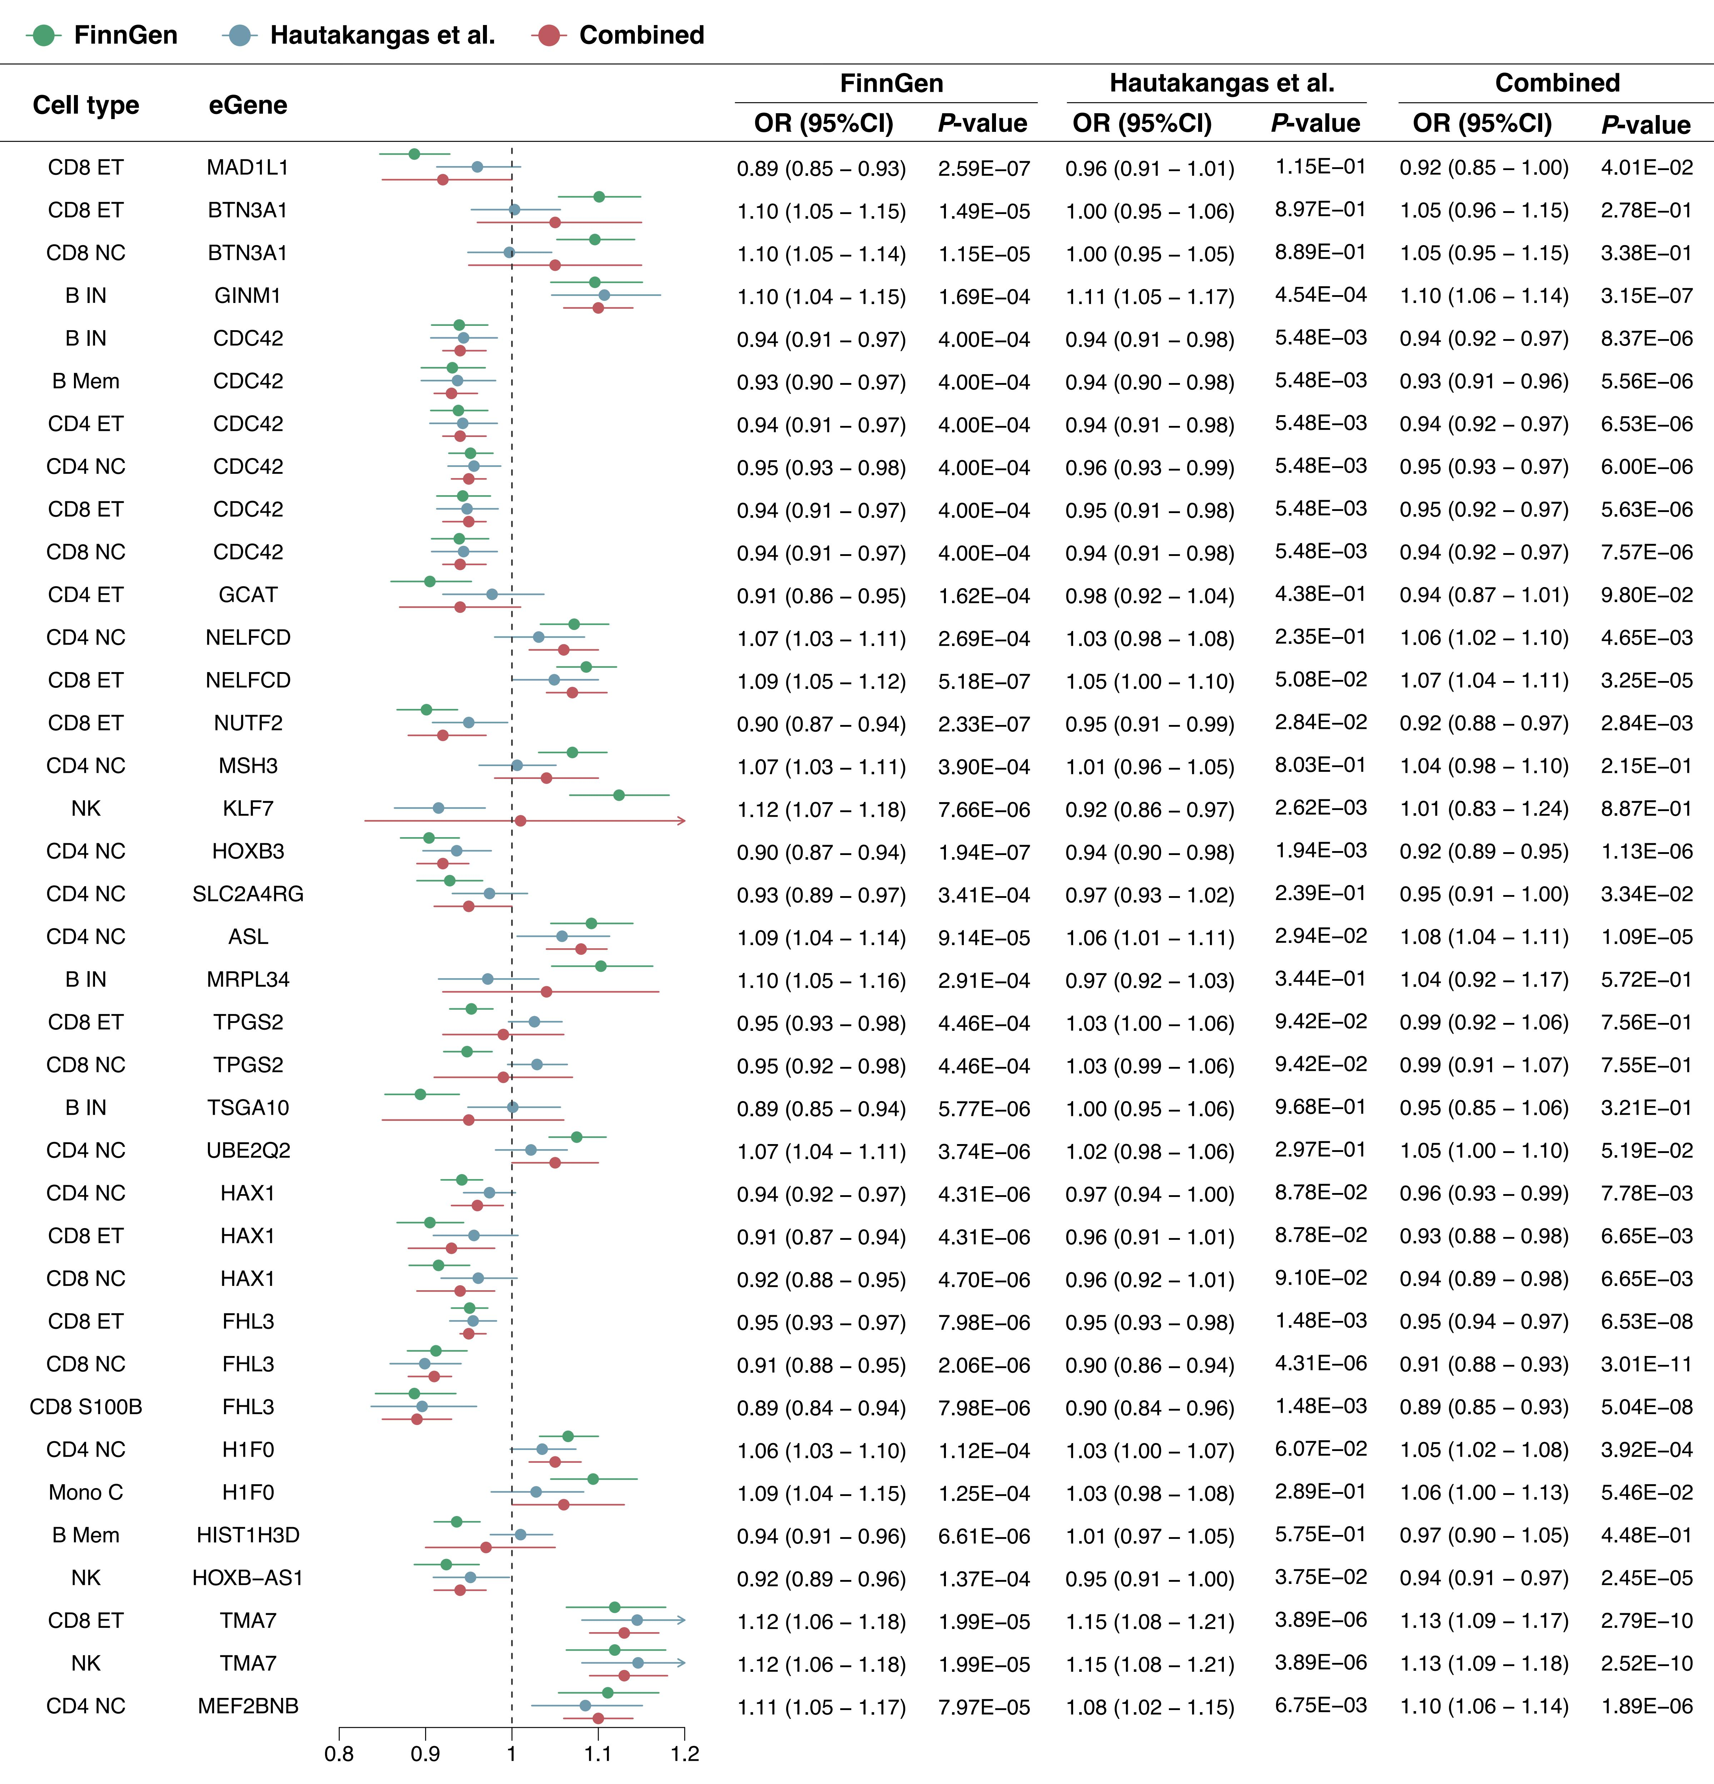
Supplementary Fig. S2 Estimates of meta-analysis from discovery dataset and replication dataset for 25 prioritized eGenes on migraine. Discovery dataset: GWAS summary data from FinnGen. Replication dataset: Meta-GWASs from Hautakangas et al.
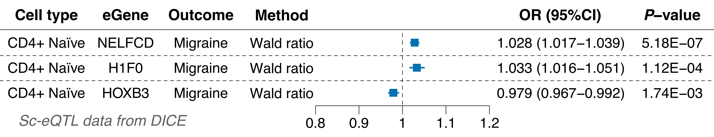
Supplementary Fig. S3 Forest plot of MR results for three eGenes using sc-eQTL data from the DICE cohort.
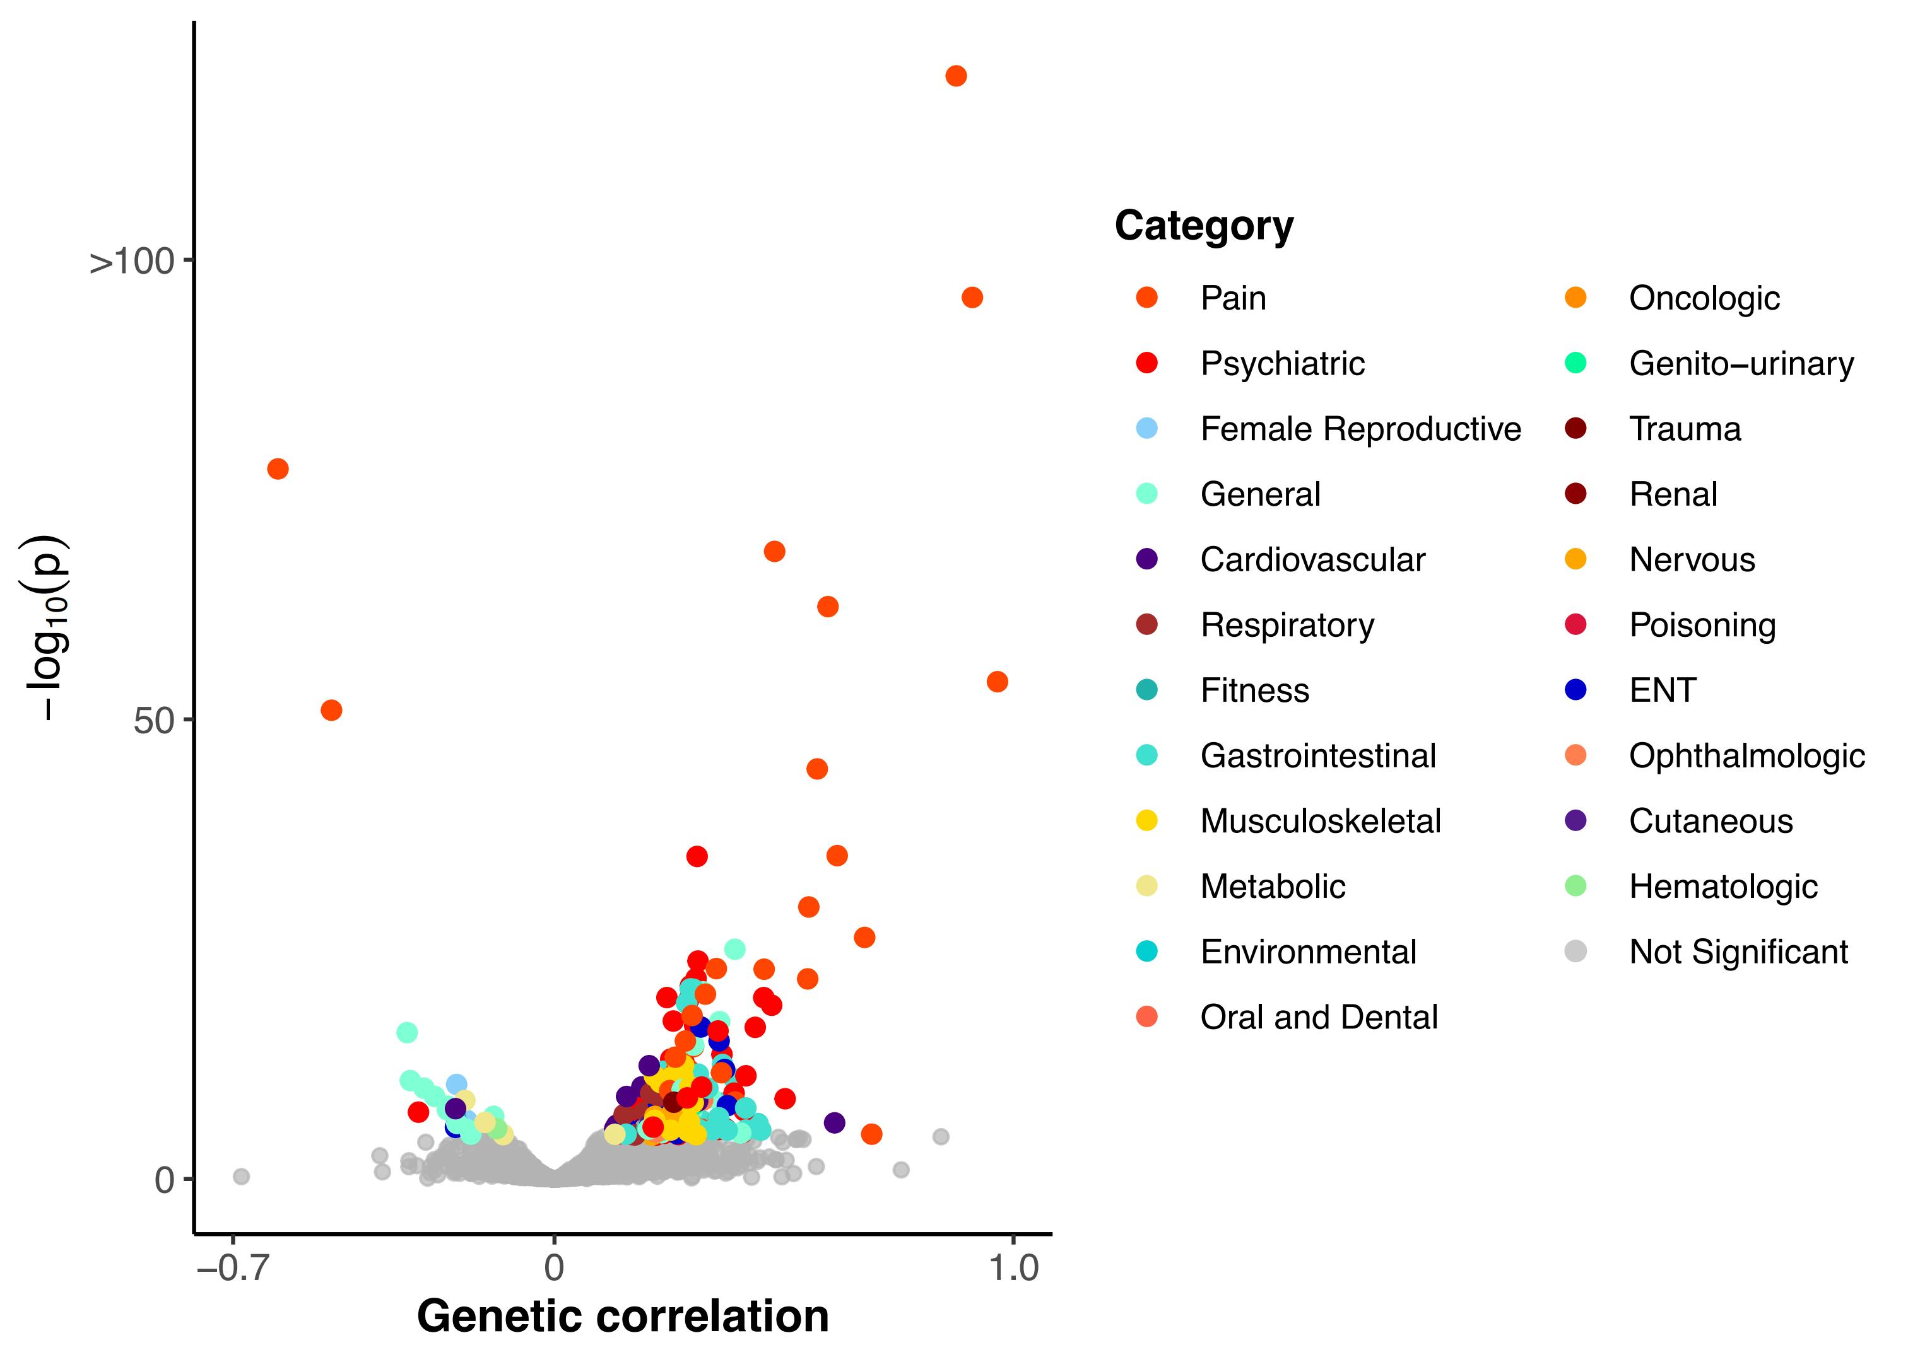
Supplementary Fig. S4 Genetic correlation volcano plot between migraine and 2,871 human phenotypes using LDSC across migraine meta-GWASs from Hautakangas et al.. Only traits passing Bonferroni correction are highlighted, revealing substantial pleiotropy, especially with pain and psychiatric traits.
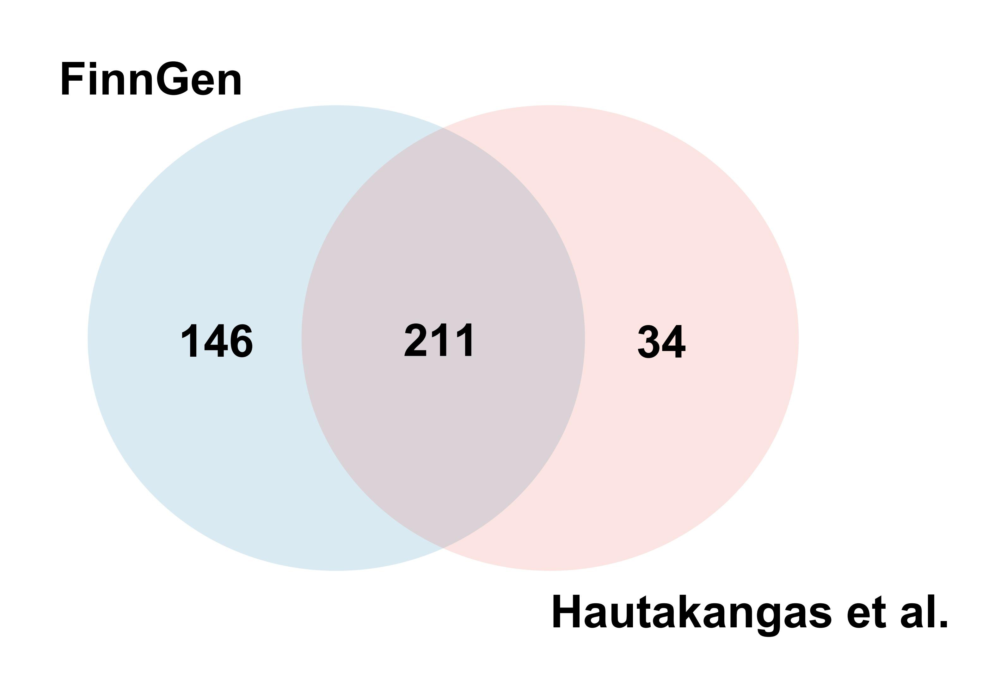
Supplementary Fig. S5 Venn diagram showing the overlap of migraine-genetically correlated traits identified from FinnGen and Hautakangas et al. GWAS datasets using LDSC. Of the total 357 significant traits from FinnGen and 245 from Hautakangas et al., 211 traits were consistently correlated across both datasets.

