Supplementary Information for:
Cortical Network Dysfunction in Migraine: Linking Genes, Metabolism and Clinical Disability
Liangfeng Kuang^{1†}, Xiaopei Xu^{1†*}, Jinpeng Niu^{2†}, Xiao Wu¹, Xiao Luo¹, Kaicheng Li¹, Qingze Zeng¹, Mengting Zhou³, Jiahui He³, Shuyue Wang¹, Chao Wang¹, Peiyu Huang¹, Jianzhong Sun^{1*}, Kaiming Liu^{3*}
1 Department of Radiology, The Second Affiliated Hospital, Zhejiang University School of Medicine, 310000, Hangzhou, China.
2 The Clinical Hospital of Chengdu Brain Science Institute. School of Life Science and Technology, University of Electronic Science and Technology of China.
3 Department of Neurology, The Second Affiliated Hospital, Zhejiang University School of Medicine, No 88 Jiefang Road, Hangzhou, Zhejiang, China.
* Correspondence author:
Kaiming Liu, M.D., Ph.D., Department of Neurology, Second Affiliated Hospital, School of Medicine, Zhejiang University, No 88 Jiefang Road, Hangzhou, Zhejiang, China. Phone & Fax: +86 057187784712; Email: 2314411@zju.edu.cn
Jianzhong Sun, Ph.D., Department of Radiology, Second Affiliated Hospital, School of Medicine, Zhejiang University, No 88 Jiefang Road, Hangzhou, Zhejiang, China. Email: 2191009@zju.edu.cn
Xiaopei Xu, M.D., Ph.D., Department of Radiology, Second Affiliated Hospital, School of Medicine, Zhejiang University, No 88 Jiefang Road, Hangzhou, Zhejiang, China. Email: xiaopeix@zju.edu.cn
† Liangfeng Kuang, Xiaopei Xu and Jinpeng Niu contributed equally to this work.

Supplemental Results
Table s1. Clinical and Demographic Characteristics.
 | Discovery cohort |  |  |  | Replication cohort
 | Migraine  (n = 139) | HCs  (n = 65) | Statistics | P | Migraine  (n = 70) | HCs  (n = 33) | Statistics | P
Age (years) | 37.3±11.5 | 39.7±12.2 | t=1.4ª | 0.174 | 37.0±12.1 | 34.0±9.1 | t = -1.3ª | 0.214
Sex (F/M) | 108/31 | 45/20 | χ²=1.69^{b} | 0.193 | 55/15 | 22/11 | χ²=1.68^{b} | 0.194
TIV, cm³ | 1456.2±166.0 | 1462.5±212.5 | t = 0.23ª | 0.817 | 1453.8±166.8 | 1445.1±239.6 | t =-0.22ª | 0.83
Disease duration, years | 10.4±8.1 | NA | NA | NA | 10.3±9.8 | NA | NA | NA
Monthly migraine attacks | 2.6±2.1 | NA | NA | NA | 3.0±2.3 | NA | NA | NA
Monthly migraine days | 2.9±2.5 | NA | NA | NA | 3.2±2.5 | NA | NA | NA
Aura Status (Yes/No) | 18/121 | NA | NA | NA | 5/65 | NA | NA | NA
Vestibular Migraine (Yes/No) | 49/90 | NA | NA | NA | 21/49 | NA | NA | NA
MIDAS | 6.9±8.18 | NA | NA | NA | 5.9±8.44 | NA | NA | NA
Analgesics, n (%) | 111 (79.9%) | NA | NA | NA | 53 (38.1%) | NA | NA | NA
Preventive medication , n (%) | 38 (27.3%) | NA | NA | NA | 18 (12.9%) | NA | NA | NA
Antidepressant, n (%) | 7 (5.0%) | NA | NA | NA | 3 (2.2%) | NA | NA | NA
Antiepileptic, n (%) | 21 (15.1%) | NA | NA | NA | 7 (5.0%) | NA | NA | NA
Beta-blocker, n (%) | 10 (7.2%) | NA | NA | NA | 4 (2.9%) | NA | NA | NA
CGRP pathway, n (%) | 0 | NA | NA | NA | 0 | NA | NA | NA
Lisinopril or candesartan, n (%) | 0 | NA | NA | NA | 0 | NA | NA | NA
Onabotulinumtoxin A, n (%) | 0 | NA | NA | NA | 0 | NA | NA | NA
Other, n (%) | 30 (21.6%) | NA | NA | NA | 9 (6.5%) | NA | NA | NA
Abbreviations: HCs, healthy controls; TIV, total intracranial volume; F/M, female/male; MIDAS, Migraine Disability Assessment.
ª Independent samples t-test.
^{b} Chi-square test.

Table s2. Regions showing abnormal MIND in migraine patients.
Name | Area Description | Sectiona name | Hemisphere | Cohen’s d
lH | Hippocampus | Medial Temporal Cortex | L | 1.45
rH | Hippocampus | Medial Temporal Cortex | R | 1.36
lPreS | PreSubiculum | Medial Temporal Cortex | L | 0.85
rPreS | PreSubiculum | Medial Temporal Cortex | R | 0.74
lEC | Entorhinal Cortex | Medial Temporal Cortex | L | 0.62
lPFt | Area PFt | Inferior Parietal Cortex | L | -0.48
lAVI | Anterior Ventral Insular Area | Insular and Frontal Opercular Cortex | L | -0.48
l5L | Area 5L | Paracentral Lobular and Mid Cingulate Cortex | L | -0.50
l2 | Area 2 | Somatosensory and Motor Cortex | L | -0.51
rSTSvp | Area STSv posterior | Auditory Association Cortex | R | -0.51
l8Av | Area 8Av | DorsoLateral Prefrontal Cortex | L | -0.52
rFOP1 | Frontal OPercular Area 1 | Posterior Opercular Cortex | R | -0.52
lIFSp | Area IFSp | Inferior Frontal Cortex | L | -0.53
rPH | Area PH | MT+ Complex and Neighboring Visual Areas | R | -0.53
r8C | Area 8C | DorsoLateral Prefrontal Cortex | R | -0.55
l47l | Area 47l (47 lateral) | Inferior Frontal Cortex | L | -0.67
Note: The anatomical labels, hemisphere and Cohen’s d values (obtained by generalized additive model) for statistically significant regions (all P_{FDR} < 0.05).

Table s3. Regional PLS2 scores
Name | Area Description | Sectiona name | Hemisphere | PLS2_Score
lH | Hippocampus | Medial Temporal Cortex | L | 0.32973
lPreS | PreSubiculum | Medial Temporal Cortex | L | 0.1905
lPHA1 | ParaHippocampal Area 1 | Medial Temporal Cortex | L | 0.18861
lV8 | Eighth Visual Area | Ventral Stream Visual Cortex | L | 0.12415
lFOP2 | Frontal OPercular Area 2 | Insular and Frontal Opercular Cortex | L | -0.10012
lIg | Insular Granular Complex | Insular and Frontal Opercular Cortex | L | -0.14572
lLBelt | Lateral Belt Complex | Early Auditory Cortex | L | -0.15151
l33pr | Area 33 prime | Anterior Cingulate and Medial Prefrontal Cortex | L | -0.15558
l25 | Area 25 | Anterior Cingulate and Medial Prefrontal Cortex | L | -0.16454
l52 | Area 52 | Early Auditory Cortex | L | -0.18295
lFOP5 | Area Frontal Opercular 5 | Insular and Frontal Opercular Cortex | L | -0.19725
lOP2-3 | Area OP2-3/VS | Posterior Opercular Cortex | L | -0.20465
lAVI | Anterior Ventral Insular Area | Insular and Frontal Opercular Cortex | L | -0.28573
lFOP3 | Frontal OPercular Area 3 | Insular and Frontal Opercular Cortex | L | -0.34144
lRI | RetroInsular Cortex | Early Auditory Cortex | L | -0.34463

Table s4. The relationship between cognitive terms and migraine-related MIND.

Cognitive term | Positive overlap | Negative overlap | r | P_{FDR}
Memory | 0.873 | 0.143 | 0.093 | 0.224
Imagery | 0.408 | 0.003 | 0.132 | 0.092
Emotion | 0.185 | 0.057 | -0.027 | 0.745
Face | 0.131 | 0.051 | 0.031 | 0.733
Fear | 0.054 | 0.000 | -0.042 | 0.733
Action | 0.018 | 0.409 | -0.064 | 0.488
Reward | 0.009 | 0.052 | -0.019 | 0.787
Pain | 0.008 | 0.229 | -0.139 | 0.092
Semantic | 0.003 | 0.087 | 0.192 | 0.006
Social cognition | 0.002 | 0.079 | 0.105 | 0.168
Language | 0.001 | 0.312 | 0.076 | 0.390
Eye gaze | 0.001 | 0.001 | -0.063 | 0.488
Working memory | 0.000 | 0.136 | -0.058 | 0.525
Visual | 0.000 | 0.106 | 0.103 | 0.168
Spatial/body | 0.000 | 0.084 | 0.035 | 0.733
Auditory | 0.000 | 0.073 | 0.021 | 0.787
Cognitive control | 0.000 | 0.052 | -0.124 | 0.110
Motion | 0.000 | 0.042 | 0.030 | 0.733
Attention | 0.000 | 0.042 | -0.014 | 0.830
Inhibition | 0.000 | 0.020 | -0.114 | 0.138
Decision making | 0.000 | 0.019 | -0.035 | 0.733
Social empathy | 0.000 | 0.017 | -0.002 | 0.974
Number | 0.000 | 0.010 | 0.038 | 0.733

Figure s1. Replicable case-control differences of MIND
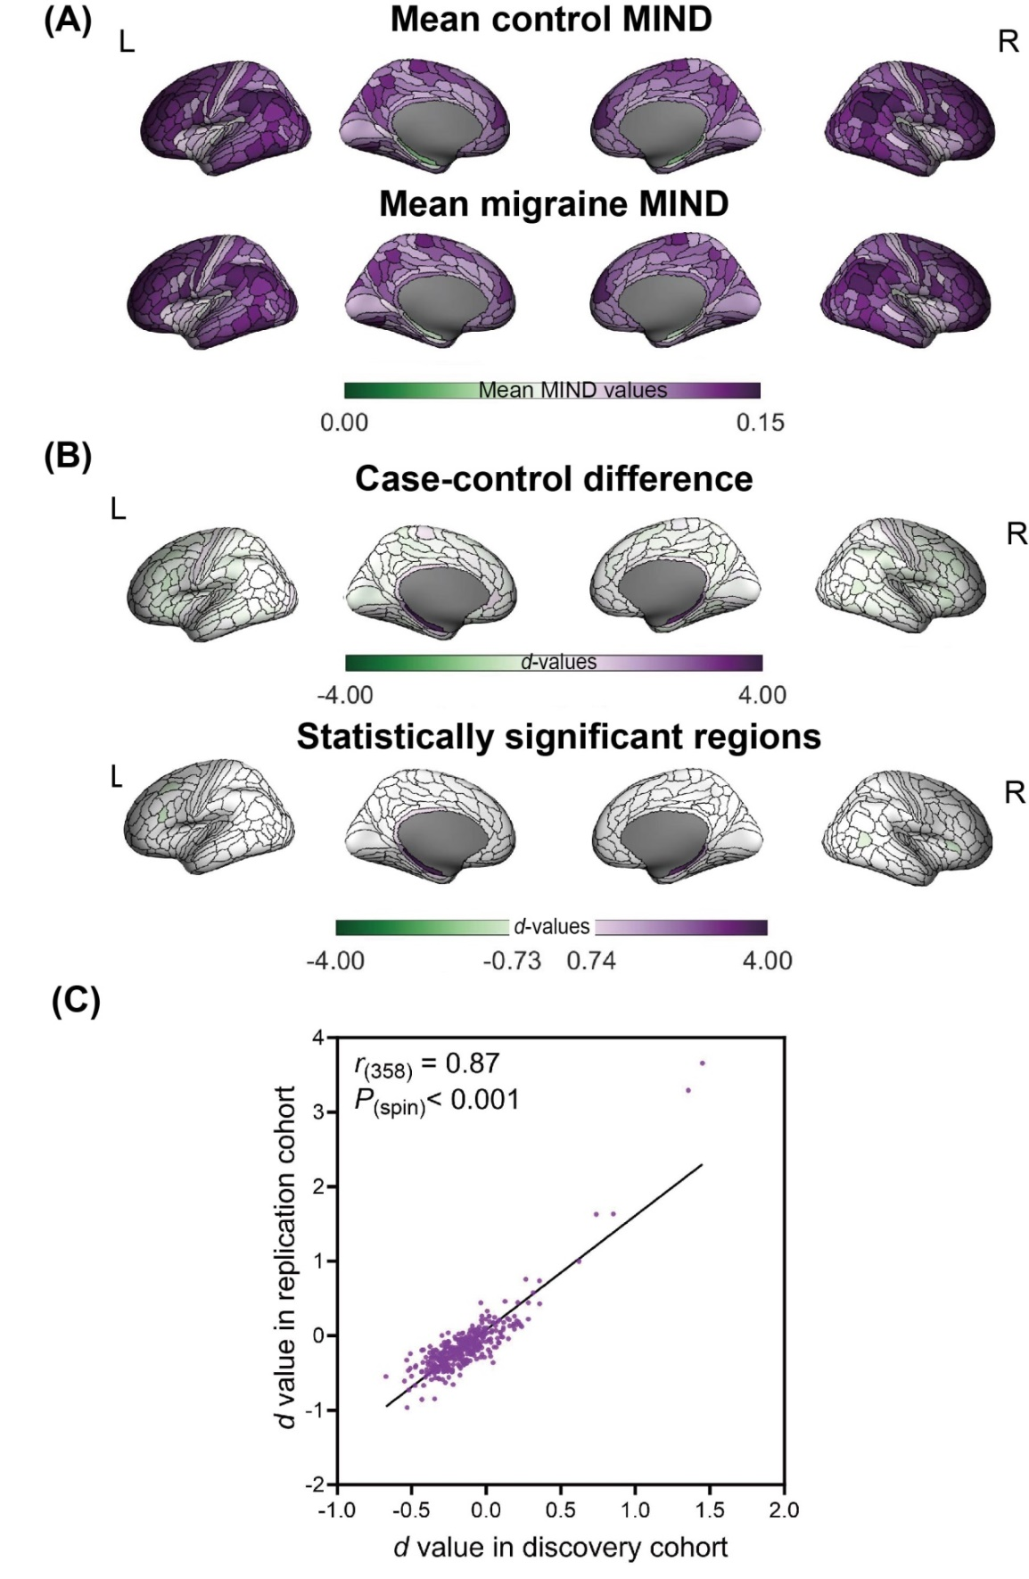

(A) Average MIND spatial distribution patterns in HCs and migraine patients. (B) Case-control difference of regional MIND between migraine patients and HCs expressed as a Cohen’s d map. Some cortical regions display statistically significant differences in MIND between migraine patients and HCs (P_{FDR} <0.05). (C) The case-control differences of MIND in replication cohort were positively correlated with the differences in discovery cohort.

Figure s2. High consistency of MIND alterations.
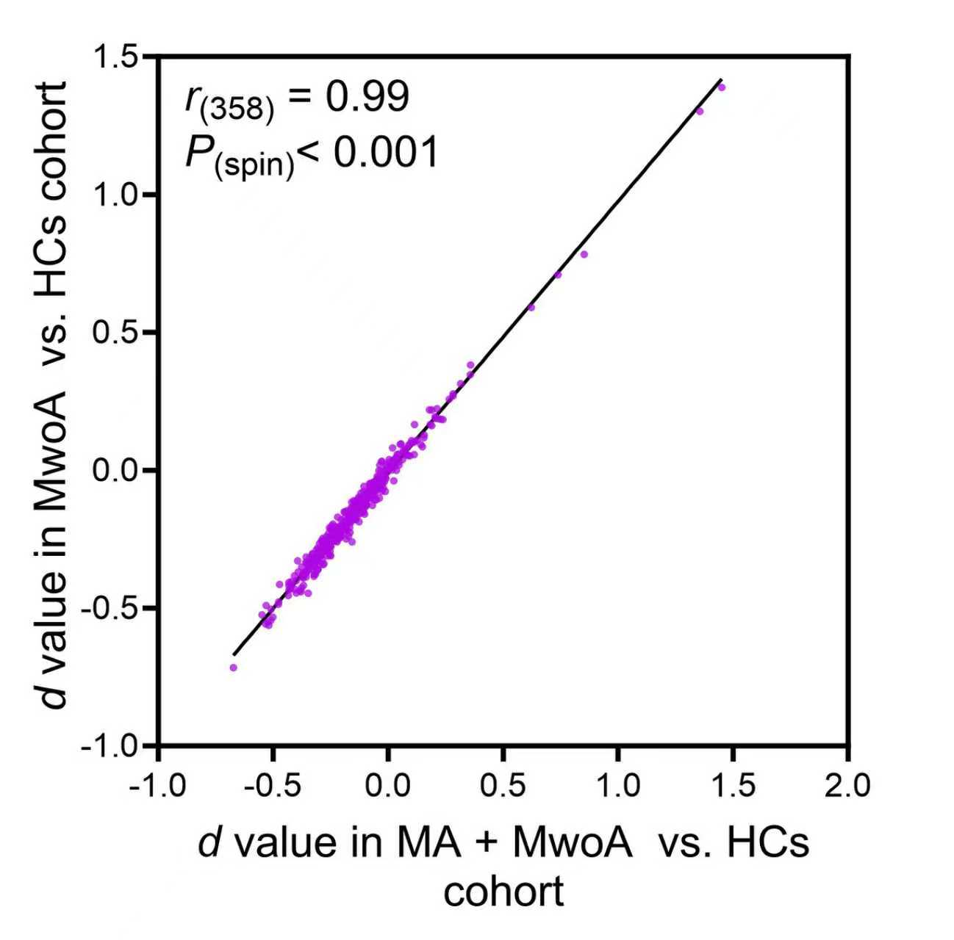
A scatter plot showing the strong spatial correlation between the case-control differences (Cohen's d values) from the primary analysis (x-axis) and the MwoA-only sensitivity analysis (y-axis). Each point represents one of the 360 cortical regions.

