Title: Sildenafil Provokes Headache but Not Migraine in Men With Migraine Without Aura: A Randomized, Placebo-Controlled Crossover Trial
Journal: The Journal of Headache and Pain

Authors’ names and affiliations: Anas Mohammad¹, Ditte Bork Iversen¹, Nete Lundager Klokker Rausgaard¹, Christina Kruuse^{2,3}, Dagmar Beier^{4,5,6}, Tore Bjerregaard Stage¹, Lanfranco Pellesi¹.

¹ Clinical Pharmacology, Pharmacy and Environmental Medicine, Department of Public Health, University of Southern Denmark, Odense, Denmark.
² Department of Brain- and Spinal Cord Injuries, Copenhagen University Hospital - Rigshospitalet, Glostrup, Denmark.
³ Department of Clinical Medicine, University of Copenhagen, Copenhagen, Denmark
⁴ Department of Neurology, Odense University Hospital, Odense, Denmark.
⁵ Department of Clinical Research, University of Southern Denmark, Odense, Denmark.
⁶ OPEN, Odense Patient Data Explorative Network, Odense University Hospital, Odense, Denmark.

Correspondence:
Lanfranco Pellesi, Clinical Pharmacology, Pharmacy, and Environmental Medicine, University of Southern Denmark, Odense, Denmark.
Email: lpellesi@health.sdu.dk.

Supplementary Table 1. Headache characteristics and related symptoms in men with migraine after sildenafil and placebo (0-12 hours observational period).

Patient No. | Peak headache (duration of headache), hours | Headache localization | Headache intensity | Headache quality | Aggravated by cough or movement | Nausea | Photophobia | Phonophobia | Migraine-like attack | Treatment (time)/efficacyª
1
Sildenafil | 4 (3) | Bilateral | Moderate | Pressing | Yes | No | No | Yes | No | None
Placebo | None | NA | NA | NA | NA | NA | NA | NA | NA | NA
2
Sildenafil | 5 (10) | Unilateral | Severe | Pressing | Yes | No | Yes | No | Yes | Sumatriptan (4 h)/Yes
Placebo | 1.2 (11) | Bilateral | Mild | Pressing | Yes | No | Yes | No | No | None
3
Sildenafil | None | NA | NA | NA | NA | NA | NA | NA | NA | NA
Placebo | 8 (10) | Unilateral | Severe | Pressing | Yes | No | No | Yes | Yes | Treo^{b} (6 and 8 h)/Yes
4
Sildenafil | 6 (6) | Unilateral | Mild | Pressing | No | No | No | No | No | None
Placebo | None | NA | NA | NA | NA | NA | NA | NA | NA | NA
5
Sildenafil | 5 (9) | Bilateral | Mild | Pulsating | Yes | No | No | No | No | None
Placebo | None | NA | NA | NA | NA | NA | NA | NA | NA | NA
6
Sildenafil | 4 (10) | Bilateral | Moderate | Pulsating | No | No | Yes | No | Yes | Rizatriptan (4 h)/Yes
Placebo | None | NA | NA | NA | NA | NA | NA | NA | NA | NA
7
Sildenafil | 4 (3) | Bilateral | Moderate | Pulsating | Yes | No | No | No | No | None
Placebo | None | NA | NA | NA | NA | NA | NA | NA | NA | NA
8
Sildenafil | 1 (0.2) | Unilateral | Mild | Pressing | No | No | No | No | No | None
Placebo | None | NA | NA | NA | NA | NA | NA | NA | NA | NA
9
Sildenafil | 7 (6) | Bilateral | Moderate | Pressing | No | No | No | No | No | None
Placebo | None | NA | NA | NA | NA | NA | NA | NA | NA | NA
10
Sildenafil | 4 (2) | Bilateral | Mild | Pressing | No | No | No | No | No | None
Placebo | None | NA | NA | NA | NA | NA | NA | NA | NA | NA
11
Sildenafil | 4 (4) | Bilateral | Mild | Pressing | Yes | No | No | No | Yes | Ibuprofen (5 h)/Yes
Placebo | None | NA | NA | NA | NA | NA | NA | NA | NA | NA
12
Sildenafil | None | NA | NA | NA | NA | NA | NA | NA | NA | NA
Placebo | 5 (11) | Bilateral | Moderate | Pressing | No | No | Yes | No | Yes | Rizatriptan (10 h)/Yes
Abbreviations: NA: not applicable. ª Pain freedom or pain relief (≥ decrease of intensity) within 2 hours. ^{b} Combination of acetylsalicylic acid (500 mg) and caffeine (50 mg).

Supplementary Table 2. Headache characteristics and related symptoms in women with migraine after sildenafil (0-12 hours observational period).

Patient No. | Peak headache (duration of headache), hours | Headache localization | Headache intensity | Headache quality | Aggravated by cough or movement | Nausea | Photophobia | Phonophobia | Migraine-like attack | Treatment (time)/efficacyª
1 | 0.8 (6.5) | Unilateral | Moderate | Pulsating | No | No | Yes | No | Yes | Treo^{b} (4 h)/Yes
2 | 8 (5) | Unilateral | Severe | Pressing | Yes | Yes | Yes | Yes | Yes | None
3 | 2 (2.5) | Unilateral | Moderate | Pressing | No | No | Yes | No | Yes | Zolmitriptan (3 h)/Yes
4 | 4 (6) | Unilateral | Moderate | Pressing | No | No | No | No | No | None
5 | 1.2 (12) | Unilateral | Moderate | Pulsating | No | No | Yes | Yes | Yes | Sumatriptan (9 h)/ Yes
6 | 4 (3) | Unilateral | Severe | Stabbing | No | Yes | No | No | Yes | Zolmitriptan (2 h) and Treo^{b} (4 h)/Yes
7 | 4 (4) | Bilateral | Moderate | Pulsating | Yes | Yes | Yes | Yes | Yes | Sumatriptan (4 h)/Yes
8 | 7 (6) | Diffuse | Severe | Pulsating | Yes | Yes | Yes | No | Yes | Sumatriptan (3 and 7 h)/Yes
9 | 5 (6.5) | Unilateral | Moderate | Pressing | No | No | Yes | No | Yes | Ibuprofen (2 and 4 h)/Yes
10 | 1 (1.5) | Unilateral | Mild | Pressing | No | Yes | Yes | Yes | No | None
11 | 3 (11) | Unilateral | Mild | Pressing | No | Yes | Yes | No | No | None
12 | 8 (10) | Unilateral | Severe | Pressing | No | Yes | Yes | No | Yes | Ibuprofen (1.3 and 10 h)/Yes
13 | 5 (10) | Unilateral | Mild | Pressing | No | Yes | No | No | No | None
14 | 0.8 (11.5) | Bilateral | Moderate | Pressing | No | No | Yes | Yes | No | None
15 | 4 (6.5) | Unilateral | Moderate | Pressing | Yes | Yes | Yes | No | Yes | Ibuprofen (2 h)/Yes
Abbreviations: NA: not applicable. ª Pain freedom or pain relief (≥ decrease of intensity) within 2 hours. ^{b} Combination of acetylsalicylic acid (500 mg) and caffeine (50 mg).

Supplementary Figure 1. Experimental drugs used in the open-label and crossover trials.

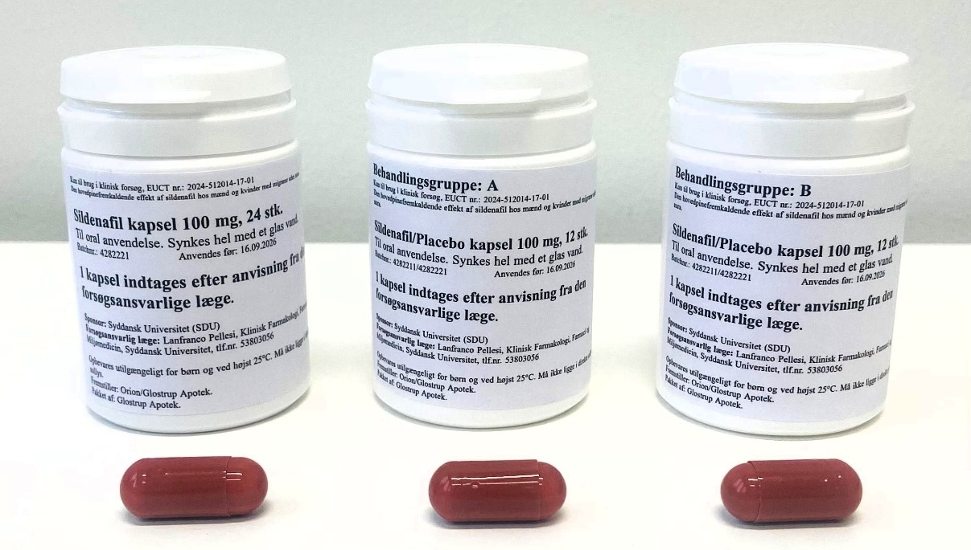

Supplementary Figure 2. Headache intensity (0-10 on a numerical rating scale) in 15 female patients with migraine following the administration of sildenafil. Each black dashed line represents an individual patient. The red line indicates the median headache intensity at each time point. The first portion of each graph (0-90 minutes, in grey) corresponds to the on-site observation phase, with time expressed in minutes. The second portion represents the home monitoring phase (up to 12 hours), with time expressed in hours.

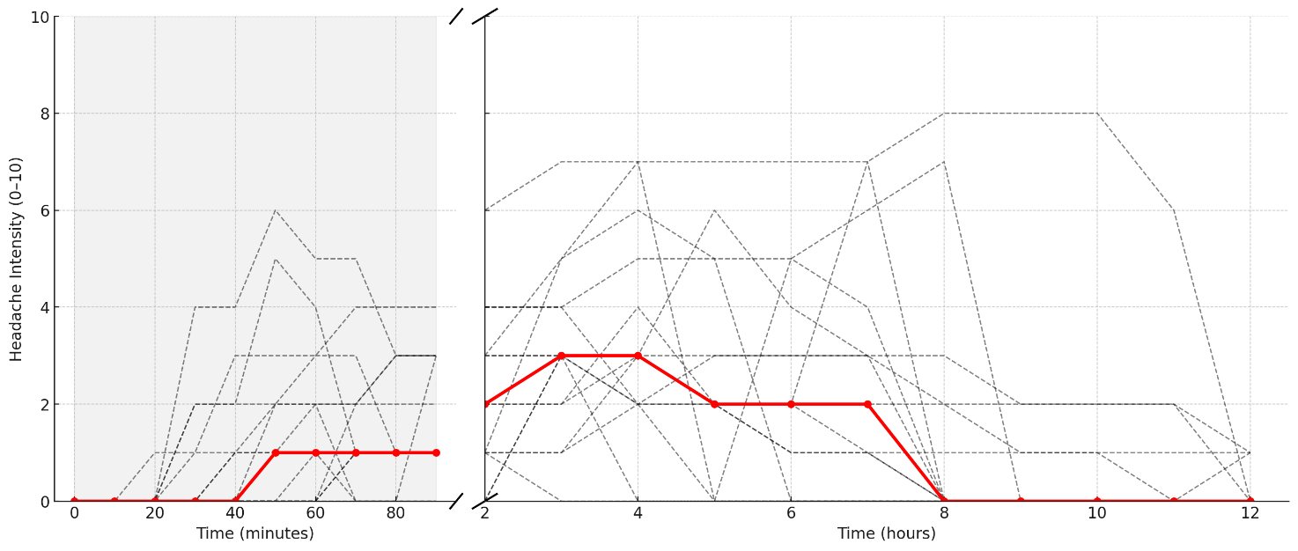

Supplementary Figure 3. Individual area-under-the-curve (AUC) values after placebo and sildenafil. (A) Mean arterial pressure (AUC, mmHg · min). (B) Heart rate (AUC, bpm · min). Red lines indicate means.

