Supplementary data

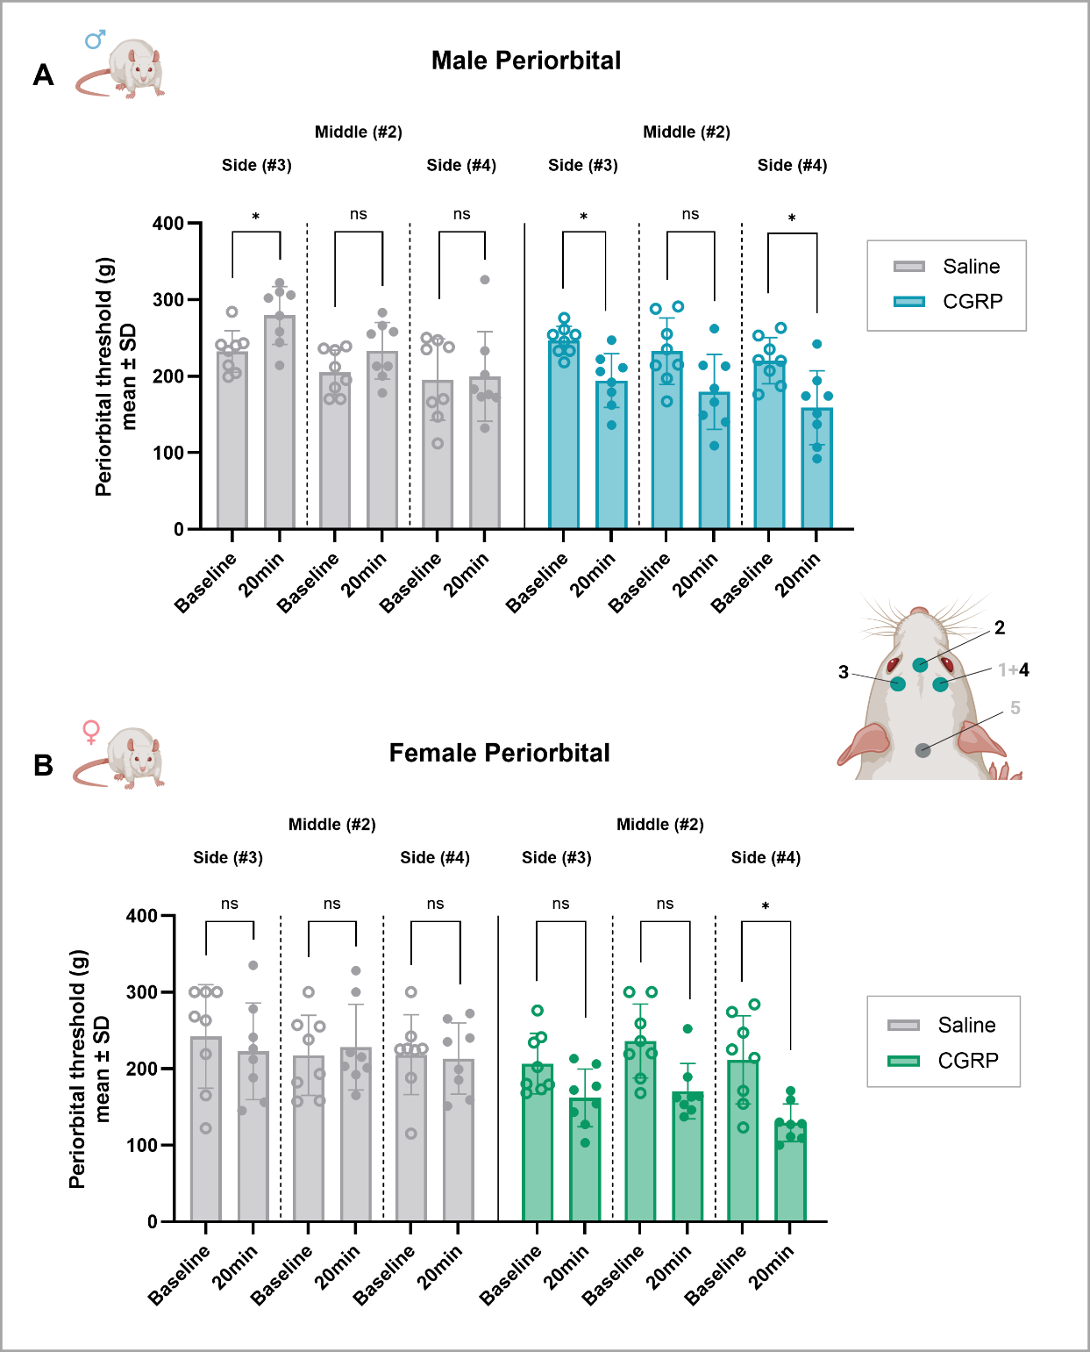
Suppl.Fig.S1. Pressure thresholds at localized periorbital sites following intravenous CGRP administration. The data shown are identical to those presented in Fig.9 (Part 3 data) of the main manuscript but are replotted to display pressure thresholds measured at the three individual periorbital sites (#2, 3, and 4, as illustrated to the right of the graphs). Male (n=16) and female (n=16) Sprague Dawley rats of study Part 3 (matched-cage) were treated with CGRP (n=8 male, 8 female) or saline (n=8 male, 8 female) intravenously and 20min later a periorbital von Frey test was performed. Baseline withdrawal threshold results were measured two days before the intervention study. The rats were housed in matched-cages, with one injection group per cage, and they were naïve to prior injections and behavioural testing before EvF assessment. Results are presented for each periorbital pressure point, shown for male rats in A) and female rats in B). Statistical comparisons between the two time-points (baseline and 20min post injection) across the three pressure point areas were performed within each injection group using 2way ANOVAs. This was followed by Sidak’s multiple comparisons test comparing baseline and 20 min for each pressure point. *; p<0.05, ns; non-significant p≥ 0.05. CGRP; calcitonin gene-related peptide, EvF; electronical von Frey.

