Supporting Information

Nr4a1 regulates microglia overactivation-mediated neuroinflammation to ameliorate cognitive impairment in trigeminal neuralgia rats
Junjie Liª, Zhilun Yangª, Xiaojuan Mi^{e}, Qiang Wang^{c}, Juan Dingª, Ziqi Fengª, Xia Ma^{d}, Liping Zhang^{d}, Juan Liu^{a,b,*}

This file includes：
- Supplementary Notes
- Supplementary Notes 1: Detailed Methodology
Supplementary Notes 1.1: Experimental animal groups and drug treatment
Supplementary Notes 1.2: Behavioral tests
Supplementary Notes 1.3: Detailed information of primary antibodies used in western blotting, including dilution ratios, catalog numbers, and suppliers
Supplementary Notes 1.4: Cell grouping and drug intervention
- Supplementary Notes 2: Confirmatory Results and Analysis
Supplementary Notes 2.1: Detailed behavioral analyses and microglial marker descriptions
Supplementary Notes 2.2: Detailed Metabolomic sequencing analysis
Supplementary Notes 2.3: Detailed protocols for in vitro model establishment and extended validation data
Supplementary Notes 2.4: Complete dataset descriptions for the PI3K/Akt2 pathway inhibition experiments
- Supplementary Table S1.
- Supplementary Figures 1-14
Supplementary Notes
Supplementary Notes 1: Detailed Methodology
Supplementary Notes 1.1: Experimental animal groups and drug treatment

Experiment 1 (evaluating phenotypic changes in cognitive impairment in TN rats): Sixty-four rats were randomly assigned to the Sham or dION-CCI group. In the Sham group, the right infraorbital nerve was exposed without ligation. In the dION-CCI group, TN model induction was performed through dION-CCI surgery, and the rats were further divided into 7-, 14-, and 28-day subgroups. The dION-CCI 7- and 14-day groups (n = 7 each) were used for immunofluorescence and western blotting. The Sham and dION-CCI 28-day groups (n = 23 each) were further allocated as follows: nine rats were used for transcriptomic and metabolomic sequencing, seven rats for real-time quantitative polymerase chain reaction (RT-qPCR) and western blotting, and nine for immunofluorescence and transmission electron microscopy (TEM). Details of behavioral tests and sample collection are shown in Figure S1.
Experiment 2 (evaluating the efficacy of Nr4a1-targeted interventions within microglia): Seventy-two rats were randomly assigned to four groups (n = 18 per group), namely, Sham + AAV⁻ (stereotactic injection of empty AAV into the hippocampus), dION-CCI + AAV⁻ (TN model with empty AAV injection), Sham + AAV⁺ (Sham rats injected with Nr4a1-overexpressing AAV), and dION-CCI + AAV⁺ (TN model injected with Nr4a1-overexpressing AAV). Within each group, six rats were used for western blotting, and the remaining 12 were used for immunofluorescence, TEM, and Golgi staining (Figure S1).
Experiment 3 (Pharmacological inhibition of the PI3K/Akt2 pathway): To mechanistically interrogate the PI3K/Akt2 pathway, eighty rats were randomly allocated into five groups (n = 16 per group): Sham + AAV⁻, dION-CCI + AAV⁻, dION-CCI + AAV⁺, dION-CCI + AAV⁺ + LY294002, and dION-CCI + AAV⁺ + MK-2206. Rats in the inhibitor groups received the PI3K inhibitor LY294002 (1.2 mg/kg/day, i.p. for 14 days) or the Akt2 inhibitor MK-2206 (100 mg/kg/day, i.p. for 5 days). These distinct regimens—selected based on established protocols for sustained pathway inhibition (LY294002) or rapid, potent target suppression (MK-2206) [1–4] and validated in our pilot studies—effectively inhibited hippocampal p-PI3K or p-Akt2, respectively, without overt toxicity. Control animals received vehicle (DMSO-saline). For each group, four rats were used for western blotting, and 12 were used for immunofluorescence, TEM, and Golgi staining (Figure S1).
References:
1 Zhao Y, Yang L, Chen M, Gao F, Lv Y, Li X, Liu H (2024) Study on Undercarboxylated Osteocalcin in Improving Cognitive Function of Rats with Type 2 Diabetes Mellitus by Regulating PI3K-AKT-GSK/3β Signaling Pathwaythrough medical images. Biotechnol Genet Eng Rev 40:2246-2261. doi.10.1080/02648725.2023.2199238
2. Ahmed HH, Essam RM, El-Yamany MF, Ahmed KA, El-Sahar AE (2023) Unleashing lactoferrin’s antidepressant potential through the PI3K/Akt/mTOR pathway in chronic restraint stress rats. Food Funct 14:9265-9278. doi.10.1039/D3FO02222F
3. Choi JI, Choi J-W, Shim K-H, Choung JS, Kim H-J, Sim HR, Suh MR, Jung JE, Kim M (2021) Synergistic effect in neurological recovery via anti-apoptotic Akt signaling in umbilical cord blood and erythropoietin combination therapy for neonatal hypoxic-ischemic brain injury. Int J Mol Sci 22:11995. doi.10.3390/ijms222111995
4. Wang Y, Gao S, Zheng V, Chen L, Ma M, Shen S, Qu J, Zhang H, Gurney ME, O’Donnell JM, Xu Y (2020) A novel PDE4D inhibitor BPN14770 reverses scopolamine-induced cognitive deficits via cAMP/SIRT1/Akt/Bcl-2 pathway. Front Cell Dev Biol 8:599389. doi.10.3389/fcell.2020.599389

Supplementary Notes 1.2: Behavioral tests

Rats were acclimated to the testing room for 30 min before each experiment. All behavioral tests were conducted between 7:00 AM and 7:00 PM under controlled light and noise conditions. Tests were performed in order of invasiveness, from least to most invasive. The apparatus was cleaned with 75% ethanol between trials. Behavioral data were analyzed using Smart 3.0 (Panlab, S.L.U., Barcelona, Spain) or manually scored by a blinded experimenter.
1. Mechanical pain threshold detection
The mechanical pain threshold was assessed using von Frey filaments and the “Up–Down” method [1]. The infraorbital nerve-innervated perinasal area, including the vibrissal pad and adjacent hairy skin, was stimulated with filaments applied perpendicularly. Each stimulus was maintained for 2-3 s. Behavioral responses were recorded, and the threshold for mechanical pain was calculated based on response patterns and the final filament used. Only rats meeting the baseline threshold criterion (15 g) were included in the study; a total of 5 rats were excluded based on this screening (1 rat in Experiment 1, and 2 rats each in Experiments 2 and 3). A significant decrease in the mechanical pain threshold on the operated side after surgery indicated successful model establishment.
2. Open field test (OFT)
Locomotor activity and potential motor deficits that could influence behavioral outcomes were evaluated using the OFT following an established protocol [2]. Each rat was placed in the center of a black cubic chamber (50 × 50 × 50 cm) and allowed to freely explore for 5 min. The total distance traveled (cm) was recorded and analyzed.
3. Novel object recognition test (NORT)
The NORT was used to assess recognition memory and hippocampal-dependent cognitive function, following established methods [2]. During the habituation phase, two identical objects were placed diagonally in a square arena (50 × 50 × 40 cm), with each object equidistant from the walls. Rats were allowed to freely explore the arena for 10 min, and the time spent exploring each object was recorded. After 24 h, one familiar object was replaced with a novel object differing in shape and color. Rats were reintroduced for 10 min, and exploration times for both objects were recorded. The discrimination index was calculated as follows: (time exploring novel object / total exploration time) × 100%.
4. Morris water maze test (MWMT)
The MWMT was conducted to assess spatial learning and memory, as described in a previous study [1]. Briefly, a circular pool (diameter, 120 cm; height, 50 cm) was filled with water rendered opaque using non-toxic black ink. A hidden platform (diameter, 10 cm) was positioned 1 cm below the surface. The acquisition phase comprised 5 consecutive days of training trials. During each trial, rats were gently placed in the water and given 60 s to locate the hidden platform. Rats that successfully reached the platform were allowed to remain on it for 15 s, whereas those that failed were guided to the platform and allowed to remain for the same duration. Escape latency, defined as the time taken to reach the platform, was recorded. On the 6th day, a probe test was performed with the platform removed. The number of crossings over the previous platform location and the percentage of time spent in the target quadrant were measured during a 60-s session.
References:
1. Li J, Mi X, Yang Z, Feng Z, Han Y, Wang T, Lv H, Liu Y, Wu K, Liu J (2025) Minocycline ameliorates cognitive impairment in rats with trigeminal neuralgia by regulating microglial polarization. Int Immunopharmacol 145:113786. doi.10.1016/j.intimp.2024.113786
2. Zhang X, Gao R, Zhang C, Teng Y, Chen H, Li Q, Liu C, Wu J, Wei L, Deng L, Wu L, Ye-Lehmann S, Mao X, Liu J, Zhu T, Chen C (2023) Extracellular RNAs-TLR3 signaling contributes to cognitive impairment after chronic neuropathic pain in mice. Signal Transduct Target Ther 8:292. doi.10.1038/s41392-023-01543-z

Supplementary Notes 1.3: Detailed information of primary antibodies used in western blotting, including dilution ratios, catalog numbers, and suppliers

Primary antibodies | Dilution ratios | Catalog numbers | Suppliers
Iba1 | 1:1000 | ab178846 | Abcam, Cambridge, UK
GFAP | 1:1000 | ab7260 | Abcam
HMGB1 | 1:1000 | ab18256 | Abcam
IL-1β | 1:1000 | AF5103 | Affinity, Cincinnati, OH, USA
TNF-α | 1:700 | AF7014 | Affinity
IL-6 | 1:700 | DF6087 | Affinity
IL-4 | 1:700 | sc-53084 | Santa Cruz, CA, USA
IL-10 | 1:1000 | DF6894 | Affinity
LC3-Ⅱ | 1:1000 | ET1701-65 | HuaBio, Hangzhou, China
p62 | 1:1000 | HA721171 | HuaBio
SYN | 1:1000 | 36406 | Cell Signaling Technology, Danvers, MA, USA
PSD95 | 1:1000 | 3409 | Cell Signaling Technology
Nr4a1 | 1:500 | sc-365113 | Santa Cruz
BDNF | 1:1000 | ab108319 | Abcam
TrkB | 1:1000 | 4603 | Cell Signaling Technology
p-PI3K | 1:1000 | 4228 | Cell Signaling Technology
PI3K | 1:1000 | 4249 | Cell Signaling Technology
p-Akt | 1:1000 | 4060 | Cell Signaling Technology
Akt | 1:1000 | 4685 | Cell Signaling Technology
p-mTOR | 1:1000 | 5536 | Cell Signaling Technology
mTOR | 1:1000 | 2983 | Cell Signaling Technology
p-Akt2 | 1:1000 | 8599 | Cell Signaling Technology
Akt2 | 1:1000 | 3063 | Cell Signaling Technology
β-actin | 1:5000 | AF7018 | Affinity

Supplementary Notes 1.4: Cell grouping and drug intervention

Figure S2 shows a flowchart of cell experiments. To investigate the role of Nr4a1 in microglia-mediated neuroinflammation, BV2 cells were assigned to four groups, namely, Control, LPS, LPS + Vec, and LPS + Nr4a1^{OE}. Based on previous studies [1] and our experimental results, 1 μg/mL LPS (055:B5; Sigma-Aldrich) was used to effectively simulate microglial inflammatory responses in vitro. Accordingly, this concentration was selected for subsequent experiments. The LPS group received 1 μg/mL LPS for 24 h; the LPS + Vec group comprised BV2 cells transfected with the empty lentiviral vector, followed by 1 μg/mL LPS treatment for 24 h; the LPS + Nr4a1^{OE} group included stable Nr4a1-overexpressing BV2 cells treated with 1 μg/mL LPS for 24 h. Subsequently, immunofluorescence staining and western blotting were performed.
To examine whether Nr4a1 regulates neuroinflammation induced by microglial overactivation via the PI3K/Akt2 pathway, BV2 cells were divided into five groups, namely, Control, LPS, LPS + Nr4a1^{OE}, LPS + Nr4a1^{OE} + LY294002, and LPS + Nr4a1^{OE} + MK-2206. The PI3K inhibitor LY294002 (10 μM, M1925; AbMole; Shanghai, China) and Akt2 inhibitor MK-2206 (0.5 μM, M1837; AbMole) were applied based on previous studies [1, 2] and our experimental data. Both inhibitors were dissolved in DMSO. Control groups were exposed to an equivalent DMSO concentration (< 0.2%) to account for potential solvent effects. The LPS + Nr4a1^{OE} + LY294002 group received 1 μg/mL LPS and 10 μM LY294002 for 24 h, whereas the LPS + Nr4a1^{OE} + MK-2206 group received 1 μg/mL LPS and 0.5 μM MK-2206 for 24 h, with both groups comprising the stable Nr4a1-overexpressing BV2 cell line. Subsequently, western blotting was conducted.
The conditioned medium from each group was collected and centrifuged at 1000 ×g for 5 min. Subsequently, the culture medium of HT22 cells was replaced by the supernatant, and the cells were incubated for 12 h. Next, immunofluorescence staining and western blotting were performed to evaluate neuronal autophagy and synaptic plasticity.
References:
1. Guo L-T, Wang S-Q, Su J, Xu L-X, Ji Z-Y, Zhang R-Y, Zhao Q-W, Ma Z-Q, Deng X-Y, Ma S-P (2019) Baicalin ameliorates neuroinflammation-induced depressive-like behavior through inhibition of toll-like receptor 4 expression via the PI3K/AKT/FoxO1 pathway. J Neuroinflammation 16:95. doi.10.1186/s12974-019-1474-8
2. Xiong Y, Liang W, Wang X, Zhu H, Yi P, Wei G, Liu H, Lin Y, Zhang L, Ying J, Hua F (2024) S100A8 knockdown activates the PI3K/AKT signaling pathway to inhibit microglial autophagy and improve cognitive impairment mediated by chronic sleep deprivation. Int Immunopharmacol 143:113375. doi.10.1016/j.intimp.2024.113375

Supplementary Notes 2: Confirmatory Results and Analysis
Supplementary Notes 2.1: Detailed behavioral analyses and microglial marker descriptions

1. Detailed behavioral analyses: In the Sham group, no significant differences were observed at any time after surgery. In contrast, the dION-CCI group exhibited significantly reduced pain thresholds on days 3, 7, 14, 21, and 28 compared with baseline and Sham group values (Figure 1b), confirming effective induction of the TN model. Motor function, evaluated using the OFT, revealed no significant differences in the total distance traveled during OFT1 and OFT2 among groups (Figure 1c, k). Similarly, in the NORT, locomotor activity did not differ between groups during NORT1 or NORT2 (Figure 1e, m), indicating that dION-CCI surgery did not impair motor function. Although no significant difference was detected in the discrimination index during NORT1 (Figure 1d, f), the dION-CCI group exhibited a significantly reduced discrimination index in NORT2 compared with the Sham group (Figure 1l, n). In the MWMT, no differences were observed during MWMT1 (Figure 1g-j); however, in MWMT2, the dION-CCI group demonstrated prolonged escape latency, made fewer platform crossings, and spent less time in the target quadrant (Figure 1o-r). These results indicate that TN rats developed hippocampal-dependent cognitive deficits, including impaired spatial learning and working memory, by Day 28.
2. Detailed microglial marker descriptions: Western blotting and immunofluorescence staining were performed at multiple time points after model induction to investigate temporal changes in hippocampal microglial activation in TN rats. Microglial activation is characterized by a transition from a highly ramified state to an amoeboid morphology, accompanied by enlarged cell bodies, shortened processes, and increased expression of ionized calcium-binding adapter molecule 1 (Iba1) [1, 2]. Elevated expression of glial fibrillary acidic protein can be triggered by excessive activation of microglia [3]. High-mobility group box 1 contributes to the initiation and maintenance of microglial activation [4].
References:
1. Gao C, Jiang J, Tan Y, Chen S (2023) Microglia in neurodegenerative diseases: mechanism and potential therapeutic targets. Signal Transduct Target Ther 8:359. doi.10.1038/s41392-023-01588-0
2. Fernández-Arjona MdM, Grondona JM, Granados-Durán P, et al (2017) Microglia morphological categorization in a rat model of neuroinflammation by hierarchical cluster and principal components analysis. Front Cell Neurosci 11:235. doi:10.3389/fncel.2017.00235
3. Liu M, Xu Z, Wang L, et al (2020) Cottonseed oil alleviates ischemic stroke injury by inhibiting the inflammatory activation of microglia and astrocyte. J Neuroinflammation 17:270. doi:10.1186/s12974-020-01946-7
4. Shi Y, Guo X, Zhang J, et al (2018) DNA binding protein HMGB1 secreted by activated microglia promotes the apoptosis of hippocampal neurons in diabetes complicated with OSA. Brain Behav Immun 73:482–492. doi:10.1016/j.bbi.2018.06.012

Supplementary Notes 2.2: Detailed Metabolomic sequencing analysis

Metabolomic sequencing was performed to investigate hippocampal metabolic alterations. Partial least squares-discriminant analysis revealed a clear separation between the Sham and dION-CCI groups, indicating distinct metabolic profiles (Figure 2a). Twelve metabolites were upregulated, and 12 were downregulated in the hippocampus of TN rats (Figure 2b). KEGG pathway enrichment analysis revealed significant involvement of autophagy, the phosphatidylinositol signaling system, and LTP pathways (Figure 2c-d).

Supplementary Notes 2.3: Detailed protocols for in vitro model establishment and extended validation data

Based on previous studies [1], an in vitro inflammatory model was established in BV2 cells using LPS. First, we transfected BV2 cells with the Nr4a1-overexpressing lentivirus at different MOI. Subsequently, the optimal puromycin concentration was determined (Figure S7a-b). Next, stable LV-Nr4a1^{OE} cells were selected using an MOI of 50 and 4 μg/mL puromycin, and the transfection efficiency was confirmed through immunofluorescence and western blotting (Figure S7c, g). Treatment with 1 μg/mL LPS, based on our experimental and previous findings [2], did not affect BV2 cell viability but induced an amoeboid morphology in more cells and promoted a predominantly pro-inflammatory activation state (Figure S7d-f). Additionally, western blotting revealed that compared with the control group, the LPS group exhibited increased expression of pro-inflammatory cytokines (TNF-α, IL-6, and IL-1β) and decreased expression of anti-inflammatory cytokines (IL-4 and IL-10); however, Nr4a1 overexpression reversed these changes (Figure S7h-m).
References:
1. Wang W, Wang Y, Wang F, Xie G, Liu S, Li Z, Wang P, Liu J, Lin L (2024) Gastrodin regulates the TLR4/TRAF6/NF-κB pathway to reduce neuroinflammation and microglial activation in an AD model. Phytomedicine 128:155518. doi.10.1016/j.phymed.2024.155518
2. Guo L-T, Wang S-Q, Su J, Xu L-X, Ji Z-Y, Zhang R-Y, Zhao Q-W, Ma Z-Q, Deng X-Y, Ma S-P (2019) Baicalin ameliorates neuroinflammation-induced depressive-like behavior through inhibition of toll-like receptor 4 expression via the PI3K/AKT/FoxO1 pathway. J Neuroinflammation 16:95. doi.10.1186/s12974-019-1474-8

Supplementary Notes 2.4: Complete dataset descriptions for the PI3K/Akt2 pathway inhibition experiments

To investigate whether Nr4a1 can influence neuronal autophagy and synaptic plasticity in TN rats via the PI3K/Akt2 pathway, we conducted in vivo and in vitro experiments. TEM and western blotting showed that compared with the dION-CCI + AAV⁺ group, the dION-CCI + AAV⁺ + LY294002 and dION-CCI + AAV⁺ + MK-2206 groups exhibited increased autophagosomes and lysosomes, elevated LC3-II levels with reduced p62, and aggravated dilation of endoplasmic reticulum cisternae in the MK-2206 subgroup (Figure S12a-d). Furthermore, crucial synaptic plasticity proteins (BDNF, TrkB, SYN, and PSD95) were downregulated in the inhibitor-treated groups (Figure S12e-j). TEM revealed thinning of the PSD and disruption of synaptic structures (Figure S12k-n), and Golgi staining indicated reduced dendritic spine density, fewer mature spines, and more immature spines across hippocampal subregions in the inhibitor-treated groups (Figure S12o-x). These findings were confirmed in vitro using HT22 cells (Figure S13a). Western blotting showed that, compared with the control and Nr4a1 overexpression groups, conditioned medium from BV2 cells subjected to LPS and inhibitor interventions led to increased LC3-II levels, decreased p62 expression, and significantly reduced protein levels of BDNF, TrkB, SYN, and PSD95 in HT22 cells. (Figure S13b-j). Consistent protein-level decreases in PSD95 were confirmed through immunofluorescence (Figure S13k-l). PI3K/Akt2 pathway inhibition compromised the beneficial effects on autophagy and synaptic plasticity previously observed following Nr4a1 overexpression in TN rat hippocampi.
Subsequently, we performed behavioral tests to evaluate how PI3K/Akt2 pathway inhibition affects cognitive function in TN rats (Figure S14a). Pain thresholds were significantly lower in all experimental groups than in the Sham + AAV⁻ group on days 3, 7, 14, 21, and 28. However, the dION-CCI + AAV⁺ group showed higher pain thresholds than the dION-CCI + AAV⁻ group on days 14, 21, and 28 (Figure S14b). Locomotor activity did not differ significantly between groups in the OFT (Figure S14c). In the NORT, the dION-CCI + AAV⁺ + LY294002 and dION-CCI + AAV⁺ + MK-2206 groups exhibited a lower discrimination index than the dION-CCI + AAV⁺ group, with no difference in overall movement (Figure S14d-f). In the MWMT, the same groups displayed increased escape latency, made fewer platform crossings, and spent less time in the target quadrant than did the dION-CCI + AAV⁺ group (Figure S14g-j). These results indicate that PI3K/Akt2 pathway inhibition attenuates the cognitive benefits associated with Nr4a1 overexpression in TN rats.

Supplementary Table S1.
PCR primers used in this study.
Primer | Forward (5′ → 3′) | Reverse (5′ → 3′)
Nr4a1 | TTGGAAAGGAAGATGCCGG | TGTCTATCCAGTCACCAAAGCC
PI3k | TGGCTTACGCTCCAGTATTTGC | TAGAAGTGGGCTTGGGTGGTTTA
Akt | CGACGTAGCCATTGTGAAGGAG | ATTGTGCCACTGAGAAGTTGTTG
GAPDH | CTGGAGAAACCTGCCAAGTATG | GGTGGAAGAATGGGAGTTGCT

Supplementary Figures

Supplementary Figure 1. Flowchart of the experimental procedure for in vivo.

Supplementary Figure 2. Flowchart of the experimental procedure for in vitro.

Supplementary Figure 3. Hippocampal microglia in TN rats exhibit time-dependent overactivation and mediate neuroinflammatory responses. (a-b) Representative immunofluorescence images and quantitative analysis of Iba1 expression in the hippocampus (n = 3-4). Scale bar = 20 μm. (c-f) Protein expression levels of Iba1, GFAP, and HMGB1 analyzed using western blotting (n = 3). (g) Enrichment of inflammation-related genes from transcriptomic sequencing data (GSEA bar plot). (h-m) Protein expression levels of IL-1β, TNF-α, IL-4, and IL-10 analyzed using western blotting (n = 3). Data are expressed as mean ± SD. *P < 0.05, **P < 0.01, ***P < 0.001.

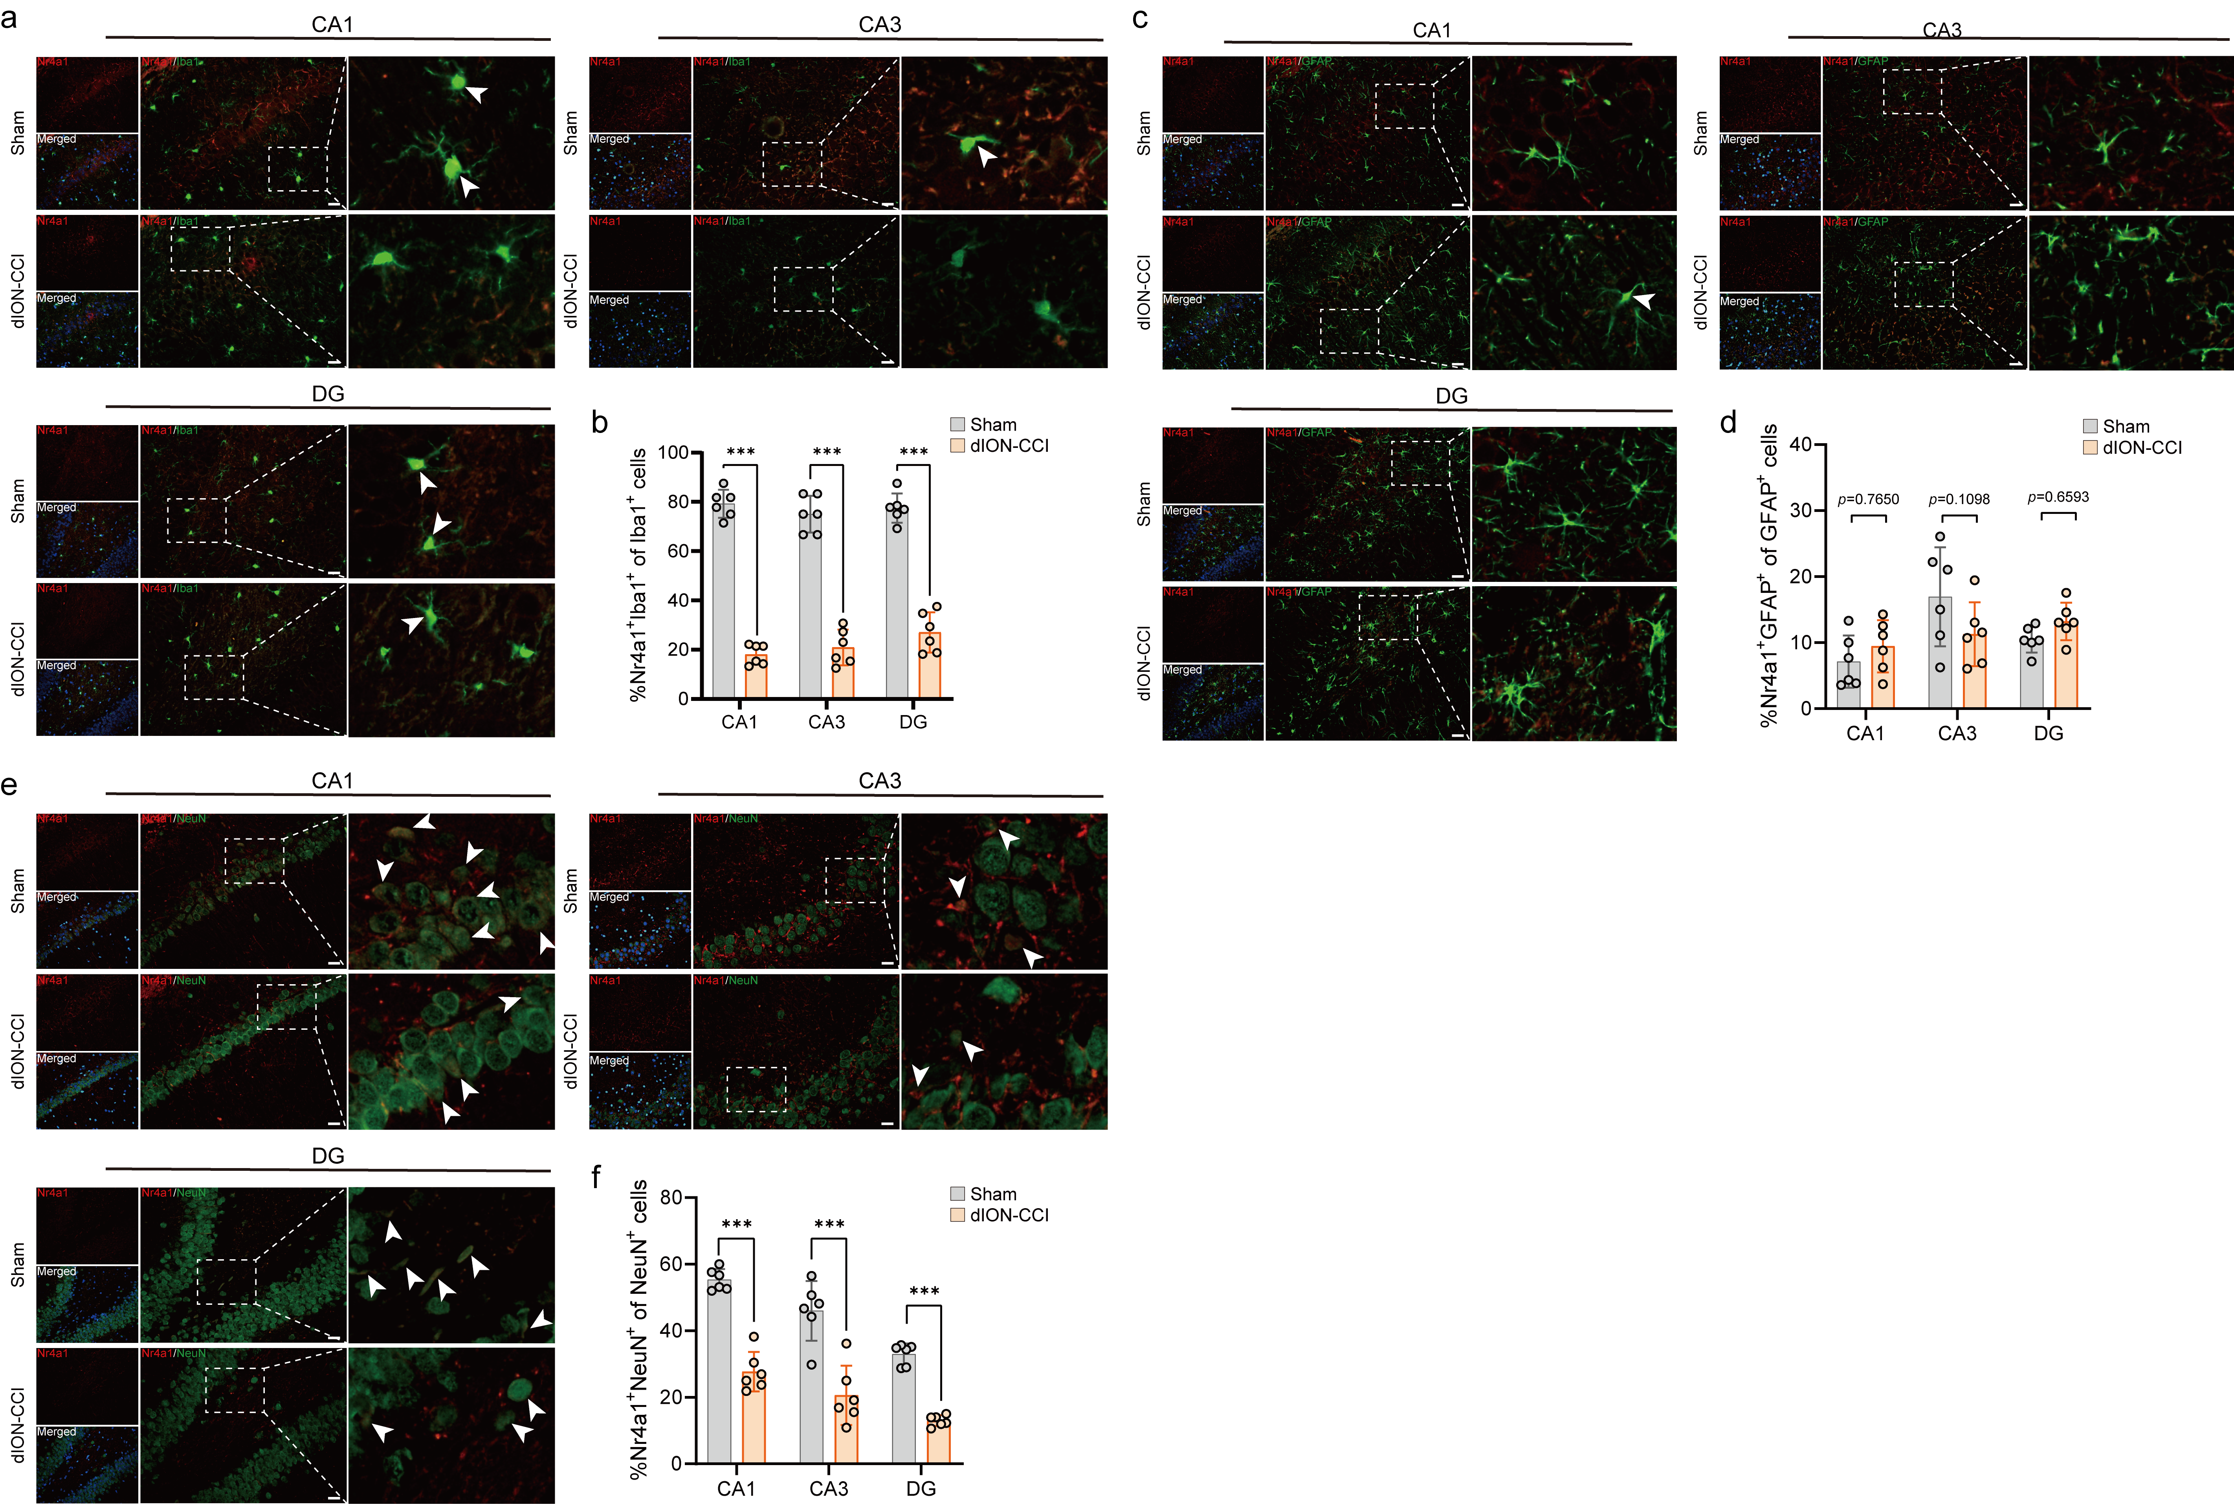
Supplementary Figure 4. Immunofluorescence staining shows reduced Nr4a1 expression in hippocampal microglia and neurons of TN rats. (a-b) Co-localization of Nr4a1 with microglia (Iba1⁺) (n = 6). Scale bar = 20 μm. (c-d) Co-localization of Nr4a1 with astrocytes (GFAP⁺) (n = 6). Scale bar = 20 μm. (e-f) Co-localization of Nr4a1 with neurons (NeuN⁺) (n = 6). Scale bar = 20 μm. White arrows indicate merged signals of Nr4a1 with Iba1, GFAP, or NeuN. +, antibody-positive expression. Data are expressed as mean ± SD. ***P < 0.001.

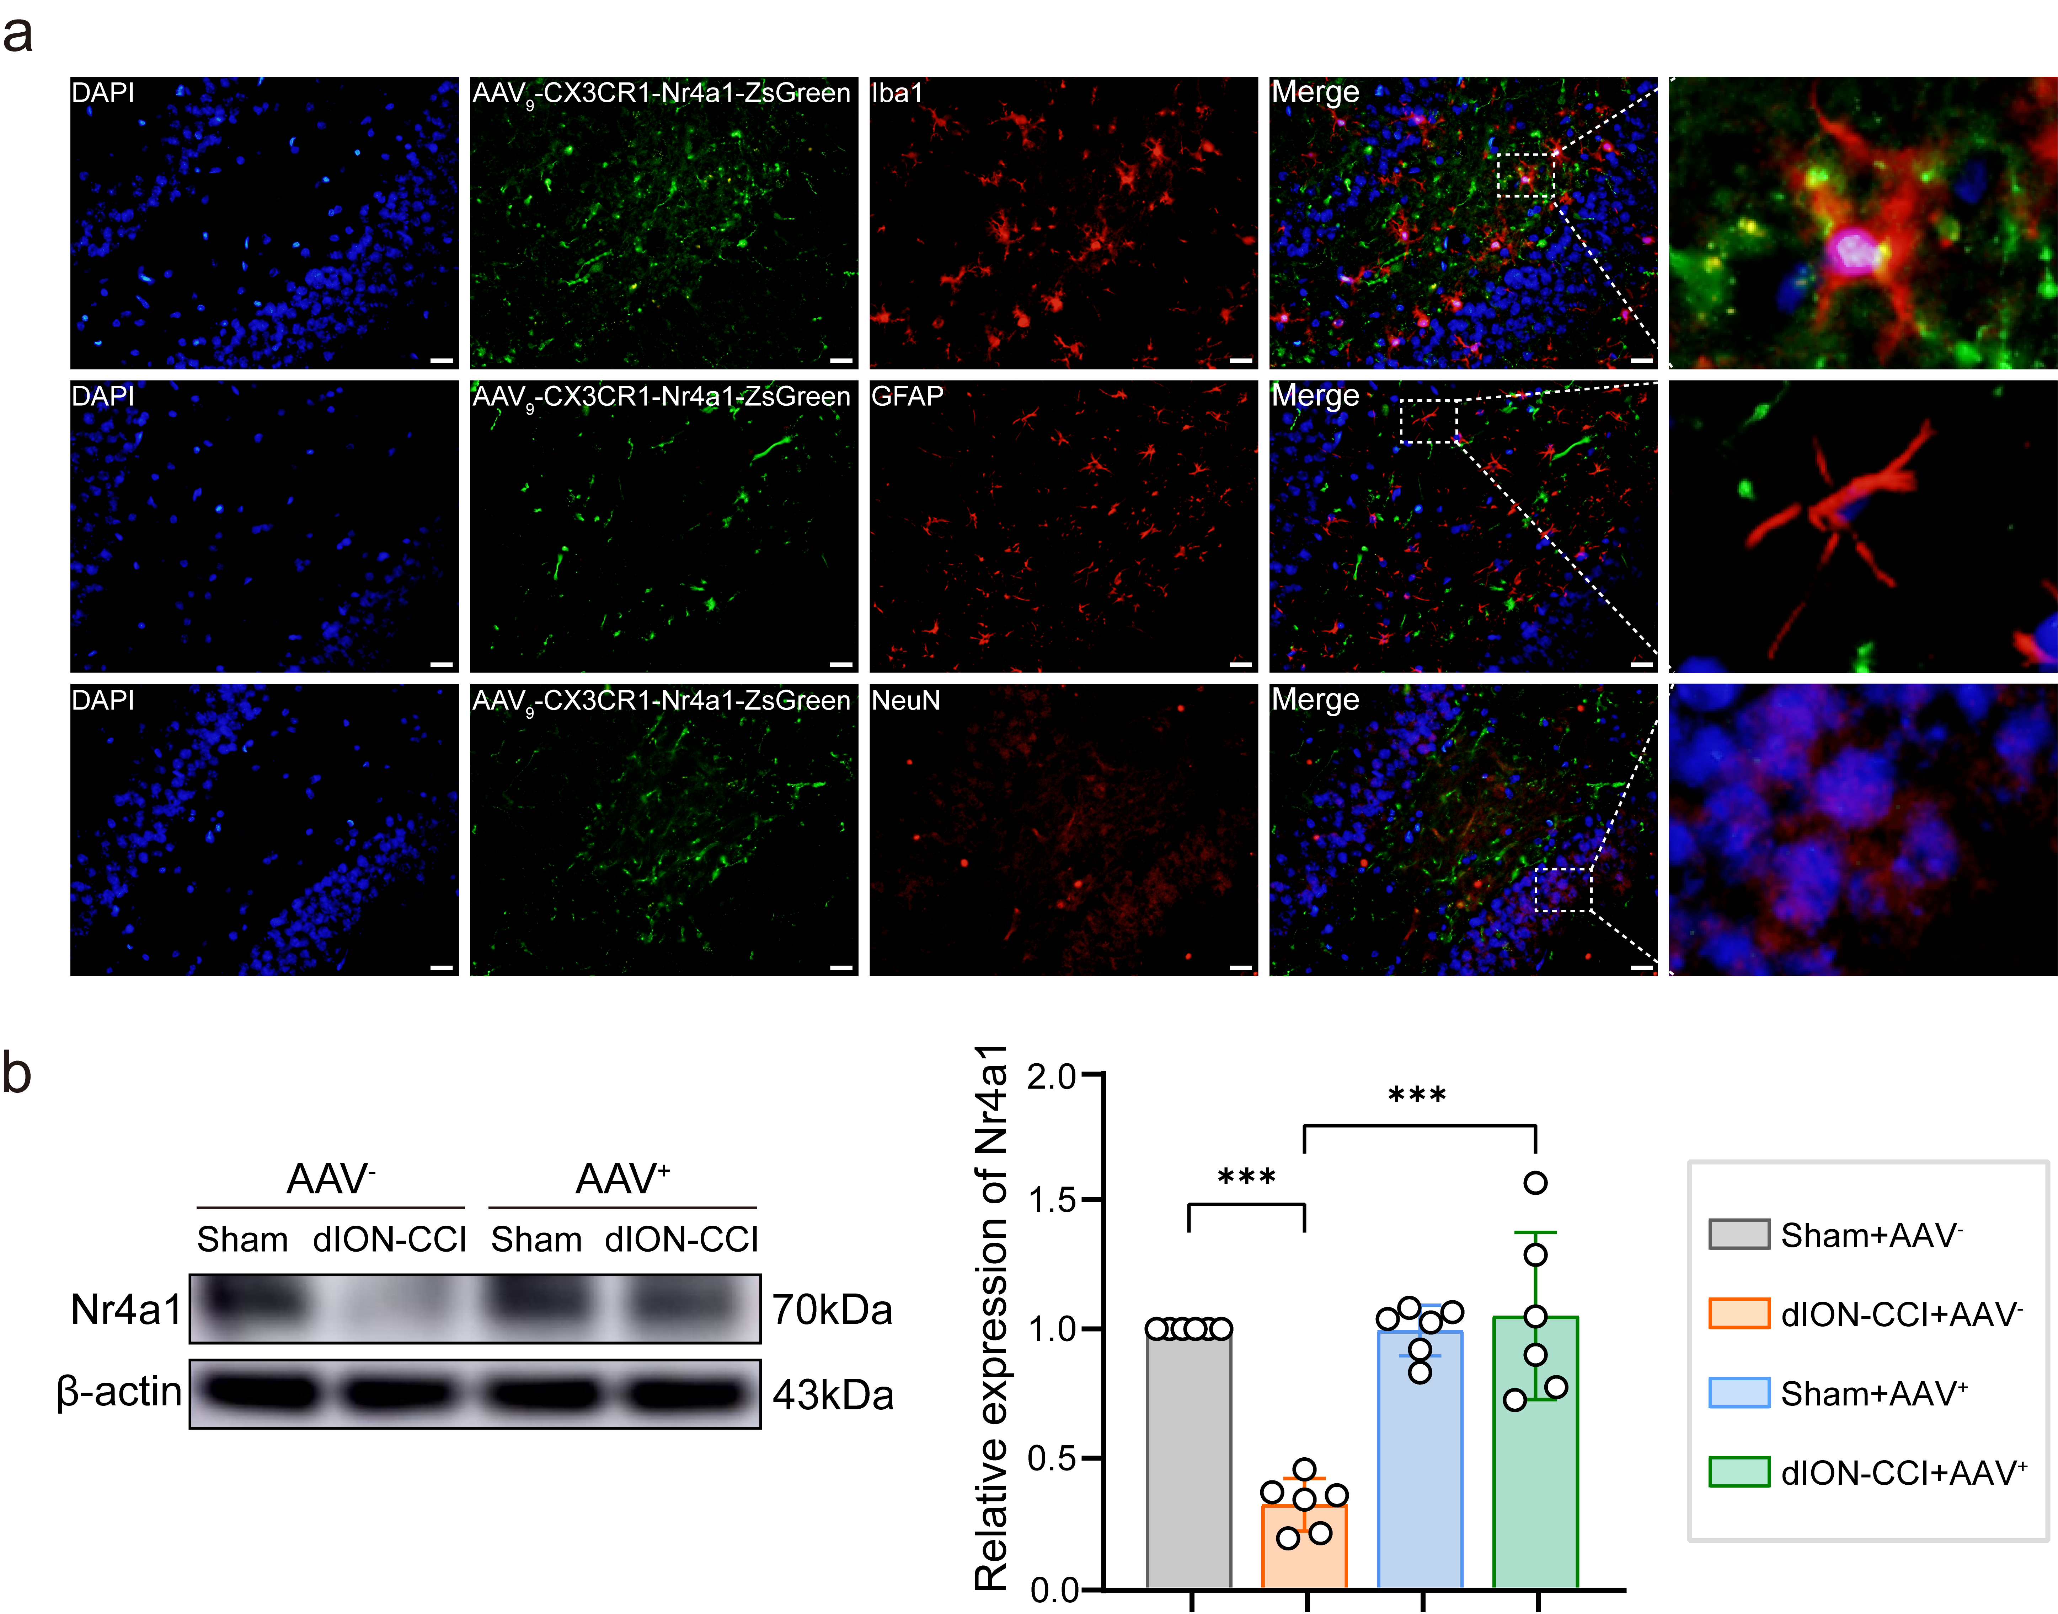
Supplementary Figure 5. Verification of hippocampal microglia-specific overexpression of Nr4a1 (a) Co-localization of AAV (green) with microglia (IBA1⁺), astrocytes (GFAP⁺), and neurons (NeuN⁺) in the hippocampus after AAV overexpression. Scale bar = 20 μm. (b) Protein expression of Nr4a1 was analyzed using western blotting (n = 6). +, antibody-positive expression. Data are expressed as mean ± SD. ***P < 0.001.

Supplementary Figure 6. Nr4a1 overexpression alleviates microglial overactivation. (a-h) Representative immunofluorescence images and quantitative analysis of Iba1 expression, microglial number, and morphological changes in the hippocampal CA3 and DG regions (n = 6). Scale bar = 20 μm. Data are expressed as mean ± SD. *P < 0.05, ***P < 0.001.
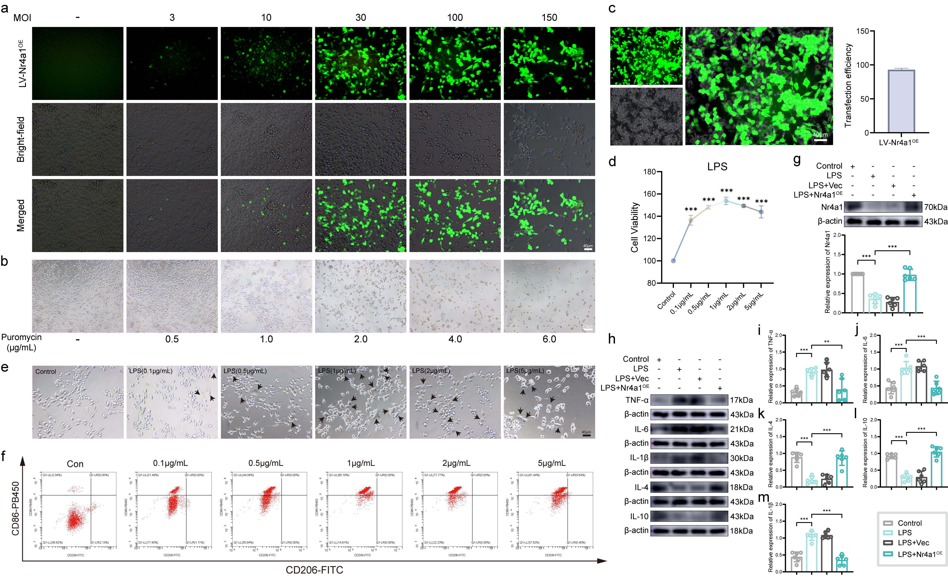
Supplementary Figure 7. Nr4a1 overexpression alleviates the inflammatory response induced by LPS in BV2 cells. (a) Representative immunofluorescence images of BV2 cells transfected with LV-Nr4a1 at different MOI. Scale bar = 40 μm. (b) Representative light microscopy images showing the effects of different puromycin concentrations on BV2 cell viability. Scale bar = 80 μm. (c) Immunofluorescence staining and transfection efficiency statistics of BV2 cells transduced with lentiviral vectors (n = 3). Scale bar = 40 μm. (d) CCK-8 assay evaluating the effects of different LPS concentrations on BV2 cell viability (n = 3). (e) Morphological changes in BV2 cells treated with different LPS concentrations. Scale bar = 40 μm. (Black arrows indicate BV2 cells with amoeboid morphology after LPS intervention). (f) Flow cytometry analysis of CD86⁺ and CD206⁺ BV2 cells after treatment with different LPS concentrations. (g-m) Protein expression levels of Nr4a1, TNF-α, IL-6, IL-1β, IL-4, and IL-10 analyzed using western blotting (n = 6). Data are expressed as mean ± SD. **P < 0.01, ***P < 0.001.
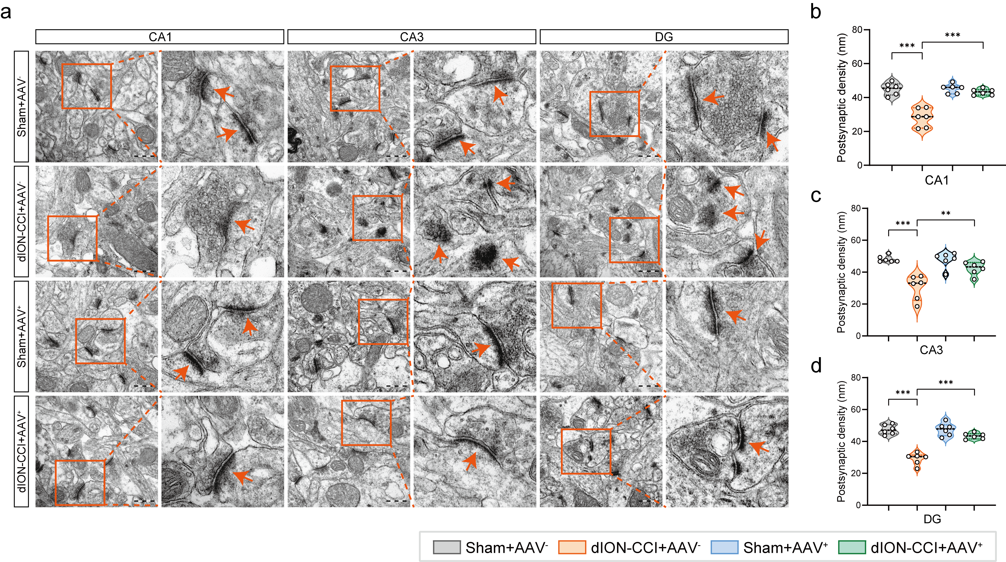
Supplementary Figure 8. Effect of Nr4a1 overexpression on hippocampal synaptic ultrastructure in TN rats. (a-d) TEM images of hippocampal synaptic structures and measurements of PSD thickness (orange arrows indicate synaptic structures) (n = 3). Scale bar=500 nm. Data are expressed as mean ± SD. **P < 0.01, ***P < 0.001.

Supplementary Figure 9. Nr4a1 overexpression ameliorates cognitive deficits in TN rats. (a) Total distance traveled in the OFT (n = 8). (b) Representative trajectory plots from the NORT. (c) Percentage of total area activity distance in the NORT (n = 8). (d) Recognition index in the NORT (n = 8). (e) Representative trajectory plots from the MWMT. (f) Escape latency to reach the target platform in the MWMT (n = 8). (g) Number of platform crossings in the MWMT (n = 8). (h) Time spent in the original platform area during the MWMT (n = 8). Data are expressed as mean ± SD. *P < 0.05, **P < 0.01, ***P < 0.001.
Supplementary Figure 10. Inhibition of the PI3K/Akt2 pathway reverses the effects of Nr4a1 overexpression on microglial activation and its mediated neuroinflammation in the hippocampus of TN rats. (a-l) Representative immunofluorescence images and quantitative analysis of Iba1 expression, microglial number, and morphological changes in the hippocampus (n = 4). Scale bar = 20 μm. (m-s) Protein expression levels of Iba1, TNF-α, IL-6, IL-1β, IL-4, and IL-10 analyzed using western blotting (n = 4). Data are expressed as mean ± SD. *P < 0.05, **P < 0.01, ***P < 0.001.

Supplementary Figure 11. Inhibition of the PI3K/Akt2 pathway reverses the effects of Nr4a1 overexpression on inflammation in BV2 cells. (a-d) Protein expression levels of p-PI3K, PI3K, p-Akt2, Akt2, p-mTOR, and mTOR in the hippocampus of rats from each group analyzed using western blotting (n = 4). (e) Effects of different concentrations of LY294002 on BV2 cell viability assessed by CCK-8 assay (n = 3). (f) Effects of different concentrations of LY294002 on p-PI3K protein expression in BV2 cells analyzed using western blotting (n = 4). (g) Effects of different concentrations of MK-2206 on BV2 cell viability assessed by CCK-8 assay (n = 3). (h) Effects of different concentrations of MK-2206 on p-Akt2 protein expression in BV2 cells analyzed using western blotting (n = 4). (i-l) Protein expression levels of p-PI3K, PI3K, p-Akt2, Akt2, p-mTOR, and mTOR analyzed using western blotting (n = 4). (m-r) Protein expression levels of TNF-α, IL-6, IL-1β, IL-4, and IL-10 analyzed using western blotting (n = 4). Data are expressed as mean ± SD. *P < 0.05, **P < 0.01, ***P < 0.001.
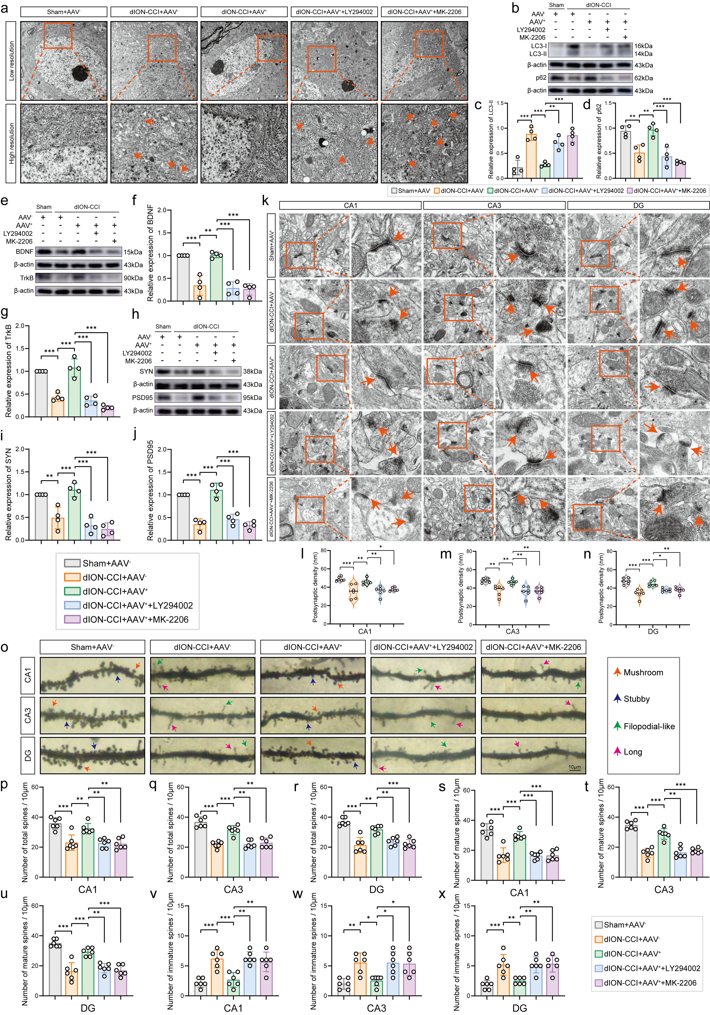
Supplementary Figure 12. Inhibition of the PI3K/Akt2 pathway reverses the beneficial effects of Nr4a1 overexpression on neuronal autophagy and synaptic plasticity in the hippocampus of TN rats. (a) Representative TEM images of hippocampal neuronal ultrastructure (orange arrows indicate autophagosomes) (n = 3). Scale bar = 2 μm. (b-d) Protein expression levels of LC3-II and p62 analyzed using western blotting (n = 4). (e-j) Protein expression levels of BDNF, TrkB, SYN, and PSD95 analyzed using western blotting (n = 4). (k-n) TEM images of hippocampal synaptic structures and measurements of PSD thickness (orange arrows indicate synaptic structures) (n = 3). Scale bar = 500 nm. (o) Representative Golgi staining images of hippocampal dendritic spines (different arrow types indicate spine morphologies). Scale bar = 10 μm. (p-x) Quantitative analysis of total dendritic spine density, mature spine density, and immature spine density in the hippocampus (n = 6). Data are expressed as mean ± SD. *P < 0.05, **P < 0.01, ***P < 0.001.

Supplementary Figure 13. Inhibition of the PI3K/Akt2 pathway reverses the beneficial effects of Nr4a1 overexpression on autophagy and synaptic plasticity in HT22 cells. (a) Experimental design for HT22 cell treatments. (b-d) Protein expression levels of LC3-II and p62 analyzed using western blotting (n = 4). (e-j) Protein expression levels of BDNF, TrkB, SYN, and PSD95 analyzed using western blotting (n = 4). (k-l) Representative immunofluorescence images and quantitative analysis of PSD95 expression in HT22 cells (n = 6). Scale bar = 20 μm. Data are expressed as mean ± SD. *P < 0.05, **P < 0.01, ***P < 0.001.
Supplementary Figure 14. Inhibition of the PI3K/Akt2 pathway reverses the beneficial effects of Nr4a1 overexpression on cognitive function in TN rats. (a) Flowchart of the experimental timeline for in vivo Part III. (b) Changes in facial mechanical pain threshold (n = 8). (c) Total distance traveled in the OFT (n = 8). (d) Representative trajectory plots from the NORT. (e) Percentage of total area activity distance in the NORT (n = 8). (f) Recognition index in the NORT (n = 8). (g) Representative trajectory plots from the MWMT. (h) Escape latency to reach the target platform in the MWMT (n = 8). (i) Number of platform crossings in the MWMT (n = 8). (j) Time spent in the original platform area during the MWMT (n = 8). Data are expressed as mean ± SD. ^P < 0.05 *P < 0.05, **P < 0.01, ***P < 0.001.

