Supplement
Supplementary Figure 1: Percentage of participants by consultation time per headache patient, shown for overall, HIC, UMIC, and LMIC groups.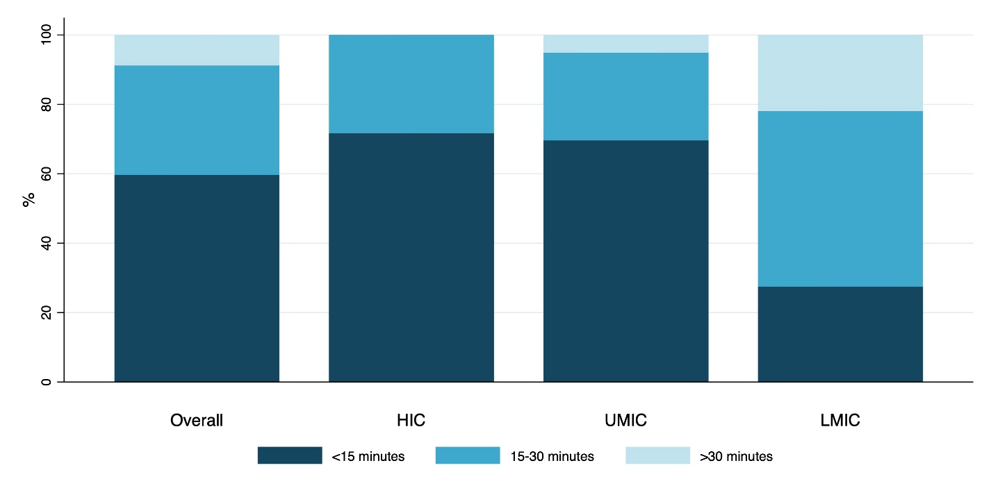

Supplementary figure 2: (A) Physicians’ perceptions of whether their patients receive a correct migraine diagnosis, (B) use of headache diaries, (C) time spent explaining general migraine knowledge, (D) discussion of migraine impairment and burden, and (E) discussion of both acute and preventive medications were compared across countries with different income levels.
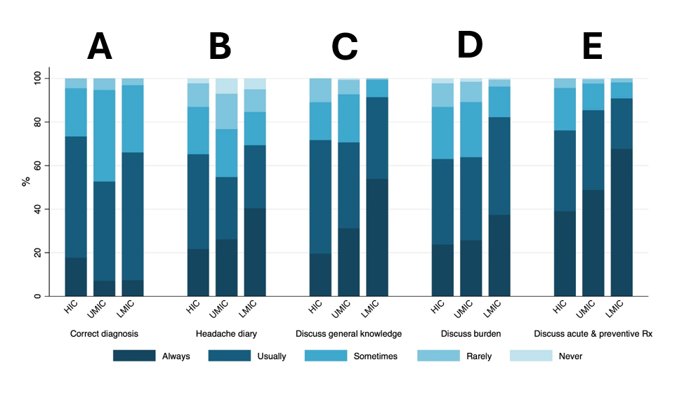

Supplementary figure 3: Available acute and preventive treatment in Southeast Asia.
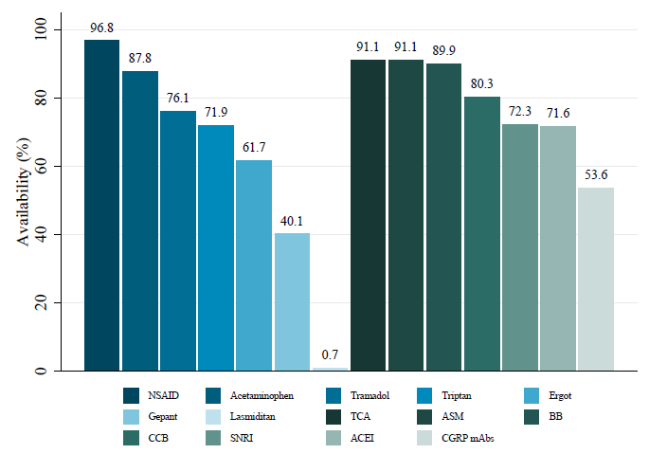

Supplementary figure 4: (A) Percentage of physicians’ perspectives on migraine patients’ use of acute medications (B) The percentage of patients using triptans (C) The percentage of patients using opioids (D) The percentage of patients who knew the limit of acute medication use that does not cause medication overuse headache (MOH) compared across countries with different income levels.
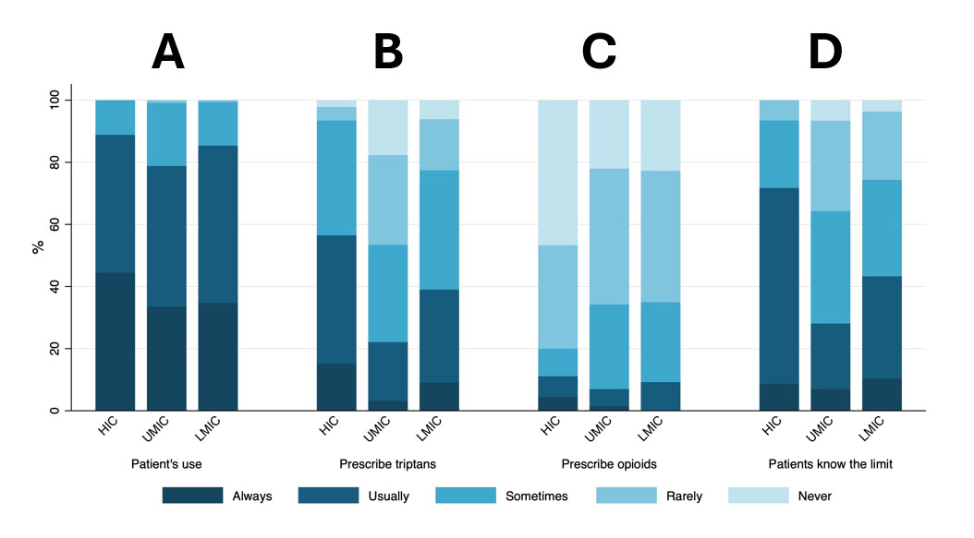

Supplementary figure 5: Percentage of patients using preventive medications across economic status and overall.
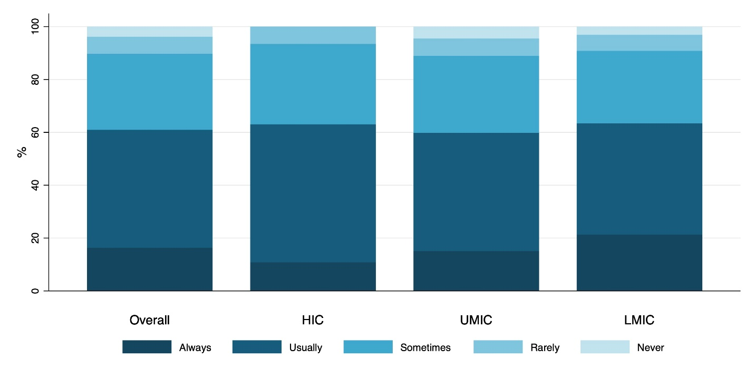

Supplementary figure 6: Percentage of (A) Physicians’ perspectives on the efficacy of anti-CGRP therapy (B) Physicians’ perspectives on the side-effect profile of anti-CGRP therapy (C) Physicians’ perspectives on whether anti-CGRP therapy should be reimbursed compared across countries with different income levels.
