Supplement
Supplementary Figure 1: Percentages of physicians by consultation time per headache patient, categorized by economic classification.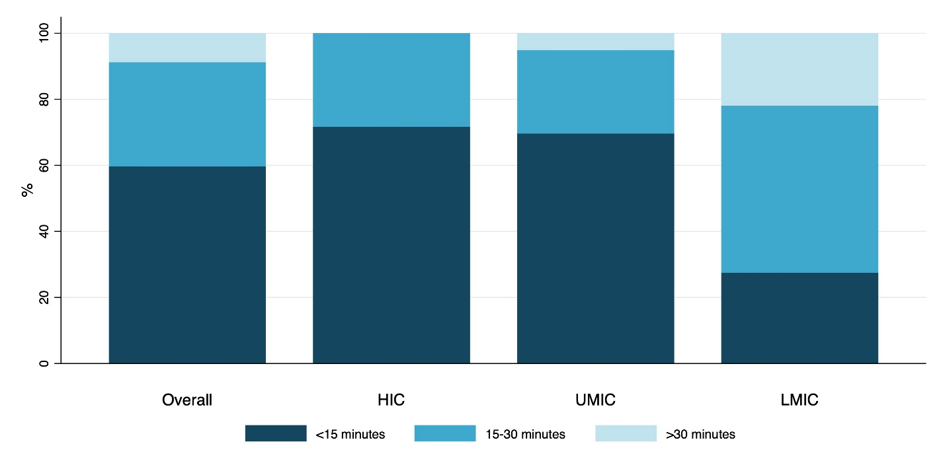
Abbreviations: HIC, high income countries; LMIC, lower-middle income countries; UMIC, upper-middle income countries.

Supplementary Figure 2: Percentages of physicians reporting key aspects of migraine management: (A) Correct migraine diagnosis prior to consultation; (B) Patients’ use of headache diaries; (C) Explanation of general migraine knowledge during clinic visit; (D) Discussion of migraine burden and impairment during clinic visit; (E) Discussion of acute and preventive medications during clinic visit, categorized by economic classification.
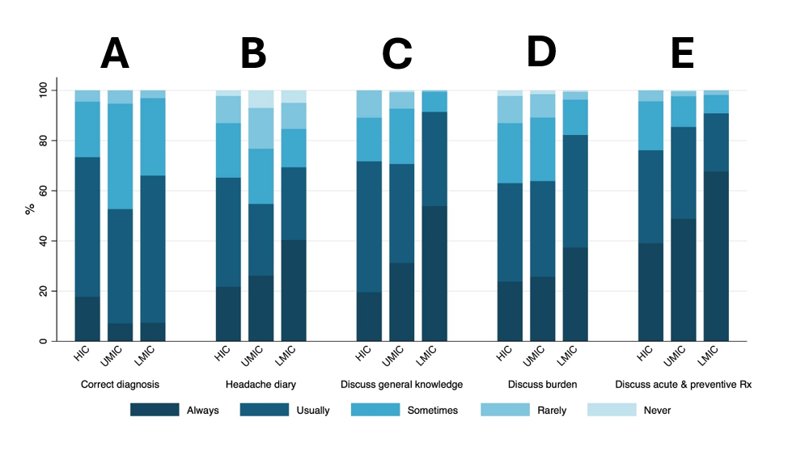
Abbreviations: HIC, high income countries; LMIC, lower-middle income countries; Rx, medications; UMIC, upper-middle income countries.

Supplementary Figure 3: Available acute and preventive treatment in Southeast and East Asia.
Abbreviations: ACEIs, angiotensin-converting enzyme inhibitors; ASMs, antiseizure medications; BBs, beta-blockers; CCBs, calcium channel blockers, Anti-CGRP, anti-calcitonin gene–related peptide therapy; NSAIDs, non-steroidal anti-inflammatory drugs; SNRIs; serotonin–norepinephrine reuptake inhibitors; TCAs, tricyclic antidepressants.

Supplementary Figure 4: Percentages of physicians’ perspectives on acute medication practices: (A) Patients’ frequent use of acute medication; (B) Prescription of triptans; (C) Prescription of opioids; (D) Patients know limits of acute medication to avoid medication overuse headache, categorized by economic classification.
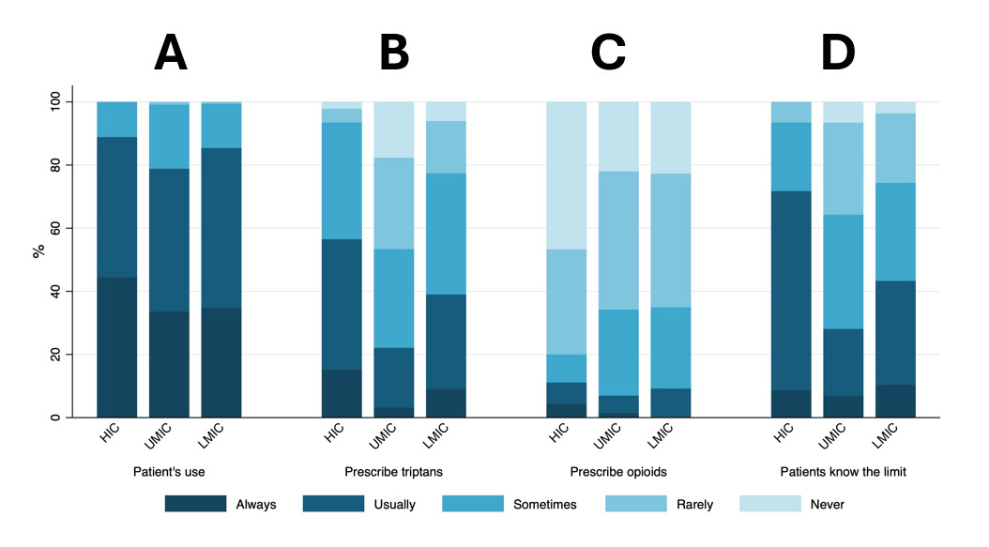
Abbreviations: HIC, high income countries; LMIC, lower-middle income countries; Rx, medications; UMIC, upper-middle income countries.

Supplementary Figure 5: Percentages of physicians’ prescription of preventive medication, categorized by economic classification.
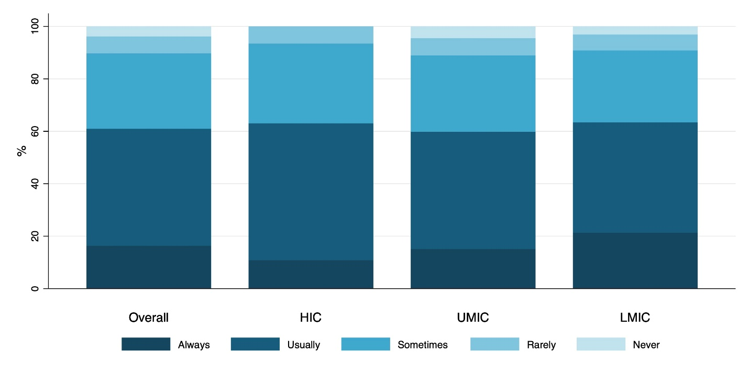
Abbreviations: HIC, high income countries; LMIC, lower-middle income countries; Rx, medications; UMIC, upper-middle income countries.

Supplementary Figure 6: Percentages of physicians’ perspectives on anti-CGRP therapy: (A) Perceived clinical efficacy; (B) Acceptable side-effect profile; and (C) Support for reimbursement inclusion, categorized by economic classification.
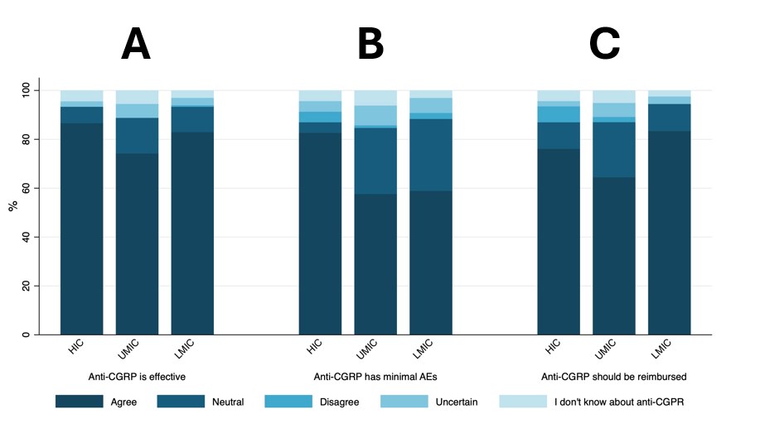
Abbreviations: AEs, adverse events; Anti-CGRP, anti-calcitonin gene-related peptide therapy; HIC, high income countries; LMIC, lower-middle income countries; Rx, medications; UMIC, upper-middle income countries.

Supplementary Table 1: Baseline characteristics and responses of participants stratified by country
Characteristics | Indonesia | Malaysia | Singapore | Taiwan | Thailand | The Philippines | Laos
Characteristics | (N=286) | (N=41) | (N=21) | (N=27) | (N=147) | (N=153) | (N=11)
Median age (IQR), y | 34.0 (31.0, 41.0) | 40.0 (36.0, 44.0) | 39.0 (35.0, 46.0) | 38.0 (33.0, 45.0) | 36.0 (31.0, 43.0) | 41.0 (35.0, 53.0) | 32.0 (30.0, 34.0)
Sex
Female | 171 (60.4%) | 20 (48.8%) | 7 (36.8%) | 10 (38.5%) | 52 (48.6%) | 81 (54.4%) | 5 (45.5%)
Male | 112 (39.6%) | 21 (51.2%) | 12 (63.2%) | 16 (61.5%) | 55 (51.4%) | 68 (45.6%) | 6 (54.5%)
Specialty
Headache specialist | 5 (1.8%) | 1 (2.4%) | 1 (5.0%) | 8 (30.8%) | 9 (6.1%) | 7 (4.6%) | 0 (0.0%)
Neurologist | 244 (85.6%) | 28 (68.3%) | 14 (70.0%) | 13 (50.0%) | 125 (85.0%) | 117 (76.5%) | 4 (36.4%)
Internist | 0 (0.0%) | 8 (19.5%) | 4 (20.0%) | 2 (7.7%) | 3 (2.0%) | 17 (11.1%) | 7 (63.6%)
Family medicine | 0 (0.0%) | 0 (0.0%) | 1 (5.0%) | 3 (11.5%) | 10 (6.8%) | 1 (0.7%) | 0 (0.0%)
General practitioner | 35 (12.3%) | 2 (4.9%) | 0 (0.0%) | 0 (0.0%) | 0 (0.0%) | 6 (3.9%) | 0 (0.0%)
Others | 1 (0.4%) | 2 (4.9%) | 0 (0.0%) | 0 (0.0%) | 0 (0.0%) | 5 (3.3%) | 0 (0.0%)
Belief that headache clinics are insufficient to meet patient needs (% yes) | 155 (54.2%) | 39 (95.1%) | 9 (45.0%) | 14 (56.0%) | 118 (80.3%) | 134 (87.6%) | 9 (81.8%)
Consultation time per headache patient
<15 minutes | 213 (74.5%) | 19 (46.3%) | 11 (55.0%) | 22 (84.6%) | 98 (66.7%) | 42 (27.5%) | 3 (27.3%)
15–30 minutes | 60 (21.0%) | 18 (43.9%) | 9 (45.0%) | 4 (15.4%) | 42 (28.6%) | 79 (51.6%) | 4 (36.4%)
>30 minutes | 13 (4.5%) | 4 (9.8%) | 0 (0.0%) | 0 (0.0%) | 7 (4.8%) | 32 (20.9%) | 4 (36.4%)
Key aspects of migraine management (% reporting "always” or “usually")
Correct migraine diagnosis | 172 (60.1%) | 16 (39.0%) | 12 (60.0%) | 21 (84.0%) | 62 (42.2%) | 103 (68.2%) | 4 (36.4%)
Use of headache diaries | 153 (53.5%) | 33 (80.5%) | 13 (65.0%) | 17 (65.4%) | 73 (50.0%) | 108 (71.1%) | 5 (45.5%)
Explanation of general migraine knowledge | 209 (73.6%) | 29 (70.7%) | 13 (65.0%) | 20 (76.9%) | 94 (64.8%) | 139 (91.4%) | 10 (90.9%)
Discussion of migraine burden and impairment | 196 (68.8%) | 26 (63.4%) | 11 (55.0%) | 18 (69.2%) | 80 (54.4%) | 127 (83.6%) | 7 (63.6%)
Discussion of acute and preventive options | 235 (82.2%) | 40 (97.6%) | 17 (85.0%) | 18 (69.2%) | 130 (88.4%) | 142 (92.8%) | 7 (63.6%)
Acute and preventive medication practices (% reporting "always” or “usually", unless otherwise noted)
Patients’ frequent use of acute medication | 223 (78.2%) | 31 (75.6%) | 16 (80.0%) | 24 (96.0%) | 119 (81.0%) | 133 (86.9%) | 7 (63.6%)
Prescription of triptans | 33 (11.6%) | 25 (62.5%) | 12 (60.0%) | 14 (53.8%) | 46 (31.7%) | 60 (39.2%) | 4 (36.4%)
Prescription of opioids (% reporting "never") | 44 (15.4%) | 14 (34.1%) | 10 (50.0%) | 11 (44.0%) | 46 (31.3%) | 33 (21.7%) | 4 (36.4%)
Patients know limits of acute medications | 73 (25.6%) | 9 (22.0%) | 11 (55.0%) | 22 (84.6%) | 51 (34.7%) | 68 (44.4%) | 3 (27.3%)
Prescription of preventive medication | 146 (51.6%) | 33 (80.5%) | 11 (55.0%) | 18 (69.2%) | 103 (70.1%) | 102 (66.7%) | 2 (18.2%)
Perspectives on anti-CGRP therapy (% reporting "agree")
Perceived clinical efficacy | 191 (67.0%) | 38 (92.7%) | 16 (80.0%) | 23 (92.0%) | 122 (83.0%) | 129 (84.3%) | 7 (63.6%)
Acceptable side-effect profile | 140 (49.5%) | 33 (82.5%) | 14 (70.0%) | 24 (92.3%) | 98 (66.7%) | 89 (58.6%) | 7 (63.6%)
Support for reimbursement inclusion | 170 (60.1%) | 37 (92.5%) | 15 (75.0%) | 20 (76.9%) | 96 (65.3%) | 129 (84.9%) | 7 (63.6%)

