Search terms:
(Migrain*) AND ("retinal stroke*" OR "retinal artery occlusion*" OR "retinal arterial occlusion*" OR "retinal vascular occlusion*" OR "retinal vessel occlusion*" OR "retinal ischem*" OR "retinal infarc*" OR "retinal vein occlusion*" OR "retinal venous occlusion*" OR "retinal vein thromb*" OR "retinal venous thromb*" OR "branch vein occlusion*" OR "branch venous occlusion*" OR "branch vein thromb*" OR "branch venous thromb*" OR "amaurosis fugax" OR "Transient monocular visual loss" OR "Transient monocular vision loss" OR "transient vision loss" OR "transient visual loss" OR "macul*")

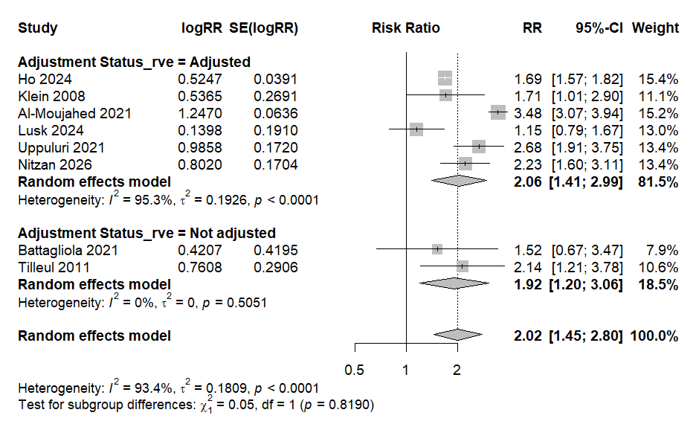
Figure S1 - Risk of any RVE in individuals with migraine versus without migraine (after removing Gil et al.)

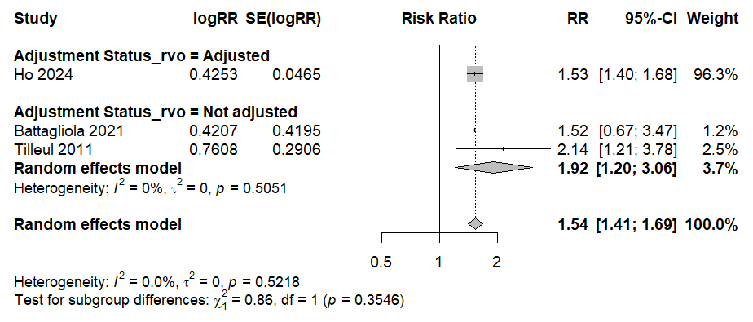
Figure S2 - Risk of RVO in individuals with migraine versus without migraine (after removing Gil et al.)

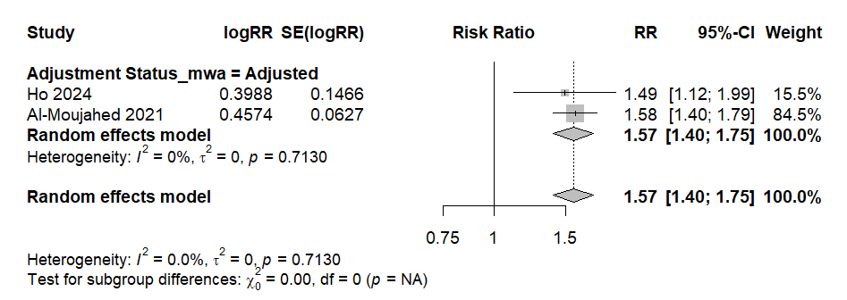
Figure S3 - Risk of RAO in individuals with MwA versus those with MwoA

Table S1: Studies Excluded by Full-text Screening

Study | Year of publication | DOI | Exclusion Reason
Risikofaktoren bei Patienten mit Amaurosis fugax  [Risk Factors in Patients with Amaurosis Fugax] | 1996 | 10.1055/s-2008-1035187 | Wrong Outcomes
MARS: Migraine and Retinal Stroke - A Population-Based Cohort Study of 39 Million Patients | 2024 | https://dx.doi.org/10.1161/str.55.suppl_1.WP252 | Abstract later published as full-text
Retinal artery occlusion in young patients without typical cardiovascular risk factors: etiologies, prognosis, and suggested work-up. | 2024 | https://dx.doi.org/10.1007/s00417-024-06527-5 | Wrong Outcomes

Table S2: Effect measures reported in each included study

Study | Effect Measure
Al-Moujahed 2021 | HR
Battagliola 2021 | OR
Gil 2025 | RR
Ho 2024 | HR
Klein 2008 | OR
Kuang 2022 | OR
Lusk 2026 | HR
Lusk 2024 | HR
Nitzan 2026 | HR
Tilleul 2011 | Raw percentage proportion of cases and control
Uppuluri 2021 | OR
Mansour 2017 | Raw percentage proportion of cases and control
Kumawat 2021 | OR

Table S3: Mapping of each study and its reported outcomes

Study | Outcome Reported? |  |  |  |  |  |  |  |  | Notes
Study | Any RVE | Any RAO | CRAO | BRAO | Any RVO | CRVO | BRVO | CSCR | AMD | Notes
Al-Moujahed 2021 | Yes | Yes | Yes | Yes | - | - | - | - | -
Battagliola 2021 | Yes | - | - | - | Yes | Yes | - | - | -
Gil 2025 | Yes | - | - | - | Yes | - | - | - | -
Ho 2024 | Yes | Yes | Yes | Yes | Yes | Yes | Yes | - | -
Klein 2008 | Yes | - | - | - | - | Yes | Yes | - | -
Kuang 2022 | - | - | - | - | - | - | - | - | Yes
Lusk 2024 | Yes | Yes | Yes | - | - | - | - | - | -
Tilleul 2011 | Yes | - | - | - | Yes | Yes | Yes | - | -
Uppuluri 2021 | Yes | - | Yes | - | - | - | - | - | -
Lusk 2026 | - | - | - | - | - | - | - | - | - | Lusk 2026 reports on the risk of CRAO in individuals using anti-CGRP therapies.
Nitzan 2026 | Yes | - | - | - | - | - | - | Yes | -
Mansour 2017 | - | - | - | - | - | - | - | Yes | -
Kumawat 2021 | - | - | - | - | - | - | - | Yes | -

