Supplementary Figure and Figure legends:

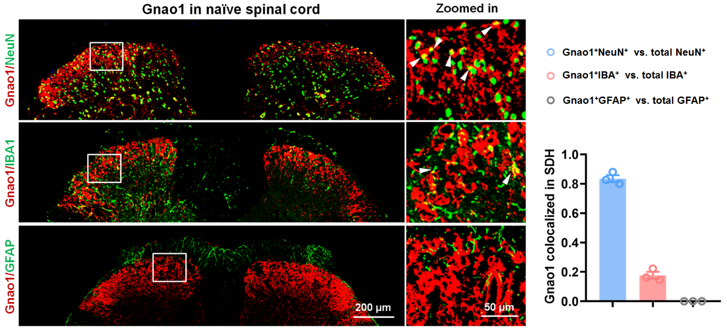

Figure S1. Gnao1 co-localizes with neuronal and microglial markers but not with astrocytic marker in the naïve spinal dorsal horn
Double immunofluorescence staining in the naïve spinal dorsal horn shows co-localization of Gnao1 (red) with the neuronal marker NeuN (green, top) and the microglial marker IBA1 (green, middle), but not with the astrocytic marker GFAP (green, bottom). Scale bars: 200 μm (overview) and 50 μm (higher-magnification views indicated by white boxes). White arrowheads highlight cells with co-localization. Bar graph shows Manders’ M1 coefficient (M1 for the fraction of Gnao1 signal overlapping with the respective marker). Data were obtained from 3 mice per group, with 5–6 sections per mouse. Analysis was performed using Image J and JACoP plugin.
Figure S2. Gnao1 is broadly expressed in various neuronal subtypes of the naïve dorsal root ganglion
Double immunofluorescence staining in the naïve dorsal root ganglion shows colocalization of Gnao1 (red) with the Aβ neuronal marker NF200 (green), the peptidergic neuronal marker CGRP (green), the non-peptidergic neuronal marker IB4 (green), and the tyrosine hydroxylase (TH)-positive neurons (green). Scale bars: 50 μm.
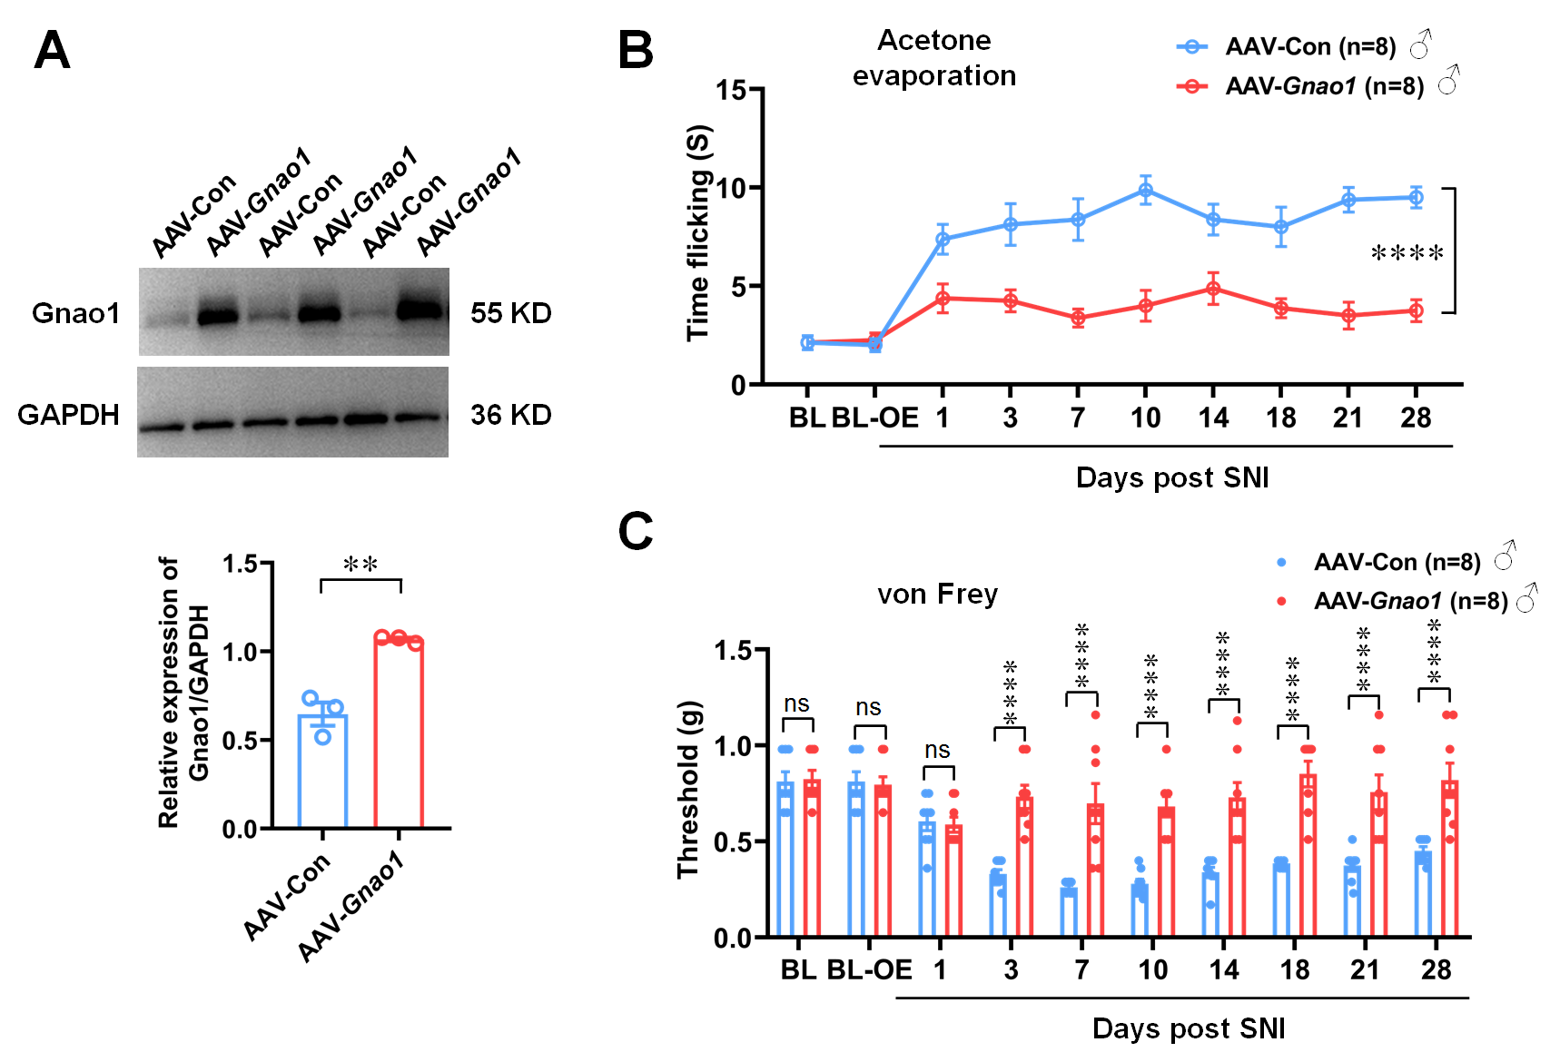
Figure S3. Overexpression of Gnao1 in the spinal cord of female mice alleviates neuropathic pain
A. Western blot analysis shows significantly higher Gnao1 protein levels in the AAV-Gnao1 groups compared to the AAV-Con. Student’s t-test, n=3. B. Duration of paw lifting/licking in the acetone evaporation test. C. Time course of changes in mechanical withdrawal thresholds assessed by von Frey filaments. Data in B and C were analyzed by two-way ANOVA followed by Dunnett’s post hoc test, n=8, ****p < 0.0001. All data are expressed as mean ± SEM.

