SUPPLEMENTARY MATERIAL
Impact of semaglutide introduction on the use of triptans: an interrupted-time series
Noémie Roland¹ (MD PhD), Heidi Elkjær Sonne¹ (MSc Pharm), Lanfranco Pellesi¹ (MD PhD), Maja Bramming² (PhD), Lise Gehrt Cardél² (PhD), Anton Pottegård¹ (DMSc Pharm PhD), Helene Kildegaard¹,³ (MD PhD)

¹ Clinical Pharmacology, Pharmacy and Environmental Medicine, Department of Public Health, University of Southern Denmark, Odense, Denmark
² Novo Nordisk A/S, Copenhagen, Denmark
³ Mary Elizabeth’s Hospital, University Hospital Copenhagen, Rigshospitalet, Copenhagen, Denmark

Table S1. Drug codes 2
Table S2. Diagnoses codes 4
Table S3. Methodological details 5
Table S4. Recorded indications across all dispensations of prophylactic antimigraine treatments identified in the cohort 6
Figure S1. Use of triptans, expressed in defined daily doses (DDD) per 10,000 users, stratified by age group and sex, among the entire adult Danish population, December 2020 to December 2025 8
Figure S2. Flowchart of the study 9
Figure S3. Model Diagnostics 10
Figure S4. Sensitivity analysis with inclusion of Month 0 11
Figure S5. Sensitivity analysis with three-month grace period 12
Figure S6. Changes in monthly number of triptan prescriptions 13
Figure S7. Changes in monthly triptan DDDs among triptan prevalent users during baseline period 14
Figure S8. Changes in monthly triptan DDDs among incident users 15
Figure S9. Changes in monthly number of incident users 16
Figure S10. Changes in monthly triptan DDDs by age groups 17
Figure S11. Changes in monthly triptan DDDs by semaglutide persistence 19
Figure S12. Changes in monthly triptan DDDs by previous use of antimigraine prophylactic medication 20
Figure S13. Changes in monthly triptan DDDs with a 24-month follow-up period 21
Figure S14. Negative exposure control 22
Figure S15. Difference-in-differences analysis (Callaway & Sant'Anna estimator). 23

Table S1. Drug codes

 | ATC code | Drug ID
Semaglutide | A10BJ06 | Wegovy: 66923, 131824, 178249, 178307, 187574, 191243, 191797, 386270, 394103, 396934, 405773, 409364, 409687, 418253, 431609, 437102, 448583, 468849, 481461, 534716, 538908, 560545
Triptans | N02CC
Antidepressants | N06A, N06CA
Anxiolytics | N05B
Antipsychotics | N05A
Antidiabetic treatments | Non-insulin glucose lowering drugs A10B excluding:  - A10BK01 | Excluding GLD indicated for obesity:  Wegovy: 66923, 131824, 178249, 178307, 187574, 191243, 191797, 386270, 394103, 396934, 405773, 409364, 409687, 418253, 431609, 437102, 448583, 468849, 481461, 534716, 538908, 560545  Saxenda: 79356, 114620, 131577, 144637, 164108, 395175, 439932, 461535, 466374, 575140, 599897
Prophylactic antimigraine medications* | Rimegepant N02CD06  Anti-CGRP monoclonal antibodies (erenumab, galcanezumab, fremanezumab and eptinezumab): N02CD01, N02CD02, N02CD03 and N02CD05  Onabotulinumtoxin A: M03AX01  Topiramate N03AX11  Metoprolol and propranolol: C07AB02 and C07AA05  Candesartan: C09CA06
Antibiotic eye drops | S01AA

Abbreviations: ATC, Anatomical therapeutical chemical classification system; CGRP, calcitonin gene-related peptide; Drug ID, Nordic article number
* We did not include amitriptyline in the coding algorithm as it does not have a migraine-specific indication and is only recommended as a third-line treatment in episodic migraine (and not in prophylaxis of chronic migraine) in Danish guidelines. Amitriptyline would introduce substantial misclassification of migraine treatment status, as most users may be treated for unrelated conditions.
For additional information, we examined the distribution of recorded indications in national registries for the use of amitriptyline, valproate, and flunarizine (the latter two also being antimigraine third-line treatments) in our cohort two years prior to the index date:
- Amitriptyline (ATC N06AA09): N=16,461 overall\ n= 912 with an indication of migraine (5.5%, of the Amitriptyline users, 0.6% of the cohort)
- Valproate (ATC N03AG01) N=4,148 overall \ n= 14 with an indication of migraine (0.4% of the Valproate users, <0.001% of the cohort)
- Flunarizine (ATC N07CA03) N=96 overall\ n= 71 with an indication of migraine (74% of the Flunarizine users, 0.05% of the cohort)

Table S2. Diagnoses codes

 | International Classification Disease-10
Type 2 Diabetes | E11
Obesity | E66
Psychoactive substance abuse | F10-F19
Schizophrenia spectrum  disorders | F20-F29
Mood disorders | F30-F39
Anxiety disorders | F40-F48, F93
Eating disorders | F50
Pregnancy outcomes | O60-O77, O80-84, Z37

Table S3. Methodological details

Monthly triptan use before and after initiation of semaglutide for weight management (Wegovy®) was compared using interrupted time series analysis with segmented linear regression, including assessments of autocorrelation and seasonality.
Immediate and slope-change effects were estimated with 95% confidence intervals (CIs) and p-values (<0.05). The 12-month relative effect was calculated as the rate ratio (RR) comparing observed outcomes with counterfactual values predicted from pre-intervention trends.
To minimize misclassification, allow for treatment stabilization, and account for potential stockpiling of triptans when patients visit the pharmacy to collect their semaglutide prescription, the first 30 days after the index date were excluded (including the day of semaglutide dispensing); subsequent months were classified as post-intervention and earlier months as pre-intervention.
For subgroup analyses, differences in post-intervention trend slopes were evaluated using Wald tests comparing coefficients across models.

Table S4. Recorded indications across all dispensations of prophylactic antimigraine treatments identified in the cohort
Drug | Recorded indication (all prescriptions) | N | %
Onabotulinumtoxin A | Unknown | 19 | 30.6%
Onabotulinumtoxin A | Treatment of facial wrinkles | 26 | 41.9%
Onabotulinumtoxin A | Severe hyperhidrosis | 11 | 17.7%
Onabotulinumtoxin A | Focal spasm | 6 | 9.7%
Candesartan | Unknown | 4491 | 21.4%
Candesartan | Migraine-related (total) | 1666 | 7.9%
Candesartan | High blood pressure / for blood pressure | 14477 | 69%
Candesartan | Heart failure | 331 | 1.6%
Candesartan | For the heart | 26 | 0.1%
Candesartan | Dizziness | N < 5 | —
Candesartan | Kidney disease | N < 5 | —
Candesartan | Nausea | N < 5 | —
Candesartan | Pain | N < 5 | —
Anti-CGRP monoclonal antibodies | Migraine-related (total) | N < 5 | 100%
Metoprolol / Propranolol | Unknown | 14178 | 15.8%
Metoprolol / Propranolol | Migraine-related (total) | 4713 | 5.3%
Metoprolol / Propranolol | High blood pressure / for blood pressure | 37589 | 41.9%
Metoprolol / Propranolol | Cardiac arrhythmia | 19132 | 21.3%
Metoprolol / Propranolol | For the heart | 3595 | 4.0%
Metoprolol / Propranolol | Heart failure (chronic) | 2489 | 2.8%
Metoprolol / Propranolol | Prevention after myocardial infarction | 1745 | 1.9%
Metoprolol / Propranolol | Prevention of angina pectoris | 3097 | 3.5%
Metoprolol / Propranolol | Tremor | 2406 | 2.7%
Metoprolol / Propranolol | Atrial fibrillation | 12 | 0.01%
Metoprolol / Propranolol | Tachycardia | 29 | 0.03%
Metoprolol / Propranolol | Hyperthyroidism / thyrotoxicosis | 248 | 0.3%
Metoprolol / Propranolol | Hyperkinetic heart syndrome | 106 | 0.1%
Metoprolol / Propranolol | Cardiovascular prevention | 11 | 0.01%
Metoprolol / Propranolol | Heart rate regulation | 22 | 0.02%
Metoprolol / Propranolol | Prevention of oesophageal variceal bleeding | 19 | 0.02%
Metoprolol / Propranolol | Agitation / anxiety | 62 | 0.07%
Metoprolol / Propranolol | Sedative | 7 | 0.01%
Metoprolol / Propranolol | Side effects / nervous disorder | 22 | 0.02%
Rimegepant | Unknown | N < 5 | —
Rimegepant | Migraine-related (total) | 213 | 98.6%
Topiramate | Unknown | 2287 | 35.6%
Topiramate | Migraine-related (total) | 2919 | 45.5%
Topiramate | Epilepsy | 955 | 14.9%
Topiramate | Pain | 104 | 1.6%
Topiramate | Neuropathic pain | 6 | 0.09%
Topiramate | Mood disorders | 68 | 1.1%
Topiramate | Psychiatric disorder | 14 | 0.2%
Topiramate | Agitation | 9 | 0.1%
Topiramate | Appetite suppressant | 14 | 0.2%
Topiramate | Weight reduction | N < 5 | —
Topiramate | Bulimia | N < 5 | —
Topiramate | Benign intracranial hypertension | 9 | 0.1%
Topiramate | Ocular hypertension / glaucoma | 14 | 0.2%
Topiramate | Cluster headache | N < 5 | —

Figure S1. Use of triptans, expressed in defined daily doses (DDD) per 10,000 users, stratified by age group and sex, among the entire adult Danish population, December 2020 to December 2025

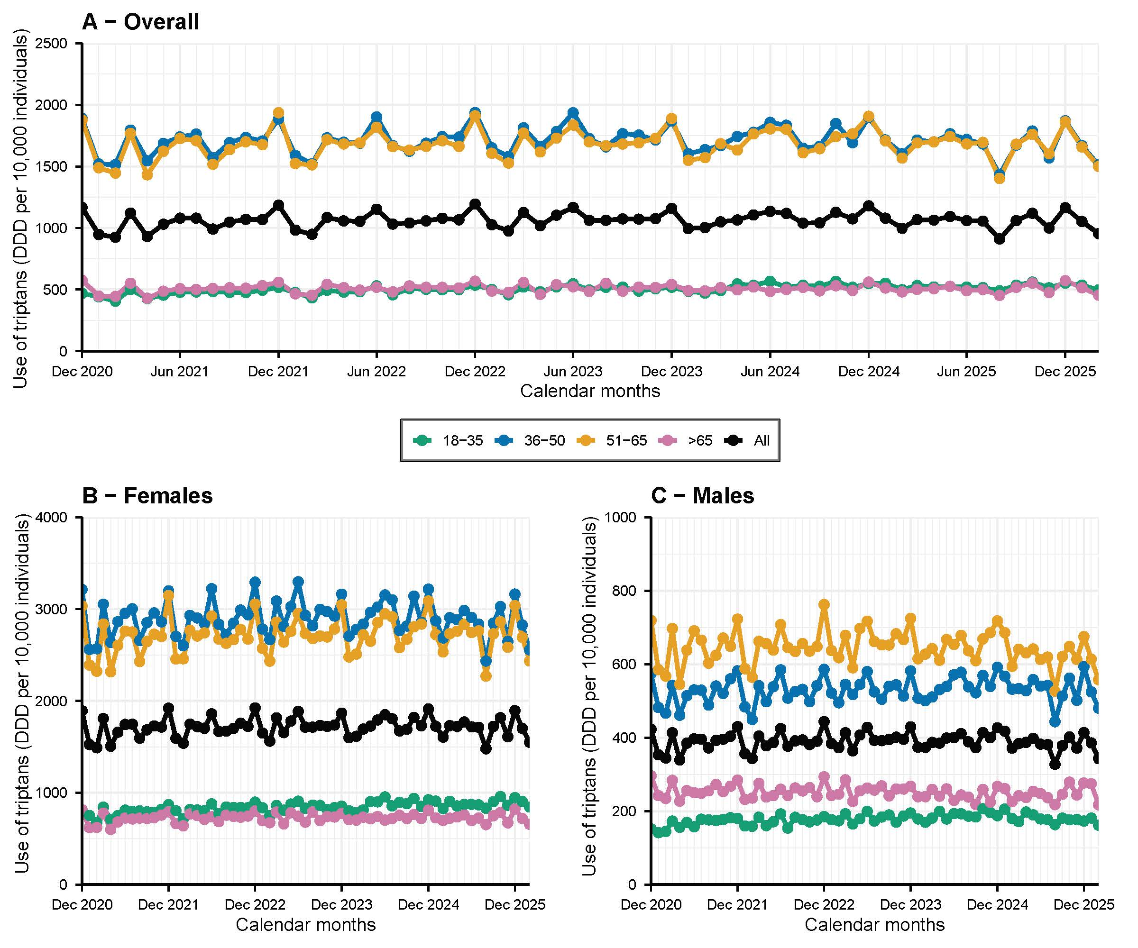
Abbreviation: DDD, Defined Daily Dose

Figure S2. Flowchart of the study

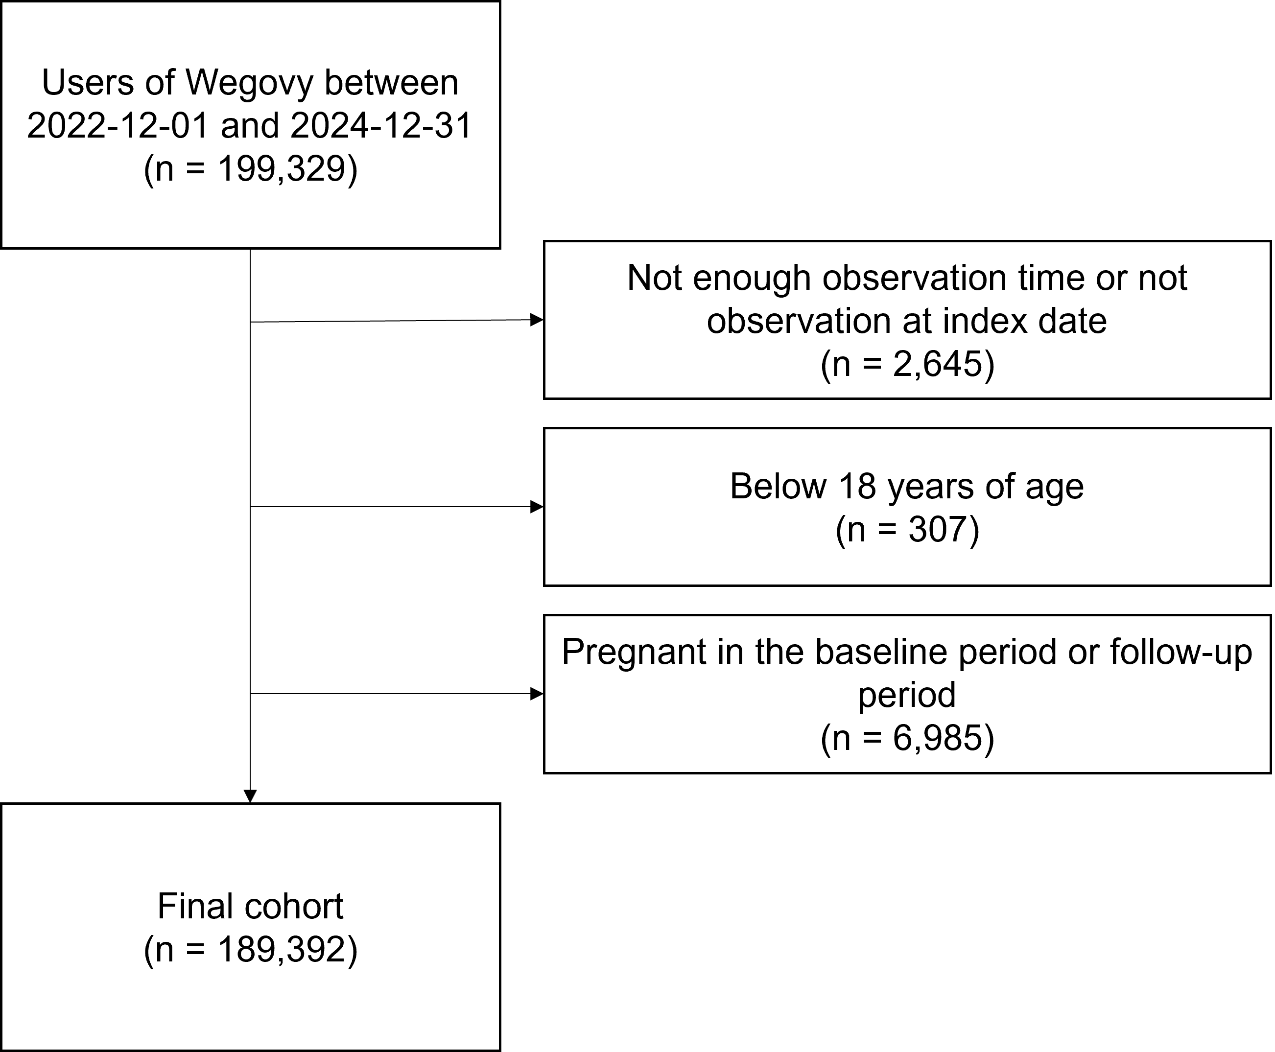

Figure S3. Model Diagnostics

- Residual autocorrelation was assessed using autocorrelation function plots and the Breusch–Godfrey test. No evidence of first-order autocorrelation was observed (p= 0.64), and no substantial autocorrelation was detected up to lag 12 (p= 0.28).
- Seasonality: We assessed residual autocorrelation by visual inspection of the autocorrelation function (ACF) of the model residuals, which showed no evidence of meaningful autocorrelation.
- Non-linearity (for each segment): Non-linearity was assessed by comparing the primary segmented linear regression model with a model including quadratic terms for the pre- and post-intervention periods. The addition of quadratic terms did not improve model fit (F = 0.55, p = 0.58), indicating no evidence of non-linearity in either segment.
- Heteroskedasticity: Heteroskedasticity was assessed using the Breusch–Pagan test. The test indicated evidence of non-constant residual variance (BP= 9.13, df= 3, p= 0.028). Visual inspection of the residuals also suggested increasing variance over time. However, results were robust to heteroskedasticity-consistent (HC3) standard errors, with no changes in the statistical significance or interpretation of the model coefficients.

Figure S4. Sensitivity analysis with inclusion of Month 0

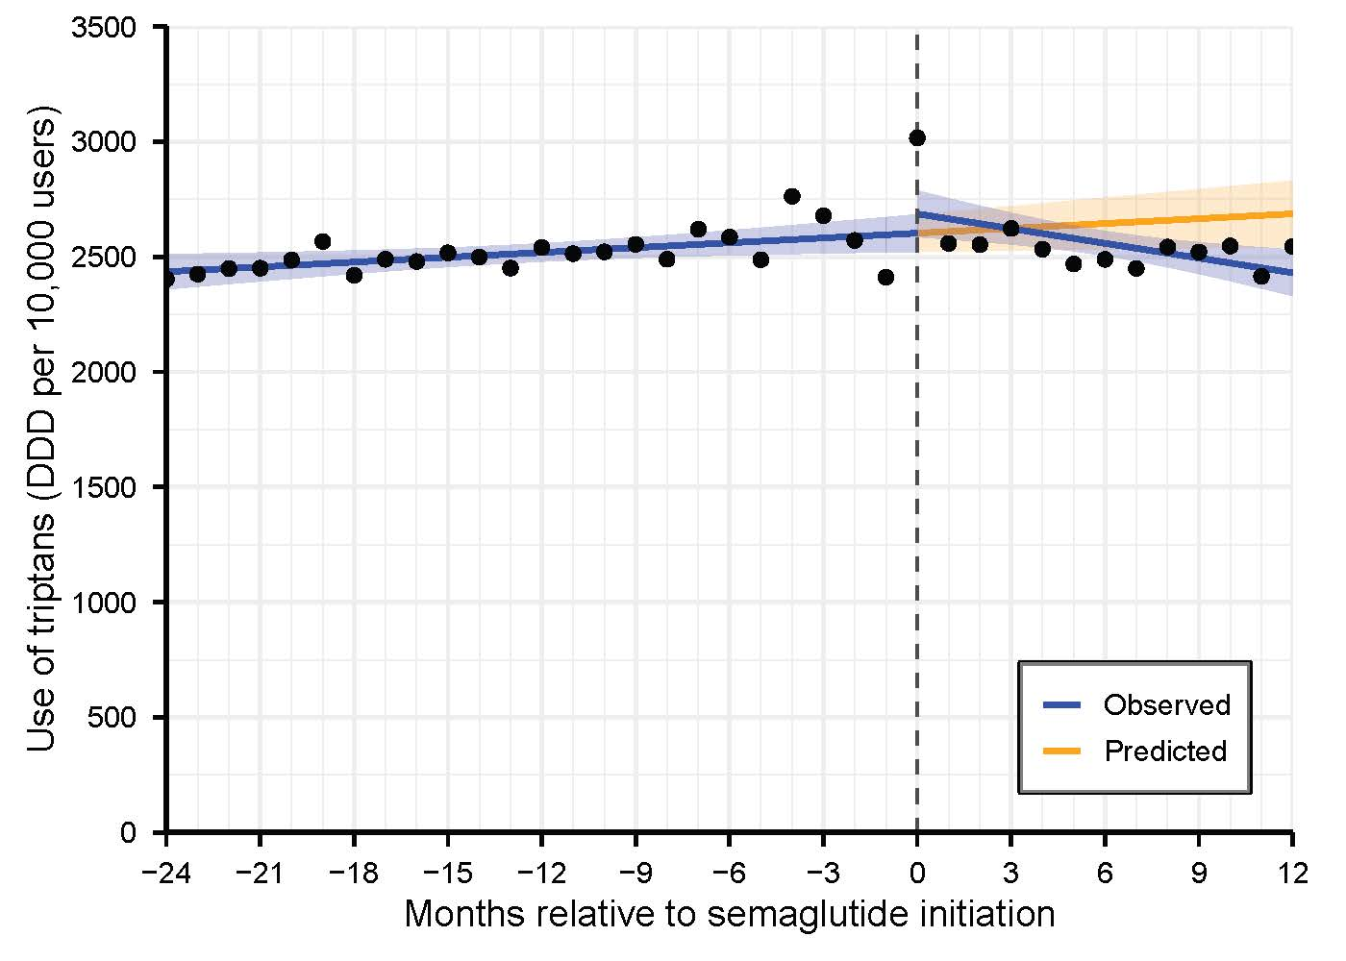

Figure S4. Interrupted time series analysis assessing changes in monthly number of triptan use per DDDs per 10,000 individuals, including M0 (N= 189,392)
Abbreviations: CI, confidence interval; DDD, Defined Daily Dose
Slope estimates represent the monthly change in outcome.

Parameter | Estimate (95% CI)  DDDs/10,000 users | p-value
Intercept (baseline level) | 2602.8 (2522.1 to 2683.5) | <0.01
Pre-intervention trend | 7.0 (1.3 to 12.6) | 0.02
Level change (immediate effect) | 83.7 (-45.1 to 212.5) | 0.20
Post-intervention trend | -28.3 (-43.6 to -13.0) | <0.01
Effect at 12 months | -256.1 (-431.5 to -80.7) | <0.01
Ratio at 12 months | 0.90 (0.85 to 0.97) | <0.01

Figure S5. Sensitivity analysis with three-month grace period

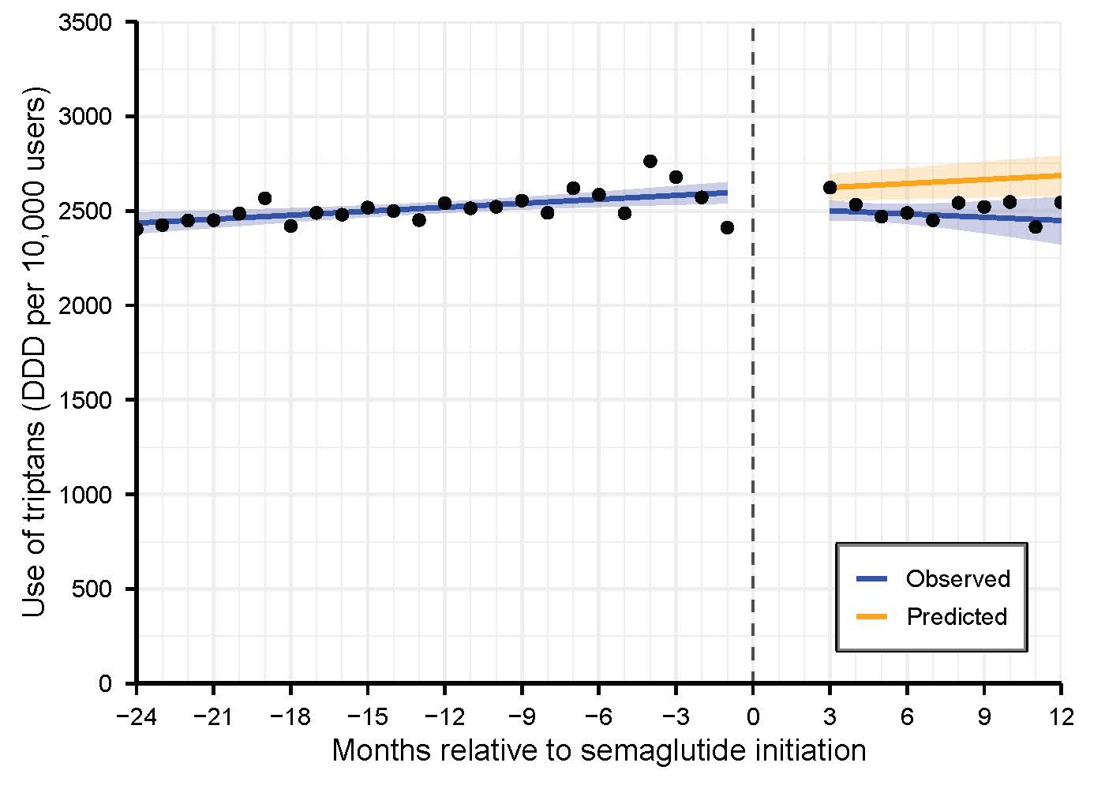

Figure S5. Interrupted time series analysis assessing changes in monthly number of triptan use per DDDs per 10,000 individuals, with a three-month grace period (N= 189,392)
Abbreviations: CI, confidence interval; DDD, Defined Daily Dose
Slope estimates represent the monthly change in outcome.

Parameter | Estimate (95% CI)  DDDs/10,000 users | p-value
Intercept (baseline level) | 2602.8 (2543.6 to 2662.1) | <0.01
Pre-intervention trend | 7.0 (2.8 to 11.1) | <0.01
Level change (immediate effect) | -84.5 (-193.0 to 24.0) | 0.12
Post-intervention trend | -12.8 (-28.8 to 3.3) | 0.11
Effect at 12 months | -237.7 (-408.7 to -66.6) | <0.01
Ratio at 12 months | 0.91 (0.85 to 0.97) | <0.01

Figure S6. Changes in monthly number of triptan prescriptions

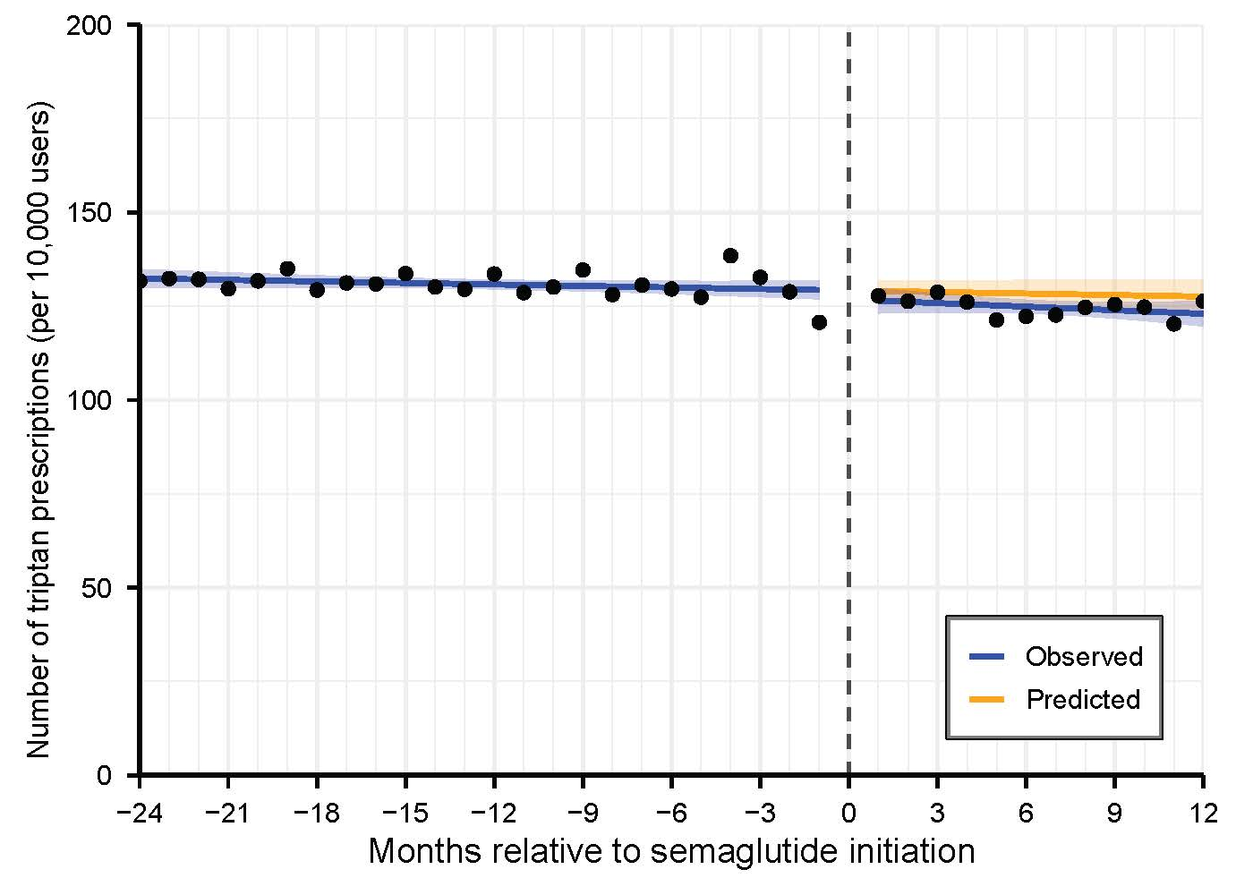

Figure S6. Interrupted time series analysis assessing changes in monthly number of triptan prescriptions per 10,000
Abbreviations: CI, confidence interval; DDD, Defined Daily Dose
Slope estimates represent the monthly change in outcome.

Parameter | Estimate (95% CI)  prescriptions | p-value
Intercept (baseline level) | 129.2 (126.6 to 131.8) | <0.01
Pre-intervention trend | -0.1 (-0.3 to 0.0) | 0.14
Level change (immediate effect) | -2.4 (-7.0 to 2.2) | 0.29
Post-intervention trend | -0.2 (-0.7 to 0.4) | 0.50
Effect at 12 months | -4.6 (-10.3 to 1.1) | 0.11
Ratio at 12 months | 0.96 (0.92 to 1.01) | 0.11

Figure S7. Changes in monthly triptan DDDs among triptan prevalent users during baseline period

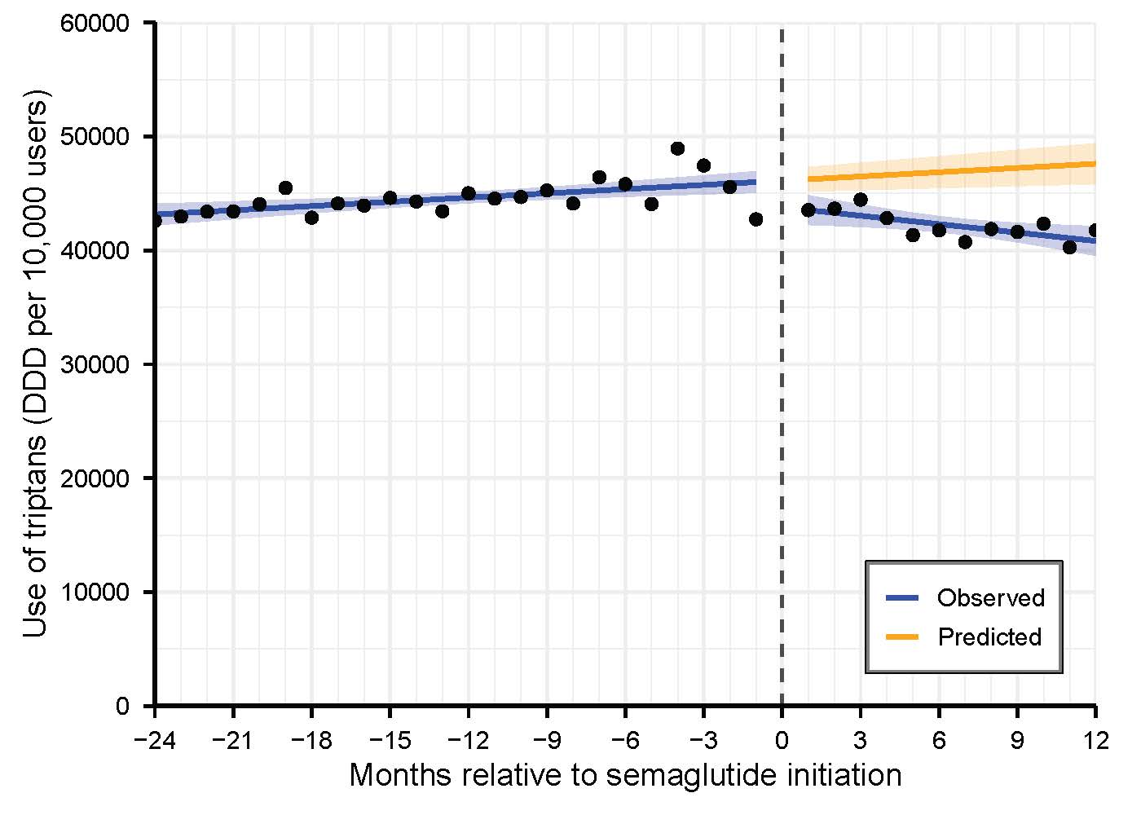

Figure S7. Interrupted time series analysis assessing changes in monthly triptan DDDs among triptan prevalent users during baseline period (N=8,632)
Abbreviations: CI, confidence interval; DDD, Defined Daily Dose
Slope estimates represent the monthly change in outcome.

Parameter | Estimate (95% CI)  DDDs/10,000 users | p-value
Intercept (baseline level) | 46117.9 (45114.6 to 47121.1) | <0.01
Pre-intervention trend | 123.8 (53.6 to 194.0) | <0.01
Level change (immediate effect) | -2338.0 (-4114.0 to -562.1) | 0.01
Post-intervention trend | -370.3 (-581.4 to -159.2) | <0.01
Effect at 12 months | -6781.6 (-8987.8 to -4575.4) | <0.01
Ratio at 12 months | 0.86 (0.82 to 0.90) | <0.01

Figure S8. Changes in monthly triptan DDDs among incident users

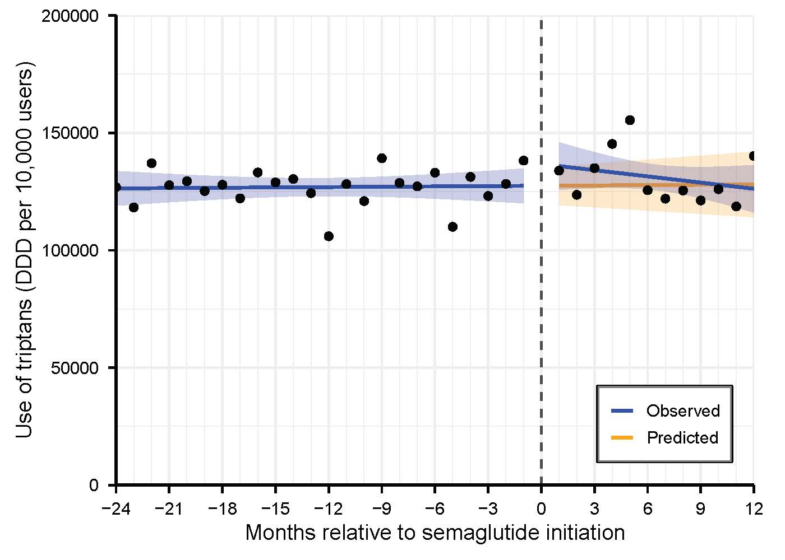

Figure S8. Interrupted time series analysis assessing changes in monthly triptan DDDs among triptan incident users (N= 2,693)
Abbreviations: CI, confidence interval; DDD, Defined Daily Dose
Slope estimates represent the monthly change in outcome.

Parameter | Estimate (95% CI)  DDDs/10,000 users | p-value
Intercept (baseline level) | 127481.1 (119666.0 to 135296.2) | <0.01
Pre-intervention trend | 46.7 (-500.3 to 593.6) | 0.86
Level change (immediate effect) | 9275.2 (-4559.0 to 23109.5) | 0.18
Post-intervention trend | -927.9 (-2572.6 to 716.7) | 0.26
Effect at 12 months | -1859.6 (-19045.1 to 15325.8) | 0.83
Ratio at 12 months | 0.99 (0.86 to 1.13) | 0.83

Figure S9. Changes in monthly number of incident users

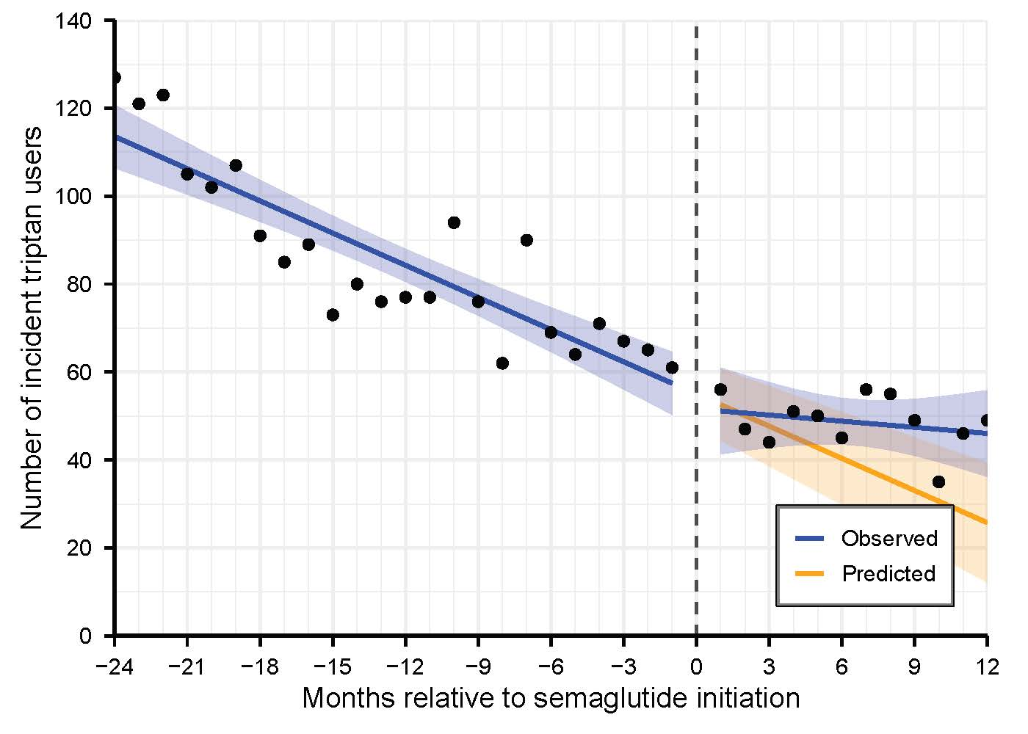

Figure S9. Interrupted time series analysis assessing changes in monthly number of incident users
Abbreviations: CI, confidence interval; DDD, Defined Daily Dose
Slope estimates represent the monthly change in outcome.

Parameter | Estimate (95% CI)  Incident users | p-value
Intercept (baseline level) | 55.0 (47.4 to 62.6) | <0.01
Pre-intervention trend | -2.4 (-3.0 to -1.9) | <0.01
Level change (immediate effect) | -3.4 (-16.9 to 10.1) | 0.61
Post-intervention trend | 2.0 (0.4 to 3.6) | 0.02
Effect at 12 months | 20.3 (3.6 to 37.1) | 0.02
Ratio at 12 months | 1.79 (1.01 to 3.16) | 0.05

Figure S10. Changes in monthly triptan DDDs by age groups

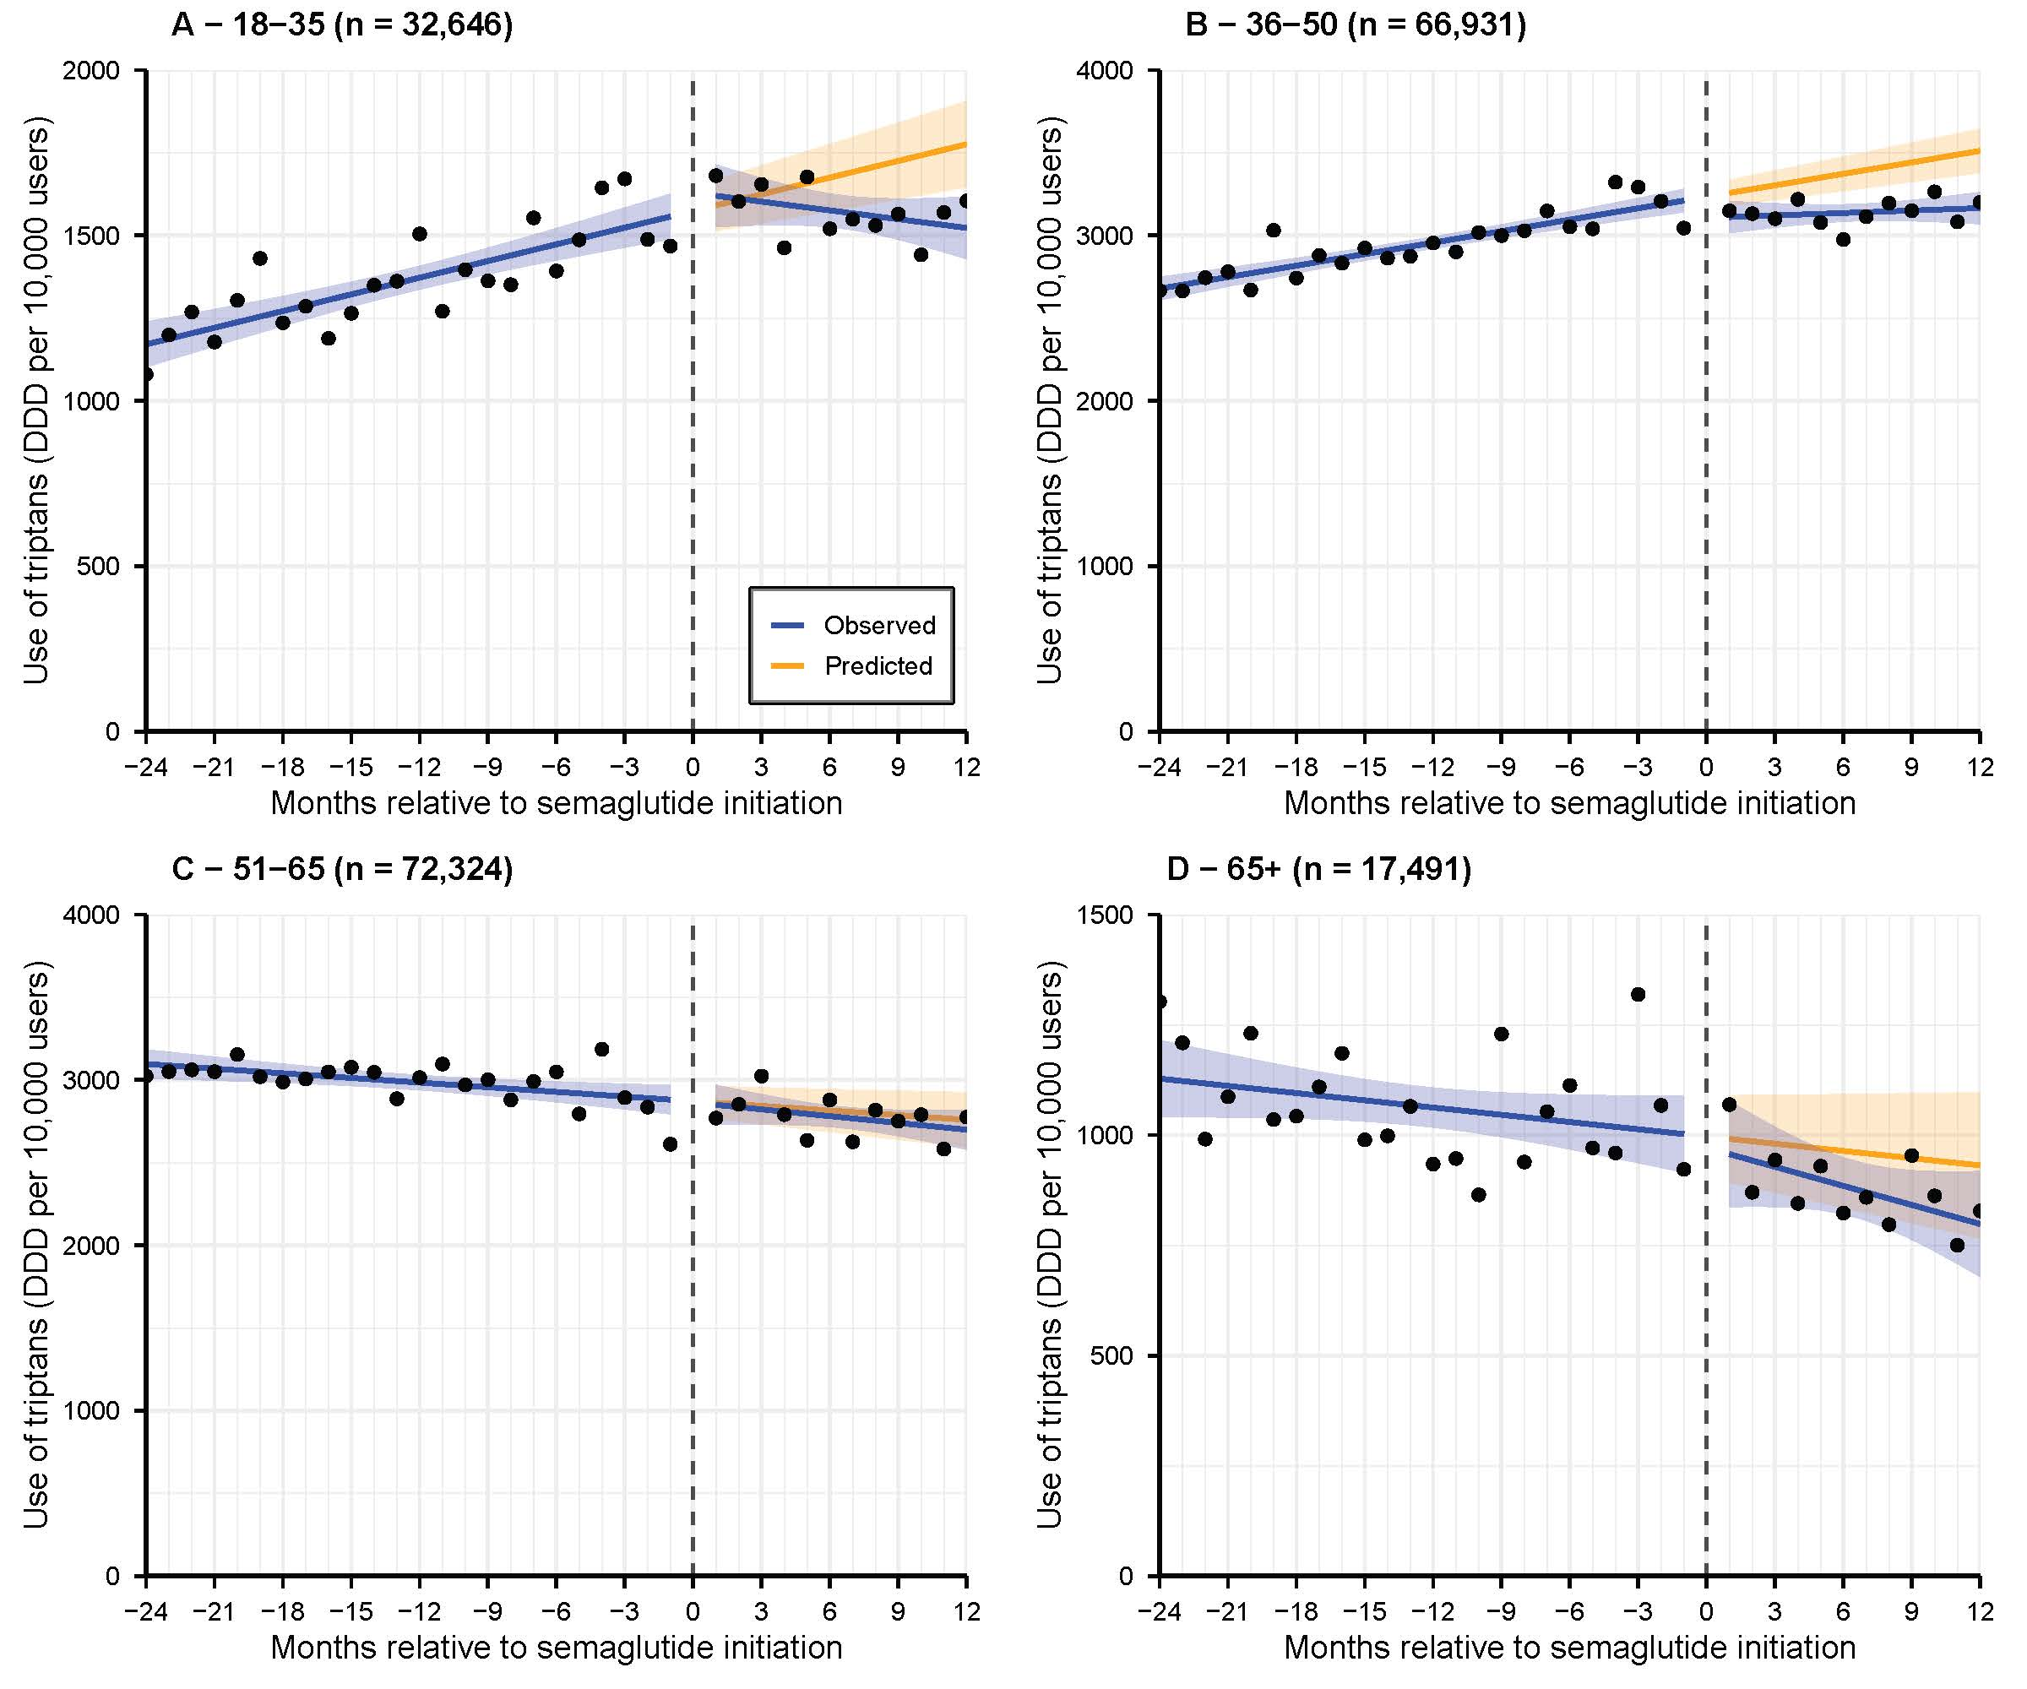

Figure S10. Interrupted time series analysis assessing changes in monthly number of triptan use per DDDs per 10,000 users, by age-group
Abbreviations: CI, confidence interval; DDD, Defined Daily Dose
Slope estimates represent the monthly change in outcome.

A.18-35 (n= 32,646)* | B.36-50 (n= 66,931)*
  Parameter | Estimate (95% CI)  DDDs/10,000 users | p-value
  Intercept (baseline level) | 1574.1 (1501.0 to 1647.3) | <0.01
  Pre-intervention trend | 16.8 (11.7 to 21.9) | <0.01
  Level change (immediate effect) | 54.7 (-74.8 to 184.2) | 0.40
  Post-intervention trend | -25.7 (-41.0 to -10.3) | <0.01
  Effect at 12 months | -253.2 (-414.0 to -92.3) | <0.01
  Ratio at 12 months | 0.86 (0.78 to 0.94) | <0.01
  Parameter | Estimate (95% CI)  DDDs/10,000 users | p-value
  Intercept (baseline level) | 3234.0 (3159.1 to 3309.0) | <0.01
  Pre-intervention trend | 23.1 (17.9 to 28.4) | <0.01
  Level change (immediate effect) | -128.0 (-260.6 to 4.7) | 0.06
  Post-intervention trend | -18.2 (-34.0 to -2.4) | 0.03
  Effect at 12 months | -346.1 (-510.9 to -181.3) | <0.01
  Ratio at 12 months | 0.90 (0.86 to 0.95) | <0.01
C.51-65 (n= 72,324)* | D. 65+ (n= 17,491)*
  Parameter | Estimate (95% CI)  DDDs/10,000 users | p-value
  Intercept (baseline level) | 2871.4 (2777.9 to 2965.0) | <0.01
  Pre-intervention trend | -9.4 (-15.9 to -2.8) | <0.01
  Level change (immediate effect) | -8.4 (-174.0 to 157.1) | 0.92
  Post-intervention trend | -4.3 (-24.0 to 15.4) | 0.66
  Effect at 12 months | -59.8 (-265.4 to 145.9) | 0.56
  Ratio at 12 months | 0.98 (0.91 to 1.05) | 0.56
  Parameter | Estimate (95% CI)  DDDs/10,000 users | p-value
  Intercept (baseline level) | 996.8 (903.8 to 1089.8) | <0.01
  Pre-intervention trend | -5.5 (-12.0 to 1.0) | 0.10
  Level change (immediate effect) | -25.6 (-190.2 to 139.0) | 0.75
  Post-intervention trend | -8.9 (-28.5 to 10.6) | 0.36
  Effect at 12 months | -133.0 (-337.4 to 71.5) | 0.19
  Ratio at 12 months | 0.86 (0.68 to 1.08) | 0.19
* Wald test of cross-model post-trend slope coefficients:
 | p-value
Age group 18-35 vs. 36-50 | 0.50
Age group 18-35 vs. 51-65 | 0.08
Age group 18-35 vs. >65 | 0.17
Age group 36-50 vs. 51-65 | 0.26
Age group 36-50 vs. >65 | 0.45
Age group 51-65 vs. >65 | 0.73

Figure S11. Changes in monthly triptan DDDs by semaglutide persistence

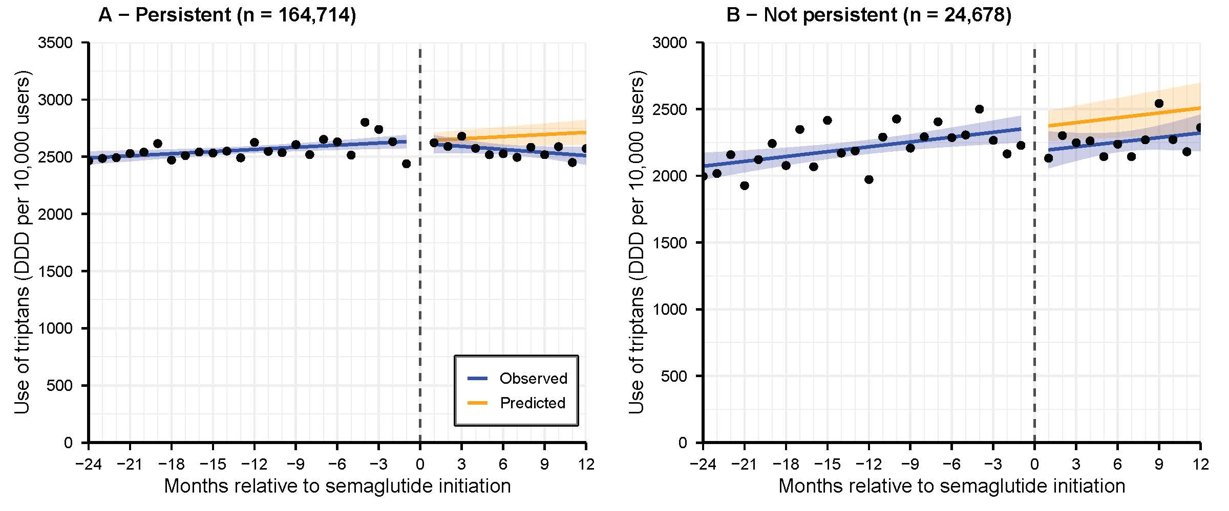

Figure S11. Interrupted time series analysis assessing changes in monthly triptan DDDs by semaglutide persistence
Abbreviations: CI, confidence interval; DDD, Defined Daily Dose
Slope estimates represent the monthly change in outcome.

- Persistent (n= 164,714)* | - Not persistent (n= 24,678)*
  Parameter | Estimate (95% CI)  DDDs/10,000 users | p-value
  Intercept (baseline level) | 2638.8 (2578.0 to 2699.6) | <0.01
  Pre-intervention trend | 6.2 (2.0 to 10.5) | <0.01
  Level change (immediate effect) | -20.7 (-128.3 to 87.0) | 0.70
  Post-intervention trend | -15.2 (-28.0 to -2.4) | 0.02
  Effect at 12 months | -203.2 (-336.9 to -69.5) | <0.01
  Ratio at 12 months | 0.93 (0.88 to 0.97) | <0.01
  Parameter | Estimate (95% CI)  DDDs/10,000 users | p-value
  Intercept (baseline level) | 2362.7 (2256.4 to 2468.9) | <0.01
  Pre-intervention trend | 12.1 (4.7 to 19.5) | <0.01
  Level change (immediate effect) | -179.5 (-367.6 to 8.6) | 0.06
  Post-intervention trend | -0.6 (-23.0 to 21.8) | 0.96
  Effect at 12 months | -186.6 (-420.2 to 47.0) | 0.11
  Ratio at 12 months | 0.93 (0.84 to 1.02) | 0.11

*Wald test of cross-model post-trend slope coefficients: p= 0.25

Figure S12. Changes in monthly triptan DDDs by previous use of antimigraine prophylactic medication

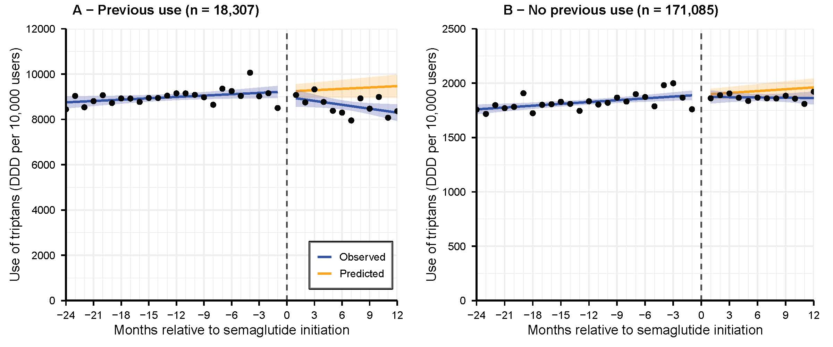

Figure S12. Interrupted time series analysis assessing changes in monthly triptan DDDs by previous use of antimigraine prophylactic medication
Abbreviations: CI, confidence interval; DDD, Defined Daily Dose
Slope estimates represent the monthly change in outcome.

- Previous use of prophylactic medications (n= 18,307)* | - No previous use (n= 171,085)*
  Parameter | Estimate (95% CI)  DDDs/10,000 users | p-value
  Intercept (baseline level) | 9230.3 (8945.9 to 9514.7) | <0.01
  Pre-intervention trend | 19.9 (-0.0 to 39.8) | 0.05
  Level change (immediate effect) | -240.0 (-743.5 to 263.4) | 0.34
  Post-intervention trend | -77.5 (-137.4 to -17.7) | 0.01
  Effect at 12 months | -1170.1 (-1795.6 to -544.7) | <0.01
  Ratio at 12 months | 0.88 (0.82 to 0.94) | <0.01
  Parameter | Estimate (95% CI)  DDDs/10,000 users | p-value
  Intercept (baseline level) | 1893.6 (1847.5 to 1939.8) | <0.01
  Pre-intervention trend | 5.6 (2.4 to 8.8) | <0.01
  Level change (immediate effect) | -20.1 (-101.7 to 61.5) | 0.62
  Post-intervention trend | -6.4 (-16.1 to 3.3) | 0.19
  Effect at 12 months | -97.4 (-198.8 to 4.0) | 0.06
  Ratio at 12 months | 0.95 (0.90 to 1.00) | 0.06

*Wald test of cross-model post-trend slope coefficients: p= 0.02

Figure S13. Changes in monthly triptan DDDs with a 24-month follow-up period

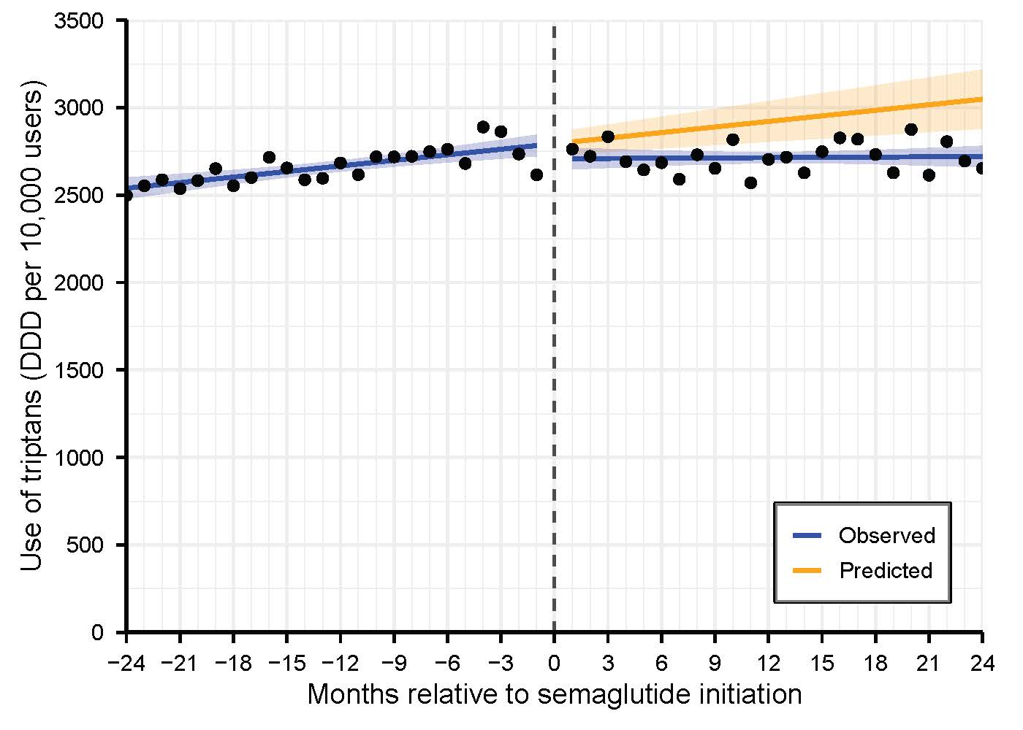

Figure S13. Interrupted time series analysis assessing changes in monthly number of triptan use per DDDs per 10,000 users with a 24-month follow-up period (N= 189,392)
Abbreviations: CI, confidence interval; DDD, Defined Daily Dose
Slope estimates represent the monthly change in outcome.

Parameter | Estimate (95% CI)  DDDs/10,000 users | p-value
Intercept (baseline level) | 2793.9 (2728.9 to 2858.9) | <0.01
Pre-intervention trend | 10.6 (6.1 to 15.1) | <0.01
Level change (immediate effect) | -85.9 (-177.8 to 6.0) | 0.07
Post-intervention trend | -10.1 (-16.5 to -3.7) | <0.01
Effect at 24 months | -328.0 (-507.6 to -148.4) | <0.01
Ratio at 24 months | 0.89 (0.84 to 0.95) | <0.01

Figure S14. Negative exposure control

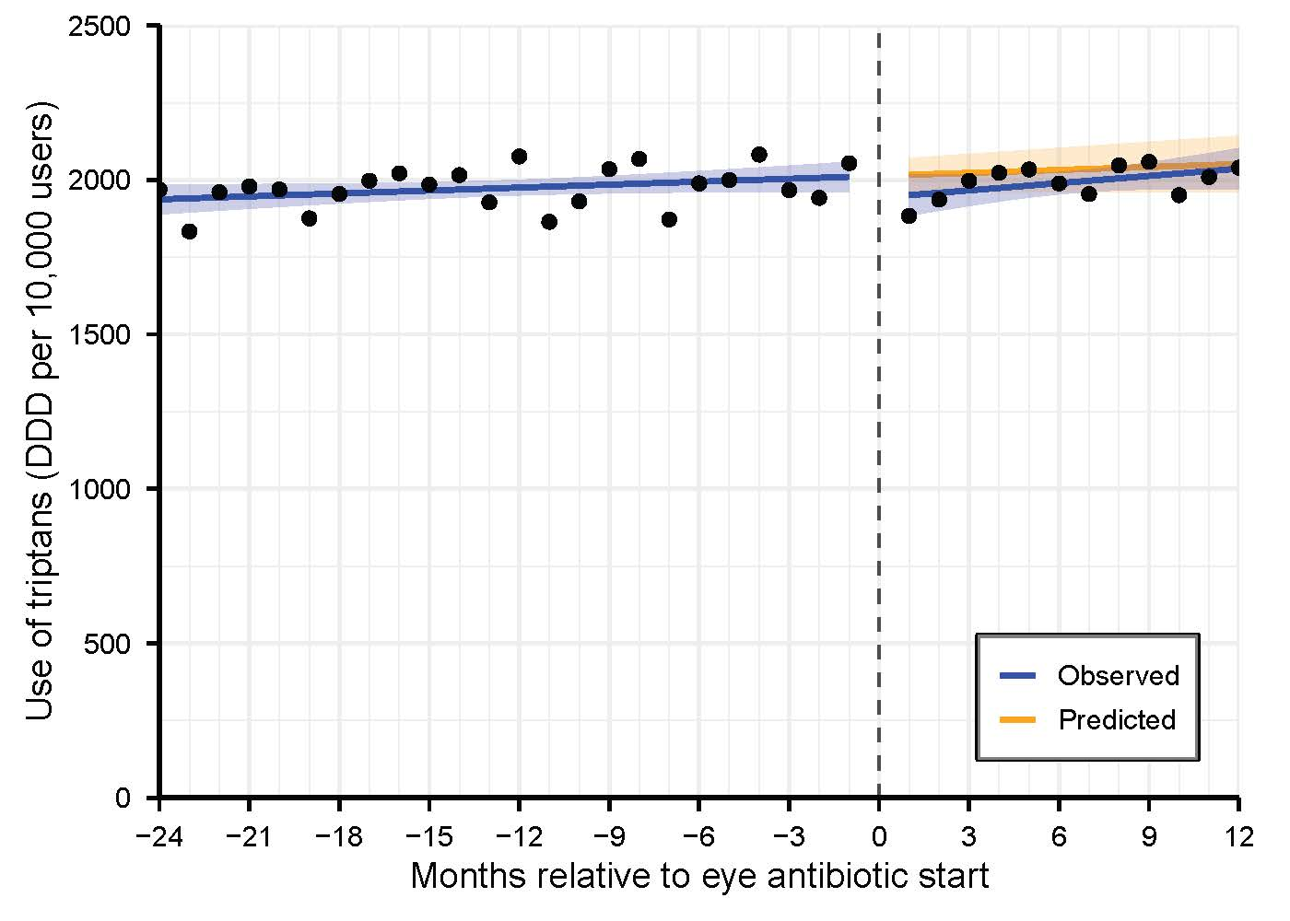
Figure S14. Interrupted time series analysis assessing changes in monthly number of triptan DDDs before and after initiation of antibiotic eye drop (N= 134,600)
Abbreviations: CI, confidence interval; DDD, Defined Daily Dose
Slope estimates represent the monthly change in outcome.

Parameter | Estimate (95% CI)  DDDs/10,000 users | p-value
Intercept (baseline level) | 2013.3 (1962.0 to 2064.7) | <0.01
Pre-intervention trend | 3.2 (-0.4 to 6.8) | 0.08
Level change (immediate effect) | -70.5 (-161.4 to 20.4) | 0.12
Post-intervention trend | 4.6 (-6.2 to 15.4) | 0.39
Effect at 12 months | -15.0 (-128.0 to 97.9) | 0.79
Ratio at 12 months | 0.99 (0.94 to 1.05) | 0.79

Figure S15. Difference-in-differences analysis (Callaway & Sant'Anna estimator).

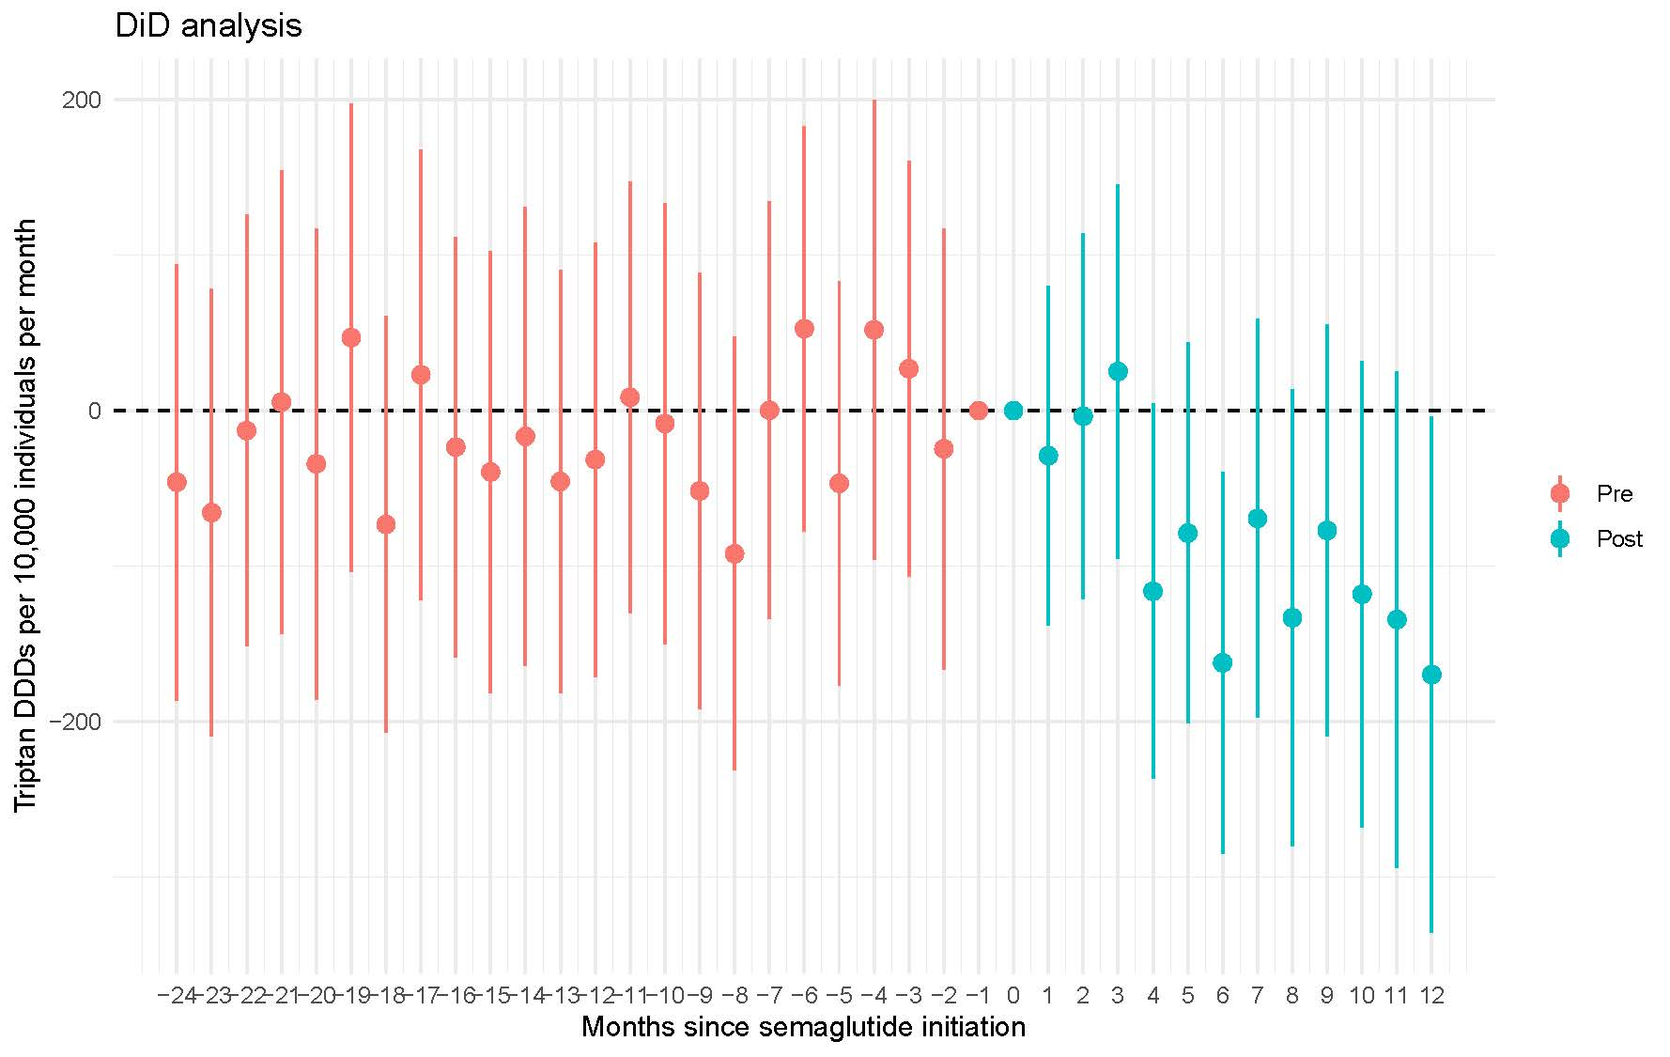
Figure S15. Difference-in-differences analysis (Callaway & Sant'Anna estimator). Average Treatment Effect on the Treated (ATT) per 10,000 users by relative month
Abbreviations: ATT, Average Treatment Effect on the Treated; DDD, Defined Daily Dose; DID, difference-in-differences

Month | ATT (95% CI) DDD/10,000 users
-24 | -46.1 (-186.5 to 94.3)
-23 | -65.6 (-209.4 to 78.1)
-22 | -12.9 (-151.8 to 126.0)
-21 | 5.5 (-143.4 to 154.4)
-20 | -34.2 (-185.7 to 117.3)
-19 | 47.0 (-103.5 to 197.4)
-18 | -73.2 (-207.3 to 60.8)
-17 | 23.1 (-121.7 to 167.9)
-16 | -23.5 (-158.5 to 111.5)
-15 | -39.5 (-181.8 to 102.7)
-14 | -16.6 (-164.3 to 131.0)
-13 | -45.6 (-181.8 to 90.5)
-12 | -31.6 (-171.3 to 108.2)
-11 | 8.6 (-130.1 to 147.2)
-10 | -8.3 (-150.1 to 133.5)
-9 | -51.7 (-192.1 to 88.7)
-8 | -92.2 (-231.6 to 47.3)
-7 | 0.2 (-134.2 to 134.6)
-6 | 52.8 (-77.6 to 183.1)
-5 | -46.8 (-176.8 to 83.2)
-4 | 52.1 (-95.7 to 199.9)
-3 | 27.0 (-106.9 to 160.9)
-2 | -24.6 (-166.4 to 117.3)
-1 | Exclusion of month 0
0 | Exclusion of month 0
1 | -29.0 (-138.3 to 80.3)
2 | -3.7 (-121.5 to 114.1)
3 | 25.2 (-95.3 to 145.7)
4 | -116.3 (-236.8 to 4.3)
5 | -78.9 (-201.3 to 43.6)
6 | -162.3 (-285.4 to -39.3)
7 | -69.4 (-197.7 to 58.8)
8 | -133.3 (-280.1 to 13.4)
9 | -77.1 (-209.8 to 55.5)
10 | -118.2 (-268.4 to 32.0)
11 | -134.5 (-294.1 to 25.2)
12 | -169.9 (-335.7 to -4.1)

https://nnbv.dk/migraene-behandling/

