Mapping structural and functional brain networks associated with migraine
Leyi Zhang¹, Xuhan Cui¹, Yangpan Ou¹, Yong Liu¹, Bing Lang¹, Wenbin Guo^{1,*}
Supplementary Materials
These supplemental materials include:
Supplementary Methods
Supplementary Tables
Table S1. Demographic information of the discovery dataset.
Table S2. Imaging parameters for resting-state fMRI scans in discovery and retest datasets in CoRR.
Table S3. Neurotransmitter receptors and transporters included in analyses.
Table S4. Sample and imaging characteristics of the resting-state studies included in the migraine analysis.
Table S5. Sample and imaging characteristics of the gray matter volume studies included in the migraine analysis.
Table S6. Distribution of brain alterations related to migraine across canonical networks.
Table S7. Leave-one-out sensitivity analysis of the structural network associated with migraine.
Table S8. Leave-one-out sensitivity analysis of the functional network associated with migraine.
Supplementary Figures
Figure S1. The flowchart of the study selection process.
Figure S2. Demographic details for both discovery and retest cohorts.
Figure S3. Structural networks derived separately from increased and decreased regions.
Figure S4. Functional networks derived separately from increased and decreased regions.
Figure S5. Structural and functional networks derived from contrasts reporting only multiple-comparison–corrected findings.
Figure S6. Functional network derived from BOLD-based measures only.
Figure S7. Functional networks derived from individual imaging modalities (ALFF, ReHo, ASL, and FDG-PET).
Figure S8. Gray matter volume and resting-state activity networks derived from the retest dataset, which were similar to those using discovery dataset.
Figure S9. Gray matter volume alteration networks related to migraine using 2-mm and 6-mm radius spheres, which were similar to those using 4-mm radius spheres.
Figure S10. Resting-state activity alteration networks related to migraine using 2-mm and 6-mm radius spheres, which were similar to those using 4-mm radius spheres.
Figure S11. Cell type–specific expression analysis indicated that the positive genes related to brain networks were primarily enriched in D1+ and D2+ spiny neurons of the striatum.

Supplementary methods

Literature search and study selection
We selected studies reporting differences in functional (resting-state activity) and structural (gray matter volume) between individuals with migraine and healthy control participants from two recently published coordinate-based neuroimaging meta-analyses, in which the search and selection procedures have been described in detail. The structural studies included publications up to August 1, 2021, whereas the functional studies covered publications up to April 2022 [1, 2]. For both meta-analyses, we further screened all included studies and retained only those that met the inclusion criteria of the present study. In addition, we conducted an updated literature search in the PubMed and Web of Science databases to identify relevant studies published between January 2021 and November 2025 using the following combination of search terms: (“migraine”) AND (“MRI” OR “fMRI” OR “magnetic resonance imaging” OR “PET” OR “positron emission tomography” OR “SPECT” OR “single photon emission computed tomography” OR “ASL” OR “arterial spin labeling” OR “neuroimaging” OR “FC” OR “functional connectivity” OR “ReHo” OR “regional homogeneity” OR “ALFF” OR “fALFF” OR “amplitude of low-frequency fluctuation*” OR “CBF” OR “blood flow” OR “glucose metabolism” OR “VBM” OR “voxel-based morphometry” OR “DBM” OR “deformation-based morphometry” OR “GMV” OR “gray matter” OR “grey matter”). To avoid possible omissions, we manually reviewed the reference lists of eligible studies.
Studies were included if they: (1) were peer-reviewed journal articles published in English; (2) employed a voxel-wise analysis and reported whole-brain thresholded results; (3) provided coordinates in either the Montreal Neurological Institute (MNI) or Talairach standard stereotactic space (studies reporting only null findings were excluded); (4) assessed participants during the interictal (headache-free) period; and (5) reported contrasts between individuals with migraine and healthy control participants, which were aged between 18 and 60. Functional studies included those assessing local spontaneous brain activity or perfusion/metabolic measures, including amplitude of low-frequency fluctuations (ALFF), fractional amplitude of low-frequency fluctuations (fALFF), regional homogeneity (ReHo), cerebral blood flow (CBF) measured by arterial spin labeling (ASL), and glucose metabolism measured by positron emission tomography (PET). Structural studies were limited to those investigating gray matter volume using voxel-based morphometry.
Studies were excluded if they: (1) involved patients with comorbid neurological conditions (e.g., epilepsy, disorders of consciousness, or multiple sclerosis); (2) focused on other types of headache (e.g., cluster headache, medication overuse headache, or tension-type headache) or specific migraine subtypes (e.g., vestibular migraine or pediatric migraine); (3) reported only region-of-interest analyses or results based on small volume correction; (4) did not include appropriate comparisons between migraine and control groups; (5) did not report stereotactic coordinates; or (6) included fewer than ten participants in either the migraine or control group. All the studies were reviewed and assessed for eligibility and discussed to reach a consensus about inclusion when there was divergence in opinions.
We obtained the findings from eligible studies according to the following criteria: (1) if a study divided the sample into subgroups, findings from the entire sample were used whenever available; (2) if data for the whole sample were not available, findings from each subgroup were treated as independent samples; (3) when a study included multiple subgroups, only those subgroups meeting the inclusion criteria were included in the analysis; and (4) for longitudinal or interventional studies, only findings obtained at baseline before treatment were included. Studies were excluded if essential information (e.g., peak coordinates or contrasts) remained unavailable after contacting the corresponding authors. Consistent with previous coordinate-based meta-analyses, we included both corrected and uncorrected findings. When both corrected and uncorrected results were reported within the same study, only the corrected results were extracted. To avoid data duplication, when two or more studies used the same dataset, only the study with the largest sample size and most comprehensive information was retained.

Data extraction and quality assessment
Two authors (LZ and XC) independently extracted data, including the primary author, year of publication, sample size, age, normalization space (MNI or Talairach), peak coordinate, and the corresponding automated anatomical label, and correction methods (uncorrected, FDR, or FWE), using a standardized checklist. We used the Imaging Methodology Quality Assessment Checklist to assess the quality of included articles objectively and to suggest their limitations in methodology, so that we may infer to weigh the importance of these findings. The 12-point checklist is modified from Shepherd et al., with three categories: subject characters (items 1-4), methods for image acquisition and analysis (items 5-10), and results and conclusions (items 11-12). The items of the checklist were revised to meet the purposes of our meta-analysis and to enhance the transparency of reports. Any discrepancies in quality assessment were discussed and resolved by all authors. The items are as follows:
Category 1: Subject score
1. Patients with migraine were evaluated prospectively, specific diagnostic criteria were applied, and demographic data were reported.
2. Healthy control subjects were evaluated prospectively, psychiatric and medical illnesses were excluded, and demographic data were reported.
3. Important variables or details (e.g., diagnostic criteria, medication status, past illness history) were checked either by stratification or statistically.
4. Sample size per group > 10, and no significant difference in age and sex existed.

Category 2: Methods for image acquisition and analysis
5. Magnet strength at least 1.5T, slice thickness at least 1.5mm in T1-weighted 3D sequence or 5mm in echo-planar imaging sequence.
6. Whole-brain analysis was automated without a priori regional selection.
7. Peak coordinates were reported in a standard space.
8. The imaging technique used was clearly described so that it could be reproduced.
9. Measurements were clearly described so that they could be reproduced.
10. Results have been corrected for multiple comparisons.

Category 3: Results and conclusions
11. Statistical parameters for significant and non-significant differences were provided.
12. Conclusions were consistent with the results obtained, and the limitations were discussed.
Note: Each item received a score of 1, 0.5, or 0 according to the criteria that were fully, partially, or not met, respectively.

Table S1. Demographic information of the discovery dataset.
SiteName | Number |  | Average age (y)
SiteName | Male | Female | Mean | SD
Berlin Mind and Brain (BMB) | 24 | 26 | 30.83 | 7.09
Beijing Normal University 1 (BNU 1) | 29 | 27 | 23.09 | 2.3
Beijing Normal University 2 (BNU 2) | 33 | 27 | 21.32 | 0.86
Beijing Normal University 3 (BNU 3) | 22 | 22 | 22.64 | 1.78
Hangzhou Normal University (HNU) | 15 | 14 | 24.45 | 2.41
Institute of Automation, Chinese Academy of Sciences (IACAS) | 12 | 9 | 27.43 | 5.18
Intrinsic Brain Activity, Test-Retest Dataset (IBATRT) | 17 | 15 | 26.59 | 7.01
Institute of Psychology, Chinese Academy of Sciences 3 (IPCAS 3) | 11 | 18 | 21.45 | 1.48
Institute of Psychology, Chinese Academy of Sciences 4 (IPCAS 4) | 9 | 7 | 23.12 | 1.54
Jinling Hospital, Nanjing University (JHNU) | 19 | 9 | 23.14 | 3.79
Ludwig-Maximilians-University 1 (LMU 1) | 11 | 9 | 24.25 | 1.83
Ludwig-Maximilians-University 2 (LMU 2) | 9 | 10 | 29.95 | 14.03
Nathan Kline Institute 1 (NKI 1) | 0 | 21 | 32.67 | 11.07
New York University 1 (NYU 1) | 10 | 15 | 29.44 | 8.64
New York University 2 (NYU 2) | 46 | 25 | 30.53 | 9.74
Southwest University 1 (SWU 1) | 6 | 12 | 21.72 | 1.78
Southwest University 2 (SWU 2) | 9 | 13 | 21.27 | 1.52
Southwest University 3 (SWU 3) | 7 | 11 | 20.5 | 1.2
Southwest University 4 (SWU 4) | 114 | 96 | 20.16 | 1.22
University of Pittsburgh School of Medicine (UPSM) | 11 | 10 | 18.75 | 0.37
University of Washington—Madison (UWM) | 13 | 11 | 24.96 | 3.3
SiteName | Number |  | Average age (y)
SiteName | Male | Female | Mean | SD
Xuanwu Hospital, Capital University of Medical Sciences (XHCUMS) | 12 | 7 | 50.11 | 5.55
Max Planck Institute (MPG1) | 10 | 9 | 24.95 | 2.04
Total | 449 | 423 | 24.55 | 7.42
The number of participants is provided per site and per sex group, together with the average age and standard deviation of each group. STD, standard deviation.

Table S2. Imaging parameters for resting-state fMRI scans in discovery and retest datasets in CoRR.
No | SiteName | Manufacturer | Flip Angle [°] | Echo Time [ms] | Repetition Time [ms] | Number of Slices | Thickness [mm] | Slice Gap [mm] | Field of View [mm²] | Acquisition Matrix
1 | Berlin Mind and Brain (BMB) | Siemens | 90 | 30 | 2300 | 34 | 4 | 0 | 192×192 | 64×64
2 | Beijing Normal University 1 (BNU 1) | Siemens | 90 | 30 | 2000 | 33 | 3.5 | 0.7 | 200×200 | 64×64
3 | Beijing Normal University 2 (BNU 2) | Siemens | 90 | 30 | 2000 | 33 | 3 | 0.6 | 200×200 | 64×64
4 | Beijing Normal University 3 (BNU 3) | Siemens | 90 | 30 | 2000 | 33 | 3.5 | 0.7 | 200×200 | 64×64
5 | Hangzhou Normal University (HNU) | GE | 90 | 30 | 2000 | 43 | 3.4 | 0 | 220×220 | 64×64
6 | Institute of Automation, Chinese Academy of Sciences (IACAS) | GE | 90 | 30 | 2000 | 32 | 4 | 0.6 | 220×220 | 64×64
7 | Intrinsic Brain Activity, Test-Retest Dataset (IBATRT) | Siemens | 90 | 30 | 1750 | 29 | 3.6 | 0.36 | 220×220 | 64×64
8 | Institute of Psychology, Chinese Academy of Sciences 3 (IPCAS 3) | Siemens | 90 | 30 | 2000 | 32 | 3 | 0.99 | 220×220 | 64×64
9 | Institute of Psychology, Chinese Academy of Sciences 4 (IPCAS 4) | GE | 90 | 30 | 2000 | 37 | 3.5 | 0 | 224×224 | 64×64
10 | Jinling Hospital, Nanjing University (JHNU) | Siemens | 90 | 30 | 2000 | 30 | 4 | 0.4 | 240×240 | 64×64
11 | Ludwig-Maximilians-University 1 (LMU 1) | Philips | 90 | 30 | 2500 | 52 | 3 | 0 | 224×233 | 76×79
12 | Ludwig-Maximilians-University 2 (LMU 2) | Siemens | 80 | 30 | 3000 | 36 | 4 | 0.4 | 192×192 | 64×64
No | SiteName | Manufacturer | Flip Angle [°] | Echo Time [ms] | Repetition Time [ms] | Number of Slices | Thickness [mm] | Slice Gap [mm] | Field of View [mm²] | Acquisition Matrix
13 | Max Planck Institute for Human Cognitive and Brain Sciences (MPG) | Siemens | 70 | 17 | 3000 | 70 | 1.5 | 0 | 192×192 | 128×128
14 | Nathan Kline Institute 1 (NKI 1) | Siemens | 80 | 30 | 2500 | 38 | 3 | 0.33 | 216×216 | 72×72
15 | New York University 1 (NYU 1) | Siemens | 90 | 25 | 2000 | 39 | 3 | 0 | 192×192 | 64×64
16 | New York University 2 (NYU 2) | Siemens | 90 | 15 | 2000 | 33 | 4 | 0 | 240×240 | 80×80
17 | Southwest University 1 (SWU 1) | Siemens | 90 | 30 | 2000 | 33 | 3 | 0.6 | 200×200 | 64×64
18 | Southwest University 2 (SWU 2) | Siemens | 90 | 30 | 2000 | 32 | 3 | 0.99 | 220×220 | 64×64
19 | Southwest University 3 (SWU 3) | Siemens | 90 | 30 | 2000 | 32 | 3 | 0.99 | 220×220 | 64×64
20 | Southwest University 4 (SWU 4) | Siemens | 90 | 30 | 2000 | 32 | 3 | 1 | 220×220 | 64×64
21 | University of Pittsburgh School of Medicine (UPSM) | Siemens | 70 | 29 | 1500 | 29 | 4 | 0 | 200×200 | 64×64
22 | University of Washington—Madison (UWM) | GE | 60 | 25 | 2600 | 64 | 3.5 | 0 | 224×224 | 64×64
23 | Xuanwu Hospital, Capital University of Medical Sciences (XHCUMS) | Siemens | 90 | 30 | 3000 | 43 | 3 | 0.48 | 192×192 | 64×64
fMRI, functional magnetic resonance imaging; CoRR, Consortium for Reliability and Reproducibility.

Table S3. Neurotransmitter receptors and transporters included in analyses.
Target | Tracer | Scanner | N | N (male) | N (female) | Age | SD of age | Parameter | Modelling method | Primary reference
5HT1a | [11C]CUMI-101 | HRRT | 8 | 3 | 5 | 28.4 | 8.8 | Bmax | MRTM2 | beliveau2017jneurosci
5HT1a | [carbonyl-11C]WAY-100635 | GE_Advance | 35 | 18 | 17 | 26.3 | 5.2 | BPnd | MRTM2 | savli2012neuroimage
5HT1b | [11C]AZ10419369 | HRRT | 36 | 24 | 12 | 27.8 | 6.9 | Bmax | MRTM2 | beliveau2017jneurosci
5HT1b | [11C]P943 | HRRT | 65 | 49 | 16 | 33.73 | 9.73 | BPnd | MRTM2 | gallezot2010jcerebbloodflowmetab
5HT1b | [11C]P943 | HRRT | 23 | 15 | 8 | 28.7 | 7 | BPnd | MRTM2 | savli2012neuroimage
5HT2a | [18F]ALTANSERIN | HR+ | 19 | 11 | 8 | 28.2 | 5.7 | BPnd |  | savli2012neuroimage
5HT2a | [11C]CIMBI-36 | HRRT | 29 | 15 | 14 | 22.6 | 2.7 | Bmax | MRTM2 | beliveau2017jneurosci
5HT2a | [11C]MDL100907 | HR+ | 3 | 3 | 0 | 41.14 | 9.94 | BPnd | SRTM | talbot2012neuroimage
5HT4 | [11C]SB207145 | HRRT | 59 | 41 | 18 | 25.9 | 5.3 | Bmax | MRTM2 | beliveau2017jneurosci
5HT6 | [11C]GSK215083 | HR+ | 30 | 30 | 0 | 36.6 | 9.04 | BPnd | MA1 | radhakrishnan2018jnuclmed
5HTT | [11C]DASB | GE_Advance | 18 | 12 | 6 | 30.5 | 9.5 | BPnd | MRTM2 | savli2012neuroimage
5HTT | [11C]DASB | HRRT | 100 | 29 | 71 | 25.1 | 5.8 | Bmax | MRTM2 | beliveau2017jneurosci
a4b2 | [18F]FLUBATINE | HRRT | 30 | 20 | 10 | 33.50 | 10.71 | Vt | equilibrium_analysis | hillmer2016neuroimage
CB1 | [18F]FMPEP-D2 | HRRT | 22 | 11 | 11 | 27.5 | 8.05 | Vt | Logan_graphical_method | laurikainen2019neuroimage
CB1 | [11C]OMAR | HRRT | 77 | 49 | 28 | 30.01 | 8.87 | Vt | MA1 | normandin2015jcerebbloodflowmetab
D1 | [11C]SCH23390 | Biograph_mMR | 13 | 6 | 7 | 33 | 13 | BPnd | MRTM2 | kaller2017eurjnuclmedmolimaging
D2 | [18F]FALLYPRIDE | HRRT | 49 | 16 | 33 | 18.41 | 0.57 | BPnd | SRTM | jaworska2020neuropsychopharmacology
D2 | [11C]FLB457 | HRRT | 37 | 17 | 20 | 48.36 | 16.93 | BPnd | SRTM | smith2017jcerebbloodflowmetab
D2 | [11C]FLB457 | HR+ | 55 | 26 | 29 | 32.45 | 9.69 | BPnd | SRTM | sandiego2015jcerebbloodflowmetab
D2 | [11C]RACLOPRIDE | HRRT | 7 | 7 | 0 | 24 | 2 | BPnd | SRTM | alakurtti2015jcerebbloodflowmetab
Target | Tracer | Scanner | N | N (male) | N (female) | Age | SD of age | Parameter | Modelling method | Primary reference
DAT | [18F]FE-PE2I | mCT | 6 | 6 | 0 | 31.06 | 7.7 | BPnd | SRTM | sasaki2012jnuclmed
DAT | [123I]FP-CIT | (SPECT) | 174 | 109 | 65 | 61 | 11 | SUVR | NA | dukart2018scirep
GABAa | [11C]FLUMAZENIL | HR+ | 6 | 6 | 0 | 43 | 4 | Vt | RPM | dukart2018scirep
GABAabz | [11C]FLUMAZENIL | HRRT | 16 | 7 | 9 | 26.6 | 8 | Bmax | Logan_analysis | norgaard2021neuroimage
H3 | [11C]GSK189254 | HRRT | 8 | 7 | 1 | 31.69 | 8.95 | Vt | MA1 | gallezot2017jcerebbloodflowmetab
M1 | [11C]LSN3172176 | HRRT | 24 | 13 | 11 | 40.45 | 11.71 | BPnd | SRTM2 | naganawa2020jnuclmed
NMDAR | [18F]GE-179 | Biograph_mMR | 10 | 6 | 4 | 40.6 | 13.3 | Vt | Logan_analysis | galovic2021preprint
NMDAR | [18F]GE-179 | GE_Discovery 690 TOF | 10 | 9 | 1 | 40.1 | 9.4 | Vt | Logan_analysis | galovic2021neuroimage
NMDAR | [18F]GE-179 | Siemens/CTI ECAT EXACT HR+ model 962 | 9 | 6 | 3 | 42.2 | 16.2 | Vt | Logan_analysis | mcginnity2014JNM
mGluR5 | [11C]ABP688 | HRRT | 22 | 12 | 10 | 67.9 | 9.6 | BPnd | SRTM | PI: Pedro Rosa-Neto
mGluR5 | [11C]ABP688 | HRRT | 28 | 15 | 13 | 33.1 | 11.2 | BPnd | SRTM | dubois2016eurjnuclmedmolimaging
mGluR5 | [11C]ABP688 | HRRT | 73 | 25 | 48 | 19.9 | 3.04 | BPnd | SRTM | smart2019eurjnuclmedmolimaging
MOR | [11C]CARFENTANIL | HRRT | 39 | 19 | 20 | 39.38 | 5.05 | BPnd | SRTM | turtonen2021biolpsychiatrycnni
MOR | [11C]CARFENTANIL | variable | 204 | 132 | 72 | 32.3 | 10.8 | BPnd | SRTM | kantonen2020neuroimage
NET | [11C]MRB | HR+ | 10 |  |  | 33.3 |  | BPnd | MRTM2 | hesse2017eurjnuclmedmolimaging
NET | [11C]MRB | HRRT | 77 | 50 | 27 | 33.4 | 9.17 | BPnd | MRTM2 | ding2010synapse
VAChT | [18F]FEOBV | HRRT | 3 | 0 | 3 | 66.6 | 0.94 | SUVR | NA | PI: Taylor W. Schmitz & R. Nathan Spreng (with Prevent AD)
VAChT | [18F]FEOBV | Biograph_mMR | 4 | 3 | 1 | 37 | 10.2 | SUVR | NA | PI: Lauri Tuominen & Synthia Guimond
VAChT | [18F]FEOBV | GE_Discovery | 5 | 4 | 1 | 68.3 | 3.1 | SUVR | NA | bedard2019sleepmed
Target | Tracer | Scanner | N | N (male) | N (female) | Age | SD of age | Parameter | Modelling method | Primary reference
VAChT | [18F]FEOBV | HRRT | 18 | 5 | 13 | 66.8 | 6.8 | SUVR | NA | aghourian2017molpsychiatry
Asterisks indicate transporters. 5-HT1a, 5-HT subtype 1a receptor; 5-HT1b, 5-HT subtype 1b receptor; 5-HT2a, 5-HT subtype 2a receptor; 5-HT4, 5-HT subtype 4 receptor; 5-HT6, 5-HT subtype 6 receptor; 5-HTT, serotonin transporter; α4β2, nicotinic acetylcholine receptor subtype α4β2; CB1, cannabinoid receptor; D1, dopamine D1 receptor; D2, dopamine D2 receptor; DAT, dopamine transporter; GABAa, GABA A receptor subtype; H3, histamine receptor subtype H3; M1, muscarinic acetylcholine receptor subtype 1; mGluR5, metabotropic glutamate receptor 5; MOR, mu-opioid receptor; NET, norepinephrine transporter; NMDA, N-methyl-D-aspartate receptor; VAChT, vesicular acetylcholine transporter; Vt means receptor/transporter availability as indexed by the volume of distribution. Bmax, Maximum Binding Capacity; SUVR, Standardized Uptake Value Ratio; MRTM2, Multilinear Reference Tissue Model 2; MA1, Multilinear Analysis.
Table S4. Sample and imaging characteristics of the functional studies included in the migraine analysis
Study | Migraine group |  |  |  |  |  |  | Healthy control group |  | Modality | Scanner | Corr. | Rating
Study | Migraine subtype | Aura | Number/  female | Age (years) | Duration (years) | VAS | Medication (%) | Number/  female | Age (years)
Li2017 [3] | Episodic | MwoA | 62/48 | 21.29 | 5.56 | 5.48 | Drug free | 42/34 | 21.21 | ALFF | 3.0 T fMRI | Y | 12
Ning2017 [4] | Episodic | MwoA | 16/13 | 28.3 | 4.78 | 5.4 | Drug free | 16/13 | 27.1 | ALFF | 3.0 T fMRI | Y | 11.5
Wang2016 [5] | NA | NA | 30/NA | 28.3 | NA | NA | NA | 24/NA | 27.1 | f/ALFF | 3.0 T fMRI | Y | 10
Wei2022 [6] | Episodic | MwoA | 55/48 | 33.58 | 7.22 | 6.49 | Drug free | 50/44 | 37.26 | ReHo and ALFF | 3.0 T fMRI | N | 10.5
Kim2021 [7] | Episodic | MwoA | 44/44 | 36.2 | 13.6 | 7.5 | Drug free | 31/31 | 35.2 | fALFF | 3.0 T fMRI | Y | 11.5
Li2020 [8] | Episodic | MwoA | 72/57 | 21.3 | 5.56 | 5.55 | Drug free | 46/34 | 21.24 | ReHo | 3.0 T fMRI | Y | 11.5
Yang2022 [9] | NA | MwoA | 25/18 | 31.36 | 8.7 | 6.16 | Drug free | 23/19 | 32.74 | fALFF | 3.0 T fMRI | Y | 11.5
Chen2019 [10] | chronic | MwoA | 17/8 | 49.59 | 7.41 | 7.24 | NA | 31/18 | 49.77 | ReHo | 3.0 T fMRI | Y | 11.5
Chen2019 [10] | Episodic | MwoA | 20/16 | 38 | 9.8 | 7.35
Chen2019 [10] | Infrequent Episodic | MwoA | 19/14 | 42 | 9.37 | 6.63
Lei2021 [11] | Episodic | NA | 22/17 | 33.32 | NA | NA | NA | 22/16 | 34.59 | ReHo | 3.0 T fMRI | Y | 11
Liu2021 [12] | Episodic | MwoA | 37/31 | 37.97 | 16.19 | 7.73 | Drug free | 15/13 | 34.88 | ReHo | 3.0 T fMRI | Y | 11.5
Zhang2016 [13] | Episodic | MwoA | 22/13 | 41.8 | 9.8 | 7.7 | NA | 22/13 | 42 | ReHo | 3.0 T fMRI | Y | 11
Zhao2013 [14] | Episodic | MWoA with long-term duration | 20/13 | 37.52 | 16.25 | 5 | Drug free | 20/15 | 28.4 | ReHo | 3.0 T fMRI | Y | 12
Zhao2013 [14] | Episodic | MWoA with short-term duration | 20/15 | 27.12 | 4.05 | 5.37 | Drug free
Zhao2014 [15] | Episodic | MwoA | 19/19 | 21.8 | 9.1 | NA | NA | 20/20 | 22.4 | ReHo | 3.0 T fMRI | Y | 11.5
Chen2018 [16] | Episodic | MwoA | 15/11 | 32 | 10 | 8 | Drug free | 15/11 | 38 | CBF | 3.0 T ASL MRI | N | 11
Michels2019 [17] | Episodic/Chronic | MwA/  MwoA | 17/13 | 32.7 | 12 | NA | 5.85 | 19/11 | 31 | CBF | 3.0 T ASL MRI | Y | 11.5
Zhang2021 [18] | Episodic | MwoA | 40/30 | 35.1 | 9.2 | 5.03 | Drug free | 42/27 | 41.05 | CBF | 3.0 T ASL MRI | Y | 11.5
Kassab2009 [19] | NA | MwA/  MwoA | 11/8 | 37 | NA | NA | Drug free | 14/4 | 36.75 | Glucose Metabolism | ¹⁸F-FDG PET | N | 10
Kim2010 [20] | Episodic | MwA/  MwoA | 20/3 | 34 | 9.9 | NA | Drug free | 20/3 | 33.7 | Glucose Metabolism | ¹⁸F-FDG PET | N | 10.5
Lisicki2019 [21] | Episodic | MwoA | 19/15 | 34.37 | 15.2 | NA | Drug free | 20/15 | 36.1 | Glucose Metabolism | ¹⁸F-FDG PET | Y | 11
Magis2016 [22] | Episodic | MwoA | 11/10 | 37.09 | NA | NA | Drug free | 20/15 | 36 | Glucose Metabolism | ¹⁸F-FDG PET | Y | 11
Feng2022 [23] | Episodic | MwoA | 60/47 | 31.72 | NA | 4.9 | Drug free | 60/45 | 29.25 | fALFF | 3.0 T fMRI | Y | 11.5
Zhou2024 [24] | Episodic | MwoA | 55/38 | 38.44 | 8.4 | 6.8 | Drug free | 40/27 | 41.2 | CBF, ALFF and ReHo | 3.0 T MRI | Y | 11.5
Zhang2023 [25] | Episodic | MwoA | 27/19 | 34.26 | 9.01 | 6.96 | Drug free | 29/13 | 30.9 | ALFF | 3.0 T fMRI | Y | 11.5
Yao2025 [26] | NA | MwoA | 41/27 | 37.34 | 4.15 | NA | Drug free within 7 days before MRI | 39/24 | 35.18 | ALFF and ReHo | 3.0 T fMRI | Y | 11.5
Yang2024 [27] | Episodic | MwoA | 50/50 | 28.36 | 1.2 | NA | Drug free | 50/50 | 27.6 | ALFF | 3.0 T fMRI | Y | 11
Wu2023 [28] | Episodic | NA | 24/17 | 31 | 6.5 | 6 | NA | 23/17 | 27 | fALFF and ReHo | 3.0 T fMRI | Y | 11
Wang2023 [29] | Episodic | MwoA | 21/17 | 36.81 | 11.57 | NA | Drug free | 21/16 | 36.15 | ALFF | 3.0 T fMRI | Y | 11
Pohl2023 [30] | Episodic | NA | 23/22 | 38 | NA | NA | NA | 27/21 | 33 | CBF | 3.0 T ASL MRI | Y | 10.5
Gui2024 [31] | Episodic | NA | 27/25 | 32 | 9 | 6.37 | Drug free | 30/26 | 30.5 | ReHo | 3.0 T fMRI | Y | 11.5
Li2024 [32] | Chronic | MwoA | 13/9 | 40.69 | 8 | 7.77 | Drug free | 15/11 | 38 | CBF | 3.0 T ASL MRI | N | 10.5
Migraine subtype (MwA, migraine with aura; MwoA, migraine without aura); VAS, visual analogue scale; ALFF, amplitude of low-frequency fluctuations; fALFF, fractional amplitude of low-frequency fluctuations; ReHo, regional homogeneity; CBF, cerebral blood flow; PET, positron emission tomography; Drug-free, patients free of medication for at least 2 weeks after enrollment; fMRI, functional magnetic resonance imaging; NA, not available; Corr., multiple correction (Y, yes; N, no).
Table S5. Sample and imaging characteristics of the gray matter volume studies included in the migraine analysis.
Study | Migraine group |  |  |  |  |  |  | Healthy control group |  | Modality | Scanner | Corr. | Rating
Study | Migraine subtype | Aura | Number/  female | Age (years) | Duration (years) | VAS | Medication (%) | Number/  female | Age (years)
Kim2008 [33] | Episodic | MwA/  MwoA | 20/17 | 33.7 | 9.8 | NA | Drug free | 33/29 | 33.8 | GMV | 1.5 T MRI | N | 10
Hubbard2014 [34] | Episodic/Chronic | MwoA | 17/13 | 41.71 | 12.53 | NA | Prophylactics (82.4%) and abortive medications (35.3%) | 18/14 | 38.89 | GMV | 3.0 T MRI | Y | 11.5
Liu2015 [35] | Episodic | MwoA | 135/135 | 21.7 | NA | NA | Drug free | 111/111 | 21.3 | GMV | 3.0 T MRI | Y | 11.5
Lai2016 [36] | Chronic | MwoA | 33/27 | 39.7 | 16.1 | NA | Drug free before scanning | 33/27 | 39.7 | GMV | 1.5 T MRI | Y | 11.5
Liu2017 [37] | Episodic | MwoA | 80/NA | 22.8 | 4.98 | 5.8 | Drug free | 50/NA | 22.6 | GMV | 3.0 T MRI | Y | 11
Zhang2017 [38] | Episodic | MwoA | 32/32 | 38.3 | 9.5 | 7.3 | Drug free | 24/24 | 38.8 | GMV | 3.0 T MRI | Y | 11.5
Coppola2017 [39] | Chronic | NA | 20/14 | 31.3 | 15 | NA | Drug free | 20/13 | 28.5 | GMV | 3.0 T MRI | N | 11
Neeb2016 [40] | Chronic | MwoA | 21/15 | 49.04 | 24.43 | NA | 43 | 21/15 | 49.4 | GMV | 3.0 T MRI | Y | 11
Arkink2017 [41] | Episodic | MwoA | 19/18 | 47 | 29 | NA | Triptans (86%), ergotamine (43%), and indometha-cin (14%) | 48/30 | 47 | GMV | 1.5 T MRI | Y | 11
PalmMeinders2017 [42] | Episodic | MwA/  MwoA | 84/57 | 57.8 | NA | NA | Prophylactics (2%), abortive treatment (57%), triptans (14%), and ergotamines (2%) | 35/25 | 54.6 | GMV | 3.0 T MRI | N | 10
Chen2018 [43] | Episodic/Chronic | NA | 56/37 | 37.5 | 16.22 | NA | Drug free within 48 h | 43/28 | 36.2 | GMV | 3.0 T MRI | Y | 10.5
Messina2018 [44] | Episodic | NA | 73/50 | 35.1 | 15 | NA | 34.20% | 46/29 | 32.9 | GMV | 3.0 T MRI | N | 11
Yang2018 [45] | Episodic | MwA/  MwoA | 22/18 | 36.8 | 6.7 | NA | Drug free | 45/33 | 40.6 | GMV | 3.0 T MRI | Y | 11.5
Bonanno2020 [46] | Episodic | MwA | 14/14 | 42.36 | 5.21 | NA | Analgesics (64%), triptans (14%), and combination analgesics (7%) | 14/14 | 42.5 | GMV | 3.0 T MRI | Y | 11.5
Bonanno2020 [46] | Episodic | MwoA | 14/14 | 43.5 | 5.21 | NA
Li2020 [8] | Episodic | MwoA | 72/57 | 21.3 | 5.56 | 5.55 | Drug free | 46/34 | 21.24 | GMV | 3.0 T MRI | Y | 11.5
Liu2020 [47] | High frequency Episodic/Chronic | MwA/  MwoA | 56/43 | 40.3 | 17.2 | NA | Drug free within 48 h | 37/27 | 39.4 | GMV | 3.0 T MRI | Y | 11.5
Yu2020 [48] | Episodic | MwoA | 39/30 | 39.74 | NA | 6.22 | Drug free | 35/20 | 34.91 | GMV | 3.0 T MRI | Y | 11
Yu2020 [48] | Chronic | MwoA | 17/8 | 49.59 | NA | 7.24 | Drug free
Chou2020 [49] | Episodic | MwA/  MwoA | 40/32 | 39.2 | 14.7 | NA | Drug free | 27/21 | 41.3 | GMV | 3.0 T MRI | Y | 11.5
Yin2023 [50] | Episodic | MwoA | 68/18 | 21.93 | 5.41 | 5.81 | Drug free | 50/23 | 21.62 | GMV | 3.0 T MRI | Y | 11.5
Liu2023 [51] | Episodic | MwoA | 31/24 | 37.58 | 7.16 | 7.78 | Drug free | 33/26 | 37.18 | GMV | 3.0 T MRI | Y | 10.5
Liu2024 [52] | Episodic | MwoA | 34/27 | 37.12 | NA | 6.97 | Drug free | 38/25 | 37.16 | GMV | 3.0 T MRI | Y | 11
Fonseka2023 [53] | Episodic | MwoA | 45/35 | 39.69 | 9.8 | 6.94 | Drug free | 46/28 | 37.57 | GMV | 3.0 T MRI | Y | 11.5
Migraine subtype (MwA, migraine with aura; MwoA, migraine without aura); VAS, visual analogue scale; GMV, gray matter volume; Drug-free, patients free of medication for at least 2 weeks after enrollment; fMRI, functional magnetic resonance imaging; NA, not available; Corr., multiple correction (Y, yes; N, no).

Table S6. Distribution of brain alterations related to migraine across canonical networks.
Canonical network | Whole contrasts (%) |  | Episodic contrasts (%) |  | MwoA contrasts (%)
Canonical network | GMV  (n=25) | Resting-state (n=39) | GMV  (n=17) | Resting-state  (n=23) | GMV  (n=15) | Resting-state (n=25)
Default | 8.5 | 0.3 | 2.4 | 0.5 | 22.3 | 1.2
Dorsal Attention | 0.5 | 27.1 | 1.9 | 32.0 | 0.8 | 22.0
Frontoparietal | 1.8 | 0.5 | 2.4 | 0.6 | 2.2 | 0.4
Limbic | 5.9 | 0.1 | 0.1 | 0.9 | 13.6 | 2.1
Somatomotor | 11.4 | 30.0 | 14.6 | 47.4 | 1.1 | 22.1
Subcortical | 71.4 | 14.4 | 50.8 | 15.4 | 69.2 | 36.8
Ventral Attention | 18.8 | 23.9 | 30.0 | 15.7 | 3.2 | 21.7
Visual | 9.5 | 45.3 | 13.6 | 40.1 | 10.2 | 34.8
GMV, gray matter volume; MwA, migraine with aura; MwoA, migraine without aura.
Table S7. Leave-one-out sensitivity analysis of the structural network associated with migraine.
Contrast removed | Dice coefficient | Spatial correlation
Kim2008 | 0.899 | 0.998
Hubbard2014 | 0.938 | 0.999
Liu2015 | 0.881 | 0.998
Lai2016 | 0.876 | 0.998
Liu2017 | 0.968 | 0.999
Zhang2017 | 0.927 | 0.999
Coppola2017 | 0.949 | 0.999
Neeb2016 | 0.963 | 0.999
Arkink2017 | 0.856 | 0.998
PalmMeinders2017 | 0.896 | 0.998
Chen2018 | 0.869 | 0.998
Messina2018 | 0.944 | 0.998
Yang2018 | 0.929 | 0.999
Bonanno2020C1 | 0.918 | 0.998
Bonanno2020C2 | 0.886 | 0.998
Li2020 | 0.900 | 0.999
Liu2020 | 0.920 | 0.999
Yu2020C1 | 0.890 | 0.998
Yu2020C2 | 0.914 | 0.999
Chou2020 | 0.881 | 0.998
Yin2023 | 0.915 | 0.999
Liu2023 | 0.877 | 0.998
Liu2024 | 0.845 | 0.999
Fonseka2023 | 0.861 | 0.998
Note: As a single study may include multiple contrasts, leave-one-out analysis was conducted at the contrast level. For example, the study Bonanno et al. (2020) contained two contrasts (Bonanno2020C1 and Bonanno2020C2), which were treated as independent units in the leave-one-out analysis.

Table S8. Leave-one-out sensitivity analysis of the functional network associated with migraine.
Contrast removed | Dice coefficient | Spatial correlation
Li2017 | 0.876 | 1.000
Ning2017 | 0.919 | 0.999
Wang2016C1 | 0.909 | 0.999
Wang2016C2 | 0.919 | 0.999
Wei2022C1 | 0.874 | 1.000
Wei2022C2 | 0.997 | 0.999
Kim2021 | 0.902 | 1.000
Li2020 | 0.883 | 1.000
Yang2022 | 0.979 | 0.999
Chen2019C1 | 0.918 | 0.999
Chen2019C2 | 0.891 | 0.999
Chen2019C3 | 0.940 | 0.999
Lei2021 | 0.915 | 1.000
Liu2021 | 0.917 | 1.000
Zhang2016 | 0.980 | 0.999
Zhao2013C1 | 0.931 | 0.999
Zhao2013C2 | 0.954 | 0.999
Zhao2014 | 0.921 | 0.999
Chen2018 | 0.868 | 1.000
Michels2019 | 0.884 | 1.000
Zhang2021 | 0.986 | 1.000
Kassab2009 | 0.950 | 1.000
Kim2010 | 0.872 | 1.000
Lisicki2019 | 0.882 | 1.000
Magis2016 | 0.985 | 0.999
Feng2022 | 0.949 | 0.999
Zhou2024C1 | 0.991 | 0.999
Zhou2024C2 | 0.864 | 1.000
Zhou2024C3 | 0.851 | 1.000
Zhang2023 | 0.868 | 1.000
Yao2025C1 | 0.987 | 0.999
Yao2025C2 | 0.977 | 0.999
Yang2024 | 0.976 | 0.999
Wu2023C1 | 0.990 | 0.999
Wu2023C2 | 0.876 | 1.000
Wang2023 | 0.877 | 1.000
Pohl2023 | 0.879 | 1.000
Gui2024 | 0.998 | 0.999
Li2024 | 0.909 | 0.999
Note: As a single study may include multiple contrasts, leave-one-out analysis was conducted at the contrast level. For example, the study Wang et al. (2016) contained two contrasts (Wang2016C1 and Wang2016C2), which were treated as independent units in the leave-one-out analysis.

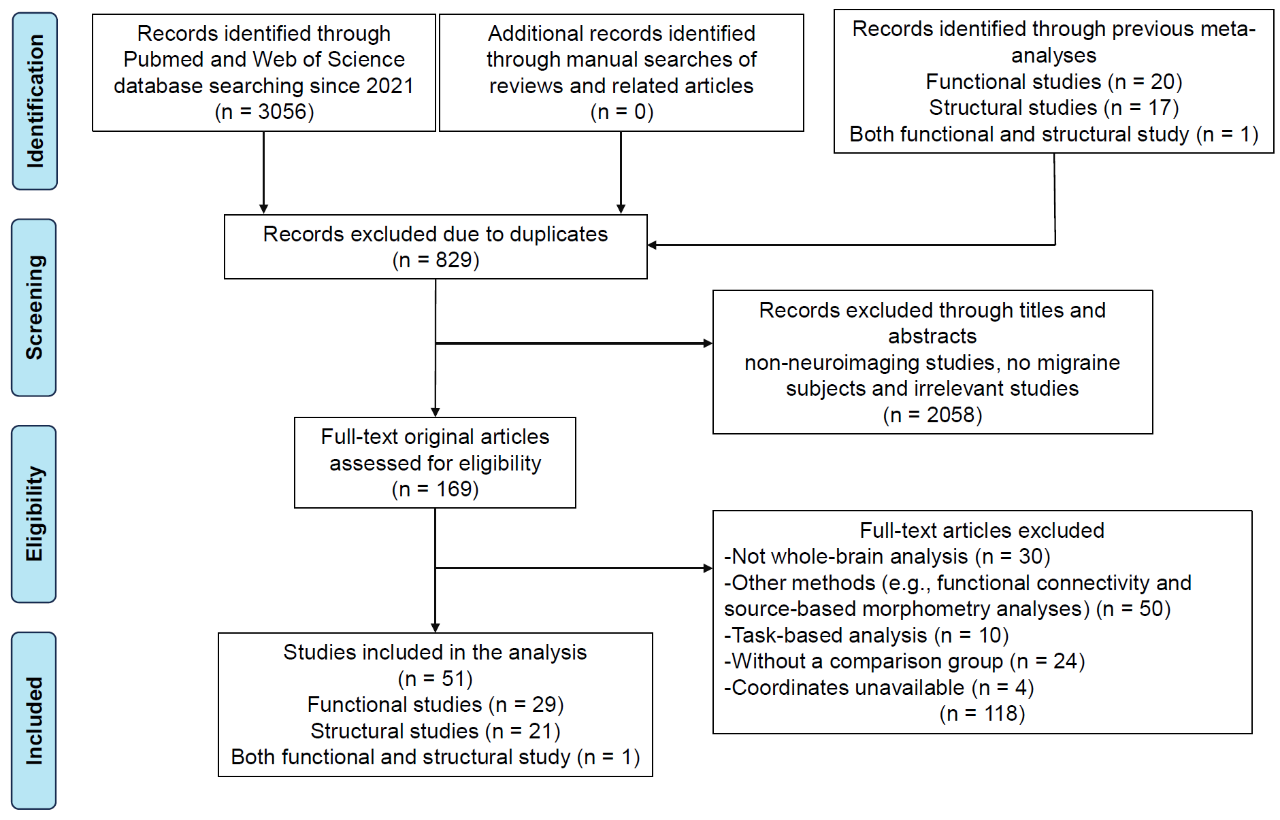
Figure S1. The flowchart of the study selection process. Note: "Other methods" refers to neuroimaging approaches other than voxel-based morphometry and measures of local spontaneous brain activity, perfusion, or metabolism, including functional connectivity, source-based morphometry, and other network-based analyses.
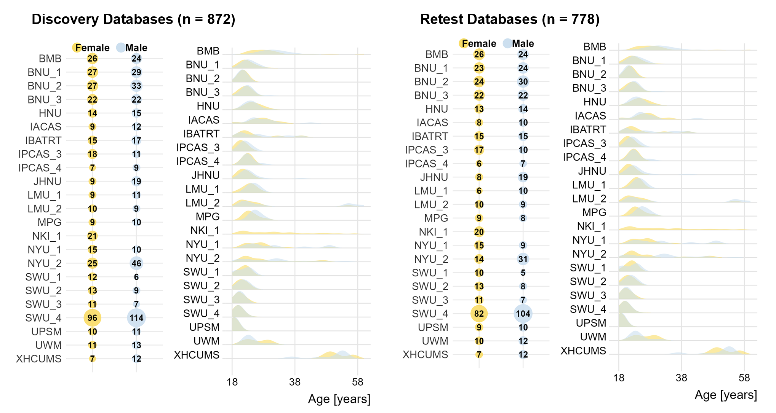
Figure S2. Demographic details for both discovery and retest cohorts.

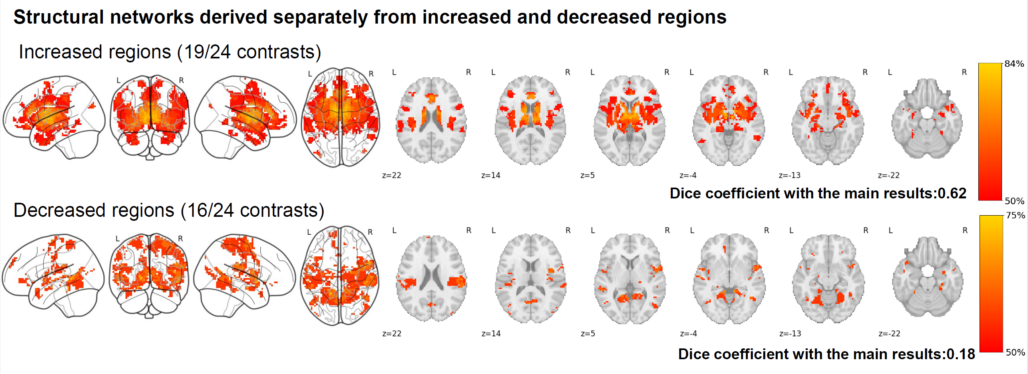Figure S3. Structural networks derived separately from increased and decreased regions. The migraine networks are shown as network probability maps thresholded at 50%, indicating brain regions functionally connected to more than 50% of the contrast seeds.

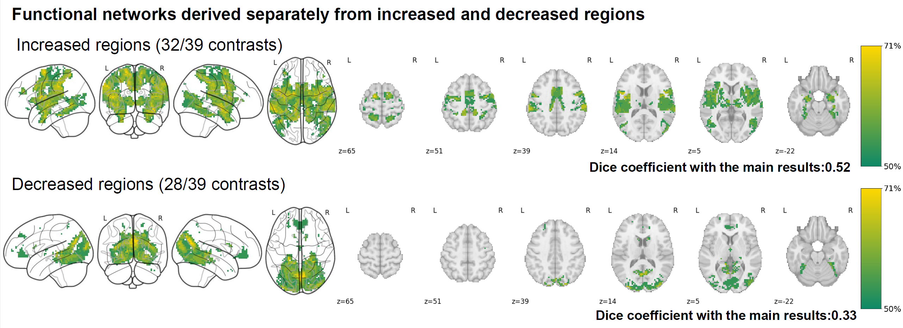Figure S4. Functional networks derived separately from increased and decreased regions. The migraine networks are shown as network probability maps thresholded at 50%, indicating brain regions functionally connected to more than 50% of the contrast seeds.

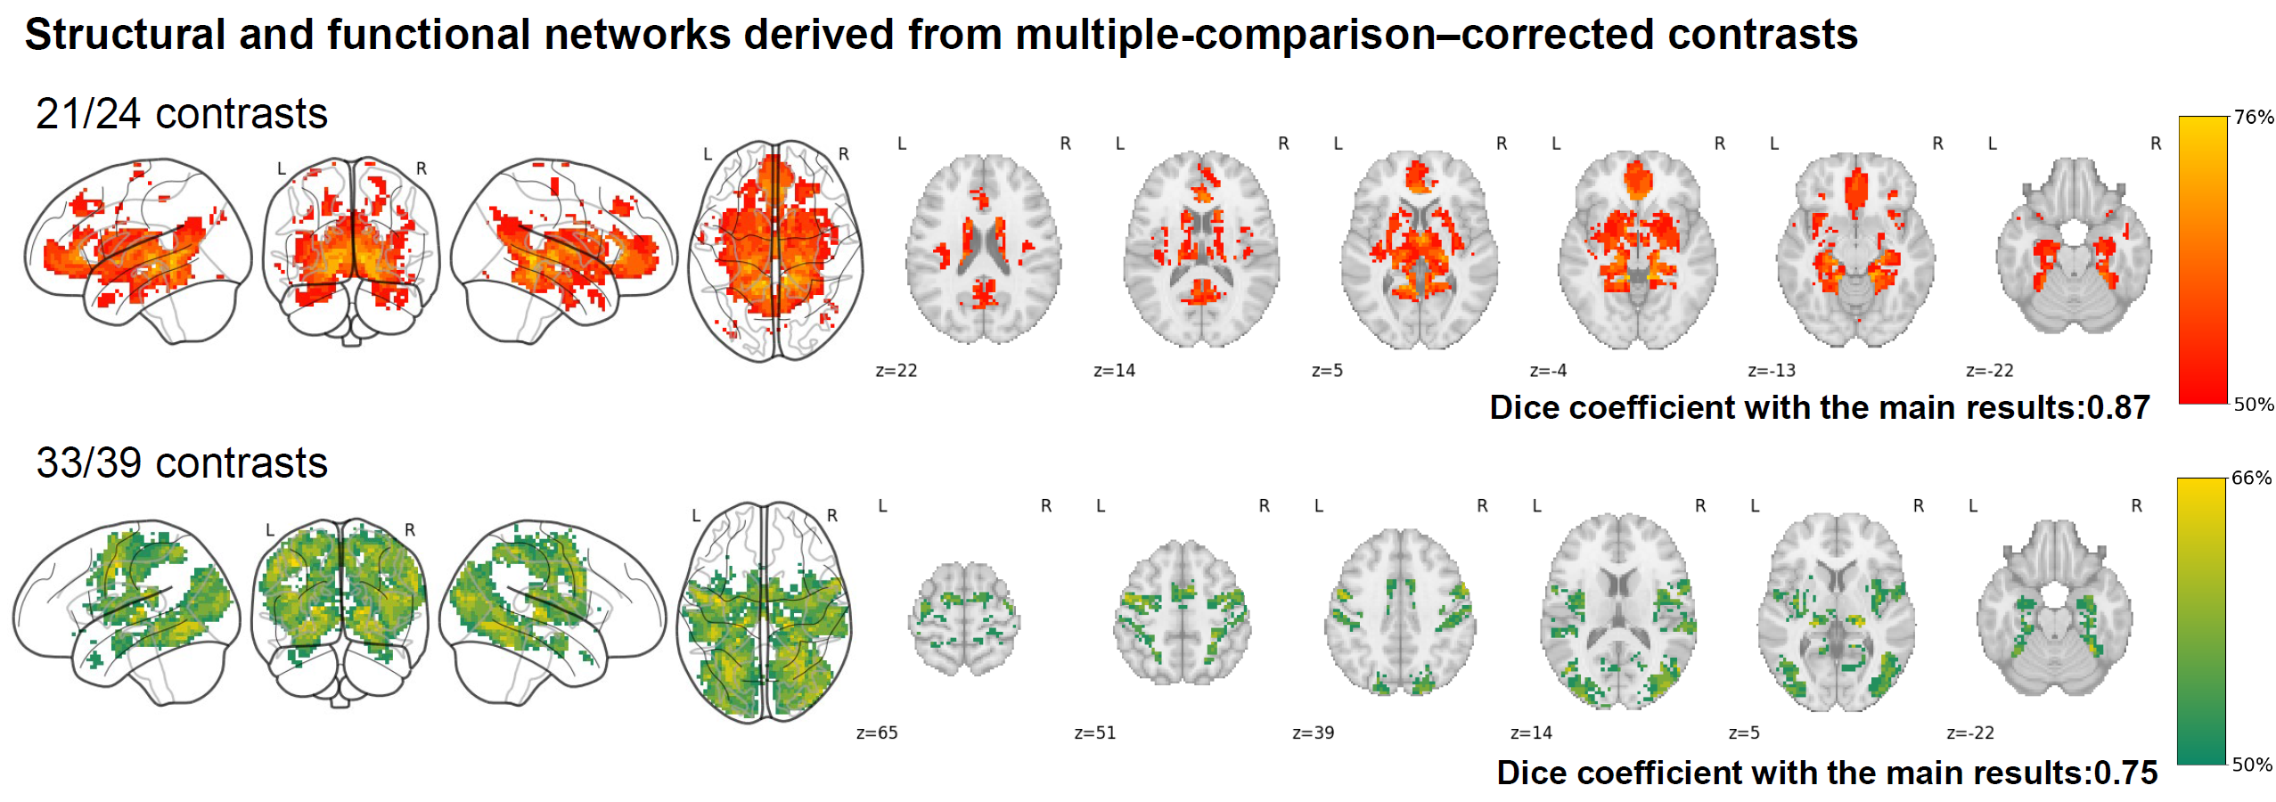Figure S5. Structural and functional networks derived from contrasts reporting only multiple-comparison–corrected findings. The migraine networks are shown as network probability maps thresholded at 50%, indicating brain regions functionally connected to more than 50% of the contrast seeds.
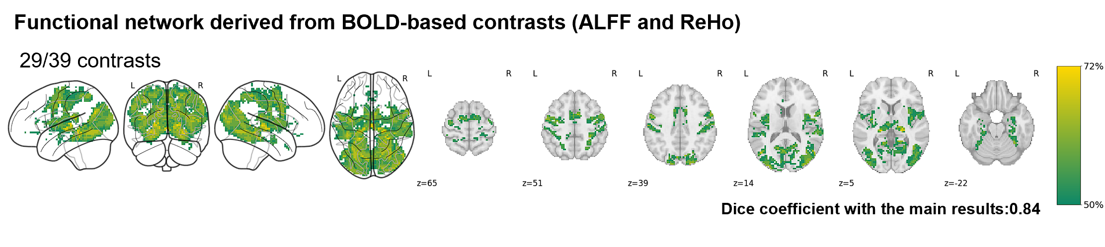Figure S6. Functional network derived from BOLD-based measures only. The migraine network is shown as a network probability map thresholded at 50%, indicating brain regions functionally connected to more than 50% of the contrast seeds. BOLD, blood oxygen level-dependent; ALFF, amplitude of low-frequency fluctuations; ReHo, regional homogeneity.

Figure S7. Functional networks derived from individual imaging modalities (ALFF, ReHo, ASL, and FDG-PET). The migraine networks are shown as network probability maps thresholded at 50%, indicating brain regions functionally connected to more than 50% of the contrast seeds. Dice coefficient analyses revealed low spatial overlap between the structural (GMV) network and each functional modality (ALFF: 0.12; ReHo: 0.36; ASL: 0.10; FDG-PET: 0.07). GMV, gray matter volume; ALFF, amplitude of low-frequency fluctuations; ReHo, regional homogeneity; ASL, arterial spin labeling; FDG-PET, fluorodeoxyglucose positron emission tomography.
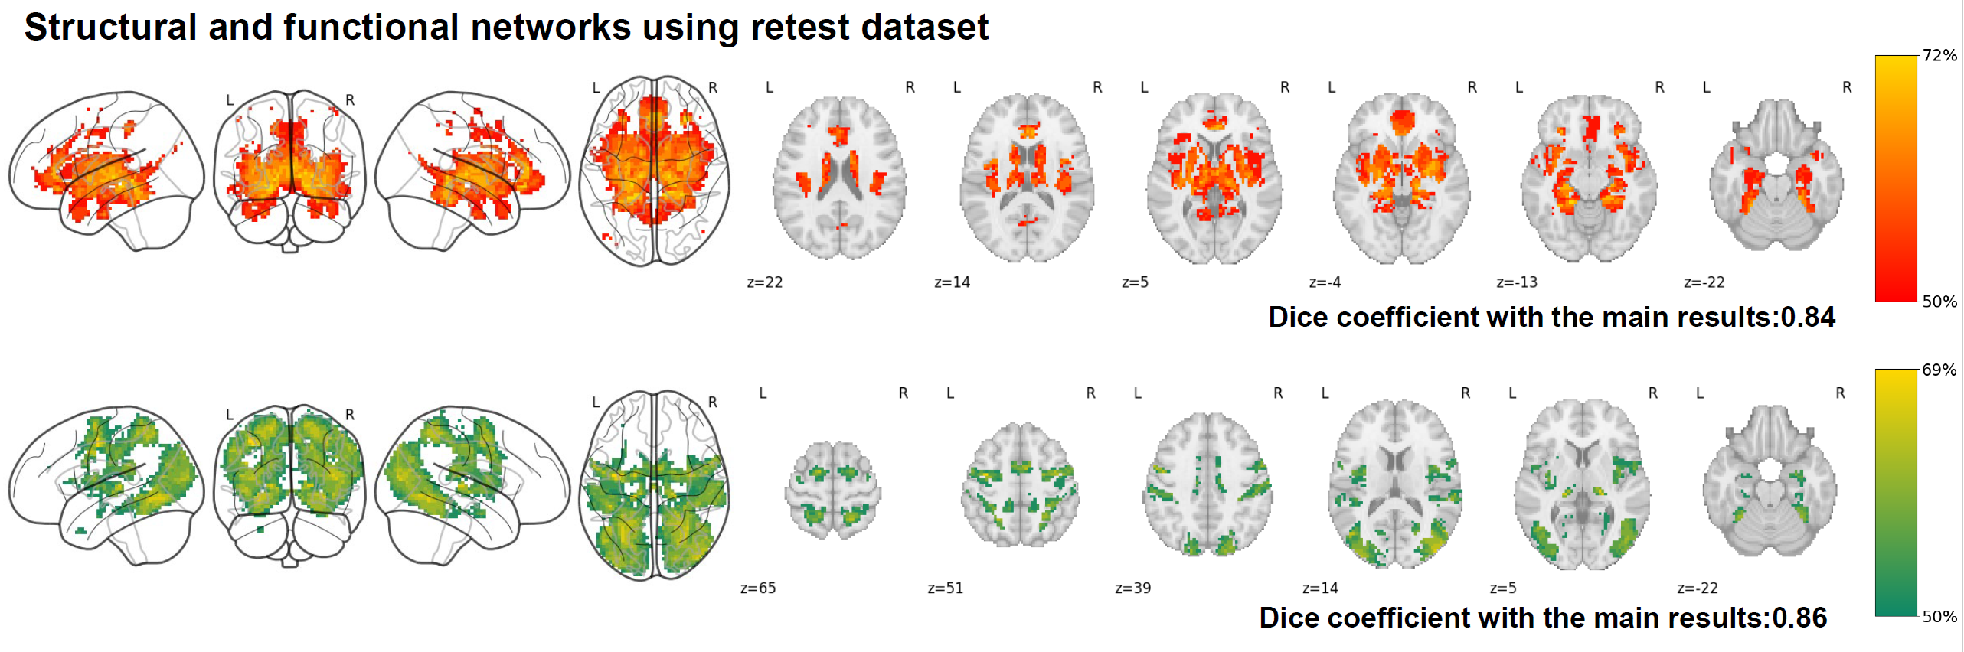
Figure S8. Gray matter volume and resting-state activity networks derived from the retest dataset, which were similar to those using discovery dataset. The migraine networks are shown as the network probability maps thresholded at 50%, indicating brain regions functionally connected to more than 50% of the contrast seeds.

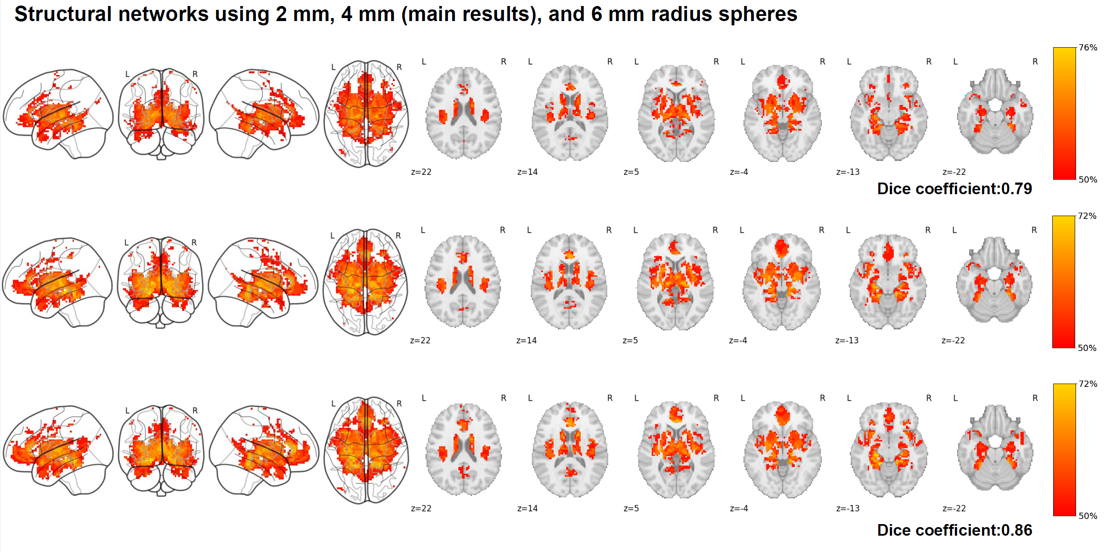
Figure S9. Gray matter volume networks related to migraine using 2-mm and 6-mm radius spheres, which were similar to those using 4-mm radius spheres. The migraine networks are shown as the network probability maps thresholded at 50%, indicating brain regions functionally connected to more than 50% of the contrast seeds.

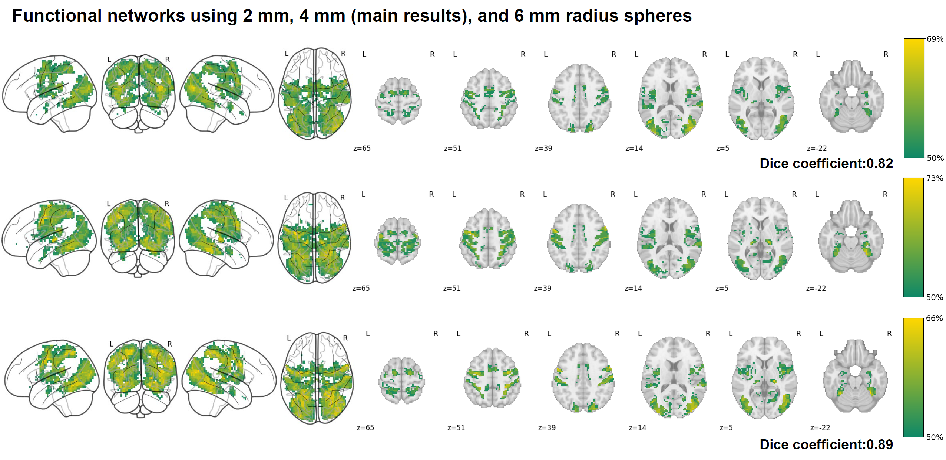
Figure S10. Resting-state activity networks related to migraine using 2-mm and 6-mm radius spheres, which were similar to those using 4-mm radius spheres. The migraine networks are shown as the network probability maps thresholded at 50%, indicating brain regions functionally connected to more than 60% of the contrast seeds.
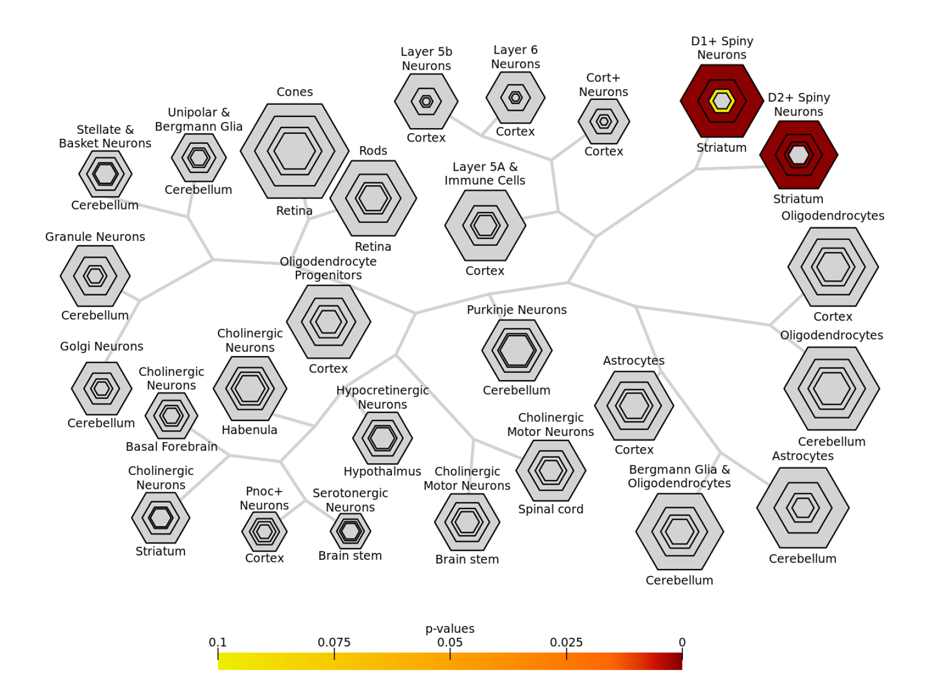
Figure S11. Cell type–specific expression analysis indicated that the positive genes related to brain networks were primarily enriched in D1+ and D2+ spiny neurons of the striatum.

References
1. Cai M, Liu J, Wang X, Ma J, Ma L, Liu M, Zhao Y, Wang H, Fu D, Wang W, et al: Spontaneous brain activity abnormalities in migraine: A meta-analysis of functional neuroimaging. Human Brain Mapping 2023, 44:571-584.
2. Zhang X, Zhou J, Guo M, Cheng S, Chen Y, Jiang N, Li X, Hu S, Tian Z, Li Z, Zeng F: A systematic review and meta-analysis of voxel-based morphometric studies of migraine. Journal of Neurology 2023, 270:152-170.
3. Li Z, Zeng F, Yin T, Lan L, Makris N, Jorgenson K, Guo T, Wu F, Gao Y, Dong M, et al: Acupuncture modulates the abnormal brainstem activity in migraine without aura patients. Neuroimage Clin 2017, 15:367-375.
4. Ning Y, Li K, Zhang Y, Liu H, Fu C, Han X, Ren Y, Zou Y: Effect of acupuncture at Zulinqi ( GB 41 ) on the amplitude of low frequency fluctuations in migraine without aura patients : a resting-state functional magnetic resonance imaging study. In.; 2017
5. Wang JJ, Chen X, Sah SK, Zeng C, Li YM, Li N, Liu MQ, Du SL: Amplitude of low-frequency fluctuation (ALFF) and fractional ALFF in migraine patients: a resting-state functional MRI study. Clin Radiol 2016, 71:558-564.
6. Wei HL, Tian T, Zhou GP, Wang JJ, Guo X, Chen YC, Yu YS, Yin X, Li J, Zhang H: Disrupted Dynamic Functional Connectivity of the Visual Network in Episodic Patients with Migraine without Aura. Neural Plast 2022, 2022:9941832.
7. Kim YE, Kim MK, Suh SI, Kim JH: Altered trigeminothalamic spontaneous low-frequency oscillations in migraine without aura: a resting-state fMRI study. BMC Neurol 2021, 21:342.
8. Li Z, Zhou J, Lan L, Cheng S, Sun R, Gong Q, Wintermark M, Zeng F, Liang F: Concurrent brain structural and functional alterations in patients with migraine without aura: an fMRI study. J Headache Pain 2020, 21:141.
9. Yang Y, Wei K, Zhang H, Hu H, Yan L, Gui W, Liu Y, Chen X: Identifying functional brain abnormalities in migraine and depression comorbidity. Quant Imaging Med Surg 2022, 12:2288-2302.
10. Chen C, Yan M, Yu Y, Ke J, Xu C, Guo X, Lu H, Wang X, Hu L, Wang J, et al: Alterations in Regional Homogeneity Assessed by fMRI in Patients with Migraine Without Aura. J Med Syst 2019, 43:298.
11. Lei M, Zhang J: Brain function state in different phases and its relationship with clinical symptoms of migraine: an fMRI study based on regional homogeneity (ReHo). Ann Transl Med 2021, 9:928.
12. Liu S, Luo S, Yan T, Ma W, Wei X, Chen Y, Zhan S, Wang B: Differential Modulating Effect of Acupuncture in Patients With Migraine Without Aura: A Resting Functional Magnetic Resonance Study. Front Neurol 2021, 12:680896.
13. Zhang J, Su J, Wang M, Zhao Y, Yao Q, Zhang Q, Lu H, Zhang H, Wang S, Li GF, et al: Increased default mode network connectivity and increased regional homogeneity in migraineurs without aura. J Headache Pain 2016, 17:98.
14. Zhao L, Liu J, Dong X, Peng Y, Yuan K, Wu F, Sun J, Gong Q, Qin W, Liang F: Alterations in regional homogeneity assessed by fMRI in patients with migraine without aura stratified by disease duration. J Headache Pain 2013, 14:85.
15. Zhao L, Liu J, Yan X, Dun W, Yang J, Huang L, Kai Y, Yu D, Qin W, Jie T, Liang F: Abnormal brain activity changes in patients with migraine: a short-term longitudinal study. J Clin Neurol 2014, 10:229-235.
16. Chen Z, Chen X, Liu M, Liu M, Ma L, Yu S: Evaluation of gray matter perfusion in episodic migraine using voxel-wise comparison of 3D pseudo-continuous arterial spin labeling. J Headache Pain 2018, 19:36.
17. Michels L, Villanueva J, O'Gorman R, Muthuraman M, Koirala N, Büchler R, Gantenbein AR, Sandor PS, Luechinger R, Kollias S, Riederer F: Interictal Hyperperfusion in the Higher Visual Cortex in Patients With Episodic Migraine. Headache 2019, 59:1808-1820.
18. Zhang D, Huang X, Mao C, Chen Y, Miao Z, Liu C, Xu C, Wu X, Yin X: Assessment of normalized cerebral blood flow and its connectivity with migraines without aura during interictal periods by arterial spin labeling. J Headache Pain 2021, 22:72.
19. Kassab M, Bakhtar O, Wack D, Bednarczyk E: Resting brain glucose uptake in headache-free migraineurs. Headache 2009, 49:90-97.
20. Kim JH, Kim S, Suh SI, Koh SB, Park KW, Oh K: Interictal metabolic changes in episodic migraine: a voxel-based FDG-PET study. Cephalalgia 2010, 30:53-61.
21. Lisicki M, D'Ostilio K, Coppola G, Parisi V, de Noordhout AM, Magis D, Schoenen J, Scholtes F, Versijpt J: Age related metabolic modifications in the migraine brain. Cephalalgia 2019, 39:978-987.
22. Magis D, D'Ostilio K, Thibaut A, De Pasqua V, Gerard P, Hustinx R, Laureys S, Schoenen J: Cerebral metabolism before and after external trigeminal nerve stimulation in episodic migraine. Cephalalgia 2017, 37:881-891.
23. Feng M, Zhang Y, Wen Z, Hou X, Ye Y, Fu C, Luo W, Liu B: Early Fractional Amplitude of Low Frequency Fluctuation Can Predict the Efficacy of Transcutaneous Auricular Vagus Nerve Stimulation Treatment for Migraine Without Aura. FRONTIERS IN MOLECULAR NEUROSCIENCE 2022, 15.
24. Zhou Q, Zhang C, Du J, Xin Z, Qi Y, Wang Y, Li SJ, Wang W, Zhou C, Liu JR, Du X: Altered neurovascular coupling in migraine without aura. J Neurosci Res 2024, 102:e25293.
25. Zhang L, Yu W, Zhang Z, Xu M, Cui F, Song W, Cao Z: Altered brain activity and functional connectivity in migraine without aura during and outside attack. NEUROLOGICAL RESEARCH 2023, 45:603-609.
26. Yao J, Yang G, Yang G, Qi Y, Liu J, Xiong Y, Zhu Y, Yang X, Zhang Q: A Resting State Functional Magnetic Resonance Imaging Study in Migraine Without Aura in Middle and High Altitude Areas. BRAIN AND BEHAVIOR 2025, 15.
27. Yang YC, Wei XY, Zhang YY, Xu CY, Cheng JM, Gong ZG, Chen H, Huang YW, Yuan J, Xu HH, et al: Modulation of temporal and occipital cortex by acupuncture in non-menstrual MWoA patients: a rest BOLD fMRI study. BMC Complement Med Ther 2024, 24:43.
28. Wu L, Wang X, Liu Q, Chai L, Tian S, Wu W: A study on alterations in functional activity in migraineurs during the interictal period. HELIYON 2023, 9.
29. Wang S, Wang H, Liu X, Yan W, Wang M, Zhao R: A resting-state functional MRI study in patients with vestibular migraine during interictal period. ACTA NEUROLOGICA BELGICA 2023, 123:99-105.
30. Pohl H, Sandor PS, Moisa M, Ruff CC, Schoenen J, Luechinger R, O'Gorman R, Riederer F, Gantenbein AR, Michels L: Occipital transcranial direct current stimulation in episodic migraine patients: effect on cerebral perfusion. SCIENTIFIC REPORTS 2023, 13.
31. Gui W, Lu F, Fu L, Deng Z, Zhao X, Cheng W, Yang Y, Wang Y: Genetic mechanisms underlying local spontaneous brain activity in episodic migraine. FRONTIERS IN NEUROSCIENCE 2024, 18.
32. Li X, Liu M, Zhao S, Chen Z: Decreased Cerebral Perfusion in Chronic Migraine: A Voxel-based Cerebral Blood Flow Analysis Using 3D Pseudo-continuous Arterial Spin Labeling. CURRENT MEDICAL IMAGING 2024, 20.
33. Kim JH, Suh SI, Seol HY, Oh K, Seo WK, Yu SW, Park KW, Koh SB: Regional grey matter changes in patients with migraine: a voxel-based morphometry study. Cephalalgia 2008, 28:598-604.
34. Hubbard CS, Khan SA, Keaser ML, Mathur VA, Goyal M, Seminowicz DA: Altered Brain Structure and Function Correlate with Disease Severity and Pain Catastrophizing in Migraine Patients. eNeuro 2014, 1:e20.14.
35. Liu J, Lan L, Mu J, Zhao L, Yuan K, Zhang Y, Huang L, Liang F, Tian J: Genetic contribution of catechol-O-methyltransferase in hippocampal structural and functional changes of female migraine sufferers. Hum Brain Mapp 2015, 36:1782-1795.
36. Lai TH, Chou KH, Fuh JL, Lee PL, Kung YC, Lin CP, Wang SJ: Gray matter changes related to medication overuse in patients with chronic migraine. Cephalalgia 2016, 36:1324-1333.
37. Liu J, Mu J, Liu Q, Dun W, Zhang M, Tian J: Brain structural properties predict psychologically mediated hypoalgesia in an 8-week sham acupuncture treatment for migraine. Hum Brain Mapp 2017, 38:4386-4397.
38. Zhang J, Wu YL, Su J, Yao Q, Wang M, Li GF, Zhao R, Shi YH, Zhao Y, Zhang Q, et al: Assessment of gray and white matter structural alterations in migraineurs without aura. J Headache Pain 2017, 18:74.
39. Coppola G, Petolicchio B, Di Renzo A, Tinelli E, Di Lorenzo C, Parisi V, Serrao M, Calistri V, Tardioli S, Cartocci G, et al: Cerebral gray matter volume in patients with chronic migraine: correlations with clinical features. J Headache Pain 2017, 18:115.
40. Neeb L, Bastian K, Villringer K, Israel H, Reuter U, Fiebach JB: Structural Gray Matter Alterations in Chronic Migraine: Implications for a Progressive Disease? Headache 2017, 57:400-416.
41. Arkink EB, Schmitz N, Schoonman GG, van Vliet JA, Haan J, van Buchem MA, Ferrari MD, Kruit MC: The anterior hypothalamus in cluster headache. Cephalalgia 2017, 37:1039-1050.
42. Palm-Meinders IH, Arkink EB, Koppen H, Amlal S, Terwindt GM, Launer LJ, van Buchem MA, Ferrari MD, Kruit MC: Volumetric brain changes in migraineurs from the general population. Neurology 2017, 89:2066-2074.
43. Chen WT, Chou KH, Lee PL, Hsiao FJ, Niddam DM, Lai KL, Fuh JL, Lin CP, Wang SJ: Comparison of gray matter volume between migraine and "strict-criteria" tension-type headache. J Headache Pain 2018, 19:4.
44. Messina R, Rocca MA, Colombo B, Pagani E, Falini A, Goadsby PJ, Filippi M: Gray matter volume modifications in migraine: A cross-sectional and longitudinal study. Neurology 2018, 91:e280-e292.
45. Yang FC, Chou KH, Lee PL, Yin JH, Chen SY, Kao HW, Sung YF, Chou CH, Tsai CK, Tsai CL, et al: Patterns of gray matter alterations in migraine and restless legs syndrome. Ann Clin Transl Neurol 2019, 6:57-67.
46. Bonanno L, Lo Buono V, De Salvo S, Ruvolo C, Torre V, Bramanti P, Marino S, Corallo F: Brain morphologic abnormalities in migraine patients: an observational study. J Headache Pain 2020, 21:39.
47. Liu HY, Lee PL, Chou KH, Lai KL, Wang YF, Chen SP, Chen WT, Wang SJ: The cerebellum is associated with 2-year prognosis in patients with high-frequency migraine. J Headache Pain 2020, 21:29.
48. Yu Y, Zhao H, Dai L, Su Y, Wang X, Chen C, Shang Y, Ke J, Hu C: Headache frequency associates with brain microstructure changes in patients with migraine without aura. Brain Imaging Behav 2021, 15:60-67.
49. Chou KH, Lee PL, Liang CS, Lee JT, Kao HW, Tsai CL, Lin GY, Lin YK, Lin CP, Yang FC: Identifying neuroanatomical signatures in insomnia and migraine comorbidity. Sleep 2021, 44.
50. Yin T, Lan L, Tian Z, Li Z, Liu M, Gao Y, Liang F, Zeng F: Parahippocampus hypertrophy drives gray matter morphological alterations in migraine patients without aura. JOURNAL OF HEADACHE AND PAIN 2023, 24.
51. Liu H, Zheng R, Zhang Y, Zhang B, Hou H, Cheng J, Han S: Two distinct neuroanatomical subtypes of migraine without aura revealed by heterogeneity through discriminative analysis. BRAIN IMAGING AND BEHAVIOR 2023, 17:715-724.
52. Liu G-y, Chen Y-c, Cao Z-m, Shi A-q, Xu L-f, Li Z-j, Yang Z-q, Yan C-q, Wang J: Mechanistic investigation of acupuncture treatment in patients with migraine: Evidence from brain imaging study (I). WORLD JOURNAL OF ACUPUNCTURE-MOXIBUSTION 2024, 34:16-23.
53. De Fonseka I, Lawanya D, Amarasinghe D, Wijewickrama I, Wishwanthi D, Fernando N, Senanayake G, Pushpakumara S, Arachchi WE: Classification of patients with migraine and healthy subjects using gross brain volume changes. NEUROLOGY AND CLINICAL NEUROSCIENCE 2024, 12:187-194.

