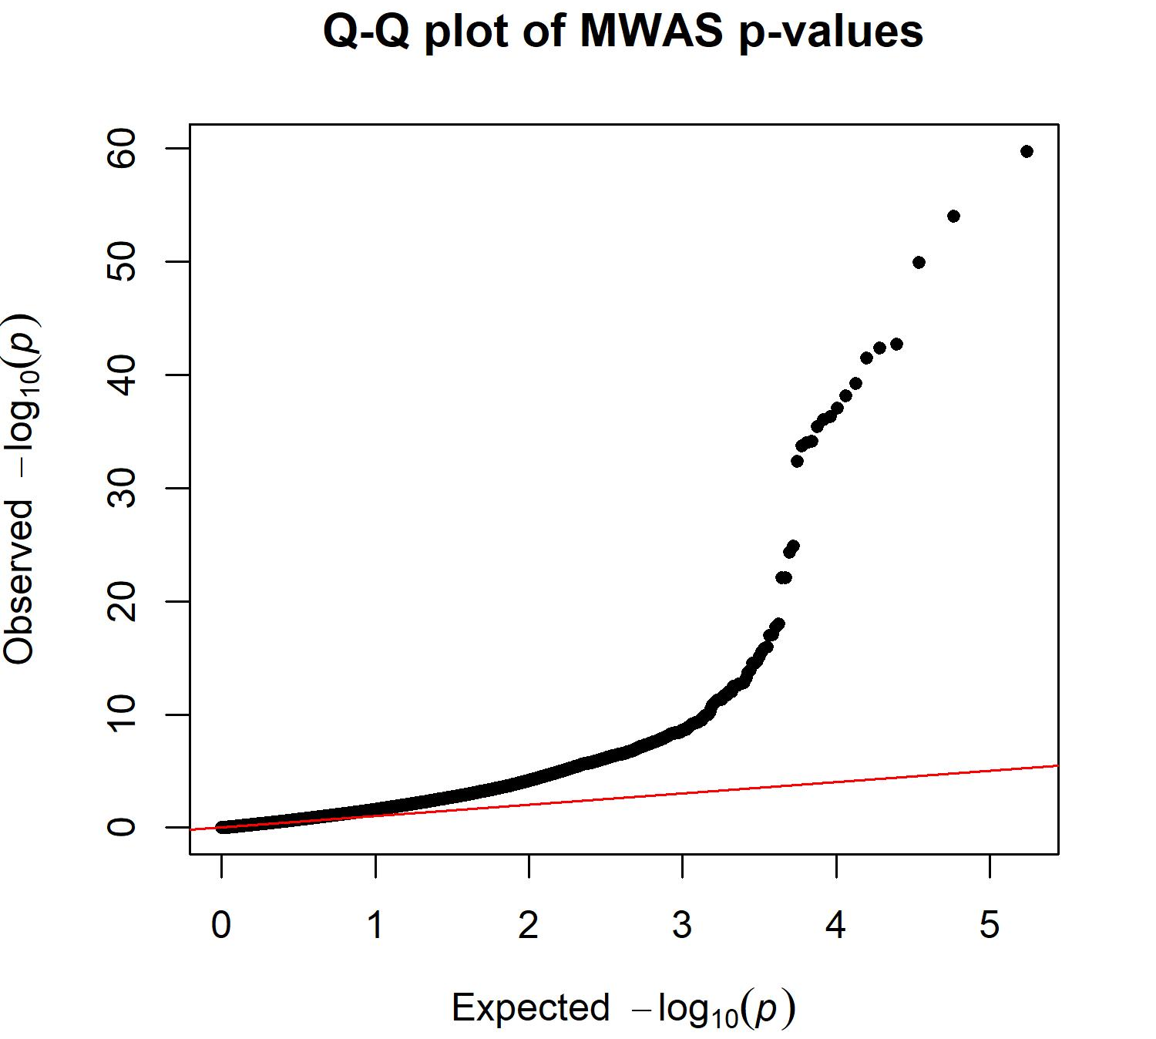

Supplementary Fig. 1 | Q-Q plot of migraine meWAS results. Deviation from the null distribution indicates enrichment of migraine-associated CpGs

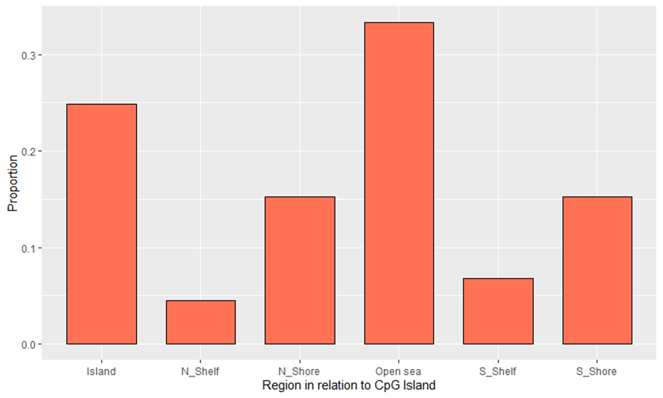

Supplementary Fig. 2 | Proportion of CpGs present in various regions. 24.9% of CpGs were present in the Island region, 4.5% of CpGs were located in the N shelf region, 15.3% of the CpGs were located in the N shore region, 33.3% of CpGs were located in the open sea region, 6.8% of CpGs were located in the S shelf region and 15.3% of CpGs were located in the S shore region

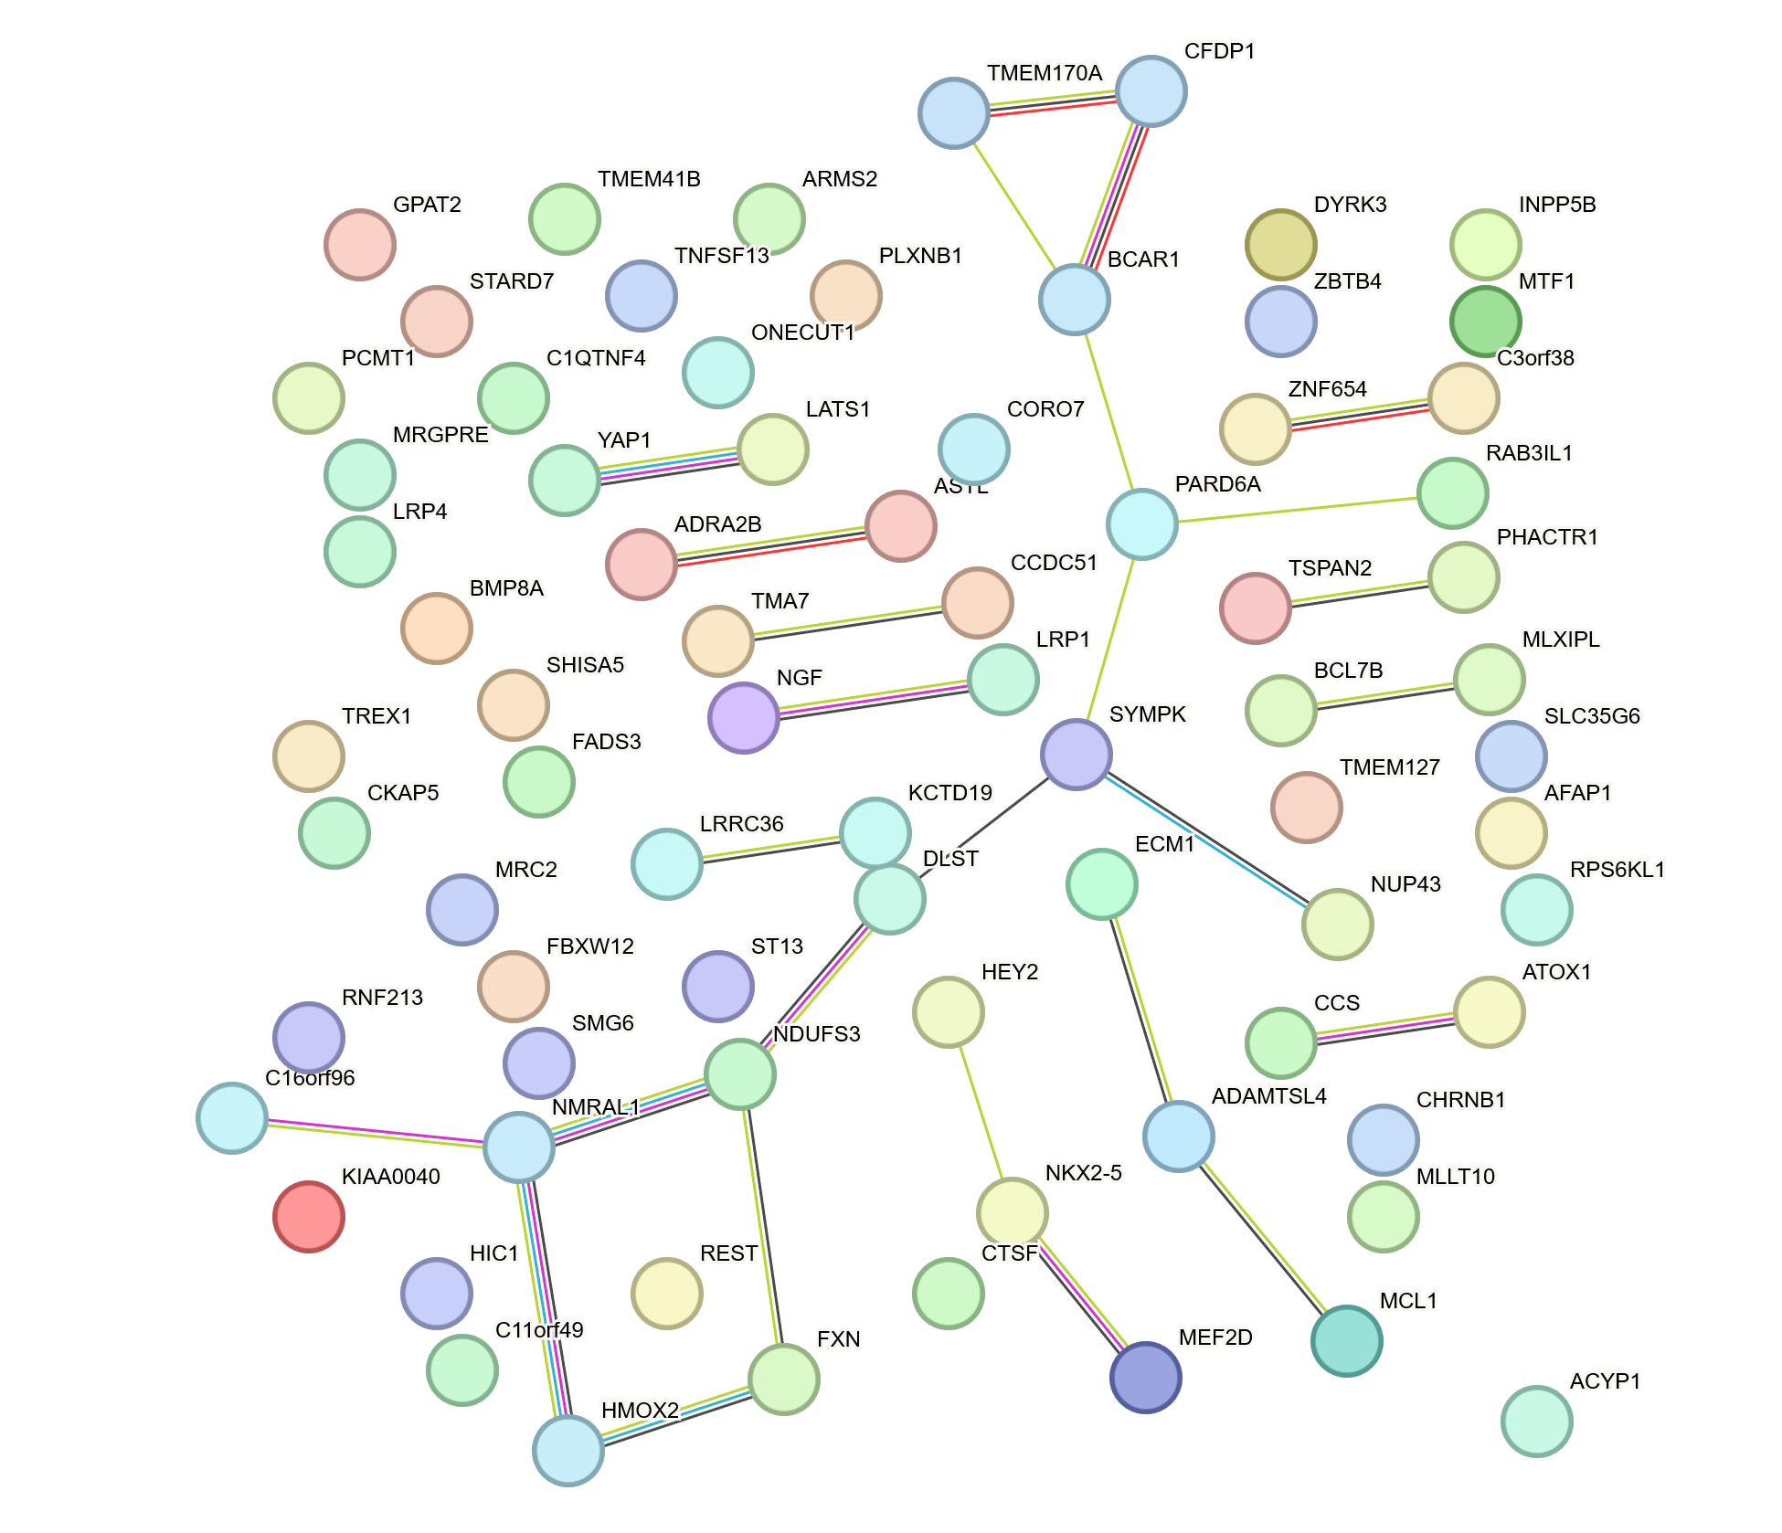

Supplementary Fig. 3 | Protein–protein interaction network generated using STRING (v12.0) for the prioritised gene set identified from colocalisation analysis (Supplementary Data 9). Edges (lines connecting proteins) represent known or predicted protein–protein associations. The network shows significantly greater connectivity than expected by chance (PPI enrichment P = 6.0 × 10^{–5}), with a largely sparse structure comprising small connected components and a limited number of local modules.

