Supplementary Materials

Migraine Demographics and Characteristics
Migraine status was determined using the Mickleborough Migraine Questionnaire (Mickleborough et al., 2016), which parallels the diagnostic framework outlined in the ICHD-3 (Headache Classification Committee of the International Headache Society (IHS), 2013) for probable migraine without aura, migraine without aura, probable migraine with aura, migraine with aura, and chronic migraine. Based on this criteria, 9 participants met the criteria for migraine without aura (8 females; mean age = 27.7), 4 met the criteria for migraine with aura (4 females; mean age = 27.75), and 9 met the criteria for probable migraine without aura (5 females; mean age = 30.33). Given that probable migraine shared symptom profiles and epidemiological characteristics with migraine, participants meeting criteria for probable migraine without aura, migraine without aura, migraine without aura, or migraine with aura were grouped into a single migraine group (22 participants; 17 females/5 males, mean age = 28.77). The migraine and control groups did not differ in age (t(41) = -1.287, p = 0.205) or years of education (t(41) = 1.147, p = 0.258). The migraine group had an average of 42.14 (standard deviation = 47.66) headaches a year, with the average headache lasting 16.52 hours (standard deviation = 23.26). The control group consisted of 21 participants (11 females/10 males, mean age = 25.52) and averaged 18.45 (standard deviation = 26.45) headaches a year, with the average headache lasting 1.69 hours (standard deviation = 1.36). Eighteen participants in the migraine group reported moderate-severe pain intensity and all participants in the control group reported headaches of only mild-moderate pain intensity. No participants reported a headache in the 48 hours prior to scanning.

Preprocessing
Results included in this manuscript come from preprocessing performed using fMRIPrep21.0.1 (Esteban et al., 2019), which is based on Nipype 1.6.1 (Gorgolewski et al., 2011).
Anatomical Preprocessing
A total of 1 T1-weighted (T1w) images per subject were found within the input BIDS dataset. The T1-weighted (T1w) image was corrected for intensity non-uniformity (INU) with N4BiasFieldCorrection (Tustison et al., 2010), distributed with ANTs 2.3.3 (Avants et al., 2008) and used as T1w-reference throughout the workflow. The T1w-reference was then skull-stripped with a Nipype implementation of the antsBrainExtraction.sh workflow (from ANTs), using OASIS30ANTs as target template. Brain tissue segmentation of cerebrospinal fluid (CSF), white-matter (WM) and gray-matter (GM) was performed on the brain-extracted T1w using fast. Volume-based spatial normalization to one standard space (MNI152NLin2009cAsym) was performed through nonlinear registration with antsRegistration (ANTs 2.3.3), using brain-extracted versions of both T1w reference and the T1w template. The following template was selected for spatial normalization: ICBM 152 Nonlinear Asymmetrical template version 2009c.
Functional Data Preprocessing
For each of the 3 EPI image series found per subject (across all tasks and sessions), the following preprocessing was performed. First, a reference volume and its skull-stripped version were generated using a custom methodology of fMRIPrep. Head-motion parameters with respect to the BOLD reference (transformation matrices, and six corresponding rotation and translation parameters) are estimated before any spatiotemporal filtering using mcflirt. BOLD runs were slice-time corrected to 0.69s (0.5 of slice acquisition range 0s-1.38s) using 3dTshift from AFNI(Cox, 1996). The BOLD time-series (including slice-timing correction when applied) were resampled onto their original, native space by applying the transforms to correct for head-motion. These resampled BOLD time-series will be referred to as preprocessed BOLD in original space, or just preprocessed BOLD. The BOLD reference was then co-registered to the T1w reference using mri_coreg (FreeSurfer), followed by flirt with the boundary-based registration(Greve & Fischl, 2009) cost-function. Co-registration was configured with six degrees of freedom. Several confounding time-series were calculated based on the preprocessed BOLD: framewise displacement (FD), DVARS and three region-wise global signals. FD was computed using two formulations following Power (absolute sum of relative motions, (Power et al., 2014) )and Jenkinson (relative root mean square displacement between affines, (Jenkinson et al., 2002)) FD and DVARS are calculated for each functional run, both using their implementations in Nipype (following the definitions by (Power et al., 2014)). The three global signals are extracted within the CSF, the WM, and the whole-brain masks. Additionally, a set of physiological regressors were extracted to allow for component-based noise correction (CompCor,(Behzadi et al., 2007)). Principal components are estimated after high-pass filtering the preprocessed BOLD time-series (using a discrete cosine filter with 128s cut-off) for the two CompCor variants: temporal (tCompCor) and anatomical (aCompCor). tCompCor components are then calculated from the top 2% variable voxels within the brain mask. For aCompCor, three probabilistic masks (CSF, WM and combined CSF+WM) are generated in anatomical space. The implementation differs from that of Behzadi et al. in that instead of eroding the masks by 2 pixels on BOLD space, the aCompCor masks are subtracted a mask of pixels that likely contain a volume fraction of GM. This mask is obtained by thresholding the corresponding partial volume map at 0.05, and it ensures components are not extracted from voxels containing a minimal fraction of GM. Finally, these masks are resampled into BOLD space and binarized by thresholding at 0.99 (as in the original implementation). Components are also calculated separately within the WM and CSF masks. For each CompCor decomposition, the k components with the largest singular values are retained, such that the retained components’ time series are sufficient to explain 50 percent of variance across the nuisance mask (CSF, WM, combined, or temporal). The remaining components are dropped from consideration. The head-motion estimates calculated in the correction step were also placed within the corresponding confounds file. The confound time series derived from head motion estimates and global signals were expanded with the inclusion of temporal derivatives and quadratic terms for each(Satterthwaite et al., 2013). Frames that exceeded a threshold of 0.5 mm FD or 1.5 standardised DVARS were annotated as motion outliers. The BOLD time-series were resampled into standard space, generating a preprocessed BOLD run in MNI152NLin2009cAsym space. First, a reference volume and its skull-stripped version were generated using a custom methodology of fMRIPrep. All resamplings can be performed with a single interpolation step by composing all the pertinent transformations (i.e. head-motion transform matrices, susceptibility distortion correction when available, and co-registrations to anatomical and output spaces). Gridded (volumetric) resamplings were performed using antsApplyTransforms (ANTs), configured with Lanczos interpolation to minimize the smoothing effects of other kernels. Non-gridded (surface) resamplings were performed using mri_vol2surf (FreeSurfer).

CONN Analysis
Results included in this manuscript come from analyses performed using CONN(Whitfield-Gabrieli & Nieto-Castanon, 2012) (RRID:SCR_009550) release 22.a (Nieto-Castanon, 2022) and SPM (RRID:SCR_007037) release 12.7771. This boilerplate was copied from the CONN output and edited only where necessary to align with the final analysis parameters.
Denoising
In addition, functional data were denoised using a standard denoising pipeline (Nieto-Castanon, 2022), including the regression of potential confounding effects characterized by white matter timeseries (5 CompCor noise components), CSF timeseries (5 CompCor noise components), motion parameters and their first order derivatives (12 factors)(Friston et al., 1996), outlier scans (below 490 factors)(Power et al., 2014), session and task effects and their first order derivatives (6 factors), QC_csf linear and quadratic regressors (2 components), QC_rot linear and quadratic regressors and their first order derivatives (12 components), QC_trans linear and quadratic regressors and their first order derivatives (12 components), QC_motion_outlier regressors and their first order derivatives (942 components), and linear trends (2 factors) within each functional run, followed by bandpass frequency filtering of the BOLD timeseries(Hallquist et al., 2013) between 0.008 Hz and 0.09 Hz. CompCor(Behzadi et al., 2007; Chai et al., 2012) noise components within white matter and CSF were estimated by computing the average BOLD signal as well as the largest principal components orthogonal to the BOLD average, motion parameters, and outlier scans within each subject's eroded segmentation masks. From the number of noise terms included in this denoising strategy, the effective degrees of freedom of the BOLD signal after denoising were estimated to range from 0 to 343.4 (average 212) across all subjects (Nieto-Castanon, submitted).
Functional connectivity multivariate pattern analysis
Functional connectivity multivariate pattern analyses (fc-MVPA)(Nieto-Castanon, 2022) were performed to estimate the first 10 eigenpatterns characterizing the principal axes of heterogeneity in functional connectivity across subjects and conditions. From these eigenpatterns, 10 associated eigenpattern-score images were derived for each individual subject and condition characterizing their brain-wide functional connectome state. Eigenpatterns and eigenpattern-scores were computed separately for each individual seed voxel as the left- and right-singular vectors, respectively, from a singular value decomposition (group-level SVD) of the matrix of functional connectivity values between this seed voxel and the rest of the brain (a matrix with one row per target voxel, and one column per subject and condition). Individual functional connectivity values were computed from the matrices of bivariate correlation coefficients between the BOLD timeseries from each pair of voxels, estimated using a singular value decomposition of the z-score normalized BOLD signal (subject-level SVD) with 64 components separately for each subject and condition(Whitfield-Gabrieli & Nieto-Castanon, 2012).
Group-level analyses were performed using a General Linear Model (GLM)(Nieto-Castanon, 2022). For each individual voxel a separate GLM was estimated, with first-level connectivity measures at this voxel as dependent variables (one independent sample per subject and one measurement per task or experimental condition, if applicable), and groups or other subject-level identifiers as independent variables. Voxel-level hypotheses were evaluated using multivariate parametric statistics with random-effects across subjects and sample covariance estimation across multiple measurements. Inferences were performed at the level of individual clusters (groups of contiguous voxels). Cluster-level inferences were based on parametric statistics from Gaussian Random Field theory (Nieto-Castanon, 2022; Worsley et al., 1996). Results were thresholded using a combination of a cluster-forming p < 0.001 voxel-level threshold, and a familywise corrected p-FWE < 0.05 cluster-size threshold.
Post-hoc seed-based connectivity analysis
Seed-based connectivity maps (SBC) were estimated characterizing the spatial pattern of functional connectivity with a seed area. Seed regions included 7 ROIs. Functional connectivity strength was represented by Fisher-transformed bivariate correlation coefficients from a weighted general linear model (weighted-GLM)(Nieto-Castanon, 2022) estimated separately for each seed area and target voxel, modeling the association between their BOLD signal timeseries. Individual scans were weighted by a boxcar signal characterizing each individual task or experimental condition convolved with an SPM canonical hemodynamic response function and rectified.
Group-level analyses were performed using a General Linear Model (GLM)(Nieto-Castanon, 2022). For each individual voxel a separate GLM was estimated, with first-level connectivity measures at this voxel as dependent variables (one independent sample per subject and one measurement per task or experimental condition, if applicable), and groups or other subject-level identifiers as independent variables. Voxel-level hypotheses were evaluated using multivariate parametric statistics with random-effects across subjects and sample covariance estimation across multiple measurements. Inferences were performed at the level of individual clusters (groups of contiguous voxels). Cluster-level inferences were based on parametric statistics from Gaussian Random Field theory(Nieto-Castanon, 2022; Worsley et al., 1996). Results were thresholded using a combination of a cluster-forming p < 0.001 voxel-level threshold, and a familywise corrected p-FWE < 0.05 cluster-size threshold.

Behavioral Results
Figure S1
Arousal Scores

Note. Displayed are the means and standard errors of perceived arousal for each film type across migraine and control participants. “Negative-Migraine” refers to the migraine group’s ratings of the negative valence/high arousal film. ‘Negative-Control” refers to the control group’s ratings of the negative valence/high arousal film. “Positive-Migraine” refers to the migraine group’s ratings of the positive valence/high arousal film. “Positive-Control” refers to the control group’s ratings of the positive valence/high arousal film. “Neutral-Migraine” refers to the migraine group’s ratings of the neutral valence/low arousal film. “Neutral-Control” refers to the control group’s ratings of the neutral valence/low arousal film.

Figure S2
Valence Scores
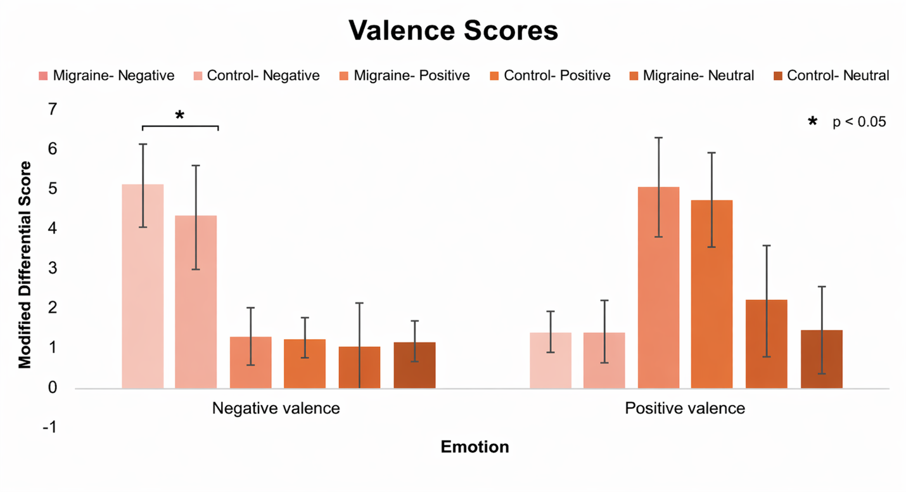
Note. Displayed are the means and standard errors of perceived valence for each film type across migraine and control participants. “Negative-Migraine” refers to the migraine group’s ratings of the negative valence/high arousal film. ‘Negative-Control” refers to the control group’s ratings of the negative valence/high arousal film. “Positive-Migraine” refers to the migraine group’s ratings of the positive valence/high arousal film. “Positive-Control” refers to the control group’s ratings of the positive valence/high arousal film. “Neutral-Migraine” refers to the migraine group’s ratings of the neutral valence/low arousal film. “Neutral-Control” refers to the control group’s ratings of the neutral valence/low arousal film.
Additional fc-MVPA with Negative Valence Rating as a Covariate

We additionally ran our fc-MVPA on the negative film as a one-way ANCOVA of migraine status (Migraine vs. Control) with sex and negative valence rating as covariates, in order to assess whether valence rating differences between migraineurs and controls may have impacted the results. Clusters were identified using a voxel-level threshold of p < 0.001 and a cluster-size family-wise error corrected threshold of p-FWE < 0.05, based on parametric cluster-level inference. Six clusters were identified in this analysis (see Figure S3 and Table S1), spanning the right SLOC, ILOC, occipital pole, SMG, and occipital FuG, and the left SFG, and were largely consistent with the clusters observed in the original analysis.
Thus, the findings in the main analysis cannot simply be attributed to valence rating differences between migraineurs and controls, as valence ratings did not significantly differ between groups, and this supplementary analysis including negative valence rating as a covariate was largely consistent findings of the original analysis.

Figure S3
Negative Film fc-MVPA with Negative Valence Rating as an additional covariate
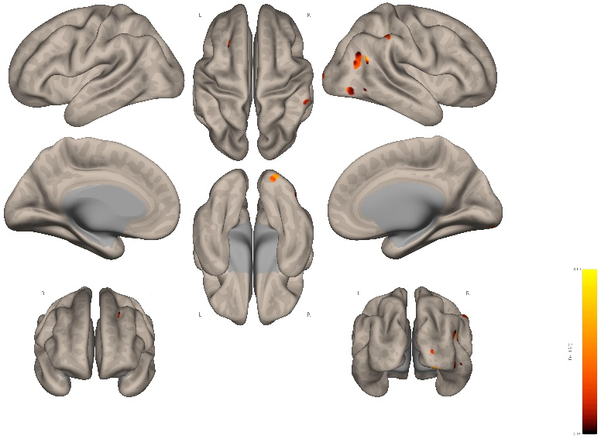
Note. The fc-MVPA revealed six clusters of whole brain differential functional connectivity between migraineurs and controls during the negative valence/high arousal film. These clusters were located in the right superior lateral occipital cortex (SLOC), right inferior lateral occipital cortex (ILOC), right occipital pole, right supramarginal gyrus (SMG), right occipital fusiform gyrus (FuG), and left superior frontal gyrus (SFG). The clusters were identified using an uncorrected voxel-level threshold of p < .001 and a cluster-size family-wise error corrected threshold of p-FWE < .05. Images in this figure were generated in CONN (Nieto-Castanon, 2022b; Whitfield-Gabrieli & Nieto-Castanon, 2012).

Table S1
Results from supplementary fc-MVPA for the negative valence/high arousal stimulus
Cluster Location | Max Voxel Coordinates  (x, y, z) |  |  |  | Cluster  size | Max Voxel Statistic,  F(4, 156) > 4.87,  k ≥ 11 | Cluster-size  p-FWE
Right SLOC | + 52 | - 60 | + 24 | 29 |  | 9.50 | .000004
Right SMG | + 62 | - 34 | + 50 | 12 |  | 8.30 | .015651
Right ILOC | + 52 | - 72 | - 6 | 12 |  | 7.83 | .015651
Left SFG | - 20 | + 20 | + 36 | 11 |  | 8.29 | .027903
Right Occipital Pole | + 30 | - 98 | + 6 | 11 |  | 8.17 | .027903
Right Occipital FuG | + 26 | - 92 | - 14 | 11 |  | 7.14 | .027903
Note. Coordinates are in MNI space. The networks of the clusters were determined using custom Python code which quantified the percentage overlap between the cluster and each network of the Yeo-17 atlas (Thomas Yeo et al., 2011). Abbreviations: ILOC=inferior lateral occipital cortex, FuG=fusiform gyrus, SFG=superior frontal gyrus, SLOC=superior lateral occipital cortex, SMG=supramarginal gyrus.

Additional fc-MVPA of Migraine Status by Film Interaction

We additionally ran the fc-MVPA as a 2 (Migraine Status: Migraine vs. Controls; between subjects) by 2 (Film: Negative vs. Positive) ANCOVA with sex as a covariate, to provide another perspective on the roles of arousal and valence on migraine-related connectivity differences. Clusters were identified using a voxel-level threshold of p < 0.001 and a cluster-size family-wise error corrected threshold of p-FWE < 0.05, based on parametric cluster-level inference.
In this analysis, four clusters were identified in which whole-brain connectivity differences between the negative and positive film were larger for migraineurs than controls (see Figure S4, and Table S2). A similar ANCOVA contrasting the negative and neutral films revealed no significant differences. This interaction between migraine status and film (negative vs. positive), suggests that the valence of emotional stimuli does contribute to differential processing in migraineurs relative to controls, supporting our decision to analyse each film separately in the main analysis. It is important to remember that the films were not matched on their audiovisual features, and thus this supplementary analysis is only intended to validate our decision to analyse the films separately. Future studies could design films which are matched on audiovisual features, yet differ on valence and arousal, to better assess how different types of emotions contribute to differential functional connectivity patterns in migraine.

Figure S4
Migraine Status by Film Type (Negative vs. Positive) fc-MVPA Interaction
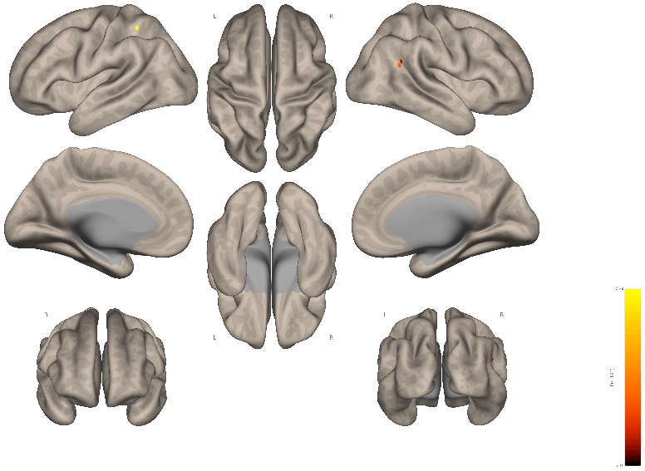
Note. The fc-MVPA revealed four clusters of whole brain differential functional connectivity in which whole-brain connectivity differences between the negative and positive film were larger for migraineurs than controls. These clusters included the left superior parietal lobule (SPL), right angular gyrus (AnG), left lateral occipital cortex (LOC) white matter, and brain stem; but note that the brain stem and LOC clusters are not visible on this surface. The clusters were identified using an uncorrected voxel-level threshold of p < .001 and a cluster-size family-wise error corrected threshold of p-FWE < .05. Images in this figure were generated in CONN (Nieto-Castanon, 2022b; Whitfield-Gabrieli & Nieto-Castanon, 2012).

Table S2
Results from supplementary fc-MVPA for the negative valence/high arousal stimulus
Cluster Location | Max Voxel Coordinates  (x, y, z) |  |  | Cluster  size | Max Voxel Statistic,  F(4, 160) > 4.86,  k ≥ 8 | Cluster-size  p-FWE
Left SPL | - 42 | - 46 | + 50 | 8 | 7.24 | .049799
Right AnG | + 60 | - 54 | + 26 | 8 | 6.19 | .049799
Left LOC white matter | - 30 | - 68 | + 14 | 8 | 5.70 | .049799
Brain stem | + 4 | - 34 | - 58 | 8 | 5.18 | .049799
Note. Coordinates are in MNI space. The networks of the clusters were determined using custom Python code which quantified the percentage overlap between the cluster and each network of the Yeo-17 atlas (Thomas Yeo et al., 2011). Abbreviations: AnG=angular gyrus, LOC=lateral occipital cortex, SPL=superior parietal lobule.

References
Avants, B. B., Epstein, C. L., Grossman, M., & Gee, J. C. (2008). Symmetric diffeomorphic image registration with cross-correlation: Evaluating automated labeling of elderly and neurodegenerative brain. Medical Image Analysis, 12(1), 26–41. https://doi.org/10.1016/j.media.2007.06.004
Behzadi, Y., Restom, K., Liau, J., & Liu, T. T. (2007). A Component Based Noise Correction Method (CompCor) for BOLD and Perfusion Based fMRI. NeuroImage, 37(1), 90–101. https://doi.org/10.1016/j.neuroimage.2007.04.042
Chai, X. J., Nieto-Castanon, A., Ongur, D., & Whitfield-Gabrieli, S. (2012). Anticorrelations in resting state networks without global signal regression. Neuroimage, 59(2), 1420-1428.
Cox, R. W. (1996). AFNI: Software for analysis and visualization of functional magnetic resonance neuroimages. Computers and Biomedical Research, an International Journal, 29(3), 162–173. https://doi.org/10.1006/cbmr.1996.0014
Esteban, O., Markiewicz, C. J., Blair, R. W., Moodie, C. A., Isik, A. I., Erramuzpe, A., Kent, J. D., Goncalves, M., DuPre, E., Snyder, M., Oya, H., Ghosh, S. S., Wright, J., Durnez, J., Poldrack, R. A., & Gorgolewski, K. J. (2019). fMRIPrep: A robust preprocessing pipeline for functional MRI. Nature Methods, 16(1), 111–116. https://doi.org/10.1038/s41592-018-0235-4
Friston, K. J., Williams, S., Howard, R., Frackowiak, R. S., & Turner, R. (1996). Movement-related effects in fMRI time-series. Magnetic Resonance in Medicine, 35(3), 346–355. https://doi.org/10.1002/mrm.1910350312
Gorgolewski, K., Burns, C. D., Madison, C., Clark, D., Halchenko, Y. O., Waskom, M. L., & Ghosh, S. S. (2011). Nipype: A flexible, lightweight and extensible neuroimaging data processing framework in python. Frontiers in Neuroinformatics, 5, 13. https://doi.org/10.3389/fninf.2011.00013
Greve, D. N., & Fischl, B. (2009). Accurate and robust brain image alignment using boundary-based registration. NeuroImage, 48(1), 63–72. https://doi.org/10.1016/j.neuroimage.2009.06.060
Hallquist, M. N., Hwang, K., & Luna, B. (2013). The nuisance of nuisance regression: Spectral misspecification in a common approach to resting-state fMRI preprocessing reintroduces noise and obscures functional connectivity. NeuroImage, 82, 208–225. https://doi.org/10.1016/j.neuroimage.2013.05.116
Headache Classification Committee of the International Headache Society (IHS). (2013). The International Classification of Headache Disorders, 3rd edition (beta version). Cephalalgia, 33(9), 629–808. https://doi.org/10.1177/0333102413485658
Jenkinson, M., Bannister, P., Brady, M., & Smith, S. (2002). Improved Optimization for the Robust and Accurate Linear Registration and Motion Correction of Brain Images. NeuroImage, 17(2), 825–841. https://doi.org/10.1006/nimg.2002.1132
Mickleborough, M. J. S., Ekstrand, C., Gould, L., Lorentz, E. J., Ellchuk, T., Babyn, P., & Borowsky, R. (2016). Attentional Network Differences Between Migraineurs and Non-migraine Controls: fMRI Evidence. Brain Topography, 29(3), 419–428. https://doi.org/10.1007/s10548-015-0459-x
Nieto-Castanon, A. (2022). Brain-wide connectome inferences using functional connectivity MultiVariate Pattern Analyses (fc-MVPA). PLOS Computational Biology, 18(11), e1010634. https://doi.org/10.1371/journal.pcbi.1010634
Power, J. D., Mitra, A., Laumann, T. O., Snyder, A. Z., Schlaggar, B. L., & Petersen, S. E. (2014). Methods to detect, characterize, and remove motion artifact in resting state fMRI. NeuroImage, 84, 320–341. https://doi.org/10.1016/j.neuroimage.2013.08.048
Satterthwaite, T. D., Wolf, D. H., Ruparel, K., Erus, G., Elliott, M. A., Eickhoff, S. B., Gennatas, E. D., Jackson, C., Prabhakaran, K., Smith, A., Hakonarson, H., Verma, R., Davatzikos, C., Gur, R. E., & Gur, R. C. (2013). Heterogeneous Impact of Motion on Fundamental Patterns of Developmental Changes in Functional Connectivity During Youth. NeuroImage, 83, 10.1016/j.neuroimage.2013.06.045. https://doi.org/10.1016/j.neuroimage.2013.06.045
Tustison, N. J., Avants, B. B., Cook, P. A., Zheng, Y., Egan, A., Yushkevich, P. A., & Gee, J. C. (2010). N4ITK: Improved N3 bias correction. IEEE Transactions on Medical Imaging, 29(6), 1310–1320. https://doi.org/10.1109/TMI.2010.2046908
Whitfield-Gabrieli, S., & Nieto-Castanon, A. (2012). Conn: A Functional Connectivity Toolbox for Correlated and Anticorrelated Brain Networks. Brain Connectivity, 2(3), 125–141. https://doi.org/10.1089/brain.2012.0073
Worsley, K. J., Marrett, S., Neelin, P., Vandal, A. C., Friston, K. J., & Evans, A. C. (1996). A unified statistical approach for determining significant signals in images of cerebral activation. Human Brain Mapping, 4(1), 58–73. https://doi.org/10.1002/(SICI)1097-0193(1996)4:1<58::AID-HBM4>3.0.CO;2-O

