Supplementary Text.

Sample sizes for cross-sectional and prospective analyses
For the cross-sectional analyses, participants with acute headache at baseline were further excluded to ensure that the control group comprised participants without migraine or acute headache symptoms. This left 388,407 participants in the metabolomic cohort, including 20,125 prevalent migraine cases and 368,282 controls, and 41,813 participants in the proteomic subset, including 2,226 cases and 39,587 controls. For the prospective analyses, only participants with prevalent migraine at baseline were excluded, whereas those with acute headache at baseline were retained because these analyses evaluated the first recorded migraine diagnosis among participants without prevalent migraine rather than comparing migraine cases with symptom-free controls. This left 453,151 participants in the metabolomic cohort, including 5,755 participants with a first recorded migraine diagnosis during follow-up and 447,396 without one, contributing a total of 6,251,966.6 person-years of follow-up. The corresponding proteomic analysis included 48,662 participants, including 645 participants with a first recorded migraine diagnosis during follow-up and 48,017 without one, contributing 666,006.0 person-years of follow-up.

Medication-adjusted sensitivity analyses of proteomic associations
In sensitivity analyses further adjusting for non-statin lipid-lowering medications, systemic beta-blockers, and valproate, 105 and 31 proteins were associated with prevalent and incident migraine, respectively (FDR < 0.05; Supplementary Table 6). Of the associations identified in the primary analyses, 86 of 93 (92.5%) cross-sectional associations and 31 of 87 (35.6%) prospective associations remained significant, all with consistent effect directions. Despite the attenuation in FDR-significant prospective associations, effect estimates remained highly concordant between the primary and additional medication-adjusted analyses (Spearman r = 0.982 and 0.996, respectively). Seven of the ten proteins associated with both prevalent and incident migraine in the primary analyses remained significant in both additional medication-adjusted analyses (C4BPB, CHGA, PRND, CDHR5, MERTK, TGOLN2, and AMBP).

Down-sampling sensitivity analyses of proteomic associations
Because a marked disparity in the number of FDR-significant protein associations was observed between female and male participants, repeated down-sampling analyses were conducted for the proteomic data to evaluate the potential influence of unequal statistical power. In each of 100 iterations, female participants were randomly sampled without replacement to match the corresponding male sample sizes within each outcome group. All proteins were reanalyzed using the same covariate-adjusted models and BH correction as in the primary sex-stratified analyses. Proteins reaching nominal or FDR significance were identified in each iteration, and the number and proportion of significant iterations were summarized for each protein.

Across 100 iterations, the median number of proteins surviving FDR correction was one in each analysis, and no proteins remained significant in 42.0% and 47.0% of iterations for prevalent and incident migraine, respectively (Supplementary Table 10).

Medication-adjusted sensitivity analyses of lipidomic associations
In sensitivity analyses further adjusting for non-statin lipid-lowering medications, systemic beta-blockers, and valproate, 132 and 115 lipid metabolomic measures were significantly associated with prevalent and incident migraine, respectively (FDR < 0.05; Supplementary Table 16). Of the associations identified in the primary analyses, 123 of 125 (98.4%) cross-sectional associations and 115 of 118 (97.5%) prospective associations remained significant, with all showing consistent effect directions. Effect estimates were highly concordant between the primary and medication-adjusted models (Spearman r = 0.988 and 0.997, respectively), with HDL-related measures remaining the most prominent inverse signals and TG-related measures remaining among the strongest positive signals.

Correlation structure among lipid metabolomic measures
Given the correlated nature of lipidomic traits, we further evaluated whether the large number of significant associations (110 of 143 lipid measures associated with both prevalent and incident migraine) might partly reflect correlations among lipid measures. We performed pairwise Spearman correlation analyses among the 143 lipid metabolomic measures, yielding 10,153 unique measure pairs (Supplementary Table 20). Lipoprotein particle concentrations were strongly correlated with the corresponding cholesterol (r = 0.872 to 0.991, median r = 0.964) and PL concentrations (r = 0.893 to 0.997, median r = 0.960), but showed more heterogeneous correlations with TG concentrations (r = 0.171 to 0.986, median r = 0.609), with particularly weak correlations observed for HDL and its particle-size subclasses (r = 0.171 to 0.375, median r = 0.293). In contrast, correlations between lipoprotein particle concentrations and the corresponding lipid proportions were generally weaker and varied in direction (r = -0.702 to 0.801, median |r| = 0.362). All correlations reported above remained significant after FDR correction (FDR < 0.05).

Joint stratification for lipid concentrations and proportions
As absolute lipid concentrations and relative lipid proportions showed partially distinct association and correlation patterns, we performed exploratory joint stratification analyses of 16 concentration–proportion pairs selected based on biological correspondence and findings from the discovery analyses (Supplementary Table 21).

Across the three additional pairs combining total TG concentration with IDL-, LDL-, or VLDL-TG (%), the joint association patterns differed from those observed for HDL-TG (%). When total TG concentration was low, a high TG proportion was generally not associated with migraine, except for an inverse association between high LDL-TG (%) and prevalent migraine (OR = 0.919, FDR < 0.05). In contrast, the high–high categories were positively associated with both outcomes (ORs = 1.143-1.188; HRs = 1.154-1.176; FDR < 0.05). High total TG concentration combined with a low TG proportion was also positively associated with prevalent migraine, with ORs comparable to those of the high–high categories (ORs = 1.149-1.183; FDR < 0.05), but was not significantly associated with incident migraine (HRs = 1.061-1.071; FDR = 0.125-0.159).

Separately, we examined the biologically matched combinations of IDL, LDL, and VLDL particle concentrations with their corresponding TG, PL, and cholesterol proportions. When particle concentration was high, higher TG proportions were consistently accompanied by more positive effect estimates, whereas higher cholesterol proportions attenuated the positive associations across all three lipoprotein classes. The patterns involving PL proportions were less consistent.

Supplementary Figures.
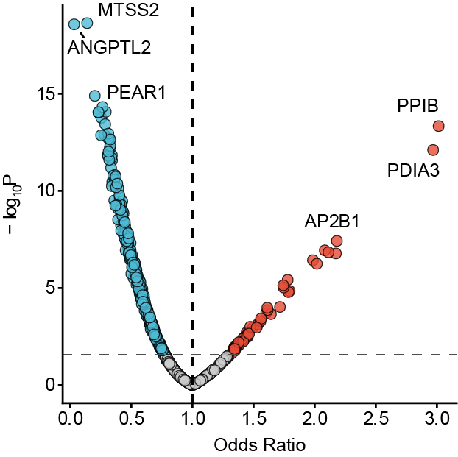
Supplementary Fig. 1 Volcano plot showing the associations of 708 plasma proteins measured in both the UK Biobank and the independent Chinese validation cohort with prevalent migraine in the validation cohort. Red and blue dots indicate proteins positively and negatively associated with migraine, respectively, whereas grey dots indicate non-significant associations. The vertical dashed line indicates an odds ratio of 1, and the horizontal dashed line represents the significance threshold, defined as false-discovery rate (FDR) < 0.05. Associations were evaluated via logistic regression.

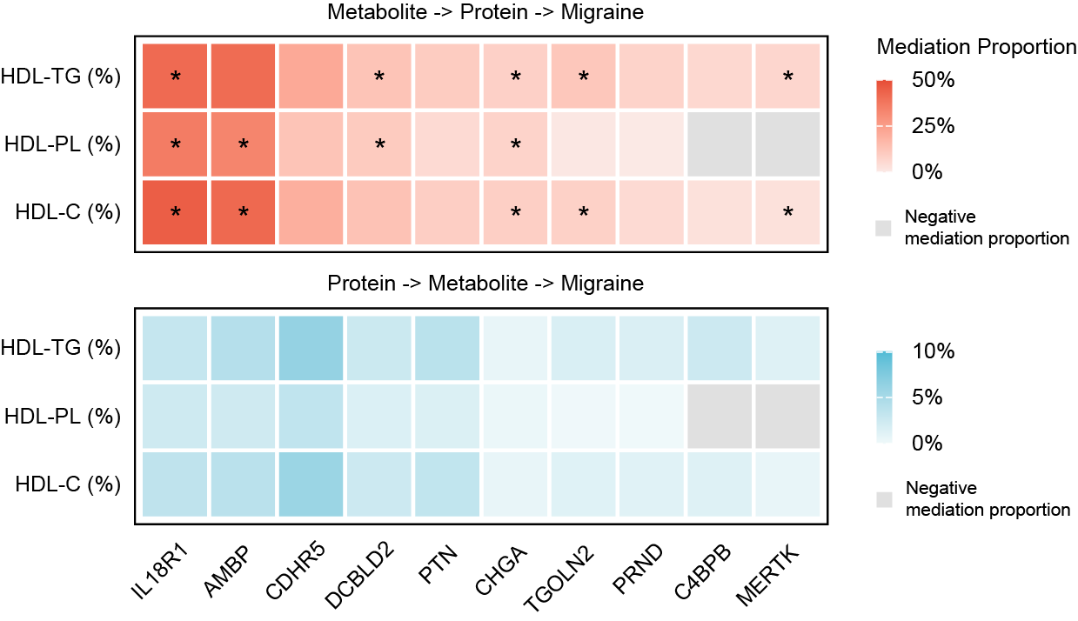
Supplementary Fig. 2 Heatmaps showing the estimated mediation proportions for two alternative mediation models of HDL lipid-composition measures, migraine-associated proteins, and migraine in females. The upper panel represents models in which proteins mediated the associations between HDL lipid-composition measures and migraine, whereas the lower panel represents models in which HDL lipid-composition measures mediated the associations between proteins and migraine. Red and blue indicate models in which proteins and metabolites served as mediators, respectively. Negative mediation proportions, reflecting opposite directions of the estimated indirect and total effects, are shown in light grey. Asterisks indicate significant indirect effects with an average causal mediation effect (ACME) FDR < 0.05.

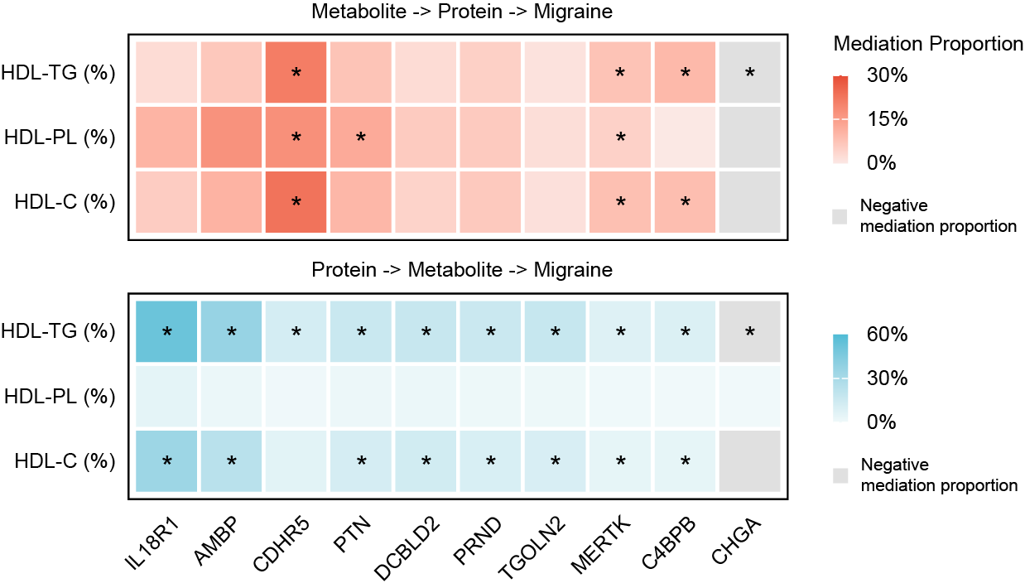
Supplementary Fig. 3 Heatmaps showing the estimated mediation proportions for two alternative mediation models of HDL lipid-composition measures, migraine-associated proteins, and migraine in males. The upper panel represents models in which proteins mediated the associations between HDL lipid-composition measures and migraine, whereas the lower panel represents models in which HDL lipid-composition measures mediated the associations between proteins and migraine. Red and blue indicate models in which proteins and metabolites served as mediators, respectively. Negative mediation proportions, reflecting opposite directions of the estimated indirect and total effects, are shown in light grey. Asterisks indicate significant indirect effects with an average causal mediation effect (ACME) FDR < 0.05.

