Supplementary Material 1

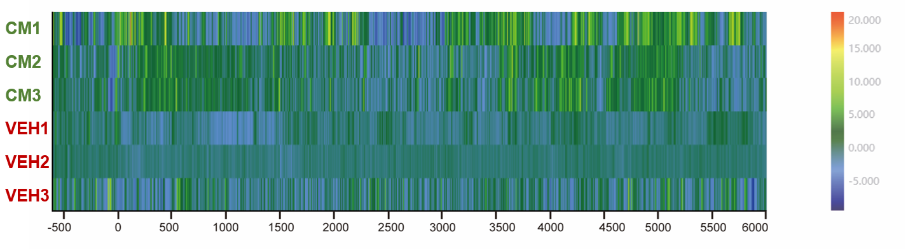

Fig. S1. Heatmap of the calcium signals in the right IC in each mouse between the CM group and the VEH group

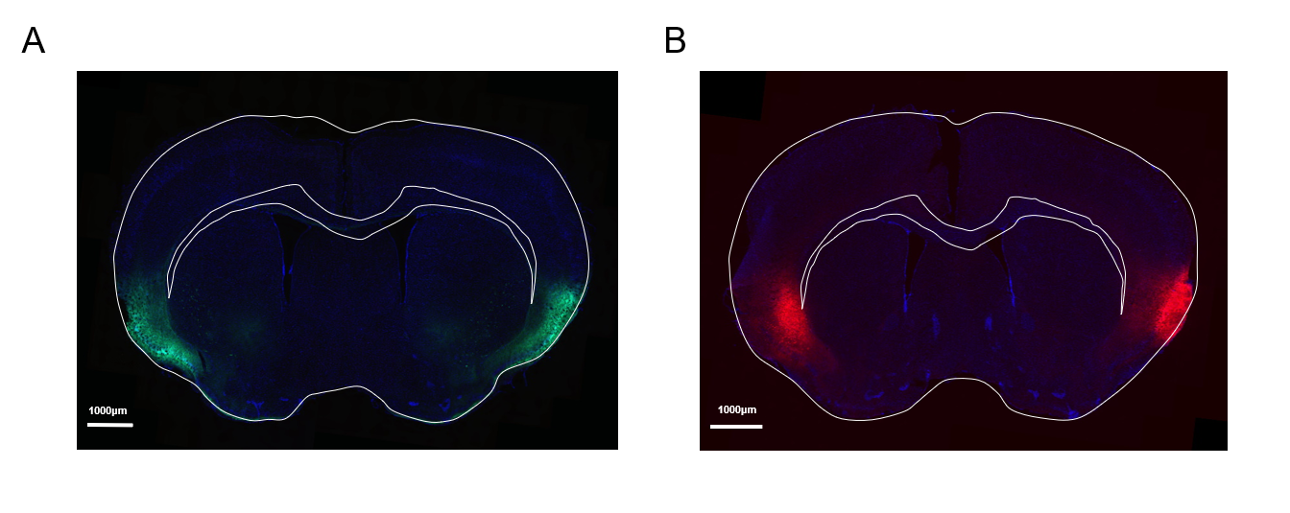

Fig. S2. Histological verification of viral expression and injection sites in chemogenetic experiments.
(A) Representative histological images showing bilateral IC expression in animals included in the hM4Di chemogenetic inhibition experiments (Fig. 6).
(B) Representative histological images showing bilateral IC expression in animals included in the hM3Dq chemogenetic activation experiments (Fig. 7).

Table S1 Virus information
Virus | Product Code | Serotype | Injection volume | Manufacturer
rAAV-CaMKIIα-EGFP | PT-0290 | AAV2/9 | 100nL | Brain VTA
rAAV-CaMKIIα-hM4D(Gi)-EGFP | PT-0524 | AAV2/9 | 100nL | Brain VTA
rAAV-CaMKIIα-mCherry | PT-0108 | AAV2/9 | 100nL | Brain VTA
rAAV-CaMKIIα-hM3D(Gq)-mCherry | PT-0049 | AAV2/9 | 100nL | Brain VTA
rAAV-CaMKIIα-GCaMP6f | PT-0119 | AAV2/9 | 100nL | Brain VTA

Table S2. Details of mice injected, included, and excluded per experiment
Experiment | Total number of mice injected with virus | Number of mice actually included | Number and reason for mice excluded
Fig. 6-GroupA | 12 | 12 | 0
Fig. 6-GroupB | 12 | 10 | Two mice were excluded due to unilateral viral expression failure and insufficient viral expression
Fig. 6-GroupC | 12 | 12 | 0
Fig. 6-GroupD | 12 | 12 | 0
Fig. 7-GroupA | 12 | 11 | One mouse was excluded due to insufficient viral expression
Fig. 7-GroupB | 12 | 12 | 0
Fig. 7-GroupC | 12 | 12 | 0
Fig. 7-GroupD | 12 | 11 | One mouse was excluded due to insufficient viral expression

Table S3. Fig. 6 longitudinal withdrawal-threshold analyses
Panel | Design factors | Primary model | Sphericity/assumptions | Effect | df1, df2 | F | P | Post-hoc / multiplicity | n / exclusions
Fig.6B–C Paw withdrawal threshold | Group (A–D); Time (D0,D3,D5,D7,D9) | Mixed repeated-measures | Mauchly W=0.77, χ²(9)=10.59, P=0.31; sphericity assumed | Group | 3,42 | 53.43 | <0.001 | Bonferroni-adjusted pairwise comparisons | n=12,10,12,12; two animals excluded from group B due to unilateral viral expression failure and insufficient viral expression
 |  |  |  | Time | 4,168 | 20.59 | <0.001
 |  |  |  | Group × Time interaction | 12,168 | 3.61 | <0.001
Fig.6D–E Periorbital withdrawal threshold | Group (A–D); Time (D0,D3,D5,D7,D9) | Mixed repeated-measures | Mauchly W=0.69, χ²(9)=15.17, P=0.09; sphericity assumed | Group | 3,42 | 58.88 | <0.001 | Bonferroni-adjusted pairwise comparisons
 |  |  |  | Time | 4,168 | 29.87 | <0.001
 |  |  |  | Group × Time interaction | 12,168 | 9.68 | <0.001

Table S4. Fig. 6 light–dark box endpoint analyses
Panel | Primary model | Assumption checks | Effect | df1, df2 | F | P | Post-hoc / multiplicity | n / exclusions
Fig.6F Total distance travelled | One-way ANOVA | Levene test: F(3,42)=0.02, P=0.10; homogeneity satisfied | Group | 3, 42 | 1.87 | 0.15 | No post-hoc required because overall test not significant | n=12,10,12,12; two mice excluded from group B due to unilateral viral expression failure and insufficient viral expression
Fig.6G Time in light compartment | Welch’s one-way ANOVA | Levene test: F(3,42)=10.67, P<0.001; variance heterogeneity detected | Group | 3,23.27 | 10.67 | <0.001 | Games-Howell

Table S5. Fig. 7 longitudinal withdrawal-threshold analyses
Panel | Design factors | Primary model | Sphericity/assumptions | Effect | df1, df2 | F | P | Post-hoc / multiplicity | n / exclusions
Fig. 7A–B  Paw threshold | Group (A–D) × Time (D0,D3,D5,D7,D9) | Mixed repeated-measures ANOVA | Mauchly’s test: W=0.49, χ²(9)=28.73, P<0.001; Greenhouse–Geisser correction applied (ε=0.75) | Group | 3,42 | 13.60 | <0.001 | Bonferroni-adjusted pairwise comparisons | A n=11; B n=12; C n=12; D n=11(One mouse of group A was excluded due to insufficient viral expression; One mouse of group D was excluded due to insufficient viral expression)
 |  |  |  | Time | 3.01,126.54 | 16.99 | <0.001
 |  |  |  | Group × Time interaction | 9.04,126.53 | 8.07 | <0.001
Fig. 7C–D  Periorbital threshold | Group (A–D) × Time (D0,D3,D5,D7,D9) | Mixed repeated-measures ANOVA | Mauchly W=0.27, χ²(9)=34.63, P<0.001; Greenhouse–Geisser correction applied (ε=0.71) | Group | 3,28 | 196.23 | <0.001 | Bonferroni-adjusted multiple comparisons
 |  |  |  | Time | 2.85,79.66 | 44.87 | <0.001
 |  |  |  | Group × Time interaction | 8.54,79.66 | 13.96 | <0.001

Table S6. Fig. 7 light–dark box endpoint analyses
Panel | Primary model | Assumption checks | Effect | df1, df2 | F | P | Post-hoc / multiplicity | n / exclusions
Fig.7E Total distance travelled | One-way ANOVA | Shapiro-Wilk: normal distribution satisfied; Levene test F(3,40)=1.43, P=0.27 | Group | 3,40 | 1.82 | 0.16 | Bonferroni-adjusted multiple comparisons | A n=11; B n=12; C n=12; D n=9(One mouse of group A was excluded due to insufficient viral expression; Three mice of group D were excluded. One mouse was excluded due to insufficient viral expression, and two mice were excluded from the final analysis as predefined behavioral outliers, with total distance traveled exceeding three standard deviations from the group mean.)
Fig.7F Time in light compartment | Welch’s one-way ANOVA | Shapiro-Wilk: normal distribution satisfied; Levene test F(3,40)=6.78, P=0.002; variance heterogeneity detecte | Group | 3,21.36 | 6.78 | 0.002 | Games-Howell

