Supplementary Material 2 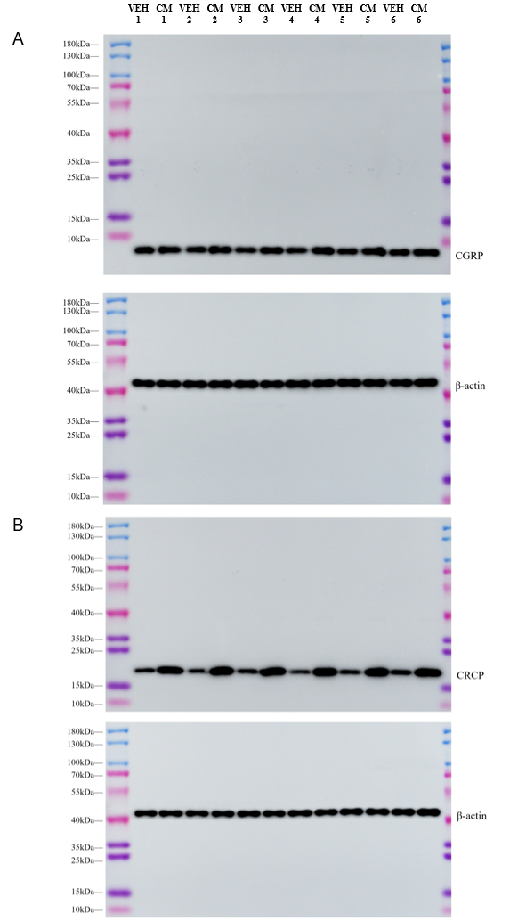

Supplementary Material 2. Full-length uncropped Western blots showing CGRP and CRCP expression in the insular cortex.
(A) Full-length uncropped Western blot images of CGRP and corresponding β-actin loading controls from independent biological samples.
(B) Full-length uncropped Western blot images of CRCP and corresponding β-actin loading controls from independent biological samples.

