SUPPLEMENTARY INFORMATION

The primary somatosensory cortex mediates trigeminal neuralgia induced depressive-like behaviors through an indirect pathway targeting the lateral habenula

Supplemental information

Supplementary Figures

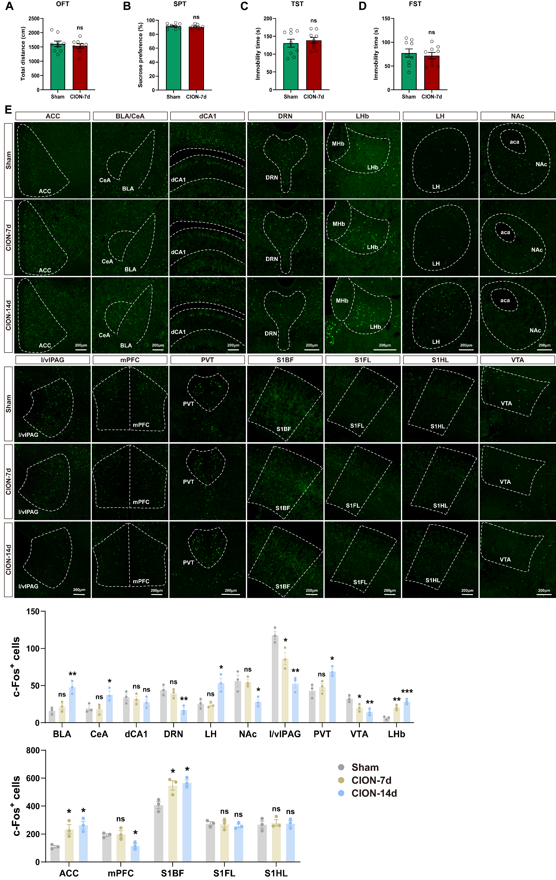
Figure S1. Immunofluorescence of the whole brain in mice at 7 and 14 days after CION surgery. (A) Total distance in the open field test (n = 9 mice/group). (B) Percentage of 1% sucrose solution consumption in the sucrose preference test (n = 9 mice/group). (C) Immobility time in the tail suspension test (n = 9 mice/group). (D) Immobility time in the forced swim test (n = 9 mice/group). (E) c-Fos expression in different brain regions of sham, CION 7‑day, and CION 14‑day mice. Scale bar = 200 μm. Quantification of c-Fos positive neurons in each of the presented brain regions (n = 3 mice/group). Data are presented as mean ± SEM. ns = no significant. *P < 0.05， **P < 0.01， ***P < 0.001. one-way ANOVA with Sidak post hoc test in E. ACC: anterior cingulate cortex; BLA: basolateral amygdala; CeA: central amygdala; dCA1: dorsal CA1; DRN: dorsal raphe nucleus; LHb: lateral habenula; LH: lateral hypothalamus; NAc: nucleus accumbens; l/vlPAG: lateral or ventrolateral periaqueductal gray; mPFC: medial prefrontal cortex; PVT: paraventricular thalamic nucleus; S1BF: primary somatosensory cortex barrel field; S1FL: primary somatosensory cortex, forelimb region; S1HL: primary somatosensory cortex, hindlimb region; VTA: ventral tegmental area.

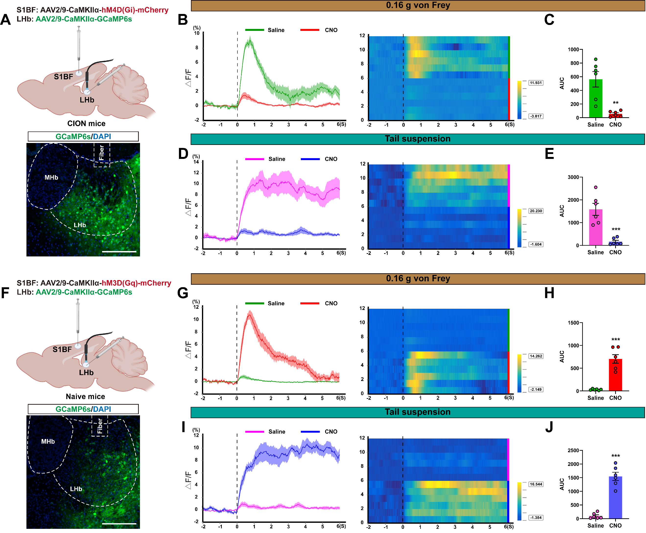
Figure S2. Chemogenetic inhibition of S1BF glutamatergic neurons attenuates the responses of LHb glutamatergic neurons to mechanical and aversive stimuli, whereas their activation enhances these responses. (A) Schematic diagram of virus injection for fiber photometry recording of LHb during chemogenetic inhibition of S1BF glutamatergic neurons (upper). Representative image showing GCaMP6s expression in the LHb (lower). Scale bar = 200 μm. (B, C) The averaged traces, heatmaps (B), and area under the curve (AUC, C) of ΔF/F in 0.16 g von Frey filament stimulation (n = 6 mice/group). (D, E) The averaged traces, heatmaps (D), and area under the curve (AUC, E) of ΔF/F in TST (n = 6 mice/group). (F) Schematic diagram of virus injection for fiber photometry recording of LHb during chemogenetic activation of S1BF glutamatergic neurons (upper). Representative image confirming GCaMP6s expression in the LHb (lower). Scale bar = 200 μm. (G, H) The averaged traces, heatmaps (G), and area under the curve (AUC, H) of ΔF/F in 0.16 g von Frey filament stimulation (n = 6 mice/group). (I, J) The averaged traces, heatmaps (I), and area under the curve (AUC, J) of ΔF/F in TST (n = 6 mice/group). Data are presented as mean ± SEM. **P < 0.01， ***P < 0.001. two-tailed unpaired t-test.

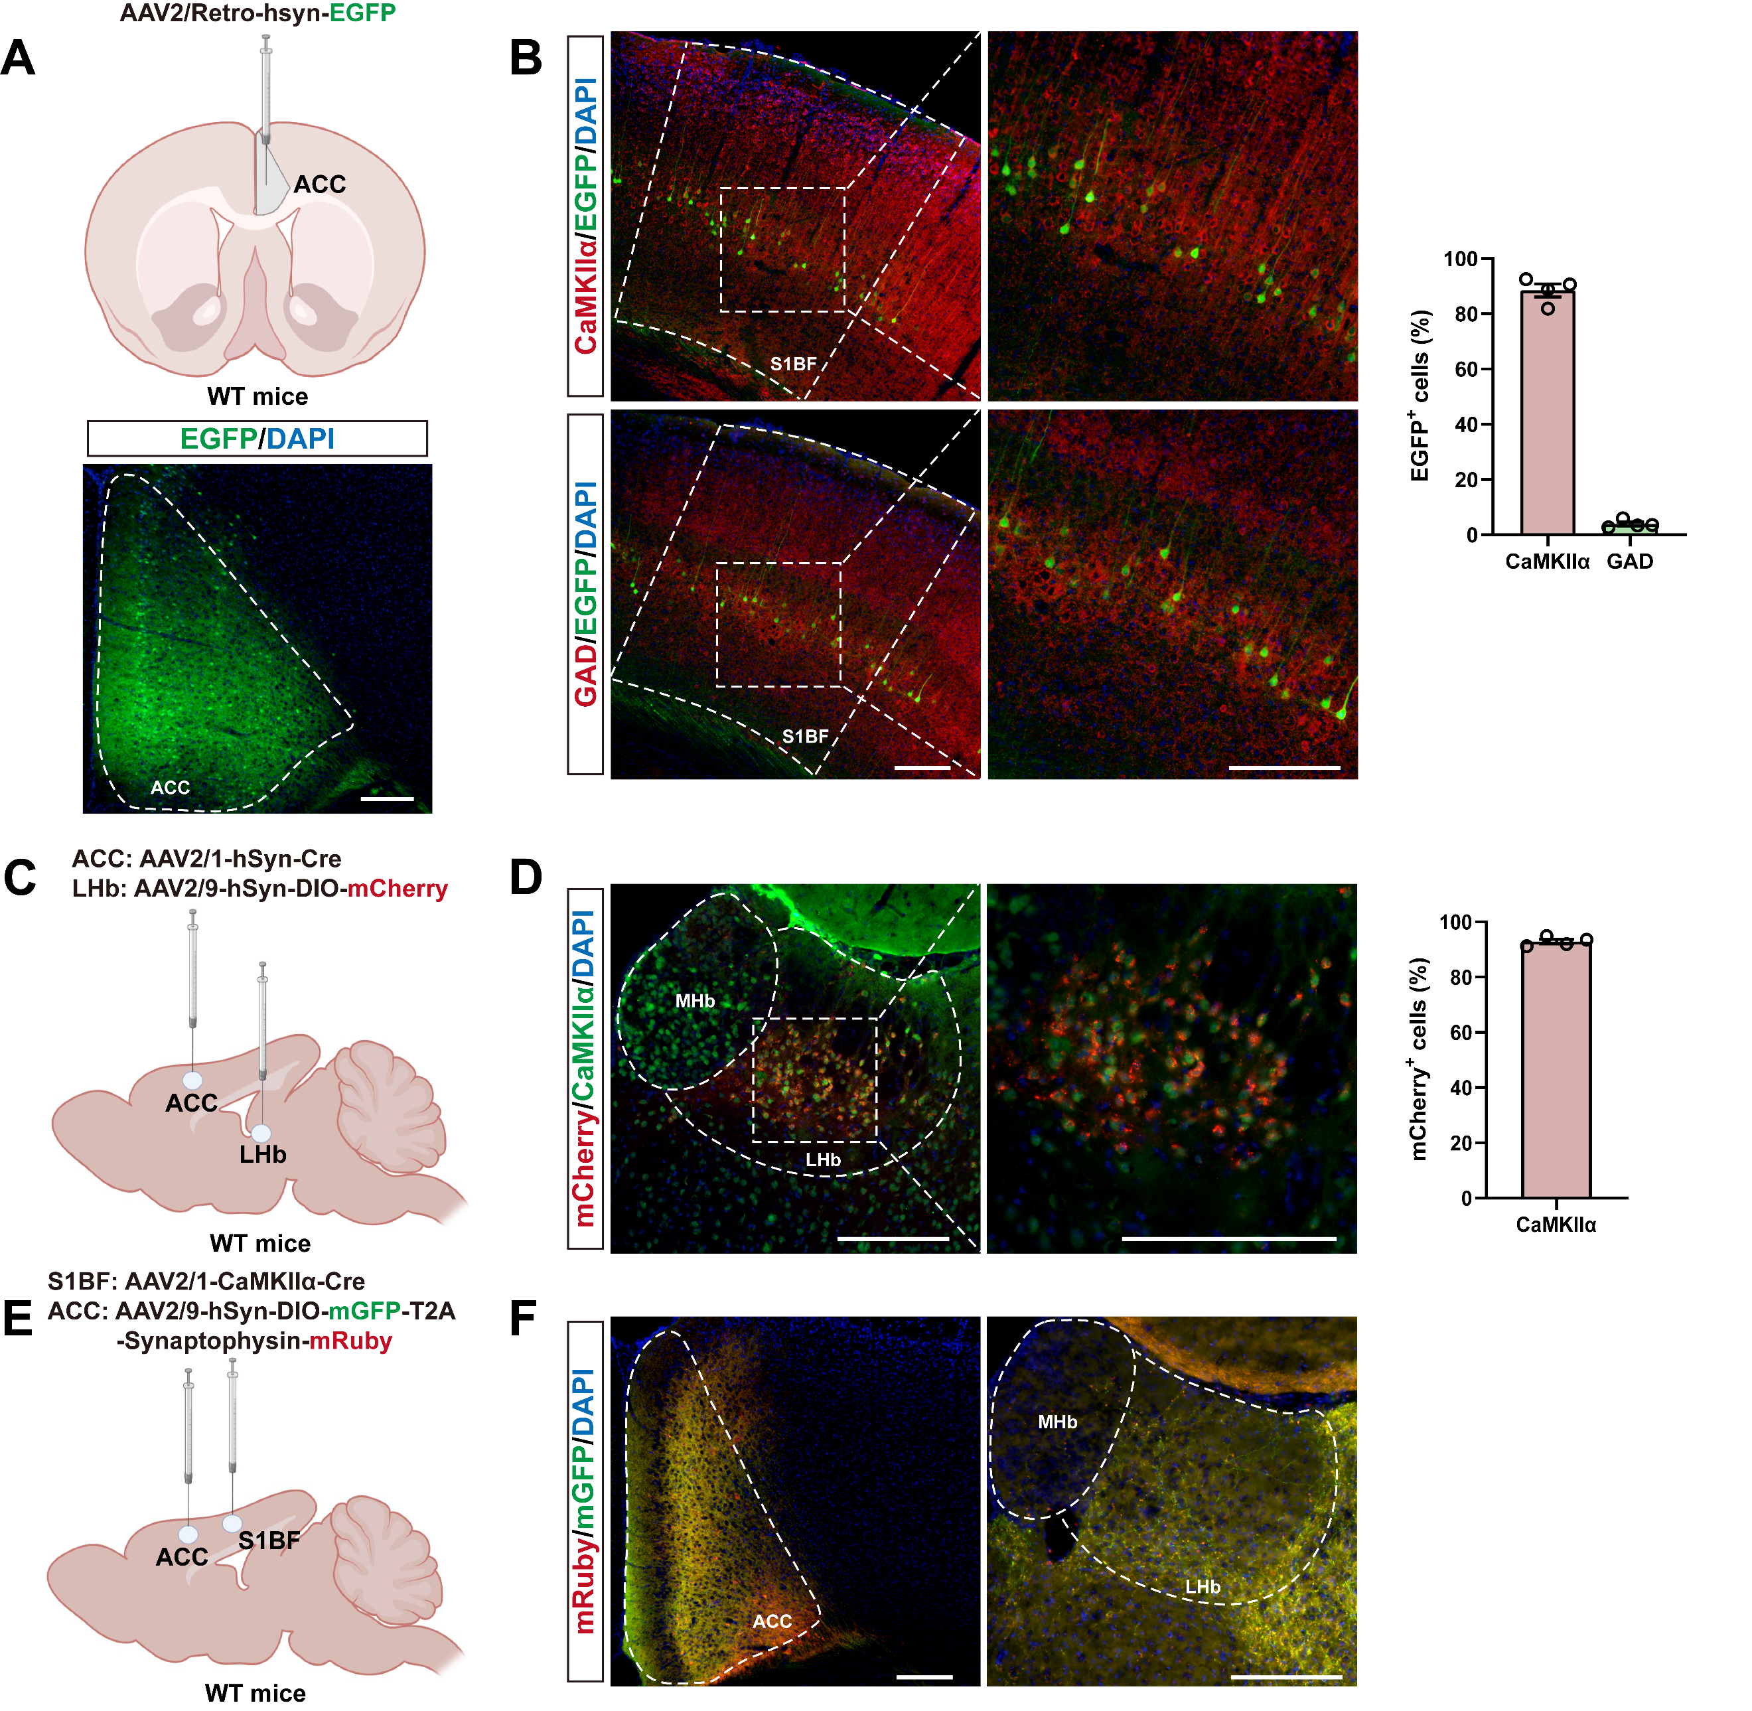
Figure S3. ACC-projecting S1BF neurons and LHb neurons innervated by the ACC are predominantly glutamatergic. (A) Schematic diagram of retrograde tracing virus injection in ACC (upper). Representative image of virus infection in the ACC (lower). Scale bar = 200 μm. (B) Left: representative images of colocalization of EGFP⁺ neurons with CaMKIIα and GAD in the S1BF. Scale bar = 200 μm. Right: quantitative analysis of colocalization (n = 4 mice/group). (C) Schematic diagram of virus injection for tracing LHb neurons innervated by the ACC. (D) Left: representative images of colocalization of mCherry⁺ neurons with CaMKIIα in the LHb. Scale bar = 200 μm. Right: quantitative analysis of colocalization (n = 4 mice/group). (E) Schematic diagram of virus injection in S1BF and ACC. (F) Representative images showing anterogradely mGFP-labeled axons and mRuby-labeled axon terminals in ACC and LHb. Scale bar = 200 μm. Data are presented as mean ± SEM.

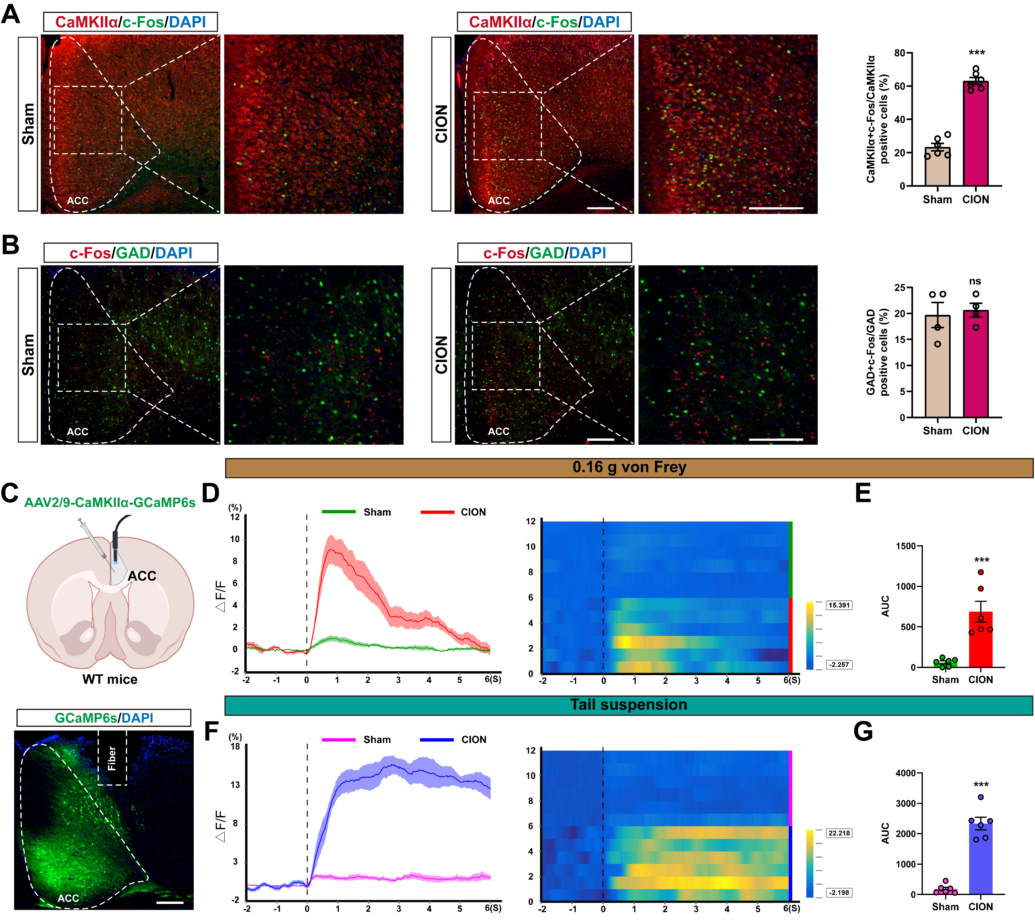
Figure S4. Increased activation of ACC glutamatergic neurons in CION mice. (A) Left: the immunostaining results showing the c-Fos expression and glutamatergic neurons in the ACC of sham and CION groups. Scale bar = 200 μm. Right: quantitative analysis of the colocalization (n = 6 mice/group). (B) Left: the immunostaining results showing the c-Fos expression and GABAergic neurons in the ACC of sham and CION groups. Scale bar = 200 μm. Right: quantitative analysis of the colocalization (n = 4 mice/group). (C) Schematic illustration of ﬁber photometry recording in ACC (upper). Representative image showing GCaMP6s expression in ACC (lower). Scale bar = 200 μm. (D, E) The averaged traces, heatmaps (D), and area under the curve (AUC, E) of ΔF/F in 0.16 g von Frey filament stimulation (n = 6 mice/group). (F, G) The averaged traces, heatmaps (F), and area under the curve (AUC, G) of ΔF/F in TST (n = 6 mice/group). Data are presented as mean ± SEM. ***P < 0.001. ns = no significant. two-tailed unpaired t test.

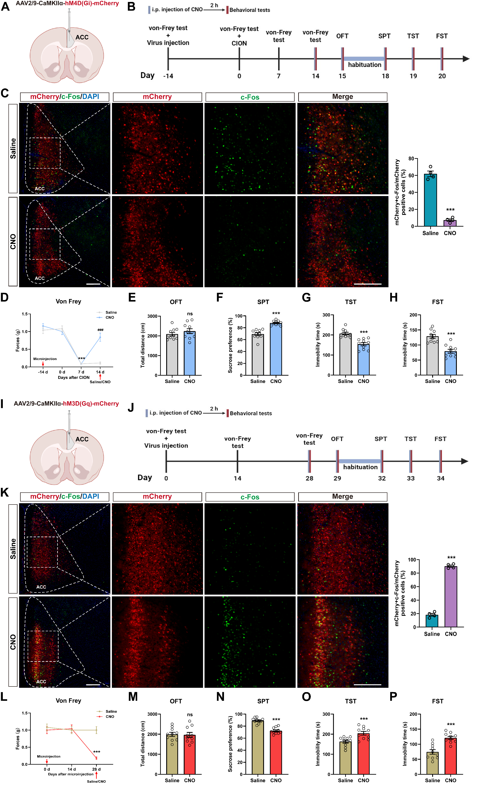
Figure S5. Chemogenetic inhibition of ACC glutamatergic neurons increases mechanical pain threshold and alleviates depressive-like behaviors in CION mice, whereas their activation reduces the threshold and induces depressive-like behaviors in naive mice. (A) Schematic diagram of virus injection in the ACC. (B) Timeline of virus injection and behavioral tests in CION mice. (C) Left: the immunostaining results showing the c-Fos expression and mCherry⁺ neurons in the ACC of saline and CNO groups. Scale bar = 200 μm. Right: quantitative analysis of the colocalization (n = 4 mice/group). (D) Effect of chemogenetic inhibition of ACC glutamatergic neurons on mechanical pain threshold in CION mice (n = 10 mice/group), ***P < 0.001 vs. 0 d, ###P < 0.001 vs. saline. (E-H) Effects of chemogenetic inhibition of ACC glutamatergic neurons on depressive-like behaviors in CION mice: total distance traveled in the open field test (E, n = 10 mice/group), percentage of 1% sucrose solution consumption (F, n = 10 mice/group), immobility time in the tail suspension test (G, n = 10 mice/group), and immobility time in the forced swim test (H, n = 10 mice/group). (I) Schematic diagram of virus injection in the ACC. (J) Timeline of virus injection and behavioral tests in naive mice. (K) Left: the immunostaining results showing the c-Fos expression and mCherry⁺ neurons in the ACC of saline and CNO groups. Scale bar = 200 μm. Right: quantitative analysis of the colocalization (n = 4 mice/group). (L) Effect of chemogenetic activation of ACC glutamatergic neurons on mechanical pain threshold in naive mice (n = 10 mice/group). (M-P) Effects of chemogenetic activation of ACC glutamatergic neurons on depressive-like behaviors in naive mice: total distance traveled in the open field test (M, n = 10 mice/group), percentage of 1% sucrose solution consumption (N, n = 10 mice/group), immobility time in the tail suspension test (O, n = 10 mice/group), and immobility time in the forced swim test (P, n = 10 mice/group). Data are presented as mean ± SEM. ***P < 0.001. ns = no significant. two-way ANOVA with Sidak post hoc test in D, L; two-tailed unpaired t-test in C, E-H, K and M-P.

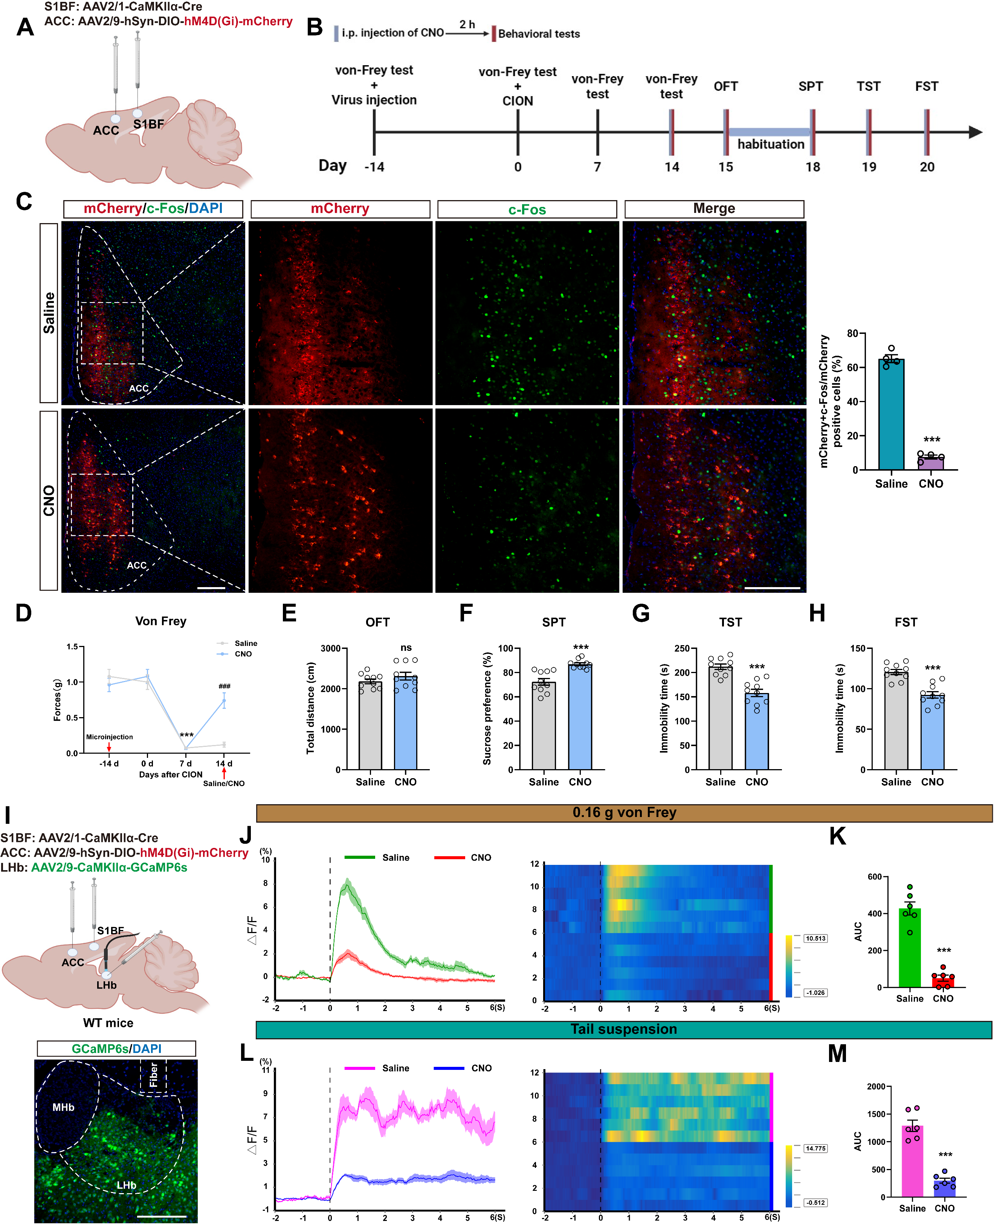
Figure S6. Chemogenetic inhibition of the S1BF-ACC glutamatergic pathway attenuates responses of LHb glutamatergic neurons to painful and aversive stimuli. (A) Schematic diagram of virus injection. (B) Timeline of virus injection and behavioral tests in CION mice. (C) Left: the immunostaining results showing the c-Fos expression and mCherry⁺ neurons in the ACC of saline and CNO groups. Scale bar = 200 μm. Right: quantitative analysis of the colocalization (n = 4 mice/group). (D) Effect of chemogenetic inhibition of the S1BF–ACC excitatory circuit on mechanical pain threshold in CION mice (n = 10 mice/group), ***P < 0.001 vs. 0 d, ###P < 0.001 vs. Saline. (E-H) Effects of chemogenetic inhibition of the S1BF-ACC excitatory circuit on depressive-like behaviors in CION mice: total distance traveled in the open field test (E, n = 10 mice/group), percentage of 1% sucrose solution consumption (F, n = 10 mice/group), immobility time in the tail suspension test (G, n = 10 mice/group), and immobility time in the forced swim test (H, n = 10 mice/group). (I) Schematic illustration of ﬁber photometry recording in LHb (upper). Representative image showing GCaMP6s expression in LHb (lower). Scale bar = 200 μm. (J, K) The averaged traces, heatmaps (J), and area under the curve (AUC, K) of ΔF/F in 0.16 g von Frey filament stimulation (n = 6 mice/group). (L, M) The averaged traces, heatmaps (L), and area under the curve (AUC, M) of ΔF/F in TST (n = 6 mice/group). Data are presented as mean ± SEM. ***P < 0.001. ns = no significant. two-way ANOVA with Sidak post hoc test in D; two-tailed unpaired t test in C, E-H, K and M.

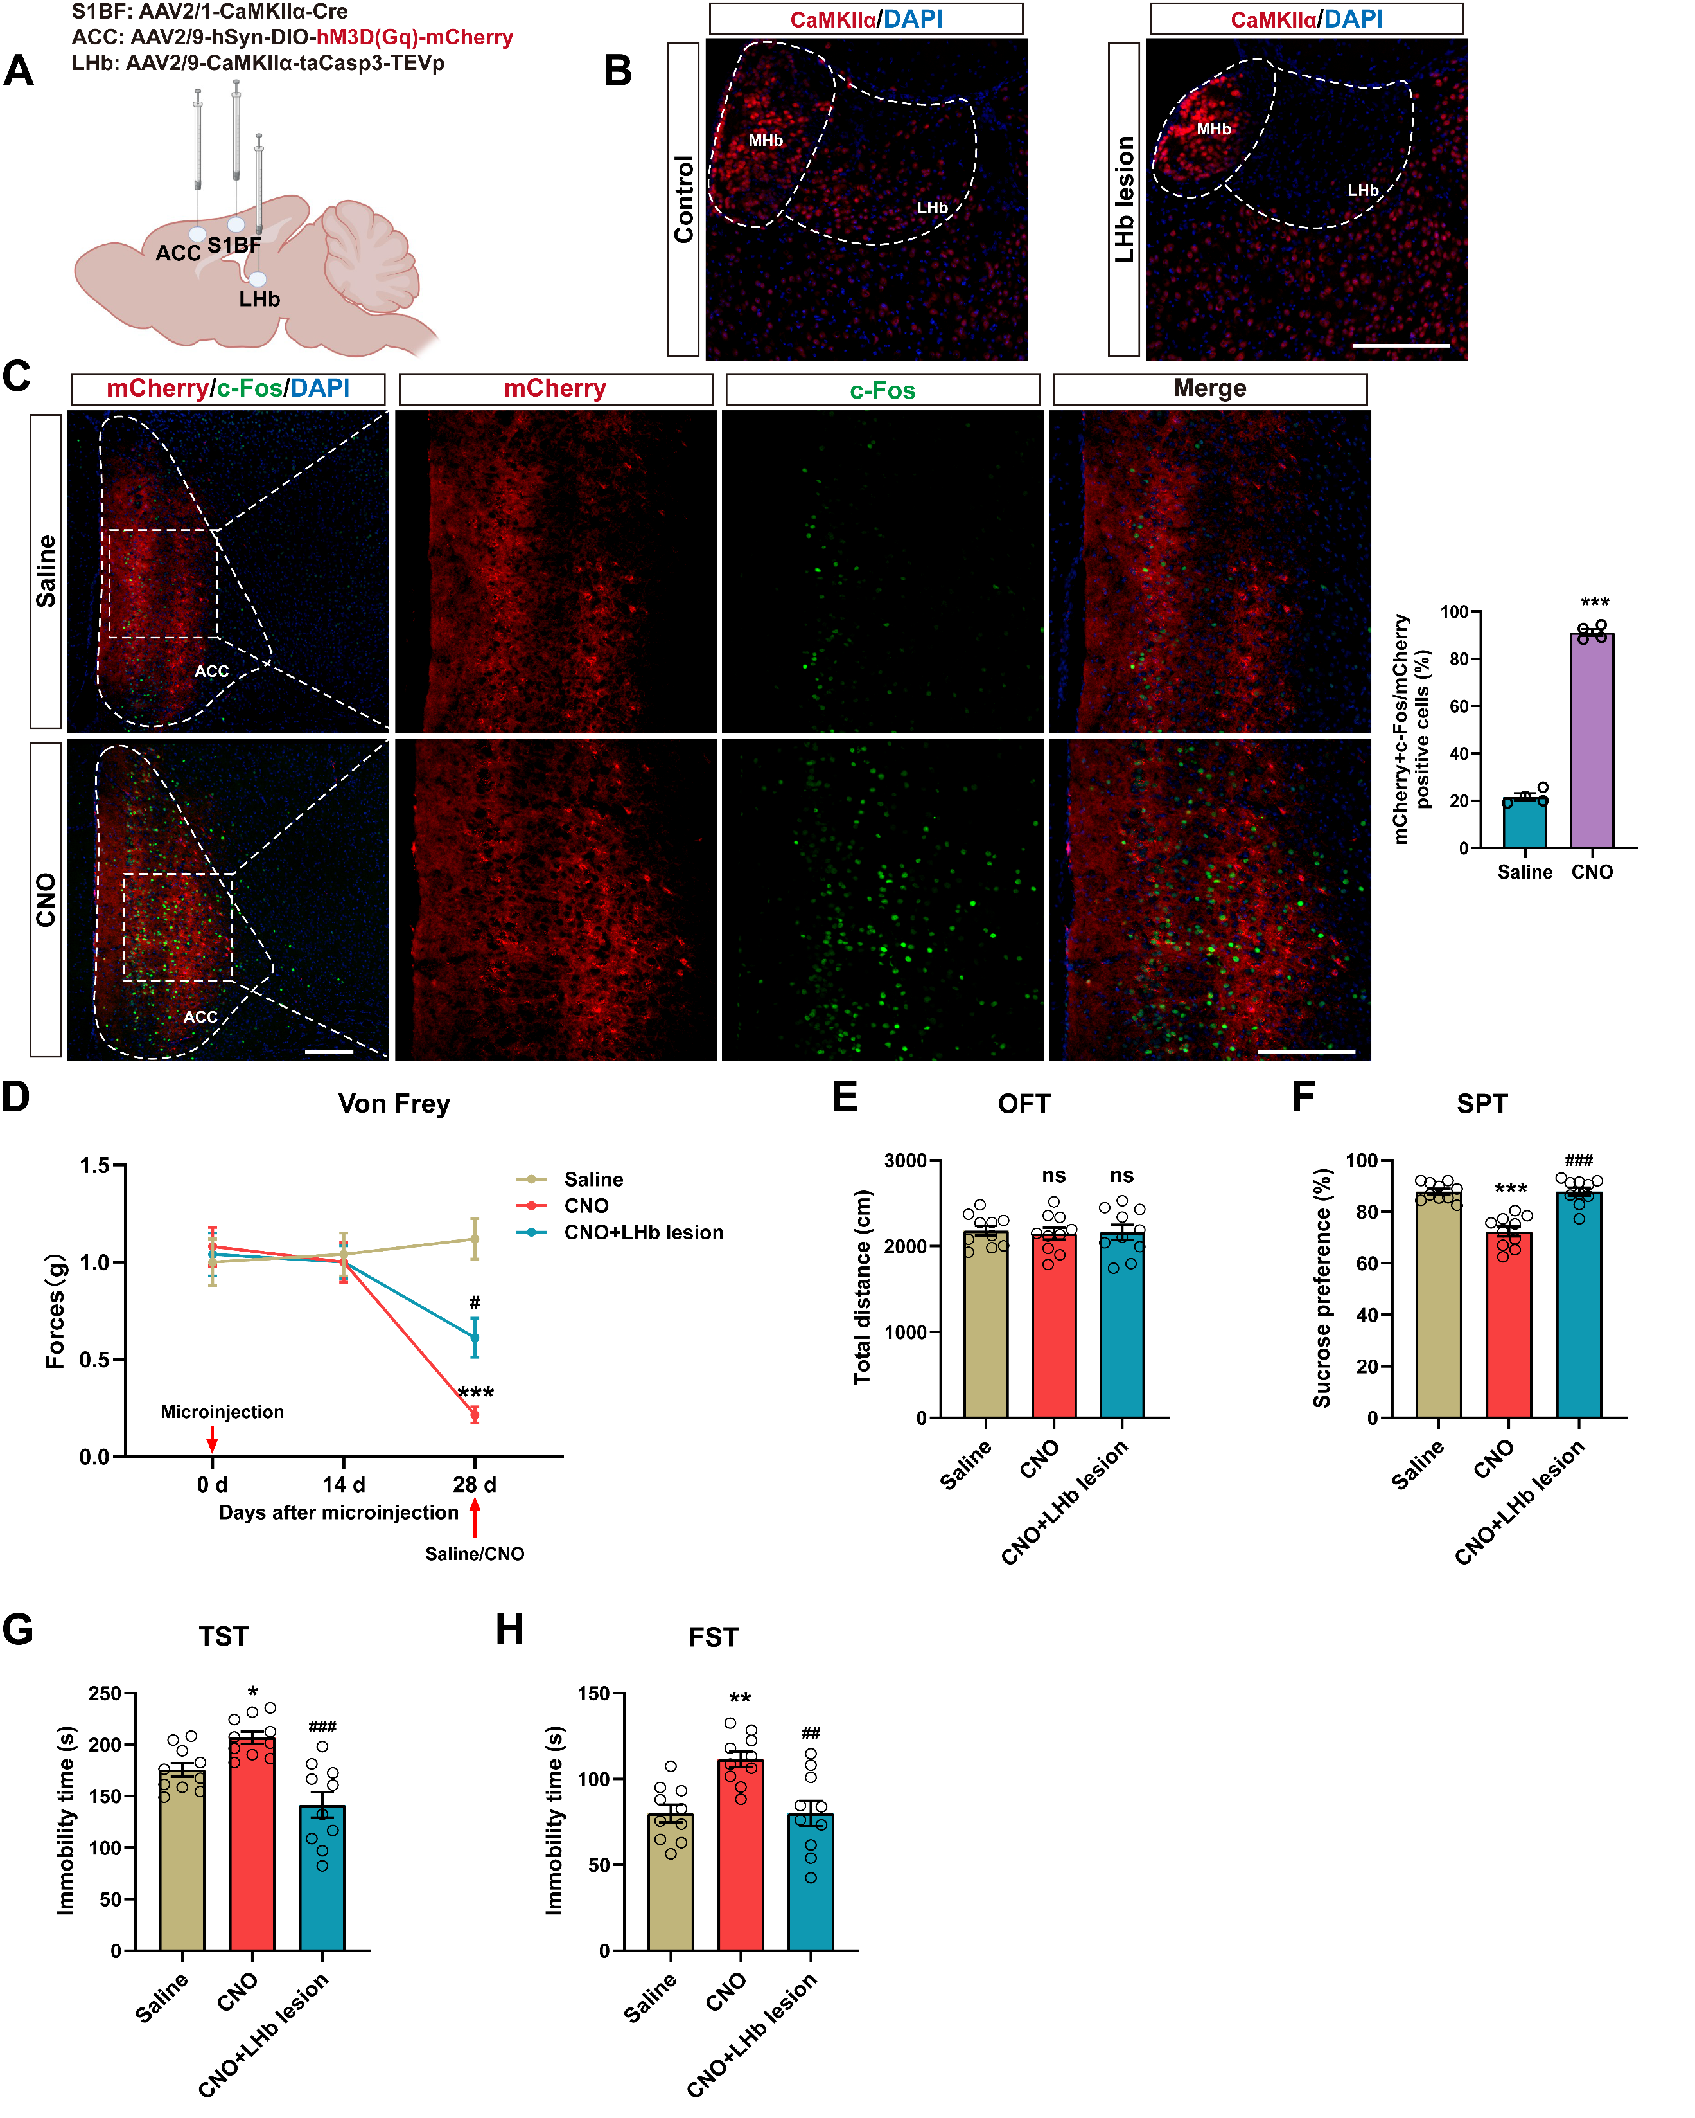
Figure S7. LHb lesions reverse hyperalgesia and depressive-like behaviors induced by chemogenetic activation of the S1BF-ACC glutamatergic pathway. (A) Schematic diagram of virus injection. (B) Representative image of LHb lesions. (C) Left: the immunostaining results showing the c-Fos expression and mCherry⁺ neurons in the ACC of saline and CNO groups. Scale bar = 200 μm. Right: quantitative analysis of the colocalization (n = 4 mice/group). (D) Effect of chemogenetic activation of the S1BF-ACC excitatory circuit and LHb lesions on mechanical pain threshold in naive mice (n = 10 mice/group), ***P < 0.001 vs. Saline; #P < 0.05 vs. CNO. (E-H) Effects of chemogenetic activation of the S1BF-ACC excitatory circuit and LHb lesions on depressive-like behaviors in naive mice: total distance traveled in the open field test (E, n = 10 mice/group), percentage of 1% sucrose solution consumption (F, n = 10 mice/group), immobility time in the tail suspension test (G, n = 10 mice/group), and immobility time in the forced swim test (H, n = 10 mice/group). Data are presented as mean ± SEM. *P < 0.05, **P < 0.01, ***P < 0.001, ##P < 0.01, ###P < 0.001. ns = no significant. two-tailed unpaired t test in C; two-way ANOVA with Sidak post hoc test in D; one-way ANOVA with Sidak post hoc test in E-H.

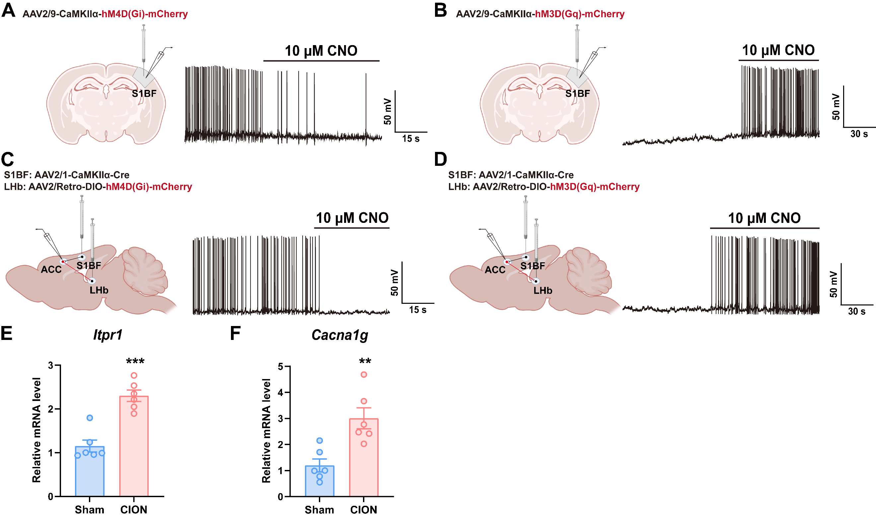
Figure S8. Functional validation of chemogenetic viruses. (A) Representative traces showing the effects of bath CNO on mCherry⁺ neurons firing in the S1BF slices from mice injected with AAV2/9-CaMKIIa-hM4D(Gi)-mCherry. (B) Representative traces showing the effects of bath CNO on mCherry⁺ neurons firing in the S1BF slices from mice injected with AAV2/9-CaMKIIa-hM3D(Gq)-mCherry. (C) Representative traces showing the effects of hM4Di on mCherry⁺ neurons firing in ACC slices. (D) Representative traces showing the effects of hM3Dq on mCherry⁺ neurons firing in ACC slices. (E) qPCR analysis of Itpr1 mRNA levels in the LHb (n=6 mice/group). (F) qPCR analysis of Cacna1g mRNA levels in the LHb (n=6 mice/group). **P < 0.01, ***P < 0.001. two-tailed unpaired t test in E and F.

Virus information:
rAAV2/9-CaMKIIa-hM3D(Gq)-mCherry-WPREs, PT-0049, 5.04E+l2 vg/ml;
rAAV2/9-CaMKIIa-hM4D(Gi)-mCherry-WPREs, PT-0050, 5.04E+l2 vg/ml;
rAAV2/Retro-hSyn-CRE-WPRE-hGH, PT-0136, 5.25E+l2 vg/ml;
rAAV2/1-hSyn-CRE-WPRE-hGH, PT-0136, 1.00E+l3 vg/ml;
rAAV2/1-CaMKIIa-CRE-WPRE-hGH, PT-0220, 1.00E+l3 vg/ml;
rAAV2/9-EF1α-DIO-hM3D(Gq)-mCherry-WPREs, PT-0042, 5.04E+l2 vg/ml;
rAAV2/9-EF1α-DIO-hM4D(Gi)-mCherry-WPREs, PT-0043, 5.76E+l2 vg/ml;
rAAV2/Retro-hSyn-EGFP-WPRE-hGH, PT-1990, 5.51E+l2 vg/ml;
rAAV2/Retro-EF1α-DIO-hM3D(Gq)-mCherry-WPREs, PT-0042, 5.04E+l2 vg/ml;
rAAV2/Retro-EF1α-DIO-hM4D(Gi)-mCherry-WPREs, PT-0043, 5.76E+l2 vg/ml;
rAAV2/9-CaMKIIa-GCaMP6S-WPRE-hGH, PT-0110, 5.25E+l2 vg/ml;
rAAV2/9-EF1α-DIO-GCaMP6S-WPRE-hGH, PT-0071, 5.05E+l2 vg/ml;
rAAV2/9-CaMKIIa-taCasp3-T2A-TEVp-WPRE-hGH, PT-1571, 5.85E+l2 vg/ml;
rAAV2/9-hSyn-DIO-mGFP-T2A-Synaptophysin-mRuby-WPRE-hGH, PT-1244, 5.79E+l2 vg/ml;

