Supplementary Table S1 Brain regions showing significant SDI differences between the migraine and HC groups in the MD- and FN-weighted sensitivity analyses
Weighting | Atlas ID | Brain region | Adjusted difference,  Migraine - HC (95% CI) | F(1, 104) | Partial η2 | p | FDR q
MD | BNA_007 | SFG_L_7_4 | -0.269 (-0.365, -0.172) | 30.40 | 0.226 | <0.001 | <0.001
MD | BNA_094 | ITG_R_7_3 | 0.168 (0.090, 0.246) | 18.27 | 0.149 | <0.001 | 0.005
MD | BNA_009 | SFG_L_7_5 | -0.180 (-0.277, -0.083) | 13.62 | 0.116 | <0.001 | 0.029
FN | BNA_007 | SFG_L_7_4 | -0.380 (-0.484, -0.275) | 51.44 | 0.331 | <0.001 | <0.001
FN | BNA_094 | ITG_R_7_3 | 0.227 (0.136, 0.319) | 24.21 | 0.189 | <0.001 | <0.001
FN | BNA_207 | LOcC_L_2_1 | 0.139 (0.072, 0.206) | 17.01 | 0.141 | <0.001 | 0.006
Note: ANCOVA was adjusted for age and sex. Adjusted differences are expressed as Migraine - HC; positive and negative values indicate higher and lower SDI in the migraine group, respectively. Benjamini-Hochberg FDR correction was performed separately for each weighting across 246 regions. Only FDR-significant regions are shown. All analyses included the same 108 participants (36 HC, 41 EM, and 31 CM). CI, confidence interval; CM, chronic migraine; EM, episodic migraine; FDR, false discovery rate; FN, fiber number; HC, healthy controls; ITG, inferior temporal gyrus; LOcC, lateral occipital cortex; MD, mean diffusivity; SDI, structural decoupling index; SFG, superior frontal gyrus; L, left; R, right.

Supplementary Table S2 Brain regions showing significant overall and pairwise SDI differences among the HC, EM, and CM groups in the MD- and FN-weighted sensitivity analyses
Weighting | Atlas ID | Brain region | Overall F(2, 103) | Partial η2 | Overall p | Overall FDR q | Significant pairwise  comparison(s) | Adjusted difference  (95% CI) | Pairwise p | Pairwise FDR q
MD | BNA_007 | SFG_L_7_4 | 23.90 | 0.317 | <0.001 | <0.001 | EM - HC | -0.190 (-0.291, -0.089) | <0.001 | 0.036
MD |  |  |  |  |  |  | CM - HC | -0.389 (-0.501, -0.277) | <0.001 | <0.001
MD |  |  |  |  |  |  | CM - EM | -0.199 (-0.306, -0.092) | <0.001 | 0.043
MD | BNA_207 | LOcC_L_2_1 | 10.33 | 0.167 | <0.001 | 0.010 | CM - EM | -0.217 (-0.314, -0.121) | <0.001 | 0.005
MD | BNA_094 | ITG_R_7_3 | 9.51 | 0.156 | <0.001 | 0.013 | EM - HC | 0.184 (0.098, 0.270) | <0.001 | 0.012
MD | BNA_009 | SFG_L_7_5 | 7.89 | 0.133 | <0.001 | 0.040 | CM - HC | -0.229 (-0.346, -0.111) | <0.001 | 0.025
FN | BNA_007 | SFG_L_7_4 | 43.50 | 0.458 | <0.001 | <0.001 | EM - HC | -0.271 (-0.375, -0.166) | <0.001 | <0.001
FN |  |  |  |  |  |  | CM - HC | -0.545 (-0.662, -0.429) | <0.001 | <0.001
FN |  |  |  |  |  |  | CM - EM | -0.275 (-0.385, -0.164) | <0.001 | <0.001
FN | BNA_207 | LOcC_L_2_1 | 22.81 | 0.307 | <0.001 | <0.001 | EM - HC | 0.209 (0.143, 0.276) | <0.001 | <0.001
FN |  |  |  |  |  |  | CM - EM | -0.177 (-0.248, -0.106) | <0.001 | <0.001
FN | BNA_094 | ITG_R_7_3 | 13.81 | 0.211 | <0.001 | <0.001 | EM - HC | 0.264 (0.164, 0.364) | <0.001 | <0.001
Note: ANCOVA was adjusted for age and sex. Adjusted pairwise differences were calculated as the first-listed group minus the second-listed group. Benjamini-Hochberg FDR correction was performed separately for each weighting across 246 regions for the overall tests and separately for each pairwise contrast. Only FDR-significant overall results and FDR-significant pairwise comparisons are shown. All analyses included the same 108 participants (36 HC, 41 EM, and 31 CM). ANCOVA, analysis of covariance; CI, confidence interval; CM, chronic migraine; EM, episodic migraine; FDR, false discovery rate; FN, fiber number; HC, healthy controls; ITG, inferior temporal gyrus; LOcC, lateral occipital cortex; MD, mean diffusivity; SDI, structural decoupling index; SFG, superior frontal gyrus; L, left; R, right.
Supplementary Table S3 Stability of ROI selection in the fully nested RD-SDI classification analysis
Comparison | Atlas ID | Brain region | Selection count | Selection frequency (%) | Mean rank
CM vs EM | BNA_207 | LOcC_L_2_1 | 150/150 | 100.0 | 1.21
 | BNA_007 | SFG_L_7_4 | 103/150 | 68.7 | 2.15
 | BNA_064 | PrG_R_6_6 | 53/150 | 35.3 | 8.12
 | BNA_097 | ITG_L_7_5 | 51/150 | 34.0 | 8.50
 | BNA_213 | Amyg_L_2_2 | 33/150 | 22.0 | 10.55
 | BNA_043 | OrG_L_6_2 | 26/150 | 17.3 | 13.39
 | BNA_179 | CG_L_7_3 | 26/150 | 17.3 | 13.53
 | BNA_028 | MFG_R_7_7 | 20/150 | 13.3 | 27.68
 | BNA_085 | MTG_L_4_3 | 19/150 | 12.7 | 17.85
 | BNA_147 | PCun_L_4_1 | 16/150 | 10.7 | 17.76
CM vs HC | BNA_007 | SFG_L_7_4 | 150/150 | 100.0 | 1.00
 | BNA_009 | SFG_L_7_5 | 6/150 | 4.0 | 2.67
 | BNA_173 | INS_L_6_6 | 5/150 | 3.3 | 9.57
 | BNA_094 | ITG_R_7_3 | 3/150 | 2.0 | 11.92
 | BNA_103 | FuG_L_3_1 | 2/150 | 1.3 | 24.95
 | BNA_059 | PrG_L_6_4 | 1/150 | 0.7 | 14.58
 | BNA_090 | ITG_R_7_1 | 1/150 | 0.7 | 16.96
 | BNA_001 | SFG_L_7_1 | 1/150 | 0.7 | 20.22
 | BNA_055 | PrG_L_6_2 | 1/150 | 0.7 | 75.93
EM vs HC | BNA_094 | ITG_R_7_3 | 146/150 | 97.3 | 1.65
 | BNA_007 | SFG_L_7_4 | 123/150 | 82.0 | 3.41
 | BNA_001 | SFG_L_7_1 | 93/150 | 62.0 | 6.71
 | BNA_115 | PhG_L_6_4 | 67/150 | 44.7 | 9.99
 | BNA_165 | INS_L_6_2 | 61/150 | 40.7 | 11.45
 | BNA_203 | LOcC_L_4_3 | 54/150 | 36.0 | 12.87
 | BNA_169 | INS_L_6_4 | 42/150 | 28.0 | 16.97
 | BNA_009 | SFG_L_7_5 | 38/150 | 25.3 | 17.08
 | BNA_021 | MFG_L_7_4 | 37/150 | 24.7 | 17.45
 | BNA_173 | INS_L_6_6 | 33/150 | 22.0 | 18.79
Note: ROI selection frequency was calculated as the number of outer training sets in which a region was selected divided by the total number of outer models (150 = 30 repetitions x 5 outer folds). Within each outer training set, ROIs were ranked according to the group effect after adjustment for age and sex; the number of retained ROIs (K = 1, 3, 5, or 10) and the SVM cost parameter were optimized within the inner cross-validation loop. Up to the 10 ROIs with the highest non-zero selection frequencies are shown for each comparison. Mean rank was calculated across all outer training sets, with a lower value indicating a higher average ranking. CM, chronic migraine; EM, episodic migraine; HC, healthy control; RD, radial diffusivity; ROI, region of interest; SDI, structural decoupling index; SVM, support vector machine.

Supplementary Table S4 Spatial-null significance of PLS components relating regional gene expression to the migraine-HC RD-SDI difference map
PLS component | Variance explained (%) | BrainSMASH spatial P | FDR q
PLS1 | 8.76 | 0.725 | 0.725
PLS2 | 6.90 | 0.569 | 0.725
PLS3 | 9.45 | 0.663 | 0.725
PLS4 | 9.54 | 0.335 | 0.725
PLS5 | 9.80 | 0.459 | 0.725
PLS6 | 9.16 | 0.161 | 0.628
PLS7 | 10.23 | 0.026 | 0.256
PLS8 | 4.40 | 0.661 | 0.725
PLS9 | 6.40 | 0.188 | 0.628
PLS10 | 4.53 | 0.599 | 0.725
Note: Values represent the percentage of variance explained in the unthresholded migraine-minus-HC RD-SDI t-map. Spatial P values were estimated using 5,000 BrainSMASH variogram-matched surrogate maps generated from Euclidean distances between the MNI-space centroids of 238 retained Brainnetome regions, while the regional gene-expression matrix containing 15,633 genes was held fixed. Benjamini-Hochberg FDR correction was applied across the 10 PLS components. Although PLS7 had a nominal spatial P value of 0.026, it did not survive FDR correction and was not interpreted. FDR, false discovery rate; HC, healthy control; MNI, Montreal Neurological Institute; PLS, partial least squares; RD, radial diffusivity; SDI, structural decoupling index.

Supplementary Figure S1 Quality control and significance testing for the BrainSMASH spatial-null model
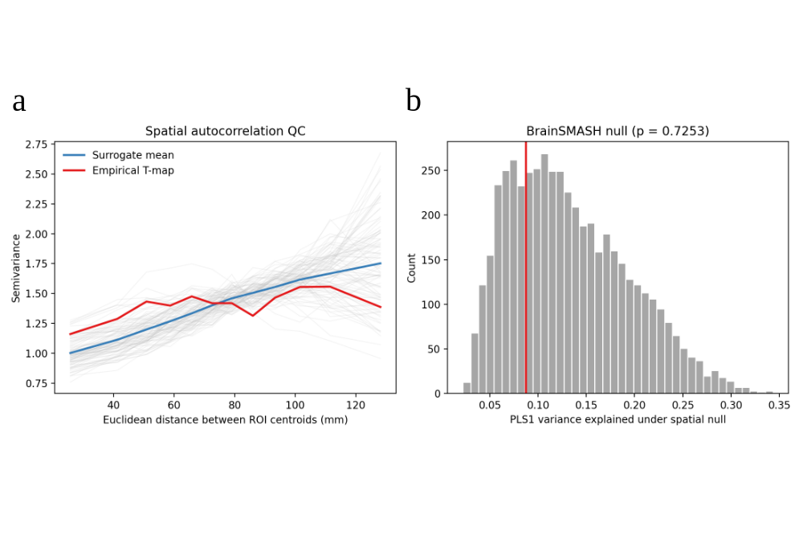
Note: (a) Empirical semivariogram of the migraine-minus-HC RD-SDI t-map compared with semivariograms derived from spatially autocorrelation-preserving BrainSMASH surrogate maps. (b) Null distribution of the variance explained by PLS1 across 5,000 BrainSMASH surrogate maps. The red vertical line indicates the empirical PLS1 variance explained (8.76%), which was not significant relative to the spatial-null distribution (P spatial= 0.725).

