Baseline source-space EEG features associated with short-term frequency increase in migraine without aura: a China Migraine Registry (CHIME) study
Additional file 1: Supplementary figures and tables
Kang Jin^{1,2}†, Siyuan Xie¹†, Longteng Ma¹, Yunyun Huo¹, Miaomiao Hu¹, Xiaoyan Zhang¹, Suyuan Tai¹, Jiayin Lin¹, Xiaoxue Meng¹, Ye Ran¹*, Dajun Xing³*, Zhao Dong¹*
Supplementary Fig. S1. EEG acquisition and preprocessing workflow.
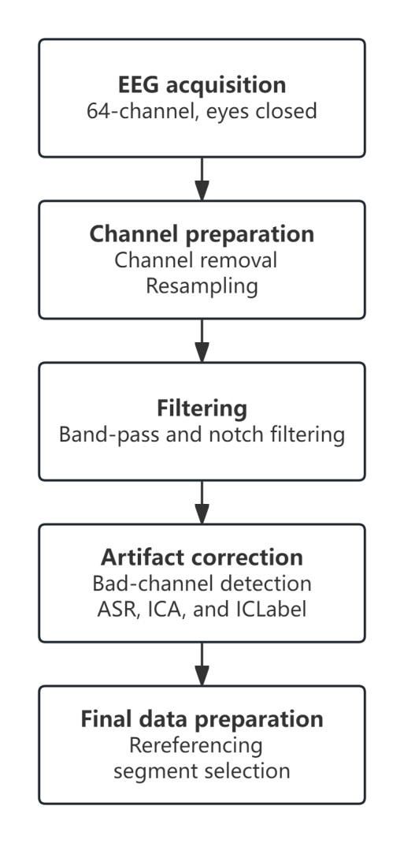
Eyes-closed resting-state EEG was acquired using a 64-channel system. After removal of non-EEG channels and resampling, the data underwent band-pass and notch filtering, bad-channel detection, artifact subspace reconstruction, independent component analysis, and ICLabel-based component classification. The data were subsequently rereferenced, and a clean continuous segment was selected for further analysis. ASR, artifact subspace reconstruction; EEG, electroencephalography; ICA, independent component analysis; ICLabel, an automated classifier for independent components.

Supplementary Fig. S2. Unparameterized source-space power spectra in HCs and patients with MO who had 0–3 MMDs at baseline.
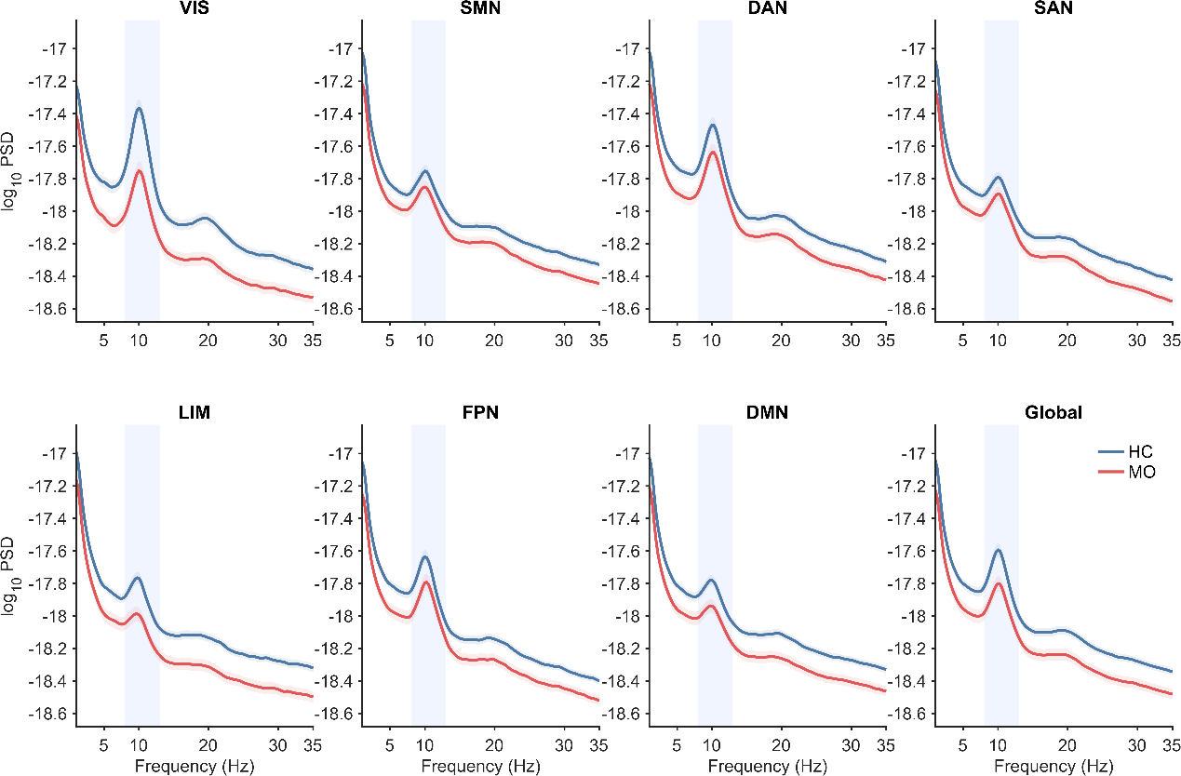
Group mean log10-transformed power spectral density curves are shown across seven functional networks and at the global level. Solid lines represent group means, shaded envelopes represent standard errors of the mean, and light blue vertical bands indicate the alpha-frequency range (8–13 Hz). The spectra contain both periodic and aperiodic components. The groups comprised 94 HCs and 126 patients with MO.
DAN, dorsal attention network; DMN, default mode network; FPN, frontoparietal control network; HC, healthy control; LIM, limbic network; MO, migraine without aura; PSD, power spectral density; SAN, salience/ventral attention network; SMN, somatomotor network; VIS, visual network.
Supplementary Fig. S3. SHAP interpretation of the combined model in the validation cohort.
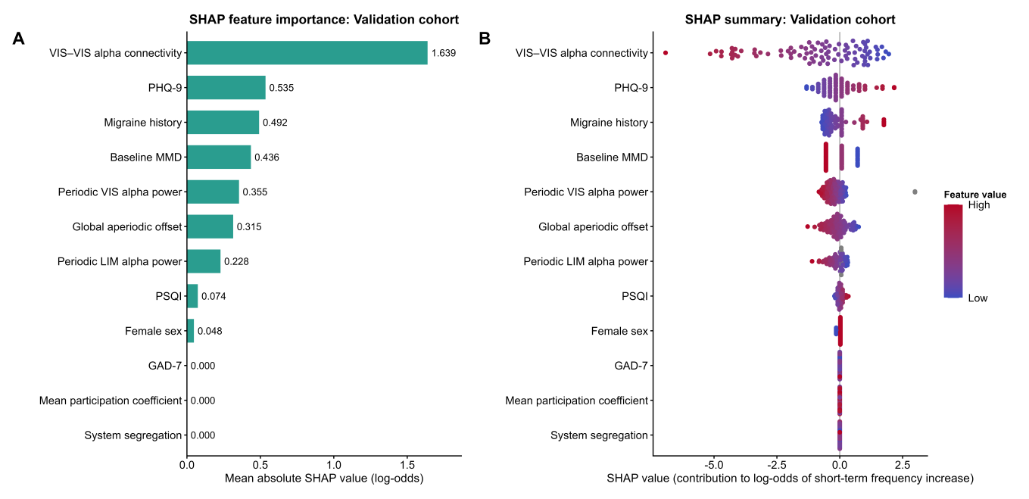
(A) Mean absolute SHAP values showing overall feature importance. (B) SHAP summary plot showing the direction and magnitude of each feature’s contribution to the predicted log-odds of short-term frequency increase. Positive SHAP values indicate a higher predicted probability, whereas negative values indicate a lower predicted probability. Colors represent feature values from low (blue) to high (red), and gray points indicate missing feature values. SHAP values were calculated using the development cohort as the background reference distribution. The validation cohort included 90 participants. In the plotted feature labels, migraine history denotes migraine disease duration.
SHAP, Shapley additive explanations.

Supplementary Fig. S4. Discrimination and calibration of the simplified clinical–EEG model for predicting short-term frequency increase.
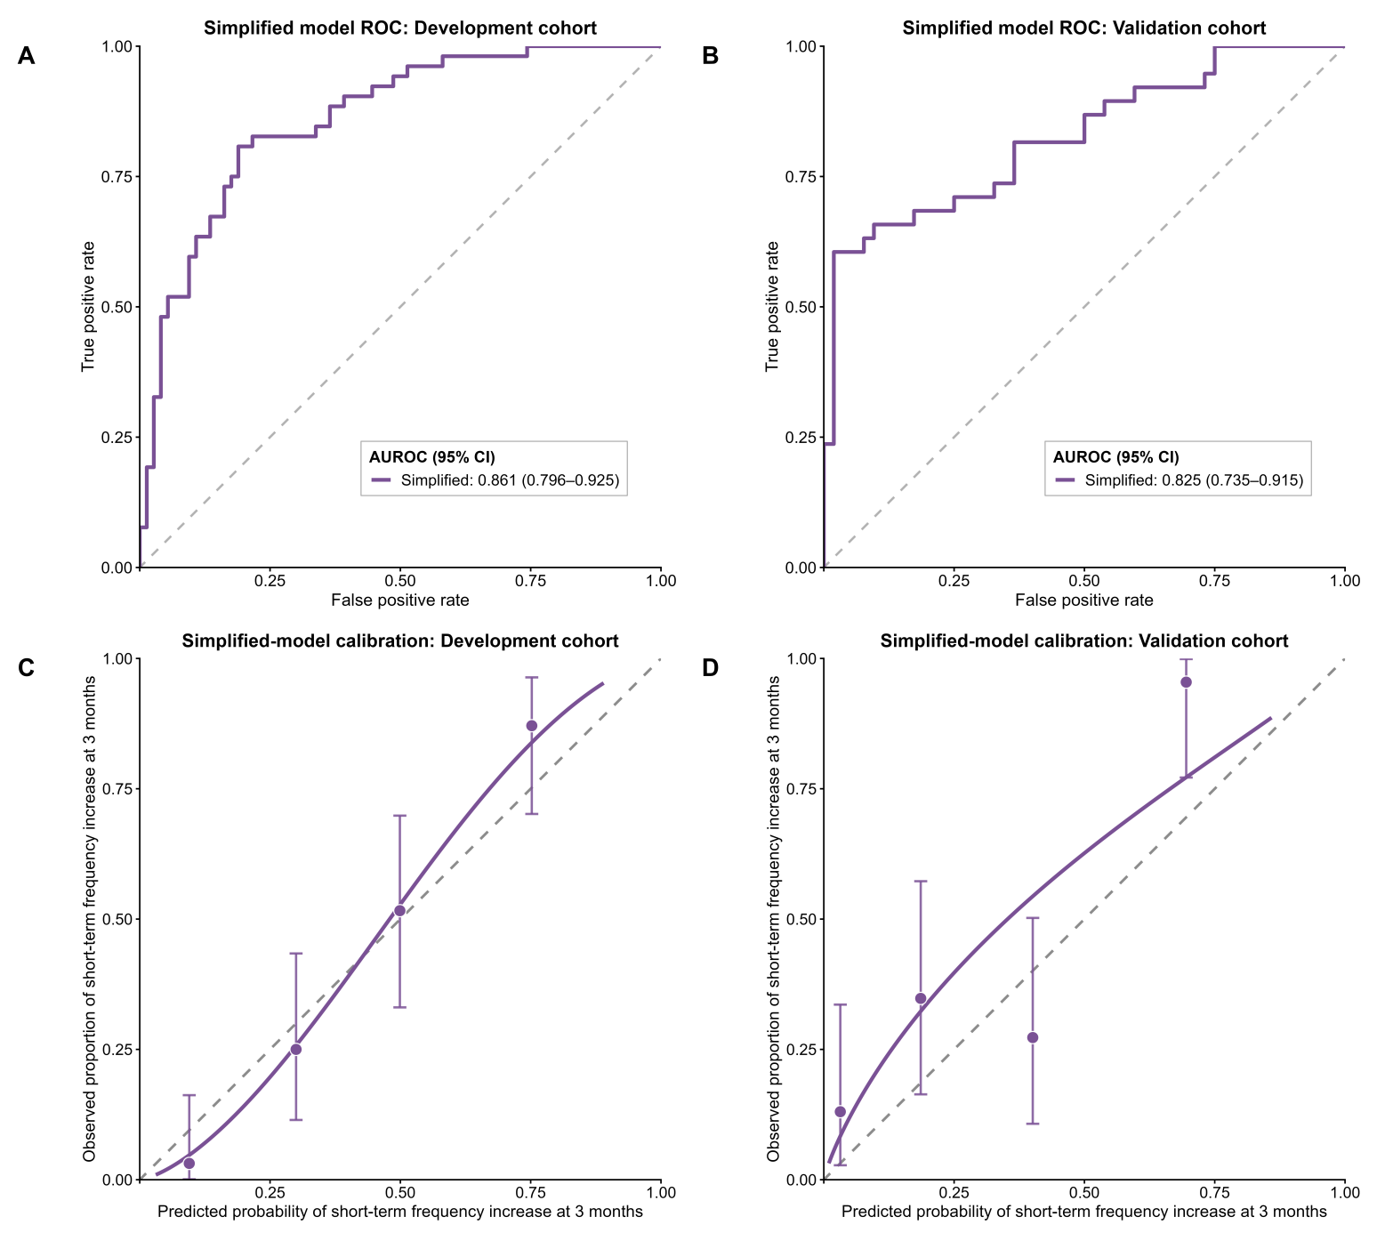
The simplified elastic-net logistic regression model included six clinical predictors—baseline monthly migraine days (MMDs), migraine disease duration, sex, Patient Health Questionnaire-9 (PHQ-9), Generalized Anxiety Disorder-7 (GAD-7), and Pittsburgh Sleep Quality Index (PSQI)—together with within-visual-network (VIS) alpha-band functional connectivity. (A, B) Receiver operating characteristic curves in the development cohort (n = 126) and temporal validation cohort (n = 90), respectively. Development-cohort performance was estimated from repeat-averaged out-of-fold predictions, whereas validation-cohort performance was evaluated using the locked model without refitting or recalibration. The area under the receiver operating characteristic curve (AUROC) was 0.861 (95% confidence interval [CI], 0.796–0.925) in the development cohort and 0.825 (95% CI, 0.735–0.915) in the validation cohort. The dashed diagonal line indicates chance-level discrimination. (C, D) Calibration plots in the development and validation cohorts, respectively. Points represent observed outcome proportions within four approximately equal-sized groups of predicted probability and are plotted against the corresponding mean predicted probabilities. Vertical error bars indicate exact 95% binomial CIs. The solid purple line represents the logistic calibration curve, and the dashed diagonal line indicates ideal calibration.

Supplementary Fig. S5. Candidate baseline EEG features associated with short-term frequency increase in the development cohort: sensitivity analysis.
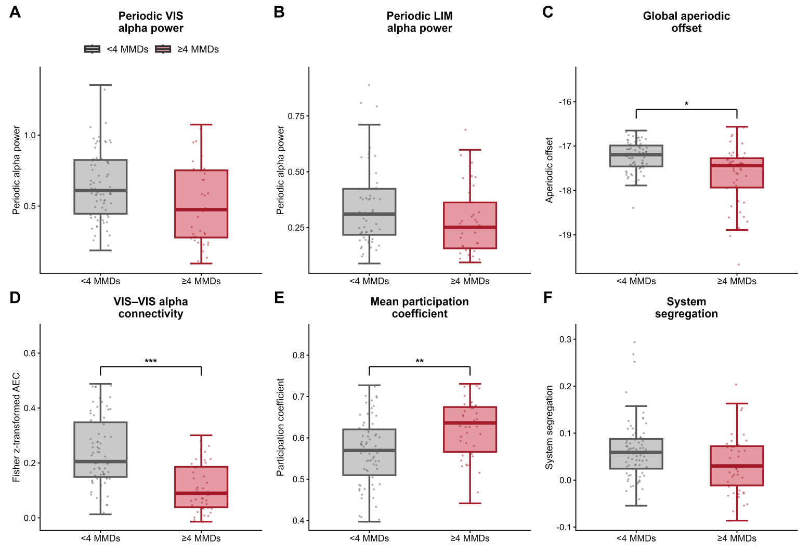
In the development cohort (n = 120), after excluding 6 boundary cases (10 across both cohorts) whose MMDs increased from 3 at baseline to 4 during the third month, six candidate baseline EEG features were compared between the ≥4-MMD and <4-MMD groups using the same adjusted models as in the primary analysis. (A) Periodic alpha power in the VIS (<4 MMDs, n = 74; ≥4 MMDs, n = 40). (B) Periodic alpha power in the LIM (<4 MMDs, n = 63; ≥4 MMDs, n = 35). Periodic alpha power represents fitted peak height above the aperiodic component in log10 power units; smaller sample sizes reflect unavailable fitted alpha peaks. (C–F) Global aperiodic offset (the intercept in log10 power space), within-VIS alpha-band connectivity, mean participation coefficient, and system segregation, respectively (for each panel: <4 MMDs, n = 74; ≥4 MMDs, n = 46). Asterisks indicate FDR-corrected significance: *q < 0.05, **q < 0.01, ***q < 0.001.

Supplementary Fig. S6. Discrimination and calibration of the clinical, EEG, and combined models in the sensitivity analysis.
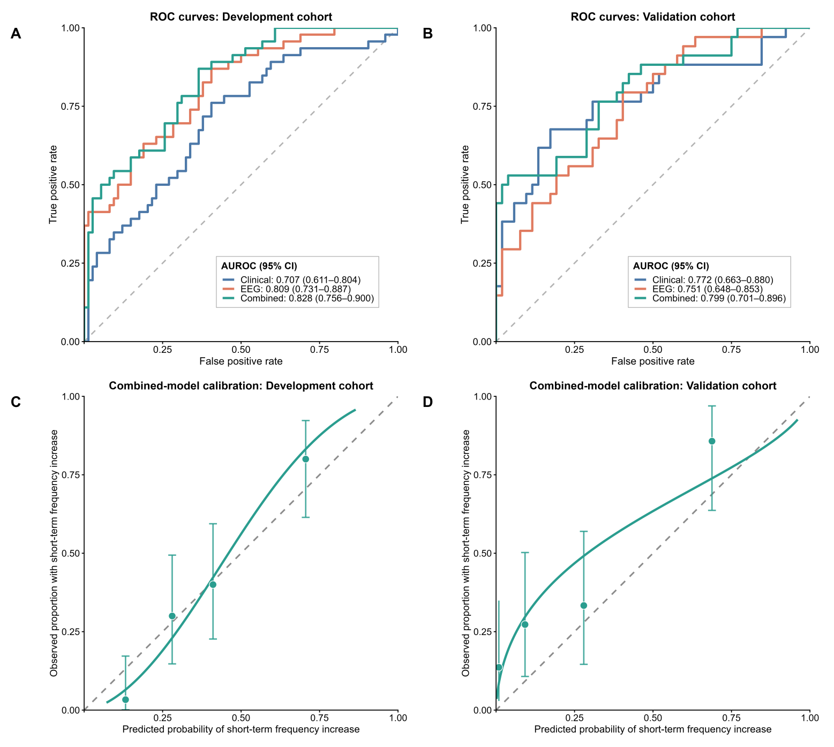
The sensitivity analysis excluded the 10 boundary cases. (A, B) Receiver operating characteristic curves for the clinical, EEG, and combined models in the development cohort (n = 120) and temporal validation cohort (n = 86), respectively. (C, D) Calibration plots for the combined model in the development and validation cohorts. Development-cohort estimates were based on repeat-averaged out-of-fold predictions; the locked models were applied unchanged in validation.

Supplementary Fig. S7. SHAP-based interpretation of the combined clinical–EEG model in the sensitivity analysis.
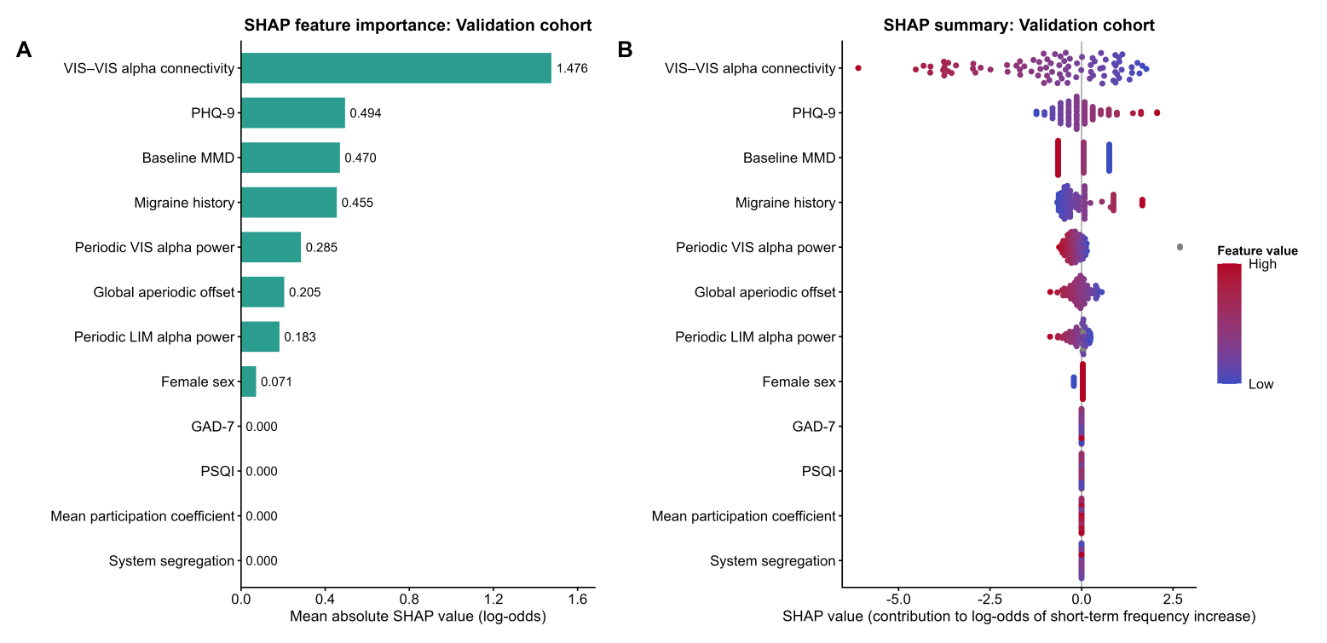
The sensitivity analysis excluded the 10 boundary cases. (A) Mean absolute SHAP values showing feature importance for the combined model in the validation cohort (n = 86). (B) SHAP summary plot showing each feature’s contribution to the predicted log-odds of short-term frequency increase. Positive values indicate a higher predicted probability and negative values a lower predicted probability. In the plotted feature labels, migraine history denotes migraine disease duration.

Supplementary Fig. S8. Discrimination and calibration of the simplified clinical–EEG model in the sensitivity analysis.
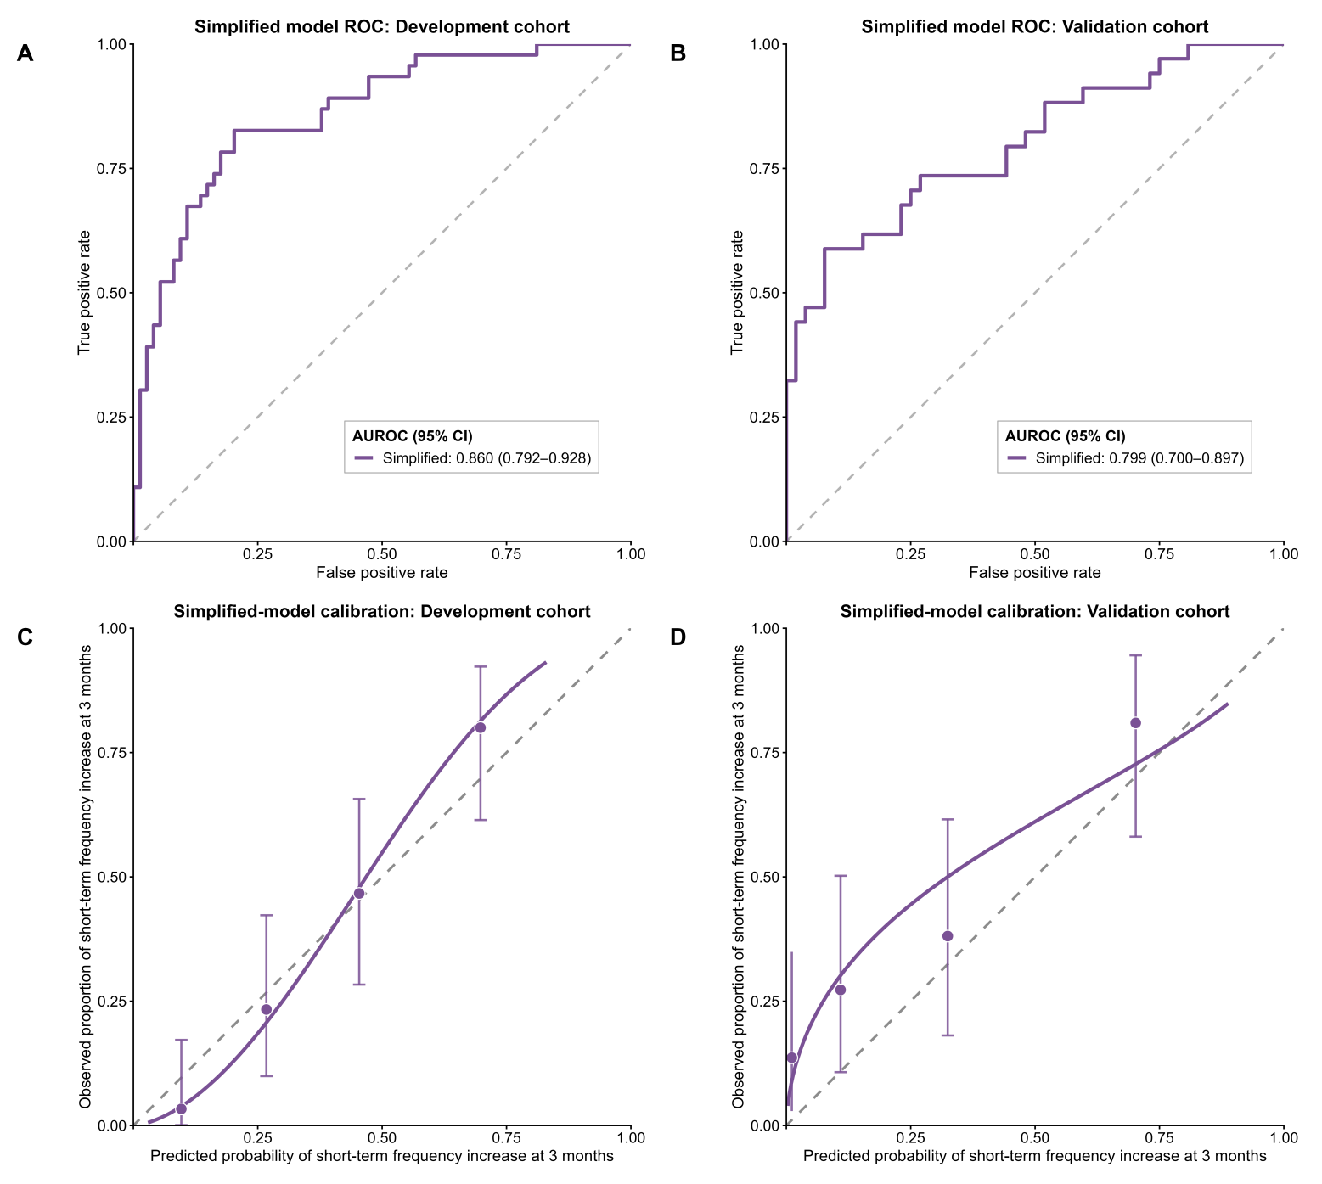
The sensitivity analysis excluded the 10 boundary cases. The simplified model included the six clinical predictors and within-VIS alpha-band connectivity. (A, B) Receiver operating characteristic curves in the development cohort (n = 120) and temporal validation cohort (n = 86), respectively. (C, D) Calibration plots in the development and validation cohorts.

Supplementary Fig. S9. Performance of the sensor-space EEG and clinical–sensor-space EEG models.
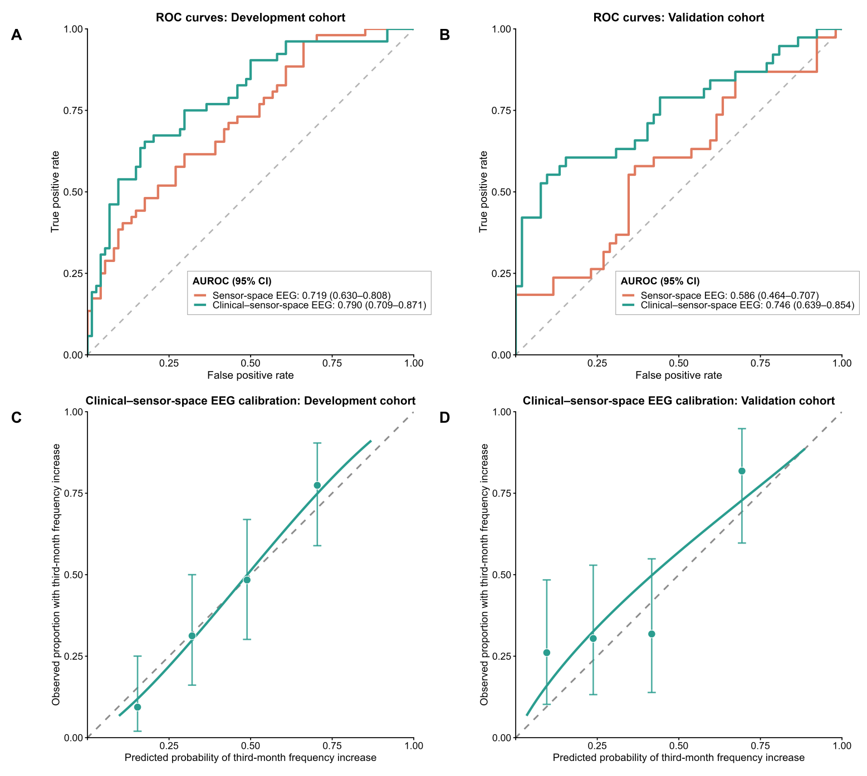
As a secondary benchmark, sensor-space models were constructed using sensor-level analogues of two EEG features with large contributions in the primary combined model: posterior periodic alpha power and within-posterior alpha-band amplitude-envelope correlation (AEC). Welch power spectral densities were estimated separately for eight prespecified posterior electrodes (O1, Oz, O2, PO3, POz, PO4, PO7, and PO8) using 2-s Hamming windows, 50% overlap, and an NFFT of 2,000. At each frequency bin, the linear power spectral density estimates were summarized using the median across the eight electrodes. The resulting posterior spectrum was parameterized over 1–35 Hz using the same fixed aperiodic model as in the source-space analysis. Posterior periodic alpha power was defined as the height of the largest fitted peak with a center frequency between 8 and 13 Hz above the aperiodic component.
For AEC, the eight posterior signals were band-pass filtered at 8–13 Hz using the same zero-phase Butterworth filtering procedure as in the source-space analysis. Hilbert analytic signals were calculated at the native sampling rate and resampled to 50 Hz with reflection padding. Each electrode pair was then processed using bidirectional pairwise orthogonalization. The amplitude envelopes were smoothed using a 0.5-s moving average and natural-log transformed. For each electrode pair, the two directional envelope correlations were averaged and then Fisher z-transformed; the mean Fisher-z value across the 28 unique electrode pairs was retained. Effective-rank measures were recorded for quality control and were not used as a full-rank eligibility criterion.
The sensor-space EEG model included these two measures, whereas the clinical–sensor-space EEG model additionally included the same clinical predictors as the primary clinical model. Both models used the same elastic-net logistic-regression framework and development/temporal-validation procedures as the primary analysis. Development-cohort performance (n = 126) was estimated from repeat-averaged out-of-fold predictions, and the locked models were applied without refitting or recalibration to the temporal validation cohort (n = 90). (A, B) Receiver operating characteristic curves for the sensor-space EEG and clinical–sensor-space EEG models in the development and validation cohorts, respectively. (C, D) Calibration plots for the clinical–sensor-space EEG model in the development and validation cohorts.

Supplementary Table S1. Baseline characteristics by third-month outcome in the development cohort.
Characteristic | ≥4-MMD group  n = 52 | <4-MMD group  n = 74 | Group comparison
Age, median (IQR), years | 34.0 (29.5–38.0) | 33.0 (28.0–37.0) | H = 1.58, p = 0.209
Sex, male/female | 5/47 | 13/61 | χ² = 1.58, p = 0.209
Male, n (%) | 5 (9.6) | 13 (17.6)
Female, n (%) | 47 (90.4) | 61 (82.4)
Education level, median (IQR) | 4.0 (4.0–4.0) | 4.0 (3.2–4.0) | H = 0.47, p = 0.493
Baseline MMDs, median (IQR) | 2.0 (1.0–3.0) | 2.0 (2.0–3.0) | H = 1.51, p = 0.219
Migraine disease duration, median (IQR), years | 10.0 (6.0–15.0) | 6.5 (4.0–10.0) | H = 8.73, p = 0.003
Typical attack duration, median (IQR), h | 24.0 (7.5–24.0) | 12.0 (5.0–24.0) | H = 3.04, p = 0.081
Headache intensity (VAS), median (IQR) | 7.0 (5.0–8.0) | 7.0 (5.0–8.0) | H = 0.13, p = 0.719
GAD-7, median (IQR) | 4.0 (3.0–5.5) | 4.0 (2.0–5.0) | H = 0.88, p = 0.348
PHQ-9, median (IQR) | 6.0 (4.5–8.0) | 5.0 (3.0–6.0) | H = 6.65, p = 0.010
PSQI, median (IQR) | 7.0 (6.0–8.0) | 6.0 (5.0–7.0) | H = 2.64, p = 0.104

Continuous and ordinal variables are presented as medians with interquartile ranges, and categorical variables as counts and percentages. Between-group comparisons used the Kruskal–Wallis test for continuous and ordinal variables and Pearson’s χ² test for sex; Fisher’s exact test was used when expected cell counts were insufficient. H denotes the Kruskal–Wallis test statistic, and χ² denotes the Pearson χ² test statistic. The <4-MMD group comprised patients with <4 MMDs during the third month after baseline, whereas the ≥4-MMD group comprised patients with ≥4 MMDs during the third month after baseline. Education level was coded as follows: 1 = primary school or below, 2 = junior high school, 3 = senior high school, 4 = bachelor’s degree, 5 = master’s degree, and 6 = doctoral degree. Migraine disease duration denotes the number of years since migraine onset, and attack duration denotes the reported average duration of a typical migraine attack.
GAD-7, 7-item Generalized Anxiety Disorder scale; IQR, interquartile range; MMDs, monthly migraine days; MO, migraine without aura; PHQ-9, 9-item Patient Health Questionnaire; PSQI, Pittsburgh Sleep Quality Index; VAS, visual analogue scale.

Supplementary Table S2. Baseline characteristics by third-month outcome in the validation cohort.
Characteristic | ≥4-MMD group  n = 38 | <4-MMD group  n = 52 | Group comparison
Age, median (IQR), years | 33.5 (27.0–41.0) | 35.5 (30.0–41.0) | H = 0.19, p = 0.659
Sex, male/female | 9/29 | 9/43 | χ² = 0.56, p = 0.455
Male, n (%) | 9 (23.7) | 9 (17.3)
Female, n (%) | 29 (76.3) | 43 (82.7)
Education level, median (IQR) | 4.0 (4.0–4.0) | 4.0 (4.0–4.0) | H = 0.74, p = 0.389
Baseline MMDs, median (IQR) | 2.0 (2.0–3.0) | 2.0 (1.0–3.0) | H = 0.20, p = 0.657
Migraine disease duration, median (IQR), years | 7.0 (4.0–20.0) | 5.5 (3.0–10.0) | H = 2.56, p = 0.109
Typical attack duration, median (IQR), h | 24.0 (6.0–24.0) | 24.0 (8.0–24.0) | H = 0.42, p = 0.518
Headache intensity (VAS), median (IQR) | 6.0 (5.0–8.0) | 6.0 (5.0–7.5) | H = 0.78, p = 0.376
GAD-7, median (IQR) | 5.0 (4.0–6.0) | 3.0 (2.0–4.0) | H = 30.86, p < 0.001
PHQ-9, median (IQR) | 6.5 (5.0–9.0) | 4.0 (3.0–5.0) | H = 31.34, p < 0.001
PSQI, median (IQR) | 8.0 (5.0–10.0) | 6.0 (5.0–7.0) | H = 8.78, p = 0.003

Continuous and ordinal variables are presented as medians with interquartile ranges, and categorical variables as counts and percentages. Between-group comparisons used the Kruskal–Wallis test for continuous and ordinal variables and Pearson’s χ² test for sex; Fisher’s exact test was used when expected cell counts were insufficient. H denotes the Kruskal–Wallis test statistic, and χ² denotes the Pearson χ² test statistic. The <4-MMD group comprised patients with <4 MMDs during the third month after baseline, whereas the ≥4-MMD group comprised patients with ≥4 MMDs during the third month after baseline. Education level was coded as follows: 1 = primary school or below, 2 = junior high school, 3 = senior high school, 4 = bachelor’s degree, 5 = master’s degree, and 6 = doctoral degree. Migraine disease duration denotes the number of years since migraine onset, and attack duration denotes the reported average duration of a typical migraine attack.
GAD-7, 7-item Generalized Anxiety Disorder scale; IQR, interquartile range; MMDs, monthly migraine days; MO, migraine without aura; PHQ-9, 9-item Patient Health Questionnaire; PSQI, Pittsburgh Sleep Quality Index; VAS, visual analogue scale.

Supplementary Table S3. Associations between baseline EEG measures and short-term frequency increase.
EEG measure | β | 95% CI | p value | q value | n
Periodic VIS alpha power | −0.100 | −0.212 to 0.012 | 0.080 | 0.096 | 120
Periodic LIM alpha power | −0.049 | −0.124 to 0.025 | 0.193 | 0.193 | 103
Global aperiodic offset | −0.417 | −0.662 to −0.171 | 0.001 | 0.002 | 126
VIS–VIS alpha connectivity | −0.140 | −0.178 to −0.102 | <0.001 | <0.001 | 126
Mean participation coefficient | 0.054 | 0.024 to 0.084 | <0.001 | 0.001 | 126
System segregation | −0.024 | −0.045 to −0.002 | 0.030 | 0.045 | 126
Six candidate baseline EEG features were evaluated in relation to short-term frequency increase, defined by third-month MMDs of ≥4 versus <4. Multivariable linear regression models were adjusted for migraine disease duration and PHQ-9 and used HC3 heteroscedasticity-consistent standard errors. β represents the adjusted difference between the ≥4-MMD and <4-MMD groups, with the <4-MMD group as the reference; negative β values indicate lower values and positive β values indicate higher values in the ≥4-MMD group. The 95% CIs were derived from HC3 robust standard errors. P values were corrected across the six prespecified EEG measures using the Benjamini–Hochberg false discovery rate procedure. Sample sizes represent complete-case data available for each model; smaller sample sizes for periodic alpha power reflect unavailable fitted alpha peaks. Periodic alpha power represents fitted peak height above the aperiodic component in log10 power units, and global aperiodic offset represents the intercept of the fixed aperiodic fit in log10 power space.
CI, confidence interval; FDR, false discovery rate; LIM, limbic network; MMDs, monthly migraine days; PHQ-9, 9-item Patient Health Questionnaire; VIS, visual network.

Supplementary Table S4. Baseline characteristics by third-month outcome in the development cohort: sensitivity analysis.
Characteristic | ≥4-MMD group  n = 46 | <4-MMD group  n = 74 | Group comparison
Age, median (IQR), years | 34.0 (29.2–38.0) | 33.0 (28.0–37.0) | H = 1.31, p = 0.253
Sex, male/female | 4/42 | 13/61 | χ² = 1.84, p = 0.175
Male, n (%) | 4 (8.7) | 13 (17.6)
Female, n (%) | 42 (91.3) | 61 (82.4)
Education level, median (IQR) | 4.0 (4.0–4.0) | 4.0 (3.2–4.0) | H = 0.47, p = 0.492
Baseline MMDs, median (IQR) | 2.0 (1.0–3.0) | 2.0 (2.0–3.0) | H = 4.48, p = 0.034
Migraine disease duration, median (IQR), years | 10.0 (5.0–15.0) | 6.5 (4.0–10.0) | H = 7.11, p = 0.008
Typical attack duration, median (IQR), h | 24.0 (8.0–24.0) | 12.0 (5.0–24.0) | H = 2.78, p = 0.096
Headache intensity (VAS), median (IQR) | 7.0 (5.0–8.0) | 7.0 (5.0–8.0) | H = 0.06, p = 0.812
GAD-7, median (IQR) | 4.0 (3.0–6.0) | 4.0 (2.0–5.0) | H = 1.06, p = 0.303
PHQ-9, median (IQR) | 6.0 (4.0–8.0) | 5.0 (3.0–6.0) | H = 5.86, p = 0.015
PSQI, median (IQR) | 7.0 (6.0–8.0) | 6.0 (5.0–7.0) | H = 1.71, p = 0.191
Continuous and ordinal variables are presented as medians with interquartile ranges, and categorical variables as counts and percentages. Between-group comparisons used the Kruskal–Wallis test for continuous and ordinal variables and Pearson’s χ² test for sex; Fisher’s exact test was used when expected cell counts were insufficient. H denotes the Kruskal–Wallis test statistic, and χ² denotes the Pearson χ² test statistic. The <4-MMD group comprised patients with <4 MMDs during the third month after baseline, whereas the ≥4-MMD group comprised patients with ≥4 MMDs during the third month after baseline. Education level was coded as follows: 1 = primary school or below, 2 = junior high school, 3 = senior high school, 4 = bachelor’s degree, 5 = master’s degree, and 6 = doctoral degree. Migraine disease duration denotes the number of years since migraine onset, and attack duration denotes the reported average duration of a typical migraine attack.
GAD-7, 7-item Generalized Anxiety Disorder scale; IQR, interquartile range; MMDs, monthly migraine days; MO, migraine without aura; PHQ-9, 9-item Patient Health Questionnaire; PSQI, Pittsburgh Sleep Quality Index; VAS, visual analogue scale.

Supplementary Table S5. Baseline characteristics by third-month outcome in the validation cohort: sensitivity analysis.
Characteristic | ≥4-MMD group  n = 34 | <4-MMD group  n = 52 | Group comparison
Age, median (IQR), years | 33.0 (27.0–43.0) | 35.5 (30.0–41.0) | H = 0.32, p = 0.575
Sex, male/female | 9/25 | 9/43 | χ² = 1.04, p = 0.307
Male, n (%) | 9 (26.5) | 9 (17.3)
Female, n (%) | 25 (73.5) | 43 (82.7)
Education level, median (IQR) | 4.0 (4.0–4.0) | 4.0 (4.0–4.0) | H = 1.17, p = 0.280
Baseline MMDs, median (IQR) | 2.0 (2.0–3.0) | 2.0 (1.0–3.0) | H = 0.01, p = 0.918
Migraine disease duration, median (IQR), years | 7.0 (4.0–20.0) | 5.5 (3.0–10.0) | H = 2.89, p = 0.089
Typical attack duration, median (IQR), h | 24.0 (6.0–24.0) | 24.0 (8.0–24.0) | H = 0.27, p = 0.601
Headache intensity (VAS), median (IQR) | 6.0 (5.0–8.0) | 6.0 (5.0–7.5) | H = 0.35, p = 0.556
GAD-7, median (IQR) | 5.0 (4.0–6.0) | 3.0 (2.0–4.0) | H = 27.66, p < 0.001
PHQ-9, median (IQR) | 6.0 (5.0–9.0) | 4.0 (3.0–5.0) | H = 27.20, p < 0.001
PSQI, median (IQR) | 8.0 (5.0–10.0) | 6.0 (5.0–7.0) | H = 7.57, p = 0.006
Continuous and ordinal variables are presented as medians with interquartile ranges, and categorical variables as counts and percentages. Between-group comparisons used the Kruskal–Wallis test for continuous and ordinal variables and Pearson’s χ² test for sex; Fisher’s exact test was used when expected cell counts were insufficient. H denotes the Kruskal–Wallis test statistic, and χ² denotes the Pearson χ² test statistic. The <4-MMD group comprised patients with <4 MMDs during the third month after baseline, whereas the ≥4-MMD group comprised patients with ≥4 MMDs during the third month after baseline. Education level was coded as follows: 1 = primary school or below, 2 = junior high school, 3 = senior high school, 4 = bachelor’s degree, 5 = master’s degree, and 6 = doctoral degree. Migraine disease duration denotes the number of years since migraine onset, and attack duration denotes the reported average duration of a typical migraine attack.
GAD-7, 7-item Generalized Anxiety Disorder scale; IQR, interquartile range; MMDs, monthly migraine days; MO, migraine without aura; PHQ-9, 9-item Patient Health Questionnaire; PSQI, Pittsburgh Sleep Quality Index; VAS, visual analogue scale.

Supplementary Table S6. Associations between baseline EEG measures and short-term frequency increase: sensitivity analysis.
EEG measure | β | 95% CI | p value | q value | n
Periodic VIS alpha power | −0.082 | −0.198 to 0.034 | 0.165 | 0.198 | 114
Periodic LIM alpha power | −0.041 | −0.119 to 0.036 | 0.291 | 0.291 | 98
Global aperiodic offset | −0.364 | −0.617 to −0.110 | 0.005 | 0.010 | 120
VIS–VIS alpha connectivity | −0.139 | −0.179 to −0.100 | <0.001 | <0.001 | 120
Mean participation coefficient | 0.056 | 0.025 to 0.087 | <0.001 | 0.001 | 120
System segregation | −0.023 | −0.046 to −0.001 | 0.043 | 0.065 | 120
Multivariable linear regression models were adjusted for migraine disease duration and PHQ-9 and used HC3 heteroscedasticity-consistent standard errors. β represents the adjusted difference between the ≥4-MMD and <4-MMD groups, with the <4-MMD group as the reference. P values were corrected across the six EEG measures using the Benjamini–Hochberg false discovery rate procedure.
CI, confidence interval; FDR, false discovery rate; MMDs, monthly migraine days; PHQ-9, 9-item Patient Health Questionnaire.
Supplementary Table S7. Performance of the clinical, EEG, and combined models in the sensitivity analysis.
Performance metric | Clinical model |  | EEG model |  | Combined model
Performance metric | Development | Validation | Development | Validation | Development | Validation
AUROC (95% CI) | 0.707 (0.611–0.804) | 0.772 (0.663–0.880) | 0.809 (0.731–0.887) | 0.751 (0.648–0.853) | 0.828 (0.756–0.900) | 0.799 (0.701–0.896)
AUPRC | 0.596 | 0.744 | 0.768 | 0.686 | 0.765 | 0.786
Brier score | 0.209 | 0.187 | 0.188 | 0.212 | 0.160 | 0.183
Calibration intercept (95% CI) | 0.027 (−0.361–0.405) | 0.109 (−0.361–0.566) | 0.001 (−0.383–0.375) | 0.273 (−0.175–0.708) | 0.006 (−0.414–0.415) | 1.044 (0.467–1.615)
Calibration slope (95% CI) | 1.331 (0.620–2.130) | 1.512 (0.815–2.340) | 3.517 (2.225–5.129) | 2.939 (1.512–4.689) | 1.545 (1.007–2.212) | 0.617 (0.350–0.956)
Threshold | 0.363 | 0.363 | 0.347 | 0.347 | 0.309 | 0.309
Balanced accuracy | 0.678 | 0.714 | 0.732 | 0.660 | 0.752 | 0.688
Sensitivity (95% CI) | 0.761 (0.612–0.874) | 0.735 (0.556–0.871) | 0.870 (0.737–0.951) | 0.647 (0.465–0.803) | 0.870 (0.737–0.951) | 0.529 (0.351–0.702)
Specificity (95% CI) | 0.595 (0.474–0.707) | 0.692 (0.549–0.813) | 0.595 (0.474–0.707) | 0.673 (0.529–0.797) | 0.635 (0.515–0.744) | 0.846 (0.719–0.931)
In the sensitivity analysis, performance in the development cohort was estimated from repeat-averaged out-of-fold predictions. Performance in the validation cohort was evaluated using the locked models without refitting or recalibration. Classification thresholds were determined from the out-of-fold development-cohort predictions using the Youden index and applied unchanged to the validation cohort. Lower Brier scores indicate better probabilistic accuracy. The ideal values for the calibration intercept and slope are 0 and 1, respectively.
AUPRC, area under the precision–recall curve; AUROC, area under the receiver operating characteristic curve; CI, confidence interval; EEG, electroencephalography.

Supplementary Table S8. Pairwise AUROC comparisons among the clinical, simplified, and combined models in the sensitivity analysis.
Cohort | Comparison | ΔAUROC (95% CI) | p value
Development | Combined vs. clinical | 0.121 (0.031–0.210) | 0.008
Development | Simplified vs. clinical | 0.153 (0.071–0.235) | <0.001
Development | Combined vs. simplified | −0.032 (−0.074–0.010) | 0.136
Validation | Combined vs. clinical | 0.027 (−0.065–0.119) | 0.568
Validation | Simplified vs. clinical | 0.027 (−0.059–0.113) | 0.541
Validation | Combined vs. simplified | 0.000 (−0.027–0.027) | 1.000
In the sensitivity analysis, AUROC differences were calculated as the AUROC of the first model minus that of the second model. Positive values favor the first model. Comparisons were performed using paired DeLong tests. The simplified model included the six clinical predictors and within-VIS alpha-band connectivity.
AUROC, area under the receiver operating characteristic curve; CI, confidence interval; VIS, visual network.

Supplementary Table S9. Performance of the sensor-space EEG and clinical–sensor-space EEG models.
Performance metric | Sensor-space EEG model |  | Clinical–sensor-space EEG model
Performance metric | Development | Validation | Development | Validation
AUROC (95% CI) | 0.719 (0.630–0.808) | 0.586 (0.464–0.707) | 0.790 (0.709–0.871) | 0.746 (0.639–0.854)
AUPRC | 0.668 | 0.568 | 0.729 | 0.753
Brier score | 0.206 | 0.256 | 0.184 | 0.195
Calibration intercept | 0.000 | 0.379 | −0.007 | 0.366
Calibration slope | 1.162 | 0.323 | 1.201 | 0.864
Threshold | 0.438 | 0.438 | 0.489 | 0.489
Balanced accuracy | 0.659 | 0.524 | 0.739 | 0.715
Sensitivity | 0.615 | 0.395 | 0.654 | 0.526
Specificity | 0.703 | 0.654 | 0.824 | 0.904
Performance of the sensor-space models in the development cohort was estimated from repeat-averaged out-of-fold predictions. Performance in the validation cohort was evaluated using the locked models without refitting or recalibration. Classification thresholds were determined from the out-of-fold development-cohort predictions using the Youden index and applied unchanged to the validation cohort. Lower Brier scores indicate better probabilistic accuracy. The ideal values for the calibration intercept and slope are 0 and 1, respectively.
AUPRC, area under the precision–recall curve; AUROC, area under the receiver operating characteristic curve; CI, confidence interval; EEG, electroencephalography.

Supplementary Table S10. DeLong comparisons of the primary combined model with the sensor-space EEG and clinical–sensor-space EEG models.
Cohort | Comparison | ΔAUROC (95% CI) | p value
Development cohort | Combined vs. sensor-space EEG | 0.152 (0.063–0.241) | <0.001
Development cohort | Combined vs. clinical–sensor-space EEG | 0.081 (0.025–0.136) | 0.004
Validation cohort | Combined vs. sensor-space EEG | 0.235 (0.119–0.352) | <0.001
Validation cohort | Combined vs. clinical–sensor-space EEG | 0.074 (−0.009–0.158) | 0.082
AUROC differences were calculated as the AUROC of the primary combined model minus that of the comparator model. Positive values favor the primary combined model. Comparisons were performed using DeLong’s test. “Combined” refers to the primary combined clinical–source-space EEG model.
AUROC, area under the receiver operating characteristic curve; CI, confidence interval; EEG, electroencephalography.

