Supplementary Materials

Supplementary Figs.1. The simplified modeling dimensions of ICCS in SolidWorks software.
Supplementary Figs.2. The simplified modeling dimensions of FNS in SolidWorks software.
Supplementary Figs.3. The simplified modeling dimensions of PCCP in SolidWorks software.
Supplementary Figs.4. The mesh diagram of the finite element analysis models in ANSYS software.
Supplementary Figs.5. The image of the internal fixation device (cannulated compression screws, FNS, PCCP).
Supplementary Figs.1. The simplified modeling dimensions of ICCS in SolidWorks software.

Supplementary Figs.2. The simplified modeling dimensions of FNS in SolidWorks software.

Supplementary Figs.3. The simplified modeling dimensions of PCCP in SolidWorks software.

Supplementary Figs.4. The mesh diagram of the finite element analysis models in ANSYS software.

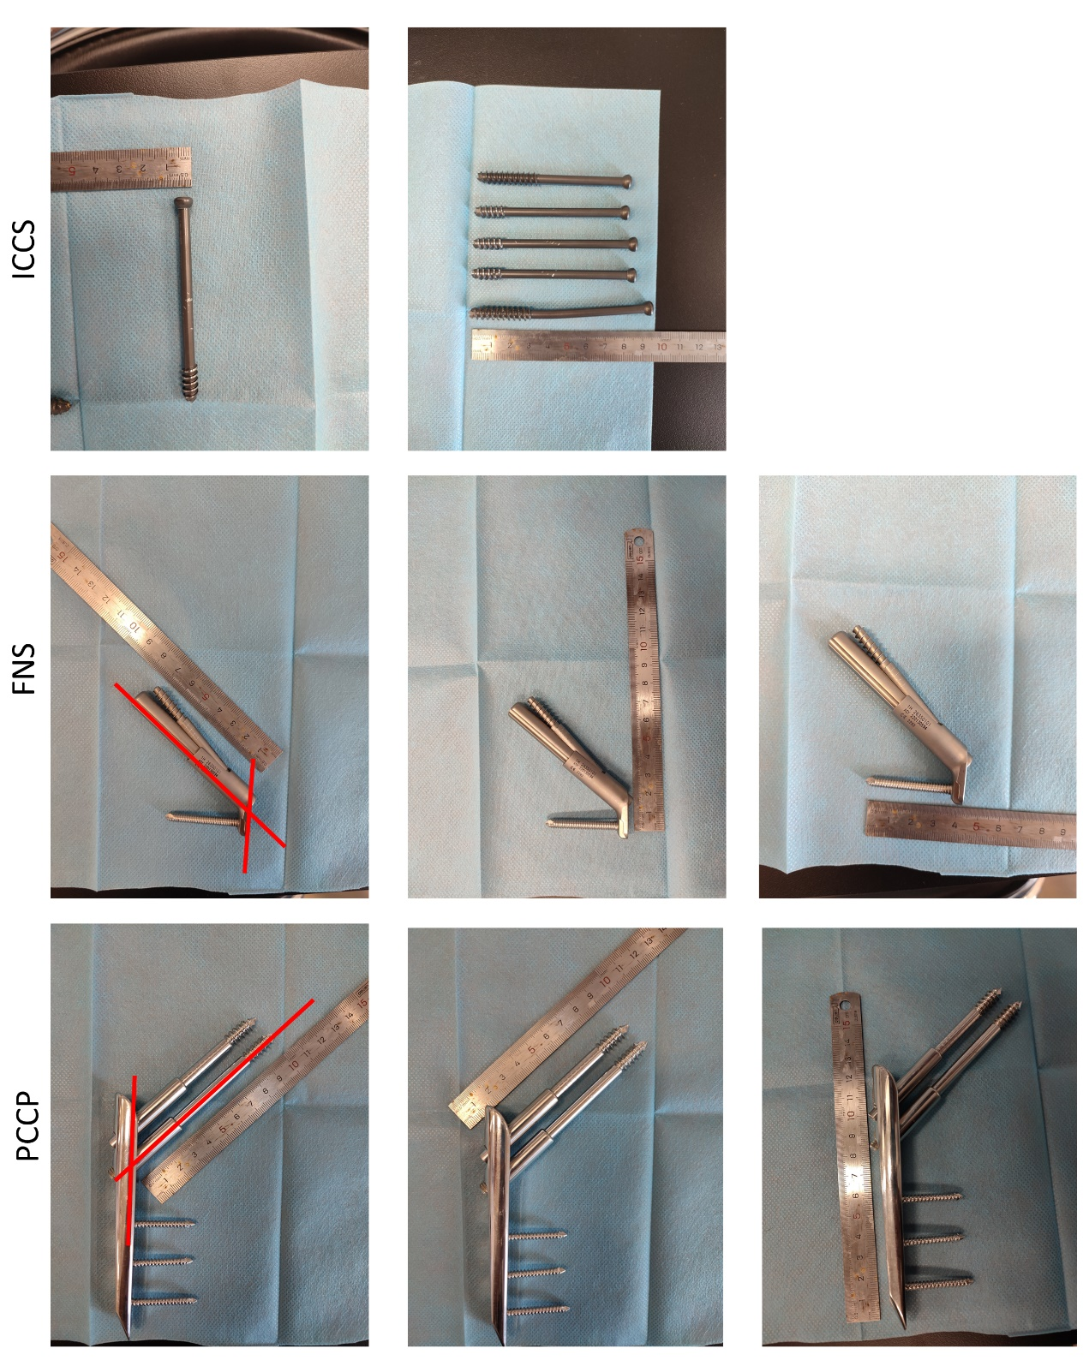

Supplementary Figs.5. The image of the internal fixation device (cannulated compression screws, FNS, PCCP).

