Appendix

Supplementary table 1: Definition of adverse events with their severity and eventual required intervention used to evaluate and classify the possible complications presents in the included studies.
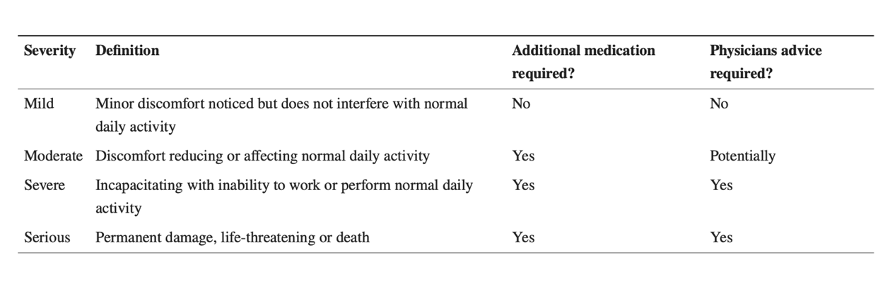

Supplementary figure 2: Graphic representation of the prevalence of the different meniscal healing grades (previously explained in the methods) evaluated trough MRI in Kaminsky et al. 2019 [13].
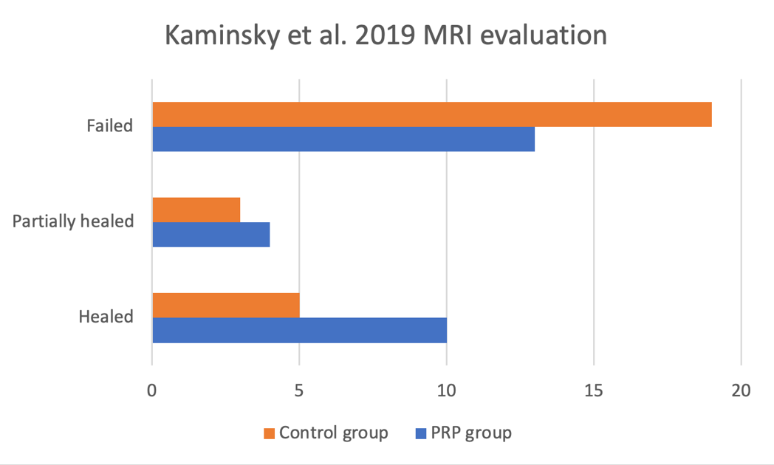

Supplementary figure 3: Graphic representation of the prevalence of the different meniscal healing grades (previously explained in the methods) evaluated cumulatively via MRI + Arthroscopic studies in Kaminsky et al. 2019 [13].

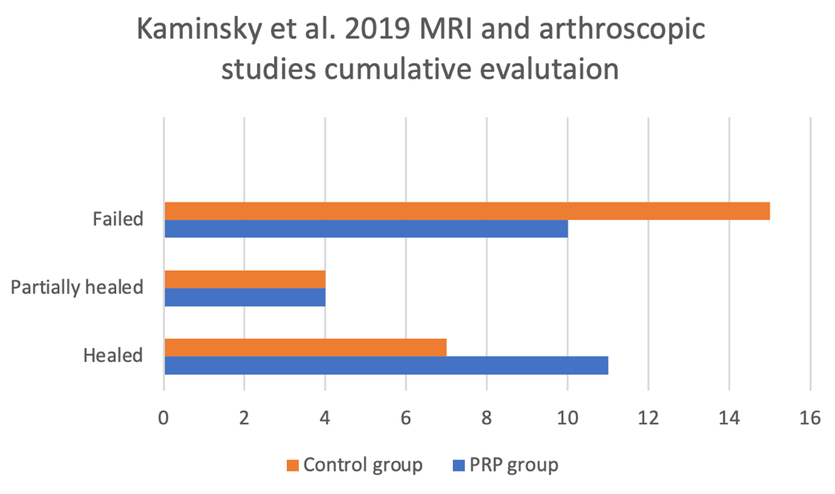

Supplementary figure 4: Graphic representation of the prevalence of the different meniscal healing grades (previously explained in methods) evaluated trough MRI in Kaminsky et al. 2018 [14].

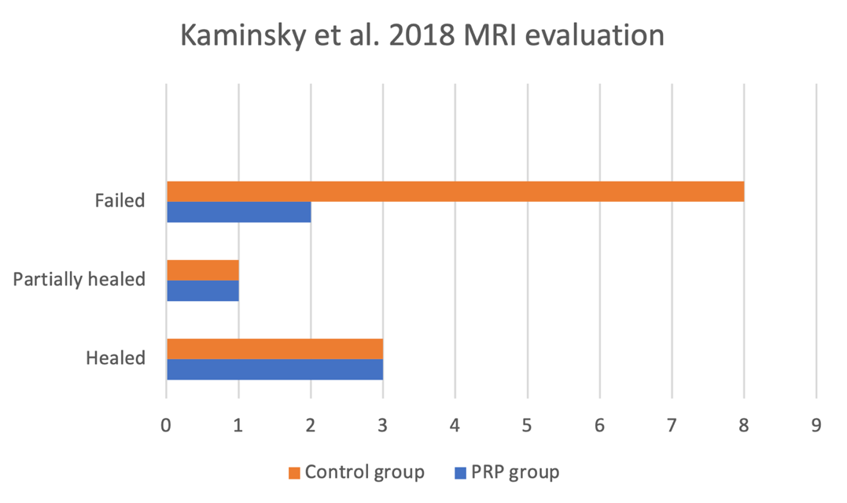

Supplementary figure 5: Graphic representation of the prevalence of the different meniscal healing grades (previously explained in methods) evaluated trough arthroscopic studies in Kaminsky et al. 2018 [14].

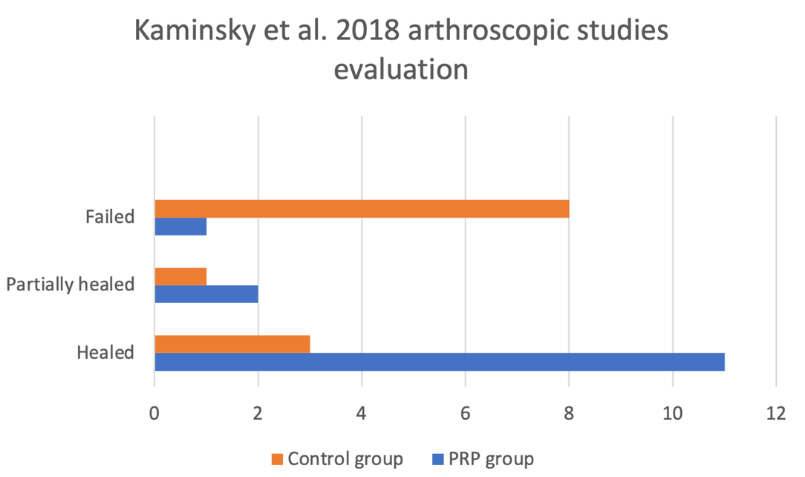

Supplementary figure number 6: Graphic representation of the prevalence of the different meniscal healing grades (previously explained in methods) evaluated cumulatively via MRI + Arthroscopic studies in Kaminsky et al. 2019 [13].

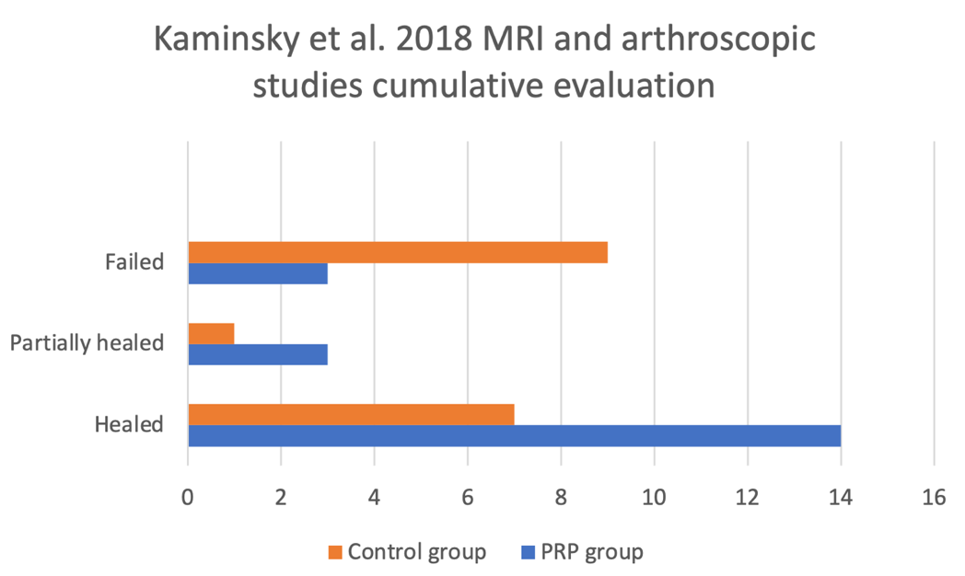

Supplementary figure number 7: Visual representation of the final outcome evaluated trough the several patient-reported tools previously described (KOOS, VAS, IKDC and WOMAC).
A positive sign (green) indicates there was a significative improvement in the PRP-treated group in relation with the indicates clinical evaluation tool compared with the control one, meanwhile the negative sign (red) indicates that there was no significative improvement in the PRP-treated group.

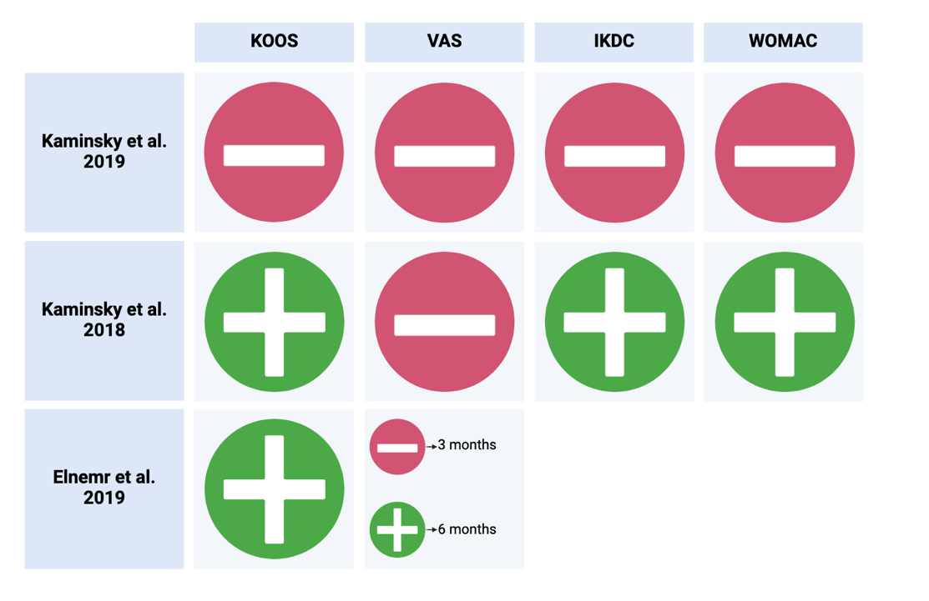

Supplementary table number 8: Possibly bias-leading elements summarized.

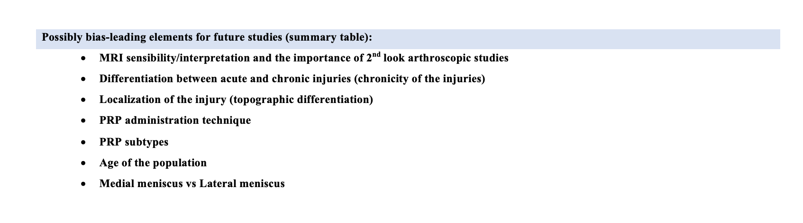

Supplementary table number 9: PICO question of this systematic review.

