Appendix 1: online questionnaire
[Questionnaire] TSA vs RSA

Level of expertise: What applies to you?
I am a:
  - Medical student
  - Resident
  - General (orthopaedic) Surgeon
  - Upper extremity Surgeon
  - Shoulder Surgeon
  - Other

Years of practice in shoulder surgery: What applies to you?
I have __ years of experience:
Slide to the appropriate amount of years | 

Amount of shoulder arthroplasties performed each year (TSA&RSA) : What applies to you?
Each year I perform approximately:
- <10 shoulder arthroplasties
- 10-30 shoulder arthroplasties
- 30-50 shoulder arthroplasties
- 50-100 shoulder arthroplasties
- >100 shoulder arthroplasties

TSA vs RSA : Of all shoulder arthroplasties that you perform, what percentage is RSA?
Each year I perform approximately__:
- 0-25% RSA
- 25-50% RSA
- 50-75% RSA
- 75-100% RSA

Do you use 3D planning?
- yes, for all cases
- yes, for some cases
- never

Practice: What applies to you (more answers possible)?
I (mainly) practice in a:
- Public Hospital
- Private Hospital (Clinic)
- University Hospital (Academic)

Country: In which country do you practice?
______________________________
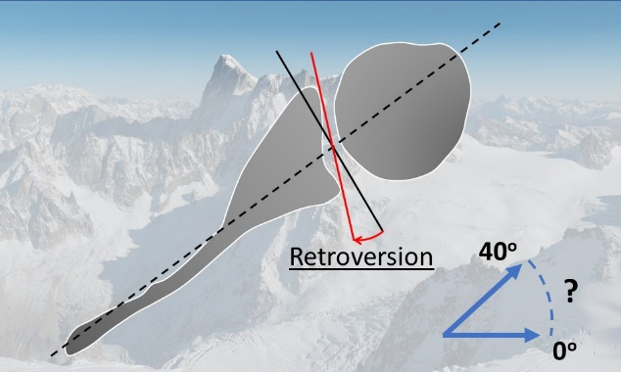
Maximum number of degrees of retroversion: Regardless of all other factors, what do you consider the maximum number of degrees of retroversion for performing an anatomic total shoulder arthroplasty (with/without augmented component) instead of a reversed shoulder arthroplasty?
- No limit

Slide to answer (In degrees)

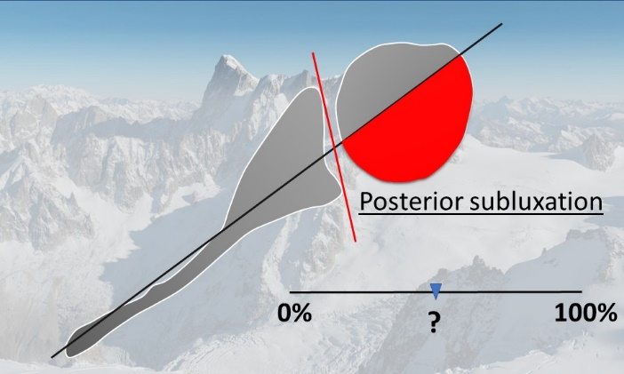

Percentage of subluxation: Regardless of all other factors, what do you consider the maximum percentage of posterior-subluxations for performing an anatomic total shoulder arthroplasty (with/without augmented component) instead of a reversed shoulder arthroplasty?
- No limit

Slide to answer (In %)

Age: Regardless of all other factors, what do you consider the maximum age for which you would still consider an anatomic total shoulder arthroplasty (with/without augmented component) instead of a Reversed shoulder arthroplasty?

- No age limit

Slide to answer (in years)

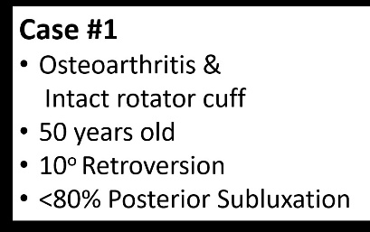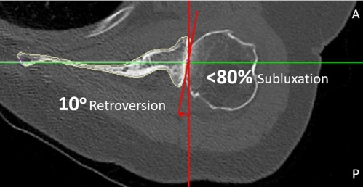
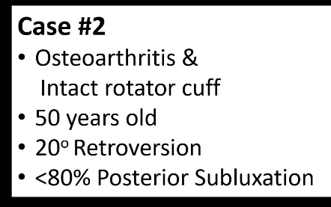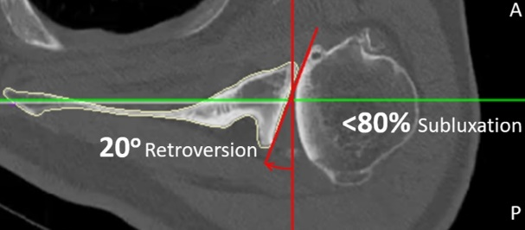
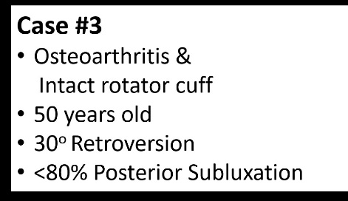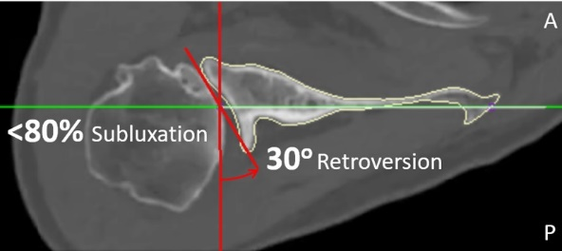
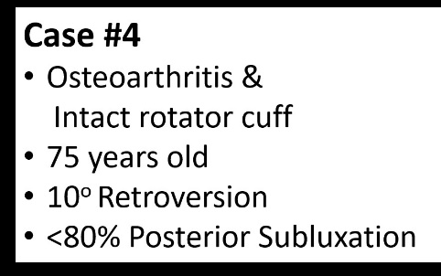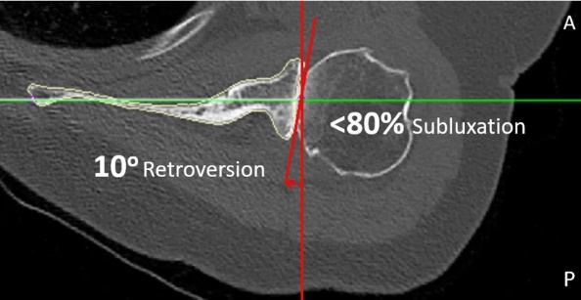
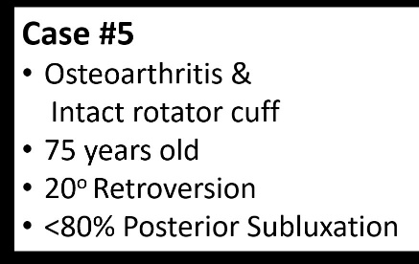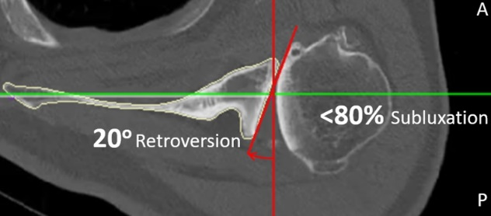\
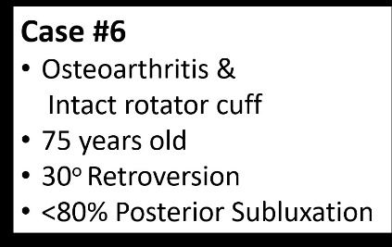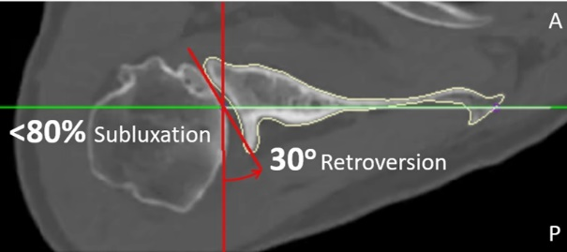
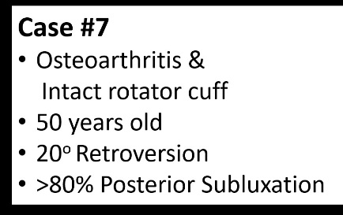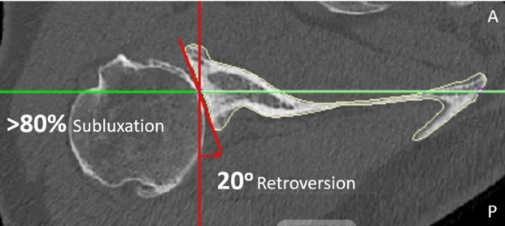
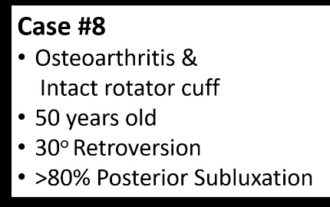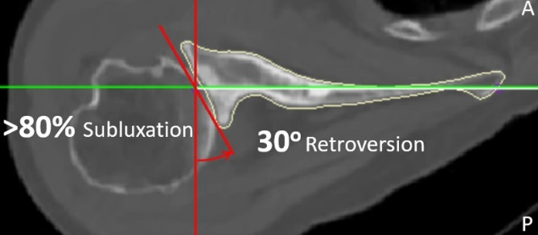
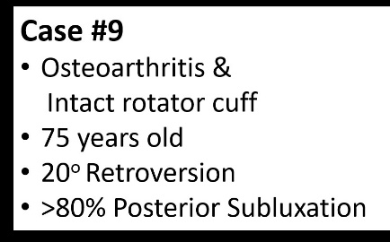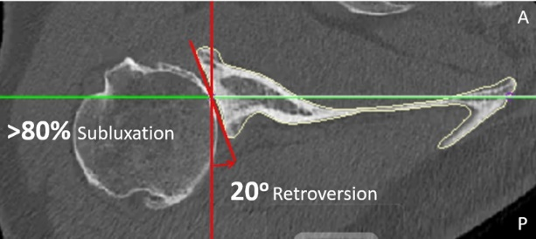
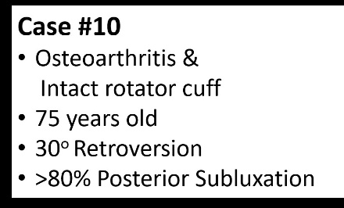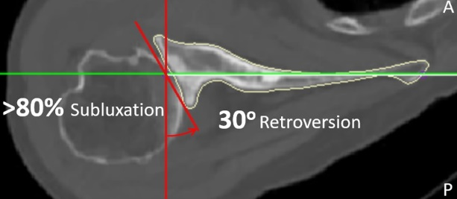

What arthroplasty would you apply ?
- TSA (without corrections, keep the anatomy as it is)
- TSA: corrective reaming
- TSA: augmented (stepped/wedged/hybrid ) glenoid component
- RSA (without corrections, keep the anatomy as it is)
- RSA: corrective reaming
- RSA: augmented component (metal)
- RSA: augmented with bone graft (autograft humeral head)
- RSA: augmented with other bone graft (illiac crest or allograft)

