Appendices systematic review

Appendix 1. Methodological quality of studies, Newcastle-Ottowa Scale (NOS)
Study, year | Selection |  |  |  |  |  | Outcome Overall
 | Representativeness  of exposed cohort | Ascertainment  of exposure | Total | Risk of bias | Assessment  of outcome | Follow up adequate  for outcomes to occur | Adequate follow up  of cohorts | Total | Risk of bias | Total stars | Overall  ranking
Basile, 2010 (28) | ★ | ★ | 2 | Low | - | ★ | - | 1 | Medium | 3 | Medium
Hirschmüller, 2011 (29) | ★ | ★ | 2 | Low | - | ★ | ★ | 2 | Low | 4 | Low
Kline, 2013 (30) | ★ | ★ | 2 | Low | - | ★ | - | 1 | Medium | 3 | Medium
Abdelazeem, 2014 (31) | ★ | ★ | 2 | Low | - | ★ | - | 1 | Medium | 3 | Medium
Chen, 2014 (32) | ★ | ★ | 2 | Low | - | ★ | - | 1 | Medium | 3 | Medium
Kayali, 2014 (33) | ★ | ★ | 2 | Low | - | ★ | - | 1 | Medium | 3 | Medium
Cao, 2015 (34) | ★ | ★ | 2 | Low | - | ★ | ★ | 2 | Low | 4 | Low
Feng, 2016 (35) | ★ | ★ | 2 | Low | - | ★ | ★ | 2 | Low | 4 | Low
Li, 2016 (36) | ★ | ★ | 2 | Low | - | ★ | ★ | 2 | Low | 4 | Low
Chen, 2017 (14) | ★ | ★ | 2 | Low | - | ★ | ★ | 2 | Low | 4 | Low
Chu, 2017 (37) | ★ | ★ | 2 | Low | - | ★ | ★ | 2 | Low | 4 | Low
Park, 2017 (38) | ★ | ★ | 2 | Low | - | ★ | - | 1 | Medium | 3 | Medium
Brand, 2019 (39) | ★ | ★ | 2 | Low | - | - | ★ | 1 | Medium | 3 | Medium
Zhan, 2019 (40) | ★ | ★ | 2 | Low | - | - | ★ | 1 | Medium | 3 | Medium
Bremer, 2020 (41) | ★ | ★ | 2 | Low | - | ★ | ★ | 2 | Low | 4 | Low
Cho, 2021 (42) | ★ | ★ | 2 | Low | - | ★ | ★ | 2 | Low | 4 | Low
Park, 2021 (43) | ★ | ★ | 2 | Low | - | ★ | ★ | 2 | Low | 4 | Low
Sugimoto, 2021 (44) | ★ | ★ | 2 | Low | - | - | ★ | 1 | Medium | 3 | Medium
Park, 2022 (45) | ★ | ★ | 2 | Low | - | ★ | - | 1 | Medium | 3 | Medium
Xie, 2022 (46) | ★ | ★ | 2 | Low | - | ★ | ★ | 2 | Low | 4 | Low

Appendix 2a. Heterogeneity analysis of the AOFAS on age groups
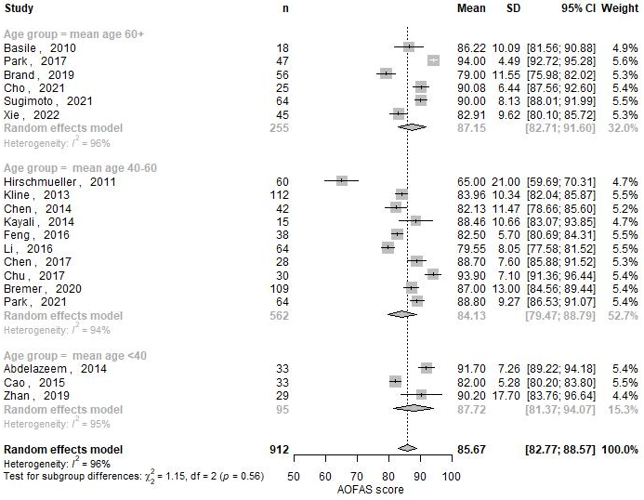
Appendix 2b. Heterogeneity analysis of the AOFAS on continent of the study
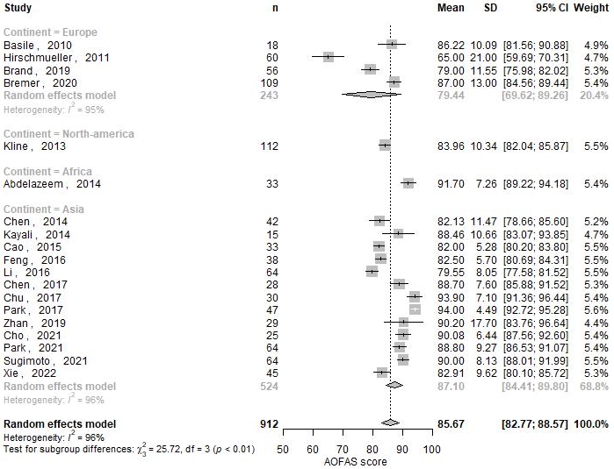

Appendix 2c. Heterogeneity analysis of the AOFAS on Sanders classification
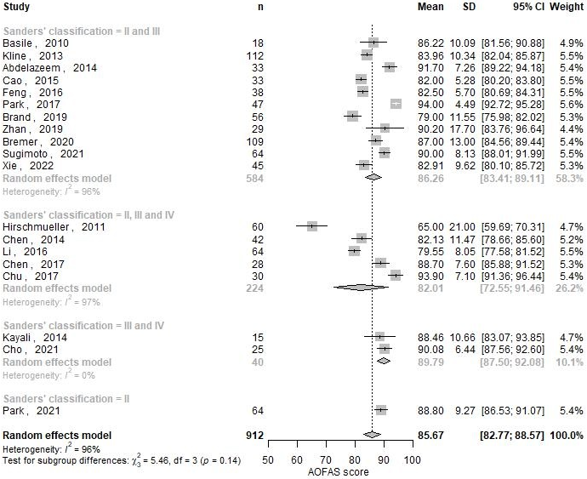

Appendix 2d. Heterogeneity analysis of the AOFAS on study design
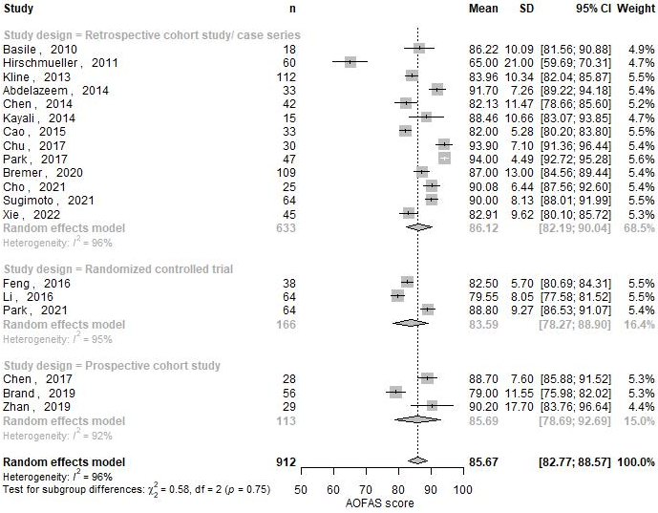

Appendix 3. Funnel plot for publication bias
