Additional file 1: Laparoscopic technical skills self- assessment versus expert assessment

Procedure: Form number:

Surgeon number: Surgeons exp.:

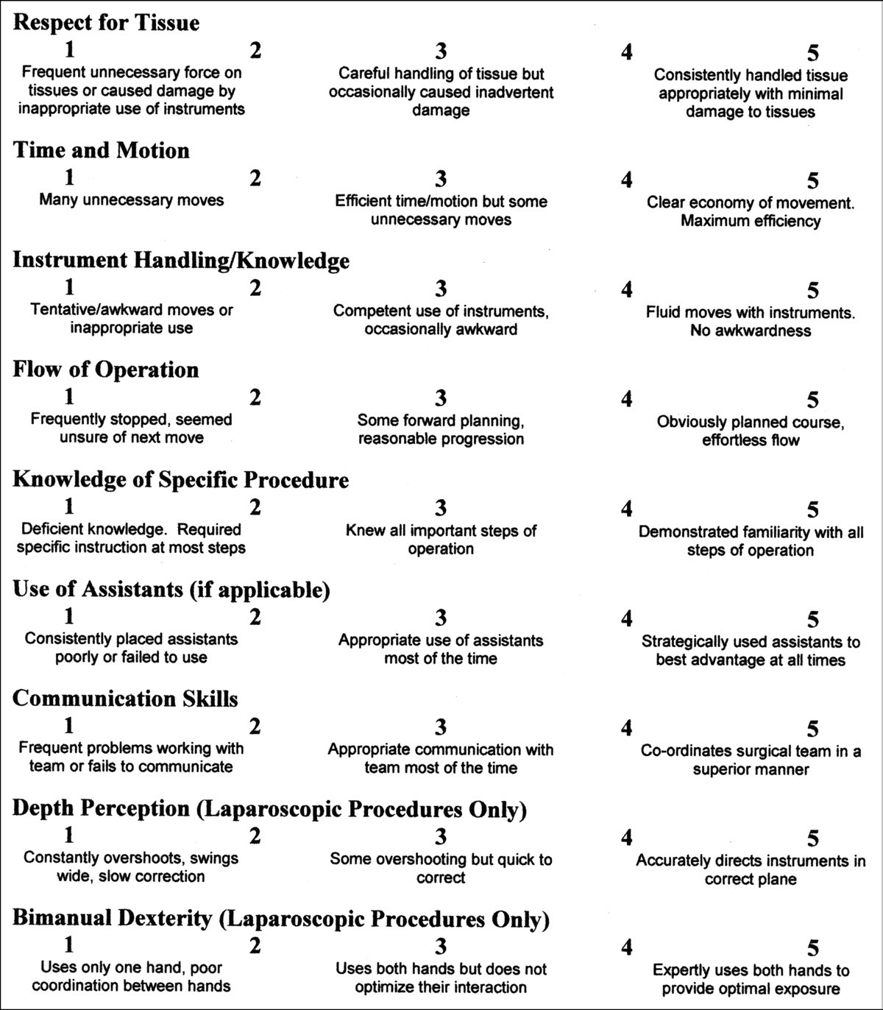
Date:

