Preventive effect and mechanism of (+) taxifolin as antioxidant towards •OH-treated bone marrow-derived mesenchymal stem cells
Xican Li ^{1, 2,*†}, Hong Xie ^{1, 2†}, Qian Jiang ¹, Gang Wei ^{1, 2}, Lishan Lin ¹, Changying Li ¹, Xingmei Ou ¹, Lichan Yang ¹, Yulu Xie ^{1, 2}, Zhen Fu^{3, 4}, Yamei Liu^{3, 4}, Dongfeng Chen ^{3, 4, *}
¹ School of Chinese Herbal Medicine, ² Innovative Research & Development Laboratory of TCM, ³ School of Basic Medical Science, ⁴ The Research Center of Integrative Medicine, Guangzhou University of Chinese Medicine, Guangzhou, China, 510006.

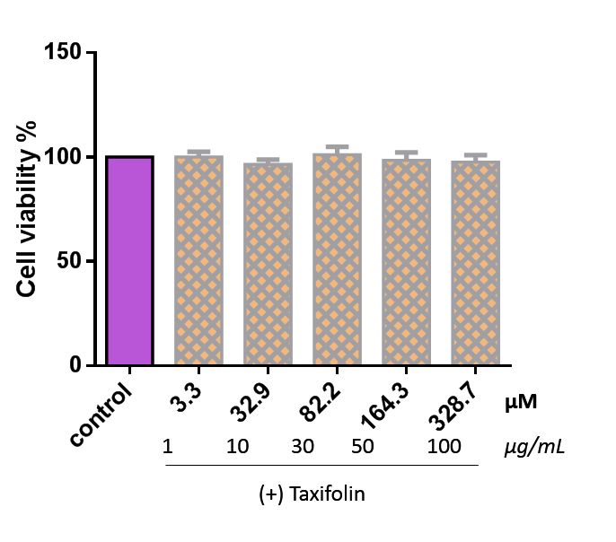
Fig. S1. The effect of (+) taxifolin towards normal bmMSCs without treatment of •OH radical (CCK-8 assay) Each value is expressed as mean±SD, n=5

(bmMSCs were seeded at 5000 cells per well into 96-well plates. After adherence for 24 hours, bmMSCs were divided into control, and sample [(+) taxifolin] groups. In the control group, bmMSCs were incubated for 24 hours in DMEM; while bmMSCs in the sample group were incubated for 24 hours in DMEM with the indicated (+) taxifolin concentrations. After incubation, 10 μL CCK-8(BB-4221-2, BestBio) was added, and the culture was incubated for an additional 2 hours. Absorbance was measured at 450 nm on a Bio-Kinetics reader (PE-1420; Bio-Kinetics Corporation, Sioux Center, IA, USA). Culture medium containing serum was used for the control group and each sample test was repeated in three independent wells.)

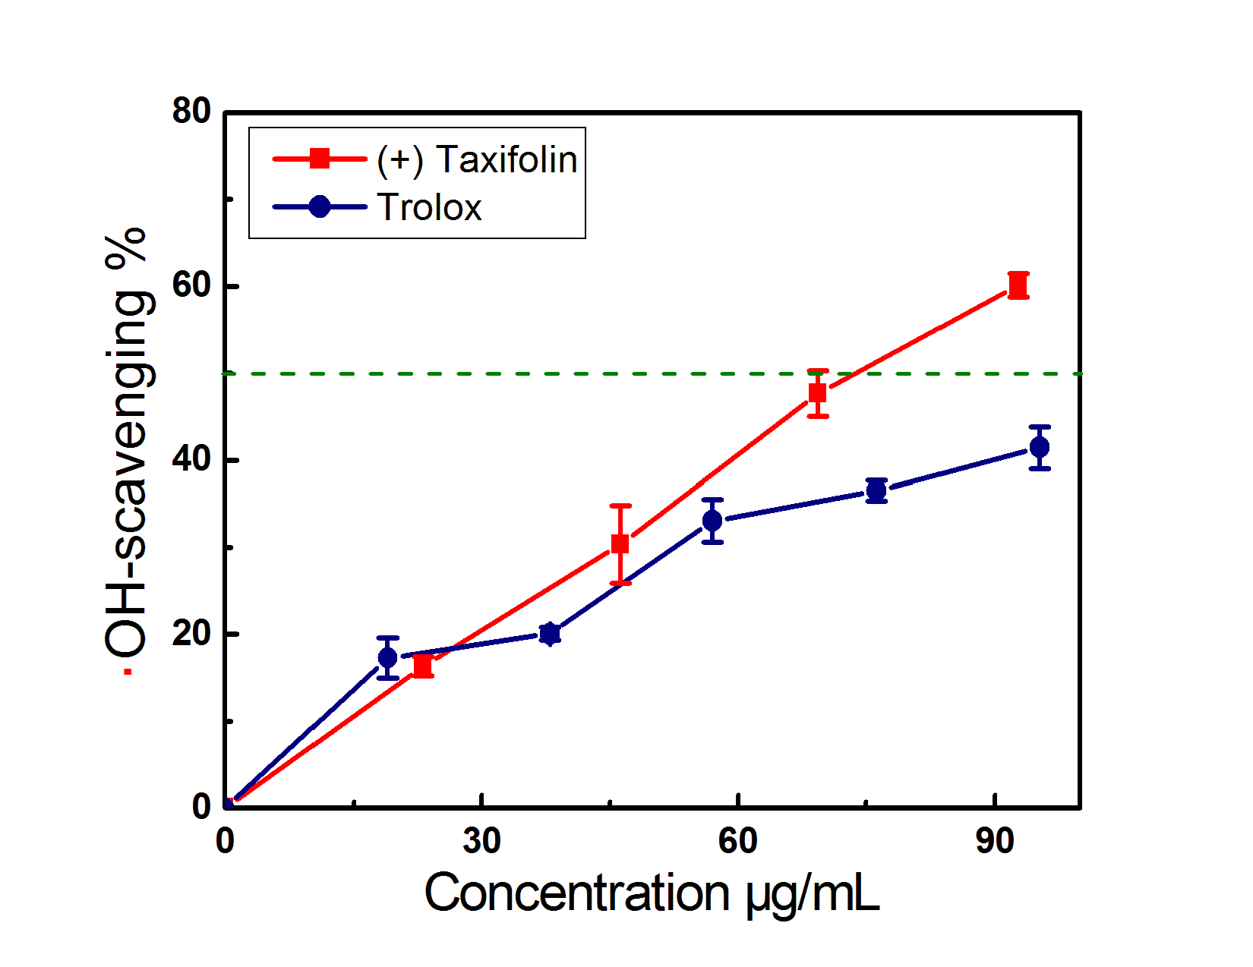
Fig. S2. Dose response curves of (+)taxifolin and Trolox in Hydroxyl-scavenging assay based on DNA. Each value is expressed as the mean±SD, n=3.

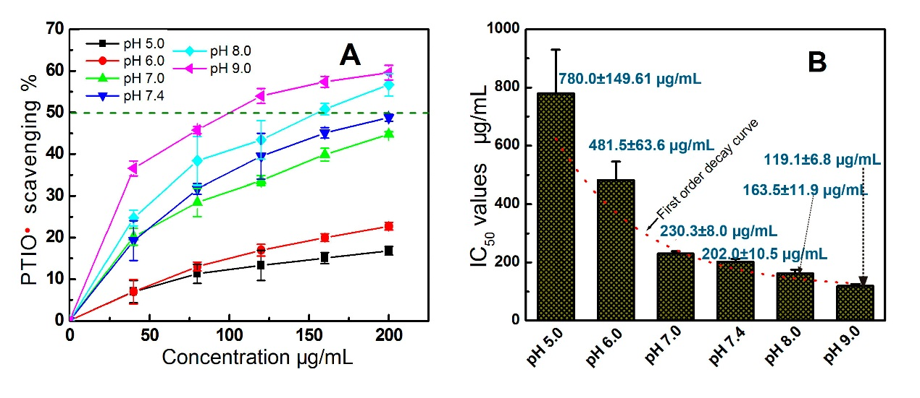

Fig. S3. (A)Dose response curves of (+) Taxifolin in PTIO•-radical-scavenging assay; (B)The IC₅₀ values of (+) taxifolin at various pH values. Each value is expressed as the mean±SD, n=3.

Table S1 The IC₅₀ values listed in different units
pH values | pH 5.0 | pH 6.0 | pH 7.0 | pH 7.4 | pH 8.0 | pH 9.0
IC₅₀ (µg/mL) | 780.0±149.6 | 481.5±63.6 | 230.3±8.0 | 202.0±10.5 | 163.5±11.9 | 119.1±6.8
IC₅₀ (mM) | 2.6±0.5 | 1.6±0.2 | 0.7±0.03 | 0.6±0.04 | 0.5±0.04 | 0.4±0.02
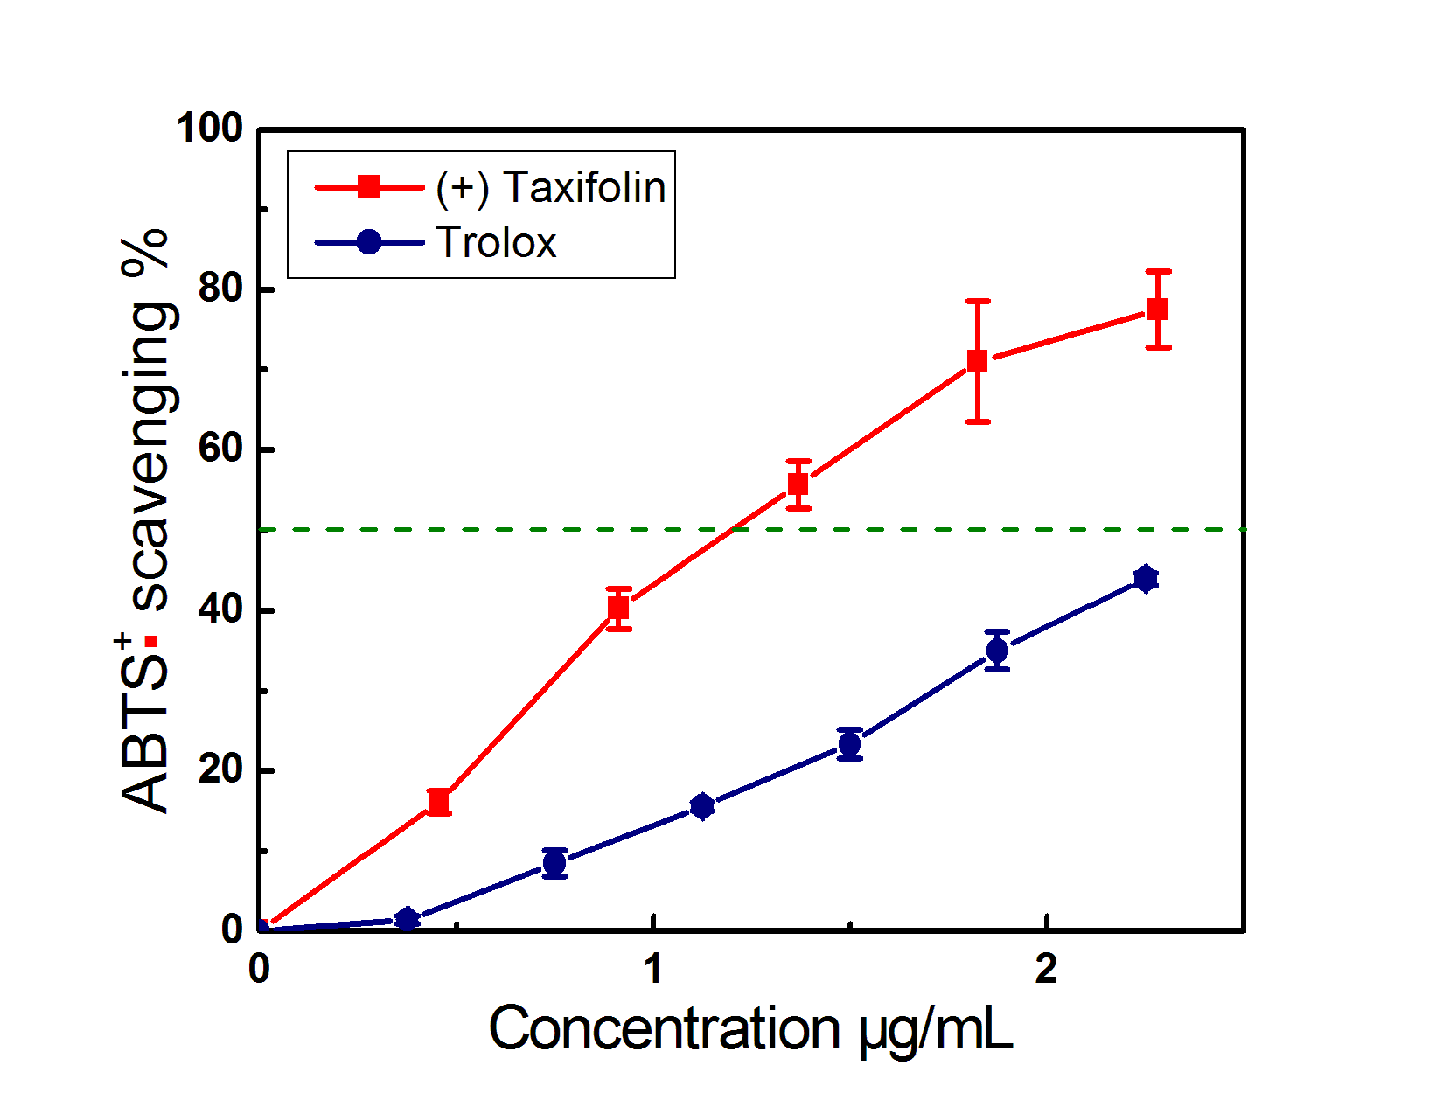
Fig. S4. Dose response curves of (+) Taxifolin and Trolox in ABTS•⁺ radical-scavenging assay. Each value is expressed as the mean±SD, n=3.

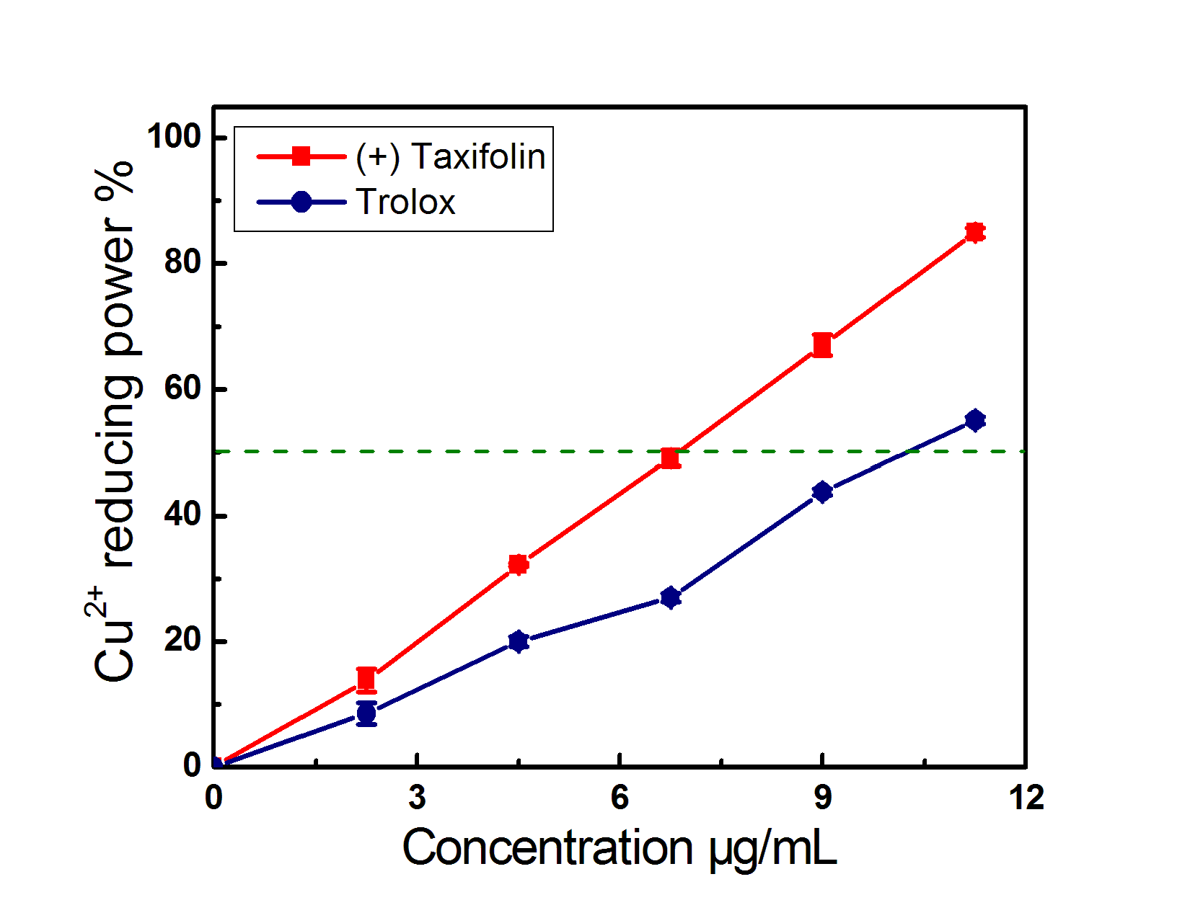
Fig. S5. Dose response curves of (+) taxifolin and Trolox in the Cu²⁺-reducing assay. Each value is expressed as the mean±SD, n=3.

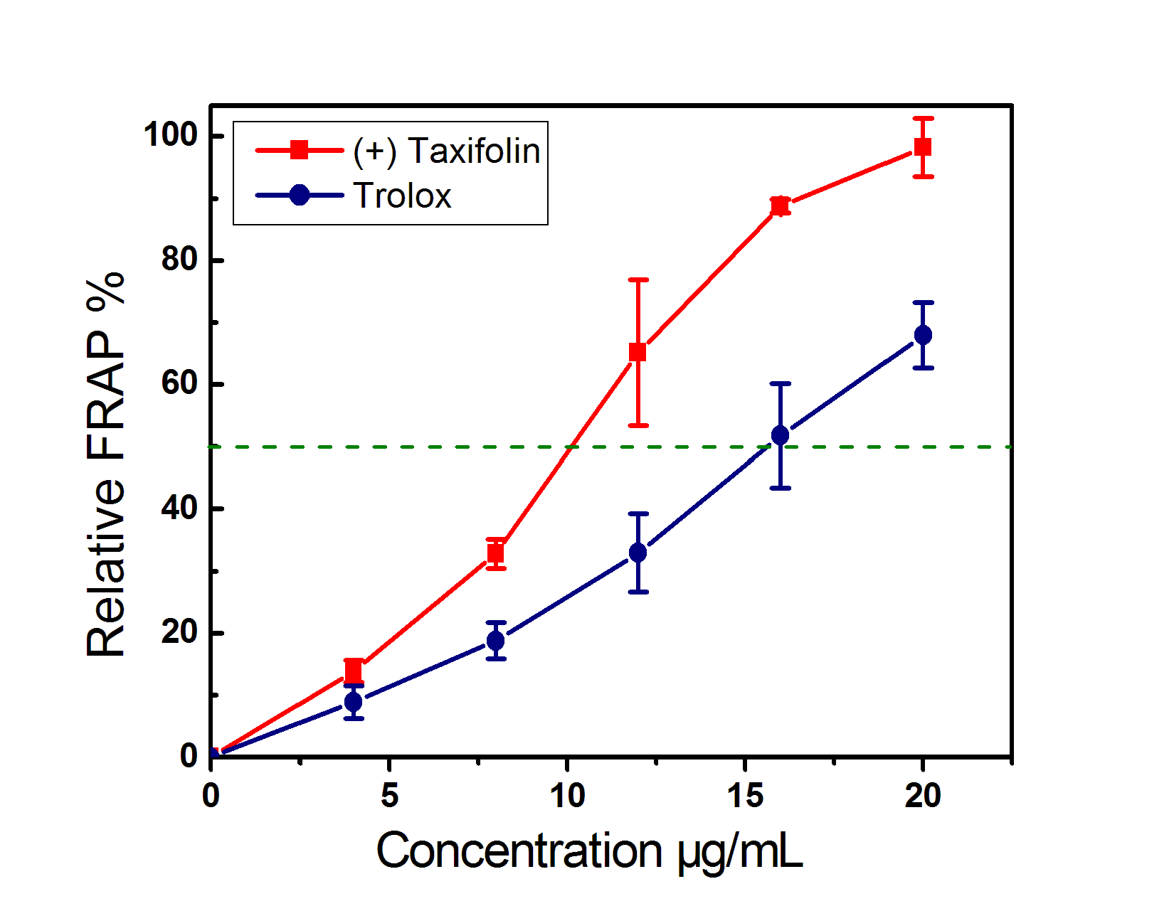
Fig. S6. Dose response curves of (+) Taxifolin and Trolox in the FRAP assay. Each value is expressed as the mean±SD, n=3.

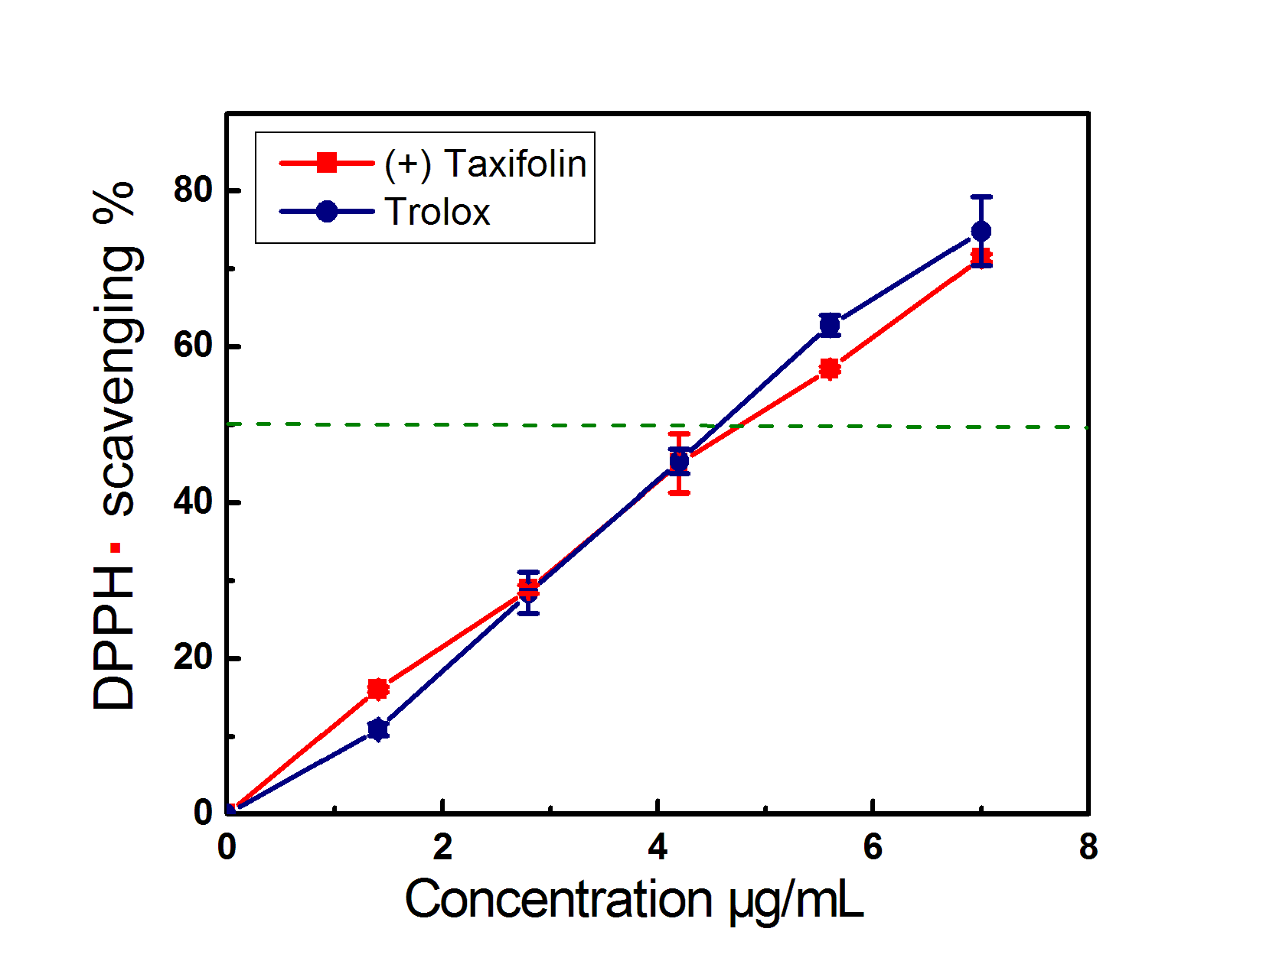
Fig. S7. Dose response curves of (+) Taxifolin and Trolox in DPPH•-radical-scavenging assay. Each value is expressed as the mean±SD, n=3.

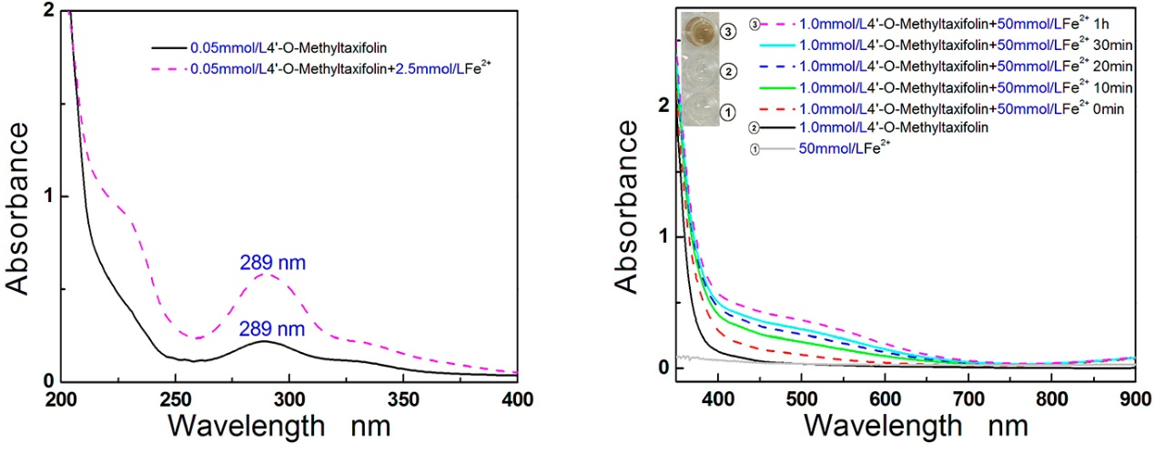

Fig. S8. The UV-visible spectra of 4'-O-methyltaxifolin-Fe²⁺ complex

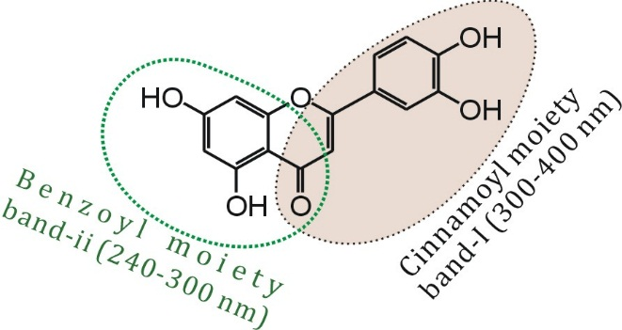
Fig. S9. The UV absorption bands of flavonoid

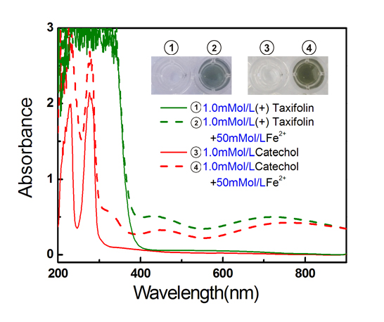
Fig. S10. The UV-Vis-spectra and solution colors of (+)taxifolin-Fe²⁺ and catechol-Fe²⁺

Fig. S11. UV-Vis-spectra of (+) taxifolin-Fe²⁺ and dihydromyricetin-Fe²⁺

