Supplementary information
METTL3-m⁶A-STAT1/NF-κB Axis: A Key Switch for the immunosuppressive capacity of mesenchymal stem cells.

Keke Tang^{1,5†}, Hong Han^{1,5†}, Ruizheng Sun^{1,5}, Yi Xu^{4,5}, Shengdi Zhang^{1,3,5}, Chen Lai^{2,4,5}*, Yu Peng^{1,3,5}*
*Corresponding author. Email: pengyu918@csu.edu.cn

This PDF file includes:

Supplementary Figure. S1 to S5
Supplementary Tables S1 to S6

Supplementary Figures
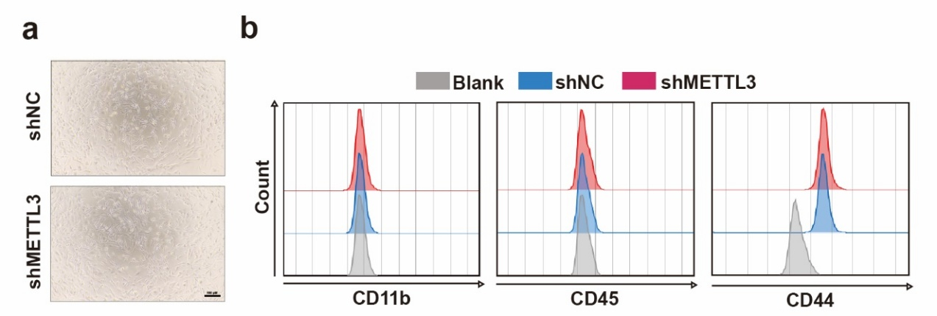
Supplementary Figure S1. Characterization of MSCs in vitro. (a) The morphology of shNC or shMETTL3 MSCs. (b) Flow cytometry identification of surface markers of shNC or shMETTL3 MSCs.

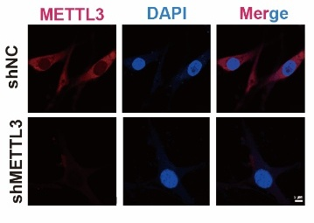
Supplementary Figure S2. Identification of METTL3 localization and knockout efficiency in MSCs by Immunofluorescence staining.

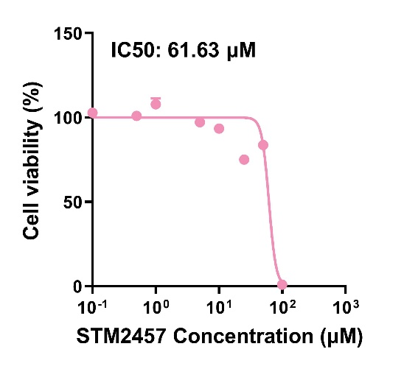
Supplementary Figure S3. The cytotoxicity of STM2457 on MSCs was assessed by MTT assay.

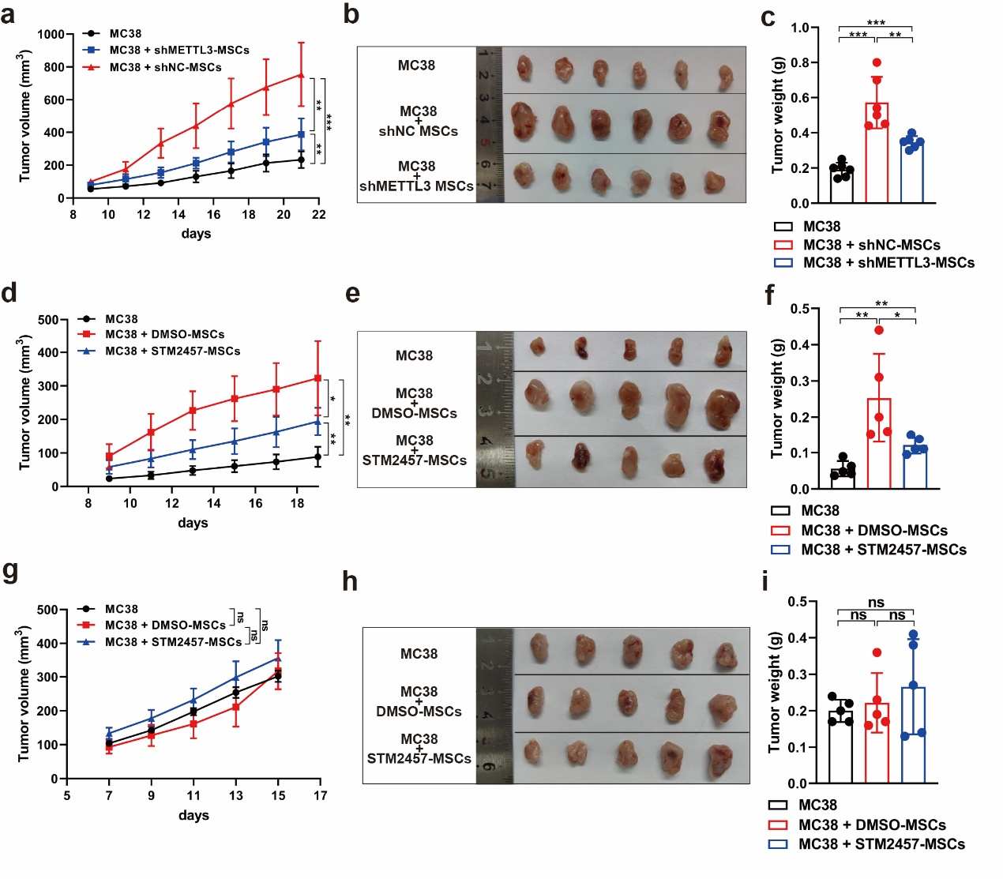
Supplementary Figure S4. Inhibition of METTL3 attenuates the immunosuppressive capacity of MSCs in vivo. (a-c) MC38 cells and the shNC or shMETTL3 MSCs were co-administered into BALB/C mice (n = 5) subcutaneously. (a) Tumor growth curve. (b) The image of the tumors. (c) The weight of the tumors. (d-f) MC38 cells and DMSO or STM2457 pretreated MSCs were co-administered into BALB/C mice (n = 5) subcutaneously. (d) Tumor growth curve. (e) The image of the tumors. (f) The weights of the tumors. (g-i) MC38 cells and DMSO or STM2457 pretreated MSCs were co-administered into BABL/c Nude mice (n = 5) subcutaneously. (g) Tumor growth curve. (h) The image of the tumors. (i) The weights of the tumors. Error bars represent SD. * p < 0.05; ** p < 0.01; *** p < 0.001; ns: no significance.

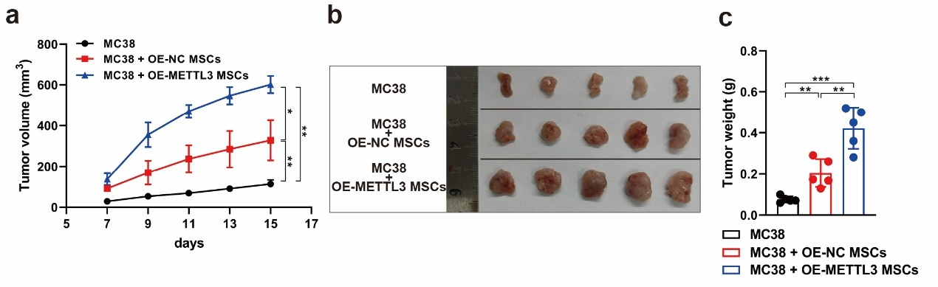
Supplementary Figure S5. Overexpression of METTL3 enchances the immunosuppressive capacity of MSCs in vivo. (a-c) MC38 cells and the OE-NC or OE-METTL3 MSCs were co-administered into BALB/C mice (n = 5) subcutaneously. (a) Tumor growth curve. (b) The image of the tumors. (c) The weight of the tumors.

Supplementary Tables
