Supplementary Figures
Supplementary Figure S1
Fig.S1: Liver injury in CH pigs
(A, B) RT-qPCR analysis of inflammatory response regulation genes and chemokine-receptor system genes in Ctrl (n = 4-6) and CH livers (n = 4-6). *p < 0.05, **p < 0.01, ***p < 0.001 (Student's t-test). (C) TG content in Ctrl (n = 9) and CH livers (n = 8). **p < 0.01 (Student's t-test). (D) Serum insulin levels in Ctrl (n = 6) and CH pigs (n = 7). **p < 0.01 (Student's t-test). Data are presented as mean ± SD.

Supplementary Figure S2
Fig.S2: Characterization of ferroptosis in CH liver
(A) GO analyses of the RNA-seq data. (B) Cleaved Caspase 3 IHC staining of Ctrl (n = 3) and CH livers (n = 3). (C) Staining was quantified as the fraction of positive cells per field (n = 3 per group). ***p < 0.001 (One-way ANOVA with post hoc Tukey’s test). Data are presented as mean ± SD.

Supplementary Figure S3
Fig.S3: T3’s anti-ferroptotic effects in hepatic cells
(A) Overview of ferroptosis inducers used in this study. (B) Viability of THLE-2 cells treated with the indicated ferroptosis inducers (n = 6 per group). (C) Morphology of THLE-2 cells treated with Erastin (5 µM) or FINO2 (50 µM) with or without T3 pre-treatment (n = 3 per group). (D, E) Viability of THLE-2 cells treated with Erastin (5 µM) or FINO2 (50 µM). T3 or Lip-1 was added 6 h before Erastin or FINO2 addition (n = 6 per group). (F-J) Viability of LX2, PHSC, PICM-19, JS-1, and HEPA1-6 cells treated with RSL3 (n = 6 per group). Data are presented as mean ± SD.

Supplementary Figure S4
Fig.S4: T3 protects hepatocytes from ferroptosis via the AMPKα-GSK3β-NRF2-GPX4 axis
(A, B) Relative expression levels of NRF2, p-AMPKα, AMPKα, p-GSK3β, and GSK3β normalized to internal control in CH (n = 3) and Ctrl livers (n = 3). *p < 0.05, **p < 0.01 (Student's t-test or Mann-Whitney test). (C) Mechanism of T3’s anti-ferroptosis effect through the AMPKα-GSK3β-NRF2-GPX4 axis. Data are presented as mean ± SD.

Supplementary Figure S5
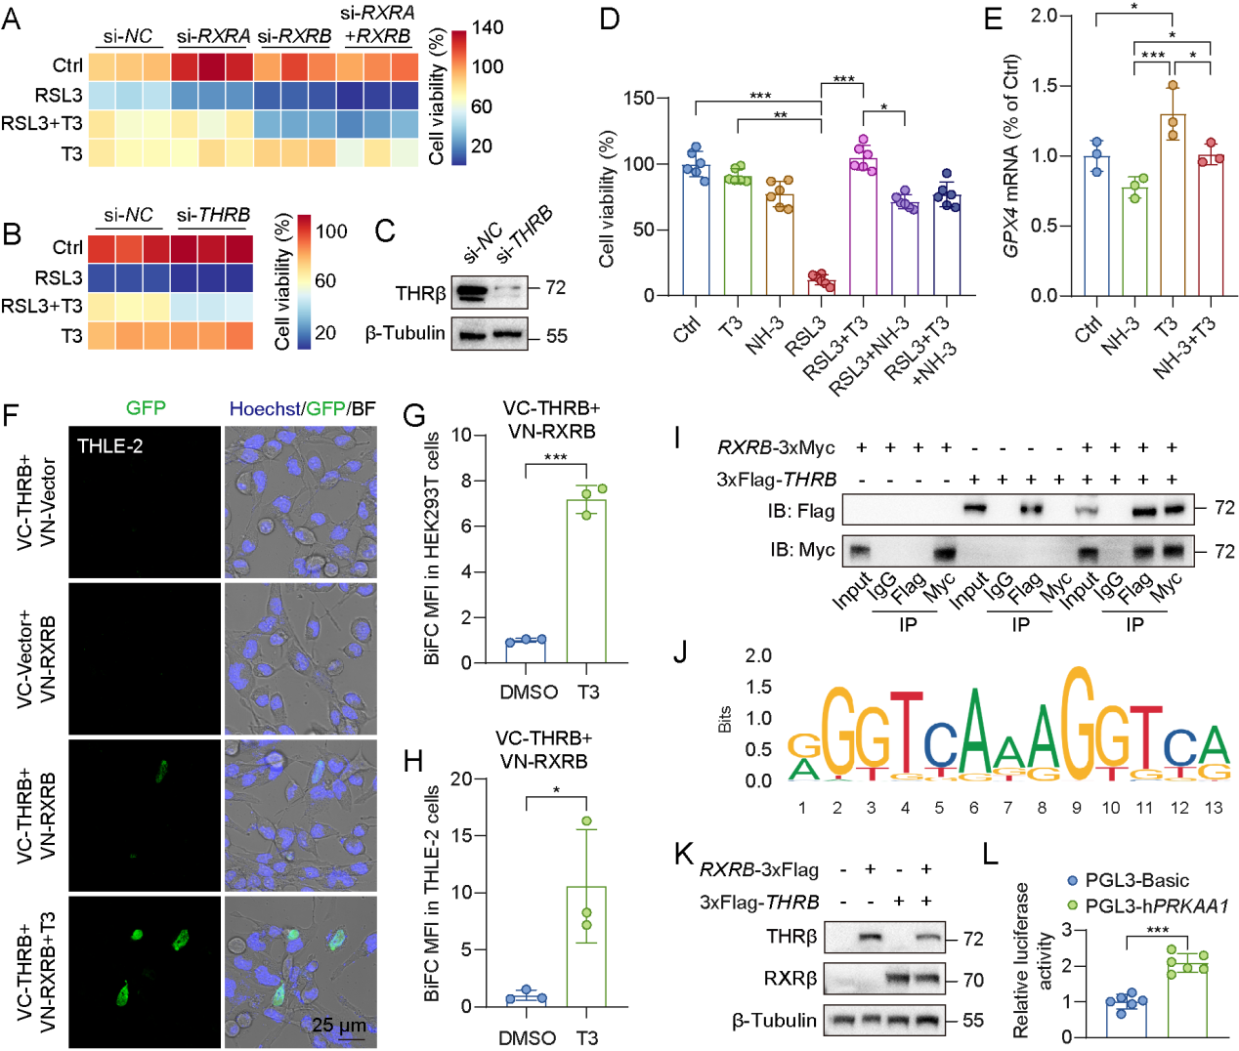Fig.S5: T3 activates AMPKα via THRβ/RXRβ heterodimers
(A) Viability of THLE-2 cells transfected with si-NC, si-RXRA, si-RXRB, or si-RXRA plus si-RXRB. T3 (10 µM) was added 6 h before RSL3 (3 µM) addition (n = 3 per group). (B) Viability of THLE-2 cells transfected with si-NC or si-THRB. T3 (10 µM) was added 6 h before RSL3 (3 µM) addition (n = 3 per group). (C) Immunoblotting of THRβ in THLE-2 cells transfected with si-NC or si-THRB. (D) Effects of NH-3 on T3’s anti-ferroptosis capacity in THLE-2 cells. T3 and NH-3 were added 6 h before the RSL3 addition (n = 6 per group). *p < 0.05, **p < 0.01, ***p < 0.001 (Kruskal-Wallis test). (E) RT-qPCR analysis of GPX4 in THLE-2 cells treated with NH-3 (1 µM), T3 (10 µM), or NH-3 with T3 (n = 3 per group). *p < 0.05, ***p < 0.001 (One-way ANOVA with post hoc Tukey’s test). (F) BiFC validation of the interactions between THRβ and RXRβ protein in THLE-2 cells (n = 3 per group). (G, H) Quantification of MFI in HEK293T (G, n = 3 per group) and THLE-2 cells (H, n = 3 per group). *p < 0.05, ***p < 0.001 (Student's t-test). (I) Co-IP validation of the interactions between THRβ and RXRβ protein in THLE-2 cells (n = 3 per group). (J) Prediction of THRβ-binding motifs on the human PRKAA1 promoter. (K) Immunoblotting of RXRβ and THRβ in HEK293T cells transfected with overexpression vectors for RXRB and/or THRB. (L) Luciferase activity for the promoter region of the human PRKAA1 gene. Experiments were conducted in HEK293T cells (n = 6 per group). ***p < 0.001 (Student's t-test). Data are presented as mean ± SD.

Supplementary Figure S6
Fig.S6: Suppressed enzyme synthesis in CH
(A-F) Serum levels of ALT, AST, ALP, ALB, TBIL, and the AST/ALT ratio of healthy controls (n = 4) and human CH neonates (n = 5). P values were adjusted for multiple testing across all measured parameters using the BH-FDR method and are reported as q values. A value of q < 0.05 was considered statistically significant. (G-K) FPKM of hepatic enzyme synthesis-related genes in Ctrl (n = 3) and CH livers (n = 3). *p < 0.05, **p < 0.01 (Student's t-test). Data are presented as mean ± SD.

Supplementary Tables
Table S1: Clinical characteristics of neonates with CH and healthy controls
Characteristics | CH | Healthy controls
Number of cases | 8 | 7
Age | 0 | 0
Male | 4 | 3
Female | 4 | 4
TSH (μIU/mL), median (range) | 9.445 (5.44-25.12) | 1.9 (1.272-2.530)
FT4 (ng/dL), median (range) | 0.94 (0.75-1.23) | 0.99 (0.90-1.04)
FT3 (pg/mL), median (range) | 2.775 (1.55-4.23) | 3.83 (2.88-4.07)
TSH, Thyroid-stimulating hormone; FT4, Free Thyroxine; FT3, Free Triiodothyronine.
Table S2: Antibodies
Name | Citation | Supplier | Cat no.
Rabbit recombinant monoclonal anti-CXCR2 | AB_2910167 | Abcam | ab225732
Rabbit monoclonal anti-MMP9 | AB_1310463 | Abcam | ab76003
Rabbit polyclonal anti-Cleaved Caspase-3 (Asp175) | AB_2341188 | Cell Signaling Technologies | 9661
Mouse monoclonal anti-4 HNE | AB_10216275 | Abcam | ab48506
Rabbit monoclonal anti-NRF2 | AB_3076406 | Abcam | ab62352
Rabbit monoclonal anti-GPX4 | AB_3101850 | Abcam | ab125066
Rabbit monoclonal anti-ACSL4 | AB_3719913 | Cell Signaling Technologies | 38493
Rabbit monoclonal anti-ALOX15 | AB_2910599 | Abcam | ab244205
Rabbit polyclonal anti-PRDX3 | AB_3082081 | Boster | PB9349
Rabbit polyclonal anti-TF | AB_1659060 | Abcam | ab82411
Rabbit polyclonal anti-SLC5A11 | AB_2189540 | Proteintech | 14089-1-AP
Rabbit monoclonal anti-AMPKα | AB_3662054 | Cell Signaling Technologies | 5831
Rabbit monoclonal anti-Phospho-AMPKα (Thr172) | AB_2799368 | Cell Signaling Technologies | 50081
Rabbit monoclonal anti-GSK3β | AB_1031009 | Cell Signaling Technologies | 9315
Rabbit monoclonal anti-Phospho-GSK3β (Ser9) | AB_10695601 | Cell Signaling Technologies | 5558
Rabbit polyclonal anti-THRα | AB_882974 | Abcam | ab53729
Mouse monoclonal anti-THRβ | AB_3719914 | Santa | sc-398007
Rabbit monoclonal anti-RXRα | AB_10975632 | Abcam | ab125001
Rabbit polyclonal anti-RXRβ | AB_10858228 | Proteintech | 14684-1-AP
Rabbit polyclonal anti-β-Tubulin | AB_10694206 | Cell Signaling Technologies | 2146
Rabbit polyclonal anti-Lamin B | AB_3717870 | Boster | BA1228
Rabbit monoclonal anti-GAPDH | AB_3075407 | Cell Signaling Technologies | 2118
Mouse monoclonal anti-Myc | AB_2734122 | Proteintech | 60003-2-Ig
Rabbit monoclonal anti-Flag | AB_3719915 | Yeasen | 30501ES60
Rabbit polyclonal anti-IgG | AB_10284964 | Cell Signaling Technologies | 2729
Rabbit polyclonal anti-Myc | AB_11182162 | Proteintech | 16286-1-AP
Mouse monoclonal anti-Flag | AB_2918475 | Proteintech | 66008-4-Ig
Goat Anti-Rabbit IgG H&L | AB_3697628 | Novoprotein | N269
Goat Anti-Mouse IgG H&L | AB_3697627 | Novoprotein | N270
HRP-linked, Anti-rabbit IgG | AB_3718177 | Cell Signaling Technologies | 7074
HRP-linked, Anti-mouse IgG | AB_2920888 | Cell Signaling Technologies | 7076
Goat anti-rabbit IgG H&L (FITC) | AB_955238 | Abcam | ab6717

Table S3: Primers used for RT-qPCR
Primer name | Forward | Reverse
p18s | GTAACCCGTTGAACCCCATT | CCATCCAATCGGTAGTAGCG
pSELL | GGAGCCCAACAACAGGAAGA | GCTTTGTGGCAGGCATCATC
pCCL16 | CTCATCCTCATCCTCGCCAC | TGTAGCCCACCACCAGTTTC
pCXCL8 | ATTCCACACCTTTCCACCCC | CCACTTTTCCTTGGGGTCCA
pCXCL14 | GGACCCAAGATCCGCTACAG | GGACATGCTCTTGGTGGTGA
pSLC37A4 | GGTCCCATTGCCTTGTTTGG | CAGATCACTTCAGCCACCCA
pIL1β | AAGATAACACGCCCACCCTG | AGACGGGCTTTTGTTCTGCT
pMMP9 | AAACTCCCTGGTGATGCTGG | TAGGCAAGGTCAGGGCAAAG
pCXCR2 | GCCCTGCCCATCTTCATCTT | ATCACCATCCGCCACTTTGT
pPPBP | TTCCAGCCCATTTCCTGTCC | TGCGCCATTCTTCCCTCAAT
pACSL4 | CGGTTGGTCAAGGCTATGGA | GGGTTTGGCTTGTCGTGAAC
pACSL6 | GGAGCATGTGGAGAGGAAGG | AAGGTCACTGGGTTTTGGGG
pALOX15 | GGCTTGGTGTCGAGAGTTCA | GCTGCTCCTTGGACTGTAGG
pSLC5A11 | CTGATGGCCGCTTACCTGAA | CGGGTTGCTACACACCTTCT
pSLC3A2 | GAGACCTAGCGAGCCTGAAG | CTGGTGCTTGTGAATTGGGC
pSLC7A11 | TGGTGGTGTGTTTGCTGTCT | AGGTCCCCAGAGAAGAGCAT
pGCLC | TCCTCCTCCAAACTCCGACA | GCACCACAAACACCACGTAC
pGCLM | GTGATGCCGCCCGATTTAAC | TCATGTGCCTCGATGTCAGG
pGSS | CCGTTCACACTCTTCCCCTC | GGTGCTGGAGAGAGTTTGCT
pHAMP | CCCATCCCAGACAAGACAGC | CAGATGGGGAAGTGGGTGTC
pTF | AAGAAGGTGAGGTGGTGTGC | TCTTCGGTGTTTTCTGCGGA
pLTF | GCTGAGAATGCTGGGGATGT | CAATTCCCTGGCCCACTCTT
pTFR1 | CTTCCCTCAAACACCTCGCT | GAGATCCAGCTTCACGAGGG
pSLC39A14 | GAGGACCAAGATACCGCCTG | GAGCCCACGATGACCTTCTC
pDMT1 | CATCATCCCCACTCTGCTGG | GAGGACCAAGATACCGCCTG
pFTH | CTGGAACTGCACAAACTGGC | GGCTTTCACCTGCTCATCCA
pFTL | GTTTGGACGGAACAGACCCA | AGATAGCTGAGAGGCGGAGT
pFPN | ATCTCCGTGTTCATGCCTGG | GGCACAGGTTTAGGGCTCAT
pFUT7 | CCCAGCACCGAGACTACATC | CTCGTTCATGCTGGTGAGGA
hRPLP0 | CAGATTGGCTACCCAACTGTT | GGGAAGGTGTAATCCGTCTCC
hSLC7A11 | GAAAGCCTGTTGTGTCCACC | TGAAGATTCCTGCTCCAATGATG
hHO-1 | AGTCTTCGCCCCTGTCTACT | GCTGGTGTGTAGGGGATGAC
hGCLC | TCCAGGTGACATTCCAAGCC | GAAATCACTCCCCAGCGACA
hGPX4 | GGAGCCAGGGAGTAACGAAG | CTTGCCCTTGGGTTGGATCT
hSLC5A11 | AAAGGAGGTGCTCTGATGGC | GATCTGGGAAGAGGATGCGG
The letter p and h are short for the “porcine” and “human”, respectively.
Table S4: si-RNAs
Target gene | sense (5'-3') | antisense (5'-3')
si-NC | UUCUCCGAACGUGUCACGUTT | ACGUGACACGUUCGGAGAATT
si-RXRA | CGAUUUCUCCACCCAGGUGAAdTdT | UUCACCUGGGUGGAGAAAUCGdTdT
si-RXRB | GCGUGACAUGAGGAUGGACAAdTdT | UUGUCCAUCCUCAUGUCACGCdTdT
si-THRB | AUUUUCUGUCAUACUGUUGGGUU | CAACAGUAUGACAGAAAAUGGUU

